Supplemental

Table S1 – Example Search string from Cochrane CENTRAL
ID | Search | Hits
#1 | MeSH descriptor: [Adjustment Disorders] explode all trees | 251
#2 | MeSH descriptor: [Mood Disorders] explode all trees | 13482
#3 | MeSH descriptor: [Affective Symptoms] explode all trees | 461
#4 | MeSH descriptor: [Anorexia Nervosa] explode all trees | 553
#5 | MeSH descriptor: [Anxiety Disorders] explode all trees | 7293
#6 | MeSH descriptor: [Suicide, Attempted] explode all trees | 445
#7 | MeSH descriptor: [Bipolar Disorder] explode all trees | 2764
#8 | MeSH descriptor: [Bulimia] explode all trees | 541
#9 | MeSH descriptor: [Fatigue Syndrome, Chronic] explode all trees | 403
#10 | MeSH descriptor: [Combat Disorders] explode all trees | 131
#11 | MeSH descriptor: [Conversion Disorder] explode all trees | 43
#12 | MeSH descriptor: [Depression] explode all trees | 13147
#13 | MeSH descriptor: [Depressive Disorder] explode all trees | 12759
#14 | MeSH descriptor: [Dysthymic Disorder] explode all trees | 181
#15 | MeSH descriptor: [Feeding and Eating Disorders] explode all trees | 1725
#16 | MeSH descriptor: [Sexual Dysfunctions, Psychological] explode all trees | 2180
#17 | MeSH descriptor: [Hypochondriasis] explode all trees | 96
#18 | MeSH descriptor: [Hysteria] explode all trees | 19
#19 | MeSH descriptor: [Erectile Dysfunction] explode all trees | 1507
#20 | MeSH descriptor: [Mental Disorders] explode all trees | 76985
#21 | MeSH descriptor: [Munchausen Syndrome] explode all trees | 2
#22 | MeSH descriptor: [Neurasthenia] explode all trees | 29
#23 | MeSH descriptor: [Neurotic Disorders] explode all trees | 301
#24 | MeSH descriptor: [Obsessive-Compulsive Disorder] explode all trees | 1090
#25 | MeSH descriptor: [Panic Disorder] explode all trees | 967
#26 | MeSH descriptor: [Phobic Disorders] explode all trees | 1405
#27 | MeSH descriptor: [Stress Disorders, Post-Traumatic] explode all trees | 2800
#28 | MeSH descriptor: [Stress, Psychological] explode all trees | 6474
#29 | MeSH descriptor: [Seasonal Affective Disorder] explode all trees | 175
#30 | MeSH descriptor: [Self-Injurious Behavior] explode all trees | 1562
#31 | MeSH descriptor: [Self Mutilation] explode all trees | 37
#32 | MeSH descriptor: [Somatoform Disorders] explode all trees | 741
#33 | (1 OR 2 OR 3 OR 4 OR 5 OR 6 OR 7 OR 8 OR 9 OR 10 OR 11 OR 12 OR 13 OR 14 OR 15 OR 16 OR 17 OR 18 OR 19 OR 20 OR 21 OR 22 OR 23 OR 24 OR 25 OR 26 OR 27 OR 28 OR 29 OR 30 OR 31 OR 32) | 1819488
#34 | MeSH descriptor: [Internet-Based Intervention] explode all trees | 236
#35 | MeSH descriptor: [Smartphone] explode all trees | 460
#36 | MeSH descriptor: [Mobile Applications] explode all trees | 888
#37 | MeSH descriptor: [Mobile Applications] explode all trees | 888
#38 | smartphone OR App OR Website | 14182
#39 | (34 OR 35 OR 36 OR 37 OR 38) | 466585
#40 | MeSH descriptor: [Clinical Trials as Topic] explode all trees | 48465
#41 | MeSH descriptor: [Adaptive Clinical Trials as Topic] explode all trees | 0
#42 | MeSH descriptor: [Clinical Trial] explode all trees | 141
#43 | MeSH descriptor: [Randomized Controlled Trials as Topic] explode all trees | 15003
#44 | MeSH descriptor: [Randomized Controlled Trial] explode all trees | 119
#45 | MeSH descriptor: [Controlled Clinical Trials as Topic] explode all trees | 15155
#46 | MeSH descriptor: [Pragmatic Clinical Trials as Topic] explode all trees | 29
#47 | (Clinical Trial or Randomised Clinical Trial OR RCT):ti,ab,kw | 644638
#48 | (40 OR 41 OR 42 OR 43 OR 44 OR 45 OR 46 OR 47) | 588930
#49 | 33 AND 39 AND 48 | 8598
Date Run: 17/09/2021 11:10:57

Table S2 – Data Extraction Template
Component | Variables | Values
Trial Characteristics | ID
Trial Characteristics | Year of Publication
Trial Characteristics | First Author
Trial Characteristics | Advertisement Strategy | Categorical: Physical Sites, Digital Site, Both
Trial Characteristics | Recruitment Strategy | Categorical: Physical Sites, Digital Site, Both
Trial Characteristics | No. of Arms
Trial Characteristics | Study Design | Categorical: Pilot, Feasibility, Parallel, Crossover, Cluster, Factorial, etc.
Trial Characteristics | Trial Type | Categorical: Superiority, Non-inferiority, Other.
Trial Characteristics | Study Duration - Intervention Follow-up
Trial Characteristics | No. Participants Randomised
CONSORT Items | Is a published protocol/trial number provided? | Categorical: Yes or No
CONSORT Items | No. Planned Participants (Sample Size)
CONSORT Items | Was the primary analysis changed? | Categorical: Yes or No
Intervention and Comparator Descriptions | Intervention Name
Intervention and Comparator Descriptions | More Detail in the Protocol? | Categorical: Yes or No
Intervention and Comparator Descriptions | Intervention Delivery Method | Categorical: Website, App, Other
Intervention and Comparator Descriptions | Intervention Type | Categorical: Virtual World, Structured Education, Online Therapy (e.g. Behavioural), Virtual Supprot Agent, Automated Chat Bot, Decision Aid
Intervention and Comparator Descriptions | Intervention Components | Categorical: Digital Only, Blended Approach
Intervention and Comparator Descriptions | Intervention Support | HEADING ONLY
Intervention and Comparator Descriptions | F2F Session | Categorical: Yes or No
Intervention and Comparator Descriptions | Telephone Communication | Categorical: Yes or No
Intervention and Comparator Descriptions | Group Delivery | Categorical: Yes or No
Intervention and Comparator Descriptions | Intervention Purporse | HEADING ONLY
Intervention and Comparator Descriptions | For Prevention of Symptoms? | Categorical: Yes or No
Intervention and Comparator Descriptions | For Treatment? | Categorical: Yes or No
Intervention and Comparator Descriptions | For Self-management? | Categorical: Yes or No
Intervention and Comparator Descriptions | Intervention Focus | Categorical: Disease Specific or Transdiagnostic
Intervention and Comparator Descriptions | Intervention Primary Function | HEADING ONLY
Intervention and Comparator Descriptions | Promote Behavioural Change | Categorical: Yes or No
Intervention and Comparator Descriptions | Encourage Social Connection | Categorical: Yes or No
Intervention and Comparator Descriptions | Improve disease knowledge | Categorical: Yes or No
Intervention and Comparator Descriptions | Intervention Features | HEADING ONLY
Intervention and Comparator Descriptions | Remote Education | Categorical: Yes or No
Intervention and Comparator Descriptions | Symptom Tracking | Categorical: Yes or No
Intervention and Comparator Descriptions | Access to Professionals | Categorical: Yes or No
Intervention and Comparator Descriptions | Forum for Patients | Categorical: Yes or No
Intervention and Comparator Descriptions | Intervention Origin | Categorical: Adapted, New or Unclear
Intervention and Comparator Descriptions | Does the intervention allow collection of trial outcomes? | Categorical: Yes or No
Intervention and Comparator Descriptions | Did the intervention provide therapy for the patients carer or family? | Categorical: Yes or No
Intervention and Comparator Descriptions | Was it reported that the intervention changed during the trial? | Categorical: Yes or No
Intervention and Comparator Descriptions | Comparator Type | Categorical: Placebo, Standard Care, Wait-List or Alternative DHMI
Intervention and Comparator Descriptions | Are those in Comparator Arm ever offered intervention? | Categorical: Yes or No
Intervention and Comparator Descriptions | If Yes - When are they offered the intervention? | Categorical: After Intervention Period, After Follow-up, Unclear.
Demographics | Diagnosis Studied | Categorical: Adjustment Disorder, Affective Disorders, Anorexia Nervosa, Anxiety, Attempted Suicide, Bipolar Disorder….
Demographics | Diagnosis Severity | Categorical: Mild, Moderate, Severe, Multiple, Self-Referred, Unclear
Demographics | Diagnosis Reporting | Categorical: Self-referred, Clinically Diagnosed, Both, Unclear
Demographics | Population Setting | Categorical: Hospital, GP, Community, School or University, Unrestricted, Other
Demographics | Age Category | Categorical: Child, Adolescent, Young Adult, Adult, Elderly
Demographics | Age Mean
Demographics | Age SD
Demographics | Proportion Female
Demographics | Ethnicity Included
Engagement Reporting | Intervention access | Categorical: Restriced, unrestricted, unclear, Not Applicable
Engagement Reporting | Intervention Delivery Pace | Categorical: Self-guided, Only when needed, Clinically Managed, Externally Managed, Automated, Unclear
Engagement Reporting | What methods were used to encourage participants engagement? | HEADING ONLY
Engagement Reporting | Automatic notifications | Categorical: Yes or No
Engagement Reporting | Reminders by clinical team | Categorical: Yes or No
Engagement Reporting | Blended intervention (F2F component) | Categorical: Yes or No
Engagement Reporting | Inclusion of Homework Tasks | Categorical: Yes or No
Engagement Reporting | Other
Engagement Reporting | Was engagement recommended? | Categorical: Yes or No
Engagement Reporting | If yes - what was the definition used?
Engagement Reporting | If yes - No. that achieved recommendation
Engagement Reporting | Was engagement described? | Categorical: Yes or No
Engagement Reporting | How was engagement desrcibed? | HEADING ONLY
Engagement Reporting | In text? | Categorical: Yes or No
Engagement Reporting | Using Tables | Categorical: Yes or No
Engagement Reporting | Using Figures | Categorical: Yes or No
Engagement Reporting | Indicators used in description
Engagement Reporting | First Engagement Summary Method | Free Text Option
Engagement Reporting | Engagement Summary Statistic | Categorical: Mean, Median, Other
Engagement Reporting | Location Estimate
Engagement Reporting | Range Estimate
Engagement Reporting | Second Engagement Summary Method | Free Text Option
Engagement Reporting | Engagement Summary Statistic | Categorical: Mean, Median, Other
Engagement Reporting | Location Estimate
Engagement Reporting | Range Estimate
Engagement Reporting | Other Engagement Information | Free Text Option, Copy from Text
Engagement Reporting | Engagment Summary (Binary) | HEADING ONLY
Engagement Reporting | Proportion achieving engagement
Engagement Reporting | Denominator
Engagement Reporting | Is there an Active User definition? | Categorical: Yes or No
Engagement Reporting | If yes - what was the definition?
Engagement Reporting | Did this definition use the digital component of the intervention? | Categorical: Yes or No
Engagement Reporting | If yes - what indicators were used?
Engagement Reporting | If yes - No. achieved this
Primary Analysis | Analysis Population Reported | Categorical: ITT, Modified ITT, Per-Protocol,
Primary Analysis | N in Analysis (Intervention)
Primary Analysis | N in Analysis (Control)
Primary Analysis | Stratification | Categorical: Age, Gender, Site etc. etc.
Primary Analysis | Outcome
Primary Analysis | Time of Primary Endpoint
Primary Analysis | Number Included in Primary Analysis
Primary Analysis | Analysis Method
Primary Analysis | Number at Primary Endpoint
Primary Analysis | Result (Binary) | HEADING ONLY
Primary Analysis | Method | Categorical: Odds Ratio, Risk Ratio
Primary Analysis | N with outcome (intervention)
Primary Analysis | N with outcome (control)
Primary Analysis | Result (Continuous) | HEADING ONLY
Primary Analysis | Baseline Mean (if adjusted for)
Primary Analysis | Mean (Continuous)
Primary Analysis | SD (Continuous)
Primary Analysis | P-value (Continuous)
Primary Analysis | Standardised Effect Size - Derived
Primary Analysis | Was primary analysis adjusted for engagement? | Categorical: Yes or No
Primary Analysis | Was an engagement adjustment performed? | Categorical: Yes or No
IF PRIMARY NOT ADJUSTED FOR ENGAGEMENT ABOVE COMPLETE BELOW FOR ENGAGEMENT ADJUSTED ANALYSIS (if Reported)
Engagement Analysis | Analysis Population Reported | Categorical: ITT, Modified ITT, Per-Protocol,
Engagement Analysis | N in Analysis (Intervention)
Engagement Analysis | N in Analysis (Control)
Engagement Analysis | Analysis Method
Engagement Analysis | Outcome Used
Engagement Analysis | Number Included in Analysis
Engagement Analysis | Engagement Adjusted Analysis Result | HEADING ONLY
Engagement Analysis | Binary | HEADING ONLY
Engagement Analysis | Proportion
Engagement Analysis | Method
Engagement Analysis | N with outcome (per arm)
Engagement Analysis | Continous | HEADING ONLY
Engagement Analysis | Baseline Mean (if adjusted for)
Engagement Analysis | Mean (Continuous)
Engagement Analysis | SD (Continuous)
Engagement Analysis | P-value (Continuous)

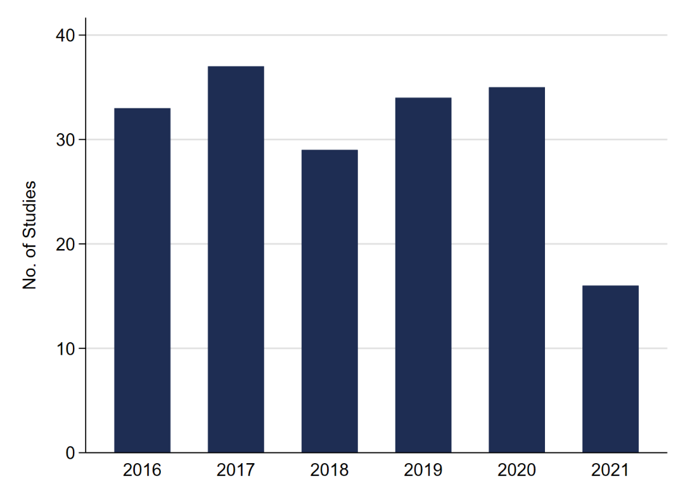
Figure S1 – The number of RCTs of DMHI in CMD publications each year

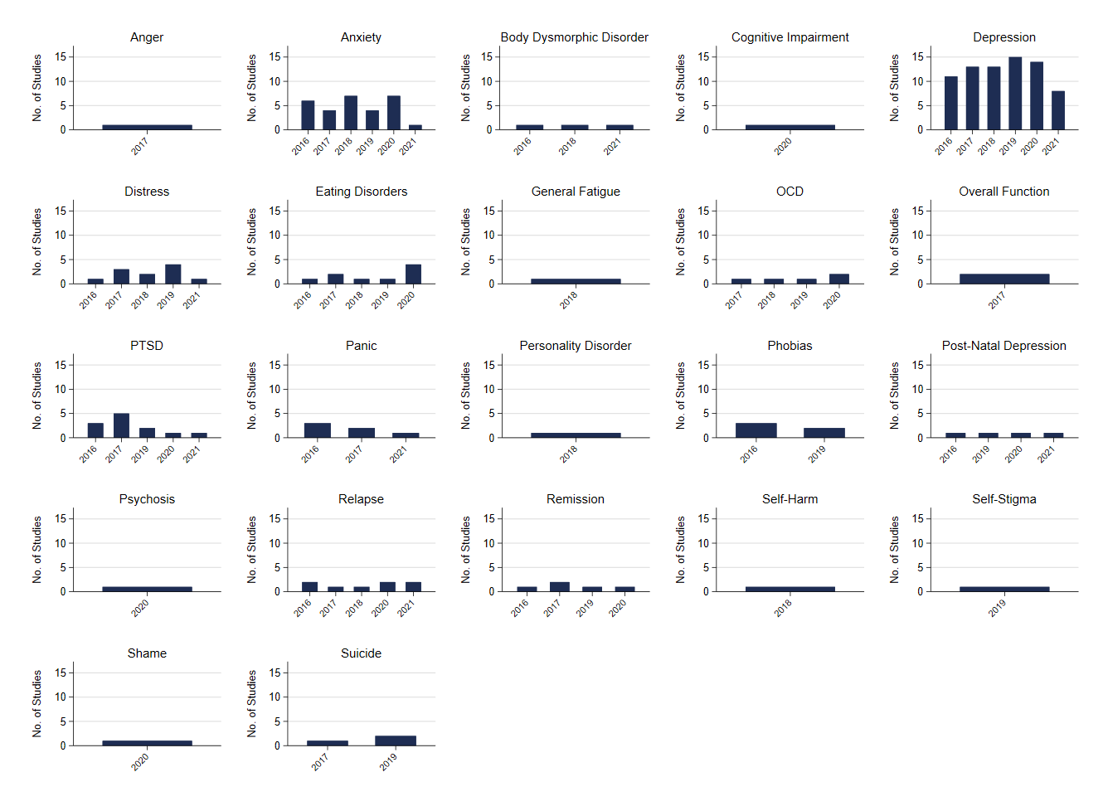
Figure S2 – The number of RCTs of DMHI in CMD publications by year for each outcome domain analysed.

Table S3 – Summary of all the health domains reported for all included trials
Primary Outcome Diagnosis, n studies (%) | N Studies | (%)
Anger | 1 | (0.5)
Anxiety | 29 | (15.8)
Body Dysmorphic Disorder | 3 | (1.6)
Cognitive Impairment | 1 | (0.5)
Depression | 74 | (40.2)
Distress | 11 | (6.0)
Eating Disorders | 9 | (4.9)
General Fatigue | 1 | (0.5)
OCD | 5 | (2.7)
Overall Function | 2 | (1.1)
PTSD | 12 | (6.5)
Panic | 6 | (3.3)
Personality Disorder | 1 | (0.5)
Phobias | 5 | (2.7)
Post-Natal Depression | 4 | (2.2)
Psychosis | 1 | (0.5)
Relapse | 8 | (4.3)
Remission | 5 | (2.7)
Self-Harm | 1 | (0.5)
Self-Stigma | 1 | (0.5)
Shame | 1 | (0.5)
Suicide | 3 | (1.6)

Table S4 – Summary of the types of indicators used to summarise user engagement.
Indicator | Total Indicators | Used in Recommendation |  |  |  | Used in Active User Definition
Indicator | Total Indicators | No | Yes | N/A |  | No | Yes | N/A
Duration of Use | 69 (18.7) | 14 (20.3) | 7 (10.1) | 48 (69.6) |  | 19 (27.5) | 2 (2.9) | 48 (69.6)
Frequency of Use | 150 (40.7) | 29 (19.3) | 1 (0.7) | 120 (80.0) |  | 35 (23.3) | 6 (4.0) | 109 (72.7)
Milestone Achieved | 124 (33.6) | 15 (12.1) | 21 (16.9) | 88 (71.0) |  | 8 (6.5) | 24 (19.4) | 92 (74.2)
Communication | 26 (7.0) | 6 (23.1) |  | 20 (76.9) |  | 7 (26.9) |  | 19 (73.1)

Table S5 – Definitions for recommended engagement levels by article identifier
Study ID | Recommended Definition
Anastasiadou 2020 | Use Daily
Arean 2016 | Access 6 times per week for 30 minutes per day
Axelsson 2018 | 1 Module Per Week
Bucker 2019 | 1 or 2 modules per week
Buntrock 2016 | At least 1 session per week
Butler 2019 | One Lesson every 1 to 2 Weeks
Campos 2019 | Two Exposure Scenarios per Week
Christoforou 2017 | 1 or 2 sessions per week at their own pace
Ciuca 2018 | One or two modules per week, depending on the complexity of the content and the homework assignments
deKleine 2019 | All four training sessions within one week
Fassnacht 2018 | One Module Per Week
Forand 2018 | One Session Per Week
Hadjistavropoulos 2016 | one module per week
Harrer 2021 | Maximum of Two Modules per Week
Hedman 2016 | Work on Homework Assignments Daily
Heller 2020 | One Module each Week
Hooley 2018 | Use Daily
Hur 2018 | 3 Trials Per Day
Ivanova 2016 | One Module per Week
Kahlke 2019 | One Session Weekly
Knaevelsrud 2017 | 2 Writing Assignments a Week
Kohle 2021 | 1.5 Hours Per Week
Lehavot 2021 | Twice a week for 8 Weeks
Lokman 2017 | 2 to 3 hours a week for a period of at least 4 weeks
McCloud 2020 | Use the app at least once per week
Milgrom 2016 | completion of all six sessions at a rate of one session per week
Moeini 2019 | 2 Sessions per Week
Nordgreen 2016 | 4 to 6 hours per week
Nygren 2019 | complete one module per week
Oehler 2020 | complete 1 workshop per week
Oromendia 2016 | One Module Per Week
Poppelaars 2016 | complete one level (approximately 20 - 40 min) per week
Pots 2016 | complete one session per week
Radomski 2020 | complete one session per week
Rasanen 2016 | one module per week
Reins 2019 | finish at least one, but preferably two modules per week
Rollman 2018 | One Session every 1 to 2 Weeks
Schulz 2016 | one session per week
Smith 2017 | complete one lesson every 1–2 weeks of the program
Stjerneklar 2019 | complete all eight modules (and module content) in the order they appeared within the 14-week intervention period
Stolz 2018 | one module per week
Teng 2019 | three times per day
Timulak 2016 | complete one module per week
Tonning 2021 | fill in the daily selfrating

Table S6 – Description of the definitions of an active user by article identifier
Study | Active User Definition
Andersson 2020 | Attended at least 6 modules of ICBT
Arean 2016 | met adherence criteria for at least 2 of the 4 weeks, defined as at least three 30 minute sessions per week
Beevers 2017 | Activated and spent at least 60 minutes actively engaged
Beshai 2020 | Completed all Modules and demonstrated High Treatment Fidelity
Braun 2021 | Completion of at least the second last standard lesson (equivalent to at least 80%) of the assigned training
Bucker 2019 | Used MOOD at least once a week
Buntrock 2016 | Completed at least 5 of the 6 sessions
Cardi 2020 | At least 4 modules completed
Castro 2020 | 4 Completed Modules
Christoforou 2017 | At least 80% of Intervention (8/10 Modules)
DeZwaan 2017 | Logged in until week 10
Ebert 2018 | 5 out of 6 Sessions Completed
Eimontas 2018 | Completed Self-report assessments at T2 and at least one intervention exercise.
Gladstone 2018 | 2 or more modules completed
Heckendorf 2019 | four or more of the five sessions as having followed the protocol
Heller 2020 | Completed the 5 Modules
Hoorelbeke 2016 | Completed all 10 sessions
Jacobi 2017 | opened at least 25% of program pages or participated in at least two one-to-one chats
Kenter 2016 | >=4 of 5 sessions
Klein 2016 | two sessions over a total duration of at least 60 min
Klein 2017 | two sessions over a total duration of at least 60 min
Kohle 2021 | Completed all 6 Modules
Lobner 2018 | Used at least once
McCloud 2020 | Used App Weekly
Montero-Marin 2016 | At Least 6 Sessions
Nilsson 2019 | those who completed more than five out of 19 self-monitoring questionnaires and commenced at least one module in myCompass
Oehler 2020 | participants having finished at least four workshops in the iFD tool
Oromendia 2016 | At least the first three modules
O'Toole 2019 | At Least 3 Sessions of Therapy
Pots 2016 | completed at least the first six sessions
Pult 2018 | Provided post-assessment data and logged in at least once
Radomski 2020 | Four or More Sessions of Breathe
Robichaud 2020 | completed all five lessons
Rollman 2018 | completed 4 or more
Schroder 2020 | utilized the intervention for at least 60 min
Spence 2017 | youth who completed (or their parent/caregiver completed) at least 3 intervention sessions
Wagner 2016 | complete at least 80% of the treatment modules

