Supplementary Materials
Bayesian additive regression trees for predicting childhood asthma in the CHILD Cohort Study

Mojtaba Ahmadiankalati¹, Himani Boury¹, Padmaja Subbarao^{3,4} Wendy Lou⁴, Zihang Lu^{1,2}
¹Department of Public Health Sciences, Queen’s University, Ontario, Canada
²Department of Mathematics and Statistics, Queen’s University, Ontario, Canada
³Department of Pediatrics, and Translational Medicine, SickKids Research Institute, The Hospital for Sick Children, Toronto, Ontario, Canada
⁴Dalla Lana School of Public Health, University of Toronto, Toronto, Ontario, Canada

Correspondence to: Zihang Lu, PhD
Department of Public Health Sciences,
Queen’s University, Carruthers Hall,
Kingston, ON
K7L 3N6
Canada
E-mail: zihang.lu@queensu.ca

Table E1: Variable names and labels of the 51 clinically relevant variables used for building the machine learning algorithms.
Variable name | Variable label
Demographic information
Sex | Sex
Race | Child race
Income | Income
Gestational_Age | Gestational age (weeks)
Mother_Education | Mother education
Father_Education | Father education
Growth characteristics
Weight_zscore_birth | Weight-age z-score at birth
Weight_zscore_3m | Weight-age z-score at 3 months
Weight_zscore_12m | Weight-age z-score at 1 year
Weight_zscore_36m | Weight-age z-score at 3 years
Height_zscore_birth | Height-age z-score at birth
Height_zscore_3m | Height-age z-score at 3 months
Height_zscore_12m | Height-age z-score at 1 year
Height_zscore_36m | Height-age z-score at 3 years
BMI_zscore_birth | BMI z-score at birth
BMI_zscore_3m | BMI z-score at 3 months
BMI_zscore_12m | BMI z-score at 1 year
BMI_zscore_36m | BMI z-score at 3 years
Family history of allergy diseases
Mother_Wheeze | Mother wheeze
Father_Wheeze | Father wheeze
Mother_FS | Mother food sensitization
Mother_IS | Mother inhalant sensitization
Father_FS | Father food sensitization
Father_IS | Father inhalant sensitization
Mother_Asthma | Mother asthma
Father_Asthma | Father asthma
Questionnaire data related to symptom presence
and severity
Respiratory_Problem | Respiratory problem at birth
FS_1y | Food sensitization at 1 year
IS_1y | Inhalant sensitization at 1 year
AD_1y | Atopic dermatitis at 1 year
FS_3y | Food sensitization at 3 years
IS_3y | Inhalant sensitization at 3 years
AD_3y | Atopic dermatitis at 3 years
AR_3Y | Atopic rhinitis at 3 years
FA_3Y | Food allergy at 3 years
Resp_Infection_3m | Respiratory infection at 3 months
Resp_Infection_1y | Respiratory infection at 1 year
Resp_Infection_3y | Respiratory infection at 3 years
Rec_Wheeze_1y | Recurrent wheeze at 1 year
Rec_Wheeze_3y | Recurrent wheeze at 3 years
Cough_3m | Cough without cold at 3 months
Cough_1y | Cough without cold at 1 year
Cough_3y | Cough without cold at 3 years
Questionnaire data related to environmental exposure
Dog_ownership | Dog ownership at 18 weeks
Cat_ownership | Cat ownership at 18 weeks
Prenatal_Smoke | Prenatal smoke exposure
Prenatal_Mat_Smoke | Prenatal maternal smoke
EBF_3m | Exclusive breastfeeding at 3 months
EBF_6m | Exclusive breastfeeding at 6 months
Biological variables
EOS_Absolute_1y | Eosinophil absolute count at 1 year
GRS | Genetic risk score for asthma

Table E2: Summary of Model Performance with Bootstrap 95% Confidence Interval for Predicting Physician Diagnosis of Asthma (definite/possible [N = 432] vs. no asthma [N = 2362]) at 5 Years based on the Test Dataset
Machine learning algorithm | Sensitivity | Specificity | PPV | NPV | F score | Balanced Accuracy | Accuracy | Brier Score | Calibration intercept | Calibration slope
BART | 0.24 (0.18,0.31) | 0.98 (0.97,1) | 0.70 (0.56,0.84) | 0.89 (0.87,0.91) | 0.36 (0.29,0.43) | 0.61 (0.58,0.64) | 0.88 (0.86,0.9) | 0.1 (0.09,0.11) | -3.74 (-5.21,-2.26) | 6.79 (5.02,8.56)
adaboost | 0.22 (0.14,0.29) | 0.97 (0.95,0.98) | 0.57 (0.44,0.7) | 0.87 (0.85,0.89) | 0.32 (0.23,0.4) | 0.59 (0.56,0.63) | 0.85 (0.83,0.87) | 0.17 (0.17,0.18) | -5.44 (-7.06,-3.83) | 11.91 (9.13,14.69)
Decision tree | 0.25 (0.17,0.33) | 0.97 (0.95,0.98) | 0.58 (0.44,0.72) | 0.87 (0.85,0.89) | 0.35 (0.26,0.44) | 0.61 (0.57,0.64) | 0.85 (0.83,0.88) | 0.05 (0.04,0.07) | -1.56 (-2.9,-0.22) | 4.78 (3.34,6.21)
Logistic regression | 0.23 (0.16,0.29) | 0.98 (0.97,0.99) | 0.70 (0.57,0.83) | 0.87 (0.85,0.89) | 0.34 (0.27,0.42) | 0.60 (0.57,0.64) | 0.86 (0.84,0.88) | 0.68 (0.66,0.7) | 2.81 (2.44,3.17) | -5.7 (-7.31,-4.09)
Neural network | 0.19 (0,0.49) | 0.97 (0.9,1.04) | 0.53 (0.28,0.78) | 0.86 (0.82,0.91) | 0.28 (0.03,0.52) | 0.58 (0.46,0.7) | 0.84 (0.81,0.88) | 0.14 (0.1,0.18) | - | -
Random forest | 0.14 (0.07,0.2) | 0.99 (0.98,1) | 0.75 (0.56,0.94) | 0.86 (0.84,0.88) | 0.23 (0.14,0.32) | 0.56 (0.53,0.6) | 0.86 (0.83,0.88) | 0.11 (0.1,0.12) | -3.99 (-5.19,-2.79) | 7.13 (5.67,8.58)
Support vector machine | 0.12 (0.04,0.2) | 0.99 (0.98,1) | 0.80 (0.59,1) | 0.86 (0.83,0.88) | 0.21 (0.1,0.32) | 0.56 (0.52,0.59) | 0.86 (0.84,0.88) | 0.11 (0.1,0.13) | -2.9 (-4.7,-1.11) | 5.65 (3.56,7.75)
BART: Bayesian additive regression tree
adaboost: Adaptive boosting
SVM: Support vector machine
PPV: Positive predictive value
NPV: Negative predictive value
“-“ values are not reported due to extremely large estimates and confidence intervals
Table E3: Summary of Model Performance with Bootstrap 95% Confidence Interval for Predicting Physician Diagnosis of Asthma (definite [N = 171] vs. no asthma [N = 2362]) at 5 Years based on the Test Dataset
Machine learning algorithm | Sensitivity | Specificity | PPV | NPV | F score | Balanced Accuracy | Accuracy | Brier Score | Calibration intercept | Calibration slope
BART | 0.27 (0.11, 0.44) | 0.99 (0.99, 1) | 0.75 (0.56, 0.94) | 0.95 (0.93, 0.97) | 0.39 (0.21, 0.58) | 0.63 (0.55, 0.71) | 0.94 (0.93, 0.96) | 0.04 (0.03, 0.05) | -5.33 (-7.98, -2.68) | 9.15 (6.26, 12.05)
adaboost | 0.2 (0.08, 0.31) | 0.99 (0.99, 1) | 0.66 (0.42, 0.9) | 0.94 (0.93, 0.96) | 0.3 (0.16, 0.44) | 0.59 (0.54, 0.65) | 0.94 (0.92, 0.95) | 0.08 (0.07, 0.08) | -6.35 (-8.92, -3.78) | 12.42 (8.79, 16.06)
Decision tree | 0.28 (0.17, 0.39) | 0.98 (0.97, 1) | 0.56 (0.38, 0.74) | 0.95 (0.94, 0.96) | 0.37 (0.26, 0.48) | 0.63 (0.58, 0.69) | 0.94 (0.92, 0.95) | 0.05 (0.04, 0.07) | -1.56 (-2.9, -0.22) | 4.78 (3.34, 6.21)
Logistic regression | 0.27 (0.14, 0.41) | 0.99 (0.98, 1) | 0.67 (0.47, 0.88) | 0.95 (0.93, 0.97) | 0.38 (0.24, 0.53) | 0.63 (0.57, 0.7) | 0.94 (0.93, 0.96) | 0.86 (0.85, 0.88) | 3.6 (3.2, 4) | -7.5 (-9.96, -5.04)
Neural network | 0.17 (-0.19, 0.54) | 0.98 (0.94, 1.02) | 0.44 (0.11, 0.76) | 0.94 (0.92, 0.97) | 0.34 (0.12, 0.56) | 0.58 (0.41, 0.74) | 0.93 (0.9, 0.95) | 0.07 (0.05, 0.09) | - | -
Random forest | 0.07 (0, 0.15) | 1 (1, 1) | 0.78 (0.4, 1.17) | 0.94 (0.92, 0.95) | 0.14 (0.02, 0.25) | 0.54 (0.5, 0.57) | 0.94 (0.92, 0.95) | 0.05 (0.04, 0.06) | -6.86 (-9.09, -4.64) | 10.93 (8.43, 13.43)
Support vector machine | 0.06 (0, 0.11) | 1 (1, 1) | 0.81 (0.39, 1.23) | 0.94 (0.92, 0.95) | 0.11 (0.01, 0.2) | 0.53 (0.5, 0.56) | 0.93 (0.92, 0.95) | 0.05 (0.04, 0.06) | -3.93 (-6.9, -0.96) | 7.47 (4.31, 10.62)
BART: Bayesian additive regression tree
adaboost: Adaptive boosting
SVM: Support vector machine
PPV: Positive predictive value
NPV: Negative predictive value
“-“ values are not reported due to extremely large estimates and confidence intervals

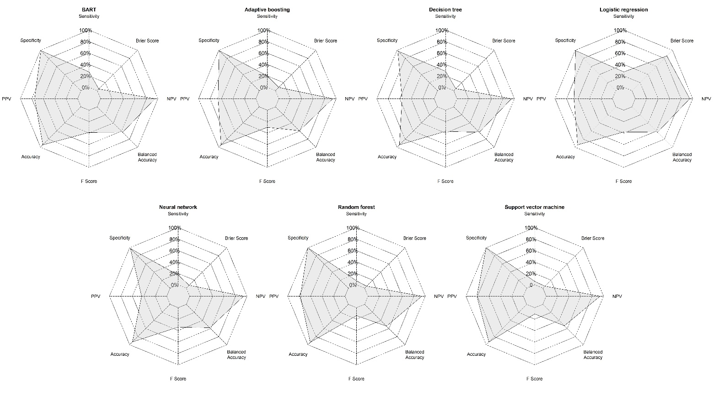
Figure E1. Spider chart of performance measures for machine learning algorithms under comparison based on the test set for physician-diagnosed asthma (definite vs. no asthma). BART: Bayesian additive regression tree; PPV: Positive predictive value; NPV: Negative predictive value

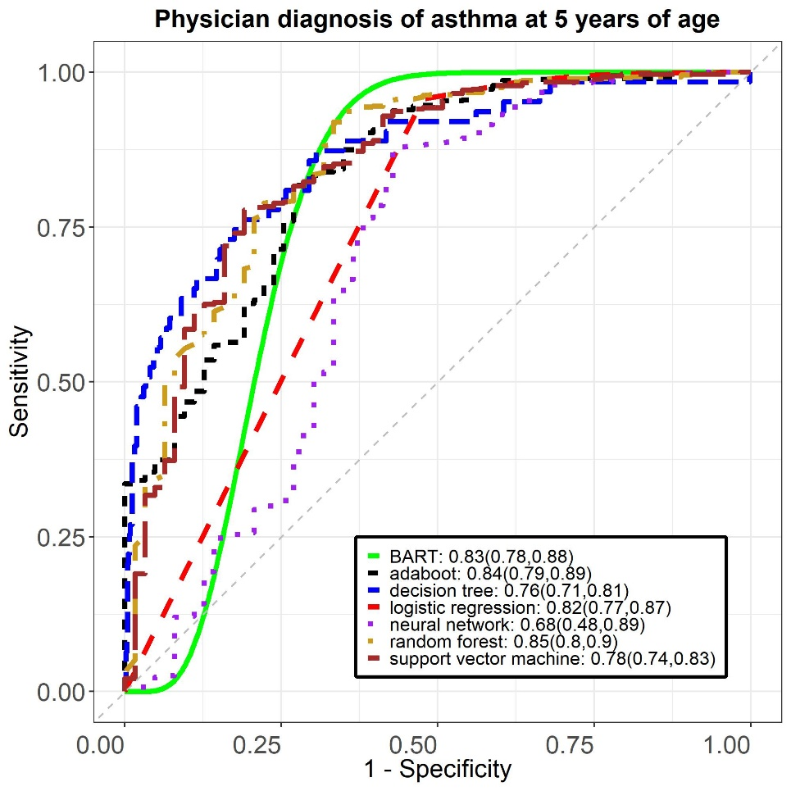
Figure E2. Receiver operating characteristics curve, area under the curves and 95% confidence intervals in machine learning algorithms based on the test set for physician-diagnosed asthma (definite vs. no asthma).

