Supplementary materials
Addressing challenges with Matching-Adjusted Indirect Comparisons to demonstrate the comparative effectiveness of entrectinib in metastatic ROS-1 positive Non-Small Cell Lung Cancer

A. Population data sources 2
B. Comparators 3
C. Comparison of eligibility criteria between entrectinib study and ESME cohort 4
D. Comparison of Efficacy Outcome Definitions between entrectinib studies and ESME cohort 5
E. Details on statistical methods 6
F. Details on Handling missing data: multiple imputation 11
G. Loveplots L1 12
H. Specific discussion of the robustness of 1L results to missing data 13
I. Weighted Kaplan-Meier curves 14
J. Tipping point on missing smoking status 15
K. Limitations related to the case study itself 16
L. References 19

Population data sources
Entrectinib: aggregated data of pooling of clinical trials. All patients who received at least one dose of entrectinib, with disease measurable at inclusion based on investigator's RECIST v1.1 criteria were enrolled in ALKA-372-001 from Oct 26, 2012, to March 27, 2018; in STARTRK-1 from Aug 7, 2014, to May 10, 2018; and in STARTRK-2 from Nov 19, 2015 to October 31st, 2018 for both 1L and 2L. The clinical cut-off date is May 1st, 2019. The inclusion/exclusion criteria, methods, objectives and endpoints are detailed in the CHMP assessment report of the product Rozlytrek® (entrectinib).
Comparator arm: individual patient data (IPD) from the Epidemio-Strategy and Medical Economics (ESME) Lung Cancer (LC) Data Platform using a retrospective data collection process (data cut-off: June 30th, 2020). This database is an ongoing academic French real-word cohort (NCT03848052) managed by UNICANCER and intends to centralize real life patient level data from 38 specialized cancer centers in France (18 private non-profit Comprehensive Cancer Centers spread over 20 sites and 18 public hospitals). There are currently 18 comprehensive cancer centers in France; representing around 8% of all lung cancer patients treated in France. To increase representativeness of the data, general and university hospitals were offered to participate in the ESME LC program. The dataset used for this work includes data from 2 public hospitals (one university hospital and one general hospital) in addition to that of the 18 comprehensive cancer centers.

Comparators
- 1L: all patients treated in first line with chemotherapy alone or in combination (pemetrexed / gemcitabine / docetaxel / vinorelbine / cisplatine) with or without bevacizumab.
Remark: Although ceritinib is not approved for this indication (off-label), it is considered a relevant comparator by the HAS (https://www.has-sante.fr/upload/docs/evamed/CT-18042_XALKORI_ROS1_PIC_REEV_AvisDef_CT18042.pdf). However, no ROS1+ mNSCLC patients were identified with ceritinib as 1st line treatment in ESME LC database; chemotherapies are the standard of care in this indication over the study period}.
- 2L: all patients treated in second line with one of the following treatments exclusively: chemotherapy alone or in combination (pemetrexed / gemcitabine / docetaxel / vinorelbine / cisplatine) or ROS1 inhibitor (crizotinib).

Comparison of eligibility criteria between entrectinib study and ESME cohort
Table S1. Comparison of eligibility criteria between entrectinib studies and ESME cohort
Inclusion Criterion | Integrated ENTRECTINIB  (ALKA-372-001, STARTRK-1, STARK-2) (1) | ESME
Age | ≥ 18 years of age | ≥ 18 years of age
Histology | histologically or cytologically confirmed NSCLC diagnosis of relapsed or refractory (locally) advanced or metastatic solid tumours | With metastatic NSCLC, histologically confirmed (de novo or relapsed disease)
Alterations | Have tumors that harbour a ROS1 gene fusion  Without a concomitant second oncodriver | With a ROS1 rearrangement positive testing result, without any concurrent mutation
Performance score | ECOG PS ≤2 | ECOG PS ≤2 or missing values
Life expectancy | Life expectancy of at least 4 weeks or 3 months | At least ≥6 months follow-up from date of data extraction unless they progressed or died earlier
Laboratory data | Acceptable baseline laboratory values
CNS involvement | Patients with controlled asymptomatic CNS or previously treated and controlled
Concomitant treatments | Steroids at a stable dose or decreasing dose (≤8 mg/day dexamethasone or equivalent) or steroids at a stable dose (≤4 mg/day dexamethasone or equivalent) for at least 2 weeks.  Seizure prophylaxis is allowed with non-EIAEDs only
Previous treatments | Prior anticancer therapy is allowed  All patients must be naïve of ROS1 inhibitor treatment at the time of considered line of treatment for comparison. | All patients must be naïve of ROS1 inhibitor treatment at the time of considered line of treatment for comparison.
Drug intake | Received at least 1 dose of entrectinib | At least one treatment line initiated for metastatic NSCLC

Comparison of Efficacy Outcome Definitions between entrectinib studies and ESME cohort
Table S2. Comparison of Efficacy Outcome Definitions between entrectinib studies and ESME cohort
Outcome | ENTRECTINIB | ESME
PFS by treatment line | Time (months) from first dose of entrectinib to first documentation of radiographic disease progression per RECIST v1.1 by Blinded Independent Central Review or death due to any cause.  Censoring rules  Patients without progression or death were censored on the date of the last tumor assessment (or, if no tumor assessment was performed after the baseline visit, at the date of first dose of entrectinib) prior to the clinical cut-off date. | Time (in months) from the index date (first dose of 1L treatment in real life) to the date of first disease progression or death for any cause.  The date of disease progression was calculated as the date of the first event among:  - Diagnosis of regional tumoral or lymph node progression  - Diagnosis of a new metastasis (new metastatic site)  - Progression of a previously diagnosed metastatic site  - End of chemotherapy / targeted therapy / immunotherapy with termination due to “Progression”  Note: for de novo metastatic lung cancer, new metastatic sites diagnosed in the 30 days after the date of diagnosis of primary tumor was be considered as disease progression. For these cases, the date of disease progression was the date of the first clinical event listed above, diagnosed more than 30 days after the primary tumor diagnosis.  Censoring rules  Patients without progression or death during the line of treatment were censored at the date of last contact or cut-off date whichever occurred first.

Details on statistical methods
General considerations
The analysis was conducted using R, in particular the mice package version 3.16.0.
During the feasibility step, among the 7 prognostic factors selected to balance the two populations, missing data were highlighted for smoking status (binary variable) and ECOG status (ordinal variable) at the index date. As planned in the protocol and in the SAP, multiple imputation by chained equation (2) was applied even for the ECOG status to impute more than 40% of missing data. The age, gender, histology, brain metastases at the index date were used as predictor variables in the imputation model. Then, smoking status was firstly imputed, a simple logistic regression was used for the smoking status. To finish, the ECOG status was included lastly in this imputation step, a logistic regression with an ordinal variable was used for this factor. The maximum number of missing data observed was 53%, therefore for all objectives, a total of 50 imputed data sets were generated. The number of iterations was fixed at 20 for all objectives and a prespecified seed was used for reproducibility. Assumptions underlying multiple imputation were checked by describing missing data (descriptive comparisons between patients with no missing data and patients with missing data were presented and Little’s test for MCAR assumption was applied).
For the weights, we use a logistic regression and the method of moments for weight estimation (3). According to the NICE recommendations (3), the method of optimization was the quasi-Newton BFGS (after Broyden, Fletcher, Goldfarb and Shanno), which makes use of the gradient function that we specified to aid minimization.

The results from the 50 complete datasets were combined for the inference providing:
- the estimate of the hazard ratio between entrectinib and comparator group,
- its 95% confidence interval
- and the associated p-value. Rubin’s rule was used to pool the analyses.

For degrees of freedom, the formulas presented by Martjin W Heymans and Riris Eekhout were used: (4)

The proportion of total variance due to missingness, lambda, (5,6) can be derived from the between and total missing data variance as:
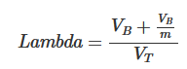
Where m is the number of imputed datasets and V_{B} and V_{T} are the between and total variance respectively. This value can be interpreted as the proportion of variation in the parameter of interest due to the missing data.

The relative increase in variance due to nonresponse is calculated as:
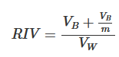
Where V_{W} is the within variance.
The degrees of freedom are calculed as:
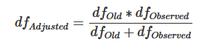
With 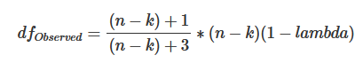
And 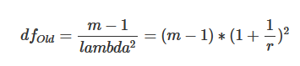
Where r is the relative increase in variance due to nonresponse (RIV), and n the number of events.

The Kaplan-Meier survival probabilities (for OS and PFS) of the 50 complete datasets was pooled using Rubin’s rule after complementary log-log transformation to obtain the survival probabilities and the corresponding 95% confidence interval for each treatment group. The method developed by Morisot and al. was applied.
Also, the results from the 50 complete datasets were combined for the inference providing median PFS and OS, 95% confidence interval (95% CI), PFS and OS rate with its 95% CI at the different time points (Kaplan-Meier curves). There is no standard error associated with median survival time, so the median survival times can be estimated using the pooled Kaplan Meier estimators, by estimating the intersection between the curve (resp. its 95% boundaries), and the 0.5 reference value.

Proportional hazard assumption assessment
The underlying assumption of the Cox’s proportional hazard model was checked. This was achieved by checking the hazard proportionality and by investigating residuals. For this step, among the 50 complete datasets, 5 datasets were randomly selected.
The survival analysis was based on the semi-parametric Cox model. The proportional hazards assumption between groups were studied using graphical methods. The log cumulative hazard curves based on Kaplan-Meier estimates according to the time (in months) using the same model as planned were plotted for each imputed dataset. The curves should be parallel between groups.
In order to study the adequacy of the fitted model, a plot of standardized Schoenfeld residuals versus rank of time (months) were displayed. If the model is satisfactory, residuals distribution should be similar according to treatment groups.
Among the 5 datasets randomly selected, if the log cumulative hazard curves are not parallel and if the Schoenfeld residual distribution are not similar between groups for at least 3 of the datasets, then the Cox model was considered as not appropriate with evidence of departure from the hazard proportionality. In this case, another model could be tested as a piecewise Cox model. Otherwise, the Cox’s proportional hazard model was considered as appropriate.

QBA on unknown factors
As bias factor was mentioned regularly in the scoping review, we used this quantity to assess the bias of our results to unmeasured confounders for PFS Cox results between L1 vs HTA. We plan to calculate Bias factor according to different values of risk ratio.
Since Evalue was the most commonly used method cited in our scoping review, we plan to calculate Evalue on the HR and its upper bound from the PFS Cox results between L1 vs HTA to quantify the bias for unmeasured confounder.
The bias factor and Evalue are used in the following context:
U is an unmeasured binary confounder, RRUY is the risk ratio between U and the outcome Y and RRXU is the risk ratio between the exposure X and the confounder U.

Bias factor answers the question: “Given unmeasured confounding of specific strength, how strong would the true causal effect still be?” (7).
According to VanderWeele and Ding (2017) (8), the bias factor is calculated with the following formula:
$$BF=\frac{RR_{UY}×RR_{XU}}{RR_{UY}+RR_{XU}-1}$$
and requires providing plausible values for RRUY, RRUX.

As we conducted a survival analysis, our estimates are Hazard ratio (HR) and not Risk Ratio. However, it is possible to use the previous formula with HR. Ding and VanderWeele (2016) (9) showed that the equation can be applied in survival analyses under the assumption of a rare time-to event outcome (<15% at the end of the follow-up). In this case, RRUY is then replaced by HRUY.
If the outcome is not rare, it is possible to use the following formula introduced by VanderWeele (2017) (10):
$RR≈\frac{\left(1-{0.5}^{sqrt\left(HR\right)}\right)}{1-{0.5}^{sqrt\left(1/HR\right)}}$
As our event of interest is not rare, this is the formula that was used in our sensitivity analysis.
The potential true unobserved RR were plotted in a bias plot (where the x-axis corresponds to RR of confounder-exposure association and y-axis corresponds to RR of confounder-outcome association). If appropriate, the y-axis was transformed back numerically into HR estimations.
To illustrate the impact of such confounder, the graph displayed thresholds of RR:
- where the upper 95% CI of true RR is equal to 1 (rendering the effect of the entrectinib non-significant),
- where the true RR of the treatment effect is equal to 1,
- where the lower 95%CI of the true RR is equal to 1 (meaning the entrectinib would be significantly worse than the comparator: French HTA)
To illustrate the range of the plausible RR tested, we calculated:
- the RR associations of some measured covariates (if possible, every covariate used in the propensity score) with the outcome (HR obtained from each imputed dataset from ESME cohort and pooled with Rubin’s rule adjusted on all the other illustrated covariates, then converted into RR)
- the RR associations of the same measured covariates with the treatment group (unadjusted RR obtained on the aggregated data from L1 HTA ESME cohort and L1 entrectinib population from each imputed dataset and pooled with Rubin’s rule).
that were displayed on the bias plot. If the covariate has more than two modalities, some categories were combined to end-up with only 2 possible modalities.

Evalue was introduced by VanderWeele and Ding (8). It is derived from the Bias Factor and based on the assumption that RRUY=RRXU. As a result, the Evalue is the solution of the equation:
$$RR_{obs}=BF⟺RR_{obs}=\frac{Evalue²}{2Evalue-1}$$
$$⟺Evalue=RR_{obs}+\sqrt{RR_{obs}×\left(RR_{obs}-1\right)}$$
It captures the minimum strength of association, on the RR scale, that an unmeasured confounder needs to have with both Y and X for the observed RR to be nullified (RRtrue = 1).
To perform a Evalue calculation, we also converted our Hazard Ratios into Risk Ratios according to VanderWeele formula (10). The Evalue was then be converted back numerically into HR equivalent.

Tipping point analysis
A tipping point analysis is a sensitivity analysis that helps to assess the robustness of the results to departure from MAR by modifying the imputations to partially missing variables towards MNAR.

Under MAR, an imputation model for the incomplete dichotomous variable $Z$ (like smoking status) is (11):
$$logit\left\{Pr⁡(Z=1|X) \right\}=β_{0}+βX_{i}$$

A corresponding imputation model under MNAR is:
$$logit\left\{\operatorname{Pr}\left(Z=1|X,R\right) \right\}=β_{0}+βX_{i}+δ(1-R)$$

With $X$ being the covariables and R a dichotomous variable that equals 1 if $Z$ is observed and 0 if $Z$ is missing. If $δ=0$, given the fully observed data, the mechanism causing the missing data of $Z$ does not depend on $Z$, meaning the mechanism is MAR. However, if $δ≠0$, the missingness mechanism depends on the missing $Z$, meaning the mechanism is MNAR. In practice, the goal is to vary the value of $δ$ to assess the “tipping point” where the treatment outcome is no longer significant.

Since the ECOG status is a variable with three levels (0,1,2), the corresponding imputation model under MNAR in our case is a multinomial model that can be written as a succession of logistic regressions:

$$ln\frac{Pr⁡(ECOG=1)}{Pr⁡(ECOG=0)}=β_{01}+ β_{11}X_{1i}+β_{21}X_{2i} + …+ β_{p1}X_{pi}+ δ_{1}(1-R_{i})$$

$$ln\frac{Pr⁡(ECOG=2)}{Pr⁡(ECOG=0)}=β_{02}+ β_{12}X_{1i}+β_{22}X_{2i} + …+ β_{p2}X_{pi}+ δ_{2}(1-R_{i})$$

With $δ_{2}=2*δ_{1}$.

For the Smoking status, a logistic regression with delta adjustment was used, as seen above.

Details on Handling missing data: multiple imputation

Assumption Check

Before setting up the multiple imputation, the mechanism of the missing data was investigated in the ESME cohort.
Descriptive statistics and comparison between patients with no missing data and patients with missing data for smoking or ECOG performance status was performed. All p-values are superior to 5% for all prognostic variables planned to be included in the propensity score model, which confirms that no difference was detected between the two groups and leads us to consider the data as missing completely at random (MCAR).
This must be considered with caution, as sample sizes were small (14 vs 16) and no adjustment on test multiplicity.
The Little’s test was also performed, where the null hypothesis is missing data are MCAR. The test gives a p-value of 0.478 which is superior to 5%.
The null hypothesis cannot be rejected indicating that the data can be MCAR.

Conclusion on assumption: both conclusions converge towards the plausibility of MCAR data, or at least missing at random (MAR) data, for the L1 Recognized French HTA. Therefore, the multiple imputation was used.

Convergence
Multiple imputation was then carried out to be able to include smoking status and ECOG performance status in the weighting process.
The model for imputation included age, sex, histology of adenocarcinoma and brain metastasis (no, without or with radiography) – and ECOG for smoking status, and smoking status for ECOG. A total of 50 datasets were generated with 20 iterations. To check the convergence of the models, the trace lines for both variables according to the number of iterations are displayed in the next
with the means on the left and the standard deviance on the right. No trend is observed on the graph and the trace lines intermingle well, indicating the model has converged.
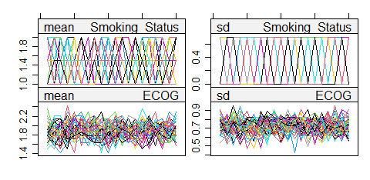

Figure S1: Multiple imputations convergence graphs by iteration – L1 Recognized French HTA
Furthermore, the $\hat{R }$statistics were calculated. All values are below the threshold of 1.1, the imputation converged. With regards to the values of imputations, it is consistent with the observed values on patients included in the complete-cases analysis.
Conclusion on validation of multiple imputation model:
All checks showed that imputation model converge for this comparator arm (Recognized French HTA) and population (L1).

Loveplots L1
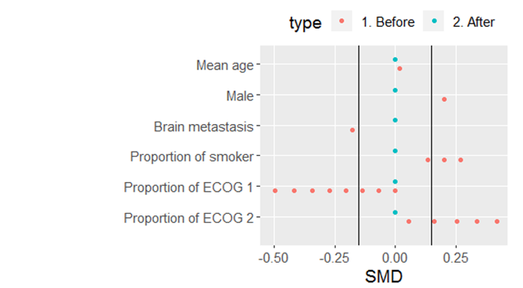
Figure S2: Loveplot L1

SMD: standardized mean deviation

Specific discussion of the robustness of 1L results to missing data
A limitation of the analysis of the robustness of the 1L results to missing data is that we initially restricted imputation to ECOG scores between 0 and 2 in the ESME database. We therefore excluded the possibility of ECOG scores > 2, as patients with such recorded values are very rare in ESME (no ROS1+ mNSCLC patient in 1L had an ECOG value > 2), making it impossible to model and impute them. Nevertheless, a possible criticism is that there is a bias in the ESME database (e.g. reporting bias for patients with ECOG > 2), which would work to the disadvantage of the comparator arm, as patients with ECOG > 2 would have been incorrectly imputed with 0-2 scores and included in the comparator arm. However, this criticism does not hold thanks to the complete case analysis (sensitivity analysis): if we assume that all patients with missing ECOG data in the comparator arm have a score > 2 and therefore a worse prognosis, the complete case analysis excluding them should drastically change the PFS. However, this is not the case, and the HRs are stable. Our results therefore appear to be quite robust to potential reporting bias for patients with ECOG > 2. This analysis shows the importance of combining sensitivity analyses (here tipping point and complete case analysis).

Weighted Kaplan-Meier curves
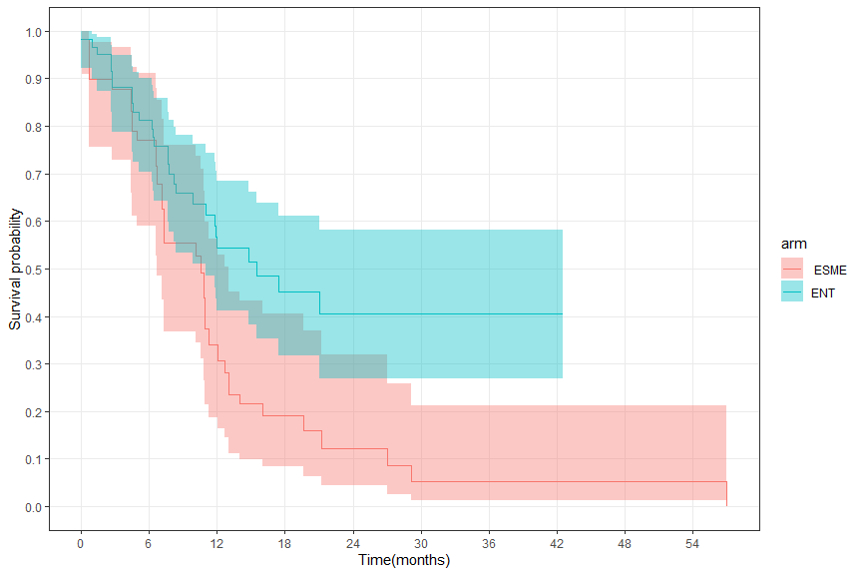
Figure S3: Survival probabilities estimated by weighted KM on Progression-free survival assessed by BICR, L1 entrectinib vs French HTA

Note: the median PFS under chemotherapies in 1L mNSCLC ROS1-positive is 10.58 months in the ESME database.(12,13)

Tipping point on missing smoking status

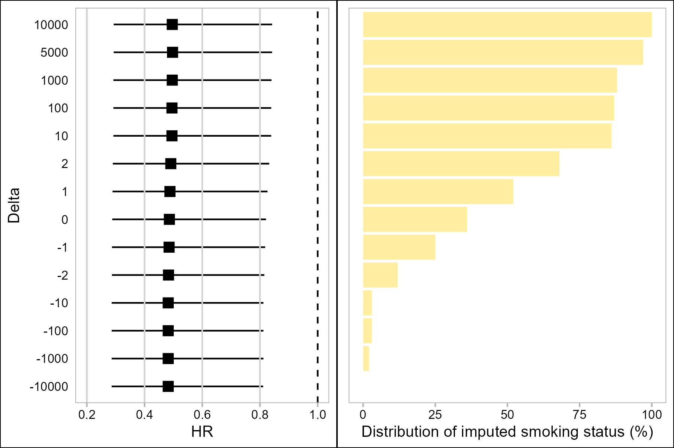

Figure S4: Tipping point analysis on weighted Cox on Progression-free survival assessed by BICR, smoking status - Legend: On the left: the weighted Cox HR on PFS on L1 HTA population with CI95% and p-values, depending on the delta; on the right side: the corresponding distribution of imputed smoking status at Yes.

Table S5: sensitivity analyses on missing smoking status: Results of the weighted Cox by replacing all missing values by a fixed value
All smoking status missing values replaced by | Hazard Ratio | [CI 95 %] | p-value
non-smoker | 0.481 | [0.285, 0.81] | 0.0068
smoker | 0.499 | [0.294, 0.849] | 0.0113

Limitations related to the case study itself
- Limitation of the endpoint definitions
In Entrectinib clinical trials, tumor was commonly assessed using RECIST criteria and PFS is defined as the delay between the first dose of entrectinib and progression using RECIST criteria. As RECIST criteria are not routinely performed outside clinical trials, real world PFS (rwPFS) is defined as the delay between treatment initiation and progression based on investigator judgement or death.
Despite conceptual similarities between PFS and rwPFS, there are differences: (1) difference in cadence of visits and frequencies of scans between routine clinical practice and trial settings (2) real progression is not defined only using RECIST criteria and other parameters such as performance status or clinical progression may be used to define progression based on investigator judgment. These differences may introduce bias (14): (1) misclassification bias (2) surveillance bias
Despite this discrepancies and bias, the ability of real world data to serve as external controls to single-arm trials with rwPFS as endpoint was explored in different studies (15–17). It was demonstrated thant rwPFS can reasonably replicate the PFS of chemotherapy control arms(15).
Finally, as real-world tumor assessments are less frequent, it is reasonable to assume that the potential bias between rwPFS and PFS could be to the detriment of the entrectinib arm, as progression may be detected later in real life, artificially lengthening the progression-free survival curve of the ESME (chemotherapy) arm, which is conservative.

- Limitation of the choice of the efficacy measure
Despite the strong underlying assumptions, the hazard ratio metric is widely used to estimate the effectiveness of a time-to-event endpoint. However, other metrics could have been used, such as the restricted mean survival time difference as it does not require prior assumptions on the hazards of the groups being compared. Some authors argue (18) that estimates of treatment efficacy should be clinically-interpretable and, to the greatest extent possible, assumption-free. To this end, the pseudo-value approach of Andersen (19), or the estimating-equation approach of Tian (20) could be used.

- Limitation of the overlap assumption (eligibility criteria)
Aggregate data of 1st-line patients on entrectinib included 3 patients out of 60 (5%) that are treated at a locally advanced stage. However, we decided to consider only patients with metastatic stages in the ESME data because it would have been too difficult, if not impossible, to adjust the ESME population for disease stage when there were only 3 affected patients in the entrectinib arm (large imbalance between arms, significant loss of the Effective Sample Size (ESS), and unreliable adjustment). In fact, with only 30 ROS1+ 1L metastatic patients in ESME, to obtain 5% locally advanced ESME patients, we would have to sample "between 1 and 2" locally advanced patient(s) in the chemotherapy arm (ESME). In addition, the ESS of these patients would be further reduced after weighting. Therefore, we found it implausible to claim that we were evaluating the efficacy of entrectinib in a "representative" population with a mix of locally advanced and metastatic patients, when 95% of patients are at a metastatic stage and only 1 to 3 patients are locally advanced per arm.

Regarding the potential impact of the absence of locally advanced patients in the chemotherapy (ESME) arm, this is considered negligible and unlikely to explain the estimated effect size, considering:
- The very small number of locally advanced patients in the entrectinib arm (3 out of 60)
- No evidence for PFS difference between locally advanced and metastatic ROS1+ NSCLC patients treated with 1L chemotherapy
  - IIIB-IIIC vs. IVA-IVB: HR = 1.051 (0.425-2.600; p = 0.914). Table 2 (ref 1)
  - IIIb vs IV: adjusted HR: not found. Univariate HR = 0.851 (0.437-1.661; p= 0.637); Tables 3 and 4 (ref 2)
- A large effect size estimated in our study between the entrectinib arm and the chemotherapy arm (ESME), i.e. an HR of 0.49.
- A conservative estimated median PFS in the chemotherapy (ESME) arm of 10.6 months, which is higher than what would be expected from the literature, i.e. 8.6 months (1) and 8.5 months (2) in in clinical trials on ROS1+ NSCLC populations which included 10.6% and 19.6% locally advanced patients, respectively.
- Other ROS1+ retrospective study:
- First-line IIIB / IV patients with ROS1 rearrangement-positive NSCLC treated with pemetrexed-based chemotherapy: median PFS = 6.8 months (21)
- Other studies but with ALK+ alteration:
The kinase domains of ALK and ROS1 share substantial homology (22)
- First-line stage IIIB / IV ALK rearranged non-squamous NSCLC treated with chemotherapy in the ASCEND-4 trial (23): median PFS = 8.1 months (5.8-11.1).
- First line locally advanced or metastatic ALK+ NSCLC treated with chemotherapy (pemetrexed and either cisplatin or carboplatin) (24): median PFS = 7.0 months
- First-line metastatic non-squamous NSCLC with EGFR or ALK genetic alteration, under bevacizumab plus chemotherapy:(25) median PFS = 6.1 months (and in the Intention-To-Treat population : median PFS = 6.8 months (6.0-7.1))
- First-line immunotherapy in advanced NSCLC with ALK, ROS1, or RET alteration (analyzed together due to the limited sample size for each group): (26) median FPS (n=12) : median PFS = 3.1 (1.9–4.2).
- Advanced NSCLC in the Flatiron Health-Foundation Medicine Clinico-Genomic Database (CGDB) Chemotherapy cohort, in the “Fusion group”, all lines, (ALK: n=39; ROS1: n=12; RET: n=14 ): (27) median PFS = 3.98 mo (3.61 – NA).
- Systematic review of the clinical effectiveness of first-line chemotherapy for adult patients with locally advanced or metastatic non-small cell lung cancer (not alteration specific) (28): Median PFS/TTP ranged from 3.0 to 8.4 months

- Limitations of the data sources
Differences between the two data sources (multi-country clinical trials versus French real-world database) may introduce biases in terms of adherence, compliance, care management, availability of treatments, etc. Unfortunately, these potential biases are difficult to avoid or correct in data that has already been collected and/or aggregated. Although the impact of these potential biases is difficult to estimate, the use of QBAs may prove useful in attempting to quantify them and then assess their impact.

- Limitations of the multiple imputation model
Multiple imputation of ECOG PS and smoking status missing values was performed, as described in supplementary material section E. Multiple imputation was done without including the outcome in the imputation model as this step was performed blinded of the outcomes to avoid data dredging, However, this can lead to biased estimates, unless it is specifically assumed that the outcome is not associated with the missingness mechanism. Conversely, not being blinded to the results entails a higher risk of data dredging. Thus, in such (non-blinded) situations, the need to pre-specify the weight estimation model, as proposed in this article, is all the more important.

References
1. Dziadziuszko R, Krebs MG, De Braud F, Siena S, Drilon A, Doebele RC, et al. Updated Integrated Analysis of the Efficacy and Safety of Entrectinib in Locally Advanced or Metastatic ROS1 Fusion–Positive Non–Small-Cell Lung Cancer. J Clin Oncol. 2021 Apr 10;39(11):1253–63.
2. https://stefvanbuuren.name/fimd/sec-choices.html [Internet]. [cited 2024 Jun 11]. Available from: https://stefvanbuuren.name/fimd/sec-choices.html
3. Phillippo D, Ades T, Dias S, Palmer S, Abrams KR, Welton NJ. NICE DSU Technical Support Document 18: Methods for population-adjusted indirect comparisons in submissions to NICE [Internet]. 2016. Available from: https://research-information.bris.ac.uk/en/publications/nice-dsu-technical-support-document-18-methods-for-population-adj
4. Chapter9 Rubin’s Rules | Book_MI.knit [Internet]. [cited 2022 Mar 9]. Available from: https://bookdown.org/mwheymans/bookmi/rubins-rules.html#degrees-of-freedom-and-p-values
5. Stef van Buuren. Part I : Basics. In: Flexible Imputation of Missing Data, Second Edition [Internet]. [cited 2023 Aug 16]. Available from: https://stefvanbuuren.name/fimd/sec-whyandwhen.html
6. Raghunathan T. Missing Data Analysis in Practice , by Trivellore Raghunathan: Boca Raton, FL: CRC Press, 2016, $63.96, ISBN 978-1-4822-1192-4. J Biopharm Stat. 2016 Nov;26(6):1146–7.
7. Cusson A, Infante-Rivard C. Bias factor, maximum bias and the E-value: insight and extended applications. Int J Epidemiol. 2020 Oct 1;49(5):1509–16.
8. VanderWeele TJ, Ding P. Sensitivity Analysis in Observational Research: Introducing the E-Value. Ann Intern Med. 2017 Aug 15;167(4):268–74.
9. Ding P, VanderWeele TJ. Sensitivity Analysis Without Assumptions. Epidemiol Camb Mass. 2016 May;27(3):368–77.
10. VanderWeele T. On a square-root transformation of the odds ratio for a common outcome. Epidemiol Camb Mass. 2017 Nov;28(6):e58–60.
11. Leacy FP, Floyd S, Yates TA, White IR. Analyses of Sensitivity to the Missing-at-Random Assumption Using Multiple Imputation With Delta Adjustment: Application to a Tuberculosis/HIV Prevalence Survey With Incomplete HIV-Status Data. Am J Epidemiol. 2017 Jan 10;amjepid;kww107v1.
12. Shen L, Qiang T, Li Z, Ding D, Yu Y, Lu S. First-line crizotinib versus platinum-pemetrexed chemotherapy in patients with advanced ROS1-rearranged non-small-cell lung cancer. Cancer Med. 2020 May;9(10):3310–8.
13. Xu H, Zhang Q, Liang L, Li J, Liu Z, Li W, et al. Crizotinib vs platinum-based chemotherapy as first-line treatment for advanced non-small cell lung cancer with different ROS1 fusion variants. Cancer Med. 2020 May;9(10):3328–36.
14. Adamson BJS, Ma X, Griffith SD, Sweeney EM, Sarkar S, Bourla AB. Differential frequency in imaging‐based outcome measurement: Bias in real‐world oncology comparative‐effectiveness studies. Pharmacoepidemiol Drug Saf. 2022 Jan;31(1):46–54.
15. Ton TGN, Pal N, Trinh H, Mahrus S, Bretscher MT, Machado RJM, et al. Replication of Overall Survival, Progression-Free Survival, and Overall Response in Chemotherapy Arms of Non–Small Cell Lung Cancer Trials Using Real-World Data. Clin Cancer Res. 2022 Jul 1;28(13):2844–53.
16. Griffith SD, Miksad RA, Calkins G, You P, Lipitz NG, Bourla AB, et al. Characterizing the Feasibility and Performance of Real-World Tumor Progression End Points and Their Association With Overall Survival in a Large Advanced Non–Small-Cell Lung Cancer Data Set. JCO Clin Cancer Inform. 2019 Dec;(3):1–13.
17. Mhatre SK, Machado RJM, Ton TGN, Trinh H, Mazieres J, Rittmeyer A, et al. Real‐World Progression‐Free Survival as an Endpoint in Lung Cancer: Replicating Atezolizumab and Docetaxel Arms of the OAK Trial Using Real‐World Data. Clin Pharmacol Ther. 2023 Dec;114(6):1313–22.
18. McCaw ZR, Tian L, Wei J, Claggett BL, Bretz F, Fitzmaurice G, et al. Choosing clinically interpretable summary measures and robust analytic procedures for quantifying the treatment difference in comparative clinical studies. Stat Med. 2021 Dec 10;40(28):6235–42.
19. Andersen PK, Pohar Perme M. Pseudo-observations in survival analysis. Stat Methods Med Res. 2010 Feb;19(1):71–99.
20. Tian L, Zhao L, Wei LJ. Predicting the restricted mean event time with the subject’s baseline covariates in survival analysis. Biostatistics. 2014 Apr 1;15(2):222–33.
21. Song Z, Su H, Zhang Y. Patients with ROS 1 rearrangement‐positive non‐small‐cell lung cancer benefit from pemetrexed‐based chemotherapy. Cancer Med. 2016 Oct;5(10):2688–93.
22. Huber KVM, Salah E, Radic B, Gridling M, Elkins JM, Stukalov A, et al. Stereospecific targeting of MTH1 by (S)-crizotinib as an anticancer strategy. Nature. 2014 Apr 10;508(7495):222–7.
23. Soria JC, Tan DSW, Chiari R, Wu YL, Paz-Ares L, Wolf J, et al. First-line ceritinib versus platinum-based chemotherapy in advanced ALK -rearranged non-small-cell lung cancer (ASCEND-4): a randomised, open-label, phase 3 study. The Lancet. 2017 Mar;389(10072):917–29.
24. Solomon BJ, Mok T, Kim DW, Wu YL, Nakagawa K, Mekhail T, et al. First-Line Crizotinib versus Chemotherapy in ALK -Positive Lung Cancer. N Engl J Med. 2014 Dec 4;371(23):2167–77.
25. Socinski MA, Jotte RM, Cappuzzo F, Orlandi F, Stroyakovskiy D, Nogami N, et al. Atezolizumab for First-Line Treatment of Metastatic Nonsquamous NSCLC. N Engl J Med. 2018 Jun 14;378(24):2288–301.
26. Tian T, Li Y, Li J, Xu H, Fan H, Zhu J, et al. Immunotherapy for patients with advanced non-small cell lung cancer harboring oncogenic driver alterations other than EGFR: a multicenter real-world analysis. Transl Lung Cancer Res. 2024 Apr;13(4):861–74.
27. Negrao MV, Skoulidis F, Montesion M, Schulze K, Bara I, Shen V, et al. Oncogene-specific differences in tumor mutational burden, PD-L1 expression, and outcomes from immunotherapy in non-small cell lung cancer. J Immunother Cancer. 2021 Aug;9(8):e002891.
28. Pilkington G, Boland A, Brown T, Oyee J, Bagust A, Dickson R. A systematic review of the clinical effectiveness of first-line chemotherapy for adult patients with locally advanced or metastatic non-small cell lung cancer. Thorax. 2015 Apr 1;70(4):359–67.

