Supplementary Material
Adjustment of dRMST using IPT Weighting
Let $j=1,…,J$ index follow-up times were at least one event occurred. Adjusted KM curves are estimated for arm $z=0,1$ by first weighting the number of patients who experienced the event or were still at risk at time $t_{j}$:
$$y_{j, z}^{'}= \sum_{i:T_{i}≥t_{j}}{w_{i}}1(z_{i}=z), \\ d_{j, z}^{'}= \sum_{i:T_{i}=t_{j}}{w_{i}δ_{i}}1(z_{i}=z),$$where $T_{i}$, $δ_{i}$, and $w_{i}$ denote the outcome, event indicator and propensity score for patient $i$ respectively. The adjusted KM curve at time $t$ is then given by:
$\hat{S_{z}}\left(t\right)= \sum_{t_{j}≤t}{\left[1- \frac{d_{j, z}^{'}}{y_{j, z}^{'}}\right]}, z=0, 1.$ (S1)
An estimate of the adjusted RMST up to time horizon $τ$ is then given by:
$$\hat{μ_{z}}=\int_{0}^{τ}{\hat{S_{z}}\left(t\right)\text{d}t,} z=0,1,$$where the above integral is computed using numerical integration. The adjusted dRMST is then estimated as $\hat{ν}=\hat{μ_{1}}-\hat{μ_{0}}$. A variance estimator for the adjusted RMST was proposed by Conner et al (1) and is given by:
$\hat{V}\left(\hat{μ_{z}}\right)=\sum_{j:t_{j}≤τ}{{\left[\sum_{i=j}^{τ}{\hat{S_{z}}(t_{i})(t_{i+1}-t_{i})}\right]}^{2}\frac{d_{j, z}^{'}}{M_{j,z}(y_{j, z}^{'}-d_{j, z}^{'})}}, z=0, 1,$ (S2)
where,
$$M_{j,z}=\frac{{\left[\sum_{i:T_{i}≥t_{j}}{w_{i}}1(z_{i}=z)\right]}^{2}}{\sum_{i:T_{i}≥t_{j}}{w_{i}^{2}}1(z_{i}=z)}.$$As the adjusted RMSTs are independent the variance of the adjusted dRMST is estimated by:
$\hat{V}\left(\hat{ν}\right)= \hat{V}\left(\hat{μ_{1}}\right)+ \hat{V}\left(\hat{μ_{0}}\right).$ (S3)
True Adjusted dRMST
Computation of the true adjusted dRMST first requires calculation of conditional survival curves. Under the delayed treatment effect model with exponential survival, conditional survival curves are given by:
$S(t|z,λ,β_{z},β_{u}, u)= \text{exp}\left\{\text{-}\text{H}(t|z,λ,β_{z}, β_{u}, u)\right\}, u=0,1,$ (S4)
where $H(t|z,λ,β_{z}, u)$ denotes the cumulative hazard function conditional on $u$ defined for each arm by:
$H(t|z = 0,λ,β_{z}, β_{u}, u)=λt\text{exp(}uβ_{u}),$ (S5)
$H(t|z = 1,λ,β_{z},β_{u}, u)=λt\text{exp(}u×β_{u}) + λ(t - t_{0})\text{exp(}uβ_{u}+β_{z})×1(t - t_{0}), u=0, 1$, (S6)
where,
$$1(t - t_{0})=\left\{\begin{aligned}0 0≤t≤t_{0}, \\ 1 t >t_{0}. \end{aligned}\right.$$
Adjusted survival curves for each arm are then obtained by marginalisation of $u$ as follows:
$S(t|λ,β_{z},β_{u})=\sum_{u=0}^{1}{S(t|z,λ,β_{z},β_{u}, u)}, z=0,1.$ (S7)
Adjusted survival is computed for a range of points in $t ∈ \left[0,\left.τ\right]\right.$ and numerical integration then used to compute the adjusted RMST up to $τ$ for each arm. The adjusted dRMST is then the difference between adjusted RMSTs.

MCMC Diagnostics
Table A1 displays the effective sample size (ESS) for selected parameters in the simulation study.
Table A1: ESS¹ for selected parameters under each simulation scenario.
Simulation scenario |  |  | Parameter
$$α_{u}^{2}$$ | $$β_{u}^{3}$$ | $$λ$$ | $$β_{z}$$ | $$u_{i}^{4}$$
Small 1 | $$log⁡(0.5)$$ | 43.30 | 496.62 | 445.99
 | $$log⁡(2)$$ | 44.88 | 519.17 | 471.72
Small 2 | $$log⁡(0.5)$$ | 50.90 | 522.46 | 445.32
 | $$log⁡(2)$$ | 43.64 | 461.87 | 461.83
Large 1 | $$log⁡(0.5)$$ | 423.03 | 559.39 | 987.18
 | $$log⁡(2)$$ | 463.41 | 507.38 | 984.39
Large 2 | $$log⁡(0.5)$$ | 466.34 | 547.24 | 986.23
 | $$log⁡(2)$$ | 386.66 | 558.24 | 985.09
1: Averaged over 100 simulations.
2: Parameters for the logistic propensity model: Values induce the following imbalances:
Small 1: $Pr(Z = 1|U = 1) =0.4$, Small 2: $Pr(Z = 1|U=1) = 0.6,$
Large 1: $Pr(Z = 1|U=1) = 0.2$, Large 2: $Pr(Z = 1|U=1) = 0.8.$
3: Conditional log(HR) capturing the effect of $u$ on survival: Values correspond to either a halving ($\text{log(0.5)}$)
or doubling ($\text{log(2)}$) of the hazard.
4: Averaged over all patients and simulations.

Figures A1 and A2 display thinned traceplots of the sampled chains for the parameters $\text{log(λ)}$ and $β_{z}$ respectively.
Figure A1: Thinned traceplots of the sampled chains for $\text{log(λ)}$ across simulation scenarios.

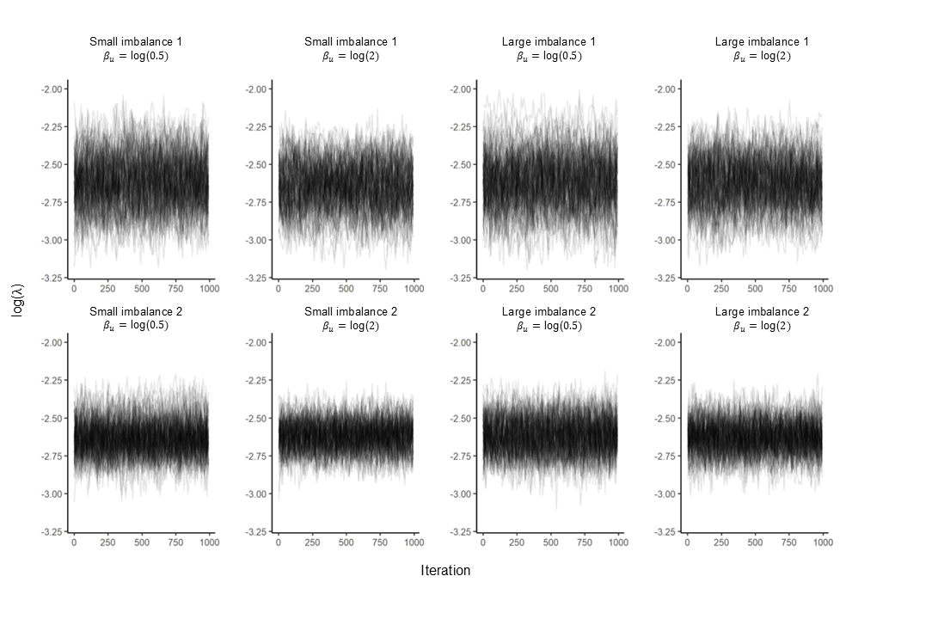

Figure A2: Thinned traceplots of the sampled chain for $β_{z}$ across simulation scenarios.
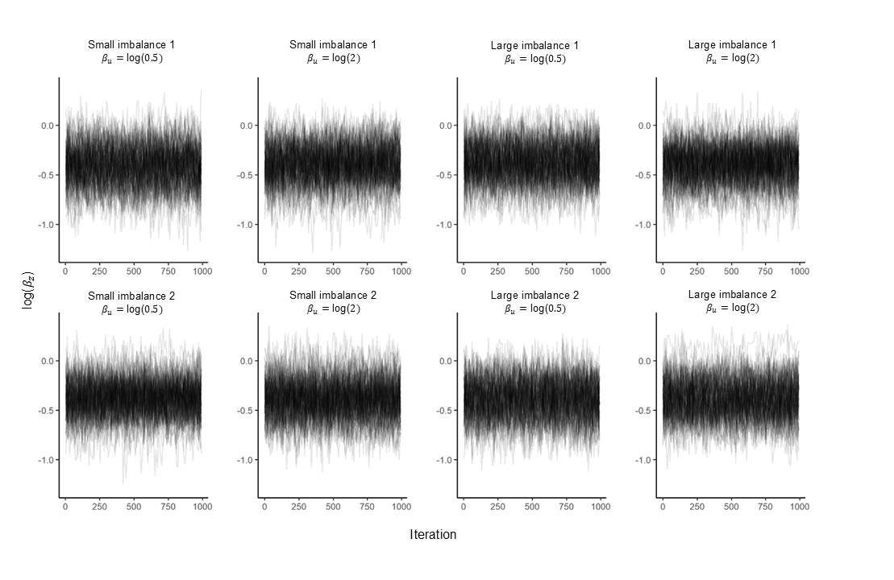

References
1. Conner SC, Sullivan LM, Benjamin EJ, LaValley MP, Galea S, Trinquart L. Adjusted restricted mean survival times in observational studies. Statistics in Medicine. 2019;38(20):3832–60.

