Supplemental Online Content

Power and sample size calculation for non-inferiority trials with treatment switching in intention-to-treat analysis comparing RMSTs
Austin Shih^{1,#}, Chih-Yuan Hsu^{2,3,#,*}, and Yu Shyr^{2,3,*}
¹ Department of Mathematics, Vanderbilt University, Nashville, TN 37240, United States
² Department of Biostatistics, Vanderbilt University Medical Center, Nashville, TN 37203, United States
³ Center for Quantitative Sciences, Vanderbilt University Medical Center, Nashville, TN 37203, United States
#Austin Shih and Chih-Yuan Hsu contributed equally to this work
*Correspondence: Chih-Yuan Hsu: chih-yuan.hsu@vumc.org; Yu Shyr: yu.shyr@vumc.org

- Details for censoring distribution
- Parameters determination in beta, gamma, uniform, and independent exponential distributions via $r_{s}$ and $ρ_{s}$
- Figure s1. Weibull survival functions with different shape values, $m_{1}$ = 1, and $m_{2}$ = 1.1 (left) and 0.9 (right).
- Table s1. Type I errors for “increasing” entry when $R_{2}\left(τ\right)=R_{1}\left(τ\right)-δ$ at $τ$ = 4.
- Table s2. Required sample sizes ($n$) and powers at $n_{ns}$ with $r_{s}$ = 0.5 and 0.25, shape = 1 and $r$ = 1, under $m_{2}/m_{1}$ = 1.
- Table s3. Required sample sizes ($n$) and powers at $n_{ns}$ with $r_{s}$ = 0.5, shape = 1.25, and $r$ = 1.
- Table s4. Required sample sizes ($n$) and powers at $n_{ns}$ with $r_{s}$ = 0.5, shape = 0.75, and $r$ = 1.
- Table s5. Required sample sizes ($n$) and powers at $n_{ns}$ with $r_{s}$ = 0.5, shape = 1, and $r$= 2.
- Table s6. Required sample sizes ($n$) and powers at $n_{ns}$ with $r_{s}$ = 0.5, shape = 1, and $r$ = 1, under various entry patterns.
- Table s7. Comparison between Weibull and gamma survival distributions in sample sizes required to achieve a power of 0.8.

Details for censoring distribution
The censoring consists of both dropout censoring and administrative censoring. The distribution of the censoring can be expressed as follows:
$$f\left(c | v\right)=d\left(c\right)I\left(0<c<T_{e}-v\right)+ \overline{D}\left(T_{e}-v\right)I\left(c=T_{e}-v\right).$$
The dropout censoring density function is assumed to be either $d(c) = h^{-1} I(0 < c < h)$ (uniform) or $d\left(c\right)=λe^{-λc}I(0<c)$ (exponential). Given the entry distribution $f_{V}(v)$, the value of $h$ or $λ$ is determined by a pre-specified censoring probability for the active control group, assuming no treatment switching. Specifically, solve $P\left(C_{1}<T_{1}\right)$ = the given censoring probability for $h$ or $λ$. The probability $P\left(C_{1}<T_{1}\right)$ is a function of $h$ or $λ$ and can be explicitly expressed as follows:
$$P\left(C_{1}<T_{1}\right)=\int_{0}^{T_{a}}{P\left(C_{1}<T_{1}\right|v)}f_{V}\left(v\right)dv,$$
where$$P\left(C_{1}<T_{1}\right|v)=\int_{0}^{T_{e}-v}{\int_{c}^{∞}{f\left(c | v\right)f_{T_{1}}\left(t\right)}dt dc}+ \int_{T_{e}-v}^{∞}{\int_{c}^{∞}{f\left(c | v\right)f_{T_{1}}\left(t\right)}dt dc} \\ =\int_{0}^{T_{e}-v}{d(c)\int_{c}^{∞}{f_{T_{1}}\left(t\right)}dt dc}+\overline{D}\left(T_{e}-v\right)\int_{T_{e}-v}^{∞}{f_{T_{1}}\left(t\right)}dt. (*)$$
If $d(c) = h^{-1} I(0 < c < h)$,
$$\left(*\right)=\int_{0}^{{min⁡(T}_{e}-v, h)}{h^{-1}\int_{c}^{∞}{f_{T_{1}}\left(t\right)}dt dc}+I\left(h>T_{e}-v\right)\left(1-h^{-1}\left(T_{e}-v\right)\right)\int_{T_{e}-v}^{∞}{f_{T_{1}}\left(t\right)}dt \\ =\int_{0}^{{min⁡(T}_{e}-v, h)}{h^{-1}S_{T_{1}}\left(c\right)dc}+I\left(h>T_{e}-v\right)\left(1-h^{-1}\left(T_{e}-v\right)\right)S_{T_{1}}\left(T_{e}-v\right).$$
For $T_{e}-T_{a}<h<T_{e}$,
$P\left(C_{1}<T_{1}\right)=\int_{0}^{T_{a}}{P\left(C_{1}<T_{1}\right|v)f_{V}\left(v\right)dv}$
$$=\int_{0}^{T_{e}-h}{\int_{0}^{h}{h^{-1}S_{T_{1}}\left(c\right)dc}}f_{V}\left(v\right)dv+\int_{T_{e}-h}^{T_{a}}{\int_{0}^{T_{e}-v}{h^{-1}S_{T_{1}}\left(c\right)dc}}f_{V}\left(v\right)dv$$
$$+\int_{T_{e}-h}^{T_{a}}{\left(1-h^{-1}\left(T_{e}-v\right)\right)S_{T_{1}}\left(T_{e}-v\right)}f_{V}\left(v\right)dv$$
For $h≤T_{e}-T_{a}$,
$P\left(C_{1}<T_{1}\right)=\int_{0}^{T_{a}}{\int_{0}^{h}{h^{-1}S_{T_{1}}\left(c\right)dc}}f_{V}\left(v\right)dv=\int_{0}^{h}{h^{-1}S_{T_{1}}\left(c\right)dc}$.
For $T_{e}≤h$,
$$P\left(C_{1}<T_{1}\right)=\int_{0}^{T_{a}}{\int_{0}^{T_{e}-v}{h^{-1}S_{T_{1}}\left(c\right)dc}}f_{V}\left(v\right)dv+\int_{0}^{T_{a}}{\left(1-h^{-1}\left(T_{e}-v\right)\right)S_{T_{1}}\left(T_{e}-v\right)}f_{V}\left(v\right)dv$$

If $d(c) = λe^{-λc}I(0<c)$,
$$\left(*\right)=\int_{0}^{T_{e}-v}{λe^{-λc}S_{T_{1}}\left(c\right) dc}+e^{-λ(T_{e}-v)}S_{T_{1}}\left(T_{e}-v\right).$$
Then,$$P\left(C_{1}<T_{1}\right)=\int_{0}^{T_{a}}{\left(\int_{0}^{T_{e}-v}{λe^{-λc}S_{T_{1}}\left(c\right) dc}+e^{-λ\left(T_{e}-v\right)}S_{T_{1}}\left(T_{e}-v\right)\right)}f_{V}\left(v\right)dv.$$

Parameters determination in beta, gamma, uniform, and independent exponential distributions via $r_{s}$ and $ρ_{s}$
We consider using $r_{s}$ and $ρ_{s}$ to determine the parameters in the assumed distributions for the switching time, where $r_{s}=E(S)/E\left(T_{1}\right)$ denotes the ratio of the average switching time to the average survival time of the active control group, and $ρ_{s}$ denotes the correlation between $S=XT_{1}$ and $T_{1}$. When $r_{s}$ and $ρ_{s}$ are given, the parameters in the assumed distributions can be obtained through solving the two equations: $r_{s}=E(S)/E\left(T_{1}\right)=E(X)$ and
$$ρ_{s}=cor\left(S, T_{1}\right)=\frac{E\left(XT_{1}^{2}\right)-E\left(XT_{1}\right)E\left(T_{1}\right)}{\sqrt{Var\left(S\right)}\sqrt{Var\left(T_{1}\right)}}=\frac{E\left(X\right)\sqrt{Var\left(T_{1}\right)}}{\sqrt{E\left(X^{2}\right)Var\left(T_{1}\right)+Var\left(X\right){\left(E\left(T_{1}\right)\right)}^{2}}} \\ =\frac{E\left(X\right)\sqrt{Var\left(T_{1}\right)}}{\sqrt{{\left(E\left(X\right)\right)}^{2}Var\left(T_{1}\right)+Var\left(X\right)E\left(T_{1}^{2}\right)}}$$
where
$$Var\left(s\right)=E\left(X^{2}\right)E\left(T_{1}^{2}\right)-{\left(E\left(X\right)\right)}^{2}{\left(E\left(T_{1}\right)\right)}^{2} \\ =E\left(X^{2}\right)E\left(T_{1}^{2}\right)-E\left(X^{2}\right){\left(E\left(T_{1}\right)\right)}^{2}+{E\left(X^{2}\right){\left(E\left(T_{1}\right)\right)}^{2}-\left(E\left(X\right)\right)}^{2}{\left(E\left(T_{1}\right)\right)}^{2} \\ =E\left(X^{2}\right)Var\left(T_{1}\right)+Var\left(X\right){\left(E\left(T_{1}\right)\right)}^{2}.$$
When $S=XT_{1}$ and $X\sim Beta(a,b)$, solving $r_{s}=a/(a+b)$ and $ρ_{s}=\left\{\frac{a}{a+b}\sqrt{Var\left(T_{1}\right)}\right\}/ {\left\{{\left(\frac{a}{a+b}\right)}^{2}Var\left(T_{1}\right)+\frac{ab}{{\left(a+b\right)}^{2}\left(a+b+1\right)}E\left(T_{1}^{2}\right)\right\}}^{1/2}$ for $a$ and $b$. When $S=XT_{1}$ and $X\sim Gamma(a,b)$, solving $r_{s}=a/b$ and $ρ_{s}=\left\{\frac{a}{b}\sqrt{Var\left(T_{1}\right)}\right\}/ {\left\{{\left(\frac{a}{b}\right)}^{2}Var\left(T_{1}\right)+\frac{a}{b^{2}}E\left(T_{1}^{2}\right)\right\}}^{1/2}$ for $a$ and $b$. When $S$ follows an exponential distribution and is independent of $T_{1}$, the mean parameter can be determined by $E\left(S\right)=r_{s} E\left(T_{1}\right).$ When $S=XT_{1}$ and $X$ follows a uniform distribution $U(0, 1)$, i.e., $S$ follows a uniform distribution $U\left(0, T_{1}\right)$, then $r_{s}$ equals 0.5 and $ρ_{s}=\left\{\frac{1}{2}\sqrt{Var\left(T_{1}\right)}\right\}/ {\left\{\frac{1}{4}Var\left(T_{1}\right)+\frac{1}{12}E\left(T_{1}^{2}\right)\right\}}^{1/2}$ .
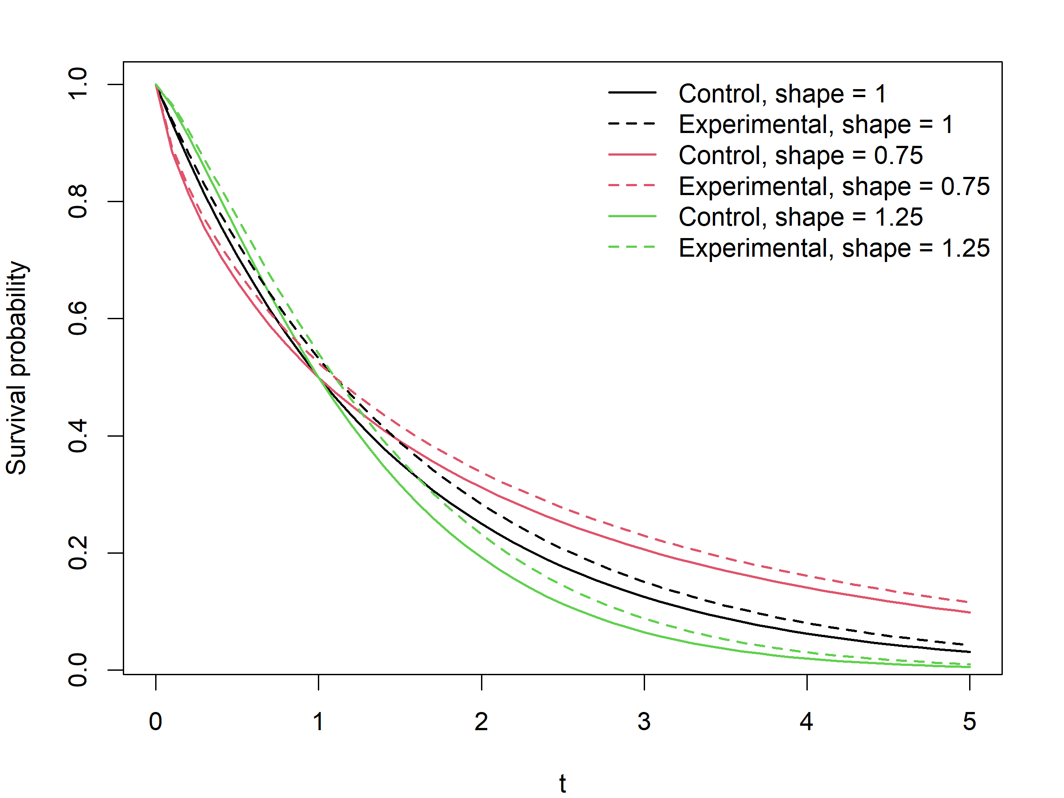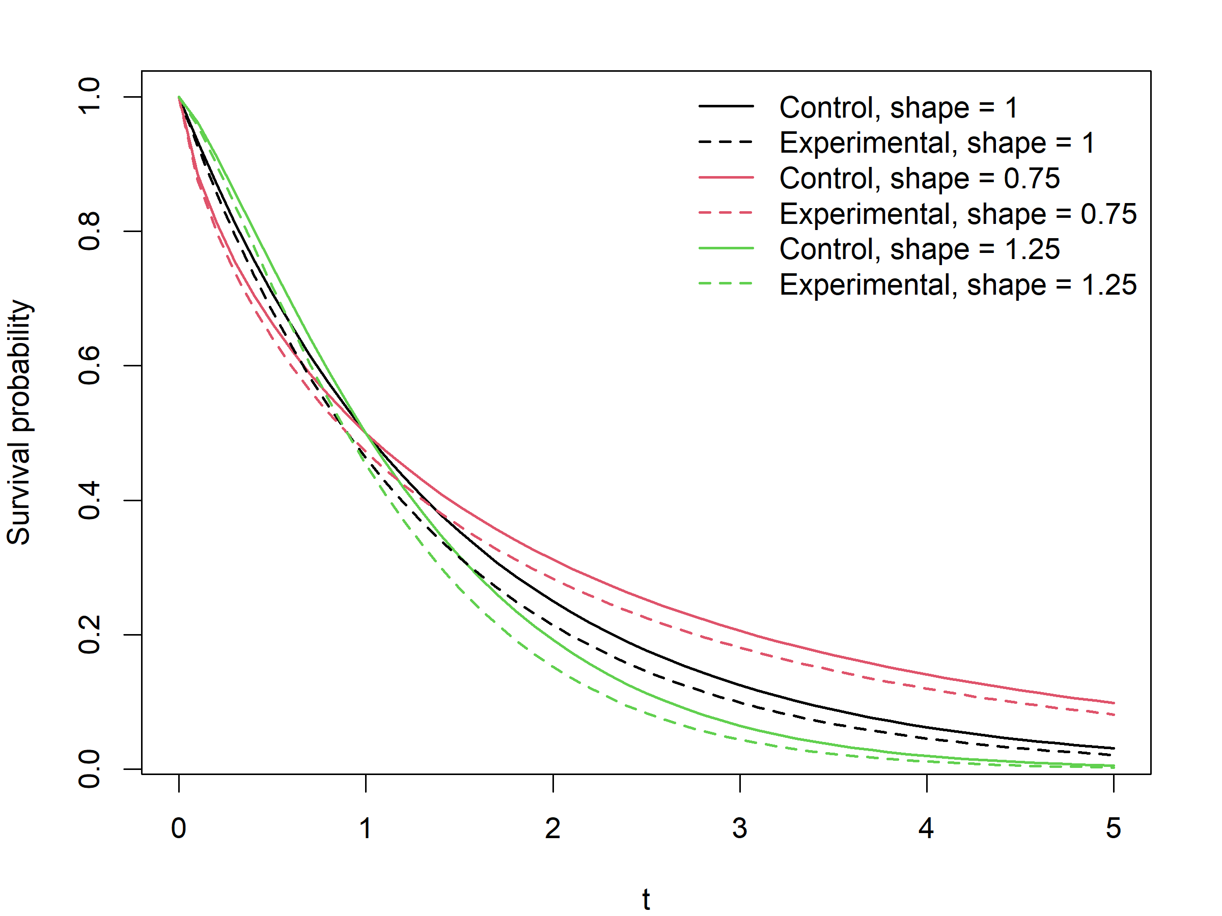
Figure s1. Weibull survival functions with different shape values, $m_{1}$ = 1 and $m_{2}$ = 1.1 (left) and $m_{1}$ = 1 and $m_{2}$ = 0.9 (right).
Table s1. Type I errors for “increasing” entry when $R_{2}\left(τ\right)=R_{1}\left(τ\right)-δ$ at $τ$ = 4, where $n$ = 628 and a one-sided significance level of 0.025.
 |  | Uniform dropout censoring |  | Exponential dropout censoring
 |  | $m_{2}$ = 0.9 | $m_{2}$ = 0.8 | $m_{2}$ = 0.9 | $m_{2}$ = 0.8
$p_{s}$ = 0.2 | adjusted | .022 | .021 | .021 | .022
 | unadjusted | .034 | .052 | .034 | .052
$p_{s}$ = 0.4 | adjusted | .022 | .025 | .022 | .024
 | unadjusted | .048 | .115 | .054 | .108

Table s2. Required sample sizes ($n$) and powers at $n_{ns}$ with $r_{s}$ = 0.5 and 0.25, shape = 1 and $r$ = 1, under $m_{2}/m_{1}$ = 1. $n_{ns}$ denotes the sample size under no treatment switching, given a power of 0.8 and a one-sided significance level of 0.025. E1 and E2 are the expected number of events in the active control and experimental groups.
$m_{2}/m_{1}$ = 1, $r_{s}$ = 0.5  $n_{ns}$ = 276; E1 = 220.7; E2 = 220.6 |  | s.dist
 |  | unif | beta | gamma | indepExp
$p_{s}$ = 0.2 | $$n$$ | 270 | 272 | 275 | 274
 | E1 | 215.9 | 217.6 | 220.0 | 219.1
 | E2 | 215.9 | 217.8 | 219.6 | 219.1
 | $$n/n_{ns}$$ | 0.978 | 0.986 | 0.996 | 0.993
 | Power at $n_{ns}$ | 0.810 | 0.801 | 0.806 | 0.802
 | Power at $n$ | 0.802 | 0.805 | 0.803 | 0.809
$p_{s}$ = 0.4 | $$n$$ | 268 | 275 | 272 | 274
 | E1 | 214.4 | 220.2 | 217.7 | 219.1
 | E2 | 214.2 | 220.0 | 217.7 | 219.1
 | $$n/n_{ns}$$ | 0.971 | 0.996 | 0.986 | 0.993
 | Power at $n_{ns}$ | 0.810 | 0.808 | 0.800 | 0.800
 | Power at $n$ | 0.803 | 0.803 | 0.806 | 0.809
$m_{2}/m_{1}$ = 1, $r_{s}$ = 0.25  $n_{ns}$ = 276; E1 = 220.7; E2 = 220.6 |  | s.dist
 |  | unif | beta | gamma | indepExp
$p_{s}$ = 0.2 | $$n$$ | - | 276 | 268 | 272
 | E1 | - | 220.9 | 214.5 | 217.6
 | E2 | - | 221.0 | 214.6 | 217.7
 | $$n/n_{ns}$$ | - | 1.000 | 0.971 | 0.986
 | Power at $n_{ns}$ | - | 0.808 | 0.806 | 0.802
 | Power at $n$ | - | 0.808 | 0.800 | 0.810
$p_{s}$ = 0.4 | $$n$$ | - | 266 | 266 | 277
 | E1 | - | 212.9 | 212.8 | 221.6
 | E2 | - | 212.8 | 212.8 | 221.8
 | $$n/n_{ns}$$ | - | 0.964 | 0.964 | 1.004
 | Power at $n_{ns}$ | - | 0.813 | 0.800 | 0.796
 | Power at $n$ | - | 0.789 | 0.792 | 0.805

Table s3. Required sample sizes ($n$) and powers at $n_{ns}$ with $r_{s}$ = 0.5, shape = 1.25, and $r$ = 1. $n_{ns}$ denotes the sample size under no treatment switching, given a power of 0.8 and a one-sided significance level of 0.025. E1 and E2 are the expected number of events in the active control and experimental groups.
$m_{2}/m_{1}$ = 1.1  $n_{ns}$ = 121; E1 = 96.7; E2 = 93.7 |  | s.dist
 |  | unif | beta | gamma | indepExp
$p_{s}$ = 0.2 | $$n$$ | 113 | 113 | 117 | 117
 | E1 | 90.1 | 90.1 | 93.2 | 93.2
 | E2 | 87.6 | 87.5 | 90.6 | 90.7
 | $$n/n_{ns}$$ | 0.934 | 0.934 | 0.967 | 0.967
 | Power at $n_{ns}$ | 0.822 | 0.815 | 0.826 | 0.825
 | Power at $n$ | 0.808 | 0.804 | 0.811 | 0.813
$p_{s}$ = 0.4 | $$n$$ | 112 | 114 | 115 | 115
 | E1 | 89.0 | 90.5 | 91.4 | 91.2
 | E2 | 86.7 | 88.1 | 89.1 | 89.0
 | $$n/n_{ns}$$ | 0.926 | 0.942 | 0.950 | 0.950
 | Power at $n_{ns}$ | 0.810 | 0.823 | 0.825 | 0.811
 | Power at $n$ | 0.797 | 0.798 | 0.799 | 0.796
$m_{2}/m_{1}$ = 0.9  $n_{ns}$ = 502; E1 = 401.4; E2 = 413.6 |  | s.dist
 |  | unif | beta | gamma | indepExp
$p_{s}$ = 0.2 | $$n$$ | 482 | 482 | 490 | 489
 | E1 | 386.6 | 386.7 | 392.8 | 392.6
 | E2 | 397.1 | 397.2 | 403.8 | 403.0
 | $$n/n_{ns}$$ | 0.960 | 0.960 | 0.976 | 0.974
 | Power at $n_{ns}$ | 0.809 | 0.813 | 0.810 | 0.818
 | Power at $n$ | 0.798 | 0.802 | 0.809 | 0.807
$p_{s}$ = 0.4 | $$n$$ | 484 | 481 | 480 | 479
 | E1 | 389.7 | 386.9 | 386.6 | 386.6
 | E2 | 399.0 | 396.4 | 395.7 | 395.0
 | $$n/n_{ns}$$ | 0.964 | 0.958 | 0.956 | 0.954
 | Power at $n_{ns}$ | 0.818 | 0.822 | 0.817 | 0.824
 | Power at $n$ | 0.808 | 0.797 | 0.800 | 0.808

Table s4. Required sample sizes ($n$) and powers at $n_{ns}$ with $r_{s}$ = 0.5, shape = 0.75, and $r$ = 1. $n_{ns}$ denotes the sample size under no treatment switching, given a power of 0.8 and a one-sided significance level of 0.025. E1 and E2 are the expected number of events in the active control and experimental groups.
$m_{2}/m_{1}$ = 1.1  $n_{ns}$ = 232; E1 = 185.5; E2 = 180.3 |  | s.dist
 |  | unif | beta | gamma | indepExp
$p_{s}$ = 0.2 | $$n$$ | 232 | 221 | 221 | 226
 | E1 | 185.0 | 176.2 | 176.2 | 179.9
 | E2 | 180.3 | 171.8 | 171.9 | 175.7
 | $$n/n_{ns}$$ | 1.000 | 0.953 | 0.953 | 0.974
 | Power at $n_{ns}$ | 0.814 | 0.812 | 0.812 | 0.812
 | Power at $n$ | 0.814 | 0.800 | 0.791 | 0.802
$p_{s}$ = 0.4 | $$n$$ | 227 | 228 | 235 | 225
 | E1 | 180.4 | 181.3 | 186.8 | 178.5
 | E2 | 176.6 | 177.3 | 182.7 | 175.1
 | $$n/n_{ns}$$ | 0.978 | 0.983 | 1.013 | 0.970
 | Power at $n_{ns}$ | 0.816 | 0.804 | 0.814 | 0.804
 | Power at $n$ | 0.803 | 0.805 | 0.819 | 0.802
$m_{2}/m_{1}$ = 0.9  $n_{ns}$ = 849; E1 = 678.8; E2 = 698.5 |  | s.dist
 |  | unif | beta | gamma | indepExp
$p_{s}$ = 0.2 | $$n$$ | 823 | 822 | 839 | 825
 | E1 | 660.2 | 659.4 | 673.0 | 662.5
 | E2 | 677.2 | 676.1 | 690.6 | 678.9
 | $$n/n_{ns}$$ | 0.969 | 0.968 | 0.988 | 0.972
 | Power at $n_{ns}$ | 0.801 | 0.811 | 0.804 | 0.811
 | Power at $n$ | 0.802 | 0.802 | 0.811 | 0.804
$p_{s}$ = 0.4 | $$n$$ | 825 | 831 | 825 | 830
 | E1 | 663.5 | 668.3 | 663.9 | 669.3
 | E2 | 679.1 | 683.9 | 678.8 | 683.2
 | $$n/n_{ns}$$ | 0.972 | 0.979 | 0.972 | 0.978
 | Power at $n_{ns}$ | 0.809 | 0.819 | 0.801 | 0.815
 | Power at $n$ | 0.799 | 0.803 | 0.802 | 0.799

Table s5. Required sample sizes ($n$) and powers at $n_{ns}$ with $r_{s}$ = 0.5, shape = 1, and $r$= 2. $n_{ns}$ denotes the sample size under no treatment switching, given a power of 0.8 and a one-sided significance level of 0.025. E1 and E2 are the expected number of events in the active control and experimental groups.
$m_{2}/m_{1}$ = 1.1  $n_{ns}$ = 124; E1 = 99.2; E2 = 192.4 |  | s.dist
 |  | unif | beta | gamma | indepExp
$p_{s}$ = 0.2 | $$n$$ | 122 | 121 | 122 | 119
 | E1 | 97.2 | 96.4 | 97.2 | 94.8
 | E2 | 189.2 | 187.8 | 189.2 | 184.5
 | $$n/n_{ns}$$ | 0.984 | 0.976 | 0.984 | 0.960
 | Power at $n_{ns}$ | 0.810 | 0.813 | 0.820 | 0.803
 | Power at $n$ | 0.809 | 0.804 | 0.801 | 0.794
$p_{s}$ = 0.4 | $$n$$ | 120 | 124 | 126 | 123
 | E1 | 95.4 | 98.4 | 100.1 | 97.6
 | E2 | 186.2 | 192.2 | 195.5 | 190.8
 | $$n/n_{ns}$$ | 0.968 | 1.000 | 1.016 | 0.992
 | Power at $n_{ns}$ | 0.807 | 0.813 | 0.801 | 0.799
 | Power at $n$ | 0.798 | 0.813 | 0.815 | 0.802
$m_{2}/m_{1}$ = 0.9  $n_{ns}$ = 502; E1 = 401.4; E2 = 827.7 |  | s.dist
 |  | unif | beta | gamma | indepExp
$p_{s}$ = 0.2 | $$n$$ | 500 | 511 | 495 | 497
 | E1 | 401.0 | 409.9 | 397.2 | 399.2
 | E2 | 824.6 | 842.7 | 816.2 | 819.5
 | $$n/n_{ns}$$ | 0.996 | 1.018 | 0.986 | 0.990
 | Power at $n_{ns}$ | 0.806 | 0.802 | 0.798 | 0.808
 | Power at $n$ | 0.801 | 0.804 | 0.794 | 0.796
$p_{s}$ = 0.4 | $$n$$ | 491 | 498 | 499 | 494
 | E1 | 395.2 | 400.7 | 401.5 | 398.6
 | E2 | 809.9 | 821.2 | 822.7 | 814.6
 | $$n/n_{ns}$$ | 0.978 | 0.992 | 0.994 | 0.984
 | Power at $n_{ns}$ | 0.804 | 0.803 | 0.809 | 0.807
 | Power at $n$ | 0.795 | 0.805 | 0.798 | 0.808

Table s6. Required sample sizes ($n$) and powers at $n_{ns}$ with $r_{s}$ = 0.5, shape = 1, and $r$ = 1, under various entry patterns. $n_{ns}$ denotes the sample size under no treatment switching, given a power of 0.8 and a one-sided significance level of 0.025. E1 and E2 are the expected number of events in the active control and experimental groups. s.dist = “gamma” is used.
$m_{2}/m_{1}$ = 1.1 |  | Entry pattern
 |  | Decreasing | Uniform | Increasing
No switching | $$n_{ns}$$ | 157 | 160 | 172
 | E1 | 125.6 | 128.0 | 137.7
 | E2 | 122.0 | 124.0 | 133.0
$p_{s}$ = 0.2 | $$n$$ | 153 | 157 | 166
 | E1 | 122.0 | 125.2 | 132.3
 | E2 | 118.9 | 121.7 | 128.3
 | $$n/n_{ns}$$ | 0.975 | 0.981 | 0.965
 | Power at $n_{ns}$ | 0.805 | 0.806 | 0.817
 | Power at $n$ | 0.793 | 0.800 | 0.812
$p_{s}$ = 0.4 | $$n$$ | 156 | 161 | 167
 | E1 | 124.0 | 127.9 | 132.6
 | E2 | 121.2 | 124.8 | 129.1
 | $$n/n_{ns}$$ | 0.994 | 1.006 | 0.971
 | Power at $n_{ns}$ | 0.801 | 0.804 | 0.821
 | Power at $n$ | 0.800 | 0.800 | 0.808
$m_{2}/m_{1}$ = 0.9 |  | Entry pattern
 |  | Decreasing | Uniform | Increasing
No switching | $$n_{ns}$$ | 627 | 636 | 687
 | E1 | 501.5 | 508.8 | 549.6
 | E2 | 515.5 | 524.1 | 568.0
$p_{s}$ = 0.2 | $$n$$ | 635 | 637 | 670
 | E1 | 509.3 | 511.0 | 537.9
 | E2 | 522.1 | 525.1 | 553.9
 | $$n/n_{ns}$$ | 1.013 | 1.002 | 0.975
 | Power at $n_{ns}$ | 0.789 | 0.795 | 0.801
 | Power at $n$ | 0.800 | 0.801 | 0.796
$p_{s}$ = 0.4 | $$n$$ | 608 | 623 | 676
 | E1 | 488.9 | 501.1 | 544.2
 | E2 | 500.1 | 513.6 | 559.0
 | $$n/n_{ns}$$ | 0.970 | 0.980 | 0.984
 | Power at $n_{ns}$ | 0.805 | 0.798 | 0.813
 | Power at $n$ | 0.789 | 0.799 | 0.800

Table s7. Comparison between Weibull and gamma survival distributions in sample sizes required to achieve a power of 0.8.
$m_{2}/m_{1}$ = 1.1 |  | s.dist
 | Distribution | unif | beta | gamma | indepExp
$p_{s}$ = 0.2 | Weibull | 113 | 113 | 117 | 117
 | Gamma | 112 | 110 | 113 | 114
$p_{s}$ = 0.4 | Weibull | 112 | 114 | 115 | 115
 | Gamma | 112 | 114 | 113 | 119
$m_{2}/m_{1}$ = 1.0 |  | s.dist
 | Distribution | unif | beta | gamma | indepExp
$p_{s}$ = 0.2 | Weibull | 205 | 200 | 201 | 197
 | Gamma | 196 | 199 | 202 | 208
$p_{s}$ = 0.4 | Weibull | 197 | 200 | 202 | 201
 | Gamma | 200 | 201 | 205 | 198
$m_{2}/m_{1}$ = 0.9 |  | s.dist
 | Distribution | unif | beta | gamma | indepExp
$p_{s}$ = 0.2 | Weibull | 482 | 482 | 490 | 489
 | Gamma | 478 | 486 | 483 | 480
$p_{s}$ = 0.4 | Weibull | 484 | 481 | 480 | 479
 | Gamma | 473 | 485 | 479 | 478

