Supplementary Materials (SM)
eTable 1. PRISMA Checklist
Section and Topic | Item # | Checklist item | Location where item is reported
TITLE
Title | 1 | Identify the report as a systematic review. | Page 1
ABSTRACT
Abstract | 2 | See the PRISMA 2020 for Abstracts checklist. | Page 4
INTRODUCTION
Rationale | 3 | Describe the rationale for the review in the context of existing knowledge. | Page 8
Objectives | 4 | Provide an explicit statement of the objective(s) or question(s) the review addresses. | Page 8
METHODS
Eligibility criteria | 5 | Specify the inclusion and exclusion criteria for the review and how studies were grouped for the syntheses. | Page 9 and 10
Information sources | 6 | Specify all databases, registers, websites, organisations, reference lists and other sources searched or consulted to identify studies. Specify the date when each source was last searched or consulted. | Page 9
Search strategy | 7 | Present the full search strategies for all databases, registers and websites, including any filters and limits used. | Page 9 and eTable 2 of ESD
Selection process | 8 | Specify the methods used to decide whether a study met the inclusion criteria of the review, including how many reviewers screened each record and each report retrieved, whether they worked independently, and if applicable, details of automation tools used in the process. | Page 9 and 10
Data collection process | 9 | Specify the methods used to collect data from reports, including how many reviewers collected data from each report, whether they worked independently, any processes for obtaining or confirming data from study investigators, and if applicable, details of automation tools used in the process. | Page 10
Data items | 10a | List and define all outcomes for which data were sought. Specify whether all results that were compatible with each outcome domain in each study were sought (e.g. for all measures, time points, analyses), and if not, the methods used to decide which results to collect. | Page 10 and 11
Data items | 10b | List and define all other variables for which data were sought (e.g. participant and intervention characteristics, funding sources). Describe any assumptions made about any missing or unclear information. | Page 10 and 11
Study risk of bias assessment | 11 | Specify the methods used to assess risk of bias in the included studies, including details of the tool(s) used, how many reviewers assessed each study and whether they worked independently, and if applicable, details of automation tools used in the process. | Page 14 and 15
Effect measures | 12 | Specify for each outcome the effect measure(s) (e.g. risk ratio, mean difference) used in the synthesis or presentation of results. | Page 10 and 11
Synthesis methods | 13a | Describe the processes used to decide which studies were eligible for each synthesis (e.g. tabulating the study intervention characteristics and comparing against the planned groups for each synthesis (item #5)). | Page 9 and 10
Synthesis methods | 13b | Describe any methods required to prepare the data for presentation or synthesis, such as handling of missing summary statistics, or data conversions. | Page 11 and 12
Synthesis methods | 13c | Describe any methods used to tabulate or visually display results of individual studies and syntheses. | Page 11 and 12
Synthesis methods | 13d | Describe any methods used to synthesize results and provide a rationale for the choice(s). If meta-analysis was performed, describe the model(s), method(s) to identify the presence and extent of statistical heterogeneity, and software package(s) used. | Page 12 and 13
Synthesis methods | 13e | Describe any methods used to explore possible causes of heterogeneity among study results (e.g. subgroup analysis, meta-regression). | Page 13 and 14
Synthesis methods | 13f | Describe any sensitivity analyses conducted to assess robustness of the synthesized results. | Page 13 and 14
Reporting bias assessment | 14 | Describe any methods used to assess risk of bias due to missing results in a synthesis (arising from reporting biases). | Page 14 and 15
Certainty assessment | 15 | Describe any methods used to assess certainty (or confidence) in the body of evidence for an outcome. | NA
RESULTS
Study selection | 16a | Describe the results of the search and selection process, from the number of records identified in the search to the number of studies included in the review, ideally using a flow diagram. | Page 16
Study selection | 16b | Cite studies that might appear to meet the inclusion criteria, but which were excluded, and explain why they were excluded. | Page 16
Study characteristics | 17 | Cite each included study and present its characteristics. | Page 16
Risk of bias in studies | 18 | Present assessments of risk of bias for each included study. | Page 19
Results of individual studies | 19 | For all outcomes, present, for each study: (a) summary statistics for each group (where appropriate) and (b) an effect estimate and its precision (e.g. confidence/credible interval), ideally using structured tables or plots. | Figure 2
Results of syntheses | 20a | For each synthesis, briefly summarise the characteristics and risk of bias among contributing studies. | Page 19
Results of syntheses | 20b | Present results of all statistical syntheses conducted. If meta-analysis was done, present for each the summary estimate and its precision (e.g. confidence/credible interval) and measures of statistical heterogeneity. If comparing groups, describe the direction of the effect. | Page 18 and Figure 3
Results of syntheses | 20c | Present results of all investigations of possible causes of heterogeneity among study results. | eTable 5 of the ESD
Results of syntheses | 20d | Present results of all sensitivity analyses conducted to assess the robustness of the synthesized results. | eTable 5 of the ESD
Reporting biases | 21 | Present assessments of risk of bias due to missing results (arising from reporting biases) for each synthesis assessed. | Page 19
Certainty of evidence | 22 | Present assessments of certainty (or confidence) in the body of evidence for each outcome assessed. | Page 19
DISCUSSION
Discussion | 23a | Provide a general interpretation of the results in the context of other evidence. | Page 19
Discussion | 23b | Discuss any limitations of the evidence included in the review. | Page 25 - 26
Discussion | 23c | Discuss any limitations of the review processes used. | Page 25 - 26
Discussion | 23d | Discuss implications of the results for practice, policy, and future research. | Page 20 - 25
OTHER INFORMATION
Registration and protocol | 24a | Provide registration information for the review, including register name and registration number, or state that the review was not registered. | NA
Registration and protocol | 24b | Indicate where the review protocol can be accessed, or state that a protocol was not prepared. | NA
Registration and protocol | 24c | Describe and explain any amendments to information provided at registration or in the protocol. | NA
Support | 25 | Describe sources of financial or non-financial support for the review, and the role of the funders or sponsors in the review. | Page 27
Competing interests | 26 | Declare any competing interests of review authors. | Page 27
Availability of data, code and other materials | 27 | Report which of the following are publicly available and where they can be found: template data collection forms; data extracted from included studies; data used for all analyses; analytic code; any other materials used in the review. | Page 27

eTable 2. Databases searched
Date | Name | Records
5/11/2023 | PUBMED | 57
5/11/2023 | MEDLINE via Ebsco | 160
5/11/2023 | EMBASE | 107

Database = PUBMED, Search date: 5/11/2023
Query | Terms | No. of Studies
1 | machine learning[Title/Abstract] | 85,955
2 | machine learning[MeSH Terms] | 56,486
3 | #1 or #2 | 111,035
4 | Cancer[Title/Abstract] OR tumor[Title/Abstract] OR tumour[Title/Abstract] OR malignancy[Title/Abstract] OR neoplasm[Title/Abstract] OR carcinoma[Title/Abstract] OR cancer*[Title/Abstract] OR tumour*[Title/Abstract] OR tumor*[Title/Abstract] OR malignan*[Title/Abstract] OR neoplas*[Title/Abstract] OR carcinoma*[Title/Abstract] | 3,969,133
5 | (((((cancer[MeSH Terms]) OR (tumor[MeSH Terms])) OR (tumour[MeSH Terms])) OR (malignancy[MeSH Terms])) OR (neoplasm[MeSH Terms])) OR (carcinoma[MeSH Terms]) | 3,826,345
6 | #4 or #5 | 5,028,691
7 | Cox Proportional Hazards model[Title/Abstract] OR Cox regression[Title/Abstract] OR Cox model[Title/Abstract] OR survival analysis[Title/Abstract] OR survival analyses[Title/Abstract] OR time-to-event analysis[Title/Abstract] | 143,732
8 | ((analyses, survival[MeSH Terms]) OR (analysis, survival[MeSH Terms])) OR (cox proportional hazards models[MeSH Terms]) | 333,035
9 | #7 or #8 | 421,188
10 | Survival[Title/Abstract] OR mortality[Title/Abstract] OR death[Title/Abstract] | 2,561,775
11 | (mortality[MeSH Terms]) OR (death[MeSH Terms]) | 570,161
12 | 10 or 11 | 2,780,212
13 | electronic health records[Title/Abstract] OR electronic health record[Title/Abstract] OR EHRs[Title/Abstract] OR EHR[Title/Abstract] OR electronic medical record[Title/Abstract] OR electronic medical records[Title/Abstract] OR EMR[Title/Abstract] OR EMRs[Title/Abstract] OR claims data[Title/Abstract] OR claims dataset[Title/Abstract] OR claims datasets[Title/Abstract] OR administrative claim[Title/Abstract] OR administrative claims[Title/Abstract] OR disease registries[Title/Abstract] OR disease registry[Title/Abstract] OR registry data[Title/Abstract] OR registry dataset[Title/Abstract] OR registry datasets[Title/Abstract] OR real-world data[Title/Abstract] OR cancer registries[Title/Abstract] OR cancer registry[Title/Abstract] | 188,074
14 | ((((((electronic medical record[MeSH Terms]) OR (electronic medical records[MeSH Terms])) OR (electronic health record[MeSH Terms])) OR (electronic health records[MeSH Terms])) OR (analyses, claims[MeSH Terms])) OR (analysis, claims[MeSH Terms])) OR (registry[MeSH Terms]) | 150,191
15 | 13 or 14 | 299,130
16 | #3 AND #6 AND #9 AND #12 and 15 | 57

Database = MEDLINE via Ebsco, Search date: 5/11/2023
Query | Terms | No. of Studies
1 | AB machine learning OR TI machine learning | 80,807
2 | MH machine learning | 32,128
3 | S1 OR S2 | 86,484
4 | AB ( Cancer or tumor OR tumour OR malignancy OR neoplasm OR carcinoma OR cancer* or tumor* or tumour* or malignan* OR neoplas* or carcinoma* ) OR TI ( Cancer or tumor OR tumour OR malignancy OR neoplasm OR carcinoma OR cancer* or tumor* or tumour* or malignan* OR neoplas* or carcinoma* ) | 3,879,758
5 | MH cancer OR MH tumor OR MH tumour OR MH malignancy OR MH malignant melanoma OR MH malignant tumor OR MH malignant neoplasm OR MH neoplasms OR MH carcinoma | 583,674
6 | S4 OR S5 | 3,985,971
7 | AB cox proportional hazards model OR TI cox proportional hazards model OR AB cox regression OR TI cox regression OR AB cox model OR TI cox model OR AB survival analysis OR TI survival analysis | 483,015
8 | MH cox proportional hazards model OR MH cox regression OR MH survival analysis | 145,480
9 | S7 OR S8 | 577,793
10 | AB mortality OR TI mortality OR AB death OR TI death OR AB survival OR TI survival | 2,607,862
11 | MH mortality OR MH death | 68,958
12 | S10 OR S11 | 2,627,649
13 | AB ( electronic health records OR electronic health record OR EHRs OR EHR or electronic medical record OR electronic medical records OR EMR OR EMRs OR claims data OR claims dataset OR claims datasets OR administrative claim OR administrative claims OR disease registries OR disease registry OR registry data OR registry dataset OR registry datasets OR real-world data OR cancer registries OR cancer registry ) OR TI ( electronic health records OR electronic health record OR EHRs OR EHR or electronic ... | 248,663
14 | MH electronic health records OR MH electronic medical record OR MH administrative claims data OR MH claims data OR MH disease registry OR MH cancer registry | 26,717
15 | S13 OR S14 | 257,619
16 | #3 AND #6 AND #9 AND #12 and 15 | 160

Database = EMBASE, Search date: 5/11/2023
Query | Search Terms | No. of Studies
1 | machine learning.mp. | 129,543
2 | exp machine learning/ | 398,209
3 | #1 or #2 | 411,553
4 | (cancer*or tumor* or tumour* or neoplas* or oncology or neoplasm* or carcinoma or adenocarcinoma or sarcoma).mp | 2,978,580
5 | exp malignant neoplasm/ | 3,917,441
6 | #4 or #5 | 4,784,744
7 | (Cox Proportional Hazards Regression or Cox regression model or Cox model or Cox regression).mp. | 170,493
8 | exp survival analysis/ | 46,145
9 | #7 or #8 | 210,891
10 | (electronic health records or electronic health record or electronic medical record or electronic medical records or claims data or claims dataset or claims datasets or administrative claim or administrative claims or disease registries or disease registry or registry data or registry dataset or registry datasets).mp. | 197,757
11 | exp medical record/ or exp electronic medical record/ | 696,652
12 | #10 or #11 | 738,122
13 | #3 AND #6 AND #9 AND #12 | 107

eTable 3. Inclusion/exclusion criteria for screening articles
Population | Population diagnosed with cancer
Intervention | none
Comparator | none
Outcomes | Time-to-event clinical outcomes
Study design | Requiring real-world observational datasets
Timing | From database inception until May 3, 2023
Setting | US-setting
Inclusion Criteria | (1) Must use at least one ML model; (2) Must focus on analyzing time-to-event survival outcome for patients diagnosed for cancer; (3) The risk predictive modeling is based on US population-based databases; (4) Must also have evaluated traditional regression-based Cox model as a comparison; (5) Be an original research paper; (6) Full text in English
Exclusion Criteria | (1) Not population-level structured data (e.g., RCT, simulation data, imaging/text data); (2) No ML based modeling (e.g., ML for feature selection); (3) No survival prediction (e.g., binary classification); (4) Not US setting; (5) Not original research paper, e.g., review article

eTable 4. Description of ML methods
Method | Basic Concept | How It Works | Pros | Cons
Random Survival Forests [1] | A method employing a collection of trees designed for handling censored survival data. | 1. Extract samples from the data using the bootstrap method.  2. Utilize each bootstrap sample to develop a survival tree.  3. Derive a cumulative hazard function (CHF) for every individual tree. The final ensemble CHF is determined by averaging these individual CHFs. | Manages vast datasets with many variables; intuitively addresses the interplay between features; resilient to anomalous data points. | Might exhibit delays when processing extensive datasets; prone to overfitting unless meticulously adjusted.
Boosted Tree [2] | The ensemble model, rooted in tree-based methods, is trained via a boosting technique. This method amalgamates numerous weaker predictions to produce a robust prediction. Throughout this training, each prediction refines a polished estimate of the concordance index, a commonly employed metric for assessing the efficacy of survival models. | A sequence of tree-based models is constructed one after the other. In this procedure, every subsequent prediction tree is fashioned from an improved version of its predecessor. | Capable of processing diverse data types; diminishes both bias and variance; offers high precision. | Prone to overfitting with excessive tree usage; necessitates meticulous adjustments; challenges in interpretation.
Artificial Neural Network [3] | A model is based on several layers of “neurons” or linked nodes. A variant of Artificial Neural Networks (ANN) can be utilized for survival data analysis. | Every neuron is constructed by accepting input from preceding neurons. This input undergoes a transformation, after which the output is relayed to subsequent neurons. During the training process, these transformation parameters undergo adjustments. | Able to represent intricate non-linear associations; exhibits great adaptability and versatility. | Demands abundant data and significant computational power; challenging to decipher; susceptible to overfitting.
Support Vector Machine [4] | A technique suitable for analyzing survival data by identifying the hyperplane that optimally widens the gap between different classes. | Aims to identify the hyperplane that enlarges the separation between the nearest points from distinct classes, utilizing kernels to cater to non-linear borders. | Performs well in spaces with many dimensions; in the appropriate dimensional context, it exhibits resistance to overfitting. | Not suitable for expansive datasets; necessitates a thoughtful kernel selection; does not cater directly to multi-class challenges.
K-Nearest Neighbor [5] | A prediction technique that does not assume a specific form for the underlying data and is designed for censored information. This method predicts a survival curve by creating a Kaplan-Meier estimator derived from the outcomes observed in the K most analogous training entries. | For a new data point, it identifies the k closest data points from the training set and forecasts based on their responses. | Straightforward in both comprehension and execution; does not make presumptions regarding the data's distribution. | Demands high computational resources for sizable datasets; can be influenced by non-pertinent attributes; the effectiveness is contingent on the selection of k.
References:
1. Ishwaran H, Kogalur UB, Blackstone EH, Lauer MS. Random survival forests. The Annals of Applied Statistics. 2008;2(3):841-860.
2. Chen Y, Jia Z, Mercola D, Xie X. A gradient boosting algorithm for survival analysis via direct optimization of concordance index. Computational and Mathematical Methods in Medicine. 2013;2013:873595.
3. Chi C-L, Street WN, Wolberg WH. Application of artificial neural network-based survival analysis on two breast cancer datasets. AMIA Annual Symposium Proceedings. 2007;2007;130-4.
4. Van Belle V, Pelckmans K, Van Huffel S, Suykens JAK. Support vector methods for survival analysis: a comparison between ranking and regression approaches. Artificial Intelligence in Medicine. 2011;53(2):107-18.
5. Zhang Z. Introduction to machine learning: k-nearest neighbors. Annals of Translational Medicine. 2016;4(11):218.

eTable 5. Characteristics ML and CPH regression models included in studies assessing cancer survival risk
Study |  | ML Algorithm and Performance |  |  |  |  | CPH Model and Performance | ML Validation Methods
Author (yr) | Predictor Variables | Random Survival Forests | Gradient Boosting | Neural Network | Survival Support Vector Machine | Other ML | CPH model | Internal Validation | External Validation
Cai et al. 2022 | (1) Age; (2) Sex; (3) Ethnicity; (4) Marital Status; (5) Tumor Location; (6) Surgery; (7) Radiotherapy; (8) Histology; (9) Grade. |  |  |  |  | LASSO penalized Cox regression model: 0.65 (0.63–0.67) |  | 10-fold cross-validation
Dong et al. 2022 | (1) Age; (2) Depth of Invasion; (3) yr when Patients were Diagnosed; (4) Diameter; (5) Differentiation; (6) Histology; (7) Lymph Node Metastases; (8) Number of Positive Lymph Nodes; (9) Number of Dissected Lymph Nodes; (10) Marital Status; (11) Primary Tumor Site; (12) Race; (13) Stage; (14) Surgery Type | 0.753 |  | DSLM: validation = 0.782, testing = 0.758  Novel prognostic model based on DSLM: validation = 0.826, testing = 0.689 |  |  | 0.731
Fan et al. 2022 | (1) Marital Status; (2) Race; (3) Gender; (4) Age; (5) Overall Survival Status; (6) Cancer-specific Survival Status; (7) Survival Time; (8) Tumor Size; (9) Tumor Extension; (10) Lymph Metastasis; (11) Distant Metastasis; (12) Surgery Type; (13) Tumor Grade | For overall survival: validation = 0.702; testing = 0.704; training AUC = 0.787; testing AUC = 0.769 |  |  |  | CoxBoost for OS: validation C-index = 0.689; testing C-index = 0.714; training AUC = 0.711; testing AUC = 0.811; for CSS: validation C-index = 0.702; testing C-index = 0.725; training AUC = 0.805; testing AUC = 0.798  Final ensemble ML model for OS: validation C-index = 0.693; testing C-index = 0.693; validation AUC = 0.799; testing AUC = 0.829; for CSS: validation C-index = 0.709; testing C-index = 0.719; validation AUC = 0.820; testing AUC = 0.819 | OS: validation C-index = 0.689; testing C-index = 0.685; training AUC = 0.805; testing AUC = 0.820 | 5-fold cross-validation
Huang et al. 2019 | (1) Baseline demographics of patients (age at diagnosis, sex, race); (2) Characteristics of tumor (tumor size, tumor extent, primary site, histologic subtype, tumor node metastasis (TNM) state); (3) Treatment (radiotherapy, chemotherapy); (4) Socioeconomic status (marital status, education background, family income, and employment status) | Not reported |  |  |  |  | OS: C-index = 0.7095  CSS: C-index = 0.7100
Jin et al. 2023 | (1) Demographic Information (Age and Sex); (2) NSCLC Cancer-related Characteristics (TNM Stage, Histology Type, Primary Site, Tumor Size, Regional Node Number Examined, Regional Node Positive Number, Laterality of the Tumor); (3) Treatment Details (Surgery of Primary Site, Radiation, and Chemotherapy) | 0.678 |  | 0.834 |  |  | Penalized CPH: 0.640 | 5-fold cross-validation | Shaanxi Provincial People’s Hospital
Kim et al. 2022 | Not reported | 1. Training (C-index = 0.663; Td1 AUC = 0.713; Td2 AUC = 0.721; Td3 AUC = 0.731); Testing (C-index = 0.633; Td1 AUC = 0.682; Td2 AUC = 0.668; Td3 AUC = 0.678)  2. Training (C-index = 0.665; Td1 AUC = 0.729; Td2 AUC = 0.708; Td3 AUC = 0.717); Testing (C-index = 0.633; Td1 AUC = 0.666; Td2 AUC = 0.676 Td3 AUC = 0.691)  3. Training (C-index = 0.662; Td1 AUC = 0.706; Td2 AUC = 0.712; Td3 AUC = 0.716); Testing (C-index = 0.621; Td1 AUC = 0.674; Td2 AUC = 0.658; Td3 AUC = 0.660) |  |  | 1. Training (C-index = 0.625; Td1 AUC = 0.697; Td2 AUC = 0.640; Td3 AUC = 0.619), Testing (C-index = 0.623; Td1 AUC = 0.684; Td2 AUC = 0.635; Td3 AUC = 0.626)  2. Training (C-index = 0.642; Td1 AUC = 0.722; Td2 AUC = 0.658; Td3 AUC = 0.640), Testing (C-index = 0.599; Td1 AUC = 0.615; Td2 AUC = 0.626; Td3 AUC = 0.634)  3. Training (C-index = 0.626; Td1 AUC = 0.669; Td2 AUC = 0.667; Td3; AUC = 0.660), Testing (C-index = 0.600; Td1 AUC = 0.647; Td2 AUC = 0.630; Td3 AUC = 0.623) |  | 1. Training (C-index = 0.648; Td1 AUC = 0.707; Td2 AUC = 0.691; Td3 AUC = 0.693); Testing (C-index = 0.643; Td1 AUC = 0.697; Td2 AUC = 0.679 Td3 AUC = 0.687)  2. Training (C-index = 0.654; Td1 AUC = 0.725; Td2 AUC = 0.687; Td3 AUC = 0.687); Testing (C-index = 0.627; Td1 AUC = 0.654; Td2 AUC = 0.667 Td3 AUC = 0.681)  3. Training (C-index = 0.650; Td1 AUC = 0.693; Td2 AUC = 0.695; Td3 AUC = 0.700); Testing (C-index = 0.629; Td1 AUC = 0.683; Td2 AUC = 0.670; Td3 AUC = 0.674) | 1. Mixing two datasets half and half and utilizing the mixed datasets for model development and validation. | 2. SEER for model development and used data from KOTUS-BP for external evaluation;  3. KOTUS-BP for model development and data from SEER for external evaluation
Li et al. 2021 | 1933 variables grouped into three groups: (1) curated, (2) labs, (3) ICD | 0.67 |  |  |  |  | 0.64 (0.61–0.67) | 5-fold cross-validation
Li et al. 2022 | (1) Age at Diagnosis; (2) Months from Diagnosis to Therapy; (3) Subtype; (4) Race; (5) Histological Type; (6) Marital Status; (7) T Stage; (8) N Stage; (9) Grade; (10) Median Household Income (Inflation Adjusted); (11) Neoadjuvant Chemotherapy; (12) Chemotherapy; (13) Radiotherapy |  | XGBoost: 1-yr testing = 0.818; 3-yr testing = 0.798; 5-yr testing = 0.791; |  | 1-yr AUC = 0.604; 3-yr AUC = 0.678; 5-yr AUC = 0.545 | ID3: 1-yr AUC = 0.655; 3-yr AUC = 0.710; 5-yr AUC = 0.668  KNN: 1-yr AUC = 0.607; 3-yr AUC = 0.664; 5-yr AUC = 0.596 |  | 10-fold cross-validation; confusion matrix
Lin et al. 2022 | (1) demographic information; (2) the clinical features (histological type, AJCC stage [AJCC 7th], T stage, N stage, M stage, the site of the tumor, tumor size, and clinical grade, the number of examined lymph nodes, the number of positive lymph nodes, and the rate of positive lymph nodes); (3) healthcare utilization (surgery, chemotherapy, and radiation) | 1-yr AUC = 0.753; 3-yr AUC = 0.744; 5-yr AUC = 0.759; C-index = 0.723 |  | Deepsurv: 1-yr AUC = 0.744; 3-yr AUC = 0.742; 5-yr AUC = 0.749; C-index = 0.700 |  |  | 1-yr AUC = 0.736; 3-yr AUC = 0.737; 5-yr AUC = 0.760; C-index = 0.670 | 10-fold cross-validation
Liu et al. 2022 | Not reported | 0.899 |  |  |  |  | Proportional hazards assumption was not met, not included in further analyses
Loureiro et al. 2021 | (1) demographic information; (2) the clinical features; (3) lab tests | 0.72 | 0.722 | 0.721 |  | Autoencoder: 0.708  Super Learner: 0.723 | ROPRO: 0.701  CPH plus elastic net: 0.708  CPH plus lasso: 0.708  CPH plus ridge regression: 0.709 | 5-fold cross-validation | OAK clinical trial database
Ouyang et el. 2022 | (1) demographic; (2) clinicopathological characteristics | 0.77 |  |  |  | Conditional survival forest: 0.72 - 0.81 |  | Cross-validation
Park et al. 2022 | (1) age at cancer diagnosis; (2) marital status at diagnosis; (3) first malignant primary tumour indicator; (4) the sequence number of tumours; (5) primary site, histology; (6) the total number of in situ/malignant tumours; (7) SEER summary stage; (8) derived stage, grade, regional lymph nodes examined; (9) regional lymph nodes positive; (10) oestrogen receptor status; (11) progesterone receptor status; (12) chemotherapy; (13) radiation; (14) sequence of radiation; (15) surgery performed, reason no cancer- directed surgery; (16) sequence of systemic therapy and surgical procedures |  | Hispanic-specific model = 0.813  Black-specific model = 0.808  All races/ethnicity model = 0.803 |  | Hispanic-specific model = 0.834  Black-specific model = 0.824  All races/ethnicity model = 0.786 | Hispanic-specific model = 0.772  Black-specific model = 0.804  All races/ethnicity model = 0.801 | Hispanic-specific model = 0.832  Black-specific model = 0.823  All races/ethnicity model = 0.821 | 5-fold cross-validation
Senders et al. 2019 | (1) age at diagnosis; (2) maximal enhancing tumor diameter in any dimension; (3) sex; (4) race and ethnicity; (5) marital status; (6) insurance status ; (7) clinical factors; (8) surgery type; (9) administration of any form of postoperative chemotherapy and/or radiotherapy | 0.69 | 0.69 |  |  | Recursive partitioning: 0.68 | 0.69 | 5-fold cross-validation
She et al. 2020 | (1) demographic; (2) tumor characteristics; (3) SEERcode; (4) treatment details |  |  | Deepsurv: 0.739 in SEER data; 0.742 in Shanghai Pulmonary Hospital data |  |  | 0.706 (0.681-0.731) in SEER data, 0.691 (0.659-0.724) in Shanghai Pulmonary Hospital data |  | Chinese dataset
Sun et al. 2023 | (1) demographic variables; (2) tumor primary site in larynx; (3) laterality of tumor; (4) extent of tumor; (5) tumor size; (6) whether regional nodes were positive; (7) AJCC overall stage; (8) T stage; (9) N stage; (10) histologic differentiation grade; (11) different surgical techniques of primary site; (12) whether lymph node was removed; (13) whether radiotherapy was undertaken; (14) whether chemotherapy was undertaken | 3-yr training set = 0.84; validation set = 0.82  5-yr training set = 0.80; validation set = 0.79 |  |  |  |  | 3-yr training = 0.74; validation = 0.72  5-yr training = 0.75; testing = 0.72 | 10-fold cross-validation
Teng et al. 2022 | (1) Age; (2) T Stage; (3) N Stage; (4) Grade; (5) Radiation; (6) Chemotherapy; (7) Malignant; (8) Marital; (9) ER; (10) PR; (11) Nodal Status; (12) Tumor Size | 0.746 | GLMBoost: 0.757 |  |  | Time-varying Transformation: 0.768 - 0.793 | CPH: 0.749-0.774  modified CPH: 0.751-0.778  Bayesian dynamic CPH: 0.778-0.802 | Bootstrapping | Shanghai Breast Cancer Survival Study
Tian et al. 2018 | (1) Age; (2) Gender; (3) Grade; (4) Histology; (5) Tumor Location; (6) Tumor Size; (7) EOD10_PN | 0.898 |  |  |  |  | CPH with mixed effects: 0.732 (0.726-0.738)
Wang et al. 2021 | (1) Age; (2) Gender; (3) Grade; (4) Histology; (5) Tumor Location; (6) Tumor Size; (7) EOD10_PN |  |  | SurvNet: 0.6003  Neural network extended Cox model: 0.5617 |  |  | 0.5955 | Internally validated by splitting to training and test | Externally validated using SEER
Yan et al. 2022 | (1) yr of Diagnosis; (2) Age; (3) Gender; (4) Histological Type; (5) Primary Site; (6) Stage; (7) Grade; (8) Surgery; (9) Radiotherapy; (10) Chemotherapy; (11) Tumor Size; (12) Number of Tumors; (13) Tumor Extension; (14) Distant Metastasis; (15) Survival Months; (16) Status. | C-index = 0.803; 1-yr AUC = 0.931; 3-yr AUC = 0.900; 5-yr AUC = 0.889; 10 yr AUC = 0.885 |  | DeepSurv: C-index = 0.832; 1-yr AUC = 0.937 (0.911-0.962); 3-yr AUC = 0.907 (0.883-0.931); 5-yr AUC = 0.895 (0.870-0.920); 10 yr AUC = 0.896 (0.870-0.921)  NMLTR: C-index = 0.821; 1-yr AUC = 0.928 (0.900-0.956); 3-yr AUC = 0.896 (0.870-0.922); 5-yr AUC = 0.889 (0.862-0.915); 10 yr AUC = 0.890 (0.863-0.917) |  |  | C-index = 0.773; 1-yr AUC = 0.923 (0.897-0.948), 3-yr AUC = 0.879 (0.852-0.906), 5-yr AUC = 0.865 (0.836-0.893), 10 yr AUC = 0.870 (0.841-0.899) | 5-fold cross-validation
Yu et al. 2022 | (1) Sex; (2) Age; (3) Marital Status; (4) Race; (5) Tumor Grade; (6) AJCC TNM Stage; (7) Tumor Size; (8) Tumor Location; (9) Degree of Tumor Invasion; (10) Surgery Status; (11) Radiotherapy Status; (12) Chemotherapy Status; (13) Survival Time; (14) Cause of Death. |  |  | DeepSurv: training = 0.824, testing = 0.821 |  |  | 0.788 | 10-fold cross-validation
Abbreviations: AUC = Area under the curve; C-index = Concordance index; OS = Overall survival; CSS = Cancer specific survival; LASSO = Least absolute shrinkage and selection operator

eTable 6. Sensitivity analysis results
- Leave-one-out method of 7 unique studies
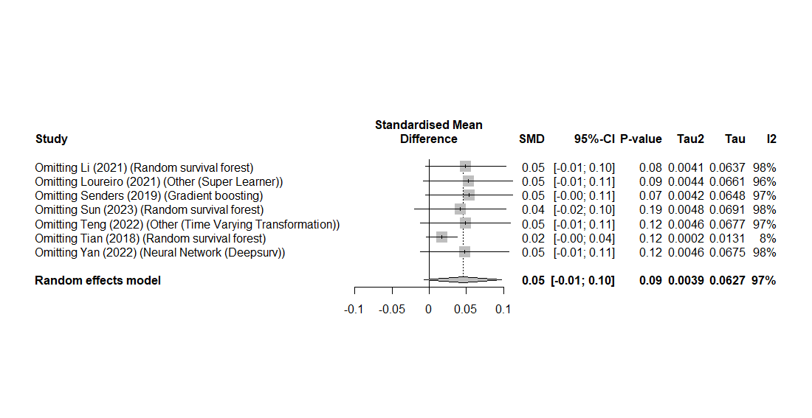
- Cumulative method of 7 unique studies
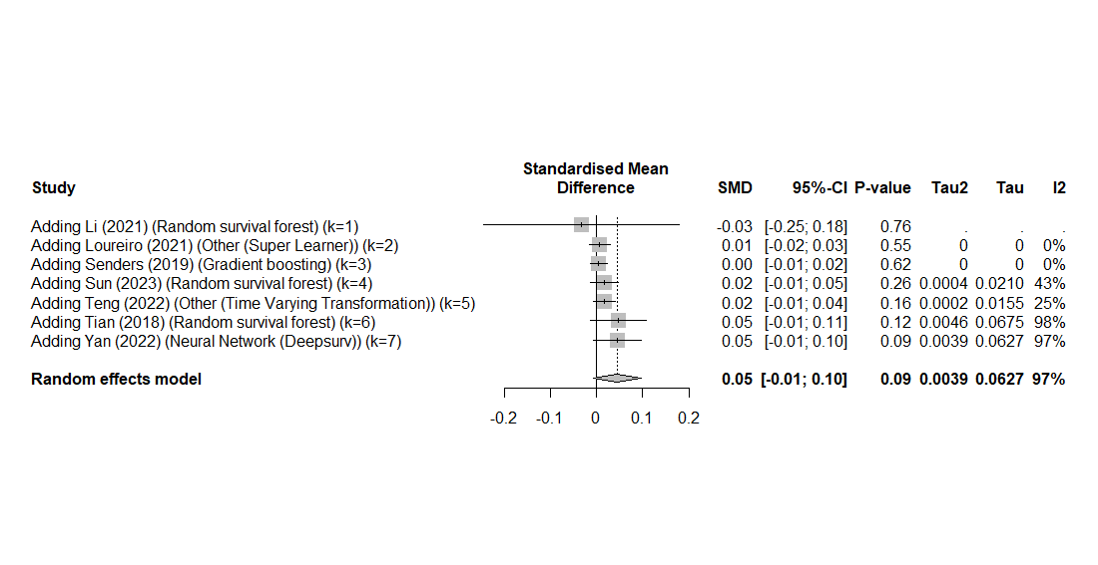
- Forest plot of all 17 machine learning models in 7 studies
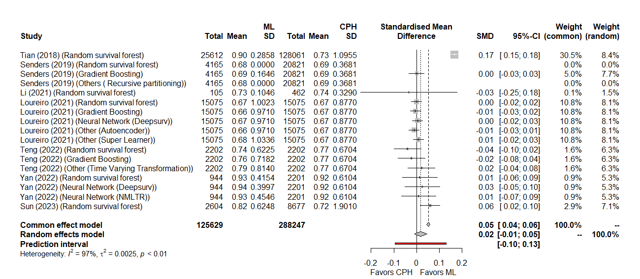
- Leave-one-out method on all 17 machine learning models in 7 studies
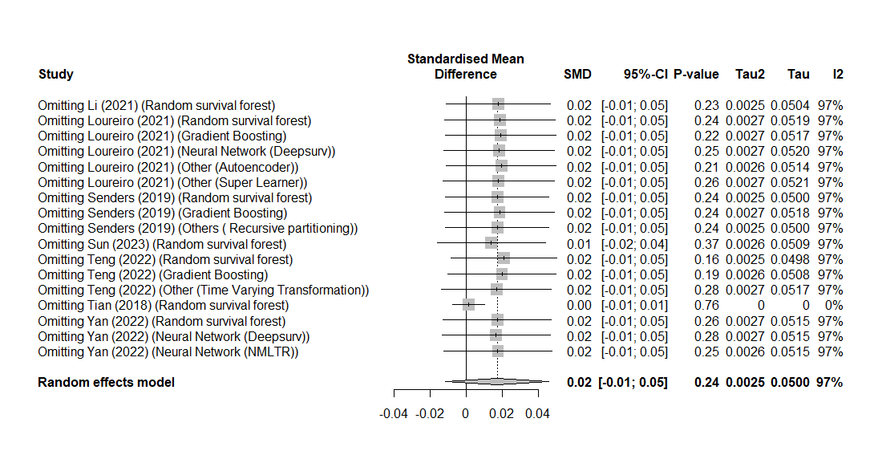
- Cumulative method on all 17 machine learning models in 7 studies
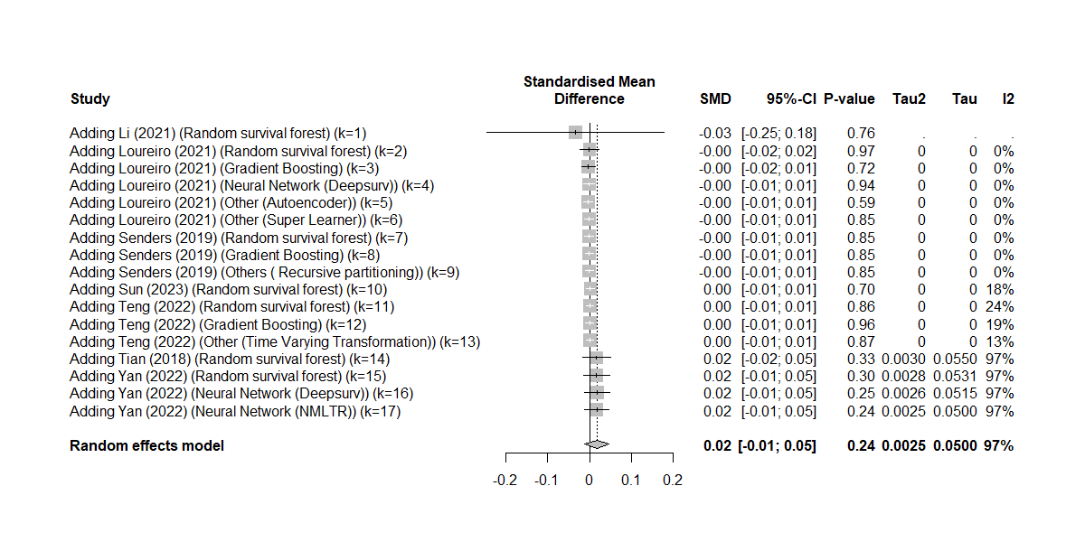

eTable 7. Quality assessment using the combined Luo checklist and TRIPOD statement
Section | Topic | Checklist Item
Title and abstract
1. Title | Nature of study | Identify the study as developing and/or validating a multivariable prediction model, the target population, and the outcome to be predicted; Identify the report as introducing a predictive model
2. Abstract | Structured summary | Provide a summary of objectives, study design, setting, participants, sample size, predictors, outcome, statistical analysis, results, and conclusions; Background; Objectives; Data sources; Performance metrics of the predictive model or models, in both point estimates and confidence intervals; Conclusion including the practical value of the developed predictive model or models
Introduction
3. Rationale | Background | Explain the medical context (including whether diagnostic or prognostic) and rationale for developing or validating the multivariable prediction model, including references to existing models; Identify the clinical goal; Review the current practice and prediction accuracy of any existing models
4. Objectives | Objectives | Specify the objectives, including whether the study describes the development or validation of the model or both; State the nature of study being predictive modeling, defining the target of prediction; Identify how the prediction problem may benefit the clinical goal
Methods
5. Describe the setting | 5a. Source of data | Determine that the study is retrospective or prospective; identify the clinical setting for the target predictive model.
 |  | Describe the source of data (e.g., randomized trial, cohort, or registry data), separately for the development and validation data sets, if applicable; identify the modeling context in terms of facility type, size, volume, and duration of available data; Identify relevant data sources and quote the ethics approval number for data access
 |  | Specify the key study dates, including start of accrual; end of accrual; and, if applicable, end of follow-up.
 | 5b. Participants | Specify key elements of the study setting (e.g., primary care, secondary care, general population) including number and location of centres.
 |  | Describe eligibility criteria for participants; State the inclusion and exclusion criteria for data.
 |  | Describe the time span of data and the sample or cohort size.
 |  | Give details of treatments received, if relevant.
6. Define the ML prediction model | 6a. Outcome | Clearly define the outcome that is predicted by the prediction model, including how and when assessed.
 |  | Define a measurement for the prediction goal (per patient or per hospitalization or per type of outcome).
 | 6b. Predictive task | Determine the form of the prediction model: (1) classification if the target variable is categorical, (2) regression if the target variable is continuous, (3) survival prediction if the target variable is the time to an event.
 |  | Explain practical costs of prediction errors (e.g., implications of underdiagnosis or overdiagnosis).
 | 6c. Predictors | Clearly define all predictors used in developing or validating the ML model, including how and when they were measured.
 |  | Define the observational units on which the response variable and predictor variables are defined.
 |  | Define the predictor variables. Extra caution is needed to prevent information leakage from the response variable to predictor variables.
7. Model Development and Validation | 7a. Data preprocessing | Describe the data preprocessing performed, including dealing with null value for a feature,  data cleaning, transformation and data standardization. For example, remove outliers with impossible or extreme responses; state any criteria used for outlier removal.
Describe how missing data were handled (e.g., complete-case analysis, single imputation, multiple imputation) with details of any imputation method; State how missing values were handled.
Describe the basic statistics of the dataset, particularly of the response variable. These include the ratio of positive to negative classes for a classification problem and the distribution of the response variable for regression problem.
 | 7b. Model training | For retrospective studies, split the data into a derivation set and a validation set. For prospective studies, define the starting time for validation data collection.
 |  | Specify type of model, all model-building procedures (including any predictor selection, hyperparameter selection if needed), and method for internal validation.
 | 7c. Model evaluation | Define the model validation strategies. Internal validation is the minimum requirement; external validation should also be performed whenever possible.
 |  | Specify the internal validation strategy. Common methods include random split, time-based split, and patient-based split.
 |  | Define the validation metrics. For regression problems, the normalized root-mean-square error should be used. For classification problems, the metrics should include sensitivity, specificity, positive predictive value, negative predictive value, area under the ROC curve, and calibration plot [19].
8.Model Selection | 8a. Reporting data imbalance | Assess whether sufficient data are available for a good fit of the model. In particular, for classification, there should be a sufficient number of observations in both positive and negative classes.
 | 8b. Model justification | Determine a set of candidate modeling techniques (e.g., logistic regression, random forest, or deep learning). If only one type of model was used, justify the decision for using that model.
 | 8c. Model evaluation | Define the performance metrics to select the best model.
 | 8d. Model selection | Specify the model selection strategy. Common methods include K-fold validation or bootstrap to estimate the lost function on a grid of candidate parameter values. For K-fold validation, proper stratification by the response variable is needed.
 |  | For model selection, include discussion on (1) balance between model accuracy and model simplicity or interpretability, and (2) the familiarity with the modeling techniques of the end user.
Results
9. Report the final model and performance | 9a. Model specification | Present the full prediction model to allow predictions for individuals (i.e. links to the final model online (coding of predictors, code and final parameters/coefficients, and with the architecture described in full in the article)); If possible, report the parameter estimates in the model and their confidence intervals. When the direct calculation of confidence intervals is not possible, report nonparametric estimates from bootstrap samples.
 |  | Comparison with other models in the literature should be based on confidence intervals.
 | 9b. Model performance | Report performance measures (with CIs) for the prediction model; Report the predictive performance of the final model in terms of the validation metrics specified in the methods section.
 | 9c. Model interpretation | Interpretation of the final model. If possible, report what variables were shown to be predictive of the response variable. State which subpopulation has the best prediction and which subpopulation is most difficult to predict.
Discussion
10. Clinical implications | Implications | Discuss the potential clinical use of the model and implications for future research; Report the clinical implications derived from the obtained predictive performance. For example, report the dollar amount that could be saved with better prediction. How many patients could benefit from a care model leveraging the model prediction? And to what extent?
11. Limitations of the model | Limitations | Discuss any limitations of the study (such as nonrepresentative sample, few events per predictor, missing data); Discuss the following potential limitations: Assumed input and output data format; Potential pitfalls in interpreting the model; Potential bias of the data used in modeling; Generalizability of the data
12. Interpretation and Unexpected results during the experiments | 12a. Interpretation | Give an overall interpretation of the results, considering objectives, limitations, and results from similar studies, and other relevant evidence.
 | 12b. Unexpected results during the experiments | Report unexpected signs of coefficients, indicating collinearity or complex interaction between predictor variables
Overall Quality [1]
Notes: The ratings of ‘yes’, ‘partly, ‘no’ or ‘unclear’ were scored to each individual domain to grade the studies. The quality for each study was defined with ‘low’, ‘moderate,’ or ‘high’ based on the combined results of individual domains. [1] We considered a study as high quality if 16 or more individual items (corresponding to total number of items for 8 domains out of 12 domains) were marked “yes” or “partly”. The study was considered as moderate quality if 12-15 items were marked “yes” or “partly” (corresponding to total number of items for 6 domains out of 12 domains); otherwise, the study was marked as low quality if only 11 or less items were marked “yes” or “partly”.

eTable 8. Quality assessment of included publications
Section | Topic | 1. Cai et al. 2022 | 2. Dong et al. 2022 | 3. Fan et al. 2022 | 4. Huang et al. 2019 | 5. Jin et al. 2023 | 6. Kim et al. 2022 | 7. Li et al. 2021 | 8. Li et al. 2022
Title and abstract
1. Title | Nature of study | Yes | Yes | Yes | Yes | Yes | Yes | Yes | Yes
2. Abstract | Structured summary | Yes | Partly (no CI) | Partly (no CI) | Partly (no CI) | Partly (no CI) | Partly (no CI) | Yes | Partly (no CI)
Introduction
3. Rationale | Background | Yes | Yes | Yes | Yes | Yes | Yes | Yes | Yes
4. Objectives | Objectives | Yes | Yes | Yes | Yes | Yes | Yes | Yes | Yes
Methods
5. Describe the setting | 5a. Source of data | Yes | Yes | Yes | Yes | Yes | Yes | Yes | Yes
 |  | Yes | Yes | Yes | Yes | Yes | Yes | Yes | Yes
 |  | Yes | Yes | Yes | Yes | Yes | Yes | Yes | Yes
 | 5b. Participants | Yes | Yes | Yes | Yes | Yes | Yes | Yes | Yes
 |  | Yes | Yes | Yes | Yes | Yes | Unclear | Yes | Yes
 |  | Yes | Yes | Yes | Yes | Yes | Yes | Yes | Yes
 |  | Yes | Unclear | Unclear | Unclear | Unclear | Unclear | Unclear | Unclear
6. Define the ML prediction model | 6a. Outcome | Yes | Yes | Yes | Yes | Yes | Yes | Yes | Yes
 |  | Yes | Yes | Yes | Yes | Yes | Yes | Yes | Yes
 | 6b. Predictive task | Yes | Yes | Yes | Yes | Yes | Yes | Yes | Yes
 |  | Yes | No | No | No | Yes | Yes | Yes | Yes
 | 6c. Predictors | Yes | Yes | Yes | Yes | Yes | No | Yes | Yes
 |  | Yes | Yes | Yes | Yes | Yes | Yes | Yes | Yes
 |  | Yes | Yes | Yes | Yes | Yes | Yes | Yes | Yes
7. Model Development and Validation | 7a. Data preprocessing | Yes | Yes | Yes | Yes | Yes | Yes | Yes | Yes
 |  | Yes | No | Yes | Yes | No | No | Yes | No
 | 7b. Model training | Yes | Yes | Yes | Yes | Yes | Yes | Yes | Yes
 |  | Yes | Yes | Yes | Yes | Yes | Yes | Yes | Yes
 | 7c. Model evaluation | Yes | Partly (no external validation) | Partly (no external validation) | Partly (no external validation) | Yes | Yes | Partly (no external validation) | Partly (no external validation)
 |  | Yes | Yes | Yes | No | Yes | Yes | Yes | Yes
 |  | Yes | Yes | Yes | Yes | Yes | Yes | Yes | Yes
8.Model Selection | 8a. Reporting data imbalance | Yes | Yes | No | Yes | Yes | Yes | No | Yes
 | 8b. Model justification | Yes | Yes | Yes | Yes | Yes | Yes | Yes | Yes
 | 8c. Model evaluation | Yes | Yes | Yes | Yes | Yes | Yes | Yes | Yes
 | 8d. Model selection | Yes | Yes | Yes | Yes | Yes | Yes | Yes | Yes
 |  | Yes | No | No | No | No | No | No | No
Results
9. Report the final model and performance | 9a. Model specification | Yes | Yes | Yes | Yes | Yes | Yes | Yes | Yes
 |  | Yes | No | No | No | No | No | No | No
 | 9b. Model performance | Yes | No | No | No | No | No | Yes | No
 | 9c. Model interpretation | Yes | Yes | Yes | Yes | Yes | Yes | Yes | Yes
Discussion
10. Clinical implications | Implications | Yes | Yes | Yes | Yes | Yes | Yes | Yes | Yes
11. Limitations of the model | Limitations | Yes | Yes | Yes | Yes | No | No | Yes | Yes
12. Interpretation and Unexpected results during the experiments | 12a. Interpretation | Yes | Yes | Yes | Yes | Yes | Yes | Yes | Yes
 | 12b. Unexpected results during the experiments | Yes | Unclear | Unclear | Unclear | Unclear | Unclear | Unclear | Unclear
Overall Quality [1] |  | High | High | High | High | High | High | High | High

Section | Topic | 9. Lin et al. 2022 | 10. Liu et al. 2022 | 11. Loureiro et al. 2021 | 12. Ouyang et el. 2022 | 13. Park et al. 2022 | 14. Senders et al. 2019 | 15. She et al. 2020 | 16.Sun et al. 2023
Title and abstract
1. Title | Nature of study | Yes | Yes | Yes | Yes | Yes | Yes | Yes | Yes
2. Abstract | Structured summary | Partly (no CI) | Partly (no CI) | Yes | Partly (no CI) | Partly (no CI) | Partly (no CI) | Partly (no CI) | Yes
Introduction
3. Rationale | Background | Yes | Yes | Yes | Yes | Yes | Yes | Yes | Yes
4. Objectives | Objectives | Yes | Yes | Yes | Yes | Yes | Yes | Yes | Yes
Methods
5. Describe the setting | 5a. Source of data | Yes | Yes | Yes | Yes | Yes | Yes | Yes | Yes
 |  | Yes | Yes | Yes | Yes | Yes | Yes | Yes | Yes
 |  | Yes | Yes | Yes | Yes | Yes | Yes | Yes | Yes
 | 5b. Participants | Yes | Yes | Yes | Yes | Yes | Yes | Yes | Yes
 |  | Yes | Yes | Yes | Yes | Yes | Yes | Yes | Yes
 |  | Yes | Yes | Yes | Yes | Yes | Yes | Yes | Yes
 |  | Unclear | Unclear | Unclear | Yes | No | Unclear | Unclear | Yes
6. Define the ML prediction model | 6a. Outcome | Yes | Yes | Yes | Yes | Yes | Yes | Yes | Yes
 |  | Yes | Yes | Yes | Yes | Yes | Yes | Yes | Yes
 | 6b. Predictive task | Yes | Yes | Yes | Yes | Yes | Yes | Yes | Yes
 |  | No | No | No | No | Yes | Yes | Yes | Yes
 | 6c. Predictors | Yes | Yes | Yes | Yes | Yes | Yes | Yes | Yes
 |  | Yes | Yes | Yes | Yes | Yes | Yes | Yes | Yes
 |  | Yes | Yes | Yes | Yes | Yes | Yes | Yes | Yes
7. Model Development and Validation | 7a. Data preprocessing | No | No | Yes | Yes | Yes | Yes | Yes | Yes
 |  | No | No | No | Yes | Yes | Yes | Yes | Yes
 | 7b. Model training | Yes | Yes | Yes | Yes | Yes | Yes | Yes | Yes
 |  | Yes | Yes | Yes | Yes | Yes | Yes | Yes | Yes
 | 7c. Model evaluation | Yes | No | Yes | Yes | Yes | Yes | Yes | Yes
 |  | Yes | No | Yes | Yes | Yes | Yes | Unclear | Yes
 |  | Yes | No | Yes | Yes | Yes | Yes | Yes | Yes
8.Model Selection | 8a. Reporting data imbalance | No | No | No | Yes | No | No | Yes | Yes
 | 8b. Model justification | Yes | Yes | Yes | Yes | Yes | Yes | Yes | Yes
 | 8c. Model evaluation | Yes | Yes | Yes | Yes | Yes | Yes | Yes | Yes
 | 8d. Model selection | Yes | No | Yes | Yes | Yes | Yes | Yes | Yes
 |  | No | No | No | No | No | No | No | Yes
Results
9. Report the final model and performance | 9a. Model specification | Unclear | Yes | Yes | Yes | Yes | Yes | Yes | Yes
 |  | No | No | Yes | Yes | Yes | Yes | Yes | Yes
 | 9b. Model performance | Yes | No | Yes | Yes | Yes | Yes | Yes | Yes
 | 9c. Model interpretation | Yes | Yes | Yes | Yes | Yes | Yes | Yes | Yes
Discussion
10. Clinical implications | Implications | Yes | Yes | Yes | Yes | Yes | Yes | Yes | Yes
11. Limitations of the model | Limitations | Yes | Yes | Yes | Yes | Yes | Yes | Yes | Yes
12. Interpretation and Unexpected results during the experiments | 12a. Interpretation | Yes | Yes | Yes | Yes | Yes | Yes | Yes | Yes
 | 12b. Unexpected results during the experiments | Unclear | No | No | No | No | No | No | Yes
Overall Quality [1] |  | High | Moderate | High | High | High | High | High | High

Section | Topic | 17.Teng et al. 2022 | 18.Tian et al. 2018 | 19.Wang et al. 2021 | 20.Yan et al. 2022 | 21.Yu et al. 2022
Title and abstract
1. Title | Nature of study | Yes | Yes | Yes | Yes | Yes
2. Abstract | Structured summary | Yes | Yes | Yes | Yes | Yes
Introduction
3. Rationale | Background | Yes | Yes | Yes | Yes | Yes
4. Objectives | Objectives | Yes | Yes | Yes | Yes | Yes
Methods
5. Describe the setting | 5a. Source of data | Yes | Yes | Yes | Yes | Yes
 |  | Yes | Yes | Yes | Yes | Yes
 |  | Yes | Yes | Yes | Yes | Yes
 | 5b. Participants | Yes | Yes | Yes | Yes | Yes
 |  | Yes | Yes | Yes | Yes | Yes
 |  | Yes | Yes | Yes | Yes | Yes
 |  | Yes | Yes | Yes | Yes | Yes
6. Define the ML prediction model | 6a. Outcome | Yes | Yes | Yes | Yes | Yes
 |  | Yes | Yes | Yes | Yes | Yes
 | 6b. Predictive task | Yes | Yes | Yes | Yes | Yes
 |  | Yes | Yes | Yes | Yes | Yes
 | 6c. Predictors | Yes | Yes | Yes | Yes | Yes
 |  | Yes | Yes | Yes | Yes | Yes
 |  | Yes | Yes | Yes | Yes | Yes
7. Model Development and Validation | 7a. Data preprocessing | Yes | Yes | Yes | Yes | Yes
 |  | Yes | Yes | Yes | Yes | Yes
 | 7b. Model training | Yes | Yes | Yes | Yes | Yes
 |  | Yes | Yes | Yes | Yes | Yes
 | 7c. Model evaluation | Yes | Yes | Yes | Yes | Yes
 |  | Yes | Yes | Yes | Yes | Yes
 |  | Yes | Yes | Yes | Yes | Yes
8.Model Selection | 8a. Reporting data imbalance | Yes | Yes | Yes | Yes | Yes
 | 8b. Model justification | Yes | Yes | Yes | Yes | Yes
 | 8c. Model evaluation | Yes | Yes | Yes | Yes | Yes
 | 8d. Model selection | Yes | Yes | Yes | Yes | Yes
 |  | Yes | Yes | Yes | Yes | Yes
Results
9. Report the final model and performance | 9a. Model specification | Yes | Yes | Yes | Yes | Yes
 |  | Yes | Yes | Yes | Yes | Yes
 | 9b. Model performance | Yes | Yes | Yes | Yes | Yes
 | 9c. Model interpretation | Yes | Yes | Yes | Yes | Yes
Discussion
10. Clinical implications | Implications | Yes | Yes | Yes | Yes | Yes
11. Limitations of the model | Limitations | Yes | No (Reason: The paper does not explicitly discuss all the potential limitations listed in the criteria. | Yes | Yes | Yes
12. Interpretation and Unexpected results during the experiments | 12a. Interpretation | Yes | Yes | Yes | Yes | Yes
 | 12b. Unexpected results during the experiments | Yes | Yes | Yes | Yes | Yes
Overall Quality [1] |  | High | High | High | High | High

