Figure S1. Participants’ transition through the disease course by sex in the Atherosclerosis Risk in Communities (ARIC) Study starting from 1987 to 2019.

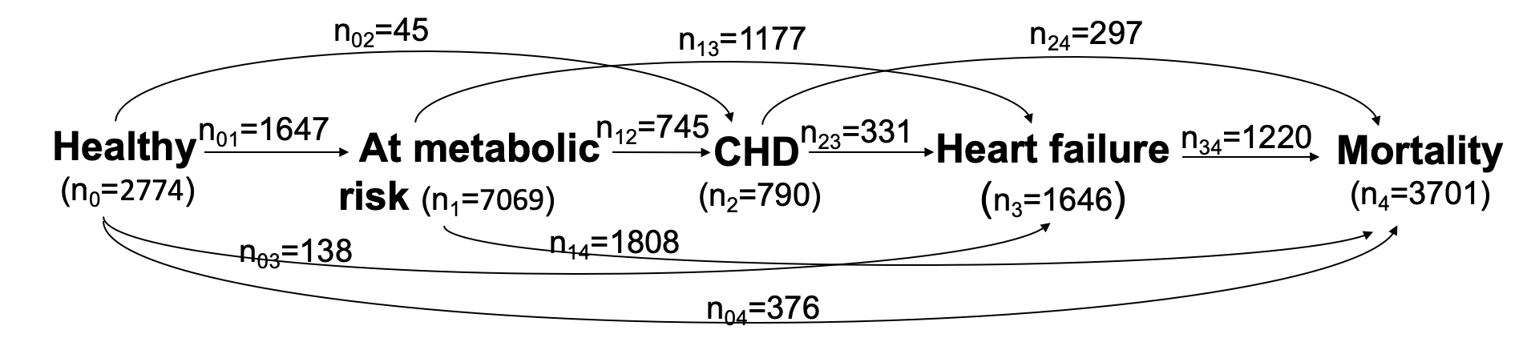
a. Women (n=8196)

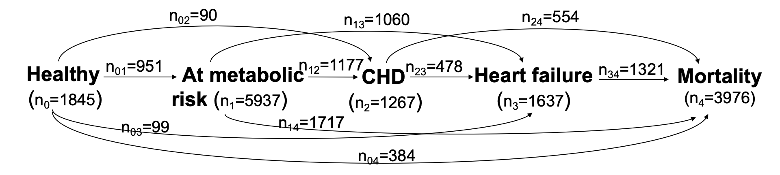
b. Men (n=6831)

Figure S2. Participants’ transition through the disease course by race in the Atherosclerosis Risk in Communities (ARIC) Study starting from 1987 to 2019.

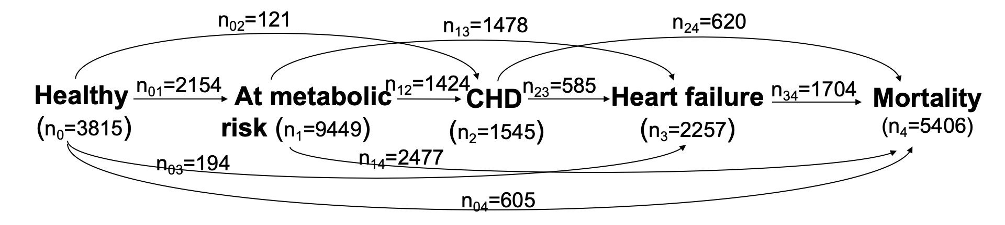
a. White (n=11,110)

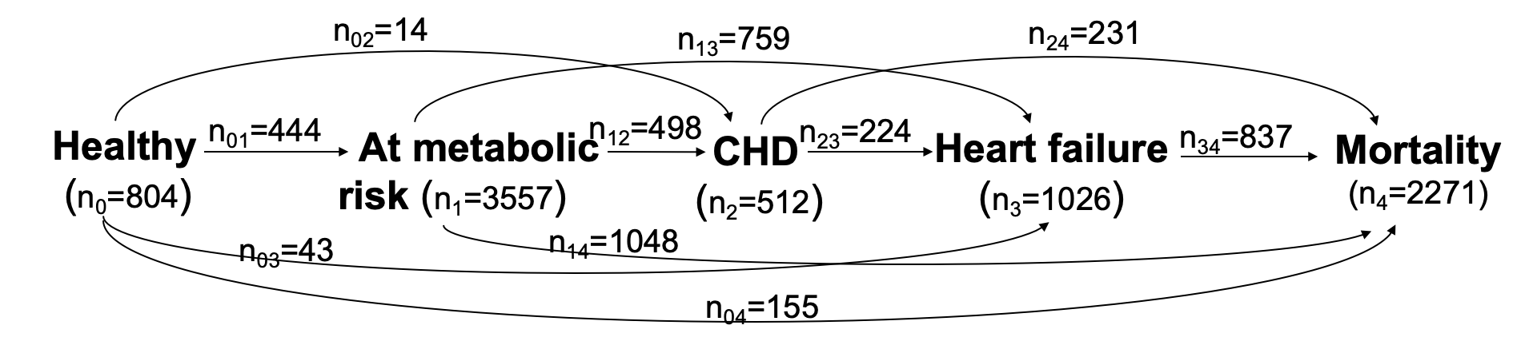
b. Black (n=3917)

Table S1. Estimated substate-specific life year (SSLY) and multimorbidity-adjusted life years (MALY) by sex in the Atherosclerosis Risk in Communities (ARIC) Study starting from 1987 to 2019.

 |  | Life Year (95% CI)
 |  | Women (n=8196) | Men (n=6831)
Substate-specific life year (SSLY) | Healthy (S₀) | 13.18 (11.01, 15.44) | 13.04 (10.73, 16.14)
Substate-specific life year (SSLY) | At metabolic risk (S₁) | 20.54 (7.63, 32.73) | 18.35 (5.47, 28.30)
Substate-specific life year (SSLY) | CHD without metabolic risk factors (S_{2|0}) | 0.18 (0.09, 0.32) | 0.51 (0.38, 0.76)
Substate-specific life year (SSLY) | CHD with metabolic risk factors (S_{2|0_1}) | 1.06 (0.42, 1.57) | 1.67 (0.45, 2.51)
Substate-specific life year (SSLY) | Heart failure with no metabolic risk factors or CHD (S_{3|0}) | 0.46 (0.32, 0.93) | 0.38 (0.25, 0.67)
Substate-specific life year (SSLY) | Heart failure only with metabolic risk factors (S_{3|0_1}) | 1.64 (0.82, 2.17) | 1.45 (0.62, 1.74)
Substate-specific life year (SSLY) | Heart failure only with CHD (S_{3|0_2}) | 0.04 (0.02, 0.08) | 0.10 (0.06, 0.14)
Substate-specific life year (SSLY) | Heart failure with metabolic risk factors and CHD (S_{3|0_1_2}) | 0.28 (0.10, 0.49) | 0.45 (0.12, 0.69)
Multimorbidity-adjusted | Multimorbidity-adjusted life years (MALY) | 27.55 (19.07, 35.36) | 23.85 (16.96, 31.88)
Multimorbidity-adjusted | Multimorbidity-adjusted life expectancy | 81.18 (79.45, 83.15) | 78.70 (76.20, 81.19)

Table S2. Estimated substate-specific life year (SSLY) and multimorbidity-adjusted life years (MALY) by race in the Atherosclerosis Risk in Communities (ARIC) Study starting from 1987 to 2019.

 |  | Life Year (95% CI)
 |  | White (n=11,110) | Black (n=3917)
Substate-specific life year (SSLY) | Healthy (S₀) | 13.33 (11.16, 15.90) | 11.75 (8.99, 13.93)
Substate-specific life year (SSLY) | At metabolic risk (S₁) | 19.85 (6.72, 31.82) | 19.24 (7.34, 27.80)
Substate-specific life year (SSLY) | CHD without metabolic risk factors (S_{2|0}) | 0.34 (0.24, 0.44) | 0.19 (0.06, 0.36)
Substate-specific life year (SSLY) | CHD with metabolic risk factors (S_{2|0_1}) | 1.31 (0.43, 1.93) | 1.23 (0.47, 1.64)
Substate-specific life year (SSLY) | Heart failure with no metabolic risk factors or CHD (S_{3|0}) | 0.40 (0.27, 0.75) | 0.41 (0.24, 0.86)
Substate-specific life year (SSLY) | Heart failure only with metabolic risk factors (S_{3|0_1}) | 1.38 (0.64, 1.76) | 1.97 (1.05, 2.70)
Substate-specific life year (SSLY) | Heart failure only with CHD (S_{3|0_2}) | 0.07 (0.04, 0.11) | 0.05 (0.02, 0.15)
Substate-specific life year (SSLY) | Heart failure with metabolic risk factors and CHD (S_{3|0_1_2}) | 0.36 (0.12, 0.56) | 0.39 (0.13, 0.64)
Multimorbidity-adjusted | Multimorbidity-adjusted life years (MALY) | 26.47 (18.59, 34.72) | 24.03 (16.54, 30.68)
Multimorbidity-adjusted | Multimorbidity-adjusted life expectancy | 80.89 (79.22, 82.73) | 77.24 (74.91, 80.89)

Table S3. Estimated disease path by sex in the Atherosclerosis Risk in Communities (ARIC) Study starting from 1987 to 2019.

Disease path | Percentage (%)
 | Women (n=8196) | Men (n=6831)
Starting from healthy state (S₀)
Healthy → non-CVD mortality (S₀ → S₄) | 20 | 29
Healthy → at metabolic risk → CVD mortality (S₀ → S₁ → S₄) | 42 | 32
Healthy → CHD → CVD mortality (S₀ → S₂ → S₄) | 1 | 4
Healthy → at metabolic risk → CHD → CVD mortality  (S₀ → S₁ → S₂ → S₄) | 6 | 8
Healthy → heart failure → CVD mortality (S₀ → S₃ → S₄) | 7 | 6
Healthy → at metabolic risk → heart failure → CVD mortality  (S₀ → S₁ → S₃ → S₄) | 20 | 15
Healthy → CHD → heart failure → CVD mortality  (S₀ → S₂ → S₃ → S₄) | 1 | 2
Healthy → at metabolic risk → CHD → heart failure → CVD mortality (S₀ → S₁ → S₂ → S₃ → S₄) | 3 | 4
Starting from at-metabolic-risk state (S₁)
At metabolic risk → CVD mortality (S₁ → S₄) | 57 | 50
At metabolic risk → CHD → CVD mortality (S₁ → S₂ → S₄) | 10 | 16
At metabolic risk → heart failure → CVD mortality (S₁ → S₃ → S₄) | 28 | 26
At metabolic risk → CHD → heart failure → CVD mortality  (S₁ → S₂ → S₃ → S₄) | 5 | 9

Table S4. Estimated disease path by race in the Atherosclerosis Risk in Communities (ARIC) Study starting from 1987 to 2019.

Disease path | Percentage (%)
 | White (n=11,110) | Black (n=3917)
Starting from healthy state (S₀)
Healthy → non-CVD mortality (S₀ → S₄) | 23 | 24
Healthy → at metabolic risk → CVD mortality (S₀ → S₁ → S₄) | 38 | 36
Healthy → CHD → CVD mortality (S₀ → S₂ → S₄) | 3 | 1
Healthy → at metabolic risk → CHD → CVD mortality  (S₀ → S₁ → S₂ → S₄) | 8 | 7
Healthy → heart failure → CVD mortality (S₀ → S₃ → S₄) | 7 | 6
Healthy → at metabolic risk → heart failure → CVD mortality  (S₀ → S₁ → S₃ → S₄) | 17 | 21
Healthy → CHD → heart failure → CVD mortality  (S₀ → S₂ → S₃ → S₄) | 1 | 1
Healthy → at metabolic risk → CHD → heart failure → CVD mortality (S₀ → S₁ → S₂ → S₃ → S₄) | 4 | 4
Starting from at-metabolic-risk state (S₁)
At metabolic risk → CVD mortality (S₁ → S₄) | 55 | 51
At metabolic risk → CHD → CVD mortality (S₁ → S₂ → S₄) | 13 | 11
At metabolic risk → heart failure → CVD mortality  (S₁ → S₃ → S₄) | 26 | 31
At metabolic risk → CHD → heart failure → CVD mortality  (S₁ → S₂ → S₃ → S₄) | 7 | 6

Explanation of the R code using simulated data to obtain the summary measures.
(https://github.com/mingding-hsph/multistate_summary_measures)

- The file ‘code_generate_data.R’ generates multi-state data.

- We simulated 2000 participants. The development of disease endpoints was simulated using exponential distributions, with the parameters shown in Table S5. We used the R package ‘crisk.sim’ to simulate competing events. The simulated data are provided in the file “multi_state_data.txt”.

- The file ‘summary_measures.r’ shows how to obtain the summary measures. We conducted the bootstrap for 1000 loops.

- The estimated SSLY, MALY, and disease path using the simulated dataset are shown in Tables S6, S7.

Table S5. Parameters simulated for the multi-state process.
 | Exponential distribution, beta0
S₀ to S₁ | -log(0.01)
S₀ to S₂ | -log(0.01)
S₀ to S₃ | -log(0.01)
S₀ to S₄ | -log(0.01)
S₁ to S₂ | -log(0.02)
S₁ to S₃ | -log(0.02)
S₁ to S₄ | -log(0.02)
S_{2|0} to S₃ | -log(0.03)
S_{2|0} to S₄ | -log(0.03)
S_{2|0_1} to S₃ | -log(0.03)
S_{2|0_1} to S₄ | -log(0.03)
S_{3|0} to S₄ | -log(0.04)
S_{3|0_1} to S₄ | -log(0.04)
S_{3|0_2} to S₄ | -log(0.04)
S_{3|0_1_2} to S₄ | -log(0.04)

Table S6. Estimated substate-specific life year (SSLY) and multimorbidity-adjusted life years (MALY) using the simulated dataset.
 | Substate-specific life years (SSLY)  (95% CI) | Multimorbidity-adjusted life years (MALY)  (95% CI)
S₀ | 11.20 (10.95, 11.42) | 13.51  (13.36, 13.66)
S₁ | 0.61 (0.51, 0.72) | 13.51  (13.36, 13.66)
S_{2|0} | 0.77 (0.66, 0.89) | 13.51  (13.36, 13.66)
S_{2|0_1} | 0.026 (0.02, 0.04) | 13.51  (13.36, 13.66)
S_{3|0} | 0.90 (0.79, 1.04) | 13.51  (13.36, 13.66)
S_{3|0_1} | 0.06 (0.04, 0.08) | 13.51  (13.36, 13.66)
S_{3|0_2} | 0.11 (0.09, 0.15) | 13.51  (13.36, 13.66)
S_{3|0_1_2} | 0.003 (0.002, 0.01) | 13.51  (13.36, 13.66)

Table S7. Estimated disease path using the simulated dataset.
Disease path | Percentage (%)
S0→S4 | 63
S0→S1→S4 | 6
S0→S2→S4 | 12
S0→S1→S2→S4 | 1
S0→S3→S4 | 15
S0→S1→S3→S4 | 1
S0→S2→S3→S4 | 2
S0→S1→S2→S3→S4 | 0.1

