Two examples of well-conducted sensitivity analyses
Example 1
Title: Tocilizumab plus dexamethasone versus dexamethasone in patients with moderate-to-severe COVID-19 pneumonia: A randomised clinical trial from
the CORIMUNO-19 study group.
SAP: As a sensitivity analysis, we will investigate different prior distributions, namely two sceptic priors centred on 0 with variance set so that a P(HR < 0.2) = P(HR > 5) = 0.05 (SD 0.975) or P(HR < 0.2) = P(HR > 5) = 0.025 (SD 0.82), and one enthusiastic informative prior centred on the targeted treatment effect (HR of 0.65) and informative with s = 0.975.
Final report: Sensitivity analyses using different prior distributions or a frequentist analysis yielded very similar results (Supplementary Table 4 and Supplementary Fig. 1)
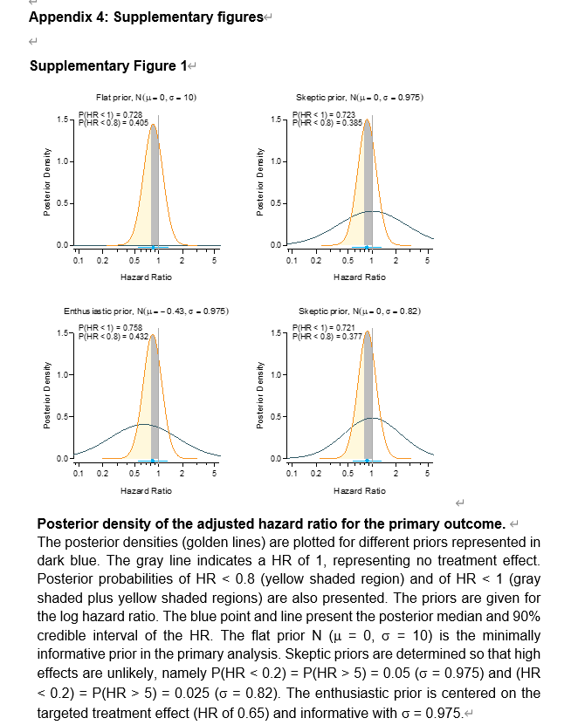
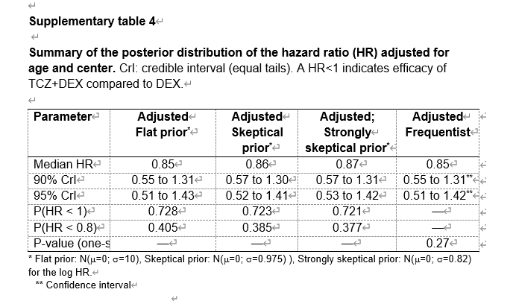
Example 2
Title: Capmatinib plus nivolumab in pretreated patients with EGFR wild-type advanced non–small cell lung cancer
SAP: The PPS will be used in the sensitivity analysis of the primary endpoint. If the PPS and the FAS are identical, then analyses described by the PPS below will not be performed.
Methods in final report: As supportive analyses, the primary analysis of PFS rate at 6 months was repeated using the per-protocol set (PPS) if the PPS was different from the FAS.
Results in final report: As the PPS was different from the FAS in the low-MET group, supportive analysis was performed for this group. With 4 patients excluded from the PPS, both the Bayesian and Kaplan-Meier analysis results based on the PPS were consistent with those based on the FAS.

