Supplemental Figures for: Inferences on the change-point in longitudinal rate of change: application to a biomarker study of Alzheimer disease

Chengjie Xiong, PhD^{1,2}, Folasade Agboola, MPH^{1,2}, Jingqin Luo, PhD^{1,3,4}
- Division of Biostatistics, Washington University School of Medicine, St. Louis, MO, USA
- Knight Alzheimer Disease Research Center, Washington University School of Medicine, St. Louis, MO, USA
- Division of Public Health Sciences, Department of Surgery, Washington University School of Medicine, St. Louis, MO, USA
- Siteman Cancer Center Biostatistics and Qualitative Research Shared Resource, Washington University School of Medicine, St. Louis, MO, USA

4.

Corresponding Author:
Jingqin Luo, Ph.D.
Division of Public Health Sciences, Department of Surgery, Washington University School of Medicine, St. Louis, MO, USA
Email: jingqinluo@wustl.edu

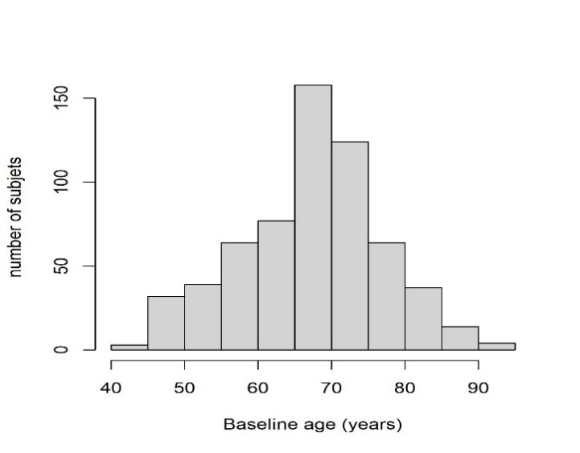
Supplemental Figure 1. Distribution of N=616 participants’ baseline age in the AD biomarker study dataset.

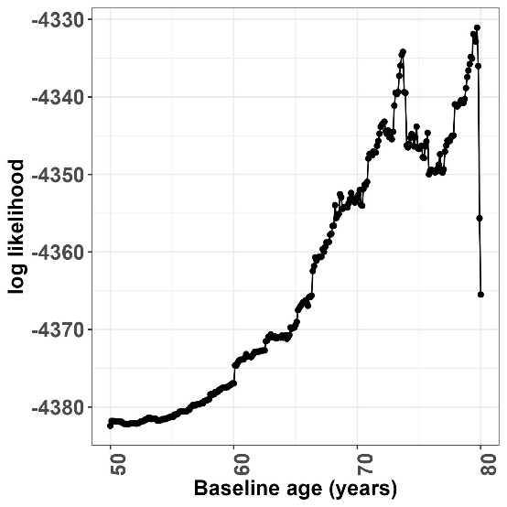
Supplemental Figure 2. Log profile likelihood along searching grid of baseline age from 50 to 80 years for the change-point

