Supplementary materials
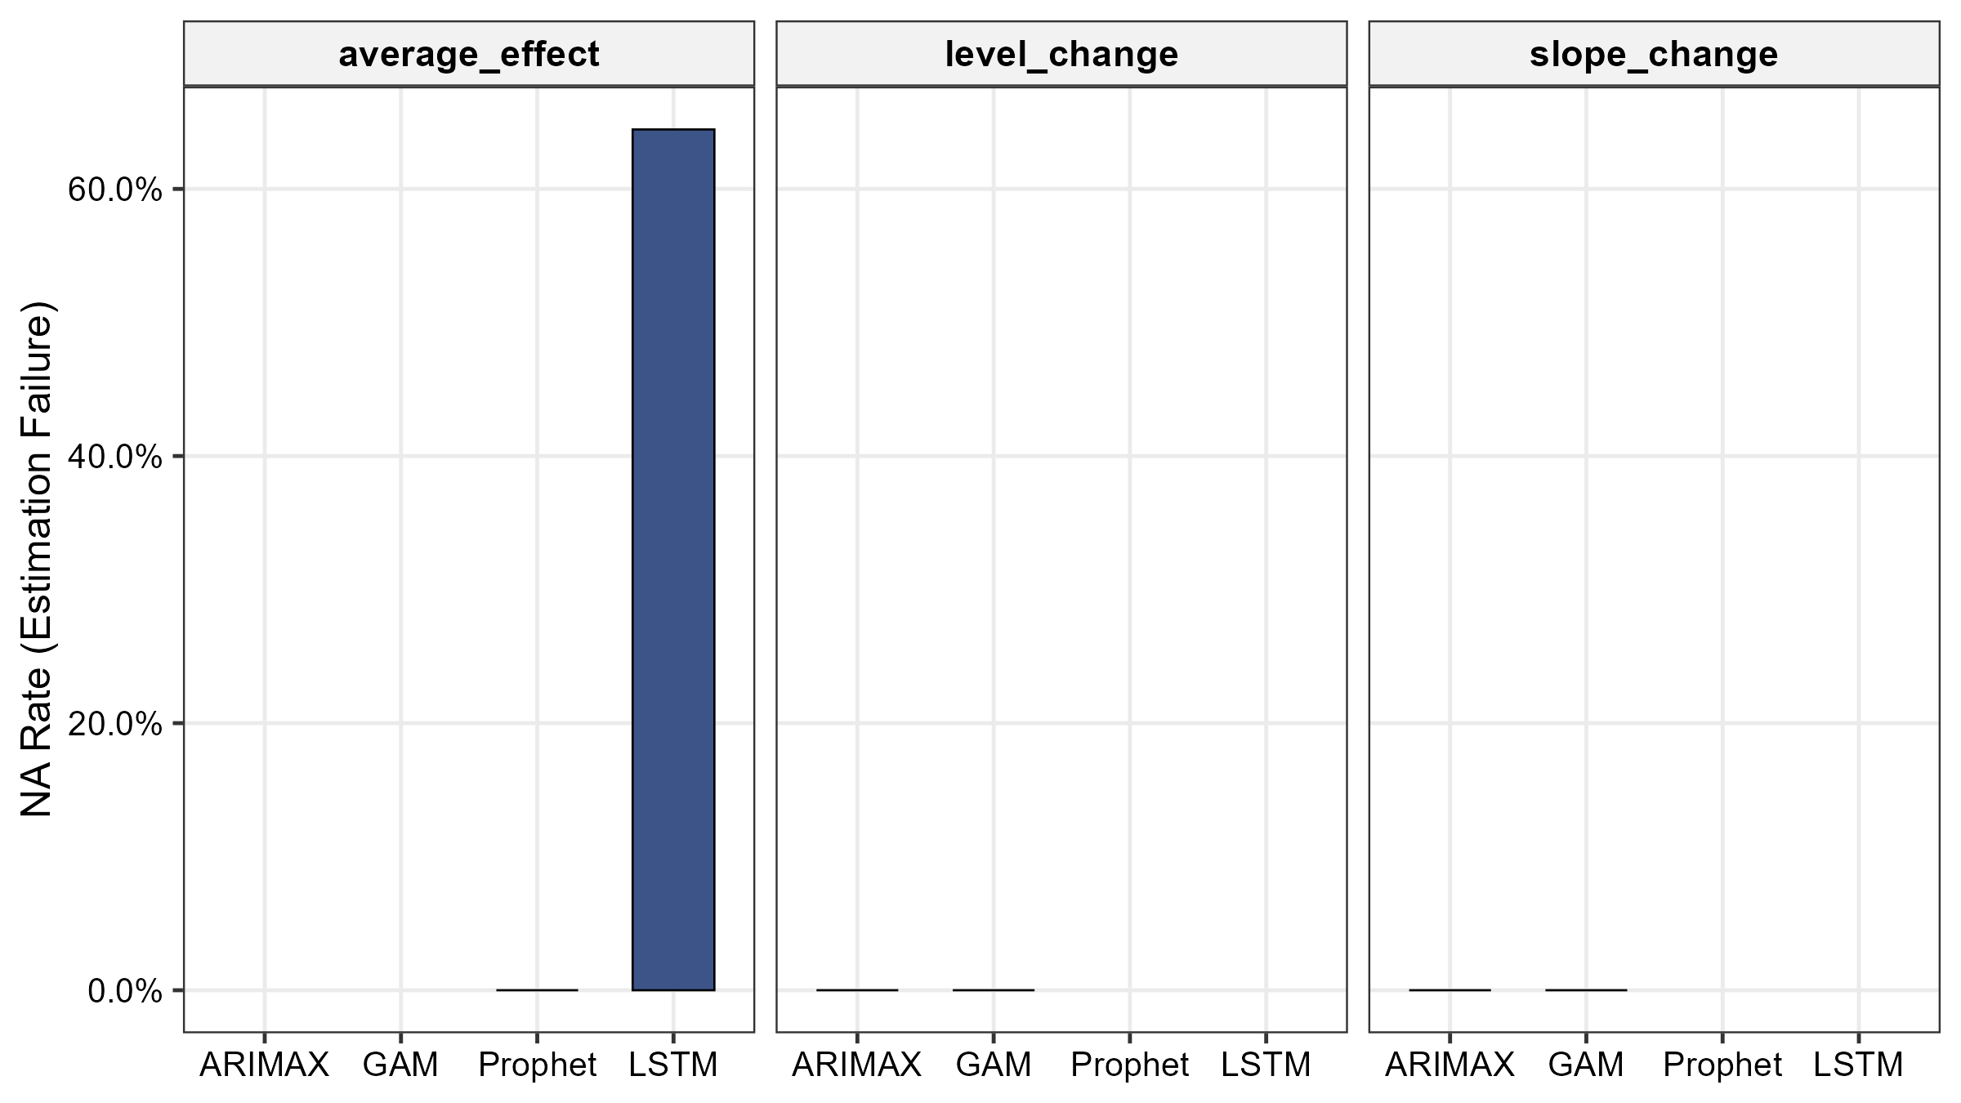Fig. S1 Model convergence failure rate. ARIMAX, GAM, and Prophet: 0% failure. LSTM: 64.5%, concentrated in short series (T = 36).
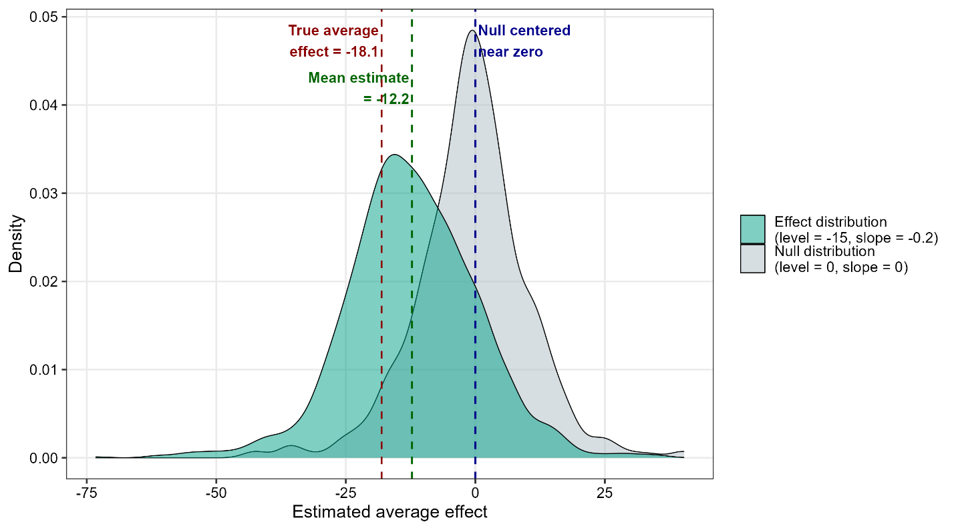Fig. S2 Empirical null versus effect distribution for Prophet (example condition: T = 60, AR = 0.3, linear trend, no seasonality, noise SD = 5, no shock, no covariates). The Null distribution (level = 0, slope = 0) is centered near zero, while the Effect distribution (level = −15, slope = −0.2) shows a mean estimate of approximately −12.2, shifted from the true average effect of −18.1. This shift illustrates Prophet's tendency toward conservative effect estimation. The substantial overlap between the two distributions illustrates Prophet's well-controlled Type I error but low statistical power.
[Supplementary_Table_S1 goes here]
Table S2. Effect of noise covariates on intervention effect estimation accuracy across four ITS models
Model | Term | RMSE |  |  |  | Mean Bias
Model | Term | n_{cov} = 0 | n_{cov} = 3 | Δ(%) |  | n_{cov} = 0 | n_{cov} = 3 | n_{cov} η2(|bias|)
ARIMAX | Level change | 7.32 | 7.53 | +2.9 |  | −0.50 | −0.50 | 0.03
GAM | Level change | 8.11 | 8.38 | +3.3 |  | −2.76 | −2.79 | 0.03
Prophet | Average effect | 15.99 | 20.80 | +30.0 |  | +1.00 | +0.69 | 1.42
LSTM | Average effect | 10.66 | 14.00 | +31.4 |  | −0.99 | +1.11 | 0.06
Note. Performance metrics are compared between scenarios with no covariates (ncov = 0) and three covariates (ncov = 3; one signal at γ = 0.5 and two noise covariates at γ = 0). Δ RMSE (%) denotes the percentage change in RMSE relative to the no-covariate baseline; the η² column reports the proportion of variance in absolute bias attributable to ncov from the factorial ANOVA. ARIMAX and GAM showed minimal degradation (Δ RMSE < 4%), whereas Prophet and LSTM showed approximately 30% RMSE inflation, indicating greater vulnerability to auxiliary regressors.
[Supplementary_Table_S3 goes here]
Supplementary Methods

Detailed specification of the LSTM model used for counterfactual prediction
1. Overview
This supplementary document provides the complete specification of the Long Short-Term Memory (LSTM) network used for counterfactual prediction in the present study, including the network architecture, training configuration, feature scaling, recursive prediction algorithm, convergence handling, and rationale for the design choices. The information is provided to ensure full transparency and reproducibility of the LSTM analysis.
The LSTM model was implemented in Python using the Keras API (with TensorFlow backend) and called from R via the reticulate package [reference 19 in the main manuscript]. The implementation followed a deliberate "default configuration" approach to reflect typical applied research conditions, as discussed in Section 6 below.
2. Software environment
The LSTM analysis was conducted in the following software environment:
R version | 4.4.2
reticulate package | 1.43.0
Python distribution | Anaconda (conda environment: qi_simulation)
Deep learning framework | TensorFlow 2.x with Keras API
Numerical computing | NumPy
Data manipulation | pandas
Feature scaling | scikit-learn (sklearn.preprocessing.MinMaxScaler)
The complete environment specification, including precise version numbers for all Python packages, is included in the public code repository accompanying this manuscript (see Availability of Data and Materials in the main manuscript).
3. Network architecture
Network type | Sequential feed-forward neural network with one recurrent layer
LSTM layer | Single layer with 50 hidden units
Output layer | Dense layer with 1 unit (linear activation)
Activation functions | Default Keras activations (tanh in LSTM, linear in Dense)
Regularization | None (no dropout, no L1/L2 penalties)
Total trainable parameters | Variable, depending on input feature dimensionality
4. Training configuration
Loss function | Mean squared error (MSE)
Optimizer | Adam (Keras default learning rate: 0.001)
Batch size | 16
Number of epochs | 100
Validation set | None
Early stopping | Not applied
Hyperparameter tuning | Not performed
Training data | Pre-intervention period only
Training was conducted independently for each simulated dataset (i.e., a fresh LSTM model was trained for each of the 256,000 simulation replications), using only pre-intervention data to avoid information leakage from the post-intervention period.
5. Reproducibility
To ensure reproducible results, random seeds were fixed prior to model training in each simulation replication:
- tf.random.set_seed(42)
- np.random.seed(42)
These seeds control the initialization of LSTM weights and the shuffling of training samples within each replication. Combined with deterministic data generation (each simulation replication uses an independent random seed in R), this ensures that the entire LSTM analysis pipeline is reproducible from the original simulation seeds.
6. Input and output specification
Input features
Input features comprised the outcome variable and all time-varying covariates included in the simulation scenario. The first feature was always the outcome (target variable); subsequent features were the covariates in the order they were generated.
- Number of features: 1 (outcome) + K (covariates), where K ∈ {0, 3} depending on simulation scenario
- Outcome variable: continuous, used as both the prediction target and an autoregressive input
- Covariates: time-varying, observed at each time point both pre- and post-intervention
Feature scaling
All features were rescaled to the [0, 1] range using sklearn's MinMaxScaler. The scaler was fit only on pre-intervention data to avoid information leakage from the post-intervention period, and the same scaler was then used to transform the post-intervention features for prediction.
Look-back window
The LSTM input sequences were constructed using a 12-month look-back window. That is, to predict the outcome at time t, the network received as input a sequence of the preceding 12 time points (each containing the outcome and all covariates). This window length was chosen as a default reflecting typical monthly QI data with annual seasonal cycles, and was not tuned across simulation scenarios.
7. Counterfactual prediction procedure
The trained LSTM was used to generate a counterfactual outcome trajectory for the post-intervention period under the assumption of no intervention. The procedure was as follows:
Step 1. Initialize the look-back window with the final 12 months of pre-intervention data (scaled features, including outcome and all covariates).
Step 2. For each post-intervention time point, generate a one-step-ahead prediction of the scaled outcome using the trained LSTM.
Step 3. Update the look-back window for the next prediction by sliding it forward by one time step. Critically, the updated window combines two sources of input:
- Covariates: actual observed values at the new time point (taken from the simulated post-intervention data)
- Outcome: predicted value from the LSTM (i.e., recursive use of the model's own output)
This recursive procedure is consistent with standard counterfactual forecasting in time series ITS analysis: the model uses what is known (covariates) and predicts what would have happened to the outcome in the absence of the intervention.
Step 4. After generating predictions for all post-intervention time points, inverse-transform the predicted outcomes back to the original outcome scale using the same MinMaxScaler. This step combines the predicted (scaled) outcomes with the (scaled) actual covariates to satisfy the multivariate inverse-transform requirement, after which only the outcome dimension is retained.
Step 5. Compute the intervention effect as the average of the pointwise differences between the actual observed outcome and the counterfactual prediction over the post-intervention period:
$$average_effect = mean(actual_outcome[post] - counterfactual_prediction[post])$$
8. Convergence handling
The LSTM analysis was designed with explicit handling of cases in which estimation could not be completed. The following conditions resulted in a missing-value (NA) return for that simulation replication:
- The pre-intervention period contained fewer than 12 time points (i.e., insufficient data to construct a single look-back window for training)
- The post-intervention period contained zero time points
- Any runtime exception was raised during data preprocessing, model training, or prediction (e.g., numerical instability, out-of-memory errors)
These NA returns are reflected in the 64.5% LSTM convergence failure rate reported in the main manuscript (Figure S1). Failures were concentrated in short-series scenarios (T = 36 months), where the available pre-intervention period (typically 18 months) left only 6 valid look-back sequences for training.
9. Rationale for the default configuration
We deliberately used the default LSTM configuration described above, rather than performing comprehensive architecture search and hyperparameter tuning. This decision was based on the following considerations:
First, the present study was framed as a comparative evaluation of analytical methods that QI researchers can apply directly without specialized methodological development. Most applied QI researchers do not have the expertise or computational resources to conduct extensive deep learning tuning, and using a tuned LSTM in our comparison would not reflect realistic applied use.
Second, the default configuration values were selected to be representative of common applied implementations:
- 50 hidden units: a moderate network size; smaller networks may underfit while larger networks risk overfitting in short ITS series
- 12-month look-back window: aligned with typical annual seasonality cycles in QI data
- 100 epochs without early stopping: a fixed training budget that avoids the need for a validation set, which would further reduce already-limited pre-intervention data
- Batch size of 16: a small batch size compatible with the limited pre-intervention sample sizes (in some scenarios, only 6–18 training sequences were available)
- Adam optimizer with default learning rate: the most commonly used optimizer in applied deep learning
Third, this design choice represents a conservative use of LSTM for ITS analysis. As discussed in the Limitations section of the main manuscript, our LSTM performance estimates may underestimate what is achievable with extensive tuning, and we identify the evaluation of tuned deep learning architectures as an important direction for future research.
We emphasize that this design choice does not undermine the validity of the comparison across the four methods. Each method (ARIMAX with auto.arima, GAM with default smoothing, Prophet with default configuration, and LSTM with default architecture) was used in its standard "applied use" form. The comparison thus reflects how these methods perform when applied as off-the-shelf tools by typical QI researchers, which is the practical context of greatest relevance to the field.
10. Code availability
The complete LSTM analyzer Python script (lstm_analyzer.py), together with all R scripts for data generation, simulation orchestration, and post-processing, is available in the public code repository accompanying this manuscript. The repository also includes the complete environment specification (requirements.txt and environment.yml) sufficient to reproduce the analysis. See Availability of Data and Materials in the main manuscript.

Table S1. Type I error rates of ARIMAX and GAM stratified by data characteristics.
Factor | Level | ARIMAX |  | GAM
Factor | Level | Level change (95% CI) | Slope change (95% CI) | Level change (95% CI) | Slope change (95% CI)
Time series length  (T, months) | 36 | 14.5% (14.2–14.8) | 24.2% (23.8–24.5) | 10.9% (10.6–11.1) | 12.9% (12.6–13.1)
Time series length  (T, months) | 60 | 13.2% (12.9–13.5) | 50.2% (49.8–50.6) | 7.4% (7.2–7.6) | 18.7% (18.4–19.0)
Trend type | Linear | 13.0% (12.8–13.3) | 13.0% (12.7–13.2) | 9.1% (8.9–9.3) | 9.5% (9.3–9.7)
Trend type | Nonlinear | 14.7% (14.4–15.0) | 61.4% (61.0–61.8) | 9.2% (8.9–9.4) | 22.1% (21.7–22.4)
Seasonality  (amplitude) | 0 | 16.6% (16.3–16.9) | 42.3% (42.0–42.7) | 11.3% (11.1–11.6) | 24.5% (24.2–24.8)
Seasonality  (amplitude) | 10 | 11.1% (10.9–11.3) | 32.0% (31.6–32.4) | 7.0% (6.8–7.1) | 7.1% (6.9–7.3)
Autocorrelation (ρ) | 0.3 | 11.7% (11.5–12.0) | 37.6% (37.2–38.0) | 7.2% (7.0–7.4) | 13.8% (13.5–14.1)
Autocorrelation (ρ) | 0.7 | 15.9% (15.7–16.2) | 36.7% (36.4–37.1) | 11.1% (10.8–11.3) | 17.8% (17.5–18.1)
Noise (SD) | 5 | 14.5% (14.3–14.8) | 41.7% (41.3–42.1) | 8.4% (8.2–8.6) | 16.8% (16.5–17.0)
Noise (SD) | 10 | 13.1% (12.9–13.4) | 32.6% (32.2–33.0) | 9.9% (9.6–10.1) | 14.8% (14.5–15.1)
External shock | None | 14.7% (14.4–15.0) | 37.5% (37.1–37.9) | 9.3% (9.1–9.6) | 15.9% (15.6–16.2)
External shock | Pulse | 13.0% (12.7–13.3) | 36.8% (36.5–37.2) | 9.0% (8.7–9.2) | 15.7% (15.4–16.0)
Number of  covariates | 0 | 13.5% (13.2–13.7) | 37.0% (36.6–37.4) | 9.2% (9.0–9.4) | 16.3% (16.0–16.6)
Number of  covariates | 3 | 14.2% (13.9–14.5) | 37.3% (37.0–37.7) | 9.1% (8.9–9.3) | 15.3% (15.0–15.6)
Note. Type I error rates are computed using a nominal significance level of α = 0.05. Cells report point estimates with Monte Carlo 95% confidence intervals based on null-scenario observations stratified by each factor level. Prophet and LSTM Type I error rates remained near the nominal level (4.8% across all conditions) and are therefore not shown.

Table S3. Monte Carlo standard errors for primary performance metrics across four ITS models
Model | Term | Power (95% CI) | Type I Error (95% CI) | Mean Bias (95% CI) | RMSE (95% CI)
ARIMAX | Level change | 72.3% (±0.25%) | 13.8% (±0.19%) | −0.50 (±0.030) | 7.85 (±0.028)
ARIMAX | Slope change | 32.0% (±0.26%) | 37.2% (±0.26%) | +0.53 (±0.003) | 0.86 (±0.002)
GAM | Level change | 70.2% (±0.25%) | 9.2% (±0.16%) | −2.77 (±0.032) | 8.69 (±0.031)
GAM | Slope change | 13.1% (±0.19%) | 15.8% (±0.20%) | +0.31 (±0.005) | 1.25 (±0.021)
Prophet | Average effect | 15.4% (±0.16%) | 4.8% (±0.17%) | +0.84 (±0.078) | 20.11 (±0.097)
LSTM | Average effect | 25.4% (±0.34%) | 4.8% (±0.28%) | +1.99 (±0.096) | 14.81 (±0.189)

Note. Values in parentheses are 95% Monte Carlo confidence interval half-widths (1.96 × MC SE). Mean Bias and RMSE were computed by pooling across all valid replications, matching main-text Table 2. Power and Type I Error were computed on the effect-present and null subsets, respectively. For LSTM, n = 91,000 valid datasets contributed to Bias and RMSE; n = 85,000 (63,000 effect-present + 22,000 null) were retained for empirical p-value analysis after excluding 6,000 effect-present datasets at the data-condition level due to insufficient valid null replicates (≤10).

