Supplementary Materials
Bayesian and frequentist meta-analysis of GCB-classification heterogeneity in TP53-reporting DLBCL cohorts at small k: an applied case study with reporting guidance
BMC Medical Research Methodology — revision 2 (manuscript version v6)
This file accompanies the main manuscript and contains the supplementary figures (S-Figures 1–5), the supplementary tables (S-Tables 1–4), the Stan model code, and the reproducibility record. The numbering of S-Tables 1–3 is unchanged from the previous version; S-Table 4 is new.

Section S0. Corrections to the Supplement at revision 2
Reviewer 1 raised two concerns about the v5 Supplement. Both were correct, and both are corrected here. This section documents them explicitly so that the changes can be checked against the previous version.
(a) The Stan code printed in the v5 Supplement was not the model used. Section S3 of the v5 Supplement reproduced two files, PD-L1.stan and PD-L1-uniform.stan, and described the first as the canonical hierarchical model with a Half-Cauchy(0, 0.5) prior on the between-study scale. That description was incorrect. Those files implement a beta-binomial detection-rate model parameterised by a prevalence π, a detection mean, and a precision φ; they contain no between-study scale τ, no binomial_logit likelihood, and no Half-Cauchy prior. They are residual files from an unrelated project and were never used to produce any result reported in this manuscript. The model actually fitted was defined inline within revision_analysis.R and had never been exported as a standalone .stan file, which is how the wrong files came to be included. The four correct model files are printed in Section S3 below. They were extracted byte-for-byte from the archived stanfit objects using rstan::get_stancode(), so they are by construction the exact code that generated the posteriors reported in S-Table 1. No posterior result has changed: every value in S-Table 1 was re-derived from the archived fits and matches the previously submitted table exactly.
(b) The supplementary figures were generated from the superseded k = 4 dataset. S-Figures 1–4 of the v5 Supplement were produced by TraditionalMeta_Revised.R, which hard-codes the four-cohort dataset used before revision 1 (Bouroumeau, Farinha, Henrique, Moreno). Farinha was excluded at revision 1, as recorded in S-Table 3, and Hu (2019) and Jing (2025) were added. Those figures therefore described a dataset the manuscript no longer analyses. All supplementary figures have been regenerated from the k = 5 data by supplementary_analysis_k5.R.
Three further inconsistencies were identified during that rebuild and are corrected. First, the Methods describe a non-parametric bootstrap in which cohorts are resampled with replacement, whereas the v5 script implemented a parametric bootstrap in which counts were redrawn from Binomial(nᵢ, p̂ᵢ); the bootstrap is now non-parametric, as described. Second, the statement that 64% of resamples returned an estimable I² could not be reproduced from any script in the repository, and the criterion for estimability was undefined; the criterion is now stated explicitly (a strictly positive REML estimate of the between-study variance) and the value, 66.6% with a Monte Carlo standard error of 0.47 percentage points at B = 10,000, is reproducible from the shipped code. Third, the v5 caption of S-Figure 3 asserted that the assay threshold was a key driver of heterogeneity, a claim withdrawn from the main text at revision 1; the caption is now descriptive only. Trim-and-fill is no longer computed anywhere, consistent with the Methods.
Two consequential corrections in the main text follow from this audit: the heterogeneity test is reported as Q(4) = 10.18, p = 0.037 (the exact value is 0.037462; v5 printed 0.038), and the posterior predictive p-values, which are unchanged, are now correctly described as P(y_rep ≥ y_obs) rather than as the proportion of replicates in which the simulated count exceeded the observed count.

Section S1. Supplementary figures

S-Figure 1. Bootstrap distribution of I² (k = 5 cohorts, B = 10,000 resamples).
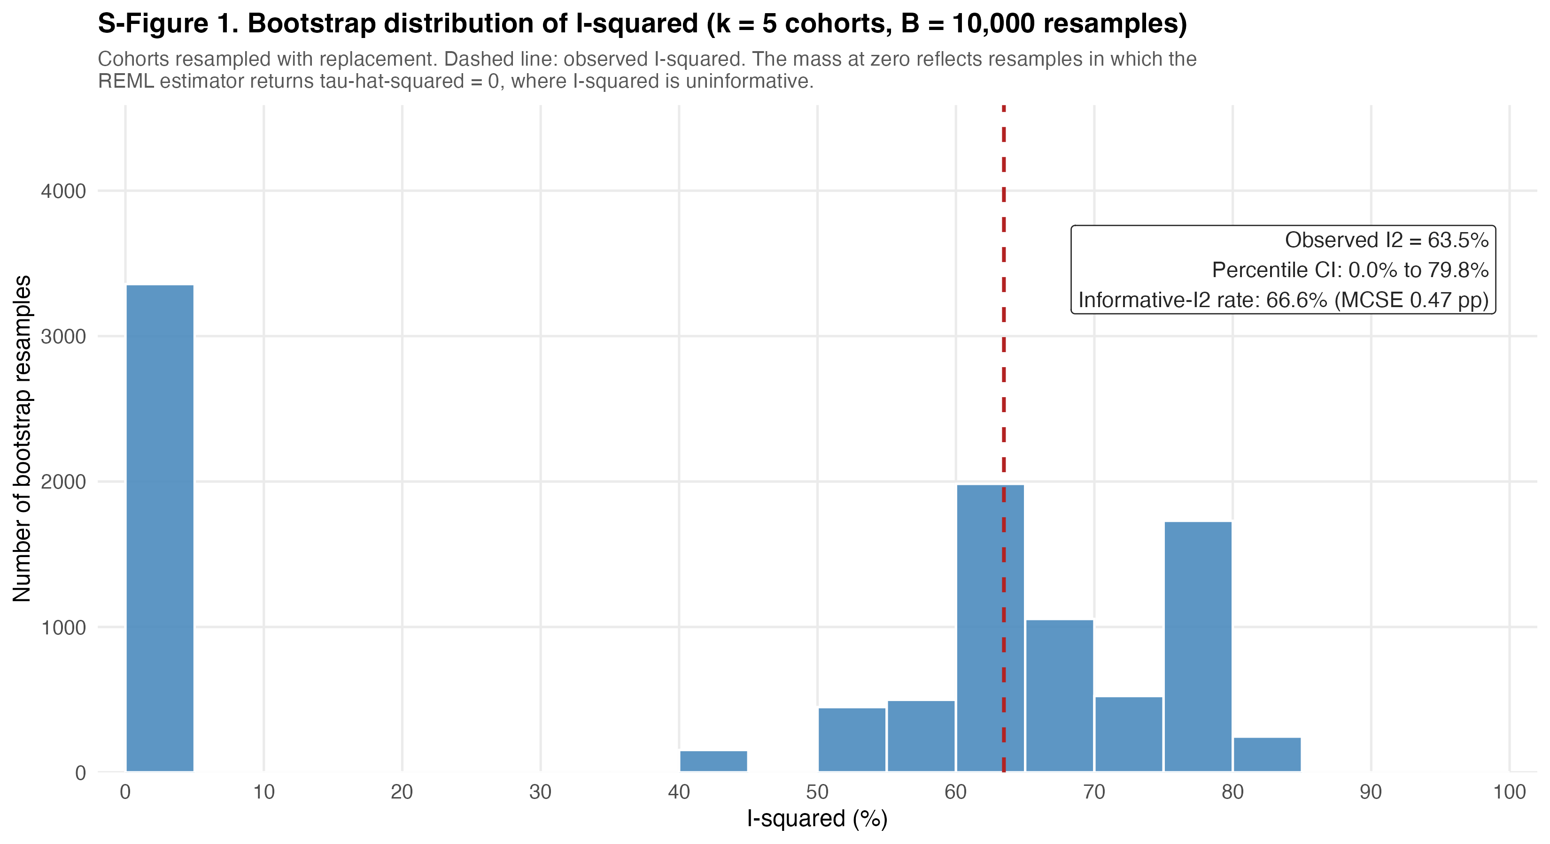
Cohorts were resampled with replacement (non-parametric bootstrap; seed 20260902). The dashed line marks the observed I² = 63.5%. The mass at zero reflects resamples in which the REML estimator returns τ̂² = 0, where I² is exactly zero and uninformative; the proportion of resamples in which I² was informative (τ̂² > 0) was 66.6% (Monte Carlo SE 0.47 percentage points). The percentile interval for I² across resamples spans 0.0%–79.8%.

S-Figure 2. Bootstrap distribution of the pooled GCB proportion (k = 5, B = 10,000).
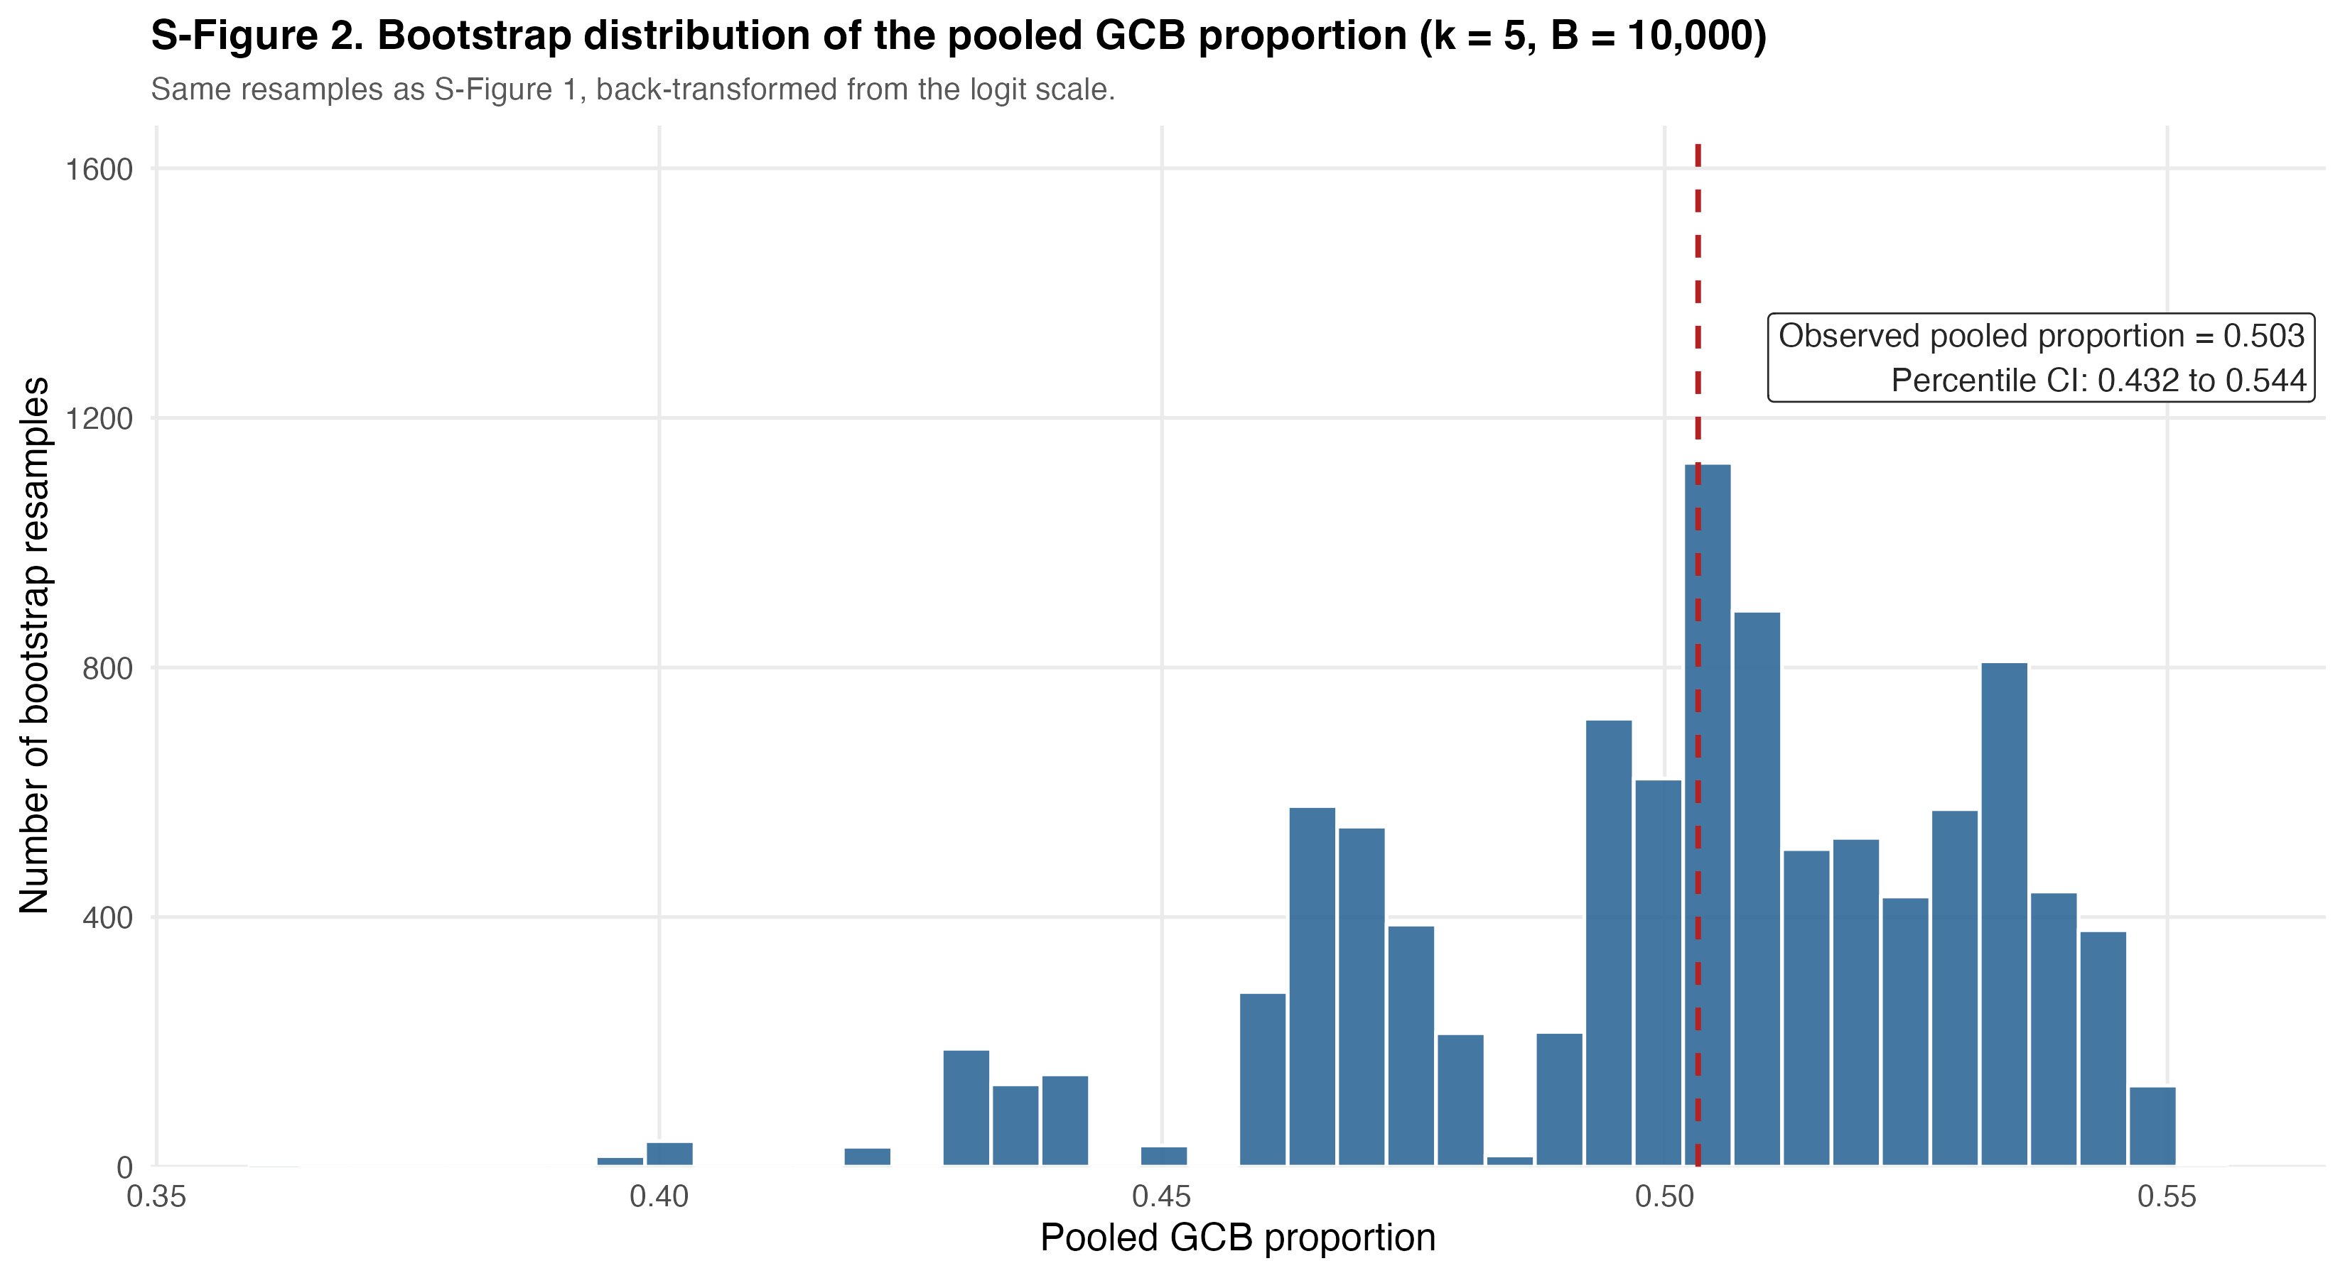
The same resamples as S-Figure 1, back-transformed from the logit scale. The dashed line marks the observed pooled proportion of 0.503; the percentile interval spans 0.432–0.544.

S-Figure 3. Leave-one-out sensitivity of I² by cohort and TP53 assay (k = 5).
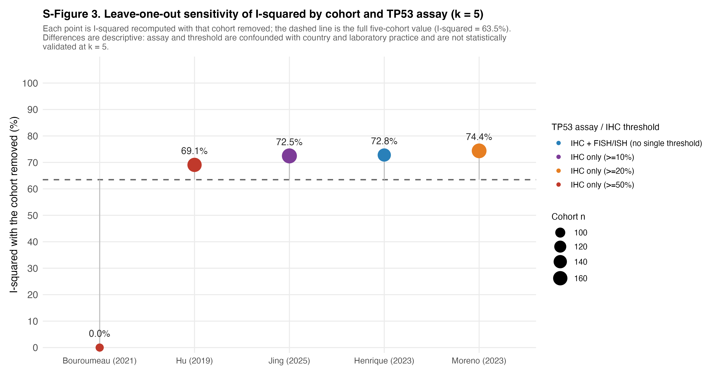
Each point is I² recomputed with that cohort removed; the dashed line is the full five-cohort value of 63.5%. Removing Bouroumeau reduces I² to 0.0%; removing any other cohort leaves I² between 69.1% and 74.4%. These differences are descriptive. Assay and IHC threshold are confounded with country and laboratory practice, and no moderator model is estimable at k = 5.

S-Figure 4. Observed GCB proportion by nominal TP53 IHC positivity threshold (k = 5).
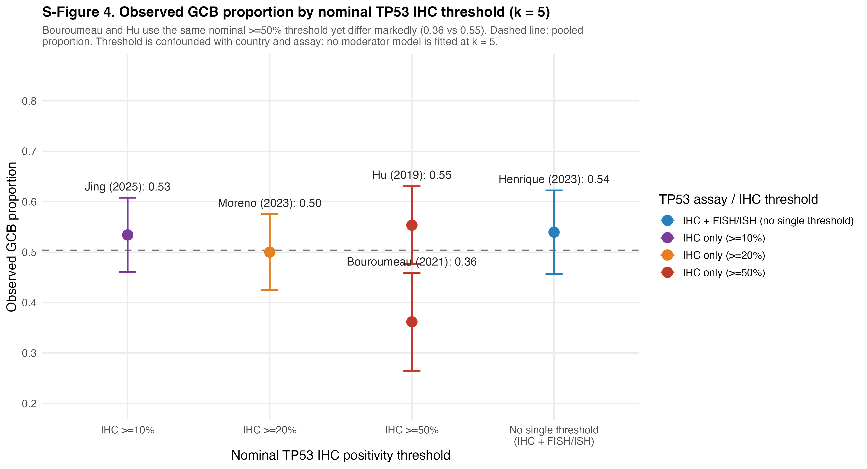
Error bars are 95% Wald intervals on the observed proportion; the dashed line is the pooled proportion. Bouroumeau and Hu apply the same nominal ≥50% threshold yet differ markedly (0.36 versus 0.55), which is the basis for the statement in the Discussion that the threshold is not statistically validated as a moderator within this dataset.

S-Figure 5. Odds-ratio meta-analysis of the association between TP53 positivity and GCB classification (k = 3).
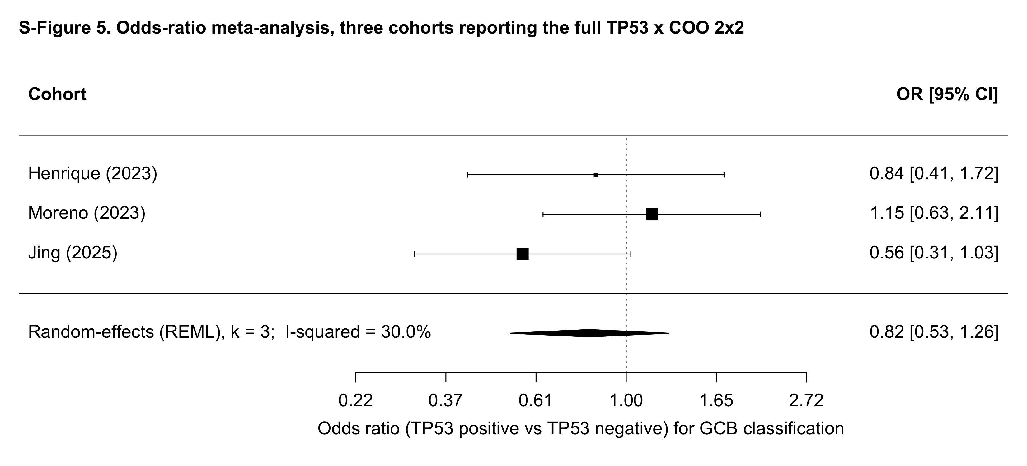
Restricted to the three cohorts that publish the full TP53 × COO 2×2 cross-tabulation (Henrique, Moreno, Jing). Random-effects REML pooled OR = 0.82 (95% CI 0.53–1.26); Q(2) = 2.73, p = 0.255; I² = 30.0%; τ² = 0.045.

Section S2. Supplementary tables

S-Table 1. Full posterior summaries under each prior on τ.
Posterior mean, standard deviation, 2.5 / 50 / 97.5 percentiles, effective sample size (n_eff) and rank-normalized R̂ for μ, τ, the pooled probability p̄ (p_overall) and the five cohort-specific pᵢ, under each of the four priors on τ. Values were re-derived from the archived stanfit objects for revision 2 and are identical to those submitted with v5.
Prior_tau | Parameter | Mean | SD | Q2.5 | Q50 | Q97.5 | n_eff | Rhat
HalfCauchy_05 | mu | 0.009 | 0.166 | -0.346 | 0.013 | 0.339 | 1,854 | 1.001
HalfCauchy_05 | tau | 0.272 | 0.195 | 0.023 | 0.236 | 0.737 | 1,396 | 1.002
HalfCauchy_05 | p_overall | 0.502 | 0.041 | 0.414 | 0.503 | 0.584 | 1,868 | 1.001
HalfCauchy_05 | p[1] | 0.430 | 0.055 | 0.317 | 0.432 | 0.525 | 2,805 | 1.001
HalfCauchy_05 | p[2] | 0.535 | 0.035 | 0.472 | 0.534 | 0.607 | 6,023 | 1.000
HalfCauchy_05 | p[3] | 0.525 | 0.035 | 0.458 | 0.523 | 0.599 | 7,141 | 1.000
HalfCauchy_05 | p[4] | 0.502 | 0.032 | 0.437 | 0.503 | 0.565 | 8,417 | 1.001
HalfCauchy_05 | p[5] | 0.524 | 0.033 | 0.463 | 0.522 | 0.592 | 7,819 | 1.000
HalfCauchy_10 | mu | 0.005 | 0.180 | -0.379 | 0.012 | 0.359 | 1,933 | 1.002
HalfCauchy_10 | tau | 0.322 | 0.231 | 0.024 | 0.278 | 0.908 | 1,264 | 1.003
HalfCauchy_10 | p_overall | 0.501 | 0.044 | 0.406 | 0.503 | 0.589 | 1,938 | 1.002
HalfCauchy_10 | p[1] | 0.422 | 0.056 | 0.314 | 0.422 | 0.524 | 2,174 | 1.001
HalfCauchy_10 | p[2] | 0.538 | 0.036 | 0.471 | 0.536 | 0.611 | 5,888 | 1.000
HalfCauchy_10 | p[3] | 0.527 | 0.036 | 0.460 | 0.526 | 0.599 | 6,892 | 1.000
HalfCauchy_10 | p[4] | 0.502 | 0.033 | 0.436 | 0.502 | 0.565 | 9,361 | 1.000
HalfCauchy_10 | p[5] | 0.525 | 0.034 | 0.461 | 0.524 | 0.594 | 6,955 | 1.000
HalfNormal_1 | mu | 0.003 | 0.189 | -0.400 | 0.016 | 0.358 | 1,122 | 1.000
HalfNormal_1 | tau | 0.317 | 0.226 | 0.021 | 0.274 | 0.913 | 1,214 | 1.002
HalfNormal_1 | p_overall | 0.501 | 0.046 | 0.401 | 0.504 | 0.589 | 1,145 | 1.000
HalfNormal_1 | p[1] | 0.422 | 0.057 | 0.312 | 0.422 | 0.525 | 2,145 | 1.000
HalfNormal_1 | p[2] | 0.537 | 0.036 | 0.472 | 0.534 | 0.612 | 5,918 | 1.000
HalfNormal_1 | p[3] | 0.527 | 0.036 | 0.459 | 0.525 | 0.602 | 6,898 | 1.000
HalfNormal_1 | p[4] | 0.502 | 0.033 | 0.433 | 0.502 | 0.567 | 8,646 | 1.000
HalfNormal_1 | p[5] | 0.524 | 0.033 | 0.461 | 0.523 | 0.591 | 7,610 | 1.000
Exponential_1 | mu | 0.011 | 0.169 | -0.355 | 0.017 | 0.331 | 1,883 | 1.004
Exponential_1 | tau | 0.290 | 0.212 | 0.018 | 0.250 | 0.802 | 1,376 | 1.001
Exponential_1 | p_overall | 0.503 | 0.042 | 0.412 | 0.504 | 0.582 | 1,888 | 1.004
Exponential_1 | p[1] | 0.426 | 0.057 | 0.315 | 0.428 | 0.527 | 2,751 | 1.000
Exponential_1 | p[2] | 0.536 | 0.036 | 0.469 | 0.535 | 0.608 | 6,277 | 1.000
Exponential_1 | p[3] | 0.526 | 0.036 | 0.458 | 0.525 | 0.601 | 7,448 | 1.000
Exponential_1 | p[4] | 0.502 | 0.033 | 0.435 | 0.503 | 0.567 | 8,998 | 1.000
Exponential_1 | p[5] | 0.524 | 0.033 | 0.463 | 0.523 | 0.592 | 6,846 | 1.001

S-Table 2. Risk of bias: JBI Prevalence Studies (k = 5) and QUIPS (k = 3).
Each NOS item from the main-manuscript risk-of-bias table is mapped to the corresponding item on the JBI Critical Appraisal Checklist for Prevalence Studies (J1–J9) for the k = 5 prevalence analysis, and to the six QUIPS domains (D1–D6) for the k = 3 odds-ratio sub-analysis. Cohorts that lost the NOS follow-up star are scored Unclear (U) on JBI item 9 (response rate / non-response handling); all five cohorts meet items 1–8 by construction. JBI items: J1 sample frame; J2 sampling; J3 sample size; J4 subject and setting description; J5 coverage; J6 valid identification of the condition; J7 standard measurement; J8 appropriate statistical analysis; J9 response rate.
Study | J1 | J2 | J3 | J4 | J5 | J6 | J7 | J8 | J9 | Yes-count | Overall
Bouroumeau (2021) | Y | Y | Y | Y | Y | Y | Y | Y | U | 8 | Low risk
Hu (2019) | Y | Y | Y | Y | Y | Y | Y | Y | Y | 9 | Low risk
Henrique (2023) | Y | Y | Y | Y | Y | Y | Y | Y | U | 8 | Low risk
Moreno (2023) | Y | Y | Y | Y | Y | Y | Y | Y | Y | 9 | Low risk
Jing (2025) | Y | Y | Y | Y | Y | Y | Y | Y | Y | 9 | Low risk

QUIPS domains: D1 study participation; D2 study attrition; D3 prognostic-factor measurement (TP53 IHC / sequencing); D4 outcome measurement (COO via the Hans algorithm); D5 study confounding; D6 statistical analysis and reporting.
Study | D1 Participation | D2 Attrition | D3 Prognostic factor (TP53) | D4 Outcome (COO) | D5 Confounding | D6 Stats/Reporting | Overall
Henrique (2023) | Low | Moderate | Low | Low | Moderate | Low | Low–Moderate
Moreno (2023) | Low | Low | Low | Low | Moderate | Low | Low
Jing (2025) | Low | Low | Low | Low | Moderate | Low | Low

S-Table 3. PRISMA-2020 excluded studies with reasons.
Records considered at title/abstract or full-text stage of the PRISMA-2020 screening flow that were excluded, with the documented reason.
Excluded study | Year | Stage of exclusion | Reason for exclusion
Xu-Monette et al. | 2,012 | Full-text | Out-of-window (pre-2018 cutoff).
Landsburg et al. | 2,023 | Full-text | Cohort lacked GCB / non-GCB classification (DLBCL not stratified by cell-of-origin).
Sang et al. | 2,021 | Title/abstract | ASH conference abstract; full TP53 × COO joint table not reported in any associated publication.
Li et al. | 2,023 | Full-text | TP53 status not reported (cohort characterized by MYC/BCL2 only).
Qin et al. | 2,022 | Full-text | No GCB / non-GCB subgroup tabulation; pooled DLBCL only.
Song et al. | 2,021 | Full-text | TP53 ↔ COO joint table not reported; only marginal frequencies shown.
Farinha et al. | 2,019 | Full-text | ASH conference abstract; full joint TP53 × COO table not available in any peer-reviewed publication (excluded from the present revision; previously included in v1).

S-Table 4. MCMC and cross-validation diagnostics.
Convergence diagnostics for each prior on τ (upper panel), and Pareto-k values from leave-one-out cross-validation together with the posterior predictive p-values under the primary Half-Cauchy(0, 0.5) prior (lower panel). Posterior predictive p-values are defined as P(y_rep ≥ y_obs). This table is new at revision 2; it reports diagnostics that were previously described only in the main text.
Prior on τ | max R̂ | min n_eff | Divergent transitions | Treedepth saturations
HalfCauchy_05 | 1.002 | 1,396 | 0 | 0
HalfCauchy_10 | 1.003 | 1,264 | 0 | 0
HalfNormal_1 | 1.002 | 1,122 | 0 | 0
Exponential_1 | 1.004 | 1,376 | 0 | 0

Cohort | Pareto-k | Posterior predictive p-value
Bouroumeau (2021) | 0.579 | 0.831
Hu (2019) | 0.770 | 0.389
Henrique (2023) | 0.850 | 0.421
Moreno (2023) | 0.790 | 0.548
Jing (2025) | 0.641 | 0.439
Three of the five Pareto-k values exceed 0.7, which is expected at k = 5; LOO is therefore reported as a model sanity check and not as a basis for model selection. elpd_loo = −19.7 (SE 2.0), p_loo = 4.1, looic = 39.3.

Section S3. Stan model code
The four files below are the complete model code for the four prior specifications on τ reported in the main text. They were extracted byte-for-byte from the archived stanfit objects with rstan::get_stancode(); the master reproduction script run_all_v6.R re-verifies this correspondence on every execution and halts if it fails. The four variants differ only in the prior line for τ; the data block, the non-centered parameterization, the likelihood and the generated quantities are identical across all four. The half-Cauchy and half-normal priors are obtained through the parameter declaration real<lower=0> tau, which truncates the symmetric density at zero.
Sampler settings for all fits: four chains, 4,000 iterations each including 2,000 warmup, adapt_delta = 0.995, max_treedepth = 15, seed = 123.

Correspondence between the manuscript specification and the code
Manuscript | Stan code
yᵢ ~ Binomial(nᵢ, pᵢ) | y[i] ~ binomial_logit(n[i], theta[i]);
logit(pᵢ) = θᵢ | p[i] = inv_logit(theta[i]);
θᵢ = μ + τ·zᵢ, zᵢ ~ N(0, 1) | vector[N] theta = mu + tau * z; / z ~ normal(0, 1);
μ ~ N(0, 1.5) | mu ~ normal(0, 1.5);
τ ~ Half-Cauchy(0, 0.5) [primary] | tau ~ cauchy(0, 0.5);
τ ~ Half-Cauchy(0, 1.0) | tau ~ cauchy(0, 1.0);
τ ~ Half-Normal(0, 1) | tau ~ normal(0, 1);
τ ~ Exponential(1) | tau ~ exponential(1);
p̄ = inv_logit(μ) | real<lower=0,upper=1> p_overall = inv_logit(mu);
posterior predictive replicates | y_rep[i] = binomial_rng(n[i], p[i]);
LOO log-likelihood | log_lik[i] = binomial_logit_lpmf(y[i] | n[i], theta[i]);

S3.1 gcb_binomial_logit_normal_halfcauchy0p5.stan
Primary specification: τ ~ Half-Cauchy(0, 0.5)
data {
int<lower=1> N;
int<lower=0> y[N];
int<lower=1> n[N];
}
parameters {
real mu;
real<lower=0> tau;
vector[N] z;
}
transformed parameters {
vector[N] theta = mu + tau * z; // non-centered
}
model {
// Priors
mu ~ normal(0, 1.5); // weakly informative on logit scale
tau ~ cauchy(0, 0.5); // <-- tau prior swapped per sensitivity
z ~ normal(0, 1);
// Likelihood
for (i in 1:N)
y[i] ~ binomial_logit(n[i], theta[i]);
}
generated quantities {
real<lower=0,upper=1> p_overall = inv_logit(mu);
vector<lower=0,upper=1>[N] p;
int<lower=0> y_rep[N];
vector[N] log_lik;
for (i in 1:N) {
p[i] = inv_logit(theta[i]);
y_rep[i] = binomial_rng(n[i], p[i]);
log_lik[i] = binomial_logit_lpmf(y[i] | n[i], theta[i]);
}
}

S3.2 gcb_binomial_logit_normal_halfcauchy1p0.stan
Sensitivity: τ ~ Half-Cauchy(0, 1.0)
data {
int<lower=1> N;
int<lower=0> y[N];
int<lower=1> n[N];
}
parameters {
real mu;
real<lower=0> tau;
vector[N] z;
}
transformed parameters {
vector[N] theta = mu + tau * z; // non-centered
}
model {
// Priors
mu ~ normal(0, 1.5); // weakly informative on logit scale
tau ~ cauchy(0, 1.0); // <-- tau prior swapped per sensitivity
z ~ normal(0, 1);
// Likelihood
for (i in 1:N)
y[i] ~ binomial_logit(n[i], theta[i]);
}
generated quantities {
real<lower=0,upper=1> p_overall = inv_logit(mu);
vector<lower=0,upper=1>[N] p;
int<lower=0> y_rep[N];
vector[N] log_lik;
for (i in 1:N) {
p[i] = inv_logit(theta[i]);
y_rep[i] = binomial_rng(n[i], p[i]);
log_lik[i] = binomial_logit_lpmf(y[i] | n[i], theta[i]);
}
}

S3.3 gcb_binomial_logit_normal_halfnormal1.stan
Sensitivity: τ ~ Half-Normal(0, 1)
data {
int<lower=1> N;
int<lower=0> y[N];
int<lower=1> n[N];
}
parameters {
real mu;
real<lower=0> tau;
vector[N] z;
}
transformed parameters {
vector[N] theta = mu + tau * z; // non-centered
}
model {
// Priors
mu ~ normal(0, 1.5); // weakly informative on logit scale
tau ~ normal(0, 1); // <-- tau prior swapped per sensitivity
z ~ normal(0, 1);
// Likelihood
for (i in 1:N)
y[i] ~ binomial_logit(n[i], theta[i]);
}
generated quantities {
real<lower=0,upper=1> p_overall = inv_logit(mu);
vector<lower=0,upper=1>[N] p;
int<lower=0> y_rep[N];
vector[N] log_lik;
for (i in 1:N) {
p[i] = inv_logit(theta[i]);
y_rep[i] = binomial_rng(n[i], p[i]);
log_lik[i] = binomial_logit_lpmf(y[i] | n[i], theta[i]);
}
}

S3.4 gcb_binomial_logit_normal_exponential1.stan
Sensitivity: τ ~ Exponential(1)
data {
int<lower=1> N;
int<lower=0> y[N];
int<lower=1> n[N];
}
parameters {
real mu;
real<lower=0> tau;
vector[N] z;
}
transformed parameters {
vector[N] theta = mu + tau * z; // non-centered
}
model {
// Priors
mu ~ normal(0, 1.5); // weakly informative on logit scale
tau ~ exponential(1); // <-- tau prior swapped per sensitivity
z ~ normal(0, 1);
// Likelihood
for (i in 1:N)
y[i] ~ binomial_logit(n[i], theta[i]);
}
generated quantities {
real<lower=0,upper=1> p_overall = inv_logit(mu);
vector<lower=0,upper=1>[N] p;
int<lower=0> y_rep[N];
vector[N] log_lik;
for (i in 1:N) {
p[i] = inv_logit(theta[i]);
y_rep[i] = binomial_rng(n[i], p[i]);
log_lik[i] = binomial_logit_lpmf(y[i] | n[i], theta[i]);
}
}

Section S4. Reproducibility record
The complete analysis package is provided with this submission as an additional file, supplement_v6.zip. Executing source("supplement_v6/run_all_v6.R") from the project root reproduces every number, table and figure in the main text and in this Supplement. By default the script reuses the archived posterior draws in rds_cache/, which are the exact draws underlying the reported results; setting REFIT <- TRUE at the top of the script recompiles the four .stan files above and refits from scratch with seed 123.
Package contents: run_all_v6.R (master script); supplementary_analysis_k5.R (frequentist supplementary analyses and S-Figures 1–5); stan/ (the four model files); figures/ and tables/ (all regenerated output); README_REPRODUCIBILITY.md (a full account of what changed at revision 2 and an equation-to-code map); SESSION_INFO_v6.txt (the sessionInfo() record of the reproduction run); MANIFEST_v6.txt (MD5 checksums of every file). The superseded script TraditionalMeta_Revised.R and the unrelated files PD-L1.stan and PD-L1-uniform.stan are retained in the authors' repository for provenance only and are not executed.

MD5 checksum manifest
MANIFEST -- generated 2026-09-02 14:24:57 +03

file bytes md5
figures/fig3_posterior_prior_sensitivity_k5.png 498850 86b01c92eb62f6e70f97873bb8ee73ab
figures/figS1_bootstrap_I2_k5.png 154368 fa41e280c6d8e5d6094972ec62866257
figures/figS2_bootstrap_pooled_k5.png 124015 94b9461a6e1293c7c2fe07852ac54bdc
figures/figS3_loo_I2_by_assay_k5.png 234883 bb3f2a6920ade133481e3471298a8280
figures/figS4_threshold_comparison_k5.png 239978 4f580b562cdcb8f40267c9b8cc9539b5
figures/figS5_forest_OR_TP53_GCB_k3.png 243226 a0d28d2c0af3de24b5da3bf5809c5eb1
README_REPRODUCIBILITY.md 6840 7452bd273f54997317a18ff106ea6f3a
run_all_v6.R 7984 2e5c163b7772b7f43e33e67b9379c8f9
SESSION_INFO_v6.txt 3230 b7ae7d1773e96180f08f235359316fc7
stan/gcb_binomial_logit_normal_exponential1.stan 832 f11d26ea272c3837430599d93b0745a3
stan/gcb_binomial_logit_normal_halfcauchy0p5.stan 832 9eadd8495d4f4ca13bbc2434c23ef8a9
stan/gcb_binomial_logit_normal_halfcauchy1p0.stan 832 3ee4e1fd9419538009d6bea876cf1f2e
stan/gcb_binomial_logit_normal_halfnormal1.stan 830 f2357dcf4c86dabab6355f34b1906caa
supplementary_analysis_k5.R 17292 e4aca6299fdc12b5786c11f288924831
tables/sT0_bootstrap_summary_k5.csv 225 c11c26e7a1cfa4c5e04d10e6918db99d
tables/sT0_frequentist_summary_k5.csv 253 29fe6a1cb7e6ae95ff2bf43816388821
tables/sT0_leave_one_out_k5.csv 1350 ac456faf1aa2fe0f3952cec316346f3c
tables/sT0_or_summary_k3.csv 263 3b93e1fb509031f6865e203e61e687e1
tables/sT1_posterior_summaries.csv 2045 06b992a940a1e093649730d1e8c158d5
tables/sT2_mcmc_diagnostics.csv 192 2329e29df682c2ba3de4f66a9e0409da
tables/sT3_ppc_pvalues.csv 131 d9cc77fa02fa3b31c518e9665be28dae
tables/sT4_pareto_k.csv 126 fac38f09c99caafb6def0d8c1971ed68

Session information
Generated: 2026-09-02 14:24:13 +03
REFIT: FALSE

R version 4.6.1 (2026-06-24)
Platform: aarch64-apple-darwin23
Running under: macOS Tahoe 26.6.2

Matrix products: default
BLAS: /System/Library/Frameworks/Accelerate.framework/Versions/A/Frameworks/vecLib.framework/Versions/A/libBLAS.dylib
LAPACK: /Library/Frameworks/R.framework/Versions/4.6/Resources/lib/libRlapack.dylib; LAPACK version 3.12.1

locale:
[1] en_US.UTF-8/en_US.UTF-8/en_US.UTF-8/C/en_US.UTF-8/en_US.UTF-8

time zone: Asia/Qatar
tzcode source: internal

attached base packages:
[1] grid tools stats graphics grDevices utils datasets
[8] methods base

other attached packages:
[1] loo_2.10.1 dplyr_1.2.1 png_0.1-9
[4] ggplot2_4.0.3 metafor_5.0-1 numDeriv_2016.8-1.1
[7] metadat_1.6-0 Matrix_1.7-5 officer_0.7.6
[10] rstan_2.32.7 StanHeaders_2.32.10 shiny_1.14.0

loaded via a namespace (and not attached):
[1] tidyselect_1.2.1 farver_2.1.2
[3] S7_0.2.2 fastmap_1.2.0
[5] tensorA_0.36.2.1 fontquiver_0.2.1
[7] mathjaxr_2.0-0 promises_1.5.0
[9] digest_0.6.39 mime_0.13
[11] lifecycle_1.0.5 posterior_1.7.0
[13] magrittr_2.0.5 compiler_4.6.1
[15] rlang_1.3.0 sass_0.4.10
[17] data.table_1.18.4 knitr_1.51
[19] labeling_0.4.3 askpass_1.2.1
[21] pkgbuild_1.4.8 curl_7.1.0
[23] xml2_1.6.0 RColorBrewer_1.1-3
[25] abind_1.4-8 miniUI_0.1.2
[27] withr_3.0.3 purrr_1.2.2
[29] stats4_4.6.1 gdtools_0.5.1
[31] xtable_1.8-8 inline_0.3.21
[33] ClaudeR_0.12.4 scales_1.4.0
[35] ggridges_0.5.7 cli_3.6.6
[37] rmarkdown_2.31 ragg_1.5.2
[39] generics_0.1.4 otel_0.2.0
[41] RcppParallel_6.2.0 rstudioapi_0.19.0
[43] cachem_1.1.0 bayesplot_1.15.0
[45] parallel_4.6.1 matrixStats_1.5.0
[47] base64enc_0.1-6 vctrs_0.7.3
[49] V8_8.2.0 jsonlite_2.0.0
[51] fontBitstreamVera_0.1.1 patchwork_1.3.2
[53] systemfonts_1.3.2 jquerylib_0.1.4
[55] tidyr_1.3.2 glue_1.8.1
[57] mcptools_1.0.2 codetools_0.2-20
[59] distributional_0.8.1 flextable_0.10.0
[61] gtable_0.3.6 later_1.4.8
[63] QuickJSR_1.11.0 tibble_3.3.1
[65] pillar_1.11.1 htmltools_0.5.9
[67] openssl_2.4.2 R6_2.6.1
[69] textshaping_1.0.5 evaluate_1.0.5
[71] lattice_0.22-9 backports_1.5.1
[73] nanonext_1.10.2 memoise_2.0.1
[75] httpuv_1.6.17 fontLiberation_0.1.0
[77] bslib_0.12.0 Rcpp_1.1.2
[79] zip_3.0.2 uuid_1.2-2
[81] checkmate_2.3.4 gridExtra_2.3.1
[83] nlme_3.1-169 xfun_0.60
[85] pkgconfig_2.0.3

