Additional file 2: Supplementary online figures:
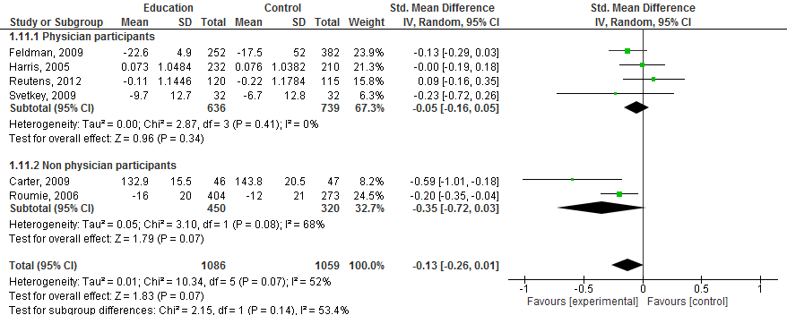
Figure A: Subgroup analysis of physician participants compared to other participants in education focused intervention trials disease target outcome at a short term time point

