Additional file 4: Association of unplanned admission rates with selected practice and PCT characteristics^{e}
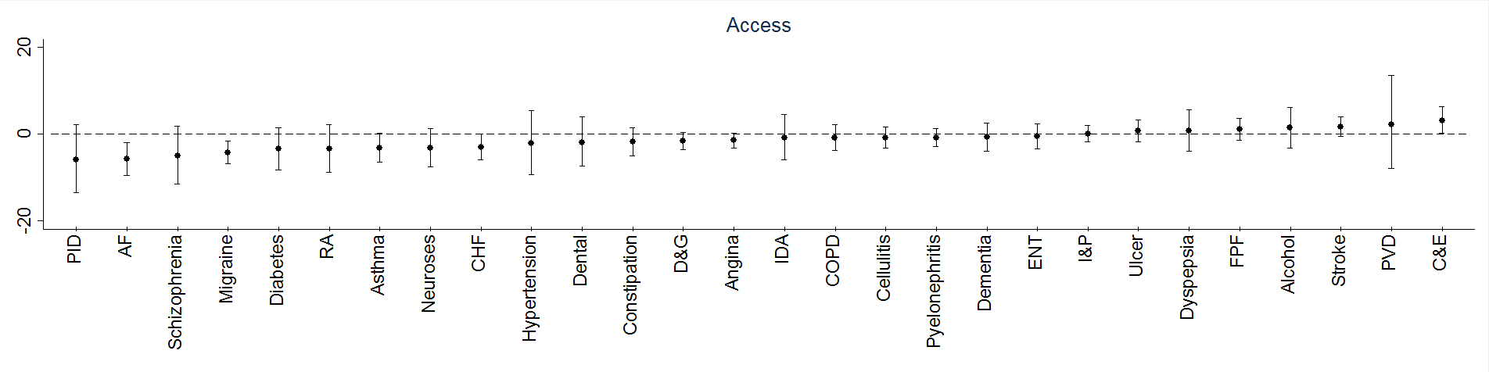
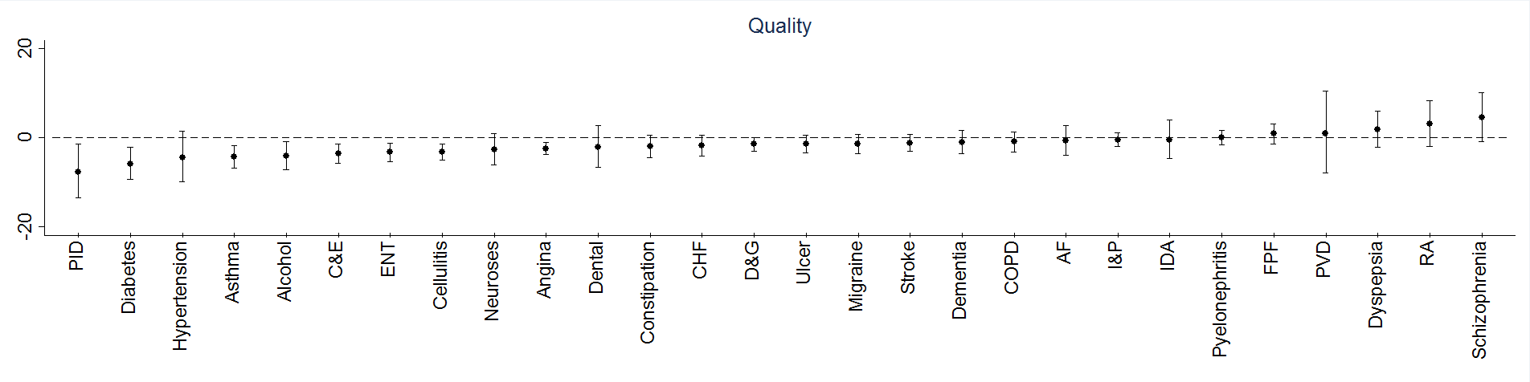
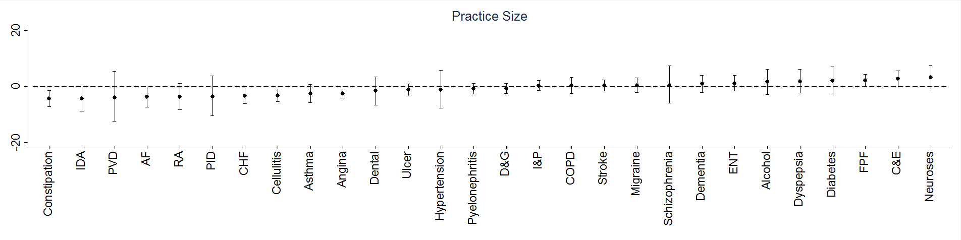
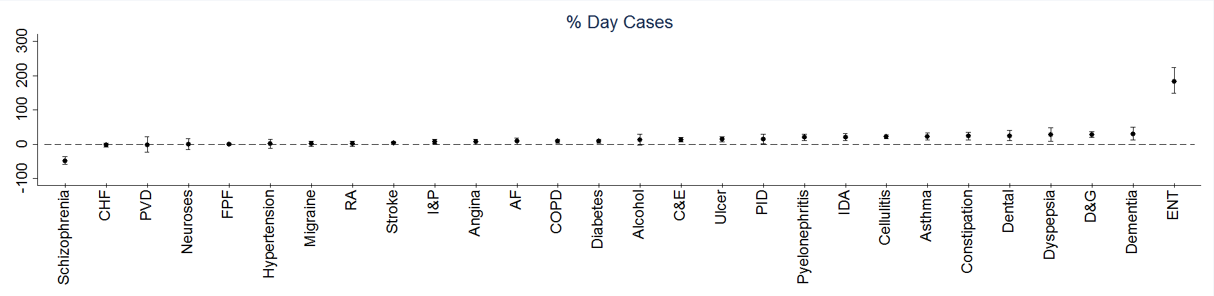
^{e} RA=Ruptured appendix; ENT=ENT infections; FPF=Fractured proximal femur; D&G=Dehydration and gastroenteritis; Migraine=Migraine / acute headache; Dementia=Senility / dementia; AF=Atrial fibrillation / flutter; C&E=Convulsions and epilepsy; IDA=Iron-deficiency anaemia; Dental=Dental condition; PVD=Peripheral vascular disease; Ulcer=Perforated / bleeding ulcer; I&P=Influenza and pneumonia; Dyspepsia=Dyspepsia / otr stomach function; Diabetes=Diabetes complications; CHF=Congest heart failure; PID=Pelvic inflammatory disease; Alcohol=Alcohol-related diseases

