Appendix 3: prevalence of dizziness – detailed information

Patients with dizziness – Patients registered at the practices
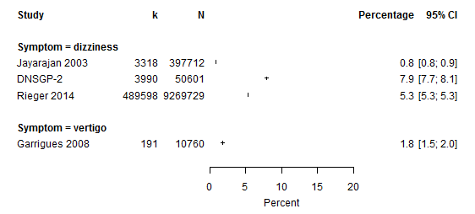
I² | Tau² | Prediction interval
100.0% (100.0-100.0%) | 0.893 | 0.0-73.4%
k: number of patients consulting at least once because of dizziness/ vertigo.
N: number of all patients registered at the practices.
Garrigues 2008 included only patients with vertigo crisis.

Patients with dizziness – Patients consulting the GPs / practices
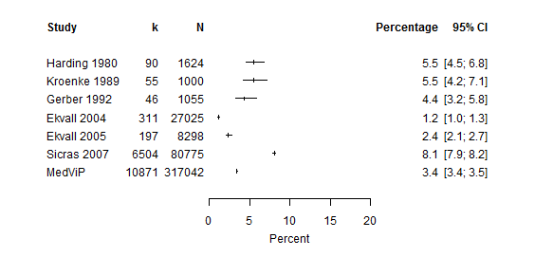
I² | Tau² | Prediction interval
99.8% (99.8-99.9%) | 0.442 | 0.6-19.5%
k: number of patients consulting at least once because of dizziness.
N: number of all patients consulting the GPs / practices

Consultations because of dizziness – All consultations
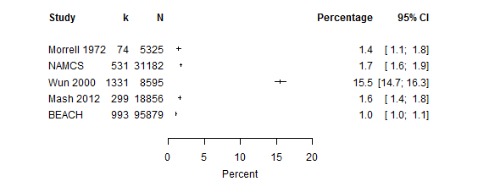
I² | Tau² | Prediction interval
99.9% (99.9-99.9%) | 2.35 | 0.0-83.3%
k: number of consultations because of dizziness/ reason for encounter = dizziness.
N: number of all consultations.

Reason for encounter = dizziness – All reasons for encounter
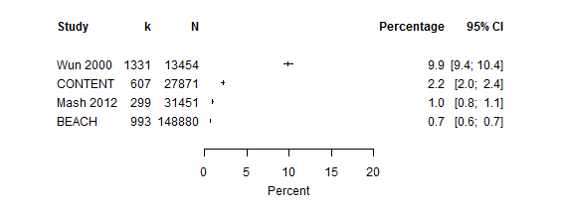
I² | Tau² | Prediction interval
99.9% (99.9-99.9%) | 2.142 | 0.0-95.8%
k: Reason for encounter = dizziness.
N: All reasons for encounter.

