Appendix 4: Aetiology of dizziness – detailed information

Aetiology: otologic peripher
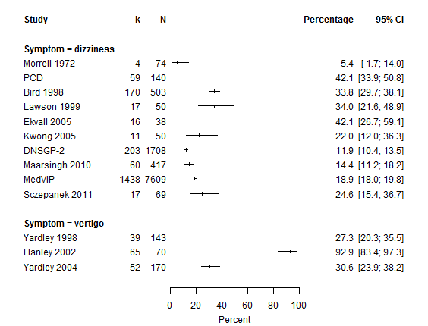
I² | Tau² | Prediction interval
95.9% (94.3-97.0%) | 0.347 | 9.1-60.1%
k: number of patients with the respective aetiology.
N: number of all patients presenting with dizziness / vertigo

Aetiology: BPPV
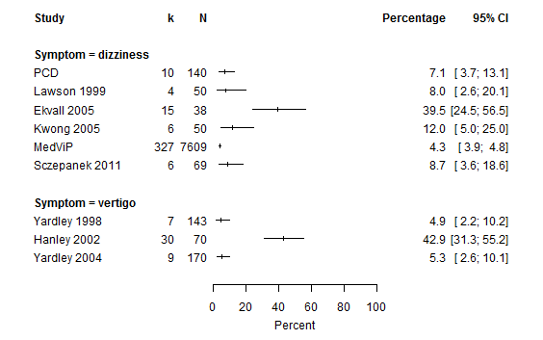
I² | Tau² | Prediction interval
95.8% (93.8-97.2%) | 1.573 | 0.5-73.7%
k: number of patients with the respective aetiology.
N: number of all patients presenting with dizziness / vertigo

Aetiology: vestibular neuritis
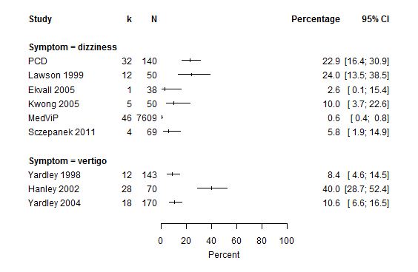
I² | Tau² | Prediction interval
98.2% (97.5-98.6%) | 4.025 | 0.1-93.7%
k: number of patients with the respective aetiology.
N: number of all patients presenting with dizziness / vertigo
Aetiology: Ménière's disease
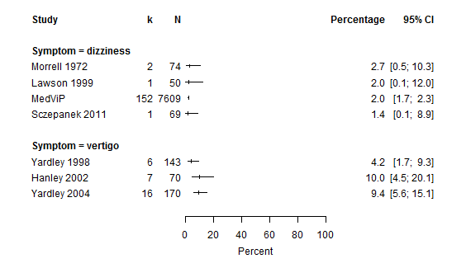
I² | Tau² | Prediction interval
88.4% (78.5-93.7%) | 0.845 | 0.3-35.4%
k: number of patients with the respective aetiology.
N: number of all patients presenting with dizziness / vertigo

Aetiology: cardiovascular
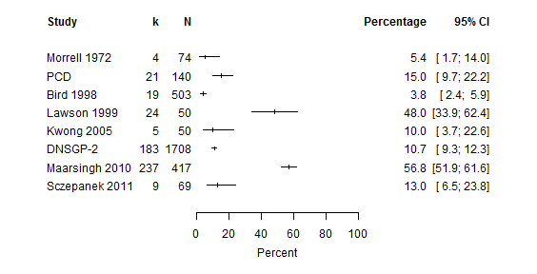
I² | Tau² | Prediction interval
98.5% (98.0-98.9%) | 2.148 | 0.4-89.1%
k: number of patients with the respective aetiology.
N: number of all patients presenting with dizziness / vertigo

Aetiology: neurological central
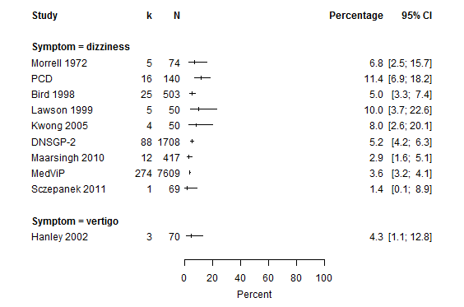
I² | Tau² | Prediction interval
76.1% (55.7-87.1%) | 0.127 | 2.2-12.0%
k: number of patients with the respective aetiology.
N: number of all patients presenting with dizziness / vertigo

Aetiology: cerebrovascular
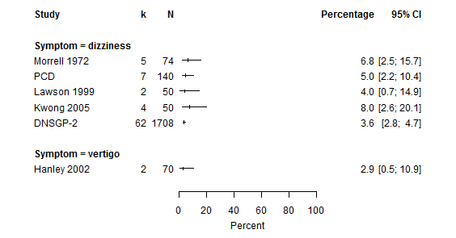
I² | Tau² | Prediction interval
0.0% (0.0-72.6%) | 0 | 3.0-5.4%
k: number of patients with the respective aetiology.
N: number of all patients presenting with dizziness / vertigo

Aetiology: psychogenic
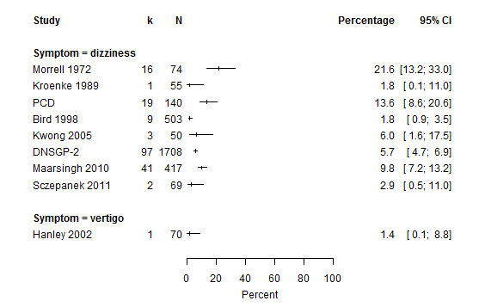
I² | Tau² | Prediction interval
87.4% (78.3-92.7%) | 0.49 | 1.1-28.3%
k: number of patients with the respective aetiology.
N: number of all patients presenting with dizziness / vertigo

Aetiolgoy: other internistic diseases
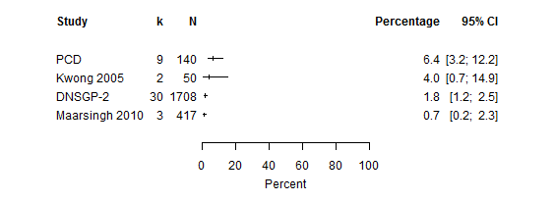
I² | Tau² | Prediction interval
81.9% (53.2-93.0%) | 0.662 | 0.0-58.7%
k: number of patients with the respective aetiology.
N: number of all patients presenting with dizziness / vertigo

Aetiology: drug effects
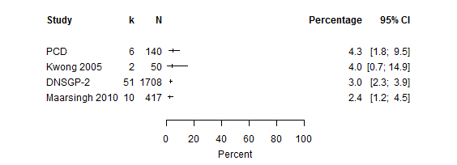
I² | Tau² | Prediction interval
0.0% (0.0-68.8%) | 0 | 1.8-5.0%
k: number of patients with the respective aetiology.
N: number of all patients presenting with dizziness / vertigo

Aetiology: no specific diagnosis
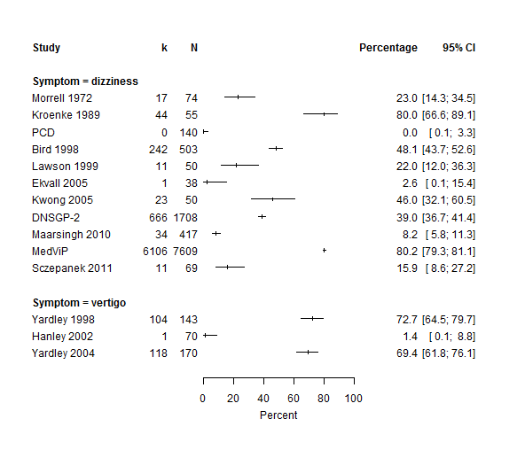
I² | Tau² | Prediction interval
99.2% (99.1-99.4%) | 1.666 | 2.4-89.3%
k: number of patients with the respective aetiology.
N: number of all patients presenting with dizziness / vertigo

Aetiology: no specific diagnosis
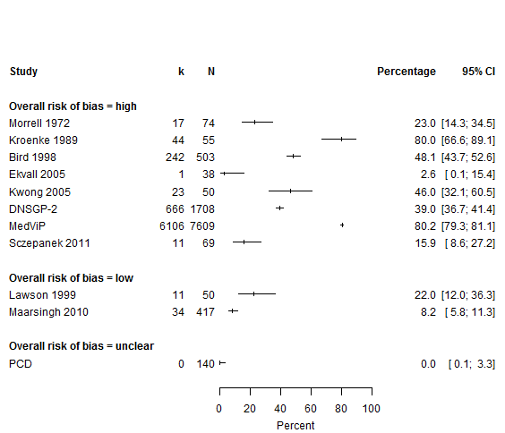
I² | Tau² | Prediction interval
99.4% (99.3-99.5%) | 1.813 | 1.6-90.5%
k: number of patients with the respective aetiology.
N: number of all patients presenting with dizziness

