Additional File 1: CPCSSN definition of Diabetes Mellitus
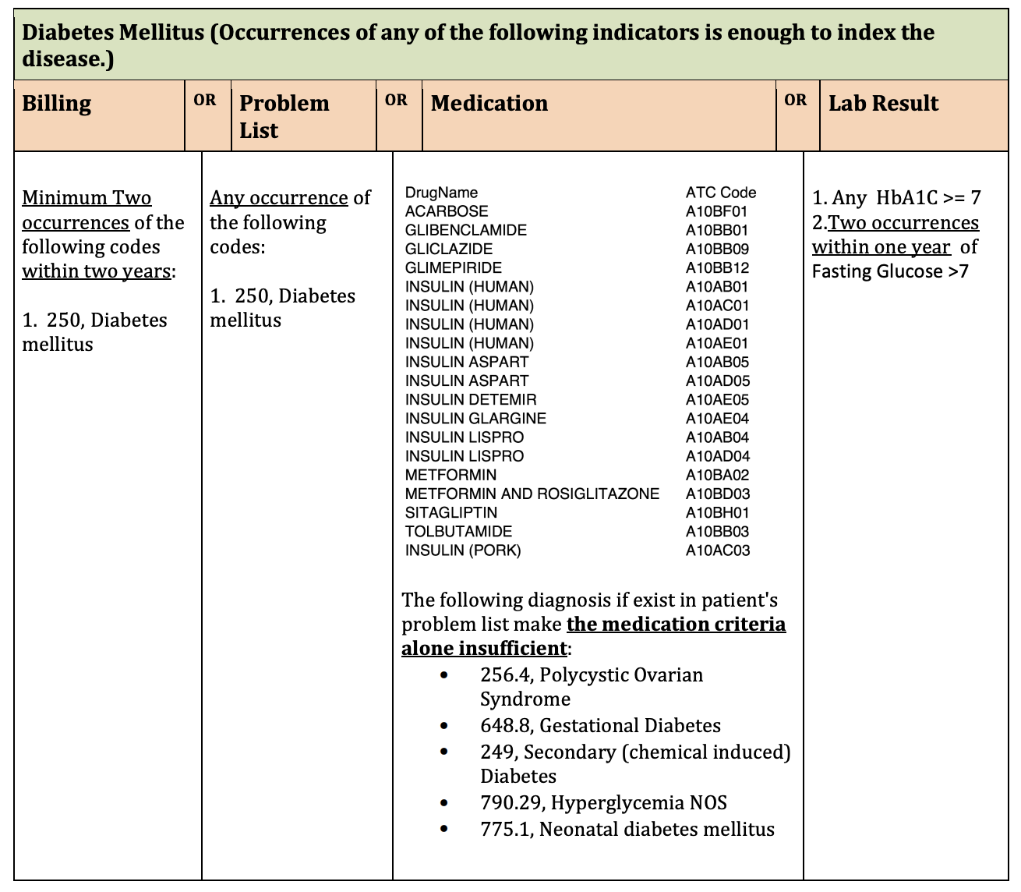
Table adapted from: Williamson, T., et. al,. CPCSSN Disease Definitions: Canadian Primary Care Sentinel Surveillance Network (CPCSSN). June 15, 2014. URL: http://cpcssn.ca/research-resources/case-definitions

