Supplementary material
The economic cost of primary care consultations associated with long Covid in non-hospitalised adults: a retrospective cohort study using UK primary care data
Authors: Jake Tufts, Naijie Guan, Dawit T Zemedikun, Anuradhaa Subramanian, Krishna Gokhale, Puja Myles, Tim Williams, Tom Marshall, Melanie Calvert, Karen Matthews, Krishnarajah Nirantharakumar, Louise Jackson, Shamil Haroon

Table of Contents
Table of Contents 2
Section 1. Supplementary Methods and Results 3
Appendix S1. Propensity score matching 3
Appendix S2. Costing method 4
Appendix S3. Sensitivity analysis 6
Section 2. Supplementary Figures 8
Supplementary Figure 1. Timeline of the dates and time periods of interest throughout the study 8
Supplementary Figure 2. Flow chart of the selection of the study population 9
Supplementary Figure 3. Kernel density plot before and after propensity score matching to show the comparison in the distribution of the propensity scores between the exposed and unexposed groups 10
Supplementary Figure 4. Standardised differences across covariates in the matched groups 11
Supplementary Figure 5. Heatmap of the difference in mean cost per patient (who had a consultation) between the unexposed patients and COVID-19 groups’ patients, stratified by demographic characteristics 12
Supplementary Figure 6. Heatmap of the difference in mean cost per patient (who had a consultation) between the unexposed patients and COVID-19 groups’ patients, stratified by demographics. – Sensitivity analysis 13
Section 3. Supplementary Tables 14
Supplementary Table 1. Table of all descriptions of COVID-19 and relevant SNOMED CT codes used to define whether a patient had COVID-19 14
Supplementary Table 2. Table of explanatory variables included in the study 15
Supplementary Table 3. Study group definitions and titles 17
Supplementary Table 4. Table of Long COVID symptoms classified by WHO Symptoms must be shown by a COVID-19 patient 12 weeks after their index date 18
Supplementary Table 5. Table of the CPRD Aurum codes and descriptions of healthcare professionals included in the study, grouped by the healthcare professional category 19
Supplementary Table 6. Table of the CPRD Aurum codes and descriptions of consultation types included in the study, grouped by the consultation type category 20
Supplementary Table 7. Table of costs per length of time for each healthcare professional 24
Supplementary Table 8. Table of the length of consultation for each healthcare professional by consultation type 25
Supplementary Table 9. Example of how the cost of a surgery consultation by a Nurse from a GP practice is calculated 26
Supplementary Table 10. Comorbidities at baseline in matched exposed and unexposed groups 27
Supplementary Table 11. Incremental cost OLS regression estimates for primary care healthcare cost associated with Long COVID 30
Supplementary Table 12. Baseline characteristics for the COVID patients used in the part 2 regression analysis (incurred a positive cost) 31
Supplementary Table 13. The mean cost of healthcare professional consultations for COVID-19 patients, stratified by subgroups of patients 35
Supplementary Table 14. Estimates of first three months (after index date + 12 weeks) of primary care resource use and costs associated with Long COVID, for patients who had at least three months of follow-up. (Sensitivity analysis) 37

Section 1. Supplementary Methods and Results

Appendix S1. Propensity score matching
Propensity score matching (1:1) was used to closely match patients from the exposed and unexposed cohorts on several important confounding factors including age, sex, body mass index (BMI), smoking status, ethnic group, socioeconomic status (Index of Multiple Deprivation, IMD),¹ index date, follow-up time from the index date, registered general practice, the number of primary care consultations in the 12 months prior to the index date (to account for informed presence bias),² comorbidities and geographical region (Supplementary Table 2).
Propensity scores were derived from a logistic regression model of the probability of having a COVID-19 diagnosis as a function of 10 categories of covariates (Supplementary Table 2), with a calliper width of one-quarter of the standard deviation of the propensity score (0.04).³ If matching is implemented properly, it can be assumed that the only systematic difference between the exposed and unexposed cohorts is the diagnosis of COVID-19, identifying the costs specifically caused by the disease.⁴ The matching performance was evaluated by comparing kernel density plots before and after matching to check the distribution of propensity scores and using the standardised differences between the groups for each variable, where a value greater than 0.1 was considered to indicate imbalance in baseline characteristics.

Appendix S2. Costing method
The costs of these consultations were estimated. Costs were assigned to the most specific cost data available. Unit costs for healthcare resources were taken from the Personal Social Services Research Unit’s (PSSRU) Unit Costs of Health and Social Care 2021, to account for inflation and variations in pricing over time, and to represent the cost perspective of the UK National Health Service (NHS).⁵ The hourly cost was available for each healthcare professional and the average consultation duration was used to calculate consultation costs. Multiple consultations on the same day with the same healthcare professional were counted as a single consultation. Further details are provided in Supplementary Tables 7-9.
The incremental cost of primary care consultations between the exposed and unexposed cohorts was then estimated. The primary costing method was an ‘incremental cost’ approach. Bottom-up costing was adopted to estimate the healthcare use, with each patient’s resource utilisation calculated using individual-level data on consultations from CPRD Aurum.⁶ The healthcare utilisation was then multiplied by its respective unit cost and summed to obtain a patient’s total cost as follows:
$$Total patient cost=\sum_{i }^{ }{{\left(Resource utilisation\right)}_{j}} ×{\left(Resource \cos{t}\right)}_{j}$$
$i=Patient, j=Type of resource$ (1)
The incremental cost associated with long COVID was then obtained by subtracting the sum of each patient’s total healthcare cost between the matched groups, 12 weeks after the index date:
$$Incremental cost _{Long COVID}=\sum_{i}^{N}{{\left(Total cost\right)}_{i, exposed}} -\sum_{i}^{N}{{\left(Total cost\right)}_{i, unexposed}}$$
$i=Patient, N=Total number of patients$ (2)
Usually, a cost of illness (COI) study includes a full year of data on all patients, as otherwise different follow-up times could be a major confounder. However, time since infection was included as a variable within the propensity score matching model to ensure similar follow-up time distributions in both cohorts.
To estimate the national incremental costs attributed to primary care consultations for non-hospitalised patients with long COVID across the whole UK population, cumulative COVID-19 incidence estimates produced by the UK Office for National Statistics (ONS) in the COVID-19 Infection Survey were used. This was done by multiplying the population size by the cumulative incidence of COVID-19, as well as the 90% credible intervals. This provided the cumulative frequency of COVID-19. This was multiplied by the proportion of non-hospitalised patients with COVID-19 who had received at least one primary care consultation within the follow-up period in our study data. This value was then multiplied by the incremental cost estimated in the first part of the analysis to provide the national incremental cost of primary care consultations associated with long COVID. This was done for England, Wales, Scotland, and Northern Ireland, and for the total UK population. This was done separately using the estimated incremental costs from both the primary and sensitivity analyses. We assumed that the incremental costs would remain constant throughout the pandemic.

Appendix S3. Sensitivity analysis
A sensitivity analysis was conducted to assess the assumption that follow-up time does not confound the costs. The dataset was restricted to only patients who had at least six months of follow-up time from their index date. Only cost data from three to six months from the index date was included in the sensitivity analysis.
The results of the sensitivity analysis are presented in Supplementary Table 14 and Supplementary Figure 6, which relate to costs among participants who had a minimum of six months of follow-up from their index date. These followed a similar trend to the cost per person year estimates in the main analysis although the overall incremental costs were higher. The exposed cohort was more costly than the unexposed cohort, with an incremental cost of £5.72 per patient. Patients in the DLC subgroup were the most expensive, followed by the SLC subgroup, with incremental costs per patient of £68.55 and £46.98, respectively when compared to the unexposed cohort.
References:
- Ministry of Housing, Communities, Local Government. English indices of deprivation 2019. GOV.UK; 2019. [cited 2022 Nov 20]. Available from: https://www.gov.uk/government/statistics/english-indices-of-deprivation-2019
- Goldstein BA, Bhavsar NA, Phelan M, Pencina MJ. Controlling for informed presence bias due to the number of health encounters in an electronic health record. American journal of epidemiology. 2016;184(11):847–55. DOI: http://dx.doi.org/10.1093/aje/kww112
- Stuart EA, Rubin DB. Best practices in quasi-experimental designs. Best practices in quantitative methods. 2008:155-76. DOI: https://dx.doi.org/10.4135/9781412995627.d14
- Akobundu E, Ju J, Blatt L, Mullins CD. Cost-of-illness studies. Pharmacoeconomics. 2006 Sep;24(9):869-90. DOI: https://doi.org/10.2165/00019053-200624090-00005
- Personal Social Services Unit. Unit Costs of Health and Social Care 2021 [Internet]. 2022 Jan 31. [Cited 22/04/2022]. Available from: DOI: 10.22024/UniKent/01.02.92342
- Pagano E, Brunetti M, Tediosi F, Garattini L. Costs of diabetes. Pharmacoeconomics. 1999 Jun;15(6):583-95. DOI: https://doi.org/10.2165/00019053-199915060-00006

Section 2. Supplementary Figures

Supplementary Figure 1. Timeline of the dates and time periods of interest throughout the study

472,173 eligible exposed patients
8,549,416 unexposed patients
Excluded unexposed patients because:
- Hospitalised within the exclusion timer period.
  - 33,043
- Transferred out of practice before index date.
  - 4,996
- Died before index date.
  - 266
- Transferred out of practice for reasons other than death.
  - 399,152
8,118,797 eligible unexposed patients
472,173 matched unexposed patients
472,173 eligible exposed patients
3,871 exposed patients with a record of diagnosed Long COVID
30,174 exposed patients with reported WHO symptoms of Long COVID after 12 weeks since index date, but without a record of Long COVID diagnosis
472,173 matched exposed patients
Excluded 7,646,624 unexposed patients due to 1:1 propensity score matching
66,303 exposed patients
444 Long COVID diagnosed
10,310 symptoms of Long COVID
64,604 unexposed patients
Excluded 405,870 exposed patients, 407,569 unexposed patients, 3,427 Long COVID diagnosed patients and 19,864 symptoms of Long COVID patients due to them not having 3 months of follow-up after 12 weeks post index date.
Main analysis
Sensitivity analysis

Supplementary Figure 2. Flow chart of the selection of the study population

The kernel density plots show that the matching was well-balanced because the density estimation lines for the two groups coincide. The standardised differences across covariates were less than 0.1 for all variables after matching (Supplementary Figure 5), which is further evidence of balanced matching.
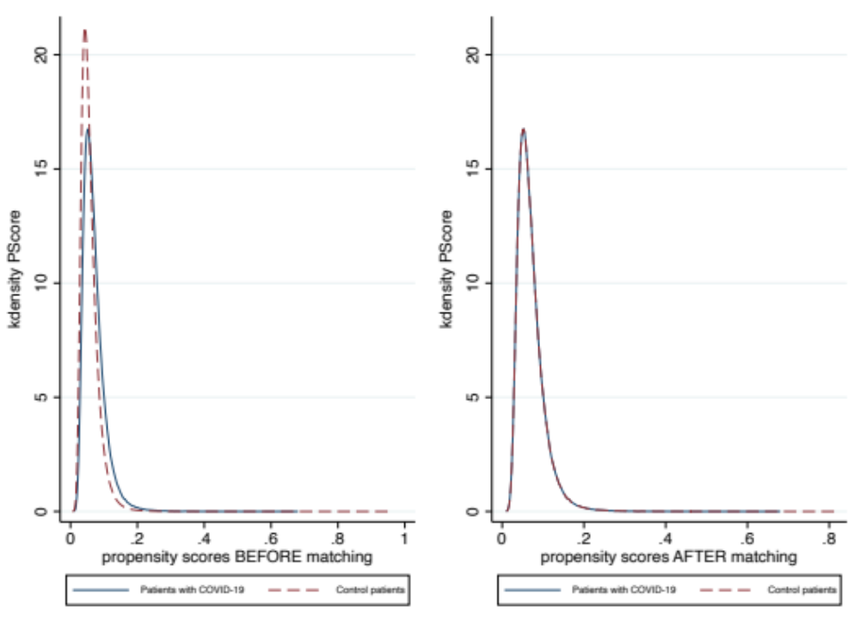

Supplementary Figure 3. Kernel density plot before and after propensity score matching to show the comparison in the distribution of the propensity scores between the exposed and unexposed groups

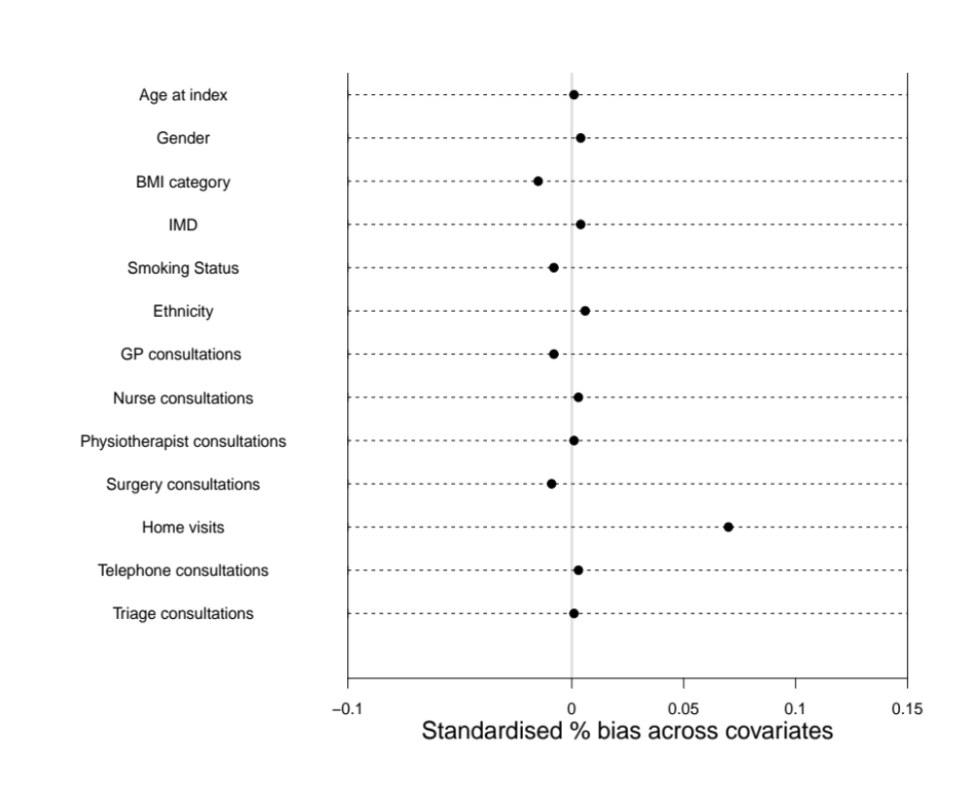

Supplementary Figure 4. Standardised differences across covariates in the matched groups

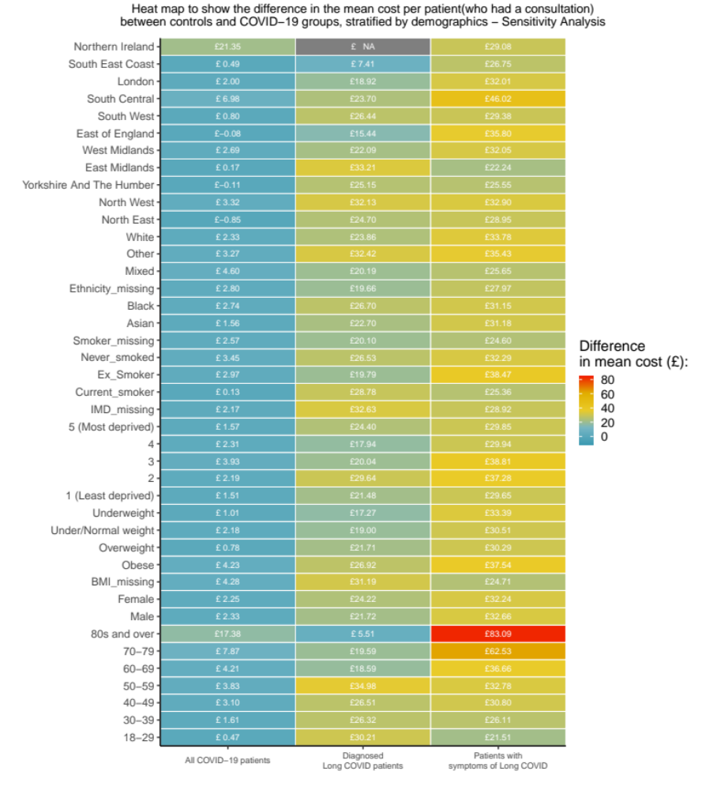

Supplementary Figure 5. Heatmap of the difference in mean cost per patient (who had a consultation) between the unexposed patients and COVID-19 groups’ patients, stratified by demographic characteristics
Note: Yellow and red represent a greater cost difference from the unexposed.

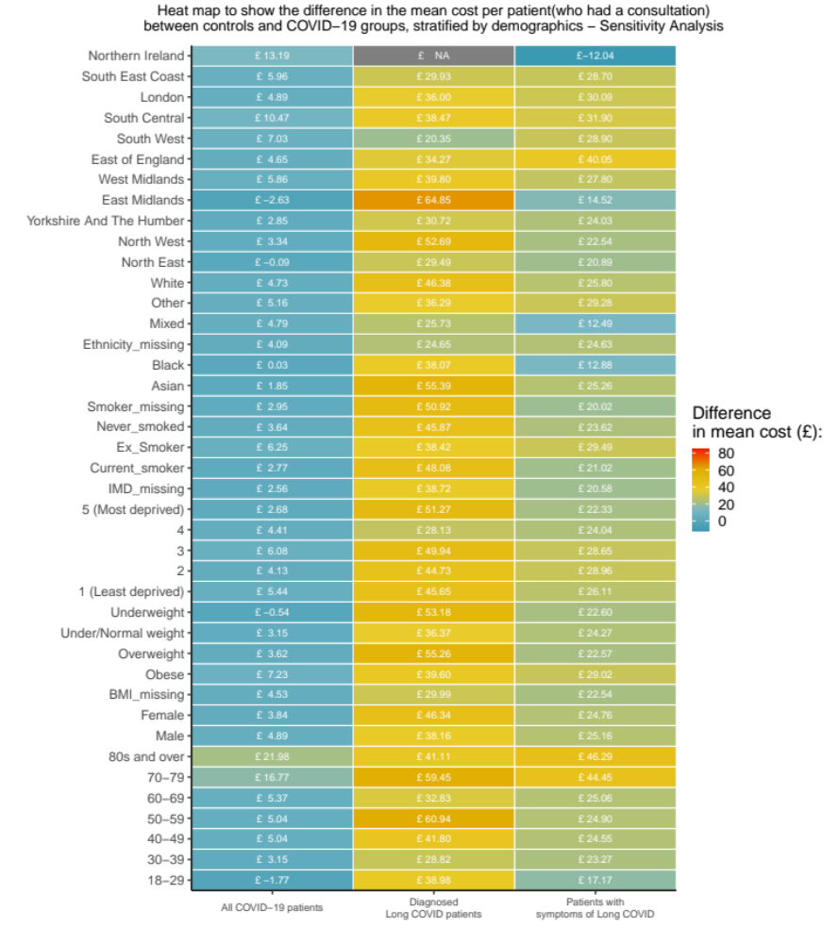

Supplementary Figure 6. Heatmap of the difference in mean cost per patient (who had a consultation) between the unexposed patients and COVID-19 groups’ patients, stratified by demographics. – Sensitivity analysis

Section 3. Supplementary Tables

Supplementary Table 1. Table of all descriptions of COVID-19 and relevant SNOMED CT codes used to define whether a patient had COVID-19
Description | SNOMED CT Code
Detection of 2019 novel coronavirus using polymerase chain reaction technique | 1240511000000100
Detection of 2019-nCoV (novel coronavirus) using polymerase chain reaction technique | 1240511000000100
Detection of SARS-CoV-2 (severe acute respiratory syndrome coronavirus 2) using polymerase chain reaction technique | 1240511000000100
Detection of Wuhan 2019-nCoV (novel coronavirus) using polymerase chain reaction technique | 1240511000000100
Wuhan 2019-nCoV (novel coronavirus) detected | 1240581000000100
2019-nCoV (novel coronavirus) detected | 1240581000000100
2019 novel coronavirus detected | 1240581000000100
SARS-CoV-2 (severe acute respiratory syndrome coronavirus 2) detected | 1240581000000100
SARS-CoV-2 (severe acute respiratory syndrome coronavirus 2) detection result positive | 1240581000000100
SARS-CoV-2 (severe acute respiratory syndrome coronavirus 2) RNA (ribonucleic acid) detection result positive | 1240581000000100
COVID-19 detected | 1240581000000100
COVID-19 confirmed by laboratory test | 1300721000000100
SARS-CoV-2 (severe acute respiratory syndrome coronavirus 2) RNA (ribonucleic acid) qualitative existence in specimen | 1321301000000100
SARS-CoV-2 (severe acute respiratory syndrome coronavirus 2) antigen detection result positive | 1322781000000100
2019-nCoV (novel coronavirus) antigen detection result positive | 1322781000000100
SARS-CoV-2 (severe acute respiratory syndrome coronavirus 2) RNA (ribonucleic acid) detection result positive | 1324601000000100
2019-nCoV (novel coronavirus) ribonucleic acid detected | 1324601000000100
SARS-CoV-2 (severe acute respiratory syndrome coronavirus 2) RNA (ribonucleic acid) detection result positive at the limit of detection | 1324881000000100
2019-nCoV (novel coronavirus) detection result positive at the limit of detection | 1324881000000100
Detection of SARS-CoV-2 (severe acute respiratory syndrome coronavirus 2) antigen | 871553007
Detection of ribonucleic acid of 2019 novel coronavirus in nasopharyngeal swab | 871556004
Detection of RNA (ribonucleic acid) of SARS-CoV-2 (severe acute respiratory syndrome coronavirus 2) in nasopharyngeal swab | 871556004
Detection of RNA (ribonucleic acid) of SARS-CoV-2 (severe acute respiratory syndrome coronavirus 2) in oropharyngeal swab | 871557008
Detection of RNA (ribonucleic acid) of SARS-CoV-2 (severe acute respiratory syndrome coronavirus 2) using polymerase chain reaction | 871560001
Detection of ribonucleic acid of COVID-19 using polymerase chain reaction | 871560001

Supplementary Table 2. Table of explanatory variables included in the study
Variable | Description | Specification | Models
Age | Age in years at index date | Continuous | * f
Age group | Age categorised into 8 groups:  18-29, 30-49, 50-59, 60-69, 70-79, 80+ | Derived categorical | g
Sex | Male or Female | Binary | * g f
BMI category | Underweight <18.5 kg/m2,  Normal weight 18.5-24 kg/m2  Overweight 25-29 kg/m  Obese ≥30 kg/m2  BMI Missing | Derived categorical | * g f
Index of Multiple Deprivation | Measure of socio-economic status from 1 to 5:  1 – Least deprived  5 – Most deprived  IMD missing | Categorial | * g f
Smoking status | Never smoked  Ex-smoker  Current smoker  Smoker Missing | Categorial | * g f
Ethnicity | White  Black  Mixed  Asian  Other  Ethnicity Missing | Categorical | * g f
Time since index | Number of weeks from index date to patient’s end of study period | Derived continuous | * f
Practice ID | Indicates which practice a patient belongs to. | Categorial | *
Prior healthcare utilisation | Number of consultations had with a healthcare professional in the 3 to 12 months prior to a patient’s index date:  GP  Nurse  Physiotherapist | Continuous | * f

Supplementary Table 2. Table of explanatory variables included in the study (Continued)
Variable | Description | Specification | Models
87 Comorbidities | Chronic health conditions, one category with patient numbers ≤5 was suppressed in accordance with CPRD guidelines for data protection. The list of comorbidities can be found in Supplementary Table 11. | Binary | *
Charlson Comorbidity Index  (CCI) | Using a CCI R package, CCI was calculated for each patient. 17 comorbidities are included and are given different scores dependant on the range a patient has. | Derived continuous | f
Region | 11 regions from England and Northern Ireland:  Northeast, North West, East Midlands, West Midlands, South East, South West, East of England, South Central, London, Northern Ireland | Categorial | g f
Note: * Included in propensity score matching. g: Included in stratification of costs. f: Included in the regression specification.

Supplementary Table 3. Study group definitions and titles
 | Main groups |  | Sub-groups  (Patients with a diagnosis of COVID-19…)
Group title | Unexposed group | Exposed group | Diagnosed Long COVID (DLC) group | Symptoms of Long COVID (SLC) group
Definition | Patients without a diagnosis of COVID-19 | Patients with a diagnosis of COVID-19 | … and a diagnosis of Long COVID | … and show at least one of the WHO symptoms of Long COVID after 12 weeks post infection

Supplementary Table 4. Table of Long COVID symptoms classified by WHO Symptoms must be shown by a COVID-19 patient 12 weeks after their index date
Symptom | SNOMED CT Code
Anosmia | 44169009
Fatigue | 84229001
Fever | 386661006
Palpitations | 80313002
Blurred vision/diplopia | 24982008
Chest pain | 29857009
Shortness of breath | 267036007
Paraesthesia | 91019004
Diarrhoea | 62315008
Headache | 25064002
Allergies | 370860007
Insomnia | 193462001
Constipation | 14760008
Joint pain | 57676002
Difficulty thinking | 285257002
Abdominal pain | 21522001
Gastritis | 4556007
Dizziness | 404640003
Menorrhagia | 386692008
Hyperacusis | 25289003
Muscle pain | 68962001
Amnesia | 48167000
Muscle cramping | 55300003
Gastric reflux | 225587003
Depression | 255339005
Dysgeusia | 271801002
Anxiety | 48694002
Menstrual changes | 80182007
Pre-menstrual syndrome | 289896006
Excessive sleep | 77692006
Hearing loss | 15188001
Post exert fatigue | 444042007

Supplementary Table 5. Table of the CPRD Aurum codes and descriptions of healthcare professionals included in the study, grouped by the healthcare professional category
CPRD Aurum codes: jobcatid | Description
GP
4 | General Medical Practitioner
5 | Salaried General Practitioner
15 | Associate Practitioner - General Practitioner
24 | GP Registrar
31 | Sessional GP
181 | Locum GP
183 | Assistant GP
General Nurse
9 | Community Nurse
48 | Enrolled Nurse
52 | Community Mental Health Nurse
61 | Sister/Charge Nurse
Staff Nurse
47 | Staff Nurse
59 | Student Practice Nurse
115 | Student District Nurse
169 | Student Community Mental Health Nurse
191 | Student Occupational Health Nurse
Specialist Nurse
27 | Specialist Nurse Practitioner
55 | Associate Practitioner - Nurse
Nurse consultant
33 | Nurse Consultant
Nurse Manager
60 | Nurse Manager
Physiotherapist Consultant
106 | Physiotherapist Consultant
Physiotherapist Specialist Practitioner
80 | Physiotherapist Specialist Practitioner
Physiotherapist Manager
136 | Physiotherapist Manager
Physiotherapist
34 | Physiotherapist
77 | Student Physiotherapist

Supplementary Table 6. Table of the CPRD Aurum codes and descriptions of consultation types included in the study, grouped by the consultation type category
CPRD Aurum codes: Consultation Source Id | Description
Surgery
751 | G.P. Evening Surgery
4221 | Surgery consultation
3509 | Nurse Surgery
10310 | Surgery Clinic
5266 | GP Surgery
2706 | GP Surgery
4231 | GP Surgery
754 | GP Surgery
7632 | GP Surgery
7659 | GP Surgery
7732 | GP Surgery
9361 | Surgery or Clinic
2711 | G.P Surgery (Pm)
4215 | Surgery Attendance
1865 | Branch Surgery
2719 | G.P. Morning Surgery
3505 | Nurse Practitioner Surgery
6963 | Walk-In Surgery
426 | Contact method: G.P.Surgery
2580 | Emergency Gp Surgery
5252 | G.P.Surgery Urgent Consultation
10303 | Surgery
9551 | Unbooked Clinic
3499 | Nurse Assessment Clinic
6140 | P.Nurse Clinic
364 | Clinic NHS
366 | Clinic note
3346 | Minor Operations Clinic
3503 | Nurse Minor Illness Clinic
5093 | Emergency Nurse Clinic
6236 | Practice Nurse Clinic
7240 | Clinic Premises
397 | Community Clinic
10310 | Surgery Clinic
4773 | Clinic
5952 | Nurse's Treatment Room Clinic
3347 | Minor Ops Clinic

Supplementary Table 6. Table of the CPRD Aurum codes and descriptions of consultation types included in the study, grouped by the consultation type category (Continued)
CPRD Aurum codes: Consultation Source Id | Description
3501 | Nurse Flu Clinic
3516 | Nurses' Flu Clinic
7395 | Diabetic Clinic
8812 | Out Of Hours Visit
3631 | Out Of Hours Night Visit
3627 | Out Of Hours Gp Visit
5869 | Night Visit
6087 | Out of hours, Practice
16305 | Out of Hours
6034 | Out of Hours
6052 | Out of Hours
6056 | Out of Hours
6062 | Out of Hours
6063 | Out of Hours
8794 | Out of Hours
8795 | Out of Hours
8796 | Out of Hours
3617 | Out of Hours
3618 | Out of Hours
8503 | Out of Hours
8504 | Out of Hours
8505 | Out of Hours
8506 | Out of Hours
6064 | Out of Hours
6065 | Out of Hours
6066 | Out of Hours
3614 | Out of Hours
3615 | Out of Hours
3616 | Out of Hours
8799 | Out of hours consultation at surgery
3632 | Out Of Hours Other Practice
9907 | Practice Nurse
2810 | GP Practice
5875 | Night visit, practice
6236 | Practice Nurse Clinic
9203 | Seen by Practice Nurse
745 | G P Consultation
421 | Consultation

Supplementary Table 6. Table of the CPRD Aurum codes and descriptions of consultation types included in the study, grouped by the consultation type category (Continued)
CPRD Aurum codes: Consultation Source Id | Description
3626 | Out Of Hours GP Service
9633 | Walk In Centre
4523 | Walk-in clinic
6963 | Walk-In Surgery
5149 | Face to face consultation
10474 | Third party consultation
Home visit
7883 | Home of Patient
3628 | Out Of Hours Home Visit
7885 | Home Visit
984 | Home Visit - In Surgery Hours
5464 | Home visit note
10627 | Visit-Home
8348 | Normal Home Visit (08:00 - 11:00)
8400 | Nursing Home
9060 | Residential Home
3430 | Night Visit - patient's home
3431 | Night Visit - patient's home
3432 | Night Visit - patient's home
7358 | Daytime Visits patients home
6517 | Seen in own home
3438 | Night Visit patients home
9061 | Residential home visit note
8703 | Nursing home visit note
8527 | Out of hours, Non-Practice
3514 | Nurse Visit
3440 | Night visit, Local rota
Telephone
3506 | Nurse Practitioner Telephone Advice
3640 | Out Of Hours-Telephone Advice
4293 | Telephone Consultation
6731 | Telephone call to relative/carer
3639 | Out Of Hours Telephone Contact/Advice
4289 | Telephone Appt
10359 | Telephone
2527 | Duty Doctor Telephone
3636 | Out Of Hours Telephone Advice
3638 | Out Of Hours Telephone Consultation

Supplementary Table 6. Table of the CPRD Aurum codes and descriptions of consultation types included in the study, grouped by the consultation type category (Continued)
CPRD Aurum codes: Consultation Source Id | Description
5040 | Duty Telephone Appt
6728 | Telephone call from a patient
6730 | Telephone call to a patient
3637 | Out Of Hours Telephone Call
4298 | Telephone encounter
6727 | Telephone Call
9417 | Telephone call from relative/carer
4283 | Telephone Advice
4302 | Telephone Surgery
Triage
9433 | Telephone Triage by Doctor
4303 | Telephone Triage
3510 | Nurse Surgery Triage
4271 | Telephone (Triage)
4394 | Triage By Phone
10510 | Triage
3511 | Nurse Triage
3512 | Nurse Triage Clinic
3513 | Nurse Triage Consultation
3512 | Nurse Triage Clinic
9433 | Telephone Triage by Doctor
4303 | Telephone Triage
6751 | Telephone triage encounter

Supplementary Table 7. Table of costs per length of time for each healthcare professional
Healthcare professional | 2021 cost per length of consultation | Source (PSSRU UCHSC*)
Physiotherapist | £65 per hour (Band 7) | Chapter 9 (2021)
Physiotherapist Specialist Practitioner | £65 per hour (Band 7) | Chapter 9 (2021)
Physiotherapist Manager | £65 per hour (Band 7) | Chapter 9 (2021)
Physiotherapist Consultant | £88 per hour (Band 8) | Chapter 9 (2021)
GP | £34 per 9.22 min | Chapter 10.3b (2021)
Nurse GP Practice | £42 per hour | Chapter 10.2 (2021)
Staff Nurse | £44 per hour (Band 5) | Chapter 10.1 (2021)
Specialist Nurse Practitioner | £66 per hour (Band 7) | Chapter 10.1 (2021)
Nurse Manager | £66 per hour (Band 7) | Chapter 10.1 (2021)
Nurse Consultant | £146 per hour (Band 9) | Chapter 10.1 (2021)
Note: * PSSRU - Personal Social Services Research
UCHSC - Unit’s Unit Costs of Health and Social Care

Supplementary Table 8. Table of the length of consultation for each healthcare professional by consultation type
Healthcare professional | Consultation type | Length of consultation | Source (PSSRU UCHSC)
Physiotherapists | Surgery | 1 hour | Chapter 9 (2021)
GP | Surgery | 9.22 min | Chapter 10.3b (2021)  Chapter 10.8a (2012)  Chapter 10.5 (2021)
GP | Home visit | 11.4 min
GP | Telephone | 7.1 min
GP | Triage | 4 min
Nurse | Surgery | 15.5 min | Chapter 10.2 (2021)  Chapter 10.7 (2012)  Chapter 10.5 (2021)
Nurse | Home visit | 25 min
Nurse | Telephone | 6.56 min
Nurse | Triage | 6.56 min

Supplementary Table 9. Example of how the cost of a surgery consultation by a Nurse from a GP practice is calculated
Nurse GP Practice cost per hour = £43

Nurse giving a surgery consultation = 15.5 mins

Cost for one Nurse from a GP practice giving a surgery consultation
= £43/60mins * 15.5 mins = £11.10

Supplementary Table 10. Comorbidities at baseline in matched exposed and unexposed groups
Comorbidity | Unexposed | Exposed
Cancer | 20,571 (4.4) | 20,621 (4.4)
Arrhythmia | 33,306 (7.1) | 33,575 (7.1)
Atrial Fibrillation | 9,185 (1.9) | 9,171 (1.9)
Hypertension | 72,412 (15.3) | 71,916 (15.2)
Heart Failure | 4,273 (0.9) | 4,176 (0.9)
Ischaemic Heart Disease | 13,219 (2.8) | 13,222 (2.8)
Myocardial Infarction | 6,599 (1.4) | 6,573 (1.4)
Valvular Heart Disease | 5,976 (1.3) | 5,923 (1.3)
Cardiomyopathy | 1,236 (0.3) | 1,213 (0.3)
Congenital Heart Disease | 2,905 (0.6) | 2,876 (0.6)
Peripheral Vascular Disease | 4,346 (0.9) | 4,470 (0.9)
Aortic Aneurysm | 960 (0.2) | 919 (0.2)
Transient Ischaemic Attack | 4,083 (0.9) | 4,192 (0.9)
Ischaemic Stroke | 2,203 (0.5) | 2,297 (0.5)
Haemorrhagic Stroke | 1,263 (0.3) | 1,331 (0.3)
Stroke Unspecified | 3,549 (0.8) | 3,640 (0.8)
Eczema | 92,173 (19.5) | 91,554 (19.4)
Psoriasis | 19,491 (4.1) | 19,392 (4.1)
Autoimmune Skin Conditions | 6,359 (1.3) | 6,421 (1.4)
Acne | 65,310 (13.8) | 64,289 (13.6)
Hay Fever | 86,186 (18.3) | 85,419 (18.1)
Chronic Sinusitis | 8,306 (1.8) | 8,237 (1.7)
Deafness | 5,120 (1.1) | 5,193 (1.1)
Blindness | 2,086 (0.4) | 2,159 (0.5)
Cataract | 15,743 (3.3) | 16,043 (3.4)
Glaucoma | 4,865 (1.0) | 4,955 (1.0)
Age-related Macular Degeneration | 3,160 (0.7) | 3,322 (0.7)
Diabetic Retinopathy | 12,748 (2.7) | 12,662 (2.7)
Inflammatory Eye Disease | 8,073 (1.7) | 8,118 (1.7)
Peptic Ulcer | 6,385 (1.4) | 6,426 (1.4)
Inflammatory Bowel Disease | 4,767 (1.0) | 4,633 (1.0)
Irritable Bowel Syndrome | 33,647 (7.1) | 33,428 (7.1)
Hepatitis B | 1,405 (0.3) | 1,362 (0.3)
Hepatitis C | 829 (0.2) | 815 (0.2)
Alcohol Related Chronic Liver Disease | 852 (0.2) | 860 (0.2)
Chronic Liver Disease (All) | 13,489 (2.9) | 13,332 (2.8)
Non-Alcoholic Fatty Liver Disease | 6,171 (1.3) | 6,066 (1.3)
Diverticular Disease | 13,687 (2.9) | 13,806 (2.9)

Supplementary Table 10. Comorbidities at baseline in matched exposed and unexposed groups (Continued)
Comorbidity | Unexposed | Exposed
Coeliac Disease | 2,094 (0.4) | 2,066 (0.4)
Chronic Pancreatitis | 372 (0.1) | 364 (0.1)
Endometriosis | 6,873 (1.5) | 6,916 (1.5)
Poly Cystic Ovarian Syndrome | 11,673 (2.5) | 11,667 (2.5)
Low Haemoglobin | 25,478 (5.4) | 25,407 (5.4)
Venous Thromboembolism | 9,289 (2.0) | 9,181 (1.9)
Coagulopathy | 5,463 (1.2) | 5,360 (1.1)
Pernicious Anaemia | 1,242 (0.3) | 1,236 (0.3)
Depression | 105,548 (22.4) | 104,666 (22.2)
Anxiety | 96,512 (20.4) | 96,129 (20.4)
Serious Mental Illness | 5,152 (1.1) | 5,167 (1.1)
Substance Misuse | 8,275 (1.8) | 8,227 (1.7)
Alcohol Misuse | 24,173 (5.1) | 24,162 (5.1)
Attention Deficit Hyperactivity Disorder | 2,462 (0.5) | 2,433 (0.5)
Eating Disorder | 4,251 (0.9) | 4,187 (0.9)
Learning Disability | 4,318 (0.9) | 4,329 (0.9)
Alzheimer’s | 3,093 (0.7) | 3,655 (0.8)
Vascular Dementia | 1,521 (0.3) | 1,903 (0.4)
Dementia Unspecified | 6,768 (1.4) | 7,886 (1.7)
Parkinson’s Disease | 893 (0.2) | 945 (0.2)
Migraine | 53,130 (1.3) | 52,587 (1.1)
Multiple Sclerosis | 1,032 (0.2) | 1,008 (0.2)
Epilepsy | 7,495 (1.6) | 7,505 (1.6)
Hemiplegia | 710 (0.2) | 703 (0.1)
Chronic Fatigue Syndrome | 1,670 (0.4) | 1,667 (0.4)
Fibromyalgia | 5,115 (1.1) | 5,027 (1.1)
Cluster Headache | 1,758 (0.4) | 1,685 (0.4)
Osteoarthritis | 52,342 (11.1) | 52,316 (11.1)
Backpain | 6,835 (1.4) | 6,826 (1.4)
Fragility Fracture | 45,198 (9.6) | 44,943 (9.5)
Falls | 37,672 (8.0) | 38,146 (8.1)
Polymyalgia Rheumatica | 2,077 (0.4) | 2,088 (0.4)
Rheumatoid Arthritis | 3,991 (0.8) | 4,043 (0.9)
Raynaud’s Disease | 5,211 (1.1) | 5,218 (1.1)
Sjogren’s Syndrome | 539 (0.1) | 532 (0.1)
Systemic Lupus Erythematosus | 600 (0.1) | 592 (0.1)
Systemic Sclerosis | 148 (0.0) | 156 (0.0)
Ankylosing Spondylitis | 777 (0.2) | 764 (0.2)
Supplementary Table 10. Comorbidities at baseline in matched exposed and unexposed groups (Continued)
Comorbidity | Unexposed | Exposed
Gout | 13,845 (2.9) | 13,703 (2.9)
Chronic Kidney Disease | 13,630 (2.9) | 13,866 (2.9)
Asthma | 95,329 (20.2) | 94,787 (20.1)
Chronic Obstructive Pulmonary Disease | 10,494 (2.2) | 10,612 (2.2)
Obstructive Sleep Apnoea | 7,054 (1.5) | 6,871 (1.5)
Other Pulmonary Disease | 2,604 (0.6) | 2,547 (0.5)
Hyperthyroidism | 5,226 (1.1) | 5,126 (1.1)
Hypothyroidism | 20,720 (4.4) | 20,565 (4.4)
Type 1 Diabetes | 2,760 (0.6) | 2,752 (0.6)
Type 2 Diabetes | 31,899 (6.8) | 31,673 (6.7)
Acquired Immune Deficiency Syndrome | 897 (0.2) | 895 (0.2)
Benign Prostatic Hyperplasia | 6,551 (1.4) | 6,574 (1.4)
Erectile Dysfunction | 21,407 (4.5) | 20,862 (4.4)

Supplementary Table 11. Incremental cost OLS regression estimates for primary care healthcare cost associated with Long COVID
Total healthcare cost | Coefficient | 95% CIs (LL, UL) |  | p-value
Exposure status
Unexposed (Reference)
Covid-19 | 2.09 | 1.95 | 2.24 | <0.001
Long Covid diagnosed | 20.50 | 18.50 | 22.50 | <0.001
Symptoms of long Covid | 39.61 | 38.94 | 40.28 | <0.001
Charlson Comorbidity Index | 0.49 | 0.43 | 0.55 | <0.001
GP consultations prior | 2.50 | 2.43 | 2.57 | <0.001
Nurse consultations prior | 1.24 | 1.09 | 1.39 | <0.001
Physio consultations prior | 1.85 | 1.14 | 2.56 | <0.001
Age (at index) | 0.15 | 0.14 | 0.15 | <0.001
Time since index date  Sex |  | 1.81 | 1.85 | <0.001
Male (Reference)
Female | 1.54 | 1.39 | 1.70 | <0.001
Ethnicity
White (Reference)
Black | -0.60 | -0.94 | -0.26 | <0.001
Other | 0.01 | -0.53 | 0.55 | 0.97
Mixed | -0.02 | -0.23 | 0.20 | 0.87
Asian | -0.59 | -1.01 | -0.16 | 0.01
Ethnicity missing | -0.26 | -0.46 | -0.06 | 0.01
IMD
1 (Least deprived) (Reference)
2 | 0.36 | 0.10 | 0.62 | 0.01
3 | 0.67 | 0.41 | 0.92 | <0.001
4 | 0.53 | 0.28 | 0.77 | <0.001
5 (Most deprived) | 0.82 | 0.56 | 1.07 | <0.001
IMD missing  Smoking status | 0.04 | -0.27 | 0.34 | 0.82
Non-smoker (Reference)
Ex-smoker | 0.30 | 0.12 | 0.49 | <0.001
Current smoker | 0.14 | -0.05 | 0.33 | 0.14
Smoking status missing | 0.23 | -0.01 | 0.47 | 0.06
BMI category:
Normal weight (Reference)
Underweight | 1.48 | 1.08 | 1.88 | <0.001
Overweight | -0.41 | -0.60 | -0.23 | <0.001
Obese | 0.21 | -0.00 | 0.43 | 0.05
BMI missing | 0.65 | 0.41 | 0.89 | <0.001
Constant | -35.27 | -36.07 | -34.47 | <0.001
Notes: R² = 0.297, MSE = 35.642

Supplementary Table 12. Baseline characteristics for the COVID patients used in the part 2 regression analysis (incurred a positive cost)
Variables | COVID-19 patients  (n = 98,476)
Age at index (mean (SD)) | 46.85 (18.10)
Gender
Male | 33,142 (33.7)
Female | 65,334 (66.3)
BMI category
Normal weight | 29,383 (29.8)
Underweight | 3,052 (3.1)
Obese | 29,356 (29.8)
Overweight | 30,779 (31.3)
Missing | 5,906 (6.0)
IMD
1 (Least deprived) | 14,839 (15.1)
2 | 15,737 (16.0)
3 | 16,422 (16.7)
4 | 19,702 (20.0)
5 (Most deprived) | 22,617 (23.0)
Missing | 9,159 (9.3)
Smoking Status
Current smoker | 20,710 (21.0)
Ex-Smoker | 38,929 (39.5)
Never smoked | 30,862 (31.3)
Missing | 7,975 (8.1)
Ethnicity
White | 66,078 (67.1)
Asian | 12,915 (13.1)
Black | 3,177 (3.2)
Mixed | 1,812 (1.8)
Other | 1,239 (1.3)
Missing | 13,255 (13.5)
Number of consultations 3 to 12 months prior to index date (mean (SD))
GP | 3.64 (4.53)
Nurse | 0.86 (2.05)
Physiotherapist | 0.02 (0.24)
Surgery | 2.21 (2.83)
Home visits | 0.18 (1.22)
Telephone | 2.09 (3.20)
Triage | 0.04 (0.37)

Supplementary Table 12. Baseline characteristics for the COVID patients used in the part 2 regression analysis (incurred a positive cost) (Continued)
Variables | COVID-19 patients  (n = 98,476)
Cancer | 5,941 (6.0)
Arrhythmia | 10,437 (10.6)
Atrial Fibrillation | 3,100 (3.1)
Hypertension | 20,091 (20.4)
Heart Failure | 1,457 (1.5)
Ischaemic Heart Disease | 4,313 (4.4)
Myocardial Infarction | 2,056 (2.1)
Valvular Heart Disease | 1,851 (1.9)
Cardiomyopathy | 345 (0.4)
Congenital Heart Disease | 687 (0.7)
Peripheral Vascular Disease | 1,338 (1.4)
Aortic Aneurysm | 294 (0.3)
Transient Ischaemic Attack | 1,453 (1.5)
Ischaemic Stroke | 758 (0.8)
Haemorrhagic Stroke | 381 (0.4)
Stroke Unspecified | 1,199 (1.2)
Eczema | 21,821 (22.2)
Psoriasis | 4,823 (4.9)
Autoimmune Skin Conditions | 1,446 (1.5)
Acne | 14,751 (15.0)
Hay Fever | 20,430 (20.7)
Chronic Sinusitis | 2,515 (2.6)
Deafness | 1,564 (1.6)
Blindness | 672 (0.7)
Cataract | 5,200 (5.3)
Glaucoma | 1,459 (1.5)
Age-related Macular Degeneration | 1,121 (1.1)
Diabetic Retinopathy | 3,972 (4.0)
Inflammatory Eye Disease | 2,150 (2.2)
Peptic Ulcer | 1,978 (2.0)
Inflammatory Bowel Disease | 1,336 (1.4)
Irritable Bowel Syndrome | 10,217 (10.4)
Hepatitis B | 258 (0.3)
Hepatitis C | 216 (0.2)
Alcohol Related Chronic Liver Disease | 251 (0.3)
Chronic Liver Disease (All) | 3,961 (4.0)
Non-Alcoholic Fatty Liver Disease | 1,835 (1.9)
Diverticular Disease | 4,497 (4.6)
Coeliac Disease | 588 (0.6)
Chronic Pancreatitis | 121 (0.1)
Endometriosis | 2,158 (2.2)

Supplementary Table 12. Baseline characteristics for the COVID patients used in the part 2 regression analysis (incurred a positive cost) (Continued)
Variables | COVID-19 patients  (n = 98,476)
Poly Cystic Ovarian Syndrome | 3,283 (3.3)
Low Haemoglobin | 7,982 (8.1)
Venous Thromboembolism | 2,916 (3.0)
Coagulopathy | 1,511 (1.5)
Pernicious Anaemia | 464 (0.5)
Depression | 29,482 (29.9)
Anxiety | 27,422 (27.8)
Serious Mental Illness | 1,682 (1.7)
Substance Misuse | 2,073 (2.1)
Alcohol Misuse | 5,898 (6.0)
Attention Deficit Hyperactivity Disorder | 505 (0.5)
Eating Disorder | 1,311 (1.3)
Learning Disability | 1,092 (1.1)
Alzheimer’s | 1,213 (1.2)
Vascular Dementia | 665 (0.7)
Dementia Unspecified | 2,613 (2.7)
Parkinson’s Disease | 300 (0.3)
Migraine | 14,707 (14.9)
Multiple Sclerosis | 310 (0.3)
Epilepsy | 1,942 (2.0)
Hemiplegia | 204 (0.2)
Chronic Fatigue Syndrome | 567 (0.6)
Fibromyalgia | 1,923 (2.0)
Cluster Headache | 468 (0.5)
Osteoarthritis | 16,242 (16.5)
Backpain | 2140 (2.2)
Fragility Fracture | 10,550 (10.7)
Falls | 11,472 (11.6)
Polymyalgia Rheumatica | 762 (0.8)
Rheumatoid Arthritis | 1,320 (1.3)
Raynaud’s Disease | 1,462 (1.5)
Sjogren’s Syndrome | 196 (0.2)
Systemic Lupus Erythematosus | 172 (0.2)
Systemic Sclerosis | 47 (0.0)
Ankylosing Spondylitis | 205 (0.2)
Gout | 3,668 (3.7)
Chronic Kidney Disease | 4,612 (4.7)
Asthma | 23,792 (24.2)
Chronic Obstructive Pulmonary Disease | 3,577 (3.6)
Obstructive Sleep Apnoea | 1,992 (2.0)
Other Pulmonary Disease | 880 (0.9)

Supplementary Table 12. Baseline characteristics for the COVID patients used in the part 2 regression analysis (incurred a positive cost) (Continued)
Variables | COVID-19 patients  (n = 98,476)
Hyperthyroidism | 1,508 (1.5)
Hypothyroidism | 6,282 (6.4)
Type 1 Diabetes | 743 (0.8)
Type 2 Diabetes | 9,714 (9.9)
Acquired Immune Deficiency Syndrome | 204 (0.2)
Benign Prostatic Hyperplasia | 1,968 (2.0)
Erectile Dysfunction | 5,371 (5.5)

Supplementary Table 13. The mean cost of healthcare professional consultations for COVID-19 patients, stratified by subgroups of patients
 | Healthcare professionals – Mean (SD)
Characteristics | GP | Nurse | Physio | All | p-value *
Age-group |  |  |  |  | < 0.001
18-29 | 27.87 (3.47) | 11.74 (5.79) | 36.16 (33.15) | 54.23 (51.46)
30-39 | 27.96 (3.54) | 11.7 (5.99) | 32.13 (33.74) | 57.13 (60.09)
40-49 | 28.03 (3.58) | 11.62 (6.02) | 30.14 (32.91) | 60.42 (64.79)
50-59 | 28.09 (3.62) | 11.42 (5.96) | 35.8 (33.48) | 63.46 (70.39)
60-69 | 28.22 (3.92) | 11.53 (6.09) | 38.33 (32.58) | 68.04 (80.81)
70-79 | 28.89 (4.78) | 12.2 (7.21) | 30.33 (33.04) | 89.08 (120.21)
80s and over | 29.71 (5.8) | 13.14 (7.92) | 15.75 (29.8) | 129.74 (150.24)
Sex |  |  |  |  | < 0.001
Male | 28.34 (4.1) | 11.66 (6.38) | 32.86 (33.29) | 64.44 (78.45)
Female | 28.24 (4.02) | 11.87 (6.28) | 33.28 (33.5) | 66.98 (79.81)
Ethnicity |  |  |  |  | < 0.001
White | 28.29 (4.09) | 11.78 (6.33) | 33.41 (33.5) | 67.26 (82.26)
Asian | 28.15 (3.64) | 12.11 (6.51) | 31.92 (33.29) | 63.56 (65.92)
Black | 28.15 (3.76) | 11.51 (5.92) | 23.56 (31.84) | 64.04 (73.28)
Mixed | 28.01 (3.63) | 11.96 (6.06) | 27.58 (32.62) | 62.13 (62.82)
Other | 28.17 (3.88) | 12.15 (5.73) | 32.5 (32.81) | 63.92 (86.41)
Missing | 28.41 (4.32) | 11.73 (6.18) | 35.02 (32.94) | 64.21 (79.32)

Supplementary Table 13. The mean cost of healthcare professional consultations for COVID-19 patients, stratified by subgroups of patients (Continued)
IMD |  |  |  |  | < 0.001
1 (Least deprived) | 28.25 (4.15) | 11.49 (6.02) | 32.28 (33.24) | 64.01 (80.65)
2 | 28.37 (4.19) | 11.55 (6.05) | 30.69 (33.18) | 66.44 (84.72)
3 | 28.29 (4.07) | 11.71 (6.14) | 30.93 (32.68) | 68.19 (84.13)
4 | 28.22 (3.92) | 11.9 (6.51) | 37.1 (33.03) | 64.99 (76.81)
5 (Most deprived) | 28.25 (3.99) | 12.11 (6.44) | 32.51 (34.58) | 67.09 (75.8)
Missing | 28.28 (3.96) | 11.88 (6.66) | 34.72 (32.8) | 65.39 (72.63)
Smoking Status |  |  |  |  | < 0.001
Current smoker | 28.2 (3.94) | 11.95 (6.59) | 28.59 (33.17) | 64.48 (75.48)
Ex-smoker | 28.34 (4.13) | 11.68 (6.29) | 33.74 (33.51) | 70.11 (86.97)
Never smoked | 28.25 (4) | 11.87 (6.16) | 35.74 (33.05) | 63.47 (73.98)
Missing | 28.24 (4) | 11.94 (6.14) | 31.72 (33.14) | 61.23 (68.92)
BMI categories |  |  |  |  | < 0.001
Obese | 28.18 (3.86) | 11.6 (6.14) | 32.78 (33.35) | 70.73 (86.19)
Overweight | 28.27 (4.02) | 11.78 (6.4) | 32.84 (33.71) | 64.97 (75.88)
Under/Normal weight | 28.33 (4.14) | 12 (6.38) | 33.92 (32.98) | 63.69 (74.88)
Underweight | 28.55 (4.63) | 11.87 (6.52) | 28.98 (34.74) | 67.68 (86.23)
Missing | 28.48 (4.31) | 12.51 (6.4) | 32.85 (33.1) | 59.19 (75.94)
Region |  |  |  |  | < 0.001
Northeast | 28.68 (4.46) | 10.96 (4.61) | 39.87 (43.01) | 68.68 (73.86)
Northwest | 28.33 (4.02) | 12.15 (6.56) | 30.49 (32.68) | 70.21 (81.57)
Yorkshire and the Humber | 27.77 (4.05) | 10.86 (5.21) | 32.67 (35.53) | 69.76 (85.74)
East Midlands | 27.66 (3.41) | 13.54 (8.36) | 37.49 (33.82) | 67.75 (69.93)
West Midlands | 28.18 (3.91) | 11.91 (6.57) | 35.24 (32.9) | 66.46 (77.21)
East of England | 28.11 (4.35) | 12.41 (5.74) | 36.9 (33.45) | 64.34 (75.01)
Southwest | 28.31 (3.96) | 11.72 (6.89) | 23.05 (31.25) | 66.17 (82.13)
South Central | 28.34 (4.37) | 10.81 (5.55) | 37.05 (32.85) | 67.41 (88.05)
London | 28.28 (3.98) | 11.53 (5.99) | 32.33 (33.09) | 60.24 (75.24)
Southeast Coast | 28.51 (4.06) | 11.53 (5.3) | 39.73 (31.87) | 59.67 (78.74)
Northern Ireland | 27.49 (5.97) | 11.22 (0.24) | N/A | 77.43 (64.24)
(*Bootstrapped t-test and ANOVA)

Supplementary Table 14. Estimates of first three months (after index date + 12 weeks) of primary care resource use and costs associated with Long COVID, for patients who had at least three months of follow-up. (Sensitivity analysis)
 | Main analysis groups: |  | COVID-19 patients with:
Cost component | Unexposed  (n = 64,604) | Exposed  (n = 66,303) | DLC  (n = 444) |  | SLC  (n = 10,310)
Consultations 12 weeks after index date
Count | 60,817 | 77,222 | 1,558 | 29,319
Rate | 0.94 | 1.16*** | 3.51*** | 2.84***
Cost (absolute)
Total | £1,545,629 | £1,965,131 | £41,059 | £730,980
Per patient | £23.92 | £29.64*** | £92.47*** | £70.90***
Per patient who had at least one consultation | £65.34 | £69.52*** | £108.62*** | £90.24***
Cost (per person year)
Total | £2,507,819 | £3,224,856 | £68,601 | £1,155,146
Mean | £38.82 | £48.64*** | £154.51*** | £112.04***
Mean (patients who had at least one consultation) | £105.38 | £113.51*** | £180.87*** | £142.42***
Notes: DLC – Diagnosed with Long COVID patient group. SLC – Symptoms of Long COVID patient group. Key: *p<0.05, **p<0.01, *** p<0.001

