Additional file 9. Subgroup analysis

1. Older adult participants aged ≥ 65 years
Disappearance of subjective symptoms (vertigo)
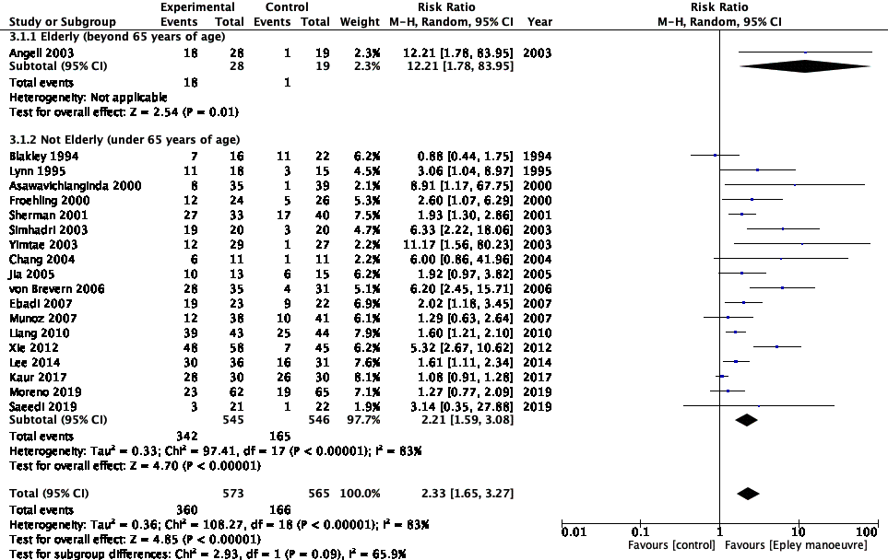
Negative findings (DH test)
Unavailable
All adverse event
Unavailable

DH test, Dix–Hallpike test; CI, confidence interval

2. Vertigo severity (above average if using a scale; for the participants)
Disappearance of subjective symptoms (vertigo)
Unavailable
Negative findings (DH test)
Unavailable
All adverse event
Unavailable
DH test, Dix–Hallpike test;

3. Duration (< 30 days or longer; for the participants)
Disappearance of subjective symptoms (vertigo)
Unavailable

Negative findings (DH test)

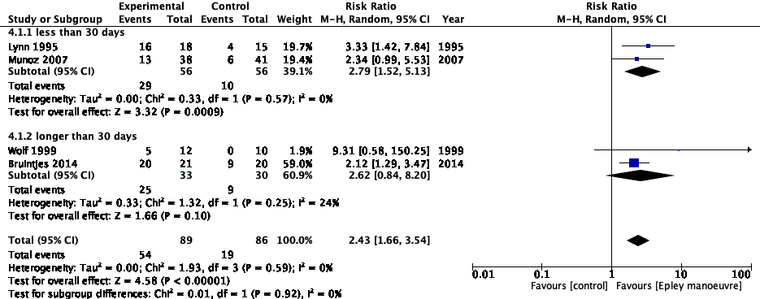

All adverse event
Unavailable

DH test, Dix–Hallpike test; CI, confidence interval

4. First episode or recurrent BPPV (for the participants)
Disappearance of subjective symptoms (vertigo)
Unavailable
Negative findings (DH test)
Unavailable
All adverse event
Unavailable

BPPV, benign paroxysmal positional vertigo; DH test, Dix–Hallpike test

5. Group that performed EM only once vs group that performed EM more than once (for the intervention)
Disappearance of subjective symptoms (vertigo)
Unavailable
Negative findings (DH test)
Unavailable
All adverse event
Unavailable

DH test, Dix–Hallpike test; EM, Epley manoeuvre

6. Group that performed EM by educated practitioners vs group that performed EM by uneducated practitioners or unknown in primary care settings
Disappearance of subjective symptoms (vertigo)
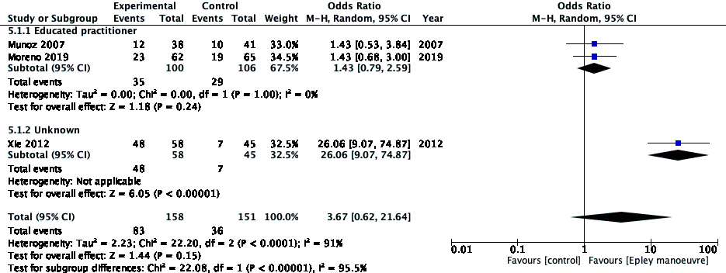
Negative findings (DH test)
Unavailable
All adverse event
Unavailable

EM, Epley manoeuvre

