Additional file 7. Forest plots for each outcome

Patients with BPPV present at primary care clinics.

Primary outcomes
1. Disappearance of subjective symptoms (vertigo)
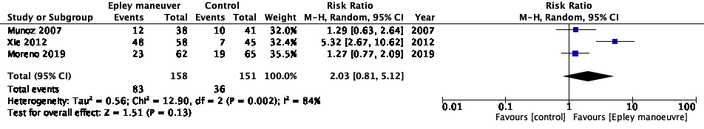
2. Negative findings (DH test)
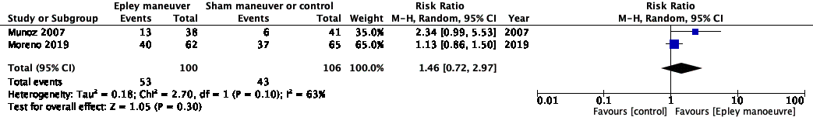
BPPV, benign paroxysmal positional vertigo; DH test, Dix–Hallpike test; CI, confidence interval

Secondary outcomes
1. Disappearance of objective symptoms (nystagmus)
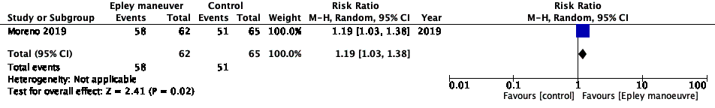
2. DHI-S
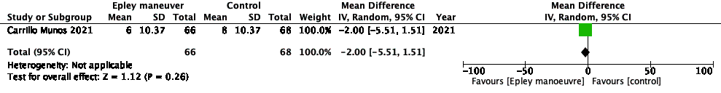
BPPV, benign paroxysmal positional vertigo; DH test, Dix–Hallpike test; CI, confidence interval

Patients with BPPV in the otolaryngology or subspecialty settings

Primary outcomes
1. Disappearance of subjective symptoms (vertigo)
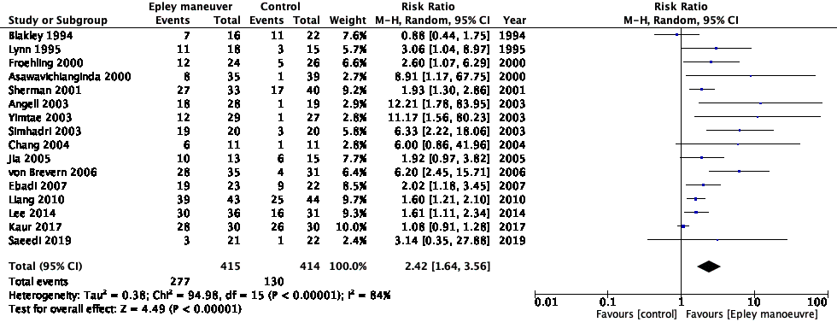
2. Negative findings (DH test)
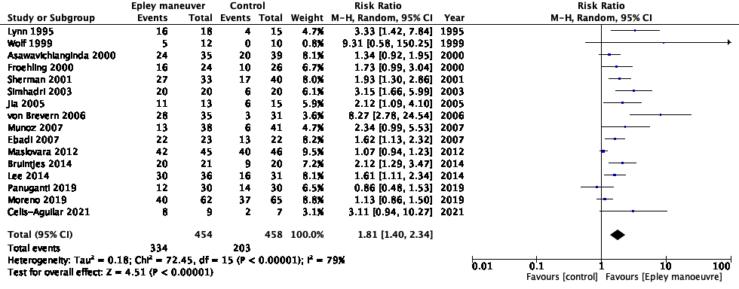
BPPV, benign paroxysmal positional vertigo; DH test, Dix–Hallpike test; CI, confidence interval

Secondary outcomes
1. Disappearance of objective symptoms (nystagmus)
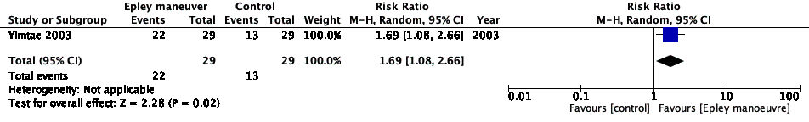
2. DHI-S
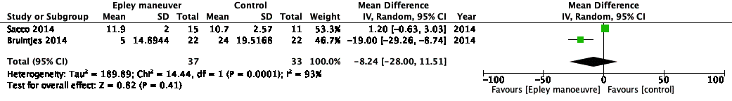
DH test, Dix–Hallpike test; CI, confidence interval

