Additional file 8. Risk of bias table

Patients with BPPV present at primary care clinic
Primary outcomes
1. Disappearance of subjective symptoms (vertigo)
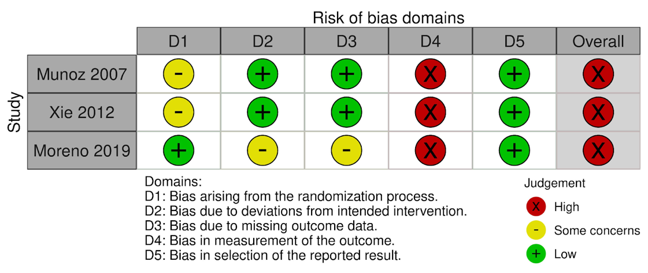
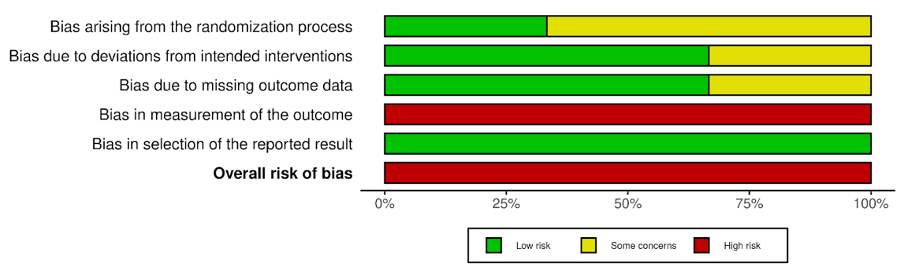
BPPV, benign paroxysmal positional vertigo

2. Negative findings (DH test)
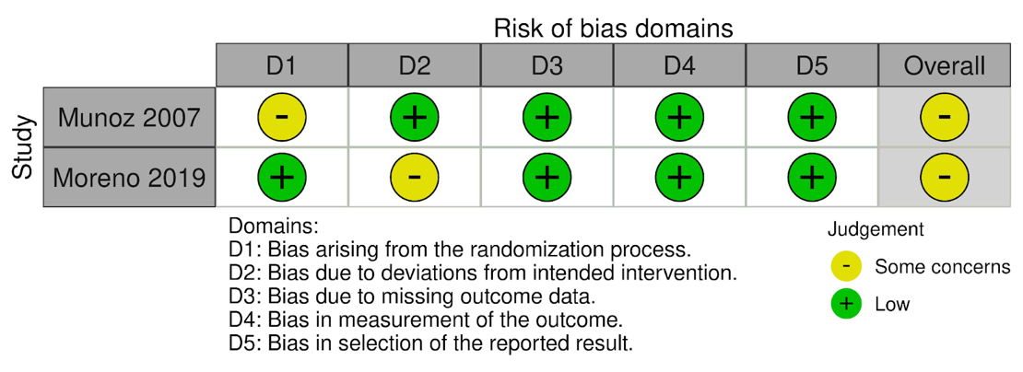
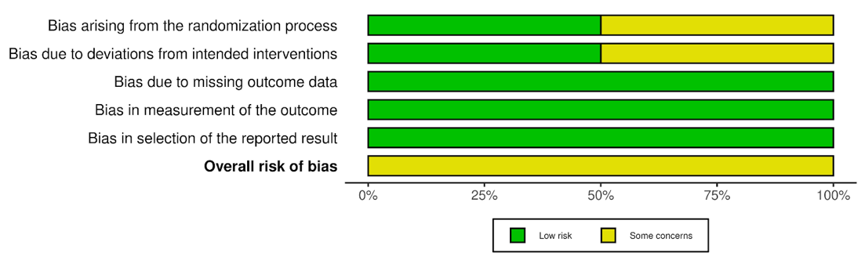
DH test, Dix–Hallpike test
3. All adverse event
None

Secondary outcomes
1. Disappearance of objective symptoms (nystagmus)
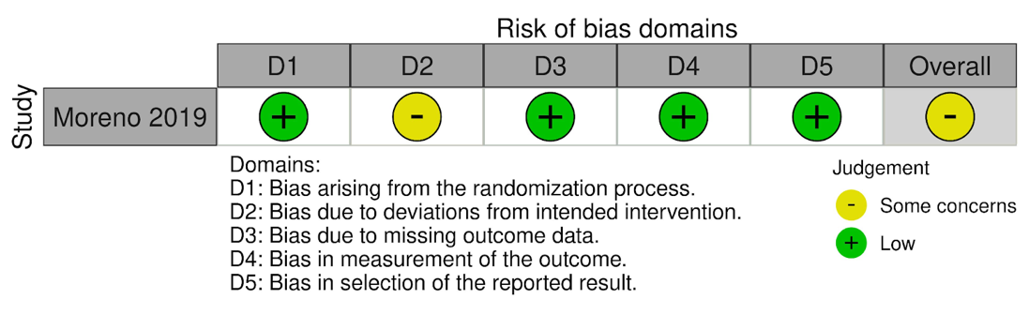
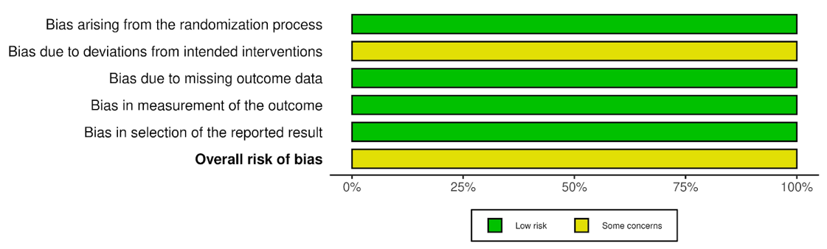

2. DHI-S

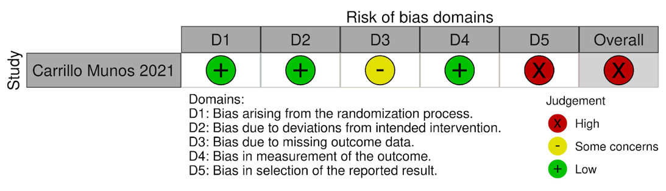
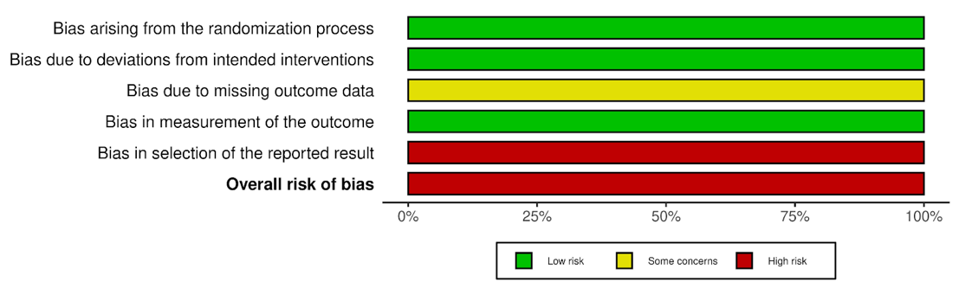
DHI-S, screening version of the Dizziness Handicap Inventory score

Patients with BPPV in otolaryngology or subspecialty settings

Primary outcomes
1. Disappearance of subjective symptoms (vertigo)
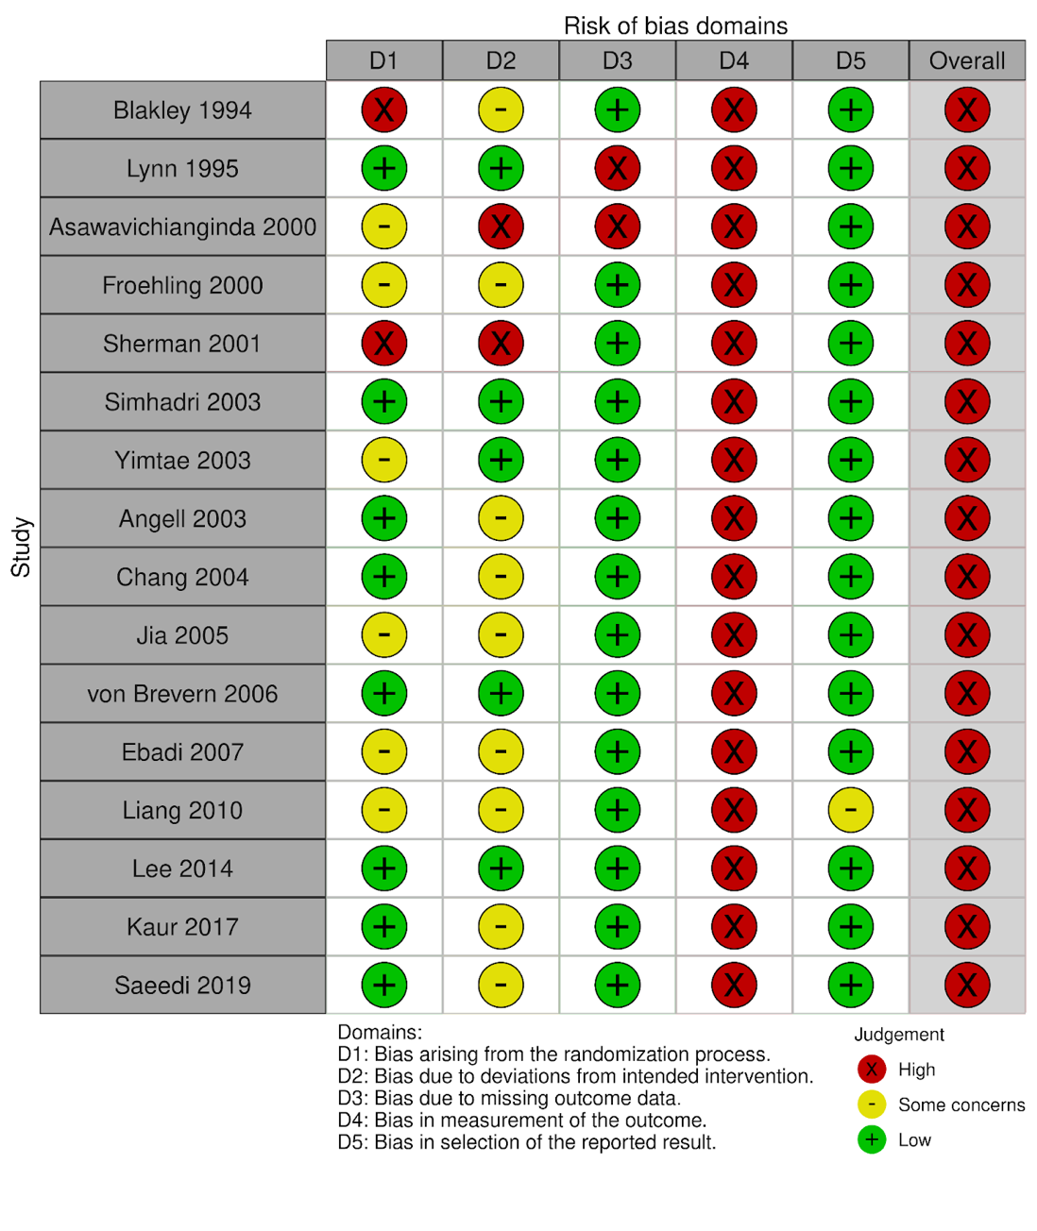
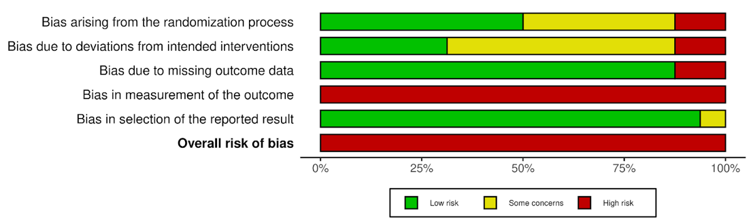
BPPV, benign paroxysmal positional vertigo

2. Negative findings (DH test)
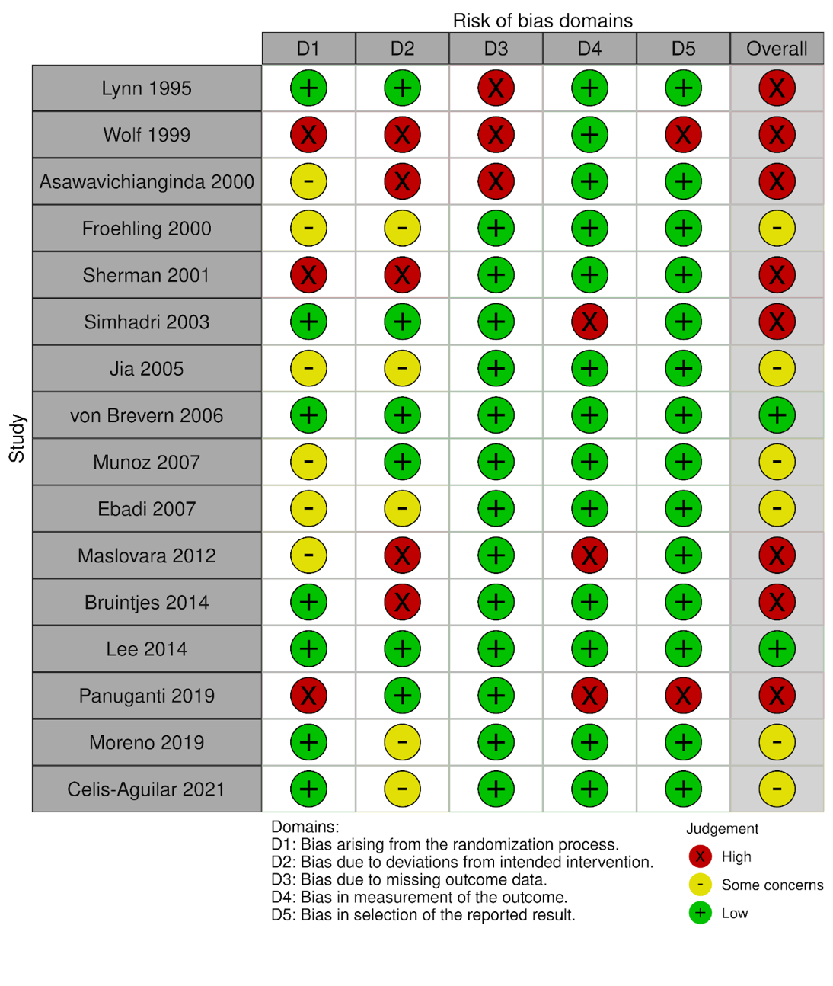
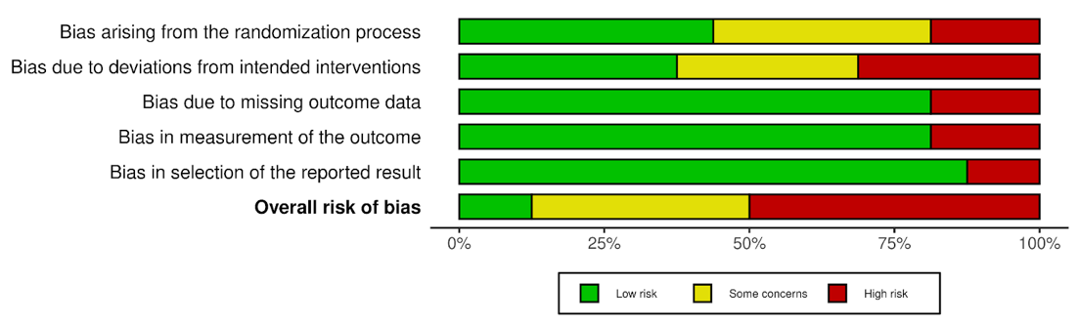
DH test, Dix–Hallpike test

3. All adverse event
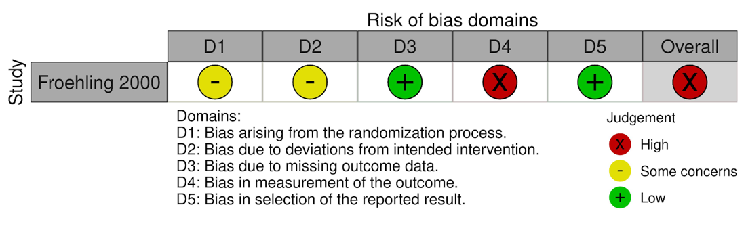
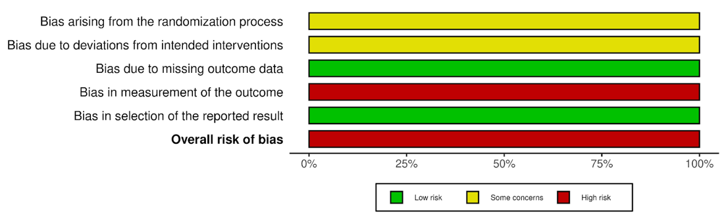

Secondary outcomes
1. Disappearance of objective symptoms (nystagmus)
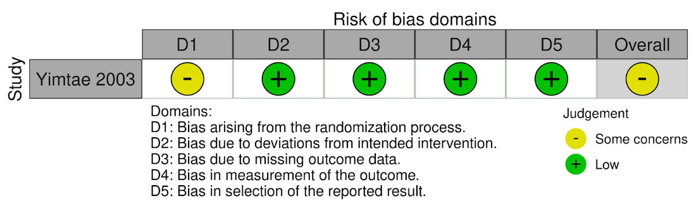
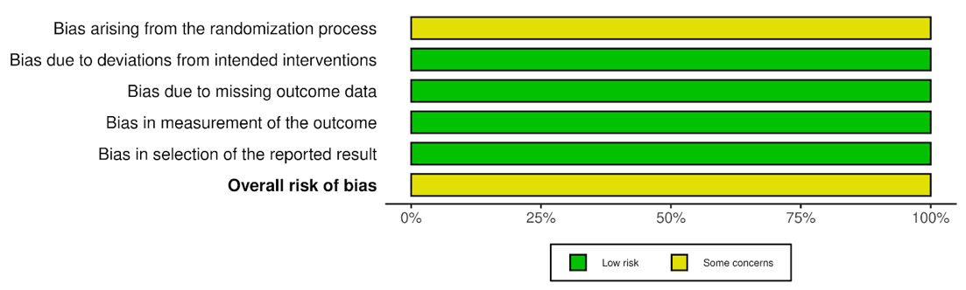

2. DHI-S
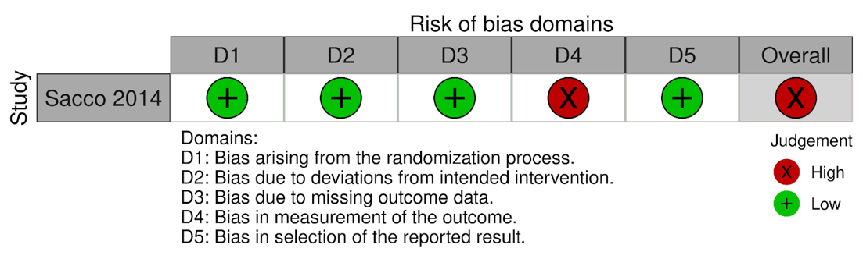
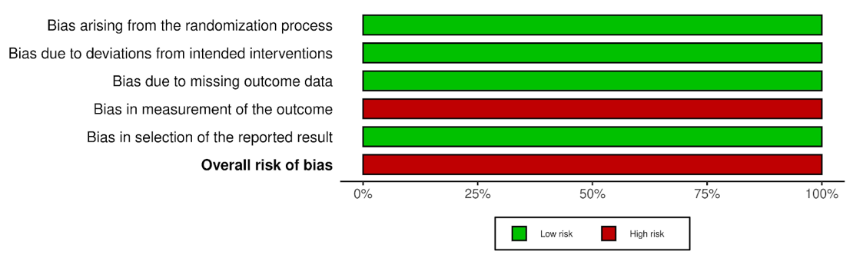
DHI-S, screening version of the Dizziness Handicap Inventory score

