Figure S1a. Histogram of the SPI score of the participants
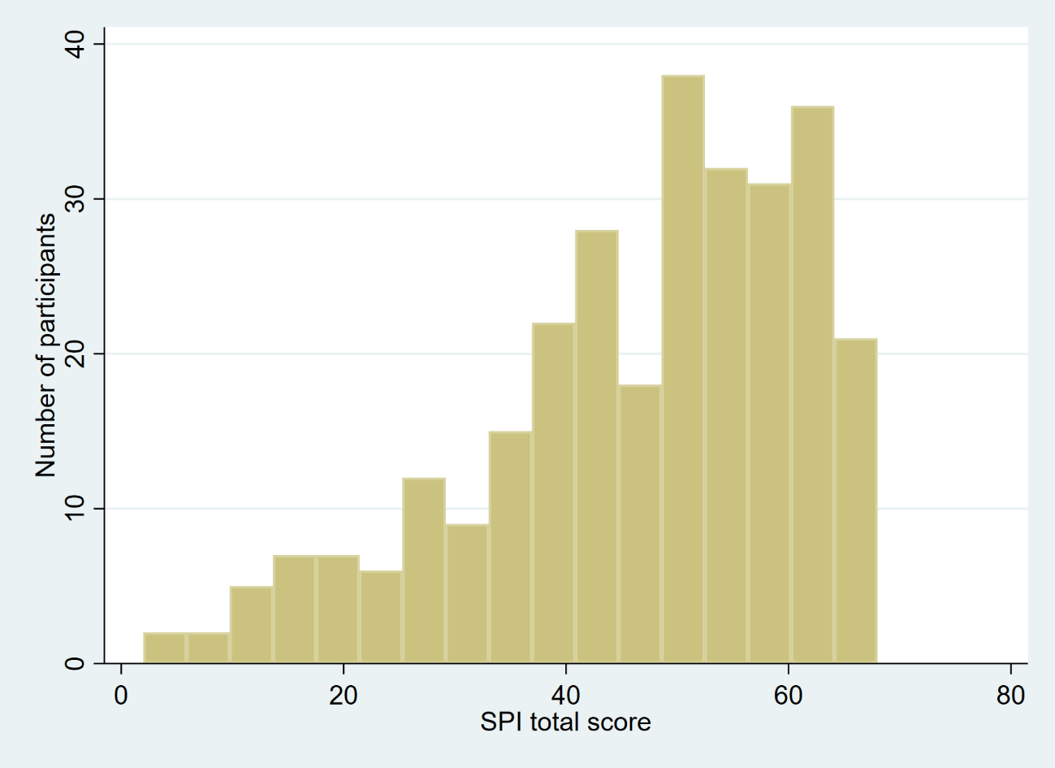

Figure S1b. Histogram of the SP4PC score of the participants
