Figure S1. FHT Software Components – Point of Care Prompt
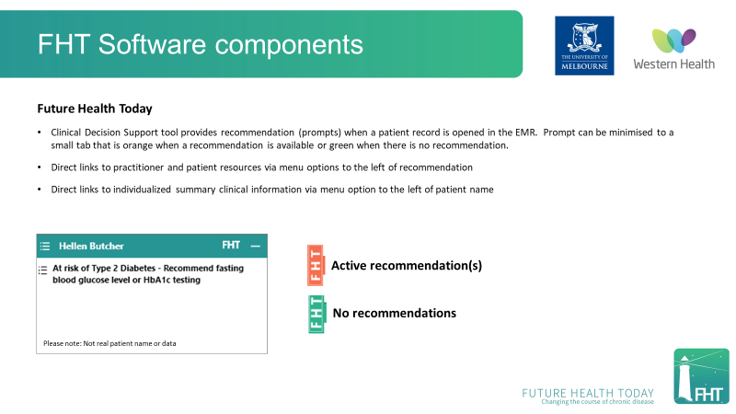

Figure S2. FHT Software Components: Dashboard
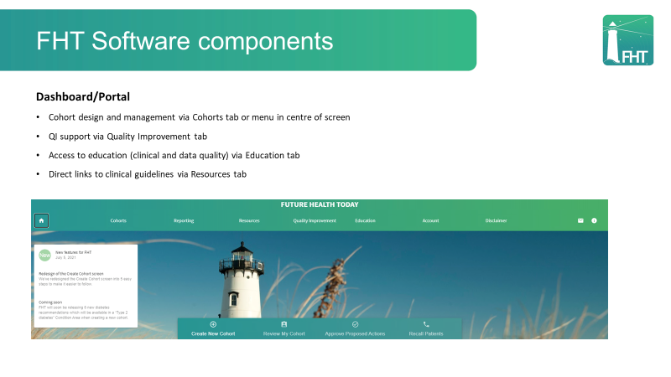

Figure S3. FHT Software Components: Cohort Creation Tool
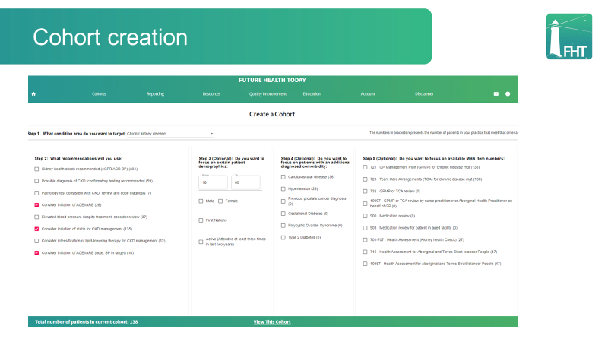

Figure S4. FHT Software Components: Cohort Review Page
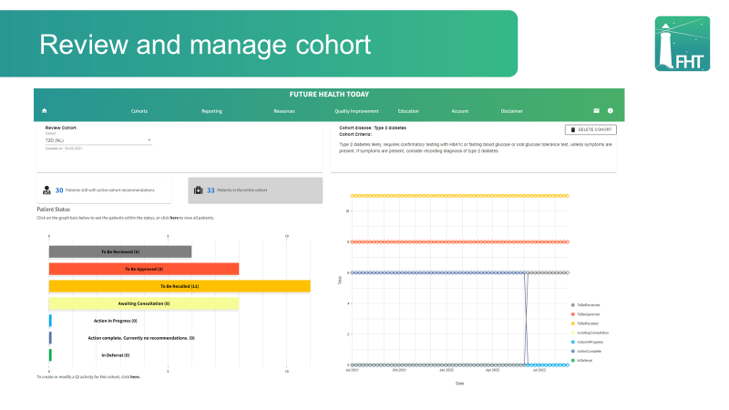
Please note that in this screenshot, the bar graph on the left displays the number of patients in the following categories: To be reviewed, To be approved (for recall or deferral), To be recalled, Awaiting consultation, Action in progress, Action complete (currently no recommendations) and In deferral. The number of patients in each category is provided in brackets beside the bar label. The line graph on the right maps change in number of patients in these categories over time.

