Additional File 1 The details of the consultations course and basic information of experts

The details of the consultations course:
Six relevant experts in different fields were invited for consultation via one-on-one online interviews during June and July 2021. Their feedback was then compiled and summarized, which led to adjustments in the attributes and their respective levels. Attributes such as ‘doctor type’ and ‘service type’ were removed from the list. Additionally, we modified the ‘secondary hospitals and tertiary hospital’ to ‘district and county hospitals, urban tertiary hospitals’ and introduced a new attribute, ‘presence of acquaintances in hospitals,’ to better represent the inpatient preferences of patients.

Table S1 Basic characteristics of experts
 | Gender | Age | Years of working | Specialty | Professional rank
A | Male | 55 | 32 | Health technology assessment | Professor
B | Male | 40 | 16 | Health management | Professor
C | Male | 36 | 11 | Health services administration | Associate Professor
D | Female | 50 | 24 | Preventive medicine | Professor
E | Male | 35 | 11 | Preventive medicine | Associate Professor
F | Male | 46 | 21 | Clinical medicine | Professor

Additional file 2
Research questionnaire on preference of inpatient institution choice among patients with multiple chronic conditions——Version 1

Part 1. Basic information
1. Age: _______ years old
2. Gender: _______
A. Male B. Female
3. Marital status: _______
A. Divorced B. Widowed C. Cohabitation D. Unmarried E. Married
4. Education: _______
A. Illiterate or semi-illiterate B. Elementary school diploma
C. Junior school diploma D. High school diploma
E. College degree F. Bachelor degree or above
5. Profession: _______
A. Worker B. Farmer C. Housework D. Unemployed/laid off
E. Others, please indicate: _______
6. Number of family members: _______
7. Total household income last year: _______
A. <¥10000 B. ¥10000-¥29999 C. ¥30000-¥59999 D. ¥60000-¥99999 E. ¥100000-¥149999 F. ¥150000-¥299999 G. ≥¥300000
Part 2. Situation of chronic diseases
1. Have you ever been diagnosed with a chronic disease by a doctor at the township/district level or above?
A. Yes B. No (Skip to Part 3)
2. What chronic diseases do you know or have been diagnosed by your doctor? What is the perceived severity of your illness? (Multiple options available)
Type of diseases | Perceived severity of illness
(1) Diabetes | A. Mild B. Moderate C. Severe
(2) Coronary Heart Disease (CHD) | A. Mild B. Moderate C. Severe
(3) Stroke/minor stroke | A. Mild B. Moderate C. Severe
(4) Hypertension | A. Mild B. Moderate C. Severe
(5) Hyperuricemia/gout | A. Mild B. Moderate C. Severe
(6) Rheumatoid Arthritis | A. Mild B. Moderate C. Severe
(7) Chronic bronchitis/Emphysema/COPD/Cor pulmonale | A. Mild B. Moderate C. Severe
(8) Interstitial Lung Disease/Pulmonary Fibrosis | A. Mild B. Moderate C. Severe
(9) Pulmonary tuberculosis | A. Mild B. Moderate C. Severe
(10) Asthma | A. Mild B. Moderate C. Severe
(11) Malignant tumor | A. Mild B. Moderate C. Severe
(12) Chronic hepatitis/Liver cirrhosis | A. Mild B. Moderate C. Severe
(13) Gastritis/Gastric ulcer | A. Mild B. Moderate C. Severe
(14) Gallstones/Cholecystitis | A. Mild B. Moderate C. Severe
(15) Non-traumatic fracture (spine/femur) | A. Mild B. Moderate C. Severe
(16) Hyperthyroidism | A. Mild B. Moderate C. Severe
(17) Hypothyroidism | A. Mild B. Moderate C. Severe
(18) Thyroid nodule/Benign thyroid tumor | A. Mild B. Moderate C. Severe
(19) Other disease, please indicate: ____________ | A. Mild B. Moderate C. Severe

Part 3. Inpatient institution selection preference measurement
Note: There are 4 multiple-choice questions below, and each question has two choices: Medical Facility A and Medical Facility B. The two choices are different in the institutional rank, waiting time for hospital admission, hospital with or without acquaintances, time from residence to hospital, out-of-pocket expenses per time, etc. Please select the choice you prefer according to your personal preferences. As you make your choice, assume that all conditions are the same except for the five attributes listed. Note that there are no right or wrong answers.

1. Choice set 1
Attributes | Medical Facility A | Medical Facility B
Institutional rank | District/county hospitals | Urban tertiary hospitals
Waiting time for hospital admission | Bed available on the day | Wait 3 days for a bed
Presence of acquaintances in hospitals | Acquaintance | No acquaintance
Travel time from residence to hospital | More than 3 hours | Less than 1 hour
Out-of-pocket expenses per visit | ¥800 | ¥5000
Which one do you prefer? | ( ) | ( )

2. Choice set 2
Attributes | Medical Facility A | Medical Facility B
Institutional rank | District/county hospitals | Urban tertiary hospitals
Waiting time for hospital admission | Wait 3 days for a bed | Bed available on the day
Presence of acquaintances in hospitals | Acquaintance | No acquaintance
Travel time from residence to hospital | More than 3 hours | Less than 1 hour
Out-of-pocket expenses per visit | ¥800 | ¥2000
Which one do you prefer? | ( ) | ( )

3. Choice set 3
Attributes | Medical Facility A | Medical Facility B
Institutional rank | District/county hospitals | Urban tertiary hospitals
Waiting time for hospital admission | Wait 3 days for a bed | Bed available on the day
Presence of acquaintances in hospitals | No acquaintance | Acquaintance
Travel time from residence to hospital | More than 3 hours | Less than 1 hour
Out-of-pocket expenses per visit | ¥2000 | ¥5000
Which one do you prefer? | ( ) | ( )

4. Choice set 4
Attributes | Medical Facility A | Medical Facility B
Institutional rank | District/county hospitals | Urban tertiary hospitals
Waiting time for hospital admission | Bed available on the day | Wait 3 days for a bed
Presence of acquaintances in hospitals | Acquaintance | No acquaintance
Travel time from residence to hospital | Less than 1 hour | More than 3 hours
Out-of-pocket expenses per visit | ¥5000 | ¥2000
Which one do you prefer? | ( ) | ( )

Research questionnaire on preference of inpatient institution choice among patients with multiple chronic conditions——Version 2

Part 1. Basic information
1. Age: _______ years old
2. Gender: _______
A. Male B. Female
3. Marital status: _______
A. Divorced B. Widowed C. Cohabitation D. Unmarried E. Married
4. Education: _______
A. Illiterate or semi-illiterate B. Elementary school diploma
C. Junior school diploma D. High school diploma
E. College degree F. Bachelor degree or above
5. Profession: _______
A. Worker B. Farmer C. Housework D. Unemployed/laid off
E. Others, please indicate: _______
6. Number of family members: _______
7. Total household income last year: _______
A. <¥10000 B. ¥10000-¥29999 C. ¥30000-¥59999 D. ¥60000-¥99999 E. ¥100000-¥149999 F. ¥150000-¥299999 G. ≥¥300000
Part 2. Situation of chronic diseases
1. Have you ever been diagnosed with a chronic disease by a doctor at the township/district level or above?
A. Yes B. No (Skip to Part 3)
2. What chronic diseases do you know or have been diagnosed by your doctor? What is the perceived severity of your illness? (Multiple options available)
Type of diseases | Perceived severity of illness
(1) Diabetes | A. Mild B. Moderate C. Severe
(2) Coronary Heart Disease (CHD) | A. Mild B. Moderate C. Severe
(3) Stroke/minor stroke | A. Mild B. Moderate C. Severe
(4) Hypertension | A. Mild B. Moderate C. Severe
(5) Hyperuricemia/gout | A. Mild B. Moderate C. Severe
(6) Rheumatoid Arthritis | A. Mild B. Moderate C. Severe
(7) Chronic bronchitis/Emphysema/COPD/Cor pulmonale | A. Mild B. Moderate C. Severe
(8) Interstitial Lung Disease/Pulmonary Fibrosis | A. Mild B. Moderate C. Severe
(9) Pulmonary tuberculosis | A. Mild B. Moderate C. Severe
(10) Asthma | A. Mild B. Moderate C. Severe
(11) Malignant tumor | A. Mild B. Moderate C. Severe
(12) Chronic hepatitis/Liver cirrhosis | A. Mild B. Moderate C. Severe
(13) Gastritis/Gastric ulcer | A. Mild B. Moderate C. Severe
(14) Gallstones/Cholecystitis | A. Mild B. Moderate C. Severe
(15) Non-traumatic fracture (spine/femur) | A. Mild B. Moderate C. Severe
(16) Hyperthyroidism | A. Mild B. Moderate C. Severe
(17) Hypothyroidism | A. Mild B. Moderate C. Severe
(18) Thyroid nodule/Benign thyroid tumor | A. Mild B. Moderate C. Severe
(19) Other disease, please indicate: ____________ | A. Mild B. Moderate C. Severe

Part 3. Inpatient institution selection preference measurement
Note: There are 4 multiple-choice questions below, and each question has two choices: Medical Facility A and Medical Facility B. The two choices are different in the institutional rank, waiting time for hospital admission, hospital with or without acquaintances, time from residence to hospital, out-of-pocket expenses per time, etc. Please select the choice you prefer according to your personal preferences. As you make your choice, assume that all conditions are the same except for the five attributes listed. Note that there are no right or wrong answers.

1. Choice set 1
Attributes | Medical Facility A | Medical Facility B
Institutional rank | Urban tertiary hospitals | District/county hospitals
Waiting time for hospital admission | Wait 3 days for a bed | Bed available on the day
Presence of acquaintances in hospitals | Acquaintance | No acquaintance
Travel time from residence to hospital | More than 3 hours | Less than 1 hour
Out-of-pocket expenses per visit | ¥5000 | ¥800
Which one do you prefer? | ( ) | ( )

2. Choice set 2
Attributes | Medical Facility A | Medical Facility B
Institutional rank | Urban tertiary hospitals | District/county hospitals
Waiting time for hospital admission | Wait 3 days for a bed | Bed available on the day
Presence of acquaintances in hospitals | Acquaintance | No acquaintance
Travel time from residence to hospital | Less than 1 hour | More than 3 hours
Out-of-pocket expenses per visit | ¥800 | ¥2000
Which one do you prefer? | ( ) | ( )

3. Choice set 3
Attributes | Medical Facility A | Medical Facility B
Institutional rank | Urban tertiary hospitals | District/county hospitals
Waiting time for hospital admission | Wait 3 days for a bed | Bed available on the day
Presence of acquaintances in hospitals | No acquaintance | Acquaintance
Travel time from residence to hospital | More than 3 hours | Less than 1 hour
Out-of-pocket expenses per visit | ¥800 | ¥2000
Which one do you prefer? | ( ) | ( )

4. Choice set 4
Attributes | Medical Facility A | Medical Facility B
Institutional rank | Urban tertiary hospitals | District/county hospitals
Waiting time for hospital admission | Bed available on the day | Wait 3 days for a bed
Presence of acquaintances in hospitals | No acquaintance | Acquaintance
Travel time from residence to hospital | Less than 1 hour | More than 3 hours
Out-of-pocket expenses per visit | ¥800 | ¥5000
Which one do you prefer? | ( ) | ( )

Research questionnaire on preference of inpatient institution choice among patients with multiple chronic conditions——Version 3

Part 1. Basic information
1. Age: _______ years old
2. Gender: _______
A. Male B. Female
3. Marital status: _______
A. Divorced B. Widowed C. Cohabitation D. Unmarried E. Married
4. Education: _______
A. Illiterate or semi-illiterate B. Elementary school diploma
C. Junior school diploma D. High school diploma
E. College degree F. Bachelor degree or above
5. Profession: _______
A. Worker B. Farmer C. Housework D. Unemployed/laid off
E. Others, please indicate: _______
6. Number of family members: _______
7. Total household income last year: _______
A. <¥10000 B. ¥10000-¥29999 C. ¥30000-¥59999 D. ¥60000-¥99999 E. ¥100000-¥149999 F. ¥150000-¥299999 G. ≥¥300000
Part 2. Situation of chronic diseases
1. Have you ever been diagnosed with a chronic disease by a doctor at the township/district level or above?
A. Yes B. No (Skip to Part 3)
2. What chronic diseases do you know or have been diagnosed by your doctor? What is the perceived severity of your illness? (Multiple options available)
Type of diseases | Perceived severity of illness
(1) Diabetes | A. Mild B. Moderate C. Severe
(2) Coronary Heart Disease (CHD) | A. Mild B. Moderate C. Severe
(3) Stroke/minor stroke | A. Mild B. Moderate C. Severe
(4) Hypertension | A. Mild B. Moderate C. Severe
(5) Hyperuricemia/gout | A. Mild B. Moderate C. Severe
(6) Rheumatoid Arthritis | A. Mild B. Moderate C. Severe
(7) Chronic bronchitis/Emphysema/COPD/Cor pulmonale | A. Mild B. Moderate C. Severe
(8) Interstitial Lung Disease/Pulmonary Fibrosis | A. Mild B. Moderate C. Severe
(9) Pulmonary tuberculosis | A. Mild B. Moderate C. Severe
(10) Asthma | A. Mild B. Moderate C. Severe
(11) Malignant tumor | A. Mild B. Moderate C. Severe
(12) Chronic hepatitis/Liver cirrhosis | A. Mild B. Moderate C. Severe
(13) Gastritis/Gastric ulcer | A. Mild B. Moderate C. Severe
(14) Gallstones/Cholecystitis | A. Mild B. Moderate C. Severe
(15) Non-traumatic fracture (spine/femur) | A. Mild B. Moderate C. Severe
(16) Hyperthyroidism | A. Mild B. Moderate C. Severe
(17) Hypothyroidism | A. Mild B. Moderate C. Severe
(18) Thyroid nodule/Benign thyroid tumor | A. Mild B. Moderate C. Severe
(19) Other disease, please indicate: ____________ | A. Mild B. Moderate C. Severe

Part 3. Inpatient institution selection preference measurement
Note: There are 4 multiple-choice questions below, and each question has two choices: Medical Facility A and Medical Facility B. The two choices are different in the institutional rank, waiting time for hospital admission, hospital with or without acquaintances, time from residence to hospital, out-of-pocket expenses per time, etc. Please select the choice you prefer according to your personal preferences. As you make your choice, assume that all conditions are the same except for the five attributes listed. Note that there are no right or wrong answers.

1. Choice set 1
Attributes | Medical Facility A | Medical Facility B
Institutional rank | District/county hospitals | Urban tertiary hospitals
Waiting time for hospital admission | Bed available on the day | Wait 3 days for a bed
Presence of acquaintances in hospitals | No acquaintance | Acquaintance
Travel time from residence to hospital | More than 3 hours | Less than 1 hour
Out-of-pocket expenses per visit | ¥5000 | ¥2000
Which one do you prefer? | ( ) | ( )

2. Choice set 2
Attributes | Medical Facility A | Medical Facility B
Institutional rank | District/county hospitals | Urban tertiary hospitals
Waiting time for hospital admission | Wait 3 days for a bed | Bed available on the day
Presence of acquaintances in hospitals | No acquaintance | Acquaintance
Travel time from residence to hospital | Less than 1 hour | More than 3 hours
Out-of-pocket expenses per visit | ¥800 | ¥2000
Which one do you prefer? | ( ) | ( )

3. Choice set 3
Attributes | Medical Facility A | Medical Facility B
Institutional rank | District/county hospitals | Urban tertiary hospitals
Waiting time for hospital admission | Wait 3 days for a bed | Bed available on the day
Presence of acquaintances in hospitals | Acquaintance | No acquaintance
Travel time from residence to hospital | Less than 1 hour | More than 3 hours
Out-of-pocket expenses per visit | ¥2000 | ¥5000
Which one do you prefer? | ( ) | ( )

4. Choice set 4
Attributes | Medical Facility A | Medical Facility B
Institutional rank | District/county hospitals | Urban tertiary hospitals
Waiting time for hospital admission | Wait 3 days for a bed | Bed available on the day
Presence of acquaintances in hospitals | No acquaintance | Acquaintance
Travel time from residence to hospital | Less than 1 hour | More than 3 hours
Out-of-pocket expenses per visit | ¥5000 | ¥800
Which one do you prefer? | ( ) | ( )

Additional file 3 Flow chart of inclusion of the study population
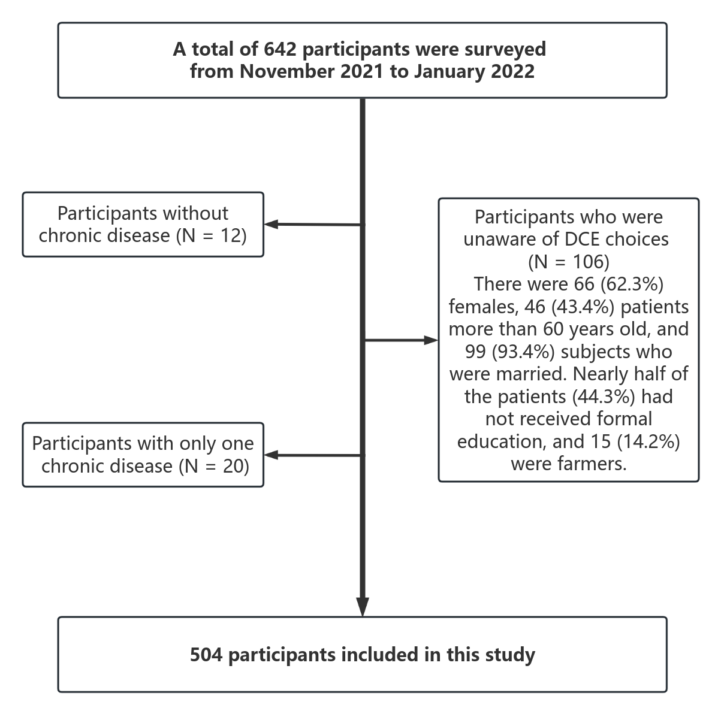

Figure S1 Flow chart of inclusion of the study population

