SUPPLEMENTARY APPENDIX

Appendix 1. Topic guide for individual interview of the participants
Opening statement

Dear participant, thank you very much for your time and effort in participating in the interview. The purpose of the study is to understand the barriers and enablers of interprofessional education on diabetes mellitus in primary care. The study team would like to know the factors that can facilitate in the implementation of IPE in primary care. You are selected as a potential participant because you are providing care at the Polyclinic. This interview goes topic by topic.

(A) Topic guide for interview of the learner (healthcare provider)
Understanding of Interprofessional collaborative practice | - Tell me about your role in working as a team in your current practice?  - Who are the other professions that comprise your current team?  - Tell me about your experience working with other categories of healthcare professionals in your team.  - What do you understand about working together as a team? Can you give an example?  - Sometimes, people tend to work in a silo, in your opinion, what do you think is the difficulty or barrier in working together as a team?  - What do you think is the key to success in working together as a team?  - How do you foresee yourself in working together as a team in managing patients with diabetes?  - How do you think interprofessional team care can help to improve patient’s care or patient’s outcomes such as diabetes control?
Understanding of Interprofessional education | - What do you understand about interprofessional education?  - What do you think is the purpose of interprofessional education?  - Have you participated in interprofessional education before, if yes, would you be able to elaborate your experience?  - What do you think are the benefits in learning together within an interprofessional team?  - According to you, what are the factors that improve team learning?  - According to you, what are the factors that inhibit team learning?
Current perceived competencies related to Knowledge on individual roles in IPE | - What do you understand about your current professional role?  - Within your interprofessional team, do you see yourself as a leader or a follower or both? Can you explain why and in what situations you are a leader or a follower?  - What do you understand about the role of other professionals within your interprofessional team?  - What are the factors that prevent you from knowing the roles of other professions?  - What would help you to understand the roles of other professions?  - People often tend to perceive doctors as more superior than other healthcare staff, do you recognize this? Can you give a situation in which this became obvious?  - What do you think about ‘interprofessional hierarchy’?  - How do you think that IPE can reduce ‘interprofessional hierarchy’?
Current perceived competencies related to Skills & Behaviour | - What do think are current state of communication between healthcare professionals in your team?  - What are the barriers you faced in communicating effectively with other healthcare professions within our team?  - What are the factors that may help to improve communication within your interprofessional team?  - How do you think IPE can help to improve the communication skills in an interprofessional team?
Current perceived competencies related to Attitudes in IPE | - What do you think are the values of interprofessional team learning?  - In your opinion, what are the factors that might influence the willingness to learn together?  - What do think are the difficulties in building trust and mutual respect between healthcare professions?  How do you think IPE can help to improve the competencies within the interprofessional teams on the willingness to work together, building trust and mutual respect?
IPE Content related to diabetes management | - With regards to providing diabetic care for our population, are there any specific areas that you would want to learn as a team? Can you elaborate in detail?  - What do you think are your knowledge gaps in diabetic care?  - What do you think are the knowledge gaps of other professions in providing diabetic are?  - Sometimes, doctors do not communicate well with the nurses on the care plan of the patient with diabetes, in your experience, what are the current gaps related to communication between healthcare professionals within a team in providing diabetic care?  - In your opinion, how fragmented are we in the collaboration within an interprofessional team with regards to diabetic care?
IPE Learning context | - What do you think is the ideal educational activity to learn as a group consisting of different profession? And why? Examples of teaching activities include lecture, problem-based learning, or group assignment.  - What is the ideal setting to conduct an IPE in diabetes care? Why?  - What is the ideal duration to conduct an IPE in diabetes care? Why? Example may be in hours or days.  - What do you think are the goals of doing IPE in diabetes care?  - What are the barriers or enablers related to learning context of IPE with regards to your expectation on the educators?  - What are the barriers or enablers related to learning context of IPE with regards to your expectation on the institution?
Factors related to educator | - What do you think are the current competencies of educators in our institution in teaching IPE?  - How can the educators be more equipped to teach IPE?  - What do you think are the barriers faced by the educators in teaching IPE?
Factors related to resources and processes | - What do you think are the resources required in the implementation of IPE?  - Who do you think are the key players in interprofessional education?  - What are the roles of the key players?  - What are the administrative challenges that you foresee in the implementation of the interprofessional education?  - How can we overcome the administrative challenges?
Factors related to Institution, policy, and professional bodies | - What do you think are the roles of institution leaders in IPE?  - From the institution perspective, what are the factors that can help to improve the implementation of interprofessional education?  - From the institution perspective, what are the factors that can hinder the implementation of interprofessional education?  - From the policy level such as ministry of health, what are the factors that can help to improve the implementation of interprofessional education?  - From the policy level, what are the factors that can hinder the implementation of interprofessional education?  - From the professional body level such as nursing board or medical council, what are the factors that can help to improve the implementation of interprofessional education?  - From the professional body level, what are the factors that can hinder the implementation of interprofessional education?
Others | - Is there anything you would like to add that may facilitate or hinder interprofessional education?
(B) Topic guide for interview of the educator
Understanding of Interprofessional collaborative practice | - Can you elaborate on who are the healthcare professions that constitute a team?  - Tell me about your understanding of interprofessional collaborative practice?  - In your opinion, what do you think of the current state of team-based care in primary healthcare system? Whether it is fragmented or cohesive? And why?  - Sometimes, people tend to work in silos, in your opinion, what do you think is the difficulty or barrier in working within the interprofessional teams?  - What do you think is the key success working in the interprofessional teams?  - How do you think interprofessional teams can help to improve patient’s care or patient’s outcomes such as diabetes control?
Understanding of Interprofessional education | - What do you understand about interprofessional education?  - What do you think is the purpose of interprofessional education?  - Have you taught in interprofessional education before, if yes, what was your experience?  - What do you think are the benefits of interprofessional education?  - According to you, what are the factors that improve interprofessional team learning?  - According to you, what are the factors that inhibit interprofessional team learning?  - What do you think are potential challenges faced by learners (health care professionals) in participating interprofessional education?  - What do you think of the factors that motivate the leaners to learn in interprofessional education?
Current perceived competencies related to knowledge of individual roles in IPE | - In your opinion, what do you think about the understanding of healthcare professionals on their own professional role within interprofessional team?  - In our opinion, what do you think of the about the understanding of healthcare professionals on role of other professions within interprofessional team?  - In your impression, within an interprofessional team, who tends to take up the role of a leader or a follower? Or it is interchangeable? Can you explain why?  - What do you think are the factors that prevent the healthcare professionals from knowing each other’s roles? What do you think are the factors that may help the healthcare professionals in knowing each other’s roles? For example, between the nurses and doctors.  - How can continuous professional development courses on IPE can contribute to the development of competencies related to understanding of own professional role and role of other professions within the interprofessional team?  - People always perceived doctor as more superior than other healthcare staff, what do you think about ‘interprofessional hierarchy’? How do you think that IPE can reduce ‘interprofessional hierarchy’?
Current perceived competencies related to Skills & Behaviour | - In your opinion, what do think is the current state of communication between healthcare professionals?  - What do think are the barriers faced by healthcare professionals in interprofessional teams to communicate effectively with each other?  - What do think are the factors that may help the healthcare professionals to improve the communication skills within the interprofessional teams?  - How can continuous professional development courses on IPE contribute to the development of competencies related to interprofessional communication skills?
Current perceived competencies related to Attitudes in IPE | - What do you think are the values of interprofessional team learning?  - In your opinion, what are the factors that might influence the willingness to learn together among the learners from different professions?  - What do think are the difficulties in building trust and mutual respect between healthcare professions?  - How do you think IPE can help to improve the competencies within the interprofessional teams to improve the willingness to work together, building trust and mutual respect?
IPE Content related to diabetes management | - With regards to providing diabetic care for our population, are there any specific areas that learners would need to learn as a team? Can you elaborate in detail?  - What do you think are the knowledge gaps of different professions in diabetic care?  - Sometimes, doctor does not communicate well with the nurses on the care plan of the patient with diabetes, in your experience, what are the current gaps related to communication between healthcare staff within an interprofessional team in providing diabetic care?  - In your opinion, how fragmented are we in the collaboration within an interprofessional team with regards to diabetic care?
IPE Learning context | - What do you think is the ideal educational activity to learn as a group consists of different profession? And why? Example of teaching activities include lecture, problem-based learning, or group assignment.  - What is the ideal setting to conduct an IPE in diabetes care?  - What is the ideal duration to conduct an IPE in diabetes care? Example may be in hours or days.  - What do you think are the goals of doing IPE in diabetes care?  - How can we assess whether the goals of IPE are met?  - What are the barriers or enablers related to learning context of IPE with regards to your expectation on the learners?  - What are the barriers or enablers related to learning context of IPE with regards to your expectation on the institution?
Factors related to educators | - How can educators be more equipped in teaching interprofessional education?  - How can educators from different professions work together in designing an interprofessional programme?  - Can you foresee any barriers in teaching interprofessional education?  - What do you think of the factors that can facilitate the teaching in interprofessional education?  - Are there any other supports needed to build the competency of the educators in delivering interprofessional education?
Factors related to resources and processes | - What are the resources required in the implementation of interprofessional education?  - Who do you think are the key players in interprofessional education?  - What are the roles of the key players?  - What are the administrative challenges that you foresee in the implementation of the interprofessional education?  - How can we overcome the administrative challenges?
Factors related to Institution, policy, and professional bodies | - What do you think are the roles of institution leaders in IPE?  - From the institution perspective, what are the factors that can help to improve the implementation of interprofessional education?  - From the institution perspective, what are the factors that can hinder the implementation of interprofessional education?  - From the policy level such as ministry of health, what are the factors that can help to improve the implementation of interprofessional education?  - From the policy level, what are the factors that can hinder the implementation of interprofessional education?  - From the professional body level such as nursing board or medical council, what are the factors that can help to improve the implementation of interprofessional education?  - From the professional body level, what are the factors that can hinder the implementation of interprofessional education?
Others | - Is there anything you would like to add that may facilitate or hinder interprofessional education?
(C) Topic guide for interview of the leader
Understanding of Interprofessional collaborative practice | - Can you elaborate on who are the healthcare professions that constitute a team?  - Tell me about your understanding of interprofessional collaborative practice?  - In your opinion, what do you think of the current state of team-based care in primary healthcare system? Whether it is fragmented or cohesive? And why?  - Sometimes, people tend to work in silos, in your opinion, what do you think is the difficulty or barrier in working within the interprofessional team?  - What do you think is the key success working in the interprofessional teams?  - How do you think interprofessional teams practice can help to improve patient’s care or patient’s outcomes such as diabetes control?
Understanding of Interprofessional education | - What do you understand about interprofessional education?  - What do you think is the purpose of interprofessional education?  - What do you think are the benefit of interprofessional education?  - According to you, what are the factors that improve interprofessional team learning?  - According to you, what are the factors that inhibit interprofessional team learning?  - What you think are the potential challenges faced by learners (health care professionals) in participating interprofessional education?  - What do you think of the factors that motivate the learners to learn in interprofessional education?  - From the institution perspective, what are the factors that can help to improve the implementation of interprofessional education?  - From the institution perspective, what are the factors that can hinder the implementation of interprofessional education?
Current perceived competencies related to Knowledge on individual roles in IPE | - In your opinion, what do you think about the understanding of healthcare professionals on their own professional role within interprofessional team?  - In our opinion, what do you think of the understanding of healthcare professionals on role of other professions within interprofessional team?  - In your impression, within an interprofessional team, who tends to take up the role of a leader or a follower? Or it is interchangeable? Can you explain why?  - What do you think are the factors that prevent the healthcare professionals from knowing each other’s roles?  - What do you think are the factors that may help the healthcare professionals in knowing each other’s roles? For example, between the nurses and doctors.  - How can continuous professional development courses on IPE contribute to the development of competencies related to understanding of own professional role and role of other professions within the interprofessional team?  - People always perceived doctor as more superior than other healthcare staff, what do you think about ‘interprofessional hierarchy’?  - How do you think that IPE can reduce ‘interprofessional hierarchy’?
Current perceived competencies related to Skills & Behaviour | - In your opinion, what do think is the current state of communication between healthcare professionals?  - What do think are the barriers faced by healthcare professionals in interprofessional teams to communicate effectively?  - How can continuous professional development courses on IPE contribute to the development of competencies related to interprofessional communication skills?
Current perceived competencies related to Attitudes in IPE | - What do think are the values of interprofessional team learning?  - In your opinion, what are the factors that might influence the willingness to learn together among the leaners from different professions?  - What do think are the difficulties in building trust and mutual respect between healthcare professions?  - How do you think IPE can help to improve the competencies within the interprofessional teams to improve the willingness to work together, building trust and mutual respect?
IPE Content related to diabetes management | - With regards to providing diabetic care for our population, are there any specific areas that learners would need to learn as a team? Can you elaborate in detail?  - What do you think are the knowledge gaps of different professions in diabetic care?  - Sometimes, doctor does not communicate well with the nurses on the care plan of the patient with diabetes, in your experience, what are the current gaps related to communication between healthcare staff within an interprofessional team in providing diabetic care?  - In your opinion, how fragmented are we in the collaboration within an interprofessional team with regards to diabetic care?
IPE Learning context | - What do you think is the ideal education activity to learn as a group consists of different profession? And why? Example of teaching activities: lecture, problem-based learning, group assignment.  - What is the ideal setting to conduct an IPE in diabetes care?  - What is the ideal duration to conduct an IPE in diabetes care? Example may be in hours or days.  - What do you think are the goals of doing IPE in diabetes care?  - How can we assess whether the goals of IPE are met?  - As the leader of institution, how can you facilitate IPE for the learners, educators, and institutions?  - What are the barriers or enablers related to learning context of IPE with regards to your expectation on the leaners?  - What are the barriers or enablers related to learning context of IPE with regards to your expectation on the educators?
Factors related to educators | - How can educators be more equipped in teaching interprofessional education?  - How can educators from different professions work together in designing an interprofessional programme?  - Can you foresee any barriers in teaching interprofessional education?  - What do you think of the factors that can facilitate the teaching in interprofessional education?  - From the institution’s perspective, how can we support the faculty development to improve the competencies of educators in teaching IPE?  - As a leader, what do you think are the other supports needed to build the competency of the teachers in delivering interprofessional education?
Factors related to resources and processes | - What are the resources required in the implementation of interprofessional education?  - Who do you think are the key players in interprofessional education?  - What are the roles of the key players?  - What are the administrative challenges that you foresee in the implementation of the interprofessional education?  - How can we overcome the administrative challenges?
Factors related to the leadership and institution | - From a leader perspective, how can we get a buy-in from senior management on the importance of interprofessional education?  - As a leader, what do you think are the factors that may hinder development and implementation of IPE?  - As a leader, what do you think are the factors that may enable the development and implementation of IPE?  - What do you think of your roles as institution’s leaders in the implementation of the interprofessional education?  - From a leader perspective, how can we sustain the initiative of interprofessional education?
Factors related to policy, and professional bodies | - From the policy level such as ministry of health, what are the factors that can help to improve the implementation of interprofessional education?  - From the policy level, what are the factors that can hinder the implementation of interprofessional education?  - From the professional body level such as nursing board or medical council, what are the factors that can help to improve the implementation of interprofessional education?  - From the professional body level, what are the factors that can hinder the implementation of interprofessional education?
Others | - Is there anything you would like to add that may facilitate or hinder interprofessional education?

Appendix 2. Demographic data of each participant
Subject ID | Age | Gender | Ethnicity | Highest education level | Professional background | Years of practice in primary care | Attended IPE in the past
PG01 | 33 | Male | Indian | Degree | Medical – Resident Physician | 8 | No
PG02 | 29 | Female | Chinese | Master | Medical – Family Physician | 4 | No
PG03 | 30 | Male | Chinese | Degree | Medical – Resident | 3 | No
PG04 | 34 | Female | Chinese | Degree | Allied Health – Pharmacist | 4 | No
PG05 | 25 | Female | Indian | Degree | Allied Health – Podiatrist | 1 | No
PG06 | 44 | Female | Chinese | Master | Allied Health – Dietician | 3 | No
TP001 | 28 | Female | Chinese | Degree | Nursing – Staff nurse | 5 | No
TP002 | 39 | Female | Javanese | National certificate in Nursing | Nursing – Enrolled Nurse | 7 | No
TP003 | 64 | Female | Chinese | O level | Nursing – Senior staff nurse | 18 | No
TP004 | 32 | Female | Chinese | Degree | Allied Health – Pharmacist | 9 | No
HQ01* | 50 | Female | Chinese | Degree | Allied Health - Pharmacist | 25 | Yes
HQ02** | 62 | Female | Chinese | Master | Nursing | 17 | No
HQ03* | 44 | Female | Chinese | Fellowship (FCFP) | Medical | 15 | Yes
HQ04* | 51 | Female | Chinese | Master | Nursing | 2 | No
HQ05** | 56 | Male | Chinese | Degree | Allied Health | 25 | Yes
HQ06** | 42 | Male | Chinese | Fellowship (FCFP) | Medical | 9 | No
SK01 | 60 | Male | Chinese | Degree | Allied Health - Pharmacist | 4.5 | No
SK02 | 31 | Male | Chinese | Degree | Allied Health – Medical social worker | 5 | Yes
SK03 | 42 | Female | Chinese | Degree (GDFM) | Medical – Family physician | 7 | No
SK04 | 50 | Female | Chinese | Master | Nursing – Advanced practice nurse | 18 | Yes
*: Holds an education portfolio; **: Holds a leadership portfolio; FCFP: Fellowship of College of Family Physician; GDFM: Graduate diploma in family medicine

Appendix 3. Questionnaire on participant’s demographics and background data
Qualitative study on the perceived enablers and facilitators of interprofessional education on diabetes in primary care.
Date:  Interview session: | Interviewer name:  Signature:
All participants
Age | ________ years
Gender | 1. Male  2. Female
Ethnicity | 1. Chinese  2. Malay  3. Indian  4. Others: ______________ (Please specify)
Highest education level | 1. Diploma  2. Advanced Diploma  3. Degree  4. Master  5. Fellowship  6. Others: __________________(Please specify)
Professional background | 1. Nursing  2. Medical  3. Pharmacy  4. Dietitian  5. Others: __________________(Please specify)
Designation | _______________________________________  (Please specify: i.e. Staff nurse, Family Physician – Associate consultant, Senior pharmacist)
Years of practice in Primary Care | ___________ years
Attended interprofessional education course in the past | 1. Yes  2. No
Applicable only to educators
Experience in conducting interprofessional education course | 1. Yes  2. No
Attended course on how to conduct interprofessional education | 1. Yes  2. No

Appendix 4. Examples of reflexive journal
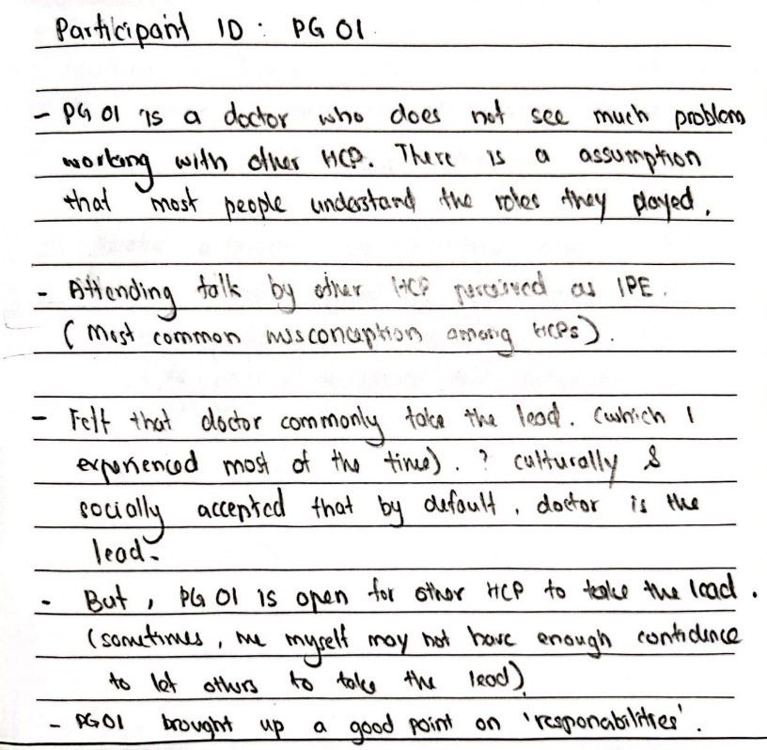
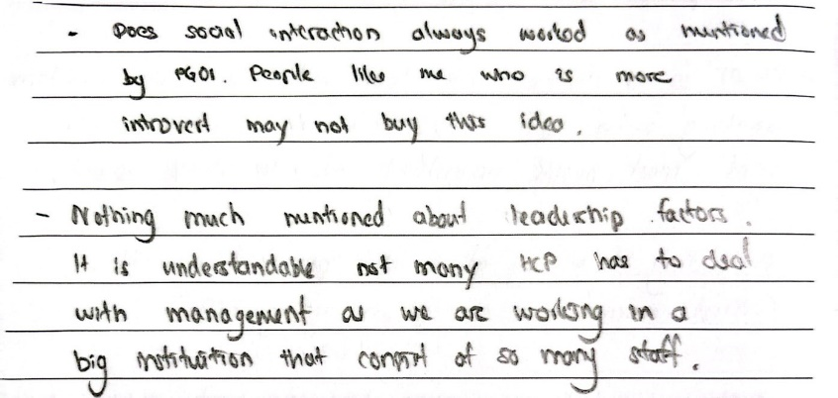

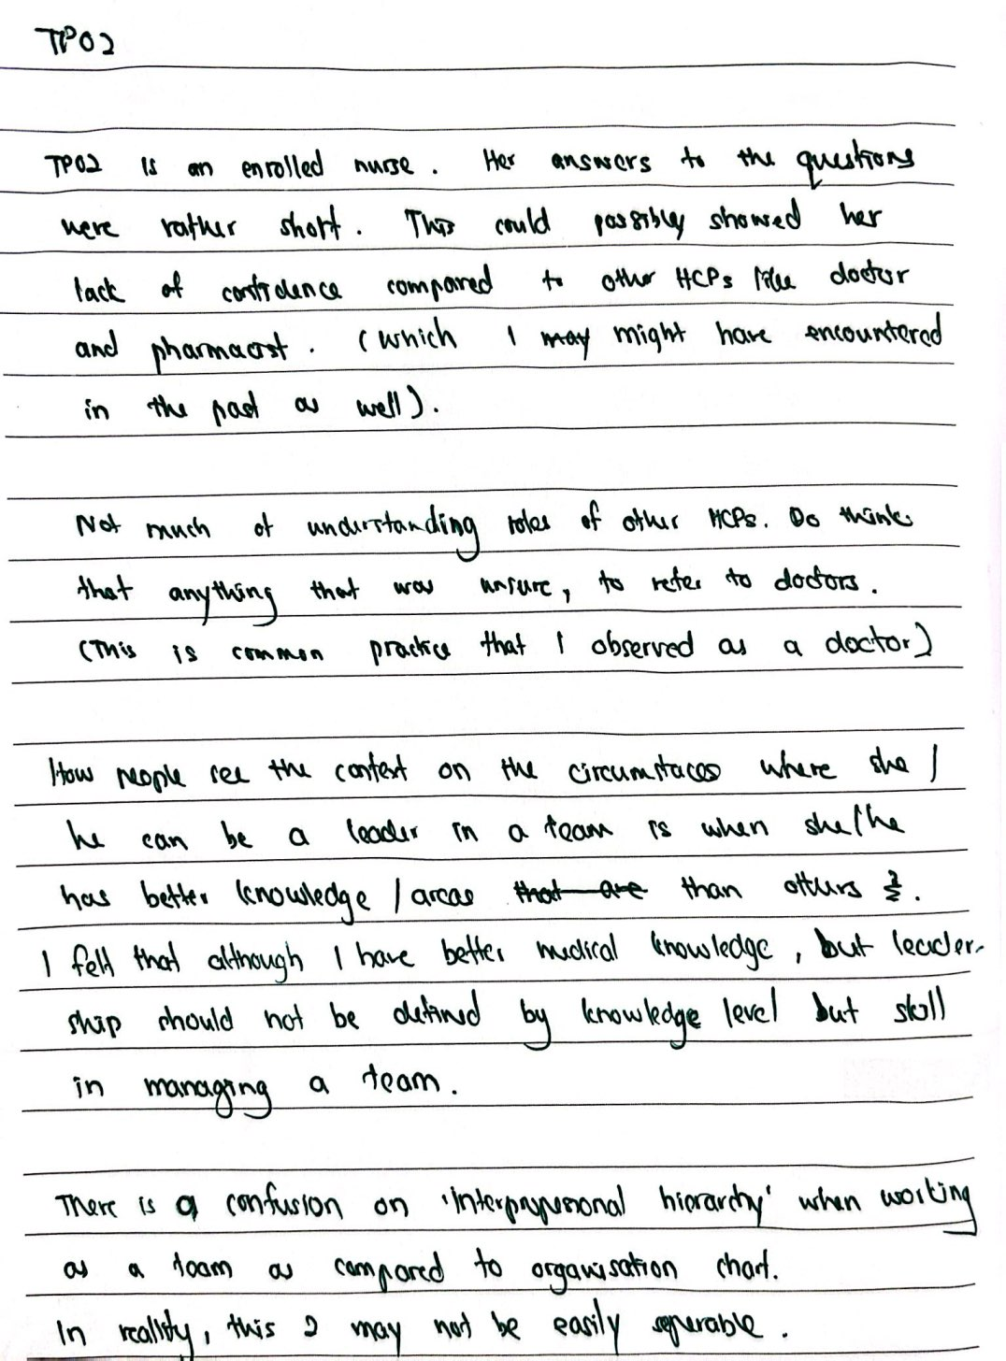

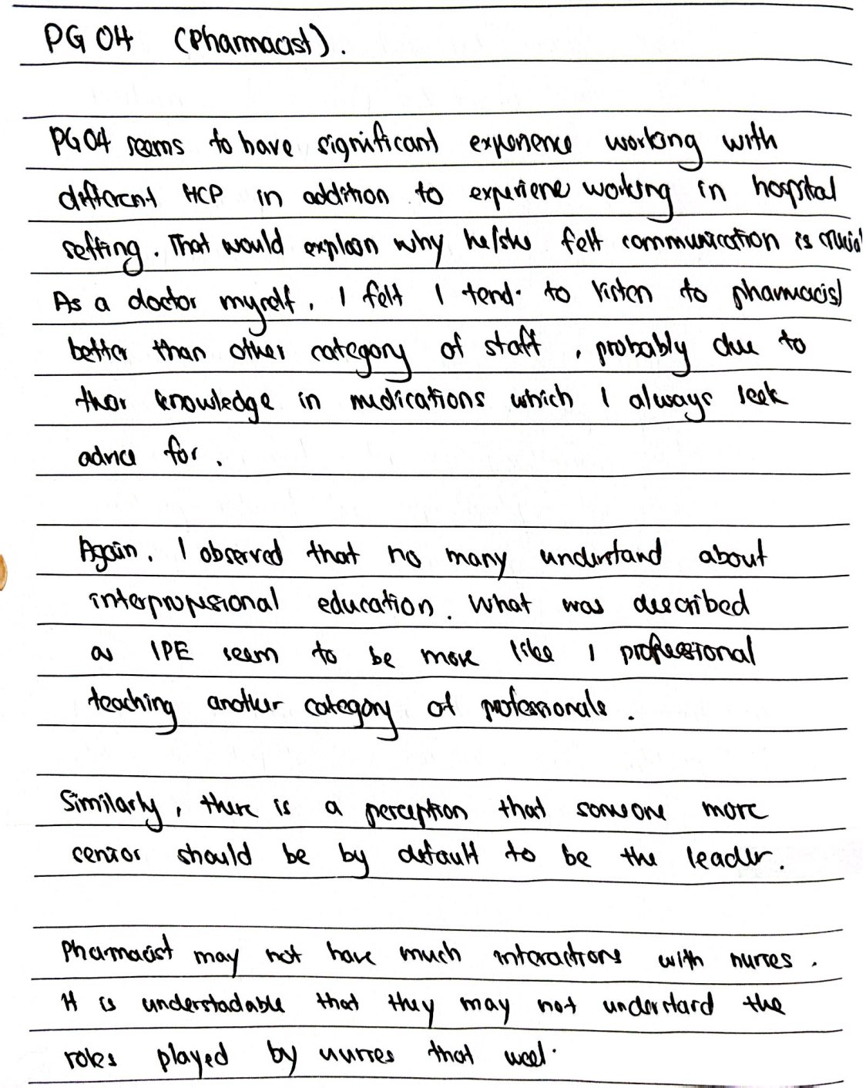

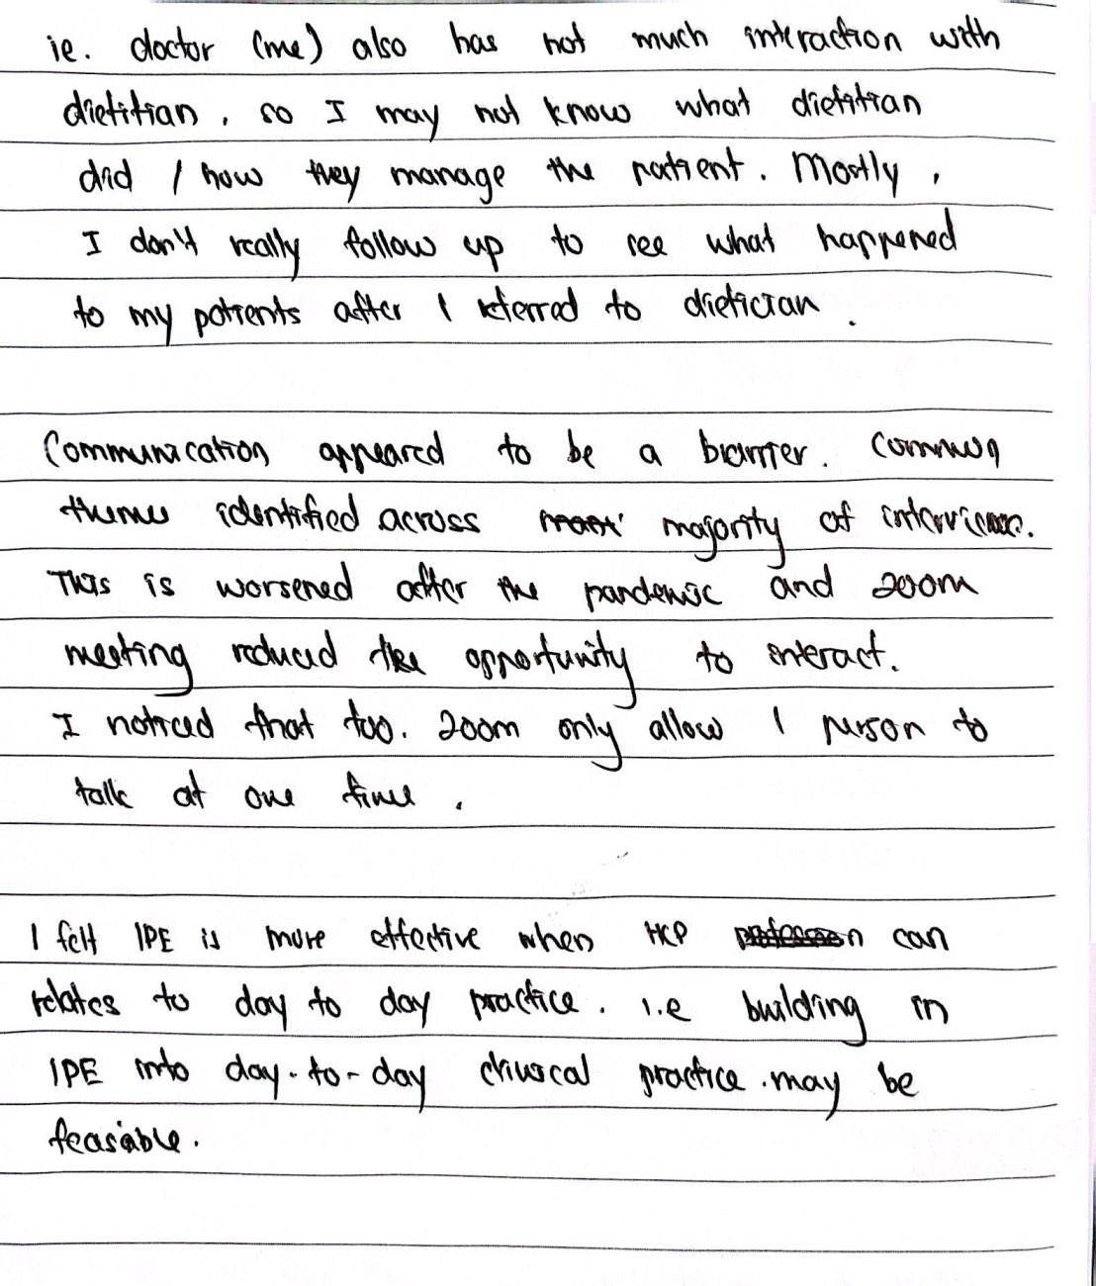
Appendix 5. The details on the perceived barriers and enablers to IPE and its example quotes
Micro level - Healthcare professionals
Interprofessional interactions influenced by learning and work environments
- Active participation through interactive session  - Shaping team dynamic through trust and openness  - Diverse learners with varying past experiences, knowledge levels, training, and learning speeds | “There must be active participation from all members. The team needs to learn from one another. If it is still a very prescribing mode in the IPE set up, listening to just what the doctors are saying, then I don’t think it is truly an IPE team.” (62-year-old, Female, Nurse)  “To improve team learning, I suppose this will go into the dynamics of teams. So, I guess it probably touches on the softer aspect, things like trust, culture of openness.” (44-year-old, Female, Doctor)  “Let's say everybody has (difference in) their experience, their knowledge, their level of training. Because there is a disparity in knowledge, you cannot contribute actively to the work (team learning).” (62-year-old, Female, Nurse)
- Team bonding activities to improve interprofessional relationships  - Exhaustion from work, family commitment, heavy load  - Time pressure at work and its influences on how people perceive the importance of IPE and reduce the opportunity to interact | “Different domains come together to know each other, like a team bonding event where you come together to think of something to do the same thing (together).” (42-year-old, Male, Doctor)  “We work very hard for during the day. At the end of the day, we are totally exhausted. So, fatigue is one of the factors, and to continue even to do it (participate in IPE) at home, I think not everybody is willing to do it. Then family commitments as well.” (60-year-old, Male, Pharmacist)  “Again, time pressure. That influences people’s perception of how important it is. I think it may not be true across the board that everyone sees the potential of interprofessional learning. There would definitely be doctors who think that it is not important.” (29-year-old, Female, Doctor)
Receptiveness towards IPE shaped by HCPs’ attitudes
- Understanding the goals of IPE  - Commitment and willingness to learn  - Recognising the added value of each other bring  - Seeing the value in improving the patient’s care through team learning  - IPE for portfolio building or professional development  - Not believing and lack of understanding in IPE | “Helps the team to work together. And helps uncover potential blind spots. That we might have about each other like sometimes we can make assumptions about what the other person does or not.” (29-year-old, Female, Doctor)  “If the staff have a strong commitment that this is going to succeed, I think it's sustainable over a longer period of time and the programme is more likely to succeed.” (60-year-old, Male, Pharmacist)  “I think the openness, willing to learn from someone not in your domain, not be restricted to wanting to learn only from your own professional group.” (51-year-old, Female, Nurse)  “I think we need to recognize the added value that each other brings to the team. Where we see that this other fellow colleague can help my job.” (44-year-old, Female, Doctor)  “What would motivate the learner is that there is a team learning and they (HCPs) see the success factor of caring for the patient. They see the value of how the team comes together to look after the patient as compared to the provider seeing a patient individually.” (62-year-old, Female, Nurse)  “Maybe it’s more for portfolio and personal development. So, we will have to go along that line to motivate learners.” (50-year-old, Female, Pharmacist)  “You (HCPs) don’t believe in IPE, and you think it’s a waste of time, you have the wrong attitude, then not likely you’ll be able to collaborate with the rest of team.” (56-year-old, Male, Pharmacist)  "Why should I send someone for this course or this project (IPE), which actually is a lot of time and at the expense of the department to help another department.” (50-year-old, Female, Pharmacist)
- Pre-existing good rapport with other HCPs  - Inertia to maintain status quo and non-receptive to change  - Self-consciousness  - Preconceive ideas about others | “Like if you don’t have good rapport with your staff, obviously you don’t want to work with people that you don’t like. (There are) various ways in building trust and respect. Definitely greater understanding of each other’s drones and abilities, competency, that will be the building block of mutual trust and respect.” (31-year-old, Male, Medical social worker)  “There’s always this normal inertia like people is kind of used to doing the thing they want to, and like didn’t think the way they do currently, should be changed.” (33-year-old, Male, Doctor)  “I think sometimes they (HCPs) worry about (own) competency. (Worried that) they may not be so competent so if I (they) share the information, some people think that your information is outdated, your concepts are wrong and so on.” (60-year-old, Male, Pharmacist)  “I think there’s always the mindset that’s, like example, the doctors are very unapproachable, or the nurses are always too busy, we have all these preconceived mindsets, so we may not really want to open up and you really learn from each other.” (32-year-old, Female, Pharmacist)
Interprofessional collaboration through enhancing interprofessional knowledgeability and overcoming interprofessional hierarchy
- Way to improve understanding of the roles of other professions  - Time constraint and busy schedule  - Confined to own’s working space  - Perceived interprofessional hierarchy | “Maybe we could spend some time in the (other) department to see what is being done there, what is the processes they do, what sort of counselling, how they advise the patients, and so on. And how different is it from us? Or what sort of advice that they could give to the patients that are very different from what we are giving to patients.” (60-year-old, Male, Pharmacist)  “Teamwork, work closely together, I think then we can help improve lor. I think teamwork, work together more often, you know, have good relationships” (64-year-old, Female, Nurse)  “Things are so busy that we need to focus on finishing our responsibilities first before we can go on learning what other people do.” (33-year-old, Male, Doctor)  “We are always in our own room with the patient, we don't really go around to check what others are doing.” (39-year-old, Female, Nurse)  “I think that there is this very deep-seated, entrenched that doctors are higher above everyone else. It doesn’t facilitate good working relationships. It also makes communication between the different professions more difficult. Because like that the nurses do not really like raise things to you.” (29-year-old, Female, Doctor)
Effective communication fostered by establishing trust and respect, and addressing psychological barriers
- Showing respect and being professional  - Trust  - Fearful to speak  - Hesitancy to approach other members | “Well, I guess communication will be very important. The way we communicate each other, how we show respect, and still professional at the same time. I mean not just the verbal, the way things are said, the choice of words and then of course the non-verbal, the body language and all that.” (44-year-old, Female, Doctor)  “I think trust and open communication, like how you build the relationship with other departments, how you will be seen as somebody who are proactively trying to help you, and so on. And in return they say, I could also do the same, and that’s how we build our relationship over the long term.” (60-year-old, Male, Pharmacist)  “Imagine I'm just two years old (referring to the level of experience) comparing to the 20-year-old guru (referring to staff with more experience), I'm fearful of what I say, whether it makes sense, or whether you know, is it something useful in terms of my ideas or suggestions? So that may be a hindrance to the communication.” (50-year-old, Female, Pharmacist)  “So, there is a bit of hesitation to go and approach a topic, like with a dietitian, I don't think we had like any formal interactions with them so it's less likely to go direct and approach them without concern or something, whereas opposed to like the nurses, where we have more direct interaction with and going more free with interacting with like mostly asking them question or a doubt. I mean that's just human nature.” (33-year-old, Male, Doctor)
Micro level - Educators
Curriculum (planning, designing, assessment, and evaluation)
- (Planning) Underpinning framework  - (Planning) Learning needs  - (Planning) Defining objectives of IPE  - (Design) Building communication skills into the programme  - (Design) Programme that improves understanding of IPE through hand-on sessions.  - (Design) Relevant content  - (Design) Having regular sessions to apply IPE skills in clinical practice  - (Assessment) Schedule follow-up and review progress  - (Evaluation) Feedback from others | “is there a method of doing or framework (planning of IPE activities) where… Team learning has to be planned.” (42-year-old, Male, Doctor)  “Maybe not being very aware of what the other person (referring to the learner) wants to learn or is knowing already. So, there may be a mismatch of the needs and expectations.” (29-year-old, Female, Doctor)  “If we are given the goals and objectives of the programme, I think we will draw from one another’s strength… That everyone may have a strength that you may not have, so never be limited by your own so-called shortcomings, other people can complement.” (50-year-old, Female, Pharmacist)  “They (referring to past IPE programme attended) actually touched on the importance of communications, be it communicate with the fellow colleagues and also towards patients as well.” (50-year-old, Female, Nurse)  “I think a good IPE programme… It has to be hands-on. That means you have lectures so that everyone sort of is on the same page, (so that) you know what the other members of the healthcare are trained, you know what competencies they have, what they can contribute to healthcare, how they can collaborate. You can start off with this as a base and then you have actual cases that allow you all to work as a team. The more cases we discuss I think the more effective you will be as a team.” (56-year-old, Male, Pharmacist)  “Always revise the contents they (referring to educators) have, through a group discussion from whoever related (experts) in the field.” (28-year-old, Female, Nurse)  “I would say the ideal situation, more discussions. I mean when we have difficult patients, I think it'll be good to share. So monthly meetings may be good, to just highlight a few cases to help to improve communication between the different (members within the) teams, and then this could be an avenue for us to discuss anything that we feel that we can improve in terms of processes.” (34-year-old, Female, Pharmacist)  “We can schedule some follow-up meetings... in a timely manner, say 2-3 months. To just follow up with what we have discussed (taught), and to see through (evaluate) if some of these action points (learning goals) have been achieved and at what state. So, it is always good to take stock of the progress.” (50-year-old, Female, Pharmacist)  “Evaluate, meaning, getting feedback and seeing how effective the learners have learned and then improving it.” (42-year-old, Male, Doctor)
Attitudes of educators and importance of professional development
- Embrace IPE  - Having the knowledge and clinical context  - Equipped with up to date on the latest research evidence  - Teaching and facilitating skills  - Friendly and a good communicator | “When they themselves embrace the IPE. They would be able to relate their own experience and be able to keep on emphasizing the importance of IPE in the patient care.” (50-year-old, Female, Nurse)  “I think the educator has to be someone who is really experienced in terms of clinical knowledge and experience, to be able to provide the best advice.” (32-year-old, Female, Pharmacist)  “So can they (educators) be more equipped, I think keeping up with latest research.” (25-year-old, Female, Podiatrist)  “You (educator) must have a good facilitation skill or coaching skill because you want to ensure that the professionals learn from each other.” (51-year-old, Female, Nurse)  “Should be friendly, able to communicate effectively. And yeah, also should be knowledgeable about the subject.” (33-year-old, Male, Doctor)
- Mentorship for skill enhancement  - Collaboration with other educators  - Investing time in training | “I think maybe someone, a mentor with experience. So, the educator can always like seek help. Approachable person that I think, this educator can always look for.” (50-year-old, Female, Pharmacist)  “I think they (educators) have to really learn from the other departments. Example in hospital they have ward rounds, and they learn from each other before they can even teach people how to do things, in a more collaborative way.” (32-year-old, Female, Pharmacist)  “I think that it’s the time limitation. Do we really have the time to prepare all this information to upgrade yourself (educators) to get up to date information on practices.” (60-year-old, Male, Pharmacist)
Meso - Institution or organisation
Resource allocation, system changes and outcome measurements in the implementation of IPE programme
- Resources in developing the programme  - Formalising the training programme  - Infrastructure  - Using an online platform (intranet) to disseminate information on the job scope of various HCPs.  - Allocate time for a regular meeting to discuss cases  - Priority is given to clinical service above education needs  - Inability to allow protected time for HCPs to participate in IPE  - System only allows more senior staff to attend multidisciplinary team meetings and it limits the understanding of each other’s roles  - No structure in place to allow communication  - Difficulty in the measurement of outcomes (Key performance index -KPI) related to IPE | “You need to allocate resources. I think this must come from the top. Sufficient resources must be given and then an effective IPE programme must be developed. Co-developed, co-created.” (56-year-old, Male, Pharmacist)  “Besides the training, the formalized kind of training that the individual will be subjected to.” (62-year-old, Female, Nurse)  “Ideally, I look at it for the new (future) polyclinic, the structure must be there to facilitate the IPE kind of model approach. Meaning that you have a team, the infrastructure must be built to encourage the team. To have an ease in communication, talking to one another.” (62-year-old, Female, Nurse)  “Would be good to use intranet to explain job scope, (and) role. As an example, like a social worker, last time we always think that they only do financial assistance, financial help, but actually they can do a lot of counselling for grieving, bereavement.” (50-year-old, Female, Nurse)  “Perhaps set aside time for us to have, maybe monthly post-mortem, (so that) we can discuss difficult cases or any cases that have been which we felt could have been managed better.” (42-year-old, Female, Doctor).  “We're running a very heavy clinic. So, to pull us out to do something else, I think it weighs very heavily on the manpower within the same department.” (60-year-old, Male, Pharmacist)  “Give protected time to the people, provide opportunities for learning, sharing of information and management of patient. with a specific problem.” (60-year-old, Male, Pharmacist)  “It's more of a senior (who) shared with me (on) who is involved in MDT. But for myself I'm not involved in it, so I don't really know what other professionals are doing.” (28-year-old, Female, Nurse)  “The other barrier could be perhaps not having a structure where all the team members can update each other immediately. If we have some tools that we can use, some applications or some structure where we can make sure that everyone is on the same page before we even have a face-to-face discussion then it would be more fruitful.” (31-year-old, Female, Medical social worker)  “But the problem again, as I said, the KPI cannot be measured. Then that makes it difficult to even budget or even propose a budget. So, the senior leadership or the management, has to be very open-minded in this. In that, they probably do believe that it helps and just go for it without the need to measure it.” (42-year-old, Male, Doctor)
Leadership support for IPE
- Leadership support and buy-in to be sustainable  - Leader ability to see the value of IPE  - Leader roles in raising awareness of IPE/ IPCP  - Promoting from the top down  - Leader taking initiative, delegating, and organizing IPE  - Lack of supervisor or departmental support  - IPE is not something promoted by leadership | “I think the most important is management support. Strong leadership and also buy in.” (60-year-old, Male, Pharmacist)  “Certainly, they (leaders) have to believe the benefits of IPE. Which I would think they are. They believe the values and being supportive on this. And then, maybe an organisation or an institution’s vision. It has to encompass a very big vision.” (50-year-old, Female, Pharmacist)  “Encouraging the professionals to go for IPE, creating awareness.” (25-year-old, Female, Podiatrist)  “To give resources and to encourage the staff” (56-year-old, Male, Pharmacist)  “I think the leaders need to be aware and need to encourage IPE, IPC. I suppose not just word of mouth, not just verbally, but they should invest resources and time. In terms of role modelling, I was saying that they should maybe encourage these entities to happen.” (44-year-old, Female, Doctor)  “I guess taking the initiative and the delegating and organizing it. That would be their role.” (33-year-old, Male, Doctor)  “As long as good for your department it is also good for your institution as a whole (referring to benefit of IPE). I think sometimes not all supervisors think the same.” (50-year-old, Female, Pharmacist)  “It's not something promoted by the leadership. So, meaning if your leader never says that it's important, then you probably will not think that is important.” (42-year-old, Male, Doctor)
Macro level - Policy / Professional bodies
Policymakers’ roles in funding and national strategy
- Provide resources such as funding  - Support IPE to be aligned with healthcare transformation  - Using the media to promote interprofessional team-based care | “They (policymakers) need to recognize the importance, make it something like a priority. So, budget it, and probably provide some grants for projects, that come out from all these learning (IPE) and collaborations.” (42-year-old, Male, Doctor)  “If there is a benefit and a powerful model of care to be implemented, I think the ministry taking the stand will be very powerful to implement this total change in how the patient should be organized and seen at a primary care level.” (62-year-old, Female, Nurse)  “They (policymakers) should also collaborate with media, in order to promote this interprofessional team so that people around can share.” (28-year-old, Female, Nurse)
Professional bodies’ roles in providing educational resources
- Providing educational resources on IPE  - Journal or articles published by professional bodies | “As for their level (professional bodies), I guess, providing information and having more talks (courses) or conference, or if there's a website for the staff to refer to, like if I want to know more about IPE, what is the website that I actually should go through.” (28-year-old, Female, Nurse)  “I mean we do read articles in their (professional bodies) journals, maybe article in there, that gets disseminated out to all the physicians.” (42-year-old, Female, Doctor)
B denotes barrier; E denotes enable

