TITLE: Team climate, job satisfaction, burnout and practice performance: Results of a national survey of staff in general practices in England

SUPPLEMENTARY MATERIALS

SUPPLEMENTARY MATERIALS 1: Survey questionnaire
Question | Topic | Item and scoring
Preliminary | Consent | Agreement of having read and understood the information for staff and willingness to participate
Preliminary | Practice ODS code | Organisation Data Service (ODS) unique practice code (six characters) so the response could be matched to a practice for analysis
1-14  Team Climate Inventoryª | Participatory safety domain | We have a ‘we are in it together’ attitude in the practice | Response options:  1 Strongly disagree  2 Disagree  3 Neither agree nor disagree  4 Agree  5 Strongly agree  Agreement (higher scores) signifies better team climate
1-14  Team Climate Inventoryª | Participatory safety domain | People keep each other informed about work-related issues in the practice
1-14  Team Climate Inventoryª | Participatory safety domain | People in the practice feel understood and accepted by each other
1-14  Team Climate Inventoryª | Participatory safety domain | There are real attempts to share information throughout the practice
1-14  Team Climate Inventoryª | Task orientation domain | Members of the practice are prepared to question the basis of what the practice is doing
1-14  Team Climate Inventoryª | Task orientation domain | Members of the practice critically appraise potential weaknesses in what the practice is doing in order to achieve the best possible outcome
1-14  Team Climate Inventoryª | Task orientation domain | Members of the practice build on each other’s ideas to achieve the best possible outcome
1-14  Team Climate Inventoryª | Support for innovation domain | People in the practice are always searching for fresh, new ways of looking at problems
1-14  Team Climate Inventoryª | Support for innovation domain | In this practice we take the time needed to develop new ideas
1-14  Team Climate Inventoryª | Support for innovation domain | People in the practice cooperate in order to help develop and apply new ideas
1-14  Team Climate Inventoryª | Filter ^{b} | Are you aware of your practice’s objectives? Yes / No (Go to Q15).
1-14  Team Climate Inventoryª | Vision domain  (If answers Yes to Filter) | How strongly to you agree or disagree with your practice’s objectives?
1-14  Team Climate Inventoryª | Vision domain  (If answers Yes to Filter) | Your practice’s objectives are clearly understood by other members of the practice
1-14  Team Climate Inventoryª | Vision domain  (If answers Yes to Filter) | Your practice’s objectives can actually be achieved
1-14  Team Climate Inventoryª | Vision domain  (If answers Yes to Filter) | These objectives are worthwhile to the organisation
15 | Job satisfaction^{c} | Please state your overall satisfaction with your job.  1 Extremely dissatisfied; 2 Mostly dissatisfied; 3 Somewhat dissatisfied; 4 Neither satisfied nor dissatisfied; 5 Somewhat satisfied; 6 Mostly satisfied; 7 Extremely satisfied
16 | Intention to quit | How likely is it that you will be working in this practice in 2 years time?  1 Very unlikely; 2 Unlikely; 3 Neutral; 4 Likely; 5 Very likely  If answers 1 Very unlikely, or 2 Unlikely: How likely is it that you will: A Retire; B Continue to work in health care; C Continue to work but not in health care
17 | Burnout | How often do you agree with the following statement: ‘I feel burned out from my work’.  Burnout was described as ‘exhaustion, cynicism and detachment from the job, sense of ineffectiveness and lack of accomplishment’ ^{d}  0 Never; 1 A few times a year; 2 Once a month or less; 3 A few times a month; 4 Once a week; 5 A few times a week; 6 Every day  High levels of burnout are identified as once a week or more (score >=4) ^{e}
18 – 20 | About respondent | What is your role in the practice? Doctor / Nurse or other health professional involved in direct patient care (DPC)/ Managerial, administrative, receptionist, estates (non-clinical) / Rather not say
18 – 20 | About respondent | What is your age group? Less than 35/ 35-54 / 55 and over / Rather not say
18 – 20 | About respondent | Are you …. Male / Female / Rather not say
21 -23 | About working post Covid-19 | At the current time, how much of your work are you doing in the practice and how much from home? Mostly in the practice / Mostly from home / Split between practice and home
21 -23 | About working post Covid-19 | Since Covid-19, has the way you work changed? A lot / A little / Not much
21 -23 | About working post Covid-19 | How has Covid-19 affected the way in which practice staff work as a team? Improved / About the same/ Worsened / Was always good and has remained so

ª Shortened version: Kivimaki M. Elovainio M. (1999), A short version of the Team Climate Inventory: Development and psychometric properties. Journal of Occupational and Organizational Psychology, 72: 241-246. Strating MM, Nieboer AP. Psychometric test of the Team Climate Inventory-short version investigated in Dutch quality improvement teams. BMC Health Serv Res 9, 126 (2009). https://doi.org/10.1186/1472-6963-9-126https://doi.org/10.1348/096317999166644

^{b} The filter question was introduced because the pilot study revealed that many respondents were unaware of their practice objectives and therefore could not complete the vision domain. The vision domain, which is usually presented first, was moved to the end of the Team Climate Inventory.
^{c} Overall job satisfaction item from Warr P, Cook J, Wall T. (1979). Scales for the measurement of some work attitudes and aspects of psychological well-being. Journal of Occupational Psychology, 52(2) 129-148. https://doi.org/10.1111/j.2044-8325.1979.tb00448.x
^{d} Overall emotional exhaustion item from Maslach Burnout Inventory: Dolan ED, Mohr D, Lempa M. et al. Using a single item to measure burnout in primary care staff: a psychometric evaluation. J Gen Intern Med. 2015 May;30(5):582-7. doi: 10.1007/s11606-014-3112-6. Epub 2014 Dec 2. PMID: 25451989; PMCID: PMC4395610.
^{e} West CP, Dyrbye LN, Sloan JA. et al. Single item measures of emotional exhaustion and depersonalization are useful for assessing burnout in medical professionals. J Gen Intern Med. 2009 Dec;24(12):1318-21. doi: 10.1007/s11606-009-1129-z. Epub 2009 Oct 3. PMID: 19802645; PMCID: PMC2787943.

SUPPLEMENTARY MATERIALS 2: Practice level variables and sources
Topic | Variable | Source
Patient population | Number of registered patients | General Practice workforce minimum data set, June 2022, (NHS Digital)
Patient population | Percentage of registered patients aged 65 or over
Workforce and Workload | - Head counts and full time equivalents (FTEs) of General Practitioners (GPs), Nurses, other Direct Patient Care (DPC) professionals (e.g. healthcare assistants, counsellors, pharmacists) and staff in non-clinical roles (managers, administrative, receptionists, estates);  - Descriptors of GPs: role (partner, salaried, registrar/ trainee, locum); age band; gender; if qualified in UK.  Computed variablesª  - Practice response rate, from practice head count  - Workforce composition:  - Percentage of total practice FTE (GP + Nurse + DPC+ non clinical) that is clinical;  - Percentage of total clinical FTE performed by GPs;  - Percentage of total GP FTE performed by partners;  - Percentage of total GP FTE performed by female GPs;  - Percentage of total GP head count aged >=55 years;  - Percentage of total GP head count qualified in the UK.  - Training practice (Yes/ No)^{b}: practice workforce data reported doctors in training (foundation years 1, 2 and / or specialist GP trainees/ registrars.  - Practice reported use of locums (Yes/ No) ^{c}.  - Part time GP working: Average GP FTE per GP head count  - Workload:  - total practice workload: (FTE of GPs + Nurses + DPC + non-clinical) / 1000 registered patients  - GP workload: (FTE of GPs) / 1000 registered patients
Practice profile measures | Urban or Rural practice | Practice Payments data 2021/22 (NHS Digital)
Practice profile measures | Deprivation decile | National General Practice Profile June 2022 (Public Health England)
Practice performance measures | - Clinical effectiveness: Percentage of attainable points achieved in the 2021/22 Quality and Outcomes Framework (QOF) annual reporting, a points system that rewards practices for quality of care across key clinical areas and public health;  - Patient’s overall experience of the practice: Percentage of patients reporting a positive (good or very good) experience of the practice in the 2022 national General Practice Patient (experience) Survey (GPPS).
ª Variables involving GP FTE includes only permanent GPs, i.e. excludes registrars/ trainees and locums.
^{b} Binary Yes/No variable used due to concerns regarding data inconsistencies in reporting of trainees
^{c} Binary Yes/No variable used because locums were only reported in a small proportion of practices and with a wide range of FTEs.

References
NHS Digital (now NHS England), General Practice Workforce Minimum Data Set https://digital.nhs.uk/data-and-information/publications/statistical/general-and-personal-medical-services/30-june-2022
NHS Digital (now NHS England). NHS Payments to General Practices, England 2021/22. https://digital.nhs.uk/data-and-information/publications/statistical/nhs-payments-to-general-practice/england-2021-22
Public Health England, (now Office for Health Improvement and Disparities) Fingertips, Public health data. National General Practice profile https://fingertips.phe.org.uk/profile/general-practice Data accessed June 2023

SUPPLEMENTARY MATERIALS 3: Analysis of working from home, how Covid-19 changed working practices, how Covid-19 affected team working for 8961 respondents who indicated role in practice.
Table S3.1 Crosstabulation: Role in the practice * At the current time, how much of your work are you doing in the practice and how much from home? ?
 |  |  | At the current time, how much of your work are you doing in the practice and how much from home? |  |  | Total
 |  |  | 1. Mainly in the practice | 2. Split between practice and home | 3. Mainly from home | Total
Role in the practice | GP | Count | 1661 | 259 | 13 | 1933
Role in the practice | GP | % within Role in the practice | 85.9% | 13.4% | 0.7% | 100.0%
Role in the practice | Nurse or other professional involved in direct patient care | Count | 1869 | 152 | 34 | 2055
Role in the practice | Nurse or other professional involved in direct patient care | % within Role in the practice | 90.9% | 7.4% | 1.7% | 100.0%
Role in the practice | Managerial, administrative, receptionist, estates | Count | 4610 | 289 | 74 | 4973
Role in the practice | Managerial, administrative, receptionist, estates | % within Role in the practice | 92.7% | 5.8% | 1.5% | 100.0%
Total |  | Count | 8140 | 700 | 121 | 8961
 |  | % within Role in the practice | 90.8% | 7.8% | 1.4% | 100.0%

Table S3.2 Crosstabulation: Role in the practice * Since Covid-19, has the way you work changed?
 |  |  | Since Covid-19, has the way you work changed? ª |  |  | Total
 |  |  | 1. Yes, a lot | 2. Yes, a little | 3. Not much at all | Total
Role in the practice | GP | Count | 1023 | 679 | 199 | 1901
Role in the practice | GP | % within Role in the practice | 53.8% | 35.7% | 10.5% | 100.0%
Role in the practice | Nurse or other professional involved in direct patient care | Count | 588 | 844 | 483 | 1915
Role in the practice | Nurse or other professional involved in direct patient care | % within Role in the practice | 30.7% | 44.1% | 25.2% | 100.0%
Role in the practice | Managerial, administrative, receptionist, estates | Count | 1370 | 1621 | 1425 | 4416
Role in the practice | Managerial, administrative, receptionist, estates | % within Role in the practice | 31.0% | 36.7% | 32.3% | 100.0%
Total |  | Count | 2981 | 3144 | 2107 | 8232
 |  | % within Role in the practice | 36.2% | 38.2% | 25.6% | 100.0%
ª A further 729 answered ‘Don’t know’: 32 GPs, 140 Nurses/DPCs, 557 non-clinical.
Table S3.3 Crosstabulation: Role in the practice * How has Covid-19 affected the way in which practice staff work as a team?
 |  |  | How has Covid-19 affected the way in which practice staff work as a team? ª |  |  |  | Total
 |  |  | 1. Team working has improved | 2. Team working is about the same | 3. Team working has worsened | 4. Team working was always good and has remained so | Total
Role in the practice | GP | Count | 489 | 645 | 365 | 287 | 1786
Role in the practice | GP | % within Role in the practice | 27.4% | 36.1% | 20.4% | 16.1% | 100.0%
Role in the practice | Nurse or other professional involved in direct patient care | Count | 307 | 640 | 396 | 360 | 1703
Role in the practice | Nurse or other professional involved in direct patient care | % within Role in the practice | 18.0% | 37.6% | 23.3% | 21.1% | 100.0%
Role in the practice | Managerial, administrative, receptionist, estates | Count | 858 | 1632 | 663 | 963 | 4116
Role in the practice | Managerial, administrative, receptionist, estates | % within Role in the practice | 20.8% | 39.7% | 16.1% | 23.4% | 100.0%
Total |  | Count | 1654 | 2917 | 1424 | 1610 | 7605
 |  | % within Role in the practice | 21.7% | 38.4% | 18.7% | 21.2% | 100.0%
ª A further 1356 answered ‘Don’t know’: 147 GPs, 352 Nurses/DPCs, 857 non-clinical.

SUPPLEMENTARY MATERIALS 4: Summary statistics and histograms of Team Climate Inventory; staff outcome scores, 9835 respondents
Table S4.1 Mean TCI [minimum possible=1,maximum possible=5]: Summary Statistics
 |  | Mean TCI domain:  Participatory Safety | Mean TCI domain: Task  Orientation | Mean TCI domain: Support for Innovation | Mean TCI domain: Vision (missing when practice objectives not known) | Mean TCI domain: Vision (set=3 when practice objectives not known) | Mean 14 item  TCI score (missing when practice objectives not known) | Mean 14 item TCI score  (Vision scores set=3 when practice objectives not known) | Mean 10 item TCI score
N | Valid | 9835 | 9835 | 9835 | 5859 | 9835 | 5859 | 9835 | 9835
N | Missing | 0 | 0 | 0 | 3976 | 0 | 3976 | 0 | 0
Mean |  | 3.8351 | 3.7455 | 3.7136 | 4.0379 | 3.6183 | 4.0095 | 3.7279 | 3.7718
Median |  | 4.0000 | 4.0000 | 4.0000 | 4.0000 | 3.5000 | 4.0000 | 3.7857 | 3.9000
Std. Deviation |  | .91872 | .86613 | .91327 | .64336 | .71135 | .67581 | .73553 | .84114
Minimum |  | 1.00 | 1.00 | 1.00 | 1.00 | 1.00 | 1.00 | 1.00 | 1.00
Maximum |  | 5.00 | 5.00 | 5.00 | 5.00 | 5.00 | 5.00 | 5.00 | 5.00
Percentiles | 10 | 2.5000 | 2.6667 | 2.3333 | 3.2500 | 3.0000 | 3.1429 | 2.7143 | 2.6000
Percentiles | 20 | 3.0000 | 3.0000 | 3.0000 | 3.5000 | 3.0000 | 3.5714 | 3.1429 | 3.1000
Percentiles | 25 | 3.2500 | 3.3333 | 3.0000 | 3.7500 | 3.0000 | 3.7143 | 3.2857 | 3.5000
Percentiles | 30 | 3.5000 | 3.3333 | 3.3333 | 3.7500 | 3.0000 | 3.7857 | 3.4286 | 3.7000
Percentiles | 40 | 3.7500 | 3.6667 | 3.6667 | 4.0000 | 3.0000 | 3.9286 | 3.6429 | 3.9000
Percentiles | 50 | 4.0000 | 4.0000 | 4.0000 | 4.0000 | 3.5000 | 4.0000 | 3.7857 | 4.0000
Percentiles | 60 | 4.0000 | 4.0000 | 4.0000 | 4.0000 | 3.7500 | 4.1429 | 3.9286 | 4.2000
Percentiles | 70 | 4.2500 | 4.0000 | 4.0000 | 4.2500 | 4.0000 | 4.3571 | 4.0714 | 4.5000
Percentiles | 75 | 4.5000 | 4.3333 | 4.3333 | 4.5000 | 4.0000 | 4.5000 | 4.2143 | 4.8000
Percentiles | 80 | 4.7500 | 4.3333 | 4.3333 | 4.7500 | 4.2500 | 4.6429 | 4.3571 | 5.0000
Percentiles | 90 | 5.0000 | 5.0000 | 5.0000 | 5.0000 | 4.7500 | 4.8571 | 4.7143 | 5.0000
Percentiles | 100 | 5.0000 | 5.0000 | 5.0000 | 5.0000 | 5.0000 | 5.0000 | 5.0000 | 5.0000

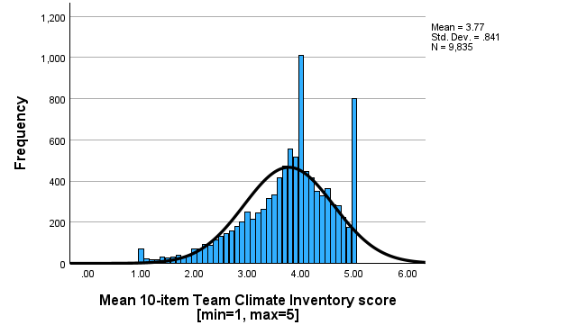
Figure S4.1 Mean TCI: histograms
SUPPLEMENTARY MATERIALS 5: Analysis of TCI responses by role for 8961 respondents who indicated role in practice

Figure S5.A TCI Domain – Participative Safety, composite stacked bar charts, N=8961
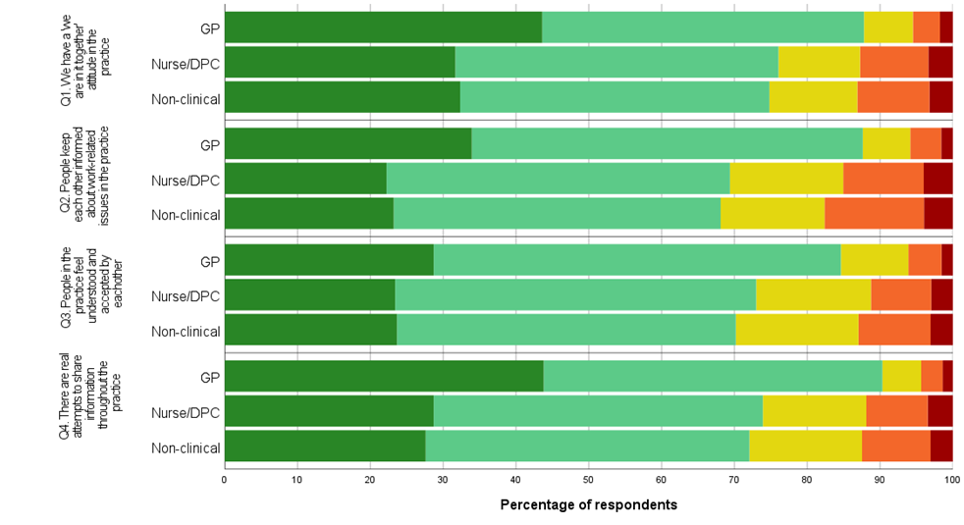
Item

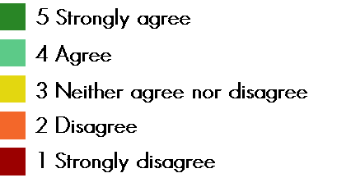

Figure S5.B TCI Domain – Task Orientation, composite stacked bar charts, N=8961
Item
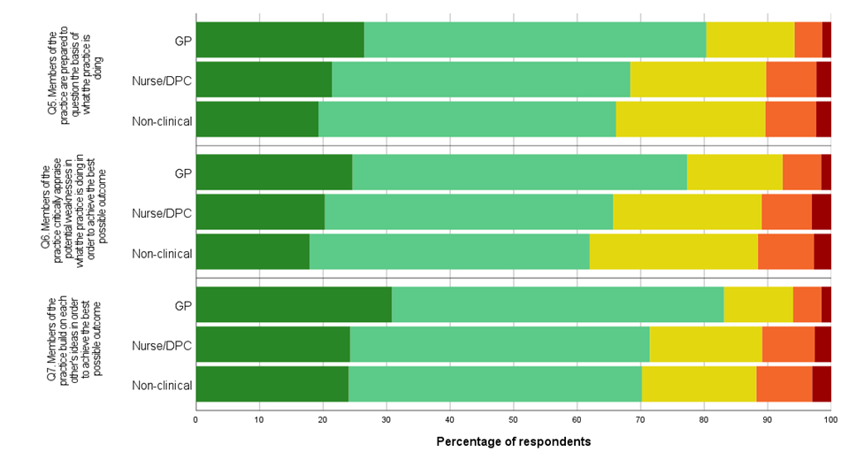

Figure S5.C TCI Domain – Support for Innovation, composite stacked bar charts, N=8961

Item
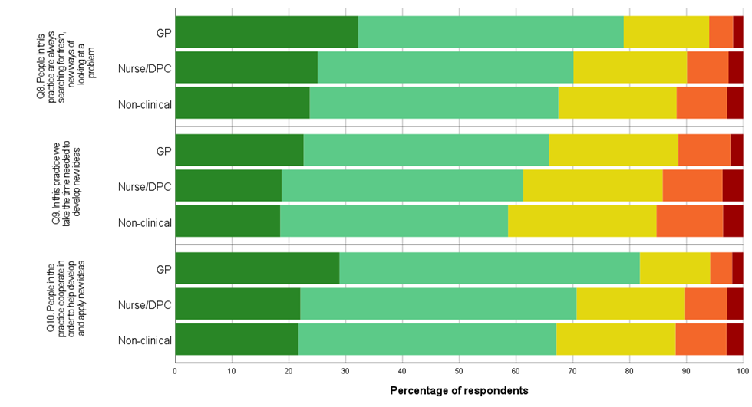

Figure S5.D TCI Domain – Vision, composite stacked bar charts, N=5499 answering the 4 items in the vision domain

Of 8961 respondents providing a role, 3462 (38.6%) stated they were not aware of their practice objectives:
30.4% of GPs, 46.4% of nurses/DPCs, 38.6% of non-clinical (Chi-Square test: p<0.001 for each pairwise comparison).

Item
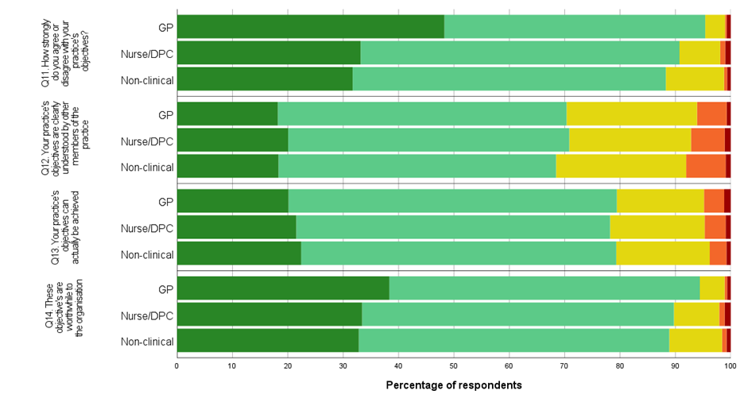

Item responses – Participatory safety domain
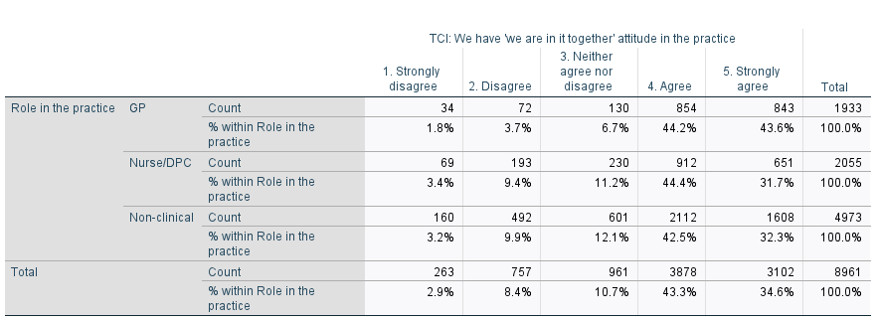
Table/Figure S5.1 Summary statistics by role (and overall) for Team Climate Inventory: Domain - Participative safety Q1

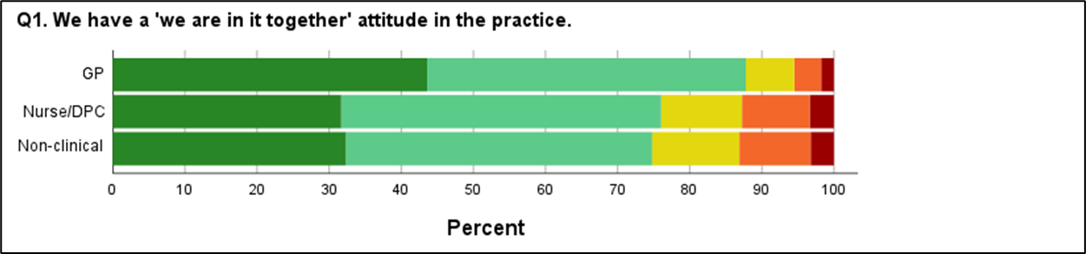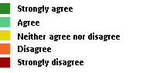
Kruskal-Wallis Test: P-value: < 0.001
A statistically significant (Mann-Whitney U test: p<0.001) more positive attitude for Q1 was identified when GPs were compared against Nurses/DPCs and against non-clinical staff. No significant difference (Mann-Whitney U test: p=0.858) was detected between the Nurses/DPCs and the non-clinical staff.
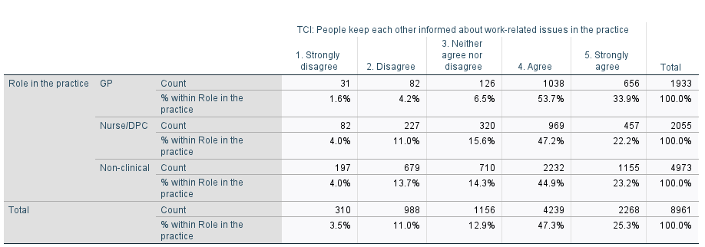
Table/Figure S5.2 Summary statistics by role (and overall) for Team Climate Inventory: Domain - Participative safety Q2

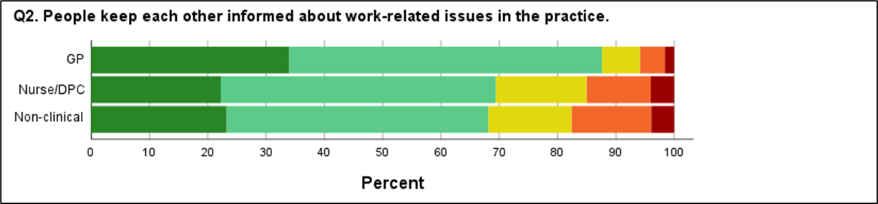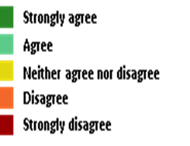
Kruskal-Wallis Test: P-value: < 0.001
A statistically significant (Mann-Whitney U test: p<0.001) more positive attitude for Q2 was identified amongst GPs when compared against Nurses/DPCs and against non-clinical staff. No significant difference (Mann-Whitney U test: p=0.574) was detected between the Nurses/DPCs and the non-clinical staff.

Table/Figure S5.3 Summary statistics by role (and overall) for Team Climate Inventory: Domain - Participative safety Q3
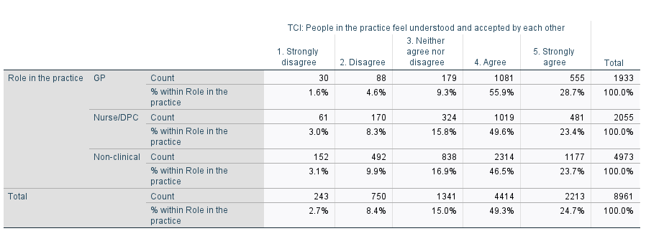

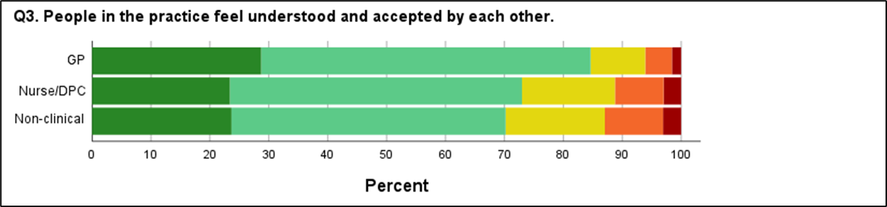

Kruskal-Wallis Test: P-value: < 0.001
A statistically significant (Mann-Whitney U test: p<0.001) more positive attitude for Q3 was identified amongst GPs when compared against Nurses/DPCs and against non-clinical staff. No significant difference (Mann-Whitney U test: p=0.147) was detected between the Nurses/DPCs and the non-clinical staff.

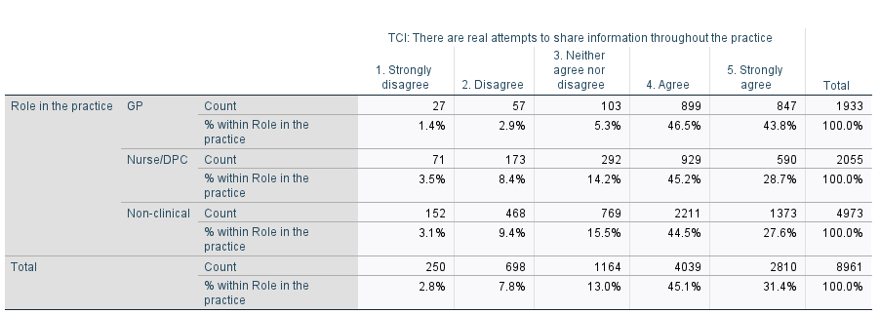
Table/Figure S5.4 Summary statistics by role (and overall) for Team Climate Inventory: Domain - Participative safety Q4

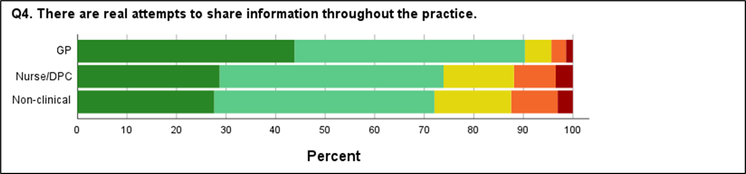
Kruskal-Wallis Test: P-value: < 0.001
A statistically significant (Mann-Whitney U test: p<0.001) more positive attitude for Q4 was identified amongst GPs when compared against Nurses/DPCs and against non-clinical staff. No significant difference (Mann-Whitney U test: p=0.160) was detected between the Nurses/DPCs and the non-clinical staff.

Item responses – Task orientation domain
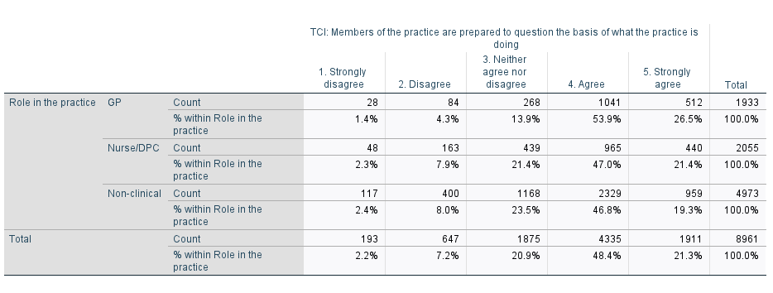
Table/Figure S5.5 Summary statistics by role (and overall) for Team Climate Inventory: Domain – Task orientation Q5

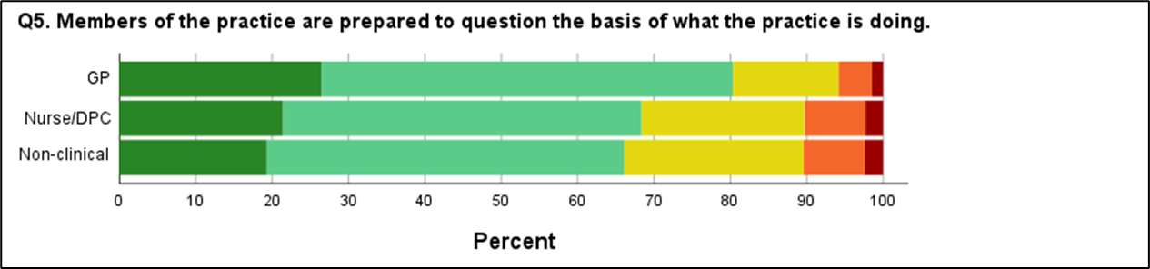

Kruskal-Wallis Test: P-value: < 0.001
A statistically significant (Mann-Whitney U test: p<0.001) more positive attitude for Q5 was identified amongst GPs when compared against Nurses/DPCs and against non-clinical staff. A statistically significant difference (Mann-Whitney U test: p=0.032) was also detected between the Nurses/DPCs and the non-clinical staff, with the Nurses/DPCs expressing a stronger level of agreement with regard to Q5.

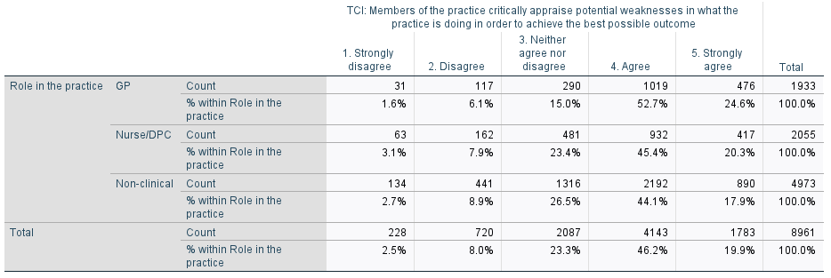
Table/Figure S5.6 Summary statistics by role (and overall) for Team Climate Inventory: Domain – Task orientation Q6

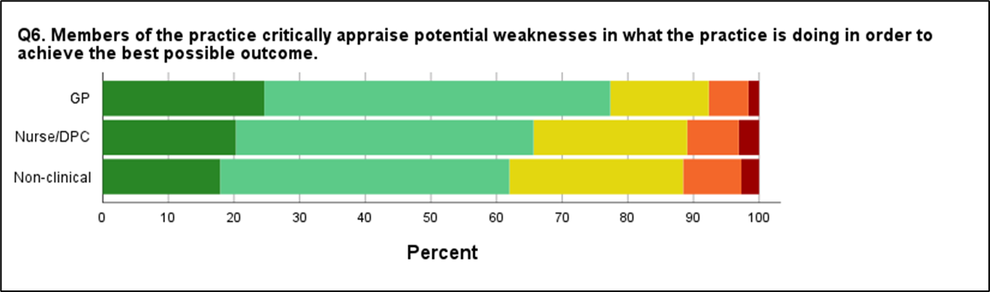
Kruskal-Wallis Test: P-value: < 0.001
A statistically significant (Mann-Whitney U test: p<0.001) more positive attitude for Q6 was identified amongst GPs when compared against Nurses/DPCs and against non-clinical staff. A statistically significant difference (Mann-Whitney U test: p=0.003) was also detected between the Nurses/DPCs and the non-clinical staff, with the Nurses/DPCs expressing a stronger level of agreement with regard to Q6.

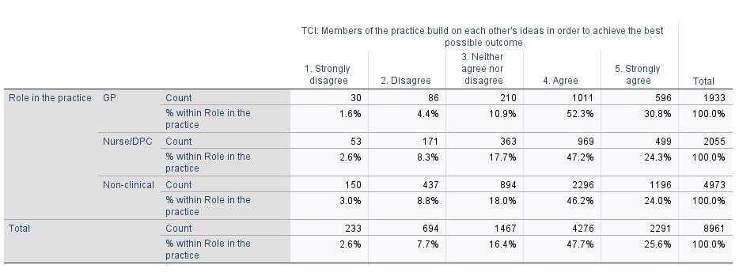
Table/Figure S5.7 Summary statistics by role (and overall) for Team Climate Inventory: Domain – Task orientation Q7

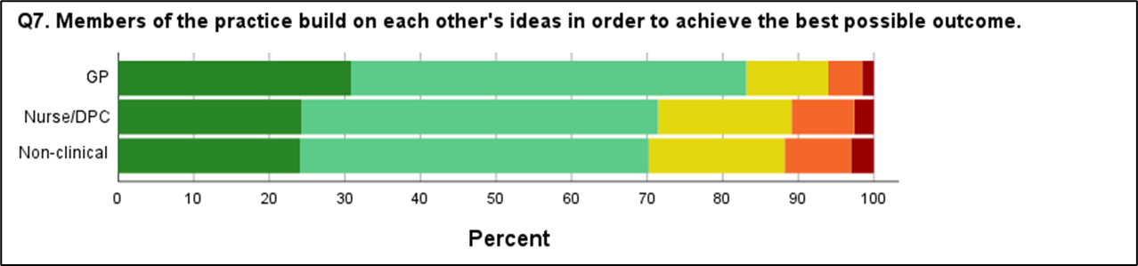
Kruskal-Wallis Test: P-value: < 0.001
A statistically significant (Mann-Whitney U test: p<0.001) more positive attitude for Q7 was identified amongst GPs when compared against Nurses/DPCs and against non-clinical staff. No significant difference (Mann-Whitney U test: p=0.384) was detected between the Nurses/DPCs and the non-clinical staff.

Item responses – Support for innovation domain
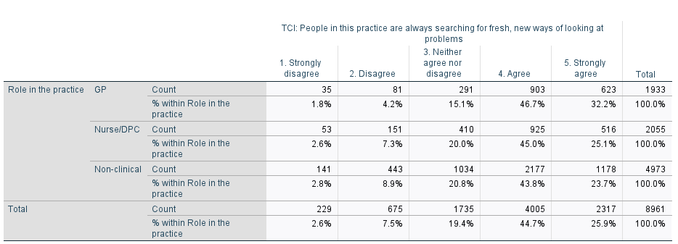
Table/Figure S5.8 Summary statistics by role (and overall) for Team Climate Inventory: Domain – Support for innovation Q8

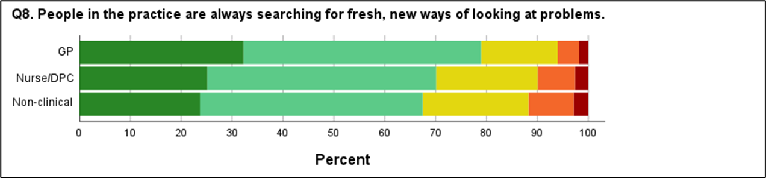
Kruskal-Wallis Test: P-value: < 0.001
A statistically significant (Mann-Whitney U test: p<0.001) more positive attitude for Q8 was identified amongst GPs when compared against Nurses/DPCs and against non-clinical staff. A statistically significant difference (Mann-Whitney U test: p=0.023) was also detected between the Nurses/DPCs and the non-clinical staff, with the Nurses/DPCs expressing a stronger level of agreement with regard to Q8.

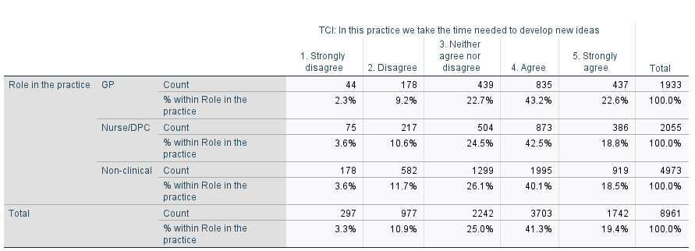
Table/Figure S5.9 Summary statistics by role (and overall) for Team Climate Inventory: Domain – Support for innovation Q9

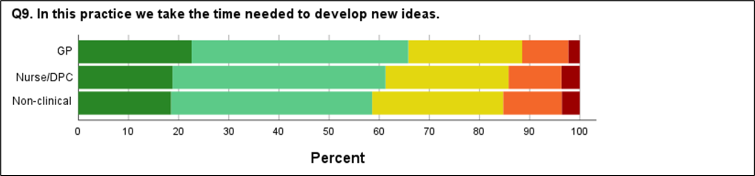
Kruskal-Wallis Test: P-value: < 0.001
A statistically significant (Mann-Whitney U test: p<0.001) more positive attitude for Q9 was identified amongst GPs when compared against Nurses/DPCs and against non-clinical staff. No significant difference (Mann-Whitney U test: p=0.105) was detected between the Nurses/DPCs and the non-clinical staff.

Table/Figure S5.10 Summary statistics by role (and overall) for Team Climate Inventory: Domain – Support for innovation Q10
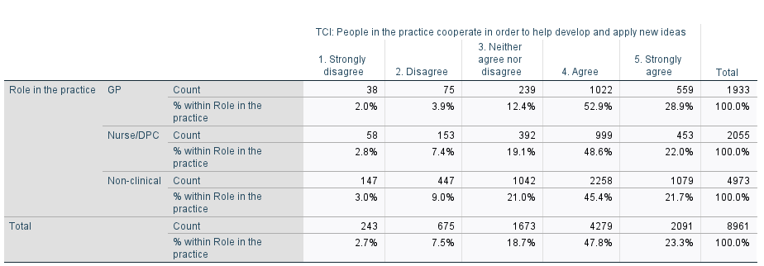

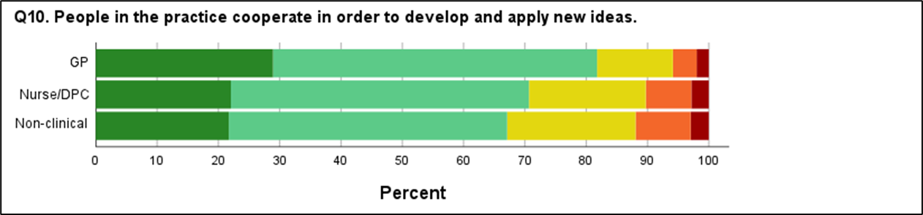
Kruskal-Wallis Test: P-value: < 0.001
A statistically significant (Mann-Whitney U test: p<0.001) more positive attitude for Q8 was identified amongst GPs when compared against Nurses/DPCs and against non-clinical staff. A statistically significant difference (Mann-Whitney U test: p=0.029) was also detected between the Nurses/DPCs and the non-clinical staff, with the Nurses/DPCs expressing a stronger level of agreement with regard to Q10.

Item responses – Vision domain
A filter question at the start of the vision domain asked if the participant was aware of their practice’s objectives. There were N= 3462 responses of “No” (38.6% of the 8961 respondents who had indicated their role at their practice). Only the remaining 5499 respondents were directed to the 4 items in the vision domain. This filter was used because piloting of the questionnaire revealed that many staff members did not know the objectives of their practice and were thus able to answer items in the vision domain. There were 30.4% of GPs, 46.4% of Nurses/DPCs and 38.6% of Managerial/Admin staff reported they were not aware of their practice’s objectives; Chi-Square test: p<0.001, with a distinct hierarchy where Nurses/DPCs > Managerial/Admin > GPs (Chi-Square test: p<0.001 for each pairwise comparison).
Table/Figure S5.11 Summary statistics by role (and overall) for Team Climate Inventory: Domain – Vision Q11
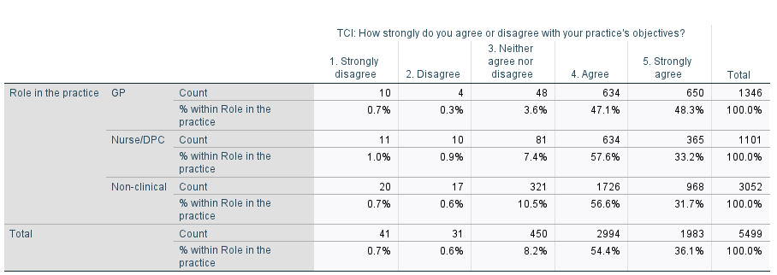

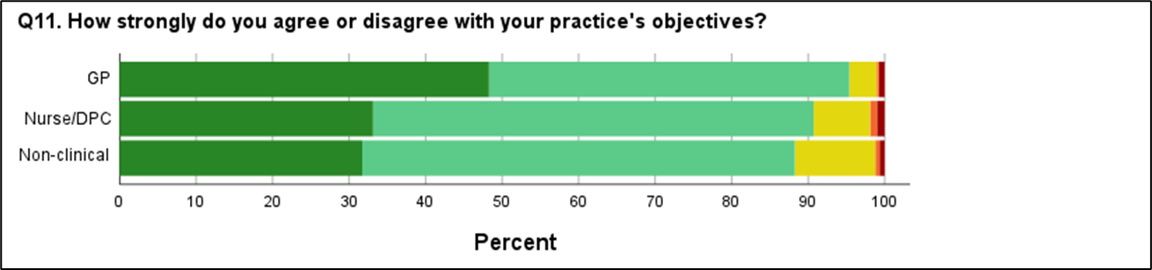
Kruskal-Wallis Test: P-value: < 0.001
A statistically significant (Mann-Whitney U test: p<0.001) stronger level of agreement for Q11 was identified amongst GPs when compared against Nurses/DPCs and against non-clinical staff. No significant difference (Mann-Whitney U test: p=0.114) was detected between the Nurses/DPCs and the non-clinical staff.

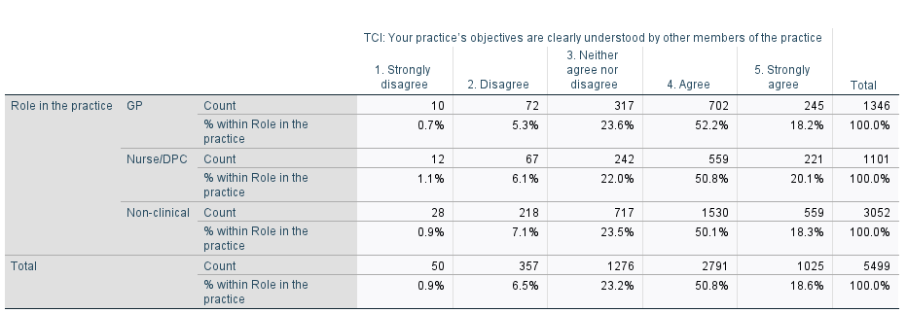
Table/Figure S5.12 Summary statistics by role (and overall) for Team Climate Inventory: Domain – Vision Q12

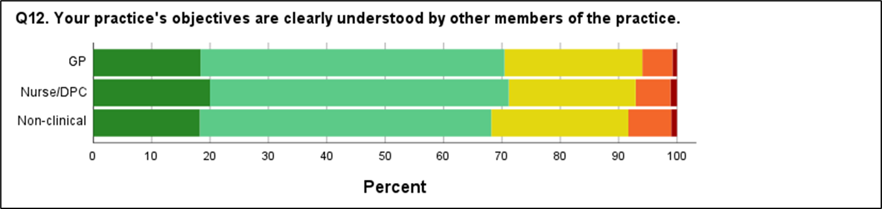

No statistically significant difference was detected for Q12 between the GPs, the Nurses/DPCs and non-clinical staff (Kruskal-Wallis test: p=0.181).

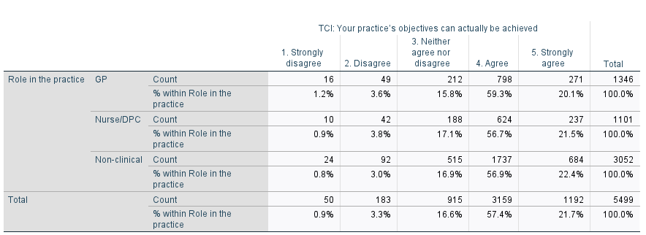
Table/Figure S5.13 Summary statistics by role (and overall) for Team Climate Inventory: Domain – Vision Q13

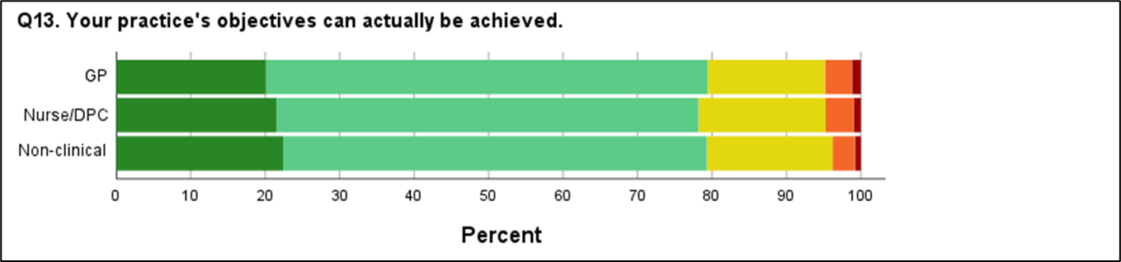

No statistically significant difference was detected for Q12 between the GPs, the Nurses/DPCs and non-clinical staff (Kruskal-Wallis test: p=0.414).

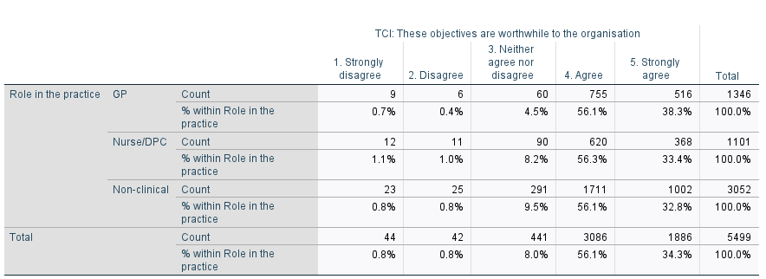
Table/Figure S5.14 Summary statistics by role (and overall) for Team Climate Inventory: Domain – Vision Q14

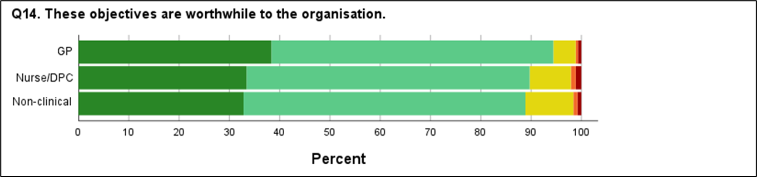
Kruskal-Wallis Test: P-value: < 0.001
A statistically significant (Mann-Whitney U test: p<0.001) stronger level of agreement for Q14 was identified amongst GPs when compared against Nurses/DPCs and against non-clinical staff. No significant difference (Mann-Whitney U test: p=0.570) was detected between the Nurses/DPCs and the non-clinical staff.

Domain means
For each participant the mean score across items in each domain were calculated. The overall means by role were then calculated and compared. The scoring system was Strongly disagree=1, Disagree=2, Neither agree nor disagree=3, Agree=4, Strongly agree=5. The computerised data entry system did not permit missing responses so there was no need to address missing items. Respondents were not prompted to respond to the TCI vision items if they stated they were not aware of their practice’s objectives.
Table S5.15 Summary statistics for the 4 TCI domain means, broken down by staff role at the GP practice

 |  | N | Mean | Std. Deviation | Std. Error | 95% Confidence Interval for Mean |  | Minimum | Maximum
 |  |  |  |  |  | Lower Bound | Upper Bound | Minimum | Maximum
TCI: Participative safety
TCI: Participative safety | GP | 1933 | 4.1809 | .72790 | .01656 | 4.1485 | 4.2134 | 1.00 | 5.00
TCI: Participative safety | Nurse/DPC | 2055 | 3.8343 | .90326 | .01993 | 3.7952 | 3.8734 | 1.00 | 5.00
TCI: Participative safety | Non-clinical | 4973 | 3.8065 | .92522 | .01312 | 3.7807 | 3.8322 | 1.00 | 5.00
TCI: Participative safety | Total | 8961 | 3.8936 | .89395 | .00944 | 3.8751 | 3.9121 | 1.00 | 5.00
TCI: Task orientation
TCI: Task orientation | GP | 1933 | 3.9957 | .77199 | .01756 | 3.9613 | 4.0301 | 1.00 | 5.00
TCI: Task orientation | Nurse/DPC | 2055 | 3.7711 | .86339 | .01905 | 3.7338 | 3.8085 | 1.00 | 5.00
TCI: Task orientation | Non-clinical | 4973 | 3.7257 | .85853 | .01217 | 3.7019 | 3.7496 | 1.00 | 5.00
TCI: Task orientation | Total | 8961 | 3.7944 | .84846 | .00896 | 3.7768 | 3.8119 | 1.00 | 5.00
TCI: Support for innovation
TCI: Support for innovation | GP | 1933 | 3.9364 | .81214 | .01847 | 3.9001 | 3.9726 | 1.00 | 5.00
TCI: Support for innovation | Nurse/DPC | 2055 | 3.7484 | .90104 | .01988 | 3.7094 | 3.7874 | 1.00 | 5.00
TCI: Support for innovation | Non-clinical | 4973 | 3.6956 | .91795 | .01302 | 3.6701 | 3.7211 | 1.00 | 5.00
TCI: Support for innovation | Total | 8961 | 3.7597 | .89720 | .00948 | 3.7411 | 3.7782 | 1.00 | 5.00
TCI: Vision
TCI: Vision | GP | 1346 | 4.1204 | .59153 | .01612 | 4.0887 | 4.1520 | 1.00 | 5.00
TCI: Vision | Nurse/DPC | 1101 | 4.0443 | .66880 | .02016 | 4.0047 | 4.0838 | 1.00 | 5.00
TCI: Vision | Non-clinical | 3052 | 4.0311 | .64003 | .01159 | 4.0084 | 4.0538 | 1.00 | 5.00
TCI: Vision | Total | 5499* | 4.0556 | .63545 | .00857 | 4.0388 | 4.0724 | 1.00 | 5.00
*Note 3462 of 8961 (38.6%) respondents providing a role stated they were not aware of their practice’s objectives; consequently there are 3462 missing scores for TCI: vision since the corresponding questions were not asked.
One way ANOVA (p<0.001) indicated a statistically significant difference between the 3 roles for each of the 4 TCI domains. Means with 95% confidence intervals appear in Table S5.15 and are displayed graphically in Figure S5.15.
GPs exhibited a significantly higher score than the Nurse/DPCs and the Non-clinical staff for each of the 4 TCI domains (unpaired t-tests: p<0.001).

Figure S5.15 Means with 95% confidence intervals for Team Climate Inventory Domains
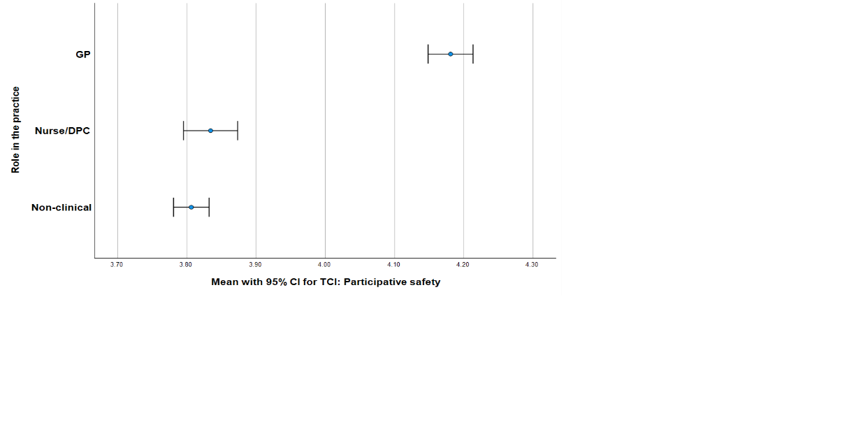 | 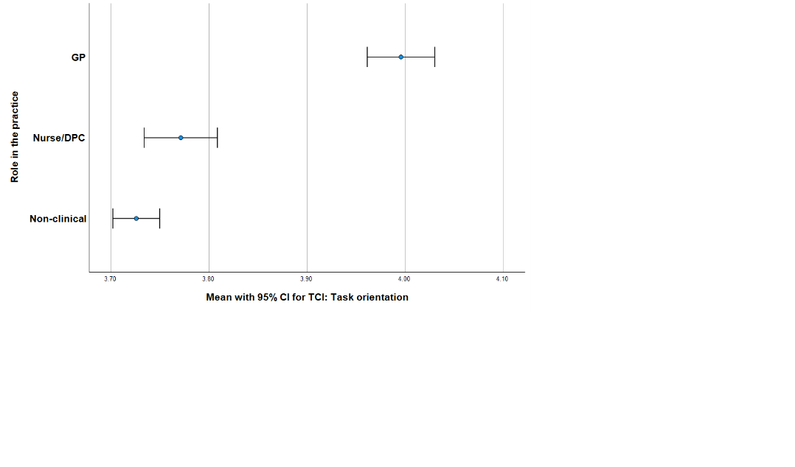
 | 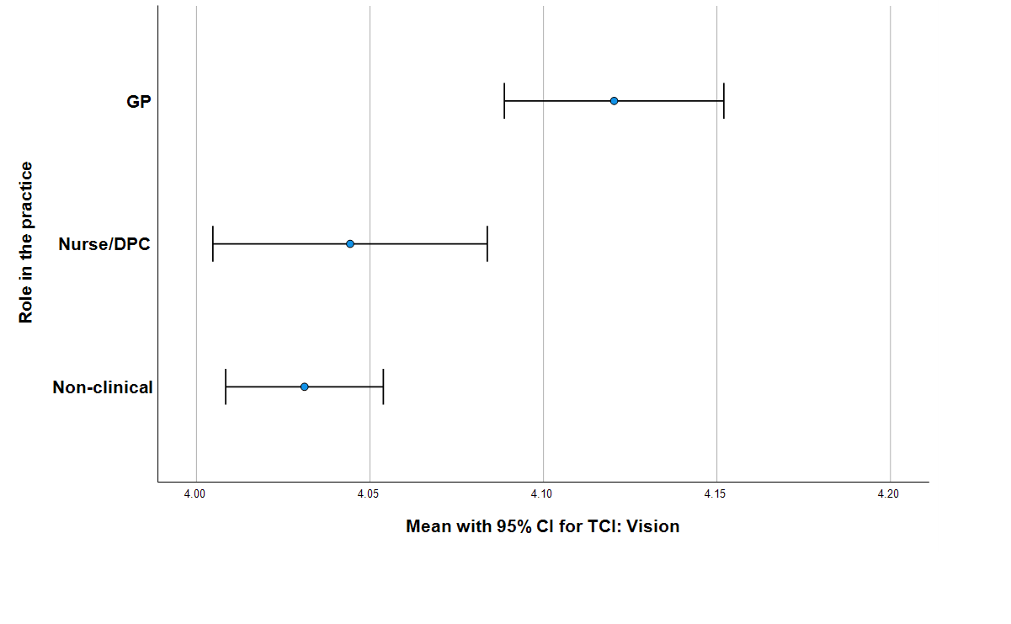

GPs were compared against the other roles combined (i.e. Nurse/DPC & Managerial/Administrative/Estates) for each mean TCI item; summary statistics, with the corresponding result of the two-sided t-test indicated in red text, appear in Table S5.16.
Table S5.16 T-Tests to compare GPs vs Other professionals
 |  | Role in the practice |  |  | N |  | Mean |  |  | Std. Deviation |  |  | Std. Error Mean
Mean TCI domain: Safety [scale 1 to 5] |  | GP |  |  | 1933 |  | 4.1809 |  |  | .72790 |  |  | .01656
 |  | Nurse/DPC & Managerial/Admin |  |  | 7028 |  | 3.8146 |  |  | .91888 |  |  | .01096
Mean TCI domain: Task [scale 1 to 5] |  | GP |  |  | 1933 |  | 3.9957 |  |  | .77199 |  |  | .01756
 |  | Nurse/DPC & Managerial/Admin |  |  | 7028 |  | 3.7390 |  |  | .86014 |  |  | .01026
Mean TCI domain: Innovation [scale 1 to 5] |  | GP |  |  | 1933 |  | 3.9364 |  |  | .81214 |  |  | .01847
 |  | Nurse/DPC & Managerial/Admin |  |  | 7028 |  | 3.7111 |  |  | .91329 |  |  | .01089
Mean TCI domain: Vision (missing when practice objectives not known) [scale 1 to 5] |  | GP |  |  | 1346 |  | 4.1204 |  |  | .59153 |  |  | .01612
 |  | Nurse/DPC & Managerial/Admin |  |  | 4153 |  | 4.0346 |  |  | .64772 |  |  | .01005
Mean TCI domain: Vision (Vision=3 when practice objectives not known) [scale 1 to 5] |  | GP |  |  | 1933 |  | 3.7801 |  |  | .71355 |  |  | .01623
 |  | Nurse/DPC & Managerial/Admin |  |  | 7028 |  | 3.6114 |  |  | .71182 |  |  | .00849
Mean TCI item score (missing when practice objectives not known) [scale 1 to 5] |  | GP |  |  | 1346 |  | 4.1518 |  |  | .59551 |  |  | .01623
 |  | Nurse/DPC & Managerial/Admin |  |  | 4153 |  | 3.9974 |  |  | .67992 |  |  | .01055
Mean TCI item score (Vision=3 when practice objectives not known) [scale 1 to 5] |  | GP |  |  | 1933 |  | 3.9743 |  |  | .63848 |  |  | .01452
 |  | Nurse/DPC & Managerial/Admin |  |  | 7028 |  | 3.7181 |  |  | .73354 |  |  | .00875
Mean TCI 10-item score [scale 1 to 5] |  | GP |  |  | 1933 |  | 4.0520 |  |  | .70705 |  |  | .01608
 |  | Nurse/DPC & Managerial/Admin |  |  | 7028 |  | 3.7609 |  |  | .83939 |  |  | .01001
Independent Samples Test |  |  | Levene's Test for Equality of Variances |  |  | t-test for Equality of Means
 |  |  | F | Sig. |  | t |  | df | Significance p |  |  | Mean Difference |  | Std. Error Difference | 95% C I of the Difference
 |  |  |  |  |  |  |  |  | One-Sided |  | Two-Sided |  |  | Std. Error Difference
 |  |  |  |  |  |  |  |  |  |  |  |  |  |  | Lower | Upper
Mean TCI domain: Safety [scale 1 to 5] | Equal variances assumed |  | 175.199 | <.001 |  | 16.187 |  | 8959 | <.001 |  | <.001 | .36634 |  | .02263 | .32197 | .41070
Mean TCI domain: Safety [scale 1 to 5] | Equal variances not assumed |  |  |  |  | 18.450 |  | 3796.229 | <.001 |  | <.001 | .36634 |  | .01986 | .32741 | .40527
Mean TCI domain: Task [scale 1 to 5] | Equal variances assumed |  | 85.188 | <.001 |  | 11.871 |  | 8959 | <.001 |  | <.001 | .25669 |  | .02162 | .21431 | .29908
Mean TCI domain: Task [scale 1 to 5] | Equal variances not assumed |  |  |  |  | 12.622 |  | 3368.603 | <.001 |  | <.001 | .25669 |  | .02034 | .21682 | .29657
Mean TCI domain: Innovation [scale 1 to 5] | Equal variances assumed |  | 62.240 | <.001 |  | 9.830 |  | 8959 | <.001 |  | <.001 | .22531 |  | .02292 | .18038 | .27024
Mean TCI domain: Innovation [scale 1 to 5] | Equal variances not assumed |  |  |  |  | 10.506 |  | 3396.752 | <.001 |  | <.001 | .22531 |  | .02145 | .18326 | .26735
Mean TCI domain: Vision (missing when practice objectives not known) [scale 1 to 5] | Equal variances assumed |  | 2.342 | .126 |  | 4.309 |  | 5497 | <.001 |  | <.001 | .08574 |  | .01990 | .04673 | .12475
 | Equal variances not assumed |  |  |  |  | 4.513 |  | 2472.511 | <.001 |  | <.001 | .08574 |  | .01900 | .04849 | .12300
Mean TCI domain: Vision (Vision=3 when practice objectives not known) [scale 1 to 5] | Equal variances assumed |  | 2.153 | .142 |  | 9.226 |  | 8959 | <.001 |  | <.001 | .16876 |  | .01829 | .13290 | .20461
 | Equal variances not assumed |  |  |  |  | 9.213 |  | 3071.108 | <.001 |  | <.001 | .16876 |  | .01832 | .13284 | .20467
Mean TCI item score (missing when practice objectives not known) [scale 1 to 5] | Equal variances assumed |  | 27.637 | <.001 |  | 7.458 |  | 5497 | <.001 |  | <.001 | .15446 |  | .02071 | .11386 | .19505
 | Equal variances not assumed |  |  |  |  | 7.978 |  | 2572.836 | <.001 |  | <.001 | .15446 |  | .01936 | .11650 | .19242
Mean TCI item score (Vision=3 when practice objectives not known) [scale 1 to 5] | Equal variances assumed |  | 69.320 | <.001 |  | 13.967 |  | 8959 | <.001 |  | <.001 | .25617 |  | .01834 | .22022 | .29212
 | Equal variances not assumed |  |  |  |  | 15.109 |  | 3463.875 | <.001 |  | <.001 | .25617 |  | .01695 | .22293 | .28941
Mean TCI 10-item score [scale 1 to 5] | Equal variances assumed |  | 108.386 | <.001 |  | 13.949 |  | 8959 | <.001 |  | <.001 | .29114 |  | .02087 | .25022 | .33205
Mean TCI 10-item score [scale 1 to 5] | Equal variances not assumed |  |  |  |  | 15.368 |  | 3572.556 | <.001 |  | <.001 | .29114 |  | .01894 | .25399 | .32828

SUPPLEMENTARY MATERIALS 6: Analysis of job satisfaction, future work intentions and burnout responses by role for 8961 respondents who indicated role in practice
Table/Figure S6.1 Job Satisfaction by Role
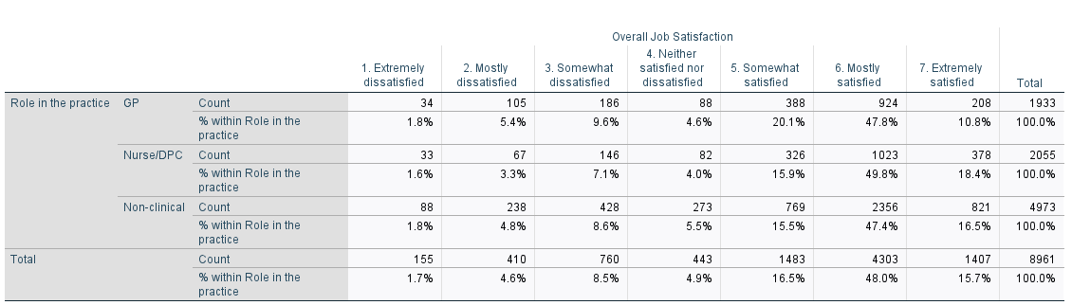

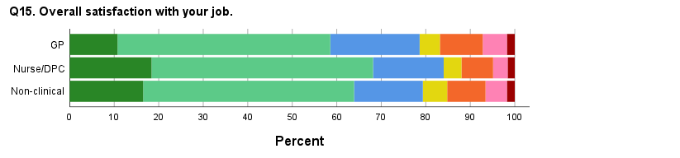  Kruskal Wallis Test, p<0.001 | 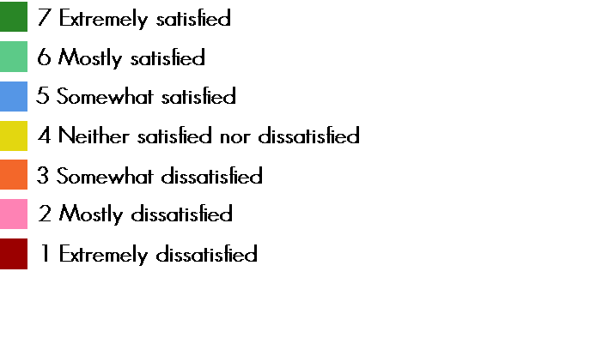

The Nurses/DPCs were significantly more satisfied with their jobs than the non-clinical staff and than the GPs; the non-clinical staff were significantly more satisfied with their jobs compared to the GPs (all comparisons Mann-Whitney U test: p<0.001).
The proportions of staff expressing satisfaction (somewhat, mostly, extremely) with their jobs were: GPs 1520/ 1933, 78.6%; nurses/DPCs 1727/ 2055, 84.0%; non-clinical 3946 / 4973, 79.3%. The numbers (proportions) mostly or extremely satisfied were: 1132 (58.6%), 1401 (68.2%) and 3177 (63.9%) respectively.

Table/Figure S6.2 Future work intention by Role

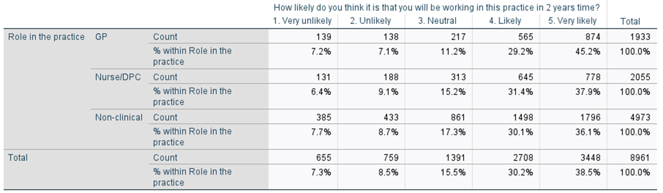

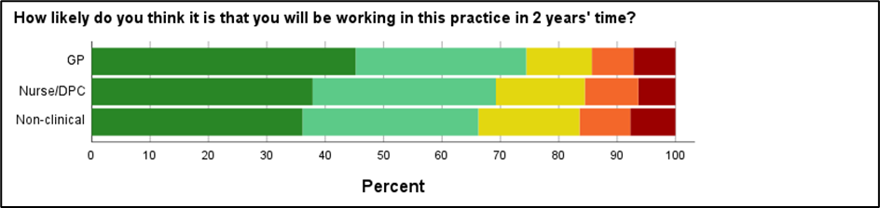  Kruskal Wallis Test, p<0.001 | 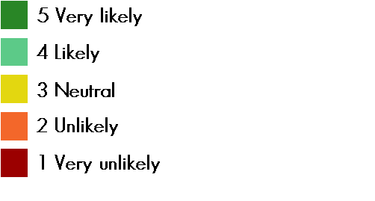

The GPs were significantly more likely than the Nurses/DPCs and than the non-clinical staff to be working at the practice in 2 years time (Mann-Whitney U test: p<0.001, both comparisons). The Nurses/DPCs were significantly more likely than the non-clinical staff to be working at the practice in 2 years time (Mann-Whitney U test: p=0.036).
The proportions of staff stating they were likely or very likely to be working in the practice in 2 years time were: GPs 1439/ 1933, 74.4%; nurses/DPCs 1423/ 2055, 69.2%; non-clinical 3294 / 4973, 68.7%.
Table/Figure S6.3 Work burnout by Role
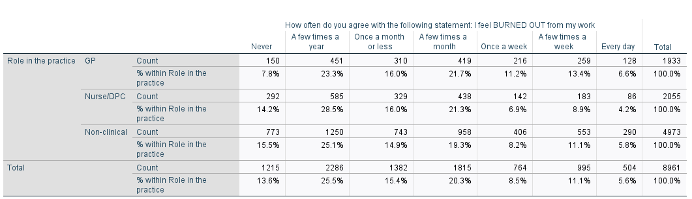

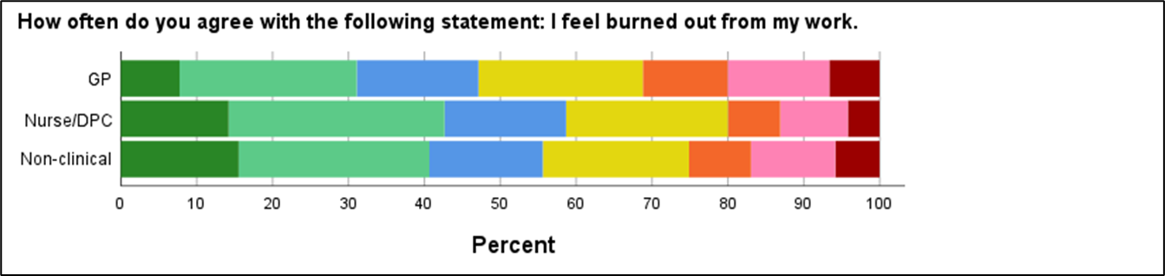  Kruskal Wallis Test, p<0.001 | 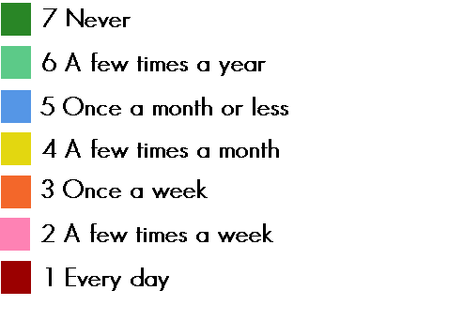
Burnout was described in the questionnaire as ‘exhaustion, cynicism and detachment from the job, sense of ineffectiveness and lack of accomplishment’ (Maslach C, Leiter MP. Understanding the burnout experience: recent research and its implications for psychiatry. World Psychiatry. 2016 Jun;15(2):103-11. doi: 10.1002/wps.20311).
The GPs were significantly more burned out from their work than the Nurses/DPCs and than the non-clinical staff (Mann-Whitney U test: p<0.001, both comparisons). The non-clinical staff were significantly more burned out from their work than the Nurses/DPCs (Mann-Whitney U test: p=0.012).
Using the cut-off of >=4 (once a week or more) for high burnout, 603/ 1933 GPs (31.2%), 411/ 2055 Nurse/DPCs (20.0%), 1249/ 4973 non-clinical staff (25.1%) experienced high burnout, with pairwise comparisons demonstrating burnout prevalence hierarchy of GPs > Non-clinical staff > Nurse/DPCs (all comparisons chi-squared test: p<0.001).
Table S6.4 Reporting of high burnout (>=4, once a week or more) and being mostly or extremely satisfied, for 8961 respondents who provided a role
Role | Number of respondents stating a role | Reporting high burnout and satisfaction  n, (%) | Pearson correlation coefficient (r) between burnout and satisfaction scales | p value of correlation
GP | 1933 | 199 (10.3%) | - 0.437 | <0.001
Nurse /DPC | 2055 | 147 (7.2%) | - 0.429 | <0.001
Non-clinical | 4973 | 438 (8.8%) | - 0.452 | <0.001
All participants including if no role given | 9835 | 835 (8.5%) | - 0.454 | <0.0005

Table S6.5 High burnout (>=4, i.e. once a week or more) by role and gender
Gender |  |  |  | Feel burned out from work once a week or more often |  | Total
 |  |  |  | No | Yes
Male | Role in the practice | GP | Count | 537 | 276 | 813
Male | Role in the practice | GP | % within Role in the practice | 66.1% | 33.9% | 100.0%
Male | Role in the practice | Nurse or other professional involved in direct patient care | Count | 143 | 36 | 179
Male | Role in the practice | Nurse or other professional involved in direct patient care | % within Role in the practice | 79.9% | 20.1% | 100.0%
Male | Role in the practice | Managerial, administrative, receptionist, estates | Count | 258 | 74 | 332
Male | Role in the practice | Managerial, administrative, receptionist, estates | % within Role in the practice | 77.7% | 22.3% | 100.0%
Male | Total |  | Count | 938 | 386 | 1324
Male |  |  | % within Role in the practice | 70.8% | 29.2% | 100.0%
Female | Role in the practice | GP | Count | 745 | 280 | 1025
Female | Role in the practice | GP | % within Role in the practice | 72.7% | 27.3% | 100.0%
Female | Role in the practice | Nurse or other professional involved in direct patient care | Count | 1456 | 357 | 1813
Female | Role in the practice | Nurse or other professional involved in direct patient care | % within Role in the practice | 80.3% | 19.7% | 100.0%
Female | Role in the practice | Managerial, administrative, receptionist, estates | Count | 3357 | 1107 | 4464
Female | Role in the practice | Managerial, administrative, receptionist, estates | % within Role in the practice | 75.2% | 24.8% | 100.0%
Female | Total |  | Count | 5558 | 1744 | 7302
Female |  |  | % within Role in the practice | 76.1% | 23.9% | 100.0%
Total | Role in the practice | GP | Count | 1282 | 556 | 1838
Total | Role in the practice | GP | % within Role in the practice | 69.7% | 30.3% | 100.0%
Total | Role in the practice | Nurse or other professional involved in direct patient care | Count | 1599 | 393 | 1992
Total | Role in the practice | Nurse or other professional involved in direct patient care | % within Role in the practice | 80.3% | 19.7% | 100.0%
Total | Role in the practice | Managerial, administrative, receptionist, estates | Count | 3615 | 1181 | 4796
Total | Role in the practice | Managerial, administrative, receptionist, estates | % within Role in the practice | 75.4% | 24.6% | 100.0%
Total | Total |  | Count | 6496 | 2130 | 8626
Total |  |  | % within Role in the practice | 75.3% | 24.7% | 100.0%

Table S6.6 Summary of responses stating likely or very likely not to be working in the practice in 2 years, by role
Role | N | Number stating very likely/ likely not to be working in practice in 2 years | % | Number (%) intend to retire |  | Number (%) intend to take another job in healthcare |  | Number (%) intend to take another job not in healthcare
GP | 1933 | 277 | 14.3% | 119 | 42.9% | 154 | 55.6% | 56 | 20.2%
Nurse /DPC | 2055 | 319 | 15.5% | 104 | 32.6% | 197 | 61.7% | 70 | 21.9%
Non-clinical | 4973 | 818 | 16.4% | 243 | 29.7% | 333 | 40.7% | 400 | 48.9%
Note – respondents could state more than one intention

Table S6.7 Summary of responses stating likely or very likely not to be working in the practice in 2 years, by role and age group
Note – respondents could state more than one intention
 | Number with age known | Intending to retire |  |  |  |  |  |  | Intending to take another job in health care |  |  |  |  |  |  | Intending to take another job not in healthcare
 | Number with age known | N | <35 years |  | 35-54 years |  | >=55 years |  | N | <35 years |  | 35-54 years |  | >=55 years |  | N | <35 years |  | 35-54 years |  | >=55 years
 | Number with age known | N | n | % | n | % | n | % | N | n | % | n | % | n | % | N | n | % | n | % | n | %
GP | 259 | 112 | 0 |  | 18 | 16.1 | 94 | 83.9 | 144 | 38 | 26.4 | 81 | 56.2 | 25 | 17.4 | 52 | 8 | 15.4 | 30 | 57.7 | 14 | 26.9
Nurse /DPC | 292 | 99 | 1 | 1.0 | 11 | 11.1 | 87 | 87.9 | 176 | 45 | 25.6 | 103 | 58.5 | 28 | 15.9 | 66 | 13 | 19.7 | 32 | 48.5 | 21 | 31.8
Non-clinical | 736 | 227 | 4 | 1.8 | 14 | 6.2 | 209 | 92.1 | 293 | 111 | 37.9 | 113 | 38.6 | 69 | 23.5 | 357 | 129 | 36.1 | 129 | 36.1 | 99 | 27.7

Table S6.8 T-Tests to compare GPs vs Other professionals
OUTCOME |  | Role in the practice |  | N |  | Mean |  |  | Std. Deviation |  |  | Std. Error Mean
Overall Job Satisfaction |  | GP |  | 1933 |  | 5.22 |  |  | 1.436 |  |  | .033
 |  | Nurse/DPC & Managerial/Admin |  | 7028 |  | 5.41 |  |  | 1.428 |  |  | .017
How likely do you think it is that you will be working in this practice in 2 years time? |  | GP |  | 1933 |  | 3.98 |  |  | 1.224 |  |  | .028
 |  | Nurse/DPC & Managerial/Admin |  | 7028 |  | 3.80 |  |  | 1.228 |  |  | .015
How often do you agree with the following statement: I feel BURNED OUT from my work |  | GP |  | 1933 |  | 2.72 |  |  | 1.720 |  |  | .039
 |  | Nurse/DPC & Managerial/Admin |  | 7028 |  | 2.32 |  |  | 1.754 |  |  | .021
Independent Samples Test |  |  | Levene's Test for Equality of Variances |  |  | t-test for Equality of Means
 |  |  | F |  | Sig. | t | df | Significance |  |  | Mean Difference |  | Std. Error Difference | 95% Confidence Interval of the Difference
 |  |  |  |  |  |  |  | One-Sided p |  | Two-Sided p |  |  | Std. Error Difference | Lower | Upper
Overall Job Satisfaction | Equal variances assumed |  | .452 |  | .502 | -5.097 | 8959 | <.001 |  | <.001 | -.187 |  | .037 | -.259 | -.115
Overall Job Satisfaction | Equal variances not assumed |  |  |  |  | -5.081 | 3064.349 | <.001 |  | <.001 | -.187 |  | .037 | -.259 | -.115
How likely do you think it is that you will be working in this practice in 2 years time? | Equal variances assumed |  | 12.273 |  | <.001 | 5.684 | 8959 | <.001 |  | <.001 | .179 |  | .032 | .117 | .241
 | Equal variances not assumed |  |  |  |  | 5.696 | 3085.784 | <.001 |  | <.001 | .179 |  | .031 | .117 | .241
How often do you agree with the following statement: I feel BURNED OUT from my work | Equal variances assumed |  | 2.061 |  | .151 | 8.918 | 8959 | <.001 |  | <.001 | .400 |  | .045 | .312 | .488
 | Equal variances not assumed |  |  |  |  | 9.017 | 3124.602 | <.001 |  | <.001 | .400 |  | .044 | .313 | .487

The corresponding result of the 2-sided t-test is indicated in red text.
Table S6.9 Mann-Whitney Tests to compare GPs vs Other professionals

Ranks
OUTCOME | Role in the practice | N | Mean Rank | Sum of Ranks
Overall Job Satisfaction | GP | 1933 | 4157.49 | 8036419.50
Overall Job Satisfaction | Nurse/DPC & Managerial/Admin | 7028 | 4569.98 | 32117821.50
Overall Job Satisfaction | Total | 8961
How likely do you think it is that you will be working in this practice in 2 years time? | GP | 1933 | 4822.55 | 9321984.50
 | Nurse/DPC & Managerial/Admin | 7028 | 4387.06 | 30832256.50
 | Total | 8961
How often do you agree with the following statement: I feel BURNED OUT from my work | GP | 1933 | 4959.56 | 9586831.50
 | Nurse/DPC & Managerial/Admin | 7028 | 4349.38 | 30567409.50
 | Total | 8961

Test statistics
 | Overall Job Satisfaction | How likely do you think it is that you will be working in this practice in 2 years time? | How often do you agree with the following statement: I feel BURNED OUT from my work
Mann-Whitney U | 6167208.500 | 6132350.500 | 5867503.500
Wilcoxon W | 8036419.500 | 30832256.500 | 30567409.500
Z | -6.618 | -6.868 | -9.340
Asymp. Sig. (2-tailed) | <.001 | <.001 | <.001
a. Grouping Variable: Role in the practice
The relevant result of a 2-sided Mann-Whitney U test is indicated in red text.

Thus, the same result is seen for each of the three outcomes, irrespective of whether a parametric test (t test) or a non-parametric test (Mann Whitney U test) is performed.
SUPPLEMENTARY MATERIALS 7: Analysis of GP responses by gender and age, n=1933; job satisfaction, future work intentions and burnout responses by role for 8961 respondents who indicated role in practice

 |  | Table S7.1 GPs: Summary Statistics for outcomes
 |  |  | Mean TCI domain: Participatory Safety [scale 1 to 5] | Mean TCI domain: Task Orientation [scale 1 to 5] | Mean TCI domain: Support for Innovation [scale 1 to 5] | Mean TCI domain: Vision (missing when practice objectives not known) [scale 1 to 5] | Mean TCI domain: Vision (Vision=3 when practice objectives not known) [scale 1 to 5] | Mean 14 item TCI score (missing when practice objectives not known) [scale 1 to 5] | Mean 14 item TCI score (Vision=3 when practice objectives not known) [scale 1 to 5] | Mean 10-item TCI score [scale 1 to 5] | Overall Job Satisfaction | How likely do you think it is that you will be working in this practice in 2 years time? | How often do you agree with the following statement: I feel BURNED OUT from my work
N | Valid |  | 1933 | 1933 | 1933 | 1346 | 1933 | 1346 | 1933 | 1933 | 1933 | 1933 | 1933
N | Missing |  | 0 | 0 | 0 | 587 | 0 | 587 | 0 | 0 | 0 | 0 | 0
Mean |  |  | 4.1809 | 3.9957 | 3.9364 | 4.1204 | 3.7801 | 4.1518 | 3.9743 | 4.0520 | 5.22 | 3.98 | 2.72
Median |  |  | 4.2500 | 4.0000 | 4.0000 | 4.0000 | 4.0000 | 4.1429 | 4.0000 | 4.1000 | 6.00 | 4.00 | 3.00
Std. Deviation |  |  | .72790 | .77199 | .81214 | .59153 | .71355 | .59551 | .63848 | .70705 | 1.436 | 1.224 | 1.720
Minimum |  |  | 1.00 | 1.00 | 1.00 | 1.00 | 1.00 | 1.00 | 1.00 | 1.00 | 1 | 1 | 0
Maximum |  |  | 5.00 | 5.00 | 5.00 | 5.00 | 5.00 | 5.00 | 5.00 | 5.00 | 7 | 5 | 6
Percentiles | 10 |  | 3.5000 | 3.0000 | 3.0000 | 3.5000 | 3.0000 | 3.5714 | 3.2143 | 3.3000 | 3.00 | 2.00 | 1.00
Percentiles | 20 |  | 3.7500 | 3.6667 | 3.3333 | 3.7500 | 3.0000 | 3.7857 | 3.5714 | 3.7000 | 4.00 | 3.00 | 1.00
Percentiles | 25 |  | 4.0000 | 3.6667 | 3.6667 | 3.7500 | 3.0000 | 3.8571 | 3.6429 | 3.8000 | 5.00 | 3.00 | 1.00
Percentiles | 30 |  | 4.0000 | 3.6667 | 3.6667 | 4.0000 | 3.0000 | 3.9286 | 3.7143 | 3.9000 | 5.00 | 4.00 | 1.00
Percentiles | 40 |  | 4.0000 | 4.0000 | 4.0000 | 4.0000 | 3.5000 | 4.0000 | 3.8571 | 4.0000 | 5.00 | 4.00 | 2.00
Percentiles | 50 |  | 4.2500 | 4.0000 | 4.0000 | 4.0000 | 4.0000 | 4.1429 | 4.0000 | 4.1000 | 6.00 | 4.00 | 3.00
Percentiles | 60 |  | 4.5000 | 4.0000 | 4.0000 | 4.2500 | 4.0000 | 4.2857 | 4.1429 | 4.2000 | 6.00 | 5.00 | 3.00
Percentiles | 70 |  | 4.5000 | 4.3333 | 4.3333 | 4.5000 | 4.2500 | 4.4286 | 4.2857 | 4.4000 | 6.00 | 5.00 | 4.00
Percentiles | 75 |  | 4.7500 | 4.6667 | 4.6667 | 4.5000 | 4.2500 | 4.5714 | 4.4286 | 4.5000 | 6.00 | 5.00 | 4.00
Percentiles | 80 |  | 4.7500 | 4.6667 | 4.6667 | 4.7500 | 4.5000 | 4.7143 | 4.5000 | 4.6000 | 6.00 | 5.00 | 5.00
Percentiles | 90 |  | 5.0000 | 5.0000 | 5.0000 | 5.0000 | 4.7500 | 4.9286 | 4.7857 | 5.0000 | 7.00 | 5.00 | 5.00
Percentiles | 100 |  | 5.0000 | 5.0000 | 5.0000 | 5.0000 | 5.0000 | 5.0000 | 5.0000 | 5.0000 | 7.00 | 5.00 | 6.00

Comparison by gender (GPs)

Table S7.2 T-Tests to compare male vs female GPs
Group Statistics
 | Gender | N | Mean | Std. Deviation | Std. Error Mean
Mean TCI domain: Participative Safety [scale 1 to 5] | Male | 813 | 4.2552 | .69661 | .02443
Mean TCI domain: Participative Safety [scale 1 to 5] | Female | 1025 | 4.1590 | .72641 | .02269
Mean TCI domain: Task Orientation [scale 1 to 5] | Male | 813 | 4.0443 | .76095 | .02669
Mean TCI domain: Task Orientation [scale 1 to 5] | Female | 1025 | 3.9951 | .75869 | .02370
Mean TCI domain: Support for Innovation [scale 1 to 5] | Male | 813 | 3.9881 | .81364 | .02854
Mean TCI domain: Support for Innovation [scale 1 to 5] | Female | 1025 | 3.9236 | .79598 | .02486
Mean TCI domain: Vision (missing when practice objectives not known) [scale 1 to 5] | Male | 618 | 4.1650 | .59769 | .02404
 | Female | 675 | 4.0967 | .57408 | .02210
Mean TCI domain: Vision (Vision=3 when practice objectives not known) [scale 1 to 5] | Male | 813 | 3.8856 | .72057 | .02527
 | Female | 1025 | 3.7222 | .69830 | .02181
Mean 14 item TCI score (missing when practice objectives not known) [scale 1 to 5] | Male | 618 | 4.1855 | .60300 | .02426
 | Female | 675 | 4.1422 | .57296 | .02205
Mean 14 item TCI score (Vision=3 when practice objectives not known) [scale 1 to 5] | Male | 813 | 4.0472 | .63480 | .02226
 | Female | 1025 | 3.9486 | .62198 | .01943
Mean 10-item TCI score [scale 1 to 5] | Male | 813 | 4.1118 | .69937 | .02453
Mean 10-item TCI score [scale 1 to 5] | Female | 1025 | 4.0392 | .69114 | .02159
Overall Job Satisfaction | Male | 813 | 5.20 | 1.489 | .052
Overall Job Satisfaction | Female | 1025 | 5.30 | 1.366 | .043
How likely do you think it is that you will be working in this practice in 2 years time? | Male | 813 | 4.04 | 1.215 | .043
 | Female | 1025 | 3.99 | 1.207 | .038
How often do you agree with the following statement: I feel BURNED OUT from my work | Male | 813 | 2.72 | 1.813 | .064
 | Female | 1025 | 2.65 | 1.631 | .051

Statistically significant differences in means (as per the second part of the table below) between male and female GPs are indicated in red text.

Independent Samples Test
 |  | Levene's Test for Equality of Variances |  | t-test for Equality of Means
 |  | F | Sig. | t | df | Significance |  | Mean Difference | Std. Error Difference | 95% Confidence Interval of the Difference
 |  |  |  |  |  | One-Sided p | Two-Sided p | Mean Difference | Std. Error Difference | Lower | Upper
Mean TCI domain: Safety [scale 1 to 5] | Equal variances assumed | 1.658 | .198 | 2.871 | 1836 | .002 | .004 | .09620 | .03350 | .03049 | .16191
Mean TCI domain: Safety [scale 1 to 5] | Equal variances not assumed |  |  | 2.885 | 1771.646 | .002 | .004 | .09620 | .03334 | .03081 | .16160
Mean TCI domain: Task [scale 1 to 5] | Equal variances assumed | .017 | .897 | 1.378 | 1836 | .084 | .168 | .04916 | .03568 | -.02082 | .11913
Mean TCI domain: Task [scale 1 to 5] | Equal variances not assumed |  |  | 1.377 | 1739.663 | .084 | .169 | .04916 | .03569 | -.02084 | .11916
Mean TCI domain: Innovation [scale 1 to 5] | Equal variances assumed | .149 | .700 | 1.709 | 1836 | .044 | .088 | .06453 | .03775 | -.00951 | .13857
Mean TCI domain: Innovation [scale 1 to 5] | Equal variances not assumed |  |  | 1.705 | 1724.642 | .044 | .088 | .06453 | .03785 | -.00970 | .13876
Mean TCI domain: Vision (missing when practice objectives not known) [scale 1 to 5] | Equal variances assumed | .576 | .448 | 2.098 | 1291 | .018 | .036 | .06838 | .03260 | .00443 | .13233
 | Equal variances not assumed |  |  | 2.094 | 1270.031 | .018 | .036 | .06838 | .03265 | .00432 | .13244
Mean TCI domain: Vision (Vision=3 when practice objectives not known) [scale 1 to 5] | Equal variances assumed | .279 | .597 | 4.913 | 1836 | <.001 | <.001 | .16341 | .03326 | .09818 | .22865
 | Equal variances not assumed |  |  | 4.895 | 1716.862 | <.001 | <.001 | .16341 | .03338 | .09794 | .22889
Mean 14 item TCI score (missing when practice objectives not known) [scale 1 to 5] | Equal variances assumed | .000 | .993 | 1.323 | 1291 | .093 | .186 | .04328 | .03271 | -.02089 | .10745
 | Equal variances not assumed |  |  | 1.320 | 1266.454 | .093 | .187 | .04328 | .03278 | -.02103 | .10760
Mean 14 item TCI score (Vision=3 when practice objectives not known) [scale 1 to 5] | Equal variances assumed | .000 | .995 | 3.343 | 1836 | <.001 | <.001 | .09854 | .02948 | .04072 | .15635
 | Equal variances not assumed |  |  | 3.335 | 1725.893 | <.001 | <.001 | .09854 | .02955 | .04058 | .15649
Mean 10-item TCI score [min=1, max=5] | Equal variances assumed | .075 | .784 | 2.225 | 1836 | .013 | .026 | .07259 | .03263 | .00859 | .13659
Mean 10-item TCI score [min=1, max=5] | Equal variances not assumed |  |  | 2.222 | 1732.749 | .013 | .026 | .07259 | .03267 | .00850 | .13668
Overall Job Satisfaction | Equal variances assumed | 5.806 | .016 | -1.464 | 1836 | .072 | .143 | -.098 | .067 | -.229 | .033
Overall Job Satisfaction | Equal variances not assumed |  |  | -1.450 | 1668.306 | .074 | .147 | -.098 | .067 | -.230 | .034
How likely do you think it is that you will be working in this practice in 2 years time? | Equal variances assumed | .036 | .849 | .752 | 1836 | .226 | .452 | .043 | .057 | -.069 | .154
 | Equal variances not assumed |  |  | .751 | 1736.829 | .226 | .453 | .043 | .057 | -.069 | .154
How often do you agree with the following statement: I feel BURNED OUT from my work | Equal variances assumed | 19.506 | <.001 | .885 | 1836 | .188 | .376 | .071 | .080 | -.087 | .229
 | Equal variances not assumed |  |  | .874 | 1650.039 | .191 | .382 | .071 | .081 | -.089 | .231

Table S7.3 Nonparametric analysis: Mann-Whitney Test ranks and p-values for Job Satisfaction, Work Intention and Burnout
 |  |  |  |  | Gender |  |  |  | N |  |  | Mean Rank |  |  |  | Sum of Ranks
Overall Job Satisfaction |  |  |  |  | Male |  |  |  | 813 |  |  | 905.58 |  |  |  | 736236.50
 |  |  |  |  | Female |  |  |  | 1025 |  |  | 930.54 |  |  |  | 953804.50
 |  |  |  |  | Total |  |  |  | 1838
How likely do you think it is that you will be working in this practice in 2 years time? |  |  |  |  | Male |  |  |  | 813 |  |  | 933.01 |  |  |  | 758537.50
 |  |  |  |  | Female |  |  |  | 1025 |  |  | 908.78 |  |  |  | 931503.50
 |  |  |  |  | Total |  |  |  | 1838
How often do you agree with the following statement: I feel BURNED OUT from my work |  |  |  |  | Male |  |  |  | 813 |  |  | 927.62 |  |  |  | 754151.50
 |  |  |  |  | Female |  |  |  | 1025 |  |  | 913.06 |  |  |  | 935889.50
 |  |  |  |  | Total |  |  |  | 1838
 |  | Overall Job Satisfaction |  |  |  |  |  | How likely do you think it is that you will be working in this practice in 2 years time? |  |  |  |  | How often do you agree with the following statement: I feel BURNED OUT from my work
Mann-Whitney U |  | 405345.500 |  |  |  |  |  | 405678.500 |  |  |  |  | 410064.500
Wilcoxon W |  | 736236.500 |  |  |  |  |  | 931503.500 |  |  |  |  | 935889.500
Z |  | -1.070 |  |  |  |  |  | -1.040 |  |  |  |  | -.593
Asymp. Sig. (2-tailed) |  | .284 |  |  |  |  |  | .298 |  |  |  |  | .553
a. Grouping Variable: Gender
So the parametric t-test and non-parametric Mann-Whitney U test show no statistically significant difference between male and female GPs for Job Satisfaction, Work Intention and Burnout.

Table S7.4 Comparison via chi-squared test of GP gender for high burnout (i.e. feeling burned out from work once a week or more often)
 |  |  |  |  |  |  | Feel burned out from work once a week or more often |  |  |  |  |  |  |  |  |  | Total
 |  |  |  |  |  |  | No |  |  |  | Yes
Gender | Male |  | Count |  |  |  | 537 |  |  |  | 276 |  |  |  |  |  | 813
Gender |  |  | % within Gender |  |  |  | 66.1% |  |  |  | 33.9% |  |  |  |  |  | 100.0%
Gender | Female |  | Count |  |  |  | 745 |  |  |  | 280 |  |  |  |  |  | 1025
Gender |  |  | % within Gender |  |  |  | 72.7% |  |  |  | 27.3% |  |  |  |  |  | 100.0%
Total |  |  | Count |  |  |  | 1282 |  |  |  | 556 |  |  |  |  |  | 1838
 |  |  | % within Gender |  |  |  | 69.7% |  |  |  | 30.3% |  |  |  |  |  | 100.0%
Chi-Square Tests |  |  |  | Value |  | df |  |  |  | Asymptotic Significance (2-sided) |  |  |  | Exact Sig. (2-sided) | Exact Sig. (1-sided)
Pearson Chi-Square |  |  |  | 9.449ª |  | 1 |  |  |  | .002
Continuity Correction^{b} |  |  |  | 9.137 |  | 1 |  |  |  | .003
Likelihood Ratio |  |  |  | 9.419 |  | 1 |  |  |  | .002
Fisher's Exact Test |  |  |  |  |  |  |  |  |  |  |  |  |  | .002 | .001
Linear-by-Linear Association |  |  |  | 9.444 |  | 1 |  |  |  | .002
N of Valid Cases |  |  |  | 1838
a. 0 cells (0.0%) have expected count less than 5. The minimum expected count is 245.93.
b. Computed only for a 2x2 table

However, when the burnout scale is dichotomised, a statistically significant larger proportion of high burnout is seen in the male cohort (p=0.002).
Comparison by age group (GPs)
Table S7.5 GPs: Summary Statistics for outcomes by age group
 |  |  | N | Mean | Std. Deviation | Std. Error | 95% Confidence Interval for Mean |  | Minimum | Maximum | Between- Component Variance
 |  |  |  |  |  |  | Lower Bound | Upper Bound | Minimum | Maximum | Between- Component Variance
Mean TCI domain: Safety [scale 1 to 5] | Less than 35 |  | 266 | 4.3440 | .64179 | .03935 | 4.2665 | 4.4215 | 1.00 | 5.00
Mean TCI domain: Safety [scale 1 to 5] | 35 - 54 |  | 1260 | 4.1712 | .70019 | .01973 | 4.1325 | 4.2099 | 1.00 | 5.00
Mean TCI domain: Safety [scale 1 to 5] | Over 55 |  | 344 | 4.1461 | .83818 | .04519 | 4.0572 | 4.2350 | 1.00 | 5.00
Mean TCI domain: Safety [scale 1 to 5] | Total |  | 1870 | 4.1912 | .72219 | .01670 | 4.1584 | 4.2239 | 1.00 | 5.00
Mean TCI domain: Safety [scale 1 to 5] | Model | Fixed Effects |  |  | .71982 | .01665 | 4.1585 | 4.2238
Mean TCI domain: Safety [scale 1 to 5] | Model | Random Effects |  |  |  | .06163 | 3.9260 | 4.4564 |  |  | .00693
Mean TCI domain: Task [scale 1 to 5] | Less than 35 |  | 266 | 4.1404 | .72881 | .04469 | 4.0524 | 4.2283 | 1.00 | 5.00
Mean TCI domain: Task [scale 1 to 5] | 35 - 54 |  | 1260 | 3.9950 | .73928 | .02083 | 3.9541 | 4.0358 | 1.00 | 5.00
Mean TCI domain: Task [scale 1 to 5] | Over 55 |  | 344 | 3.9467 | .87402 | .04712 | 3.8540 | 4.0394 | 1.00 | 5.00
Mean TCI domain: Task [scale 1 to 5] | Total |  | 1870 | 4.0068 | .76613 | .01772 | 3.9720 | 4.0415 | 1.00 | 5.00
Mean TCI domain: Task [scale 1 to 5] | Model | Fixed Effects |  |  | .76439 | .01768 | 3.9721 | 4.0414
Mean TCI domain: Task [scale 1 to 5] | Model | Random Effects |  |  |  | .05542 | 3.7683 | 4.2452 |  |  | .00543
Mean TCI domain: Innovation [scale 1 to 5] | Less than 35 |  | 266 | 4.1003 | .75789 | .04647 | 4.0088 | 4.1917 | 1.00 | 5.00
Mean TCI domain: Innovation [scale 1 to 5] | 35 - 54 |  | 1260 | 3.9238 | .80134 | .02258 | 3.8795 | 3.9681 | 1.00 | 5.00
Mean TCI domain: Innovation [scale 1 to 5] | Over 55 |  | 344 | 3.8895 | .87809 | .04734 | 3.7964 | 3.9827 | 1.00 | 5.00
Mean TCI domain: Innovation [scale 1 to 5] | Total |  | 1870 | 3.9426 | .81228 | .01878 | 3.9058 | 3.9794 | 1.00 | 5.00
Mean TCI domain: Innovation [scale 1 to 5] | Model | Fixed Effects |  |  | .81007 | .01873 | 3.9059 | 3.9793
Mean TCI domain: Innovation [scale 1 to 5] | Model | Random Effects |  |  |  | .06370 | 3.6685 | 4.2167 |  |  | .00730
Mean TCI domain: Vision (missing when practice objectives not known) [scale 1 to 5] | Less than 35 |  | 122 | 4.2766 | .58987 | .05340 | 4.1709 | 4.3824 | 1.00 | 5.00
 | 35 - 54 |  | 903 | 4.1152 | .55606 | .01850 | 4.0789 | 4.1515 | 1.00 | 5.00
 | Over 55 |  | 280 | 4.0929 | .68119 | .04071 | 4.0127 | 4.1730 | 1.00 | 5.00
 | Total |  | 1305 | 4.1255 | .58982 | .01633 | 4.0934 | 4.1575 | 1.00 | 5.00
 | Model | Fixed Effects |  |  | .58820 | .01628 | 4.0935 | 4.1574
 | Model | Random Effects |  |  |  | .04947 | 3.9126 | 4.3383 |  |  | .00409
Mean TCI domain: Vision (Vision=3 when practice objectives not known) [scale 1 to 5] | Less than 35 |  | 266 | 3.5855 | .75171 | .04609 | 3.4948 | 3.6763 | 1.00 | 5.00
 | 35 - 54 |  | 1260 | 3.7992 | .68865 | .01940 | 3.7611 | 3.8373 | 1.00 | 5.00
 | Over 55 |  | 344 | 3.8895 | .74755 | .04031 | 3.8103 | 3.9688 | 1.00 | 5.00
 | Total |  | 1870 | 3.7854 | .71411 | .01651 | 3.7530 | 3.8178 | 1.00 | 5.00
 | Model | Fixed Effects |  |  | .70900 | .01640 | 3.7533 | 3.8176
 | Model | Random Effects |  |  |  | .08818 | 3.4060 | 4.1648 |  |  | .01478
Mean 14 item TCI score (missing when practice objectives not known) [scale 1 to 5] | Less than 35 |  | 122 | 4.3226 | .61206 | .05541 | 4.2129 | 4.4323 | 1.00 | 5.00
 | 35 - 54 |  | 903 | 4.1539 | .54660 | .01819 | 4.1182 | 4.1896 | 1.00 | 5.00
 | Over 55 |  | 280 | 4.0903 | .71396 | .04267 | 4.0063 | 4.1743 | 1.00 | 5.00
 | Total |  | 1305 | 4.1560 | .59499 | .01647 | 4.1237 | 4.1884 | 1.00 | 5.00
 | Model | Fixed Effects |  |  | .59248 | .01640 | 4.1239 | 4.1882
 | Model | Random Effects |  |  |  | .06070 | 3.8949 | 4.4172 |  |  | .00640
Mean 14 item TCI score (Vision=3 when practice objectives not known) [scale 1 to 5] | Less than 35 |  | 266 | 4.0314 | .58207 | .03569 | 3.9611 | 4.1017 | 1.00 | 5.00
 | 35 - 54 |  | 1260 | 3.9741 | .61791 | .01741 | 3.9400 | 4.0083 | 1.00 | 5.00
 | Over 55 |  | 344 | 3.9751 | .72725 | .03921 | 3.8980 | 4.0522 | 1.00 | 5.00
 | Total |  | 1870 | 3.9825 | .63459 | .01467 | 3.9537 | 4.0112 | 1.00 | 5.00
 | Model | Fixed Effects |  |  | .63461 | .01468 | 3.9537 | 4.0112
 | Model | Random Effects |  |  |  | .01468ª | 3.9193ª | 4.0456ª |  |  | -.00007
Mean 10-item Team Climate Inventory score [scale 1 to 5] | Less than 35 |  | 266 | 4.2098 | .64496 | .03955 | 4.1319 | 4.2876 | 1.00 | 5.00
Mean 10-item Team Climate Inventory score [scale 1 to 5] | 35 - 54 |  | 1260 | 4.0441 | .68155 | .01920 | 4.0065 | 4.0818 | 1.00 | 5.00
Mean 10-item Team Climate Inventory score [scale 1 to 5] | Over 55 |  | 344 | 4.0093 | .80191 | .04324 | 3.9243 | 4.0943 | 1.00 | 5.00
Mean 10-item Team Climate Inventory score [scale 1 to 5] | Total |  | 1870 | 4.0613 | .70267 | .01625 | 4.0294 | 4.0932 | 1.00 | 5.00
Mean 10-item Team Climate Inventory score [scale 1 to 5] | Model Fixed Effects |  |  |  | .70031 | .01619 | 4.0295 | 4.0930
Mean 10-item Team Climate Inventory score [scale 1 to 5] | Random Effects |  |  |  |  | .06065 | 3.8003 | 4.3222 |  |  | .00672
Overall Job Satisfaction | Less than 35 |  | 266 | 5.56 | 1.225 | .075 | 5.42 | 5.71 | 1 | 7
Overall Job Satisfaction | 35 - 54 |  | 1260 | 5.18 | 1.439 | .041 | 5.10 | 5.26 | 1 | 7
Overall Job Satisfaction | Over 55 |  | 344 | 5.22 | 1.516 | .082 | 5.06 | 5.38 | 1 | 7
Overall Job Satisfaction | Total |  | 1870 | 5.24 | 1.431 | .033 | 5.18 | 5.31 | 1 | 7
Overall Job Satisfaction | Model | Fixed Effects |  |  | 1.425 | .033 | 5.18 | 5.31
Overall Job Satisfaction | Model | Random Effects |  |  |  | .130 | 4.68 | 5.80 |  |  | .031
How likely do you think it is that you will be working in this practice in 2 years time? | Less than 35 |  | 266 | 3.86 | 1.179 | .072 | 3.71 | 4.00 | 1 | 5
 | 35 - 54 |  | 1260 | 4.18 | 1.081 | .030 | 4.12 | 4.24 | 1 | 5
 | Over 55 |  | 344 | 3.44 | 1.513 | .082 | 3.28 | 3.61 | 1 | 5
 | Total |  | 1870 | 4.00 | 1.219 | .028 | 3.95 | 4.06 | 1 | 5
 | Model | Fixed Effects |  |  | 1.186 | .027 | 3.95 | 4.05
 | Model | Random Effects |  |  |  | .290 | 2.75 | 5.25 |  |  | .164
How often do you agree with the following statement: I feel BURNED OUT from my work | Less than 35 |  | 266 | 2.38 | 1.552 | .095 | 2.19 | 2.57 | 0 | 6
 | 35 - 54 |  | 1260 | 2.81 | 1.721 | .048 | 2.72 | 2.91 | 0 | 6
 | Over 55 |  | 344 | 2.51 | 1.776 | .096 | 2.32 | 2.70 | 0 | 6
 | Total |  | 1870 | 2.69 | 1.716 | .040 | 2.62 | 2.77 | 0 | 6
 | Model | Fixed Effects |  |  | 1.709 | .040 | 2.62 | 2.77
 | Model | Random Effects |  |  |  | .170 | 1.96 | 3.42 |  |  | .054
a. Warning: Between-component variance is negative. It was replaced by 0.0 in computing this random effects measure.

Statistically significant differences in means (as per the second part of the table below) between GP age groups are indicated in red text.
ANOVA
 |  | Sum of Squares |  | df |  | Mean Square |  | F |  | Sig.
Mean TCI domain: Safety [scale 1 to 5] | Between Groups |  | 7.412 |  | 2 |  | 3.706 |  | 7.153 |  | <.001
Mean TCI domain: Safety [scale 1 to 5] | Within Groups |  | 967.367 |  | 1867 |  | .518
Mean TCI domain: Safety [scale 1 to 5] | Total |  | 974.779 |  | 1869
Mean TCI domain: Task [scale 1 to 5] | Between Groups |  | 6.163 |  | 2 |  | 3.081 |  | 5.274 |  | .005
Mean TCI domain: Task [scale 1 to 5] | Within Groups |  | 1090.862 |  | 1867 |  | .584
Mean TCI domain: Task [scale 1 to 5] | Total |  | 1097.025 |  | 1869
Mean TCI domain: Innovation [scale 1 to 5] | Between Groups |  | 8.025 |  | 2 |  | 4.012 |  | 6.114 |  | .002
Mean TCI domain: Innovation [scale 1 to 5] | Within Groups |  | 1225.148 |  | 1867 |  | .656
Mean TCI domain: Innovation [scale 1 to 5] | Total |  | 1233.173 |  | 1869
Mean TCI domain: Vision (missing when practice objectives not known) [scale 1 to 5] | Between Groups |  | 3.182 |  | 2 |  | 1.591 |  | 4.598 |  | .010
 | Within Groups |  | 450.459 |  | 1302 |  | .346
 | Total |  | 453.640 |  | 1304
Mean TCI domain: Vision (Vision=3 when practice objectives not known) [scale 1 to 5] | Between Groups |  | 14.597 |  | 2 |  | 7.299 |  | 14.519 |  | <.001
 | Within Groups |  | 938.493 |  | 1867 |  | .503
 | Total |  | 953.090 |  | 1869
Mean 14 item TCI score (missing when practice objectives not known) [scale 1 to 5] | Between Groups |  | 4.598 |  | 2 |  | 2.299 |  | 6.550 |  | .001
 | Within Groups |  | 457.037 |  | 1302 |  | .351
 | Total |  | 461.635 |  | 1304
Mean 13 item TCI score (Vision=3 when practice objectives not known) [scale 1 to 5] | Between Groups |  | .743 |  | 2 |  | .372 |  | .923 |  | .398
 | Within Groups |  | 751.901 |  | 1867 |  | .403
 | Total |  | 752.645 |  | 1869
Mean 10-item TCI score [scale 1 to 5] | Between Groups |  | 7.166 |  | 2 |  | 3.583 |  | 7.305 |  | <.001
Mean 10-item TCI score [scale 1 to 5] | Within Groups |  | 915.631 |  | 1867 |  | .490
Mean 10-item TCI score [scale 1 to 5] | Total |  | 922.797 |  | 1869
Overall Job Satisfaction | Between Groups |  | 32.704 |  | 2 |  | 16.352 |  | 8.048 |  | <.001
Overall Job Satisfaction | Within Groups |  | 3793.525 |  | 1867 |  | 2.032
Overall Job Satisfaction | Total |  | 3826.229 |  | 1869
How likely do you think it is that you will be working in this practice in 2 years time? | Between Groups |  | 153.462 |  | 2 |  | 76.731 |  | 54.563 |  | <.001
 | Within Groups |  | 2625.538 |  | 1867 |  | 1.406
 | Total |  | 2778.999 |  | 1869
How often do you agree with the following statement: I feel BURNED OUT from my work | Between Groups |  | 55.133 |  | 2 |  | 27.566 |  | 9.443 |  | <.001
 | Within Groups |  | 5450.290 |  | 1867 |  | 2.919
 | Total |  | 5505.423 |  | 1869

Table S7.6 Crosstabulations of GP age group versus individual ratings for Job Satisfaction, Work Intention and Burnout
 |  |  |  |  |  |  |  | Overall Job Satisfaction |  |  |  |  |  |  |  |  |  |  |  |  |  |  |  |  |  |  |  |  |  |  |  | Total
 |  |  |  |  |  |  |  | 1. Extremely dissatisfied |  |  | 2. Mostly dissatisfied |  |  | 3. Somewhat dissatisfied |  | 4. Neither satisfied nor dissatisfied |  |  |  | 5. Somewhat satisfied |  |  |  | 6. Mostly satisfied |  |  |  | 7. Extremely satisfied
Age Group |  | Less than 35 |  |  | Count |  |  | 4 |  |  | 8 |  |  | 11 |  | 11 |  |  |  | 43 |  |  |  | 155 |  |  |  | 34 |  |  |  | 266
 |  |  |  |  | % within Age Group |  |  | 1.5% |  |  | 3.0% |  |  | 4.1% |  | 4.1% |  |  |  | 16.2% |  |  |  | 58.3% |  |  |  | 12.8% |  |  |  | 100.0%
 |  | 35 - 54 |  |  | Count |  |  | 20 |  |  | 78 |  |  | 119 |  | 59 |  |  |  | 274 |  |  |  | 583 |  |  |  | 127 |  |  |  | 1260
 |  |  |  |  | % within Age Group |  |  | 1.6% |  |  | 6.2% |  |  | 9.4% |  | 4.7% |  |  |  | 21.7% |  |  |  | 46.3% |  |  |  | 10.1% |  |  |  | 100.0%
 |  | Over 55 |  |  | Count |  |  | 8 |  |  | 17 |  |  | 42 |  | 12 |  |  |  | 56 |  |  |  | 164 |  |  |  | 45 |  |  |  | 344
 |  |  |  |  | % within Age Group |  |  | 2.3% |  |  | 4.9% |  |  | 12.2% |  | 3.5% |  |  |  | 16.3% |  |  |  | 47.7% |  |  |  | 13.1% |  |  |  | 100.0%
Total |  |  |  |  | Count |  |  | 32 |  |  | 103 |  |  | 172 |  | 82 |  |  |  | 373 |  |  |  | 902 |  |  |  | 206 |  |  |  | 1870
 |  |  |  |  | % within Age Group |  |  | 1.7% |  |  | 5.5% |  |  | 9.2% |  | 4.4% |  |  |  | 19.9% |  |  |  | 48.2% |  |  |  | 11.0% |  |  |  | 100.0%
 |  |  |  |  |  |  |  |  | How likely do you think it is that you will be working in this practice in 2 years time? |  |  |  |  |  |  |  |  |  |  |  |  |  |  |  |  |  |  |  |  | Total
 |  |  |  |  |  |  |  |  | 1. Very unlikely |  |  |  | 2. Unlikely |  |  |  |  | 3. Neutral |  |  |  | 4. Likely |  |  |  | 5. Very likely
Age Group |  |  | Less than 35 |  |  | Count |  |  | 15 |  |  |  | 25 |  |  |  | 41 |  |  |  | 87 |  |  |  | 98 |  |  |  | 266
 |  |  |  |  |  | % within Age Group |  |  | 5.6% |  |  |  | 9.4% |  |  |  | 15.4% |  |  |  | 32.7% |  |  |  | 36.8% |  |  |  | 100.0%
 |  |  | 35 - 54 |  |  | Count |  |  | 54 |  |  |  | 63 |  |  |  | 129 |  |  |  | 367 |  |  |  | 647 |  |  |  | 1260
 |  |  |  |  |  | % within Age Group |  |  | 4.3% |  |  |  | 5.0% |  |  |  | 10.2% |  |  |  | 29.1% |  |  |  | 51.3% |  |  |  | 100.0%
 |  |  | Over 55 |  |  | Count |  |  | 66 |  |  |  | 36 |  |  |  | 37 |  |  |  | 89 |  |  |  | 116 |  |  |  | 344
 |  |  |  |  |  | % within Age Group |  |  | 19.2% |  |  |  | 10.5% |  |  |  | 10.8% |  |  |  | 25.9% |  |  |  | 33.7% |  |  |  | 100.0%
Total |  |  |  |  |  | Count |  |  | 135 |  |  |  | 124 |  |  |  | 207 |  |  |  | 543 |  |  |  | 861 |  |  |  | 1870
 |  |  |  |  |  | % within Age Group |  |  | 7.2% |  |  |  | 6.6% |  |  |  | 11.1% |  |  |  | 29.0% |  |  |  | 46.0% |  |  |  | 100.0%
 |  |  |  |  |  |  | How often do you agree with the following statement: I feel BURNED OUT from my work |  |  |  |  |  |  |  |  |  |  |  |  |  |  |  |  |  |  |  |  |  |  |  | Total
 |  |  |  |  |  |  | 0. Never |  |  | 1. A few times a year |  | 2. Once a month or less |  |  | 3. A few times a month |  |  |  | 4. Once a week |  |  |  | 5. A few times a week |  |  |  | 6. Every day
Age Group | Less than 35 |  |  | Count |  |  | 23 |  |  | 68 |  | 60 |  |  | 57 |  |  |  | 25 |  |  |  | 24 |  |  |  | 9 |  |  |  | 266
Age Group |  |  |  | % within Age Group |  |  | 8.6% |  |  | 25.6% |  | 22.6% |  |  | 21.4% |  |  |  | 9.4% |  |  |  | 9.0% |  |  |  | 3.4% |  |  |  | 100.0%
Age Group | 35 - 54 |  |  | Count |  |  | 87 |  |  | 280 |  | 196 |  |  | 281 |  |  |  | 141 |  |  |  | 188 |  |  |  | 87 |  |  |  | 1260
Age Group |  |  |  | % within Age Group |  |  | 6.9% |  |  | 22.2% |  | 15.6% |  |  | 22.3% |  |  |  | 11.2% |  |  |  | 14.9% |  |  |  | 6.9% |  |  |  | 100.0%
Age Group | Over 55 |  |  | Count |  |  | 38 |  |  | 92 |  | 52 |  |  | 66 |  |  |  | 37 |  |  |  | 33 |  |  |  | 26 |  |  |  | 344
Age Group |  |  |  | % within Age Group |  |  | 11.0% |  |  | 26.7% |  | 15.1% |  |  | 19.2% |  |  |  | 10.8% |  |  |  | 9.6% |  |  |  | 7.6% |  |  |  | 100.0%
Total |  |  |  | Count |  |  | 148 |  |  | 440 |  | 308 |  |  | 404 |  |  |  | 203 |  |  |  | 245 |  |  |  | 122 |  |  |  | 1870
 |  |  |  | % within Age Group |  |  | 7.9% |  |  | 23.5% |  | 16.5% |  |  | 21.6% |  |  |  | 10.9% |  |  |  | 13.1% |  |  |  | 6.5% |  |  |  | 100.0%

Table S7.7 Non-parametric analysis: Kruskal-Wallis Tests to compare GP age groups for Job Satisfaction, Work Intention and Burnout
 | Age Group | N | Mean Rank
Overall Job Satisfaction | Less than 35 | 266 | 1052.49
Overall Job Satisfaction | 35 - 54 | 1260 | 907.59
Overall Job Satisfaction | Over 55 | 344 | 947.25
Overall Job Satisfaction | Total | 1870
How likely do you think it is that you will be working in this practice in 2 years time? | Less than 35 | 266 | 850.25
 | 35 - 54 | 1260 | 1004.34
 | Over 55 | 344 | 749.28
 | Total | 1870
How often do you agree with the following statement: I feel BURNED OUT from my work | Less than 35 | 266 | 843.22
 | 35 - 54 | 1260 | 971.96
 | Over 55 | 344 | 873.32
 | Total | 1870

 | Overall Job Satisfaction | How likely do you think it is that you will be working in this practice in 2 years time? | How often do you agree with the following statement: I feel BURNED OUT from my work
Kruskal-Wallis H | 18.252 | 77.665 | 18.670
df | 2 | 2 | 2
Asymp. Sig. | <.001 | <.001 | <.001
Thus statistically significant differences are seen for all three outcomes:-
JOB SATISFACTION: GPs under 35 most satisfied WORK INTENTION IN 2 YEARS TIME: 35-54 most likely to stay BURNED OUT: 35-54 most burned out

Table S7.8 Additional summary statistics for GP age groups
AGE GROUP Under 35 years
 |  | Overall Job Satisfaction | How likely do you think it is that you will be working in this practice in 2 years time? | How often do you agree with the following statement: I feel BURNED OUT from my work
N | Valid | 266 | 266 | 266
N | Missing | 0 | 0 | 0
Mean |  | 5.56 | 3.86 | 2.38
Median |  | 6.00 | 4.00 | 2.00
Percentiles | 25 | 5.00 | 3.00 | 1.00
Percentiles | 75 | 6.00 | 5.00 | 3.00

AGE GROUP 35-54 years
 |  | Overall Job Satisfaction | How likely do you think it is that you will be working in this practice in 2 years time? | How often do you agree with the following statement: I feel BURNED OUT from my work
N | Valid | 1260 | 1260 | 1260
N | Missing | 0 | 0 | 0
Mean |  | 5.18 | 4.18 | 2.81
Median |  | 6.00 | 5.00 | 3.00
Percentiles | 25 | 5.00 | 4.00 | 1.00
Percentiles | 75 | 6.00 | 5.00 | 4.00
AGE GROUP over 55 years
 |  | Overall Job Satisfaction | How likely do you think it is that you will be working in this practice in 2 years time? | How often do you agree with the following statement: I feel BURNED OUT from my work
N | Valid | 344 | 344 | 344
N | Missing | 0 | 0 | 0
Mean |  | 5.22 | 3.44 | 2.51
Median |  | 6.00 | 4.00 | 2.00
Percentiles | 25 | 5.00 | 2.00 | 1.00
Percentiles | 75 | 6.00 | 5.00 | 4.00

Comparison between roles (GPs versus Nurse/DPC versus Non-clinical) for future work intentions

Table S7.9 Summary statistics for responses stating likely or very likely not to be working in the practice in 2 years, by intention
Note – respondents could state more than one intention

ROLE | N | Number stating very likely/ likely not to be working in practice in 2 years | % of all respondents who gave a role | Number (%) intend to retire |  | Number (%) intend to take another job in healthcare |  | Number (%) intend to take another job not in healthcare
GP | 1933 | 277 | 14.3% | 119 | 42.9% | 154 | 55.6% | 56 | 20.2%
Nurse /DPC | 2055 | 319 | 15.5% | 104 | 32.6% | 197 | 61.7% | 70 | 21.9%
Non-clinical | 4973 | 818 | 16.4% | 243 | 29.7% | 333 | 40.7% | 400 | 48.9%
ROLE | Number with age known | Intending to retire |  |  |  |  |  |  | Intending to take another job in health care |  |  |  |  |  |  | Intending to take another job not in healthcare
ROLE | Number with age known | N | <35 years |  | 35-54 years |  | >=55 years |  | N | <35 years |  | 35-54 years |  | >=55 years |  | N | <35 years |  | 35-54 years |  | >=55 years
ROLE | Number with age known | N | n | % | n | % | n | % | N | n | % | n | % | n | % | N | n | % | n | % | n | %
GP | 259 | 112 | 0 |  | 18 | 16.1 | 94 | 83.9 | 144 | 38 | 26.4 | 81 | 56.2 | 25 | 17.4 | 52 | 8 | 15.4 | 30 | 57.7 | 14 | 26.9
Nurse /DPC | 292 | 99 | 1 | 1.0 | 11 | 11.1 | 87 | 87.9 | 176 | 45 | 25.6 | 103 | 58.5 | 28 | 15.9 | 66 | 13 | 19.7 | 32 | 48.5 | 21 | 31.8
Non-clinical | 736 | 227 | 4 | 1.8 | 14 | 6.2 | 209 | 92.1 | 293 | 111 | 37.9 | 113 | 38.6 | 69 | 23.5 | 357 | 129 | 36.1 | 129 | 36.1 | 99 | 27.7

Table S7.10 Summary statistics for responses stating likely or very likely not to be working in the practice in 2 years, by intention (only for respondents giving their age)

SUPPLEMENTARY MATERIALS 8: Crosstabulation of numbers for responses from GPs against (Nurses/ DPCs + Non-clinical staff) amongst the 809 identifiable practices
There were 316 of the 807 (39.1%) practices with no response from a GP whilst only 57 practices (7.0%) had zero responses from other types of staff (Nurses/ DPCs and / or Non-clinical), 10 of which practices (1.2% of the 809 practices) also had no response from a GP.
There were 10 practices where the only response (in one instance, 2 responses) came from staff ticking the “Rather not say” box for role in the practice.

Table S8.1 Counts of responses crosstabulated by role in the identifiable 809 practices

 |  |  | Responses from known Nurses/DPCs/Non-clinicals |  |  |  |  |  |  |  |  |  |  |  | Total
 |  |  | 0 | 1 | 2 | 3 | 4 | 5 | 6 - 10 | 11 - 20 | 21 - 35 | 36 - 50 | 51 +
Responses from known GPs | 0 | 10 |  | 131 | 61 | 34 | 14 | 12 | 38 | 15 | 1 | 0 | 0 | 316
Responses from known GPs | 1 | 40 |  | 22 | 8 | 16 | 12 | 9 | 25 | 21 | 4 | 0 | 0 | 157
Responses from known GPs | 2 | 6 |  | 6 | 5 | 9 | 7 | 9 | 33 | 24 | 6 | 0 | 0 | 105
Responses from known GPs | 3 | 0 |  | 3 | 2 | 2 | 5 | 3 | 18 | 17 | 4 | 0 | 0 | 54
Responses from known GPs | 4 | 0 |  | 0 | 1 | 4 | 0 | 3 | 18 | 17 | 5 | 1 | 0 | 49
Responses from known GPs | 5 | 0 |  | 2 | 0 | 1 | 0 | 1 | 13 | 9 | 8 | 0 | 0 | 34
Responses from known GPs | 6 - 10 | 1 |  | 0 | 0 | 0 | 2 | 0 | 10 | 32 | 17 | 4 | 1 | 67
Responses from known GPs | 11 - 20 | 0 |  | 1 | 0 | 0 | 0 | 0 | 1 | 8 | 5 | 6 | 0 | 21
Responses from known GPs | 21 - 35 | 0 |  | 0 | 0 | 0 | 0 | 0 | 0 | 0 | 1 | 1 | 4 | 6
Total |  |  | 57 | 165 | 77 | 66 | 40 | 37 | 156 | 143 | 51 | 12 | 5 | 809

SUPPLEMENTARY MATERIALS 9: Analysis of alternative criteria for selecting the sample of practice for inclusion in the analysis
Table S9.1 Breakdown of staff survey response rates
 | % staff response rate within practices
 | <10 | 10 -14.99 | 15 -19.99 | 20 -24.99 | 25 -29.99 | 30 -39.99 | 40 -49.99 | 50-50.99 | 60 – 100 | Total
Number (%) practices | 241  (29.8) | 57  (8.3) | 47  (5.8) | 59  (7.3) | 52  (6.4) | 80  (9.9) | 55  (6.8) | 54  (6.7) | 154  (21.7) | 809  (100)
Number (%) practices |  |  |  |  |  |  |  | 208 (28.4)
Number (%) respondents | 365  (4.0) | 245  (2.7) | 346  (3.8) | 518  (5.7) | 467  (5.1) | 1054  (11.0) | 825  (9.1) | 1075  (11.8) | 4198  (46.2) | 9093  (100)
Number (%) respondents |  |  |  |  |  |  |  | 5273 (58.0)

Response rates by practice were calculated by comparing the number of responses received to the workforce head count provided in the June 2022 workforce data. Only 154 /809 (21.7%) practices achieved the target staff recruitment of 60%; these practices accounted for nearly half of all respondents (46.2%). Alternative inclusion criteria that would enable incorporation of a larger number of practices and respondents were therefore explored:
- Reduce the blanket inclusion criteria to 50% of practice staff. This would produce a sample of 208 (25.7%) of practices and 58.0% of respondents
- Using findings from a prior simulation study (based on the TCI) of the accuracy of different numbers of responses from small groups, such as general practice teams (Dawson), a sample size of 355 (43.9%) of practices covering 7214 (79.3%) of respondents was derived. Specifically, the simulation study points out that minimal responses are needed in circumstances where team members agree (Dawson). It developed a sampling ratio to guide decisions as to whether the number of responses from a small group are sufficient to warrant including the group in the analysis; it also states that 30% might be seen as a ‘reasonable’ response rate in medium sized organisations. Our sample of 355 was therefore based on a sampling ratio of <0.24 (as used in a recent study of team climate in primary care in Canada (Ndetaba)) for practices with less than 20 staff head count and applying a 30% overall response requirement for practices with over 20 staff. (Dawson JF. Do we have enough? The accuracy of incomplete data from small groups. Paper to Academy of Management Annual Meeting August 2003, and personal correspondence. Ndateba I, Wong ST, Beaumier J, et al. Primary care practice characteristics associated with team functioning in primary care settings in Canada: A practice-based cross-sectional survey. J Interprof Care. 2023 May-Jun;37(3):352-361. doi: 10.1080/13561820.2022.2099359. Epub 2022 Jul 26. PMID: 35880781.)
- The final criterion considered was that, for inclusion, a practice must have at least one response from a GP and one response from the Nurse/ DPC or non-clinical group. This was tested because the analysis of all responses had shown GPs rated team climate, and the other outcomes, significantly differently from the nurses/ DPCs, and the non-clinical staff. This yielded a sample of 446 (55.1%) of practices, covering 7973 (87.7%) of respondents.

The number of practices and respondents by size (head count) of practices is shown for the whole sample and for the three different sample configurations in Table S9.2. Practices with larger head counts are more likely to be included than practices with smaller head counts in sample C; 35 practices in the smaller two size groups do not have GP respondents in sample B.
A decision was made to include option A, i.e. practices returning responses from 50% or more of their staff (N= 208, 25.7% of practices, N=5273, 58.0% of all respondents). This criterion prevented the inclusion of larger practices with small numbers of respondents who may not have provided representative responses, whilst also ensuring all included practices included at least one GP and one other staff member. (Table S9.2)

The representativeness of samples to the national profile of practices was explored. There were 6475 practices listed in the June 2022 general practice workforce data. Of these, 55 were disregarded because they either had zero recorded patients (n=38) or were closed during 2022 or were not specifically identified as a GP practice in the NHS practice payments data (NHS Digital, now NHS England, NHS Payments to General Practices, England 2021/22. https://digital.nhs.uk/data-and-information/publications/statistical/nhs-payments-to-general-practice/england-2021-22), leaving a total of 6420 practices. The characteristics of the 809 practices contributing respondents to the study, and of the A, B and C subsamples of practices identified above, were compared with the characteristics of the remaining (non-participating) practices in England with respect to: practice size (number of registered patients), index of multiple deprivation decile, urban/rural location and whether (yes/no) the practice trained foundation year doctors and/or specialty GP trainees. In all comparisons, participating practices were larger, less deprived and more likely to train than other practices in England. There was a slight tendency for included practices to be from rural areas. (Table S9.3)

Further comparisons were made between practices responding to the survey and non participating practices with respect to workforce composition. Responding practices tended to have higher proportions of the practice FTE that are clinical and GP and specifically female GP and GPs that are trained in the UK. (Table S9.3)
The sample based on 50% or more staff respondents differed from practices nationally on fewer criteria than the other alternative samples. (Table S9.3)

Table S9.2: Comparison of alternative samples by size of practice and number of respondents
 |  | All responses: Distribution of practices & responses by practice size (Head count) |  | Number and % of all responses included with alternative practice inclusion criteria, by practice staff size (Head count)
 |  |  |  | A. 50% staff head count response in practice |  | B. Practice head count <20, sampling ratio of 0.24 (Dawson, Ndetaba); larger practices: 30% of staff head count |  | C. At least 1 GP and 1 other respondent in practice
 |  | n | % | n | % | n | % | n | %
PRACTICES Practice staff size (Head count June 2022) | 1-10 | 39 | 4.8 | 17 | 43.6 | 19ª | 48.7 | 15 | 38.5
PRACTICES Practice staff size (Head count June 2022) | 11-20 | 160 | 19.8 | 38 | 23.8 | 82ª | 51.2 | 60 | 37.5
PRACTICES Practice staff size (Head count June 2022) | 21-30 | 202 | 25.0 | 50 | 24.8 | 79 | 39.1 | 104 | 51.5
PRACTICES Practice staff size (Head count June 2022) | 31-40 | 166 | 20.5 | 39 | 23.5 | 67 | 40.4 | 102 | 61.4
PRACTICES Practice staff size (Head count June 2022) | 41-50 | 103 | 12.7 | 36 | 35.0 | 55 | 53.4 | 72 | 69.9
PRACTICES Practice staff size (Head count June 2022) | 51-75 | 86 | 10.6 | 15 | 17.4 | 30 | 34.9 | 53 | 61.6
PRACTICES Practice staff size (Head count June 2022) | 76-100 | 34 | 4.2 | 7 | 20.6 | 13 | 38.2 | 24 | 70.6
PRACTICES Practice staff size (Head count June 2022) | 100 -299 | 19 | 2.3 | 6 | 31.6 | 10 | 52.6 | 16 | 84.2
PRACTICES Practice staff size (Head count June 2022) | Total | 809 | 100 | 208 | 25.7 | 355 | 43.9 | 446 | 55.1
Chi-Square ^{b}, test of differences in % included between size groups |  |  |  | p=0.026 |  | p<0.001 |  | p<0.001
Mann Whitney U ^{c}, test of likelihood of inclusion based on practice size |  |  |  | p=0.433 |  | p=0.230 |  | p<0.001
 |  | n | % | n | % | n | % | n | %
RESPONDENTS Practice staff size (Head count June 2022) | 1-10 | 175 | 1.9 | 141 | 80.6 | 148 | 84.6 | 121 | 69.1
RESPONDENTS Practice staff size (Head count June 2022) | 11-20 | 909 | 10.0 | 538 | 59.2 | 776 | 85.4 | 610 | 67.1
RESPONDENTS Practice staff size (Head count June 2022) | 21-30 | 1478 | 16.3 | 861 | 58.3 | 1156 | 78.2 | 1201 | 81.3
RESPONDENTS Practice staff size (Head count June 2022) | 31-40 | 1770 | 19.5 | 995 | 56.2 | 1368 | 77.3 | 1558 | 88.0
RESPONDENTS Practice staff size (Head count June 2022) | 41-50 | 1637 | 18.0 | 1123 | 68.6 | 1425 | 87.0 | 1518 | 92.7
RESPONDENTS Practice staff size (Head count June 2022) | 51-75 | 1344 | 14.8 | 600 | 44.6 | 940 | 69.9 | 1232 | 91.7
RESPONDENTS Practice staff size (Head count June 2022) | 76-100 | 765 | 8.4 | 393 | 51.4 | 575 | 75.2 | 726 | 94.9
RESPONDENTS Practice staff size (Head count June 2022) | 100 -299 | 1015 | 11.2 | 622 | 61.3 | 826 | 81.4 | 1007 | 99.2
RESPONDENTS Practice staff size (Head count June 2022) | Total | 9093 | 100 | 5273 | 58.0 | 7214 | 79.3 | 7973 | 87.7
Chi-Square ^{b}, test of differences in % between size groups |  |  |  | p<0.001 |  | p=0.049 |  | p<0.001
Mann Whitney U ^{c}, test of likelihood of inclusion based on practice size |  |  |  | p=0.488 |  | p=0.331 |  | p<0.001
ª There were no GP respondents in 6 /19 practices in the 1-10 size group and in 29/82 practices in the 11-20 size group using these criteria
^{b} Chi-Square tests the null hypothesis that all size groups have the same inclusion percentage; if p<0.05, at least 1 group has a significantly different proportion included.
^{c} Mann Whitney U test; if p<0.05 there is a significant trend in the likelihood of inclusion according to practice size, i.e. in sample C, members of large size groups are more likely to be included but there is no significant difference in likelihood in the other two samples.

Table S9.3: Comparison of characteristics of samples of practices to non-participating practices
 |  | All practices in England |  | All included practices |  |  | A. 50% staff head count response in practice |  | B. Practice head count <20, sampling ratio of 0.24 (Dawson, Ndetaba); larger practices: 30% of staff head count |  |  | C. At least 1 GP and 1 other respondent in practice
Number of practices  (% of total) |  | N=6420 |  | N=809 (12.6%) |  |  | N=208  (3.2%) |  | N=355  (5.5%) |  |  | N=446  (6.9%)
Characteristic |  | n | % | n |  | % | n | % | n | % |  | n | %
Location  (Missing for 51 practices) | Rural | 1077 | 16.9 | 161 |  | 20.0 | 37 | 17.9 | 70 | 19.9 |  | 93 | 21.0
Location  (Missing for 51 practices) | Urban | 5292 | 83.1 | 642 |  | 80.0 | 170 | 82.1 | 281 | 80.1 |  | 350 | 79.0
Location  (Missing for 51 practices) | Total | 6369 | 100 | 803 |  | 100 | 207 | 100 | 351 | 100 |  | 443 | 100
Location  (Missing for 51 practices) | Chi Sqª |  |  | p=0.011 |  |  | p=0.707 |  | p=0.119 |  |  | p=0.017
Practice trains foundation (FY1/2) &/or specialty GP trainees (ST1-4) | No | 3247 | 50.9 | 335 |  | 41.4 | 90 | 43.3 | 149 | 42.0 |  | 143 | 32.1
 | Yes | 3130 | 49.1 | 474 |  | 58.6 | 118 | 56.7 | 206 | 58.0 |  | 303 | 67.9
 | Total | 6377 | 100 | 3130 |  | 100 | 208 | 100 | 355 | 100 |  | 446 | 100
 | Chi Sqª |  |  | p<0.001 |  |  | p=0.025 |  | p<0.001 |  |  | p<0.001
 | Total practices N=6420 |  |  | n |  | Mean  (SD) | n | Mean  (SD) | n | Mean  (SD) |  | n | Mean  (SD)
Practice size  Total patients | Sample |  |  | 809 |  | 11449  (8303) | 208 | 11495  (9019) | 355 | 11380  (9692) |  | 446 | 12552  (9555)
Practice size  Total patients | Rest of England |  |  | 5611 |  | 9339  (6115) | 6212 | 9542  (6357) | 6065 | 9501  (6215) |  | 5794 | 9385  (6122)
Practice size  Total patients | Unpaired t test |  |  | p<0.001 |  |  | p<0.001 |  | p<0.001 |  |  | p<0.001
Deprivation decile (1 least - 10 most deprived)  (Missing for 4 practices) | Sample |  |  | 808 |  | 4.95  (2.70) | 207 | 4.95  (2.54) | 354 | 4.92  (2.63) |  | 445 | 4.82  (2.58)
 | Rest of England |  |  | 5606 |  | 5.52  (2.88) | 6207 | 5.47  (2.87) | 6060 | 5.48  (2.87) |  | 5969 | 5.50  (2.88)
 | Unpaired t test |  |  | p<0.001 |  |  | p=0.005 |  | p<0.001 |  |  | p<0.001
Workforce measures^{b}
% of total practice FTE that is clinical (GP+ Nurse+ DPC) | Sample |  |  | 809 |  | 43.48  (8.87) | 208 | 44.46  (9.19) | 355 | 43.55  (9.01) |  | 446 | 43.88  (8.46)
% of total practice FTE that is clinical (GP+ Nurse+ DPC) | Rest of England |  |  | 5358 |  | 42.12  (9.61) | 5959 | 42.22  (9.53) | 5812 | 42.22  (9.55) |  | 5721 | 42.18  (9.60)
% of total practice FTE that is clinical (GP+ Nurse+ DPC) | Unpaired t test |  |  | p<0.001 |  |  | p<0.001 |  | p=0.007 |  |  | p<0.001
% of total clinical FTE that is performed by GPs | Sample |  |  | 809 |  | 48.23  (15.62) | 208 | 49.00  (16.50) | 355 | 48.37  (15.94) |  | 446 | 48.19  (15.15)
% of total clinical FTE that is performed by GPs | Rest of England |  |  | 5357 |  | 50.68  (16.94) | 5958 | 50.41  (16.80) | 5811 | 50.48  (16.84) |  | 5720 | 50.53  (16.90)
% of total clinical FTE that is performed by GPs | Unpaired t test |  |  | p<0.001 |  |  | p=0.235 |  | p=0.021 |  |  | p=0.002
% of GP FTE that is performed by locum GPs | Sample |  |  | 809 |  | 3.14  (11.07) | 208 | 2.61  (10.39) | 355 | 2.46  (9.49) |  | 446 | 1.77  (7.69)
% of GP FTE that is performed by locum GPs | Rest of England |  |  | 5562 |  | 3.77  (12.45) | 6163 | 3.73  (12.35) | 6016 | 3.77  (12.43) |  | 5925 | 3.84  (12.57)
% of GP FTE that is performed by locum GPs | Unpaired t test |  |  | p=0.137 |  |  | p=0.129 |  | p=0.014 |  |  | p<0.001
% of GP FTE that is performed by partners | Sample |  |  | 809 |  | 60.46  (28.43) | 208 | 63.98  (26.17) | 355 | 61.36  (27.54) |  | 446 | 59.88  (26.15)
% of GP FTE that is performed by partners | Rest of England |  |  | 5562 |  | 63.66  (28.69) | 6163 | 63.23  (28.76) | 6016 | 63.37  (28.74) |  | 5925 | 63.51  (28.84)
% of GP FTE that is performed by partners | Unpaired t test |  |  | p=0.003 |  |  | p=0.684 |  | p=0.200 |  |  | p=0.005
% of GP FTE that is performed by female GPs | Sample |  |  | 809 |  | 52.24  (23.71) | 208 | 52.68  (24.14) | 355 | 52.20  (22.78) |  | 446 | 54.27  (21.38)
% of GP FTE that is performed by female GPs | Rest of England |  |  | 5562 |  | 48.02  (26.73) | 6163 | 48.41  (26.46) | 6016 | 48.34  (26.58) |  | 5925 | 48.12  (26.69)
% of GP FTE that is performed by female GPs | Unpaired t test |  |  | p<0.001 |  |  | p=0.013 |  | p=0.002 |  |  | p<0.001
% of GP head count in practice that is <55 years | Sample |  |  | 809 |  | 76.29  (22.64) | 208 | 75.59  (23.78) | 355 | 76.64  (22.33) |  | 446 | 78.48  (19.26)
% of GP head count in practice that is <55 years | Rest of England |  |  | 5557 |  | 73.28  (26.85) | 6158 | 73.60  (26.45) | 6011 | 73.49  (26.58) |  | 5920 | 73.30  (26.79)
% of GP head count in practice that is <55 years | Unpaired t test |  |  | p<0.001 |  |  | p=0.238 |  | p=0.011 |  |  | p<0.001
% of GP head count in practice that is trained in the UK | Sample |  |  | 809 |  | 73.10  (27.21) | 208 | 74.49  (25.03) | 355 | 74.40  (25.17) |  | 446 | 76.40  (22.97)
% of GP head count in practice that is trained in the UK | Rest of England |  |  | 5545 |  | 67.86  (31.49) | 6146 | 68.33  (31.19) | 5999 | 68.19  (31.30) |  | 5908 | 67.94  (31.47)
% of GP head count in practice that is trained in the UK | Unpaired t test |  |  | p<0.001 |  |  | p<0.001 |  | p<0.001 |  |  | p<0.001
Average FTE per GP | Sample |  |  | 809 |  | 0.74  (0.18) | 208 | 0.75  (0.18) | 355 | 0.74  (0.17) |  | 446 | 0.74  (0.16)
Average FTE per GP | Rest of England |  |  | 5562 |  | 0.74  (0.20) | 6163 | 0.74  (0.20) | 6016 | 0.74  (0.20) |  | 5925 | 0.74  (0.20)
Average FTE per GP | Unpaired t test |  |  | p=0.424 |  |  | p=0.501 |  | p=0.821 |  |  | p=0.599
Practice FTE / 1000 patients (workload)  (Missing for 251 where practice FTE not available for all workforce groups) | Sample |  |  | 809 | 2.35  (0.74) |  | 208 | 2.34  (0.80) | 355 |  | 2.38  (0.75) | 446 |  | 2.46  (0.74)
 | Rest of England |  |  | 5353 | 2.25  (0.78) |  | 5954 | 2.27  (0.78) | 5807 |  | 2.25  (0.78) | 5716 |  | 2.25  (0.78)
 | Unpaired t test |  |  | p<0.001 |  |  | p=0.133 |  | p=0.002 |  |  | p<0.001

ª Chi Square tests difference between sample practice and all other practices in England
^{b} Workforce data were fully provided for 6371 GPs, 6150 Nurses, 5576 DPCs, 6391 Non-clinical.

Dawson JF. Do we have enough? The accuracy of incomplete data from small groups. Paper to Academy of Management Annual Meeting August 2003, and personal correspondence.

Ndateba I, Wong ST, Beaumier J, et al. Primary care practice characteristics associated with team functioning in primary care settings in Canada: A practice-based cross-sectional survey. J Interprof Care. 2023 May-Jun;37(3):352-361. doi: 10.1080/13561820.2022.2099359.

Data sources:
Workforce data, number of registered patients and training status from June 2022 General Practice Workforce data (NHS Digital, now NHS England, General Practice Workforce Minimum Data Set https://digital.nhs.uk/data-and-information/publications/statistical/general-and-personal-medical-services/30-june-2022).
Deprivation decile from General Practice profiles (Public Health England, (now Office for Health Improvement and Disparities) Fingertips, Public health data. National General Practice profile https://fingertips.phe.org.uk/profile/general-practice Data accessed June 2023).
Urban/ Rural from Payments to General Practice data (NHS Digital (now NHS England). NHS Payments to General Practices, England 2021/22. https://digital.nhs.uk/data-and-information/publications/statistical/nhs-payments-to-general-practice/england-2021-22).

SUPPLEMENTARY MATERIALS 10: Regional distribution of subsample of 208 practices with >=50% of staff responding

Similar to the distribution of all participants (Table 1 footnote), more than one half of the 208 practices in the subsample came from three regions, the East of England (23.1%), North West London (21.2%) and the North West Coast (10.6%). Amongst the rest of the 15 regions, 7 contributed less than 5% of the practices.

CRNª region | Number of practices | % of total |  | CRNª region | Number of practices | % of total
East Midlands | 18 | 8.7 |  | North West London | 44 | 21.2
East of England | 48 | 23.1 |  | South London | 0 | 0.0
Greater Manchester | 8 | 3.8 |  | South West Peninsular | 11 | 5.3
Kent, Surrey, Sussex | 1 | 0.5 |  | Wessex | 2 | 1.0
North East & North Cumbria | 5 | 2.4 |  | Thames Valley & South Midlands | 7 | 3.4
North Thames | 7 | 3.4 |  | West Midlands | 1 | 0.5
North West Coast | 22 | 10.6 |  | West of England | 19 | 9.1
Yorkshire & Humberside | 15 | 7.2
 |  |  |  | TOTAL | 208 | 100
ª From April 2024, the 15 NIHR Clinical Research Networks were replaced by 12 Research Delivery Networks
SUPPLEMENTARY MATERIALS 11: Analysis of individual responses within the subsample of 208 practices with >= 50% response rates, including GP responses by gender and age
 |  |  |  |  |  |  | Table S11.1 Summary Statistics for outcomes – all 5273 respondents
 |  | TCI mean score: Participative safety |  |  | TCI mean score: Task orientation |  |  | TCI mean score: Support for innovation |  | TCI mean score: Vision |  | TCI mean score: Vision (with imputation) |  | Mean 14 item TCI score |  | Mean 14 item TCI score  (with imputation) |  | Mean 10-item TCI score |  | Overall Job Satisfaction |  | How likely do you think it is that you will be working in this practice in 2 years time? | How often do you agree with the following statement: I feel BURNED OUT from my work
N | Valid | 5273 |  |  |  | 5273 |  |  | 5273 |  | 3109 |  | 5273 |  | 3109 |  | 5273 |  | 5273 |  | 5273 | 5273 |  | 5273
N | MMissing | 0 |  |  |  | 0 |  |  | 0 |  | 2164 |  | 0 |  | 2164 |  | 0 |  | 0 |  | 0 | 0 |  | 0
Mean |  | 3.88 |  |  | 3.77 |  |  | 3.76 |  | 4.05 |  | 3.62 |  | 4.03 |  | 3.75 |  | 3.81 |  | 3.81 |  | 3.83 | 2.39
Median |  | 4.00 |  |  | 4.00 |  |  | 4.00 |  | 4.00 |  | 3.50 |  | 4.00 |  | 3.79 |  | 3.90 |  | 3.90 |  | 4.00 | 2.00
Std. Deviation |  | 0.89 |  |  | 0.86 |  |  | 0.89 |  | 0.65 |  | 0.72 |  | 0.67 |  | 0.72 |  | 0.82 |  | 0.82 |  | 1.213 | 1.735
Minimum |  | 1 |  |  | 1 |  |  | 1 |  | 1 |  | 1 |  | 1 |  | 1 |  | 1 |  | 1 |  | 1 | 0
Maximum |  | 5 |  |  | 5 |  |  | 5 |  | 5 |  | 5 |  | 5 |  | 5 |  | 5 |  | 5 |  | 5 | 6

Of the 5273 respondents in the 208 practices, 4797 (91.0%) provided their role of which 2627 (54.8%) were non-clinical, the rest being GPs and nurse/DPCs in near equal measure (1082, 20.5% and 1088, 20.6% respectively). Amongst 1030 GPs providing their gender, slightly more were female (577, 56.0%) than male (453, 44.0%) whereas the majority of the nurse/DPC and non-clinical respondents were female (87/1054, 91.7%; 169/2537, 93.3% respectively). Overall, 3912/4621 (84.7%) participants with known gender were female.
Table S11.2 Mean (SD) of outcomes by role in 208 practices with >= 50% response rates, n=5273 respondents
 | N  {%} | Team Climate Inventory, mean of item scores by domain and overall.  With reference to their practice, respondents select 1 strongly disagree, 2 disagree, 3 neither disagree nor agree, 4 agree, 5 strongly agree with each of 14 statements that describe a good team climate |  |  |  |  |  |  |  |  | Job  Satisfaction  (1 Extremely,  2 Mostly,  3 Somewhat Dissatisfied;  4 Neutral,  5 Somewhat,  6 Mostly,  7 Extremely Satisfied)) | Still working in practice in 2 years  (1 Very unlikely;  2 Unlikely;  3 Neutral;  4 Likely;  5 Very likely) | Burnout  (0 Never;  1 A few times a year; 2 Once a month or less;  3 A few times a month; 4 Once a week; 5 A few times a week;  6 Every day) | High  burnout (>=4, once a week or more),  n {%}^{c}
 | N  {%} | Participative Safety | Task Orientation | Support for  Innovation | Visionª | Visionª  (with imputation) | Mean  14-item TCI scoreª | Mean 14-item TCI score (with imputation)ª |  | Mean  10-item  TCI score
GP | 1082  {22.6%} | 4.23  (0.71) | 4.02  (0.78) | 3.99  (0.79) | 4.16  (0.58) | 3.80  (0.72) | 4.19  (0.60) | 4.01  (0.63) | 4.10  (0.70) |  | 5.32  (1.40) | 4.02  (1.19) | 4.02  (1.19) | n=320  {29.6%}
Nurse, DPC | 1088  {22.7%} | 3.90  (0.87) | 3.84  (0.84) | 3.81  (0.87) | 4.07  (0.69) | 3.59  (0.74) | 4.05  (0.69) | 3.78  (0.71) | 3.85  (0.80) |  | 5.56  (1.34) | 3.92  (1.16) | 2.15  (1.61) | n=206  {18.9%}
Non-clinical | 2627  {54.8%} | 3.83  (0.91) | 3.73  (0.85) | 3.72  (0.90) | 4.03  (0.65) | 3.61  (0.71) | 3.99  (0.68) | 3.72  (0.73) | 3.77  (0.83) |  | 5.40  (1.42) | 3.80  (1.23) | 2.32  (1.77) | n=636  {24.2%}
Total | 4797  {100%} | 3.93  (0.87) | 3.82  (0.84) | 3.80  (0.88) | 4.07  (0.64) | 3.65  (0.72) | 4.06  (0.66) | 3.80  (0.71) | 3.86  (0.81) |  | 5.42  (1.40) | 3.88  (1.21) | 2.35  (1.73) | n=1162  {24.2%}
Grand Total ^{b} | 5273 | 3.88  (0.89) | 3.77  (0.86) | 3.76  (0.89) | 4.05  (0.65) | 3.62  (0.72) | 4.03  (0.68) | 3.75  (0.72) | 3.81  (0.82) |  | 5.35  (1.43) | 3.83  (1.21) | 2.39  (1.73) | n=1318  {25.0%}

ª Unlike the other TCI domains which were completed by all respondents, the vision domain was only completed by participants stating they were aware of the practice objectives. The mean of the vision domain was calculated twice, once based on only those respondents completing it, and secondly by inputting a neutral score of 3 (neither agree nor disagree for the missing items. Mean 10-item TCI score covers only the Participative safety, Task orientation and Support for innovation domains that all participants answered
^{b} Includes N=476, 9.0% of 5273 respondents from the 208 practices who did not state a role
^{c} Burnout was described as ‘exhaustion, cynicism and detachment from the job, sense of ineffectiveness and lack of accomplishment’ (Maslach C, Leiter MP. Understanding the burnout experience: recent research and its implications for psychiatry. World Psychiatry. 2016 Jun;15(2):103-11. doi: 10.1002/wps.20311)

In line with the whole sample of respondents, GPs in this subsample, compared to the other professional groups, reported significantly higher TCI scores (all p<0.001), higher burnout (p<0.001), lower job satisfaction (p=0.008) and that they were more likely to still be in the practice in 2 years time (p<0.001) (all tests: unpaired t-test).

Comparison of GPs by gender and age
There was no significant difference between male and female GPs with respect to job satisfaction, likelihood of still being in the practice in 2 years and burnout (scale). Male GPs recorded significantly higher overall mean (SD) TCI scores (4.08 (0.65) vs 3.99 (0.69) p=0.019)- but only when imputation occurred for missing data in the vision score. Age of GP did not affect TCI scores, but a statistically significant difference existed with respect to intention to remain in the practice beyond 2 years (35-54 age group being more likely to stay than younger and older GPs). There was a tendency for GPs below the age of 35 to report higher satisfaction than older GPs; the 35-54 group reported worst burnout- see tables below. There was a significantly higher prevalence of high burnout (score >=4, once a week or more) among male than female GPs – see Table S9.2 below
Table S11.3 Comparison of male versus female GPs in 208 practices
 | Gender | N | Mean | Std. Deviation | Std. Error Mean
Mean TCI domain: Participative Safety [scale 1 to 5] | Male | 453 | 4.2875 | .72847 | .03423
Mean TCI domain: Participative Safety [scale 1 to 5] | Female | 577 | 4.2192 | .67590 | .02814
Mean TCI domain: Task Orientation [scale 1 to 5] | Male | 453 | 4.0721 | .79310 | .03726
Mean TCI domain: Task Orientation [scale 1 to 5] | Female | 577 | 4.0231 | .75936 | .03161
Mean TCI domain: Support for Innovation [scale 1 to 5] | Male | 453 | 4.0338 | .82954 | .03898
Mean TCI domain: Support for Innovation [scale 1 to 5] | Female | 577 | 3.9850 | .76083 | .03167
Mean TCI domain: Vision (missing when practice objectives not known) [scale 1 to 5] | Male | 343 | 4.2041 | .57409 | .03100
 | Female | 371 | 4.1381 | .56648 | .02941
Mean TCI domain: Vision (Vision=3 when practice objectives not known) [scale 1 to 5] | Male | 453 | 3.9117 | .71869 | .03377
 | Female | 577 | 3.7318 | .70994 | .02956
Mean 14 item TCI score (missing when practice objectives not known) [scale 1 to 5] | Male | 343 | 4.2166 | .61608 | .03327
 | Female | 371 | 4.1989 | .55973 | .02906
Mean 14 item TCI score (Vision=3 when practice objectives not known) [scale 1 to 5] | Male | 453 | 4.0796 | .64671 | .03039
 | Female | 577 | 3.9877 | .60707 | .02527
Mean 10-item TCI score [scale 1 to 5] | Male | 453 | 4.1468 | .73281 | .03443
Mean 10-item TCI score [scale 1 to 5] | Female | 577 | 4.0901 | .66119 | .02753
Overall Job Satisfaction | Male | 453 | 5.30 | 1.457 | .068
Overall Job Satisfaction | Female | 577 | 5.40 | 1.323 | .055
How likely do you think it is that you will be working in this practice in 2 years time? | Male | 453 | 4.05 | 1.194 | .056
 | Female | 577 | 4.07 | 1.165 | .048
How often do you agree with the following statement: I feel BURNED OUT from my work | Male | 453 | 2.61 | 1.822 | .086
 | Female | 577 | 2.54 | 1.599 | .067

Statistically significant differences in means (as per the second part of the table below) between male and female GPs are indicated in red text.
Independent Samples Test
 |  | Levene's Test for Equality of Variances |  | t-test for Equality of Means
 |  | F | Sig. | t | df | Significance |  | Mean Difference | Std. Error Difference | 95% Confidence Interval of the Difference
 |  |  |  |  |  | One-Sided p | Two-Sided p | Mean Difference | Std. Error Difference | Lower | Upper
Mean TCI domain: Participative Safety [scale 1 to 5] | Equal variances assumed | .126 | .722 | 1.555 | 1028 | .060 | .120 | .06829 | .04391 | -.01787 | .15446
Mean TCI domain: Participative Safety [scale 1 to 5] | Equal variances not assumed |  |  | 1.541 | 934.486 | .062 | .124 | .06829 | .04431 | -.01866 | .15525
Mean TCI domain: Task Orientation [scale 1 to 5] | Equal variances assumed | .372 | .542 | 1.008 | 1028 | .157 | .314 | .04900 | .04861 | -.04638 | .14439
Mean TCI domain: Task Orientation [scale 1 to 5] | Equal variances not assumed |  |  | 1.003 | 950.427 | .158 | .316 | .04900 | .04887 | -.04689 | .14490
Mean TCI domain: Support for Innovation [scale 1 to 5] | Equal variances assumed | 1.342 | .247 | .983 | 1028 | .163 | .326 | .04887 | .04970 | -.04866 | .14640
Mean TCI domain: Support for Innovation [scale 1 to 5] | Equal variances not assumed |  |  | .973 | 928.409 | .165 | .331 | .04887 | .05022 | -.04969 | .14743
Mean TCI domain: Vision (missing when practice objectives not known) [scale 1 to 5] | Equal variances assumed | .135 | .714 | 1.544 | 712 | .062 | .123 | .06594 | .04271 | -.01791 | .14979
 | Equal variances not assumed |  |  | 1.543 | 706.034 | .062 | .123 | .06594 | .04273 | -.01795 | .14983
Mean TCI domain: Vision (Vision=3 when practice objectives not known) [scale 1 to 5] | Equal variances assumed | 1.933 | .165 | 4.015 | 1028 | <.001 | <.001 | .17990 | .04481 | .09197 | .26782
 | Equal variances not assumed |  |  | 4.009 | 965.264 | <.001 | <.001 | .17990 | .04487 | .09183 | .26796
Mean 14 item TCI score (missing when practice objectives not known) [scale 1 to 5] | Equal variances assumed | .132 | .717 | .402 | 712 | .344 | .688 | .01769 | .04401 | -.06870 | .10409
 | Equal variances not assumed |  |  | .401 | 691.124 | .344 | .689 | .01769 | .04417 | -.06903 | .10442
Mean14 item TCI score (Vision=3 when practice objectives not known) [scale 1 to 5] | Equal variances assumed | .198 | .656 | 2.343 | 1028 | .010 | .019 | .09188 | .03922 | .01492 | .16885
 | Equal variances not assumed |  |  | 2.325 | 940.498 | .010 | .020 | .09188 | .03952 | .01432 | .16944
Mean 10-item TCI score [scale 1 to 5] | Equal variances assumed | .888 | .346 | 1.302 | 1028 | .097 | .193 | .09188 | .03922 | .01492 | .16885
Mean 10-item TCI score [scale 1 to 5] | Equal variances not assumed |  |  | 1.286 | 919.630 | .099 | .199 | .09188 | .03952 | .01432 | .16944
Overall Job Satisfaction | Equal variances assumed | 5.424 | .020 | -1.142 | 1028 | .127 | .254 | -.099 | .087 | -.270 | .071
Overall Job Satisfaction | Equal variances not assumed |  |  | -1.128 | 923.132 | .130 | .259 | -.099 | .088 | -.272 | .073
How likely do you think it is that you will be working in this practice in 2 years time? | Equal variances assumed | .040 | .842 | -.264 | 1028 | .396 | .792 | -.020 | .074 | -.165 | .126
 | Equal variances not assumed |  |  | -.263 | 959.588 | .396 | .793 | -.020 | .074 | -.165 | .126
How often do you agree with the following statement: I feel BURNED OUT from my work | Equal variances assumed | 15.956 | <.001 | .691 | 1028 | .245 | .490 | .074 | .107 | -.136 | .283
 | Equal variances not assumed |  |  | .680 | 904.675 | .248 | .497 | .074 | .108 | -.139 | .287

Table S11.4 Non-parametric analysis: Mann-Whitney U Tests to compare male versus female GPs for Job Satisfaction, Work Intention and Burnout
 | Gender | N | Mean Rank | Sum of Ranks
Overall Job Satisfaction | Male | 453 | 508.25 | 230235.50
Overall Job Satisfaction | Female | 577 | 521.19 | 300729.50
Overall Job Satisfaction | Total | 1030
How likely do you think it is that you will be working in this practice in 2 years time? | Male | 453 | 513.98 | 232831.50
 | Female | 577 | 516.70 | 298133.50
 | Total | 1030
How often do you agree with the following statement: I feel BURNED OUT from my work | Male | 453 | 519.02 | 235115.00
 | Female | 577 | 512.74 | 295850.00
 | Total | 1030
 | Overall Job Satisfaction | How likely do you think it is that you will be working in this practice in 2 years time? | How often do you agree with the following statement: I feel BURNED OUT from my work
Mann-Whitney U | 127404.500 | 130000.500 | 129097.000
Wilcoxon W | 230235.500 | 232831.500 | 295850.000
Z | -.749 | -.156 | -.342
Asymp. Sig. (2-tailed) | .454 | .876 | .732
So no statistically significant difference between male and female GPs for the above 3 outcomes when the scales interpreted as ordinal instead of linear.
Table S11.5 Comparison of GP age groups in the 208 practices
 |  |  | N | Mean | Std. Deviation | Std. Error | 95% Confidence Interval for Mean |  | Minimum | Maximum | Between- Component Variance
 |  |  |  |  |  |  | Lower Bound | Upper Bound | Minimum | Maximum | Between- Component Variance
Mean TCI domain: Safety [scale 1 to 5] | Less than 35 |  | 164 | 4.3445 | .68243 | .05329 | 4.2393 | 4.4497 | 1.00 | 5.00
Mean TCI domain: Safety [scale 1 to 5] | 35 - 54 |  | 706 | 4.2365 | .63928 | .02406 | 4.1893 | 4.2838 | 1.00 | 5.00
Mean TCI domain: Safety [scale 1 to 5] | Over 55 |  | 175 | 4.1414 | .92479 | .06991 | 4.0035 | 4.2794 | 1.00 | 5.00
Mean TCI domain: Safety [scale 1 to 5] | Total |  | 1045 | 4.2376 | .70326 | .02175 | 4.1949 | 4.2802 | 1.00 | 5.00
Mean TCI domain: Safety [scale 1 to 5] | Model | Fixed Effects |  |  | .70155 | .02170 | 4.1950 | 4.2801
Mean TCI domain: Safety [scale 1 to 5] | Model | Random Effects |  |  |  | .05442 | 4.0034 | 4.4717 |  |  | .00489
Mean TCI domain: Task [scale 1 to 5] | Less than 35 |  | 164 | 4.1199 | .77176 | .06026 | 4.0009 | 4.2389 | 1.00 | 5.00
Mean TCI domain: Task [scale 1 to 5] | 35 - 54 |  | 706 | 4.0279 | .74674 | .02810 | 3.9727 | 4.0830 | 1.00 | 5.00
Mean TCI domain: Task [scale 1 to 5] | Over 55 |  | 175 | 3.9752 | .90127 | .06813 | 3.8408 | 4.1097 | 1.00 | 5.00
Mean TCI domain: Task [scale 1 to 5] | Total |  | 1045 | 4.0335 | .77890 | .02409 | 3.9862 | 4.0808 | 1.00 | 5.00
Mean TCI domain: Task [scale 1 to 5] | Model | Fixed Effects |  |  | .77852 | .02408 | 3.9862 | 4.0807
Mean TCI domain: Task [scale 1 to 5] | Model | Random Effects |  |  |  | .03470 | 3.8842 | 4.1828 |  |  | .00123
Mean TCI domain: Innovation [scale 1 to 5] | Less than 35 |  | 164 | 4.0772 | .78812 | .06154 | 3.9557 | 4.1988 | 1.00 | 5.00
Mean TCI domain: Innovation [scale 1 to 5] | 35 - 54 |  | 706 | 3.9858 | .77498 | .02917 | 3.9286 | 4.0431 | 1.00 | 5.00
Mean TCI domain: Innovation [scale 1 to 5] | Over 55 |  | 175 | 3.9657 | .86884 | .06568 | 3.8361 | 4.0953 | 1.00 | 5.00
Mean TCI domain: Innovation [scale 1 to 5] | Total |  | 1045 | 3.9968 | .79349 | .02455 | 3.9486 | 4.0450 | 1.00 | 5.00
Mean TCI domain: Innovation [scale 1 to 5] | Model | Fixed Effects |  |  | .79345 | .02454 | 3.9486 | 4.0450
Mean TCI domain: Innovation [scale 1 to 5] | Model | Random Effects |  |  |  | .02565 | 3.8864 | 4.1072 |  |  | .00011
Mean TCI domain: Vision (missing when practice objectives not known) [scale 1 to 5] | Less than 35 |  | 77 | 4.2890 | .62574 | .07131 | 4.1469 | 4.4310 | 1.00 | 5.00
 | 35 - 54 |  | 501 | 4.1527 | .54556 | .02437 | 4.1048 | 4.2006 | 1.00 | 5.00
 | Over 55 |  | 143 | 4.1241 | .63556 | .05315 | 4.0191 | 4.2292 | 1.00 | 5.00
 | Total |  | 721 | 4.1616 | .57425 | .02139 | 4.1196 | 4.2036 | 1.00 | 5.00
 | Model | Fixed Effects |  |  | .57324 | .02135 | 4.1197 | 4.2035
 | Model | Random Effects |  |  |  | .04215 | 3.9802 | 4.3429 |  |  | .00248
Mean TCI domain: Vision (Vision=3 when practice objectives not known) [scale 1 to 5] | Less than 35 |  | 164 | 3.6052 | .77390 | .06043 | 3.4859 | 3.7245 | 1.00 | 5.00
 | 35 - 54 |  | 706 | 3.8180 | .69661 | .02622 | 3.7665 | 3.8695 | 1.00 | 5.00
 | Over 55 |  | 175 | 3.9186 | .72080 | .05449 | 3.8110 | 4.0261 | 1.00 | 5.00
 | Total |  | 1045 | 3.8014 | .71856 | .02223 | 3.7578 | 3.8451 | 1.00 | 5.00
 | Model | Fixed Effects |  |  | .71328 | .02206 | 3.7581 | 3.8447
 | Model | Random Effects |  |  |  | .09122 | 3.4090 | 4.1939 |  |  | .01539
Mean 14 item TCI score (missing when practice objectives not known) [scale 1 to 5] | Less than 35 |  | 77 | 4.3098 | .67640 | .07708 | 4.1563 | 4.4634 | 1.00 | 5.00
 | 35 - 54 |  | 501 | 4.2000 | .53622 | .02396 | 4.1530 | 4.2471 | 1.00 | 5.00
 | Over 55 |  | 143 | 4.1144 | .72473 | .06060 | 3.9946 | 4.2342 | 1.00 | 5.00
 | Total |  | 721 | 4.1948 | .59521 | .02217 | 4.1512 | 4.2383 | 1.00 | 5.00
 | Model | Fixed Effects |  |  | .59375 | .02211 | 4.1514 | 4.2382
 | Model | Random Effects |  |  |  | .04976 | 3.9807 | 4.4089 |  |  | .00372
Mean 14 item TCI score (Vision=3 when practice objectives not known) [scale 1 to 5] | Less than 35 |  | 164 | 4.0279 | .61198 | .04779 | 3.9335 | 4.1222 | 1.00 | 5.00
 | 35 - 54 |  | 706 | 4.0185 | .60092 | .02262 | 3.9741 | 4.0629 | 1.00 | 5.00
 | Over 55 |  | 175 | 4.0045 | .74049 | .05598 | 3.8940 | 4.1150 | 1.00 | 5.00
 | Total |  | 1045 | 4.0176 | .62750 | .01941 | 3.9795 | 4.0557 | 1.00 | 5.00
 | Model | Fixed Effects |  |  | .62807 | .01943 | 3.9795 | 4.0558
 | Model | Random Effects |  |  |  | .01943ª | 3.9340ª | 4.1012ª |  |  | -.00144
Mean 10-item TCI score [scale 1 to 5] | Less than 35 |  | 164 | 4.1970 | .68305 | .05334 | 4.0916 | 4.3023 | 1.00 | 5.00
Mean 10-item TCI score [scale 1 to 5] | 35 - 54 |  | 706 | 4.0987 | .65524 | .02466 | 4.0503 | 4.1471 | 1.00 | 5.00
Mean 10-item TCI score [scale 1 to 5] | Over 55 |  | 175 | 4.0389 | .84919 | .06419 | 3.9122 | 4.1656 | 1.00 | 5.00
Mean 10-item TCI score [scale 1 to 5] | Total |  | 1045 | 4.1041 | .69646 | .02154 | 4.0618 | 4.1464 | 1.00 | 5.00
Mean 10-item TCI score [scale 1 to 5] | Model Fixed Effects |  |  |  | .69562 | .02152 | 4.0619 | 4.1463
Mean 10-item TCI score [scale 1 to 5] | Random Effects |  |  |  |  | .04081 | 3.9285 | 4.2797 |  |  | .00236
Overall Job Satisfaction | Less than 35 |  | 164 | 5.56 | 1.278 | .100 | 5.36 | 5.76 | 1 | 7
Overall Job Satisfaction | 35 - 54 |  | 706 | 5.29 | 1.406 | .053 | 5.19 | 5.40 | 1 | 7
Overall Job Satisfaction | Over 55 |  | 175 | 5.33 | 1.444 | .109 | 5.12 | 5.55 | 1 | 7
Overall Job Satisfaction | Total |  | 1045 | 5.34 | 1.395 | .043 | 5.26 | 5.43 | 1 | 7
Overall Job Satisfaction | Model | Fixed Effects |  |  | 1.393 | .043 | 5.26 | 5.43
Overall Job Satisfaction | Model | Random Effects |  |  |  | .087 | 4.97 | 5.72 |  |  | .011
How likely do you think it is that you will be working in this practice in 2 years time? | Less than 35 |  | 164 | 3.87 | 1.185 | .093 | 3.68 | 4.05 | 1 | 5
 | 35 - 54 |  | 706 | 4.20 | 1.068 | .040 | 4.12 | 4.28 | 1 | 5
 | Over 55 |  | 175 | 3.58 | 1.471 | .111 | 3.36 | 3.80 | 1 | 5
 | Total |  | 1045 | 4.04 | 1.187 | .037 | 3.97 | 4.12 | 1 | 5
 | Model | Fixed Effects |  |  | 1.163 | .036 | 3.97 | 4.12
 | Model | Random Effects |  |  |  | .243 | 3.00 | 5.09 |  |  | .114
How often do you agree with the following statement: I feel BURNED OUT from my work | Less than 35 |  | 164 | 2.13 | 1.492 | .117 | 1.90 | 2.36 | 0 | 6
 | 35 - 54 |  | 706 | 2.72 | 1.713 | .064 | 2.59 | 2.85 | 0 | 6
 | Over 55 |  | 175 | 2.45 | 1.793 | .136 | 2.18 | 2.71 | 0 | 6
 | Total |  | 1045 | 2.58 | 1.706 | .053 | 2.48 | 2.69 | 0 | 6
 | Model | Fixed Effects |  |  | 1.694 | .052 | 2.48 | 2.68
 | Model | Random Effects |  |  |  | .215 | 1.66 | 3.51 |  |  | .085
a. Warning: Between-component variance is negative. It was replaced by 0.0 in computing this random effects measure.
Statistically significant differences in means (as per the second part of the table below) between GP age groups are indicated in red text.
ANOVA

 |  |  | Sum of Squares |  | df |  | Mean Square |  | F |  | Sig.
Mean TCI domain: Safety [scale 1 to 5] | Between Groups | 3.494 |  | 2 |  | 1.747 |  | 3.549 |  | .029
Mean TCI domain: Safety [scale 1 to 5] | Within Groups | 512.844 |  | 1042 |  | .492
Mean TCI domain: Safety [scale 1 to 5] | Total | 516.338 |  | 1044
Mean TCI domain: Task [scale 1 to 5] | Between Groups | 1.841 |  | 2 |  | .921 |  | 1.519 |  | .219
Mean TCI domain: Task [scale 1 to 5] | Within Groups | 631.542 |  | 1042 |  | .606
Mean TCI domain: Task [scale 1 to 5] | Total | 633.383 |  | 1044
Mean TCI domain: Innovation [scale 1 to 5] | Between Groups | 1.315 |  | 2 |  | .658 |  | 1.044 |  | .352
Mean TCI domain: Innovation [scale 1 to 5] | Within Groups | 656.008 |  | 1042 |  | .630
Mean TCI domain: Innovation [scale 1 to 5] | Total | 657.323 |  | 1044
Mean TCI domain: Vision (missing when practice objectives not known) [scale 1 to 5] | Between Groups | 1.490 |  | 2 |  | .745 |  | 2.266 |  | .104
 | Within Groups | 235.936 |  | 718 |  | .329
 | Total | 237.426 |  | 720
Mean TCI domain: Vision (Vision=3 when practice objectives not known) [scale 1 to 5] | Between Groups | 8.911 |  | 2 |  | 4.456 |  | 8.757 |  | <.001
 | Within Groups | 530.137 |  | 1042 |  | .509
 | Total | 539.048 |  | 1044
Mean 14 item TCI score (missing when practice objectives not known) [scale 1 to 5] | Between Groups | 1.957 |  | 2 |  | .979 |  | 2.776 |  | .063
 | Within Groups | 253.120 |  | 718 |  | .353
 | Total | 255.077 |  | 720
Mean 14 TCI score (Vision=3 when practice objectives not known) [scale 1 to 5] | Between Groups | .048 |  | 2 |  | .024 |  | .061 |  | .941
 | Within Groups | 411.035 |  | 1042 |  | .394
 | Total | 411.083 |  | 1044
Mean 10-item TCI score [scale 1 to 5] | Between Groups | 2.179 |  | 2 |  | 1.090 |  | 2.252 |  | .106
Mean 10-item TCI score [scale 1 to 5] | Within Groups | 504.213 |  | 1042 |  | .484
Mean 10-item TCI score [scale 1 to 5] | Total | 506.392 |  | 1044
Overall Job Satisfaction | Between Groups | 9.662 |  | 2 |  | 4.831 |  | 2.488 |  | .084
Overall Job Satisfaction | Within Groups | 2023.060 |  | 1042 |  | 1.942
Overall Job Satisfaction | Total | 2032.722 |  | 1044
How likely do you think it is that you will be working in this practice in 2 years time? | Between Groups | 61.093 |  | 2 |  | 30.547 |  | 22.578 |  | <.001
 | Within Groups | 1409.793 |  | 1042 |  | 1.353
 | Total | 1470.886 |  | 1044
How often do you agree with the following statement: I feel BURNED OUT from my work | Between Groups | 49.501 |  | 2 |  | 24.751 |  | 8.623 |  | <.001
 | Within Groups | 2990.753 |  | 1042 |  | 2.870
 | Total | 3040.255 |  | 1044
Note above that mean TCI Safety domain score DECREASED as age increased, whilst mean TCI Vision domain score INCREASED as age increased. However, the latter association only occurs when missing Vision data have been imputed using a score of 3 (Neither agree nor disagree).

Table S11.6 Non-parametric analysis: Kruskal-Wallis Tests to compare GP age groups for Job Satisfaction, Work Intention and Burnout

Ranks
 | Age Group | N | Mean Rank
Overall Job Satisfaction | Less than 35 | 164 | 569.40
Overall Job Satisfaction | 35 - 54 | 706 | 511.13
Overall Job Satisfaction | Over 55 | 175 | 527.40
Overall Job Satisfaction | Total | 1045
How likely do you think it is that you will be working in this practice in 2 years time? | Less than 35 | 164 | 469.02
 | 35 - 54 | 706 | 557.33
 | Over 55 | 175 | 435.11
 | Total | 1045
How often do you agree with the following statement: I feel BURNED OUT from my work | Less than 35 | 164 | 447.29
 | 35 - 54 | 706 | 547.39
 | Over 55 | 175 | 495.54
 | Total | 1045

Test Statistics
 | Overall Job Satisfaction | How likely do you think it is that you will be working in this practice in 2 years time? | How often do you agree with the following statement:  I feel BURNED OUT from my work
Kruskal-Wallis H | 5.808 | 33.653 | 16.953
df | 2 | 2 | 2
Asymp. Sig. | .055 | <.001 | <.001
So, in agreement with the parametric analysis, non-parametric analysis shows a statistically significant difference between the 3 age groups for Work Intention (35-54 group doing best) and Burnout (35-54 group doing worst); and almost for Job Satisfaction (with under 35 group doing best).

Relevant summary statistics for each GP age group are shown below.

Table S11.7 Additional summary statistics for GP age groups

AGE GROUP <35 years
 |  | Overall Job Satisfaction | How likely do you think it is that you will be working in this practice in 2 years time? | How often do you agree with the following statement: I feel BURNED OUT from my work
N | Valid | 164 | 164 | 164
N | Missing | 0 | 0 | 0
Median |  | 6.00 | 4.00 | 2.00
Minimum, Maximum |  | 1, 7 | 1, 5 | 0, 6
Percentiles | 25 | 5.00 | 3.00 | 1.00
Percentiles | 75 | 6.00 | 5.00 | 3.00

Overall Job Satisfaction |  | Frequency | Percent | Valid Percent | Cumulative Percent
Valid | 1. Extremely dissatisfied | 3 | 1.8 | 1.8 | 1.8
Valid | 2. Mostly dissatisfied | 5 | 3.0 | 3.0 | 4.9
Valid | 3. Somewhat dissatisfied | 8 | 4.9 | 4.9 | 9.8
Valid | 4. Neither satisfied nor dissatisfied | 6 | 3.7 | 3.7 | 13.4
Valid | 5. Somewhat satisfied | 24 | 14.6 | 14.6 | 28.0
Valid | 6. Mostly satisfied | 95 | 57.9 | 57.9 | 86.0
Valid | 7. Extremely satisfied | 23 | 14.0 | 14.0 | 100.0
Valid | Total | 164 | 100.0 | 100.0
How likely do you think it is that you will be working in this practice in 2 years time?
 |  | Frequency | Percent | Valid Percent | Cumulative Percent
Valid | 1. Very unlikely | 9 | 5.5 | 5.5 | 5.5
Valid | 2. Unlikely | 17 | 10.4 | 10.4 | 15.9
Valid | 3. Neutral | 22 | 13.4 | 13.4 | 29.3
Valid | 4. Likely | 55 | 33.5 | 33.5 | 62.8
Valid | 5. Very likely | 61 | 37.2 | 37.2 | 100.0
Valid | Total | 164 | 100.0 | 100.0
How often do you agree with the following statement: I feel BURNED OUT from my work
 |  | Frequency | Percent | Valid Percent | Cumulative Percent
Valid | 0. Never | 16 | 9.8 | 9.8 | 9.8
Valid | 1. A few times a year | 53 | 32.3 | 32.3 | 42.1
Valid | 2. Once a month or less | 36 | 22.0 | 22.0 | 64.0
Valid | 3. A few times a month | 31 | 18.9 | 18.9 | 82.9
Valid | 4. Once a week | 11 | 6.7 | 6.7 | 89.6
Valid | 5. A few times a week | 14 | 8.5 | 8.5 | 98.2
Valid | 6. Every day | 3 | 1.8 | 1.8 | 100.0
Valid | Total | 164 | 100.0 | 100.0
AGE GROUP 36-54 years
 |  |  |  |  | Overall Job Satisfaction |  |  |  |  | How likely do you think it is that you will be working in this practice in 2 years time? |  |  |  |  |  |  |  |  | How often do you agree with the following statement: I feel BURNED OUT from my work
N |  |  |  | Valid | 706 |  |  |  |  | 706 |  |  |  |  |  |  |  |  | 706
 |  |  |  | Missing | 0 |  |  |  |  | 0 |  |  |  |  |  |  |  |  | 0
Median |  |  |  |  | 6.00 |  |  |  |  | 5.00 |  |  |  |  |  |  |  |  | 3.00
Minimum, Maximum |  |  |  |  | 1, 7 |  |  |  |  | 1, 5 |  |  |  |  |  |  |  |  | 0, 6
Percentiles |  |  |  | 25 | 5.00 |  |  |  |  | 4.00 |  |  |  |  |  |  |  |  | 1.00
 |  |  |  | 75 | 6.00 |  |  |  |  | 5.00 |  |  |  |  |  |  |  |  | 4.00
Overall Job Satisfaction |  |  |  |  |  |  |  | Frequency |  |  |  | Percent |  |  | Valid Percent |  |  | Cumulative Percent
Valid | 1. Extremely dissatisfied |  |  |  |  |  |  | 11 |  |  |  | 1.6 |  |  | 1.6 |  |  | 1.6
Valid | 2. Mostly dissatisfied |  |  |  |  |  |  | 35 |  |  |  | 5.0 |  |  | 5.0 |  |  | 6.5
Valid | 3. Somewhat dissatisfied |  |  |  |  |  |  | 61 |  |  |  | 8.6 |  |  | 8.6 |  |  | 15.2
Valid | 4. Neither satisfied nor dissatisfied |  |  |  |  |  |  | 39 |  |  |  | 5.5 |  |  | 5.5 |  |  | 20.7
Valid | 5. Somewhat satisfied |  |  |  |  |  |  | 126 |  |  |  | 17.8 |  |  | 17.8 |  |  | 38.5
Valid | 6. Mostly satisfied |  |  |  |  |  |  | 352 |  |  |  | 49.9 |  |  | 49.9 |  |  | 88.4
Valid | 7. Extremely satisfied |  |  |  |  |  |  | 82 |  |  |  | 11.6 |  |  | 11.6 |  |  | 100.0
Valid | Total |  |  |  |  |  |  | 706 |  |  |  | 100.0 |  |  | 100.0
How likely do you think it is that you will be working in this practice in 2 years time?
 |  |  |  |  |  | Frequency |  |  | Percent |  |  |  | Valid Percent |  |  | Cumulative Percent
Valid |  |  | 1. Very unlikely |  |  | 30 |  |  | 4.2 |  |  |  | 4.2 |  |  | 4.2
 |  |  | 2. Unlikely |  |  | 31 |  |  | 4.4 |  |  |  | 4.4 |  |  | 8.6
 |  |  | 3. Neutral |  |  | 72 |  |  | 10.2 |  |  |  | 10.2 |  |  | 18.8
 |  |  | 4. Likely |  |  | 206 |  |  | 29.2 |  |  |  | 29.2 |  |  | 48.0
 |  |  | 5. Very likely |  |  | 367 |  |  | 52.0 |  |  |  | 52.0 |  |  | 100.0
 |  |  | Total |  |  | 706 |  |  | 100.0 |  |  |  | 100.0
How often do you agree with the following statement: I feel BURNED OUT from my work
 |  |  |  |  |  |  | Frequency |  |  |  | Percent |  |  | Valid Percent |  |  | Cumulative Percent
Valid |  | 0. Never |  |  |  |  | 56 |  |  |  | 7.9 |  |  | 7.9 |  |  | 7.9
 |  | 1. A few times a year |  |  |  |  | 160 |  |  |  | 22.7 |  |  | 22.7 |  |  | 30.6
 |  | 2. Once a month or less |  |  |  |  | 117 |  |  |  | 16.6 |  |  | 16.6 |  |  | 47.2
 |  | 3. A few times a month |  |  |  |  | 154 |  |  |  | 21.8 |  |  | 21.8 |  |  | 69.0
 |  | 4. Once a week |  |  |  |  | 71 |  |  |  | 10.1 |  |  | 10.1 |  |  | 79.0
 |  | 5. A few times a week |  |  |  |  | 108 |  |  |  | 15.3 |  |  | 15.3 |  |  | 94.3
 |  | 6. Every day |  |  |  |  | 40 |  |  |  | 5.7 |  |  | 5.7 |  |  | 100.0
 |  | Total |  |  |  |  | 706 |  |  |  | 100.0 |  |  | 100.0

AGE GROUP Over 55 years
 |  |  |  |  | Overall Job Satisfaction |  |  |  |  | How likely do you think it is that you will be working in this practice in 2 years time? |  |  |  |  |  |  |  |  | How often do you agree with the following statement: I feel BURNED OUT from my work
N |  |  |  | Valid | 175 |  |  |  |  | 175 |  |  |  |  |  |  |  |  | 175
 |  |  |  | Missing | 0 |  |  |  |  | 0 |  |  |  |  |  |  |  |  | 0
Median |  |  |  |  | 6.00 |  |  |  |  | 4.00 |  |  |  |  |  |  |  |  | 2.00
Minimum, Maximum |  |  |  |  | 1, 7 |  |  |  |  | 1,5 |  |  |  |  |  |  |  |  | 0,6
Percentiles |  |  |  | 25 | 5.00 |  |  |  |  | 2.00 |  |  |  |  |  |  |  |  | 1.00
 |  |  |  | 75 | 6.00 |  |  |  |  | 5.00 |  |  |  |  |  |  |  |  | 4.00
Overall Job Satisfaction |  |  |  |  |  |  |  | Frequency |  |  |  | Percent |  |  | Valid Percent |  |  | Cumulative Percent
Valid | 1. Extremely dissatisfied |  |  |  |  |  |  | 2 |  |  |  | 1.1 |  |  | 1.1 |  |  | 1.1
Valid | 2. Mostly dissatisfied |  |  |  |  |  |  | 8 |  |  |  | 4.6 |  |  | 4.6 |  |  | 5.7
Valid | 3. Somewhat dissatisfied |  |  |  |  |  |  | 20 |  |  |  | 11.4 |  |  | 11.4 |  |  | 17.1
Valid | 4. Neither satisfied nor dissatisfied |  |  |  |  |  |  | 7 |  |  |  | 4.0 |  |  | 4.0 |  |  | 21.1
Valid | 5. Somewhat satisfied |  |  |  |  |  |  | 28 |  |  |  | 16.0 |  |  | 16.0 |  |  | 37.1
Valid | 6. Mostly satisfied |  |  |  |  |  |  | 83 |  |  |  | 47.4 |  |  | 47.4 |  |  | 84.6
Valid | 7. Extremely satisfied |  |  |  |  |  |  | 27 |  |  |  | 15.4 |  |  | 15.4 |  |  | 100.0
Valid | Total |  |  |  |  |  |  | 175 |  |  |  | 100.0 |  |  | 100.0
How likely do you think it is that you will be working in this practice in 2 years time?
 |  |  |  |  |  | Frequency |  |  | Percent |  |  |  | Valid Percent |  |  | Cumulative Percent
Valid |  |  | 1. Very unlikely |  |  | 29 |  |  | 16.6 |  |  |  | 16.6 |  |  | 16.6
 |  |  | 2. Unlikely |  |  | 16 |  |  | 9.1 |  |  |  | 9.1 |  |  | 25.7
 |  |  | 3. Neutral |  |  | 19 |  |  | 10.9 |  |  |  | 10.9 |  |  | 36.6
 |  |  | 4. Likely |  |  | 47 |  |  | 26.9 |  |  |  | 26.9 |  |  | 63.4
 |  |  | 5. Very likely |  |  | 64 |  |  | 36.6 |  |  |  | 36.6 |  |  | 100.0
 |  |  | Total |  |  | 175 |  |  | 100.0 |  |  |  | 100.0
How often do you agree with the following statement: I feel BURNED OUT from my work
 |  |  |  |  |  |  | Frequency |  |  |  | Percent |  |  | Valid Percent |  |  | Cumulative Percent
Valid |  | 0. Never |  |  |  |  | 22 |  |  |  | 12.6 |  |  | 12.6 |  |  | 12.6
 |  | 1. A few times a year |  |  |  |  | 51 |  |  |  | 29.1 |  |  | 29.1 |  |  | 41.7
 |  | 2. Once a month or less |  |  |  |  | 20 |  |  |  | 11.4 |  |  | 11.4 |  |  | 53.1
 |  | 3. A few times a month |  |  |  |  | 31 |  |  |  | 17.7 |  |  | 17.7 |  |  | 70.9
 |  | 4. Once a week |  |  |  |  | 21 |  |  |  | 12.0 |  |  | 12.0 |  |  | 82.9
 |  | 5. A few times a week |  |  |  |  | 20 |  |  |  | 11.4 |  |  | 11.4 |  |  | 94.3
 |  | 6. Every day |  |  |  |  | 10 |  |  |  | 5.7 |  |  | 5.7 |  |  | 100.0
 |  | Total |  |  |  |  | 175 |  |  |  | 100.0 |  |  | 100.0

Table S11.8: Burnout comparison by role and gender in the 208 practices with >=50% of staff responding

Crosstabulation: Role in the practice * Feel burned out from work once a week or more often * Gender
Gender |  |  |  | Feel burned out from work once a week or more often |  | Total
 |  |  |  | No | Yes
Male | Role in the practice | GP | Count | 308 | 145 | 453
Male | Role in the practice | GP | % within Role in the practice | 68.0% | 32.0% | 100.0%
Male | Role in the practice | Nurse or other professional involved in direct patient care | Count | 70 | 17 | 87
Male | Role in the practice | Nurse or other professional involved in direct patient care | % within Role in the practice | 80.5% | 19.5% | 100.0%
Male | Role in the practice | Managerial, administrative, receptionist, estates | Count | 126 | 43 | 169
Male | Role in the practice | Managerial, administrative, receptionist, estates | % within Role in the practice | 74.6% | 25.4% | 100.0%
Male | Total |  | Count | 504 | 205 | 709
Male |  |  | % within Role in the practice | 71.1% | 28.9% | 100.0%
Female | Role in the practice | GP | Count | 431 | 146 | 577
Female | Role in the practice | GP | % within Role in the practice | 74.7% | 25.3% | 100.0%
Female | Role in the practice | Nurse or other professional involved in direct patient care | Count | 791 | 176 | 967
Female | Role in the practice | Nurse or other professional involved in direct patient care | % within Role in the practice | 81.8% | 18.2% | 100.0%
Female | Role in the practice | Managerial, administrative, receptionist, estates | Count | 1808 | 560 | 2368
Female | Role in the practice | Managerial, administrative, receptionist, estates | % within Role in the practice | 76.4% | 23.6% | 100.0%
Female | Total |  | Count | 3030 | 882 | 3912
Female |  |  | % within Role in the practice | 77.5% | 22.5% | 100.0%
Total | Role in the practice | GP | Count | 739 | 291 | 1030
Total | Role in the practice | GP | % within Role in the practice | 71.7% | 28.3% | 100.0%
Total | Role in the practice | Nurse or other professional involved in direct patient care | Count | 861 | 193 | 1054
Total | Role in the practice | Nurse or other professional involved in direct patient care | % within Role in the practice | 81.7% | 18.3% | 100.0%
Total | Role in the practice | Managerial, administrative, receptionist, estates | Count | 1934 | 603 | 2537
Total | Role in the practice | Managerial, administrative, receptionist, estates | % within Role in the practice | 76.2% | 23.8% | 100.0%
Total | Total |  | Count | 3534 | 1087 | 4621
Total |  |  | % within Role in the practice | 76.5% | 23.5% | 100.0%

N.B. ROLE “Rather not say” and/or GENDER “Rather not say” for n=652 respondents amongst the N=5273, so n=652 excluded from above table.

Comparing the prevalence of high burnout (feel burned out from work once a week or more often) between male GPs (32.0%) and female GPs (25.3%), the higher prevalence amongst male GPs was statistically significant (Chi-squared test: p=0.018).

SUPPLEMENTARY MATERIALS 12: Practice characteristics, workforce and workload correlation matrix; summary statistics with bivariate analysis against mean 10 item TCI score (N=208 practices with at least 50% response rate)
Associations between the practice characteristics, workforce and workload variables, using the most appropriate statistical test, are shown in Table S12.1 .
Table S12.1 Correlations between predictor variables pertaining to practice characteristics, workforce and workload

Correlations - statistically significant associations (p<=0.05) highlighted in PINK
 |  | Total patients (in thousands) [June 2022] | % of patients over 65 years [June 2022] | Deprivation decile [1=least...10=most] | % of Total Practice FTE(excluding Registrars & Locums) which is Clinical (i.e.GP (excluding Registrars & Locums)+NURSE+DPC) | % of Total Clinical FTE (excluding Registrars & Locums) performed by GPs (excluding Registrars & Locums) | % of TOTAL GP FTE (excluding Registrars & Locums) performed by Partner GPs | % of GP FTE (excluding Registrars & Locums) that is Female | % of GP Head Count (excluding Registrars & Locums) who are 54 and under | % of GP Head Count who were trained in the UK | Average FTE per GP (excluding Registrars & Locums) | Total Practice FTE (excluding Registrars & Locums) per 1000 patients (June 2022) | Total permanent fully qualified GP FTE (i.e. excluding Registrars & Locums) per 1000 patients (June 2022) | Urban | GP practice trains Registrars ST1-4 and/or OTH and/or FY12s | GP workforce includes Locum(s) | Multiple branches
Total patients (in thousands) [June 2022] | Pearson Correlation | 1 | -.054 | -.001 | .042 | -.101 | -.062 | .009 | .198 | .101 | -.045 | -.068 | -.154 | NS # | GP training > None # | NS # | Multiple > Single #
Total patients (in thousands) [June 2022] | Sig. (2-tailed) |  | .438 | .986 | .550 | .148 | .376 | .899 | .004 | .145 | .521 | .328 | .026 | .095 | <.001 | .108 | <.001
Total patients (in thousands) [June 2022] | N | 208 | 208 | 207 | 208 | 208 | 208 | 208 | 208 | 208 | 208 | 208 | 208 | 207 | 208 | 208 | 207
% of patients over 65 years [June 2022] | Pearson Correlation | -.054 | 1 | -.322 | .199 | -.277 | .005 | -.102 | .108 | .038 | .112 | .659 | .416 | Rural > Urban # | NS # | NS # | Multiple > Single #
% of patients over 65 years [June 2022] | Sig. (2-tailed) | .438 |  | <.001 | .004 | <.001 | .938 | .144 | .121 | .587 | .108 | <.001 | <.001 | <.001 | .163 | .112 | .002
% of patients over 65 years [June 2022] | N | 208 | 208 | 207 | 208 | 208 | 208 | 208 | 208 | 208 | 208 | 208 | 208 | 207 | 208 | 208 | 207
Deprivation decile [1=least...10=most] | Pearson Correlation | -.001 | -.322 | 1 | -.214 | -.032 | .083 | -.054 | -.089 | -.173 | .077 | -.080 | -.218 | Rural < Urban # | NS # | NS # | NS #
Deprivation decile [1=least...10=most] | Sig. (2-tailed) | .986 | <.001 |  | .002 | .648 | .234 | .436 | .201 | .013 | .269 | .249 | .002 | <.001 | .484 | .430 | .474
Deprivation decile [1=least...10=most] | N | 207 | 207 | 207 | 207 | 207 | 207 | 207 | 207 | 207 | 207 | 207 | 207 | 207 | 207 | 207 | 207
% of Total Practice FTE(excluding Registrars & Locums) which is Clinical (i.e.GP (excluding Registrars & Locums)+NURSE+DPC) | Pearson Correlation | .042 | .199 | -.214 | 1 | -.167 | -.059 | .127 | .199 | .180 | .017 | .044 | .317 | Rural > Urban # | NS # | NS # | NS #
 | Sig. (2-tailed) | .550 | .004 | .002 |  | .016 | .393 | .069 | .004 | .009 | .812 | .530 | <.001 | <.001 | .137 | .067 | .310
 | N | 208 | 208 | 207 | 208 | 208 | 208 | 208 | 208 | 208 | 208 | 208 | 208 | 207 | 208 | 208 | 207
% of Total Clinical FTE (excluding Registrars & Locums) performed by GPs (excluding Registrars & Locums) | Pearson Correlation | -.101 | -.277 | -.032 | -.167 | 1 | .234 | -.068 | -.179 | -.018 | .201 | -.436 | .412 | Rural < Urban # | NS # | NS # | Single > Multiple #
 | Sig. (2-tailed) | .148 | <.001 | .648 | .016 |  | <.001 | .327 | .010 | .798 | .004 | <.001 | <.001 | <.001 | .893 | .896 | .001
 | N | 208 | 208 | 207 | 208 | 208 | 208 | 208 | 208 | 208 | 208 | 208 | 208 | 207 | 208 | 208 | 207
% of TOTAL GP FTE (excluding Registrars & Locums) performed by Partner GPs | Pearson Correlation | -.062 | .005 | .083 | -.059 | .234 | 1 | -.206 | -.309 | -.125 | .500 | -.059 | .162 | NS # | NS # | NS # | NS #
 | Sig. (2-tailed) | .376 | .938 | .234 | .393 | <.001 |  | .003 | <.001 | .073 | <.001 | .397 | .020 | .137 | .747 | .957 | .709
 | N | 208 | 208 | 207 | 208 | 208 | 208 | 208 | 208 | 208 | 208 | 208 | 208 | 207 | 208 | 208 | 207
% of GP FTE (excluding Registrars & Locums) that is Female | Pearson Correlation | .009 | -.102 | -.054 | .127 | -.068 | -.206 | 1 | .182 | .192 | -.291 | -.062 | -.045 | NS # | NS # | NS # | NS #
% of GP FTE (excluding Registrars & Locums) that is Female | Sig. (2-tailed) | .899 | .144 | .436 | .069 | .327 | .003 |  | .008 | .005 | <.001 | .370 | .523 | .660 | .850 | .804 | .176
% of GP FTE (excluding Registrars & Locums) that is Female | N | 208 | 208 | 207 | 208 | 208 | 208 | 208 | 208 | 208 | 208 | 208 | 208 | 207 | 208 | 208 | 207
% of GP Head Count (excluding Registrars & Locums) who are 54 and under | Pearson Correlation | .198 | .108 | -.089 | .199 | -.179 | -.309 | .182 | 1 | .353 | -.289 | .162 | .144 | Rural > Urban # | GP training > None # | No locums > Locums # | NS #
 | Sig. (2-tailed) | .004 | .121 | .201 | .004 | .010 | <.001 | .008 |  | <.001 | <.001 | .019 | .038 | .045 | <.001 | .032 | .274
 | N | 208 | 208 | 207 | 208 | 208 | 208 | 208 | 208 | 208 | 208 | 208 | 208 | 207 | 208 | 208 | 207
% of GP Head Count who were trained in the UK | Pearson Correlation | .101 | .038 | -.173 | .180 | -.018 | -.125 | .192 | .353 | 1 | -.313 | .059 | .140 | NS # | GP training > None # | NS # | NS #
% of GP Head Count who were trained in the UK | Sig. (2-tailed) | .145 | .587 | .013 | .009 | .798 | .073 | .005 | <.001 |  | <.001 | .400 | .044 | .355 | .009 | .588 | .146
% of GP Head Count who were trained in the UK | N | 208 | 208 | 207 | 208 | 208 | 208 | 208 | 208 | 208 | 208 | 208 | 208 | 207 | 208 | 208 | 207
Average FTE per GP (excluding Registrars & Locums) | Pearson Correlation | -.045 | .112 | .077 | .017 | .201 | .500 | -.291 | -.289 | -.313 | 1 | -.063 | .147 | NS # | NS # | NS # | NS #
Average FTE per GP (excluding Registrars & Locums) | Sig. (2-tailed) | .521 | .108 | .269 | .812 | .004 | <.001 | <.001 | <.001 | <.001 |  | .363 | .034 | .619 | .239 | .350 | .321
Average FTE per GP (excluding Registrars & Locums) | N | 208 | 208 | 207 | 208 | 208 | 208 | 208 | 208 | 208 | 208 | 208 | 208 | 207 | 208 | 208 | 207
Total Practice FTE (excluding Registrars & Locums) per 1000 patients (June 2022) | Pearson Correlation | -.068 | .659 | -.080 | .044 | -.436 | -.059 | -.062 | .162 | .059 | -.063 | 1 | .452 | Rural > Urban # | NS # | No locums > Locums # | Multiple > Single #
 | Sig. (2-tailed) | .328 | <.001 | .249 | .530 | <.001 | .397 | .370 | .019 | .400 | .363 |  | <.001 | <.001 | .332 | .019 | <.001
 | N | 208 | 208 | 207 | 208 | 208 | 208 | 208 | 208 | 208 | 208 | 208 | 208 | 207 | 208 | 208 | 207
Total permanent fully qualified GP FTE (i.e. excluding Registrars & Locums) per 1000 patients (June 2022) | Pearson Correlation | -.154 | .416 | -.218 | .317 | .412 | .162 | -.045 | .144 | .140 | .147 | .452 | 1 | Rural > Urban # | GP training > None # | No locums > Locums # | NS #
 | Sig. (2-tailed) | .026 | <.001 | .002 | <.001 | <.001 | .020 | .523 | .038 | .044 | .034 | <.001 |  | <.001 | .004 | .005 | .458
 | N | 208 | 208 | 207 | 208 | 208 | 208 | 208 | 208 | 208 | 208 | 208 | 208 | 207 | 208 | 208 | 207
Urban | Pearson Correlation | NS # | Rural > Urban # | Rural < Urban # | Rural > Urban # | Rural < Urban # | NS # | NS # | Rural > Urban # | NS # | NS # | Rural > Urban # | Rural > Urban # | 1 | NS ¬ | NS ¬ | Multiple more likely if Rural¬
Urban | Sig. (2-tailed) | .095 | <.001 | <.001 | <.001 | <.001 | .137 | .660 | .045 | .355 | .619 | <.001 | <.001 |  | .691 | .467 | <.001
Urban | N | 207 | 207 | 207 | 207 | 207 | 207 | 207 | 207 | 207 | 207 | 207 | 207 | 207 | 207 | 207 | 207
GP practice trains Registrars ST1-4 and/or OTH and/or FY12s | Pearson Correlation | GP training > None # | NS # | NS # | NS # | NS # | NS # | NS # | GP training > None # | GP training > None # | NS # | NS # | GP training > None # | NS ¬ | 1 | Locums less likely if GP training¬ | GP training more likely if Multiple¬
GP practice trains Registrars ST1-4 and/or OTH and/or FY12s | Sig. (2-tailed) | <.001 | .163 | .484 | .137 | .893 | .747 | .850 | <.001 | .009 | .239 | .332 | .004 | .691 |  | .043 | .048
GP practice trains Registrars ST1-4 and/or OTH and/or FY12s | N | 208 | 208 | 207 | 208 | 208 | 208 | 208 | 208 | 208 | 208 | 208 | 208 | 207 | 208 | 208 | 207
GP workforce includes Locum(s) | Pearson Correlation | NS # | NS # | NS # | NS # | NS # | NS # | NS # | No locums > Locums # | NS # | NS # | No locums > Locums # | No locums > Locums # | NS ¬ | Locums less likely if GP training¬ | 1 | NS ¬
GP workforce includes Locum(s) | Sig. (2-tailed) | .108 | .112 | .430 | .067 | .896 | .957 | .804 | .032 | .588 | .350 | .019 | .005 | .467 | .043 |  | .579
GP workforce includes Locum(s) | N | 208 | 208 | 207 | 208 | 208 | 208 | 208 | 208 | 208 | 208 | 208 | 208 | 207 | 208 | 208 | 207
Multiple branches | Pearson Correlation | Multiple > Single # | Multiple > Single # | NS # | NS # | Single > Multiple # | NS # | NS # | NS # | NS # | NS # | Multiple > Single # | NS ¬ | Multiple more likely if Rural¬ | GP training more likely if Multiple¬ | NS ¬ | 1
Multiple branches | Sig. (2-tailed) | <.001 | .002 | .474 | .310 | .001 | .709 | .176 | .274 | .146 | .321 | <.001 | .458 | <.001 | .048 | .579
Multiple branches | N | 207 | 207 | 207 | 207 | 207 | 207 | 207 | 207 | 207 | 207 | 207 | 207 | 207 | 207 | 207 | 207
FOOTNOTE – Statistical test when not Pearson correlation: # Unpaired t-test ¬ Chi-squared test

N.B. Variables involving GP FTE include only permanent GPs, i.e. exclude registrars/trainees and locums.

Summary statistics for the practice characteristics, workforce and workload variables are shown in table S12.2, with distribution comments and test of association with the mean 10 item TCI score (using the most appropriate statistical text) alongside.

Table S12.2 Predictor variables: summary statistics and individual associations with primary outcome (10 item Mean TCI score)

Predictor  [continuous scale] | N | Mean  (SD) | Median  (Range) | Distribution comments | Test for association with 10 item  Mean TCI score  (RED if significant) | Direction :  correlation coefficient  (RED if significant)
PRACTICE CHARACTERISTICS
Total patients in thousands [June 2022] | 208 | 11.50  (9.02) | 9.49  (1.71 to 87.20) | Right skewed with 2 high outliers (66544,87199) | Pearson Correlation:p<0.001 | -0.252
% of patients over 65 years [June 2022] | 208 | 18.61  (7.39) | 18.38  (0.08 to 43.54) | Bell-shaped | Pearson Correlation:p=0.191 | -0.091
Deprivation decile [1=least...10=most] | 207 | 4.95  (2.54) | 5.0  (1 to 10) | Bell-shaped - close to uniform | Pearson Correlation:p=0.701 | -0.027
WORKFORCE ª
% of Total Practice FTE which is Clinical (i.e.GP+NURSE+DPC) | 208 | 46.41  (9.60) | 45.00  (20.87 to 100.0) | Bell-shaped aside from 2 high outliers (93.49, 100.0) | Pearson Correlation:p=0.514 | -0.045
% of Total Clinical FTE performed by GP | 208 | 48.38  (16.56) | 48.91  (0 to 100.0) | Bell-shaped | Pearson Correlation:p=0.036 | +0.146
% of GP FTE performed by Partner GPs | 208 | 65.38  (26.62) | 68.33  (0 to 100.0) | Bell-shaped aside from spikes at 0 (n=10) and 100 (n=38) | Spearman’s Rho:p=0.299 | +0.072
% of GP FTE that is Female | 208 | 52.94  (24.93) | 52.31  (0 to 100.0) | Bell-shaped aside from spikes at 0 (n=13) and 100 (n=16) | Spearman’s Rho:p=0.966 | +0.003
% of GP head count who are 54 and under | 208 | 74.38  (25.83) | 80.0  (0 to 100.0) | Left-skewed with spikes at 0 (n=11) and 100 (n=53) | Spearman’s Rho:p=0.150 | -0.100
% of GP head count who were trained in the UK | 208 | 74.49  (25.03) | 80.0  (0 to 100.0) | Left-skewed with spikes at 0 (n=9) and 100 (n=52) | Spearman’s Rho:p=0.048 | +0.137
Average FTE per GP | 208 | 0.774  (0.198) | 0.737  (0.344 to 1.867) | Bell-shaped aside from 1 very high outlier (1.867). Data are dubious: 23 practices had average > 1 FTE, incl. 12 practices with > 1.1 FTE | Pearson Correlation:p=0.818 | +0.016
WORKLOAD ª
Total Practice FTE (excluding Registrars & Locums) per 1000 patients | 208 | 2.215  (0.772) | 2.119  (0.496 to 5.683) | Bell-shaped | Pearson Correlation:p=0.120 | -0.108
Total permanent GP FTE per 1000 patients | 208 | 0.466  (0.173) | 0.461  (0 to 0.989) | Bell-shaped | Pearson Correlation:p=0.874 | +0.011
Predictor  [categorical] | N | Yes: n | Percentage | Distribution comments | Test for association with  Mean TCI (RED if significant) | Direction of association  (RED if significant)
PRACTICE CHARACTERISTICS
Urban | 207 | 170 | 82.1% | 1 practice with unclear location | Unpaired t-test:p=0.440 | Rural > Urban
Multiple branches | 207 | 59 | 28.5% | 1 practice with missing data | Unpaired t-test: p=0.034 | Single > Multiple
GMS contract | 207 | 145 | 70.0% | 1 practice with missing data | Unpaired t-test: p=0.212 | PMS/APMS > GMS
WORKFORCE
GP practice trains Registrars ST1-4 and/or OTH and/or FY12s | 208 | 118 | 56.7% | Inconsistencies at several GP training practices between registrar head counts and FTEs rendered a continuous FTE predictor unreliable. | Unpaired t-test: p=0.017 | Lower TCI where Training  Mean(SD) –  Training: 3.83 (0.33)  No training: 3.95 (0.43)
GP workforce includes Locum(s) | 208 | 24 | 11.5% | Inconsistencies at several GP practices between locum head counts and FTEs rendered a continuous FTE predictor unreliable. And further investigation of inconsistencies in locum provision over time deemed even this simplified No/Yes variable unreliable. | Unpaired t-test: p=0.006 | Higher TCI where Locums  Mean(SD) –  Locums: 4.08 (0.42)  No locums: 3.85 (0.37)

ª Variables involving GP FTE include only permanent GPs, i.e. exclude registrars/trainees and locums.

SUPPLEMENTARY MATERIALS 13: Strengths and Limitations of the study
A strength of the study is its relevance to the ongoing challenges faced by general practice in England and potential for informing future policy and planning. It is unique in its attempt to capture data on team climate and staff outcomes from a national sample and in exploring the implications for quality of care and staff wellbeing following the changes in general practice precipitated by the Covid-19 pandemic. The study was conducted robustly applying widely used and well validated instruments. Assistance with recruitment was provided nationally by the Clinical Research Networks.
However, the study is limited in several respects. Recruitment of practices was challenging and obtaining responses to meet our original 60% target of staff within practices was a further hurdle. It is likely that the study suffered from selection bias and that only practices with an interest in research and with capacity to participate volunteered to take part. This concern is supported by the relatively low rates of burnout and high job satisfaction that were found. There was also limited variability within the sample with respect to team climate with mean practice scores being mostly either favourable or strongly favourable. Efforts were made to encourage all types of practices to participate. A commitment was made to share findings with practices, benchmarked to overall averages, for use in future training and planning. In recognition of the considerable pressures on general practice, the questionnaire was kept short and easy to complete. This included single item overall measures for job satisfaction and burnout which, though validated and used by others, may be less accurate than composite series of questions.
With many participating practices not achieving a 60% within practice response rate, alternative criteria for including practices were examined and the final sample (208 practices with at least half of staff responding) enabled inclusion of a quarter of all participating practices and 58% of individual respondents. This sample is larger than other studies of team climate in primary care [1,2,3,4,5] but still only represents 3.2% of practices in England. Included practices differed from other practices on several criteria, being larger, in less deprived areas, more likely to be involved in training and having higher proportions of the practice FTE in clinical roles. Also, regional differences existed with most responses coming from four different areas due to varying capacity of CRNs to support engagement. Whilst it is not possible to claim the sample was nationally representative, it did include a range of practice sizes, from urban and rural areas and serving both deprived and more affluent populations. An individual level analysis was undertaken, in addition to the practice level modelling, so that the data from respondents that did not properly report their practice ODS code, and from practices with staff response rates below 50%, could be included. Response rates in some practices included in the practice level analysis were relatively low (at 50% or just above), and if there was variation in views within such practices, the mean outcome measures could have been biased [6]. No tests of within practice agreement were performed because of the large number of practices involved. Recruitment challenges highlight the problems of recruiting staff working in general practice to national studies.
Efforts were made to ensure staff were not deterred from participating by confidentiality concerns. Submission was organised through a third party and participants were not asked to give their names. Minimal details on role, age and gender were requested although this lack of granular detail restricted nuanced analysis (e.g. differences in views of salaried from partner GPs or between nurses and other staff involved in direct patient care could not be ascertained). Moreover, data were lost because some respondents preferred not to provide their role, age of gender, and because practice ODS codes were wrongly provided. We were reliant on practices following the guidelines and only including their own staff. Investigation of one instance where the number of responses exceeded the official practice head count, however, revealed that visiting community staff had been asked to participate. It is not known if this occurred in any other practices.
The survey was undertaken two years after the start of the covid-19 pandemic whilst practices were still adjusting, and most respondents acknowledged that ways of working had changed since the pandemic. The analysis was cross sectional, providing only measures of association; the methodological problems of uncovering causal relationships in studies such as this have been acknowledged by others [7]. It was an important finding from the questionnaire pilot that many staff did not know their practice objectives. The decision to exclude such respondents (around one third in the main survey) from completing the four items in the vision domain was taken to minimise concerns about the integrity of ratings but it meant high levels of missing information for this domain. The overall mean TCI score was affected by decisions regarding imputation (mean 3.73 using a neutral score of 3 and 4.01 when only individuals stating awareness of practice objectives were included). Given concerns about the validity of both these, an overall mean TCI was computed using just the ten items in the other three domains for use in the practice level modelling. Practice activity and reporting data for 2021/22 QOF may have been affected by a payment protection scheme, applied due to the Covid-19 pandemic, which may have affected the modelling of this outcome. As experienced in another study, the QOF analysis was constrained by lack of variation in the scores and found no association with team climate [1].
References
1 Goh TT, Eccles MP, Steen N. Factors predicting team climate, and its relationship with quality of care in general practice. BMC Health Serv Res 9, 138 (2009). https://doi.org/10.1186/1472-6963-9-138
2 Howard M, Brazil K, Akhtar-Danesh N. et al. Self-reported teamwork in family health team practices in Ontario: organizational and cultural predictors of team climate. Can Fam Physician. 2011 May;57(5):e185-91. PMID: 21571706; PMCID: PMC3093607.
3 Ndateba I, Wong ST, Beaumier J, et al. Primary care practice characteristics associated with team functioning in primary care settings in Canada: A practice-based cross-sectional survey. J Interprof Care. 2023 May-Jun;37(3):352-361. doi: 10.1080/13561820.2022.2099359. Epub 2022 Jul 26. PMID: 35880781.
4 Bower P, Campbell S, Bojke C. et al. Team structure, team climate and the quality of care in primary care: an observational study. Qual Saf Health Care. 2003 Aug;12(4):273-9. doi: 10.1136/qhc.12.4.273. PMID: 12897360; PMCID: PMC1743743.
5 Proudfoot J, Jayasinghe UW, Holton C. et al. Team climate for innovation: what difference does it make in general practice? Int J Qual Health Care. 2007 Jun;19(3):164-9. doi: 10.1093/intqhc/mzm005. Epub 2007 Mar 2. PMID: 17337517.
6 Dawson JF. Do we have enough? The accuracy of incomplete data from small groups. Paper to Academy of Management Annual Meeting August 2003, and personal correspondence
7 Goh, T.T., Eccles, M.P. Team climate and quality of care in primary health care: a review of studies using the Team Climate Inventory in the United Kingdom. BMC Res Notes 2, 222 (2009). https://doi.org/10.1186/1756-0500-2-222

