Appendix

Appendix 1. Search Strategy ( January 2012 to February 2024)
a: Medline (via PubMed)
Step | Category | Terms
1 | Terms for “group appointment” | (Visit[ti] OR visits[ti] OR appointment[ti] OR appointments[ti] OR clinic[ti] OR clinics[ti] OR "Appointments and Schedules"[Mesh]) AND (group[ti] OR shared[ti] OR cluster[ti])
2 | Terms for “shared visits” | (Shared medical appointment[tiab] OR shared medical appointments[tiab] OR group care[tiab] OR group medical appointment[tiab] OR group medical appointments[tiab] OR cluster visit[tiab] OR cluster visits[tiab] OR group visit[tiab] OR group visits[tiab] OR shared medical visit[tiab] OR shared medical visits[tiab] OR group medical clinic[tiab] OR group medical clinics[tiab])
3 | Combined intervention terms | #1 OR #2
4 | Terms of RCT study design | (randomized controlled trial[pt] OR controlled clinical trial[pt] OR randomized[tiab] OR randomised[tiab] OR randomization[tiab] OR randomisation[tiab] OR placebo[tiab] OR drug therapy[sh] OR randomly[tiab] OR trial[tiab] OR groups[tiab] OR clinical trial[pt] OR clinical trial[tw] OR clinical trials[tw] OR evaluation studies[pt] OR evaluation studies as topic[MeSH Terms] OR evaluation study[tw] OR evaluation studies[tw] OR intervention study[tw] OR intervention studies[tw] OR cohort studies[MeSH Terms] OR cohort[tw] OR longitudinal studies[MeSH Terms] OR longitudinal[tw] OR longitudinally[tw] OR prospective[tw] OR prospectively[tw] OR follow up[tw] OR comparative study[pt] OR comparative study[tw] OR systematic[subset] OR meta-analysis[pt] OR meta-analysis as topic[MeSH Terms] OR meta-analysis[tw] OR meta-analyses[tw]) NOT (Editorial[pt] OR Letter[pt] OR Case Reports[pt] OR Comment[pt]) NOT (animals[mh] NOT humans[mh])
5 | Intervention AND RCT | #3 AND #4
6 | Terms for observational studies | pre-post[tiab] OR post-test[tiab] OR posttest[tiab] OR pretest[tiab] OR pre-test[tiab] OR pretest[tiab] OR quasi-experiment*[tiab] OR quasiexperimental*[tiab] OR quasirandom*[tiab] OR quasi-random*[tiab] OR quasi-control*[tiab] OR quasi control*[tiab] OR (time series[tiab] AND interrupt[tiab]) OR (time points[tiab] AND (multiple[tiab] OR one[tiab] OR two[tiab] OR three[tiab] OR four[tiab] OR five[tiab] OR six[tiab] OR seven[tiab] OR eight[tiab] OR nine[tiab] OR ten[tiab]) OR month*[tiab] OR day*[tiab] OR week*[tiab] OR hour*[tiab]) OR (before[tiab] AND after[tiab]) OR (*before[tiab] AND during[tiab])
7 | Intervention and Observational | #3 AND #6
8 | Applies limits to combined RCT and observational studies | #5 OR #7
9 | Diabetes | #8 AND diabetes[tw]
b: Embase
Step | Category | Terms
1 | Terms for “group appointment” | (visit:ti OR visits:ti OR appointment:ti OR appointments:ti OR clinic:ti OR clinics:ti OR 'hospital management'/de) AND (group:ti OR shared:ti OR cluster:ti)
2 | Terms for “shared visits” | 'shared medical appointment':ab,ti OR 'shared medical appointments':ab,ti OR 'group care':ab,ti OR 'group medical appointment':ab,ti OR 'group medical appointments':ab,ti OR 'cluster visit':ab,ti OR 'cluster visits':ab,ti OR 'group visit':ab,ti OR 'group visits':ab,ti OR 'shared medical visit':ab,ti OR 'shared medical visits':ab,ti OR 'group medical clinic':ab,ti OR 'group medical clinics':ab,ti
3 | Combined intervention terms | #1 OR #2
4 | Terms for RCT study design | ('randomized controlled trial':it OR 'controlled clinical trial':it OR 'clinical trial':it OR 'evaluation study':it OR 'comparative study':it OR 'meta analysis':it OR randomized:ab,ti OR randomised:ab,ti OR randomization:ab,ti OR randomisation:ab,ti OR placebo:ab,ti OR randomly:ab,ti OR trial:ab,ti OR groups:ab,ti OR 'clinical trial' OR 'clinical trials' OR 'evaluation study' OR 'evaluation studies' OR cohort OR longitudinal OR longitudinally OR prospective OR prospectively OR 'follow up' OR 'comparative study' OR 'meta analysis' OR 'meta analyses' OR 'systematic review'/exp/mj OR 'drug therapy':lnk OR 'evaluation study'/de OR 'cohort analysis'/de OR 'longitudinal study'/de OR 'meta analysis (topic)'/de) NOT (editorial:it OR letter:it OR 'case report':it OR comment:it) NOT ('animal'/de NOT 'human'/de)
5 | Intervention AND RCT | #3 AND #4
6 | Terms for observational studies | 'pre post':ab,ti OR 'post test':ab,ti OR pretest:ab,ti OR 'pre test':ab,ti OR 'quasi experiment*':ab,ti OR quasiexperiment*:ab,ti OR quasirandom*:ab,ti OR 'quasi random*':ab,ti OR 'quasi control*':ab,ti OR quasicontrol*:ab,ti OR ('time series':ab,ti AND interrupt:ab,ti) OR ('time points':ab,ti AND (multiple:ab,ti OR one:ab,ti OR two:ab,ti OR three:ab,ti OR four:ab,ti OR five:ab,ti OR six:ab,ti OR seven:ab,ti OR eight:ab,ti OR nine:ab,ti OR ten:ab,ti)) OR month*:ab,ti OR day*:ab,ti OR week*:ab,ti OR hour*:ab,ti OR (before:ab,ti AND after:ab,ti) OR (before:ab,ti AND during:ab,ti)
7 | Intervention and Observational | #3 AND #6
8 | Applies limits to combined RCT and observational studies | #5 OR #7
9 | Diabetes | #8 AND diabetes:ti,ab,kw
c: EBSCO
Step | Category | Terms
1 | Terms for “group appointment” | (TI ( visit OR visits OR appointment OR appointments OR clinic OR clinics ) OR SU ( "Appointments and Schedules" ) )AND TI ( group OR shared OR cluster )
2 | Terms for “shared visits” | TI ( "shared medical appointment" OR "shared medical appointments" OR "group care" OR "group medical appointment" OR "group medical appointments" OR "cluster visit" OR "cluster visits" OR "group visit" OR "group visits" OR "shared medical visit" OR "shared medical visits" OR "group medical clinic" OR "group medical clinics" ) OR AB ( "shared medical appointment" OR "shared medical appointments" OR "group care" OR "group medical appointment" OR "group medical appointments" OR "cluster visit" OR "cluster visits" OR "group visit" OR "group visits" OR "shared medical visit" OR "shared medical visits" OR "group medical clinic" OR "group medical clinics" )
3 | Combined intervention terms | #1 OR #2
4 | Terms for RCT study design | TI ( randomized OR randomised OR randomization OR randomisation OR placebo ) OR AB ( randomized OR randomised OR randomization OR randomisation OR placebo ) OR SU drug therapy OR TI ( randomly OR trial OR groups ) OR AB ( randomly OR trial OR groups ) OR TX ( “clinical trial” OR “clinical trials” ) OR SU "evaluation studies " OR TX ( "evaluation study" OR evaluation studies ) OR SU ("intervention studies" )OR TX ( "intervention study" OR "intervention studies" ) OR SU( "cohort studies" )OR TX (cohort )OR SU( "longitudinal studies") OR TX ( "longitudinal” OR longitudinally OR "prospective" OR prospectively OR "follow up" ) OR TX ("comparative study" )OR SU (meta-analysis) OR TX ( "meta-analysis" OR "meta-analyses" ) NOT SU ( animals NOT humans )  with limits: meta-analysis, randomized controlled trials, comparative studies, longitudinal method, clinical trials
5 | Intervention AND RCT | #3 AND #4
6 | Terms for observational studies | TI ( “pre-post” OR “post-test” OR “post test” OR pretest OR pre-test OR “pre test” OR quasi-experiment* OR quasiexperiment* OR quasirandom* OR quasi-random* OR quasi-control* OR quasicontrol* OR ("time series" AND interrupt) OR (“time points” AND (multiple OR one OR two OR three OR four OR five OR six OR seven OR eight OR nine OR ten OR month* OR day* OR week* OR hour*)) OR (before AND after) OR (*before AND during ) OR AB ( “pre-post” OR “post-test” OR “post test” OR pretest OR pre-test OR “pre test” OR quasi-experiment* OR quasiexperiment* OR quasirandom* OR quasi-random* OR quasi-control* OR quasicontrol* OR ("time series" AND interrupt) OR (“time points” AND (multiple OR one OR two OR three OR four OR five OR six OR seven OR eight OR nine OR ten OR month* OR day* OR week* OR hour*) )OR (before AND after) OR (*before AND during ))
7 | Intervention and Observational | #3 AND #6
8 | Applies limits to combined RCT and observational studies | #5 OR #7
9 | Diabetes | #8 AND TX(diabetes)
d: PsycINFO
Step | Category | Terms
1 | Terms for “group appointment” | TI ( visit OR visits OR appointment OR appointments OR clinic OR clinics ) OR SU ( “Appointments and Schedules” )  AND TI ( group OR shared OR cluster )
2 | Terms for “shared visits” | TI ( "shared medical appointment" OR "shared medical appointments" OR "group care" OR "group medical appointment" OR "group medical appointments" OR "cluster visit" OR "cluster visits" OR "group visit" OR "group visits" OR "shared medical visit" OR "shared medical visits" OR "group medical clinic" OR "group medical clinics" ) OR AB ( "shared medical appointment" OR "shared medical appointments" OR "group care" OR "group medical appointment" OR "group medical appointments" OR "cluster visit" OR "cluster visits" OR "group visit" OR "group visits" OR "shared medical visit" OR "shared medical visits" OR "group medical clinic" OR "group medical clinics" )
3 | Combined intervention terms | #1 OR #2
4 | Terms for RCT study design | TI ( randomized OR randomised OR randomization OR randomisation OR placebo ) OR AB ( randomized OR randomised OR randomization OR randomisation OR placebo ) OR SU drug therapy OR TI ( randomly OR trial OR groups ) OR AB ( randomly OR trial OR groups ) OR TX ( “clinical trial” OR “clinical trials” ) OR SU "evaluation studies " OR TX ( "evaluation study" OR evaluation studies ) OR SU ("intervention studies" )OR TX ( "intervention study" OR "intervention studies" ) OR SU( "cohort studies" )OR TX (cohort )OR SU( "longitudinal studies") OR TX ( "longitudinal” OR longitudinally OR "prospective" OR prospectively OR "follow up" ) OR TX ("comparative study" )OR SU (meta-analysis) OR TX ( "meta-analysis" OR "meta-analyses" ) NOT SU ( animals NOT humans )  with limits: meta-analysis, randomized controlled trials, comparative studies, longitudinal method, clinical trials
5 | Intervention AND RCT | #3 AND #4
6 | Terms for observational studies | TI ( “pre-post” OR “post-test” OR “post test” OR pretest OR pre-test OR “pre test” OR quasi-experiment* OR quasiexperiment* OR quasirandom* OR quasi-random* OR quasi-control* OR quasicontrol* OR ("time series" AND interrupt) OR (“time points” AND (multiple OR one OR two OR three OR four OR five OR six OR seven OR eight OR nine OR ten OR month* OR day* OR week* OR hour*) OR (before AND after) OR (*before AND during ) OR AB ( “pre-post” OR “post-test” OR “post test” OR pretest OR pre-test OR “pre test” OR quasi-experiment* OR quasiexperiment* OR quasirandom* OR quasi-random* OR quasi-control* OR quasicontrol* OR ("time series" AND interrupt) OR (“time points” AND (multiple OR one OR two OR three OR four OR five OR six OR seven OR eight OR nine OR ten OR month* OR day* OR week* OR hour*) OR (before AND after) OR (*before AND during )
7 | Intervention and Observational | #3 AND #6
8 | Applies limits to combined RCT and observational studies | #5 OR #7
9 | Diabetes | #8 AND TX(diabetes)
e: Web of Science
Step | Category | Terms
1 | Terms for “group appointment” | (TI =( visit OR visits OR appointment OR appointments OR clinic OR clinics ) OR TS =( “Appointments and Schedules”) )AND (TI= ( group OR shared OR cluster ) )
2 | Terms for “shared visits” | TS=( "shared medical appointment" OR "shared medical appointments" OR "group care" OR "group medical appointment" OR "group medical appointments" OR "cluster visit" OR "cluster visits" OR "group visit" OR "group visits" OR "shared medical visit" OR "shared medical visits" OR "group medical clinic" OR "group medical clinics" )
3 | Combined intervention terms | #1 OR #2
4 | Terms for RCT study design | TS=(randomized OR randomised OR randomization OR randomisation) OR TS=(placebo ) OR TS=(“drug therapy”) OR TS= (randomly OR trial) OR TS=( groups ) OR TS=( “clinical trial” OR “clinical trials” OR “evaluation studies” OR “evaluation study”) OR TS=(“comparative study” OR meta-analysis OR meta-analyses OR systematic) OR TS=(“evaluation studies as the topic” OR “clinical trials as topic” OR “cohort studies” OR “longitudinal studies” OR “meta-analysis as topic”) NOT DT=(Editorial OR Letter OR “Case Reports” OR Comment ) NOT TS=(animals) NOT TS=(humans)
5 | Intervention AND RCT | #3 AND #4
6 | Terms for observational studies | TS=( pre-post OR post-test OR “post test” OR pretest OR pre-test OR “pre test” OR quasi-experiment* OR quasi-experiment* OR quasirandom* OR quasi-random* OR quasi-control* OR quasi control*) OR TS= ("time series" AND interrupt) OR TS= (“time points” AND (multiple OR one OR two OR three OR four OR five OR six OR seven OR eight OR nine OR ten ) OR month* OR day* OR week* OR hour* OR (before AND after) OR (*before AND during ) )
7 | Intervention and Observational | #3 AND #6
8 | Applies limits to combined RCT and observational studies | #5 OR #7
9 | Diabetes | #8 AND TS=diabetes
f: CINAHL
Step | Category | Terms
1 | Terms for “group appointment” | (TI ( visit OR visits OR appointment OR appointments OR clinic OR clinics ) OR SU ( "Appointments and Schedules" ) )AND TI ( group OR shared OR cluster )
2 | Terms for “shared visits” | TI ( "shared medical appointment" OR "shared medical appointments" OR "group care" OR "group medical appointment" OR "group medical appointments" OR "cluster visit" OR "cluster visits" OR "group visit" OR "group visits" OR "shared medical visit" OR "shared medical visits" OR "group medical clinic" OR "group medical clinics" ) OR AB ( "shared medical appointment" OR "shared medical appointments" OR "group care" OR "group medical appointment" OR "group medical appointments" OR "cluster visit" OR "cluster visits" OR "group visit" OR "group visits" OR "shared medical visit" OR "shared medical visits" OR "group medical clinic" OR "group medical clinics" )
3 | Combined intervention terms | #1 OR #2
4 | Terms for RCT study design | TI ( randomized OR randomised OR randomization OR randomisation OR placebo ) OR AB ( randomized OR randomised OR randomization OR randomisation OR placebo ) OR SU drug therapy OR TI ( randomly OR trial OR groups ) OR AB ( randomly OR trial OR groups ) OR TX ( “clinical trial” OR “clinical trials” ) OR SU "evaluation studies " OR TX ( "evaluation study" OR evaluation studies ) OR SU ("intervention studies" )OR TX ( "intervention study" OR "intervention studies" ) OR SU( "cohort studies" )OR TX (cohort )OR SU( "longitudinal studies") OR TX ( "longitudinal” OR longitudinally OR "prospective" OR prospectively OR "follow up" ) OR TX ("comparative study" )OR SU (meta-analysis) OR TX ( "meta-analysis" OR "meta-analyses" ) NOT SU ( animals NOT humans )  with limits: meta-analysis,randomized controlled trials,comparative studies, longitudinal method, clinical trials
5 | Intervention AND RCT | #3 AND #4
6 | Terms for observational studies | TI ( “pre-post” OR “post-test” OR “post test” OR pretest OR pre-test OR “pre test” OR quasi-experiment* OR quasiexperiment* OR quasirandom* OR quasi-random* OR quasi-control* OR quasicontrol* OR ("time series" AND interrupt) OR (“time points” AND (multiple OR one OR two OR three OR four OR five OR six OR seven OR eight OR nine OR ten OR month* OR day* OR week* OR hour*)) OR (before AND after) OR (*before AND during ) OR AB ( “pre-post” OR “post-test” OR “post test” OR pretest OR pre-test OR “pre test” OR quasi-experiment* OR quasiexperiment* OR quasirandom* OR quasi-random* OR quasi-control* OR quasicontrol* OR ("time series" AND interrupt) OR (“time points” AND (multiple OR one OR two OR three OR four OR five OR six OR seven OR eight OR nine OR ten OR month* OR day* OR week* OR hour*) )OR (before AND after) OR (*before AND during ))
7 | Intervention and Observational | #3 AND #6
8 | Applies limits to combined RCT and observational studies | #5 OR #7
9 | Diabetes | #8 AND TX(diabetes)
g: CNKI and WangFang
Step | Category | Terms
1 | Terms for “group appointment” | “共享门诊” OR “团体医疗访问”
2 | Terms for “shared visits” | “糖尿病”
3 | Combined intervention terms | #1 AND #2

Appendix 2 RE-AIM extraction tool
Extraction items | Explanation
Study characteristics
Author, year, country | /
target population | PLWD who were adults (≥18 years of age), including type 1 and type 2 diabetes mellitus (T1DM and T2DM)
study design | randomized controlled trials (RCTs), quasi-experimental studies, pre/post-design studies, and interrupted time-series designs
study setting | The location(s) where the intervention was (were) delivered.  Example: Government Veterans Affairs, Private clinic, Specialist Clinic, University-affiliated clinic
purpose | What was the purpose of the study?  Example: This study aimed to assess the effectiveness of SMA in Mainland China.
Level/Unit of study | Single/multi-centre
SMA intervention characteristics
period | Duration of intervention (months)
Duration of an intervention | Average visit duration (mins)
Interval between interventions | e.g., weekly, Once per 2 weeks, once per 3 weeks
Intervention team disciplines | What categories of people were included in the implementation team?  e.g., Clinicians(endocrinologists), Nurses, Pharmacists, Public health physicians/diabetes educators
Number of patients per group | How many patient participants per SMA intervention service group?
intervention procedures | What were the implementation procedures for the SMA service? Who was responsible for each service?
health education | Availability of health education in the SMA service.  Yes/no/Not reported
psychological intervention, daily management, or diet adjustment guidance | Whether there was psychological intervention, daily health management, or diet adjustment guidance?  e.g., Yes/no/Not reported
experience sharing/interaction | Availability of experience sharing/interaction  e.g., Yes/no/Not reported
Involvement of family members or friends | Whether there were family members or friends involved in the SMA service?  e.g., Yes/no/Not reported
RE-AIM framework-based outcomes
Reach | Number, proportion, and representativeness of participants take part in SMA who met inclusion
Number and proportion of patients | The number of PLWD recruited: This was an absolute number, referring to the number of PLWDs successfully recruited.  Example: There were sixty PLWDs enrolled in the SMA intervention from April to May, 2022.
Number and proportion of patients | The percentage of PLWD recruited relative to the target population: the researcher used the sample size divided by the target population in each study.  Example: 60 (number of people agree to participate)/600 (number of eligible participants contacted for participation) ×100% =10%
Number and proportion of patients | The number of PLWD who joined the project midway: This refers to the number of PLWDs who were enrolled midway through the course of the project.  Example: In a 12-month SMA intervention, a certain number of patients had already been enrolled during the first 6 months. In the 7th month, 30 new PLWD joined the project, making the number of PLWD enrolled midway through the project 40.
Number and proportion of patients | The percentage of PLWD joining midway: The number of PLWDs enrolled midway through the project as a proportion of the total number of participants (including both initially recruited and those enrolled midway).  Example: Assuming 60 PLWDs were initially recruited, and 40 PLWDs joined midway, the proportion of PLWDs enrolled midway was 40/ (60 + 40) ×100% = 40%.
Number and proportion of patients | The number of PLWD who discontinued participation mid-project: This refers to the number of PLWDs who withdrew midway through the course of the project.  Example: In an SMA intervention, 60 patient participants initially participated. During the course of the project, 6 patients withdrew for various reasons, so the number of PLWDs who withdrew midway through the project was 6.
Number and proportion of patients | The percentage of PLWD who withdrew halfway: The number of PLWDs who withdrew midway through the project as a proportion of the total number of participants (initially recruited patients).  Example: If 60 PLWDs were initially recruited for the project and 6 patients withdrew midway, the proportion of patients who withdrew midway was 6/60 ×100% =10%.
Effectiveness | Effectiveness of SMA interventions at the patient level
PLWD's biochemical indicators | Biochemical indicators reflect the physiological and metabolic status of the PLWD.  Example: HbA1c, FG, Blood lipids (TC, LDL-c, HDL-c, TG), BP, BMI
PLWD's physical and behavioral indicators | Physical and behavioral indicators focus on the PLWD's physical condition and daily behavioral performance, reflecting the impact of SMA interventions on the patient participant's quality of life and self-management abilities.  Example: scored of different questionnaires, including quality of life, medication compliance, diet, diabetic self-efficacy, diabetes management behavior .
The cost of PLWD access to care | Cumulative number of hospitalizations, total hospitalization days, and associated costs resulting from diabetes exacerbations or complications throughout the trial period.  Example: One year after the implementation of the SMA intervention, the 60 PLWDs enrolled in the intervention had 20 hospital admissions, a total of 100 hospital days, and medical expenses amounting to 50,000 due to related reasons.
The cost of PLWD access to care | Patients' treatment outcomes (cured, improved, ineffective) following each hospitalization.  Example: After the SMA intervention, during hospitalizations, the patient's blood glucose levels were well controlled with SMA intervention, and the symptoms of complications were alleviated, resulting in a diagnosis of treatment improvement.
Adoption | Number, proportion, and representation of institutions and physicians participating in SMA
Indicators at the level of medical institutions | The number and motivations behind participating institutions and their representation in the study: The number of medical institutions that meet the recruitment criteria and have signed informed consent to participate in the SMA intervention, along with the reasons for their participation and their representativeness (i.e., the degree to which the participating institutions resemble all institutions meeting the recruitment criteria, considering factors such as geographic location, service scale, resource allocation, and patient population characteristics).  Example: There were a total of 48 medical institutions in the region, of which 12 participated in the project, making the number of participating institutions 12. Among these, 6 institutions joined because they were optimistic about the project's effect on managing PWLD; 4 institutions participated due to recommendations and encouragement from higher health authorities; and two institutions joined because of their collaborative relationship with the project research team. In terms of representativeness, if these 12 institutions encompass various types and qualities of medical services and have a relatively even geographic distribution, it can be said that these participating institutions were highly representative.
Indicators at the level of medical institutions | The number and reasons for institutions' withdrawal or joining: The number of institutions that withdrew prior to the project's completion, along with the reasons for their withdrawal; and the number of institutions that were added, including the rationale for their inclusion.  Example: Initially, 12 institutions participated in the SMA intervention. During the project, two institutions withdrew. Upon investigation, one institution withdrew due to the strain on human and material resources during the implementation of the project, which made it unable to continue bearing the related work. The other institution withdrew due to internal management policy adjustments, which no longer supported participation in the project. At the same time, three new institutions joined. Two of these institutions decided to join after seeing the positive results achieved by other participating institutions and hoped to learn from their experience. The third institution joined due to a local government policy encouraging medical institutions to participate in the project.
Physician-level indicators | The number and motivations behind SMA service providers' participation in the study, along with their representation in the study: The number of SMA service providers who met the recruitment criteria and agreed to join the project, the motivations for their participation, and the representativeness of the prividers (i.e. the similarity between the participating prividers and all providers who met the recruitment criteria, including their' socio-demographic characteristics, education level, title, etc.).  Example: In the SMA project, a total of 12 providers (or clinicians) participated. The survey revealed that eight providers (or clinicians) joined because they were interested in new methods of diabetes management, two providers (or clinicians) participated due to requirements and arrangements from their medical institutions, and two providers (or clinicians) joined because of good collaborative relationships with the project researchers. In terms of representativeness, if the 12 providers (or clinicians) include specialists in endocrinology, general internal medicine providers (or clinicians), and community general practitioners with different professional backgrounds, and if there was a varied distribution in terms of professional titles and work experience, it can be said that these participating providers (or clinicians) were highly representative.
Physician-level indicators | The number of providers (or clinicians) who dropped out or joined the midterm: The number of providers (or clinicians) who withdrew before the completion of the project, the reasons for their withdrawal, the number of new providers (or clinicians) who joined, and the reasons for their inclusion.  Example: At the beginning of the project, 12 providers (or clinicians) participated. As the project progressed, one doctor withdrew due to an increased workload that made it challenging to balance project responsibilities. At the same time, three new providers (or clinicians) joined after observing the positive learning and practical results achieved by other providers (or clinicians) in the project, which attracted them to participate.
Implementation | The extent to which the implementation was completed according to the researcher's requirements (i.e., "fidelity"), the localization of SMA implementation process, and the cost of SMA implementation
Fidelity of implementation | The proportion of physicians performing and completing SMA intervention packages and reasons: This indicator measures the proportion of providers (or clinicians) who execute and complete the SMA intervention while exploring the underlying reasons for their participation and completion.  Example: Assuming that 12 providers (or clinicians) participated in the execution of the SMA project after the project concluded, it was found that ten providers (or clinicians) fully executed and completed the intervention plan. Therefore, the proportion of providers (or clinicians) who executed and completed the plan was 83%. Further investigation revealed that eight providers (or clinicians) who completed the plan believed that the SMA intervention helped improve the treatment outcomes for patients, which motivated them to carry out the intervention actively.
Fidelity of implementation | The extent to which the project was being implemented as originally planned: The evaluation of the extent to which the project was implemented according to the initial plan.  Example: The steps for each implementation were initially outlined in the SMA project plan. However, during the actual implementation, some regions modified the plan due to factors such as insufficient implementation time and excessive waiting time for patients not undergoing the SMA intervention. By comparing the original plan with the actual execution, it was found that there was a certain degree of deviation in the implementation process. The degree of implementation might only be 50% of the original plan (e.g.,, if the SMA intervention includes ten specified actions and only five were executed, the implementation rate would be 50%).
Fidelity of implementation | Duration and frequency of intervention: This indicator focuses on the duration and frequency of the intervention. Duration refers to the length of time from the beginning to the end of the intervention. Frequency refers to the number of times the intervention measures were implemented within a specific period.  Example: The duration of the SMA intervention was 12 months, with an intervention frequency of once per month.
Cost of implementation | The expenses incurred for both financial resources and staff hours dedicated to the implementation of SMA: This indicator measures the financial costs incurred by patients and the time costs of staff during the implementation of the SMA intervention.  Example: When implementing the SMA intervention, the patient's costs include the time spent traveling to the medical institution and the costs of medications, among other expenses. The doctor's costs include the time spent learning and executing the intervention and any other related activities.
Maintenance | The extent to which SMA was consistently implemented after the study ended
Fllow-up | Was the intervention sustained? Were indicators for the aforementioned four dimensions reported?: This indicator measured the extent to which the SMA intervention can be sustained and consistently implemented in real-world applications after the study's conclusion.  Example: The HbA1c of PLWD was measured six months after the SMA intervention ends.

Appendix 3. Detailed Study Characteristics of Shared Medical Appointments for Diabetes
Study  Design | Location  Setting  Organization  Total N | Age in Years (SD)  Sex (%)  Race/ethnicity (%) | Target Condition  Mean Baseline HbA1c% (SD)  (for Diabetes Studies) | SMA Planned Visits  Study Duration | Describe the process of SMA implementation | Quality
RCT
Wagner, 2001 | US  Primary care  HMO  707 | 60.7(NR)  Male (53)  White (72.8) | Types 1 and 2 diabetes  HbA1c: 7.5 (NR) | 8 visits  24 months | Yes | Good
Trento, 2001 | Italy  Diabetes Clinic  University-affiliated clinic  112 | 61.5 (NR)  Male (54)  NR | Type 2 diabetes  HbA1c: 7.4 (1.4) | 7-8 visits  24 months | No | Good
Clancy, 2003 | US  Primary care  University-affiliated clinic  120 | 54.0 (NR)  Male (22)  Black (77.5) | Type 2 diabetes  HbA1c: 10.5 (NR) | 6 visits  6 months | Yes | Good
Trento, 2005 | Italy  Diabetes Clinic  University-affiliated clinic  62 | Median 27-31 (NR)  Male (60)  NR | Type 1 diabetes  HbA1c: 8.26 (0.15) | 15 visits  36 months | Yes | Fair
Clancy, 2007 | US  Primary care  University-affiliated clinic  186 | 56.0 (NR)  Male (28)  Black (83.3) | Type 2 diabetes  HbA1c: 9.3 (0.2) | 12 visits  12 months | Yes | Fair
Edelman, 2010 | US  Primary care  VA Health System  239 | 60.8 (10.0)  Male (96.2)  White(42.9); African(54.1); American/Other(3.0) | Types 1 and 2 diabetes  HbA1c: 9.2 (1.3) | 7 visits  12 months | Yes | Fair
Gutierrez, 2011 | US  Primary care  University-affiliated clinic  103 | NR (NR)  Male (NR)  Hispanic (100) | Type 2 diabetes  HbA1c: NR (NR) | 36 visits offered  17 months | No | Poor
Naik,  2011 | US  Primary care  VA Health System  87 | 63.6 (7.9)  Male (NR)  Black (31.0) | Type 2 diabetes  HbA1c: 8.86 (1.3) | 4 visits  3 months intervention; 12 months follow-up | Yes | Fair
Sadur,  2011 | US  Primary care  HMO  185 | 56.0 (9.1)  Male (57)  White (74.6) | Types 1 and 2 diabetes  HbA1c: 9.7 (1.8) | 6 visits  6 months | No | Good
Taveira, 2011 | US  Primary care  VA Health System  88 | 60.8 (9.6)  Male (98  White (99) | Types 1 and 2 diabetes  HbA1c: 8.3 (1.7) | 9 visits  6 months | Yes | Fair
Liu,  2012 | China  Primary care  Health Care Clinic  208 | 61.99(9.8)  Male (37.8)  Chinese 100 | Type 2 diabetes  HbA1c: NR | 12 visits  12 months |  | Good
Jackson, 2013 | US  Primary care  VA Health System  239 | NR  Male (96)  White36.4; African American59; other4. 6 | Types 1 and 2 diabetes  HbA1c: 9.2 (0.1) | NR  42 months | Yes | Good
Berry,  2016 | US  Primary care  the Community-based Health Center  80 | 51.4(8.5)  Male (NR)  non-Hispanic Black (77.4), non-Hispanic White (17.9), bilingual Hispanic (2.4), Asian Pacific (1.2), and American Indian (1.2) | Type 2 diabetes  HbA1c: 8.8 (2.1) | 5 visits  15 months | No | Good
Vaughan,  2017 | US  Primary care  Community Clinics  50 | 51.3 (NR)  Male (16)  98 Hispanic Patients | Type 2 diabetes  HbA1c: 8.7 (2.5) | 6 visits  6 months | Yes | Fair
Wu,  2018 | US  Primary care  VA Health System  214 | 65.4 (NR)  Male (96)  Caucasian76.8  African American10.8  Other12.4 | Type 2 diabetes  HbA1c: 8.2 (1.5) | once weekly for over 4 weeks, followed by 4 booster sessions held once every 3 months  13 months | Yes | Fair
Singer  2018  RCT | Israel  Tertiary Outpatient  Specialist Clinic  60 | 53.2(15.3)  Male (NR)  NR | Type 2 diabetes  HbA1c: 8.3 (1.2) | 4 visits  36 months | Yes | Fair
Vaughan, 2020 | USA  University-affiliated clinic  non-profit community clinic  89 | 55.99 (7.12)  male(22.73)  NR | type 2 diabetes  HbA1c: 9.02 (1.98) | Once a month, 180min at a time  6 months | No | Good
Lou  2020 | China  Primary care  Local CHCs and Hospital  1095 | 66.29(8.93)  Male (48.3)  Chinese 100 | Type 2 diabetes  HbA1c: 7.76 (1.68) | 24 visits  24months | No | Good
Karaivanov 2021 | US  Primary care  Community Clinics  23 | 51.15 (9.10)  Male (38)  NR | Type 2 diabetes  HbA1c: 6.7 (1.32) | 6 visits  6 months | Yes | Fair
Vaughan, 2021 | USA  Government VA  non-profit community clinic  59 | 52.5 (7.8)  male(40.9)  Latino(a)s | type 2 diabetes  HbA1c: 7.61（1.2） | NR  12 mouths | No | Good
Heisler, 2021 | USA  Private clinic/integrated system (HMO)  VA Health System  1537 | 67.1 (9.2)  male (97)  / | type 2 diabetes  HbA1c: 9.1 ( 1.5) | NR  2 years | No | Good
Baig,  2022 | five Midwestern states  healthcare  six CHCs  133 | 55.1 (11.8)  male (29.4)  Non-Hispanic White (31.4); Non-Hispanic Black (43.1); Hispanic or Latino(17.6); Native American(7.8) | type 2 diabetes  HbA1c: 10.2（1.7） | CHCs were asked to hold six monthly GVs with 8–10 patients per group.GVs at the sites lasted from 120–210 min, the median being 120 min.  12 mouths | No | Good
Naik,  2022 | USA  Primary care  CHC  272 | 53.5 (12.2)  male(32)  NR | type 2 diabetes  HbA1c: NR (NR) | Once a month,  6 months | No | Poor
Yang 2023 | China  Diabetes Clinic  University-affiliated clinic  86 | 51.25(3.14)  Male (53)  NR | Type 2 diabetes  HbA1c: NR (NR) | 6 visits  6 months | Yes | Fair
Suzanne 2023 | Boston  Primary care  /  309 | 55.54 (11.5)  Male (0)  African American or Black (63)  Hispanic or Latino (34) | Type 2 diabetes  HbA1c: 9.70 (1.7) | 8 visits  6 months | Yes | Fair
Quasi-experimental studies

Bray,  2005 | US  Primary care  University-affiliated clinic  160 | 59.4 (14.3)  Male (44)  NR | Types 2 diabetes  HbA1c: 8.2 (2.6) | 4 visits  12 months | Yes | Fair
Culhane-Pera,  2005 | US  Federally qualified health center  Government  61 | 56.8 (NR)  Male (36)  NR | Type 2 diabetes  HbA1c: 9.3 (NR) | 7 visits  28 months | No | Poor
Kirsh,  2007 | US  Primary care  VA Health System  79 | 61.0 (9.9)  Male (NR)  NR | Type 2 diabetes  HbA1c: 10.4 (0.3) | NA (drop-in)  4 months) | No | Poor
Jessee, 2012 | US  Primary care  Uncertain  26 | 56 (NR)  Male (NR)  NR | Type 2 diabetes  HBA1c: 9.27 (NR) | 3 visits  3 months | Yes | Good
Watts,  2015 | US  Primary care  VA Health System  1290 | 62.6(9.09)  Male (96)  White (24.4)  AA (61.4) | Types 2 diabetes  HbA1c: NR (NR) | 8 visits  3 months | No | Poor
Mallow, 2015 | US  Primary care  Affiliated clinic  104 | NR  Male (26.1)  White (95.5) | Types 2 diabetes  HbA1c: NR (NR) | 6 visits  12 months | Yes | Fair
Marianne, 2016 | US  Primary care  VA Health System  988 | 70.1(9.4)  Male (98)  White (71.7) | Types 2 diabetes  HbA1c: 8.55 (1.72) | NR  36 months | No | Poor
Newby, 2016 | US  Primary care  Private clinic  250 | 57 (NR)  Male (41.2)  AA100 | Types 2 diabetes  HbA1c: 9.4 (1.95) | 12 visits  12 months | Yes | Fair
Hartzler,  2018 | US  Primary care  VA Health System  59 | NR  Male (37.3)  NR | Types 2 diabetes  HbA1c: 9.98 (1.83) | 15 visits  15 months | Yes | Good
Omogbai,  2018 | US  Primary care  VA Health System  30 | 64.7(5.36)  Male (100)  White (60)  AA (27)  Hispanic (13) | Types 1 and 2 diabetes  HbA1c:10.35 (0.83) | 6 visits  6 months | Yes | Fair
Noya,  2020 | US  Primary care  Government  139 | 54.2(NR)  Male (45.3)  White (16.5)  Latinx (69.1) | Types 2 diabetes  HbA1c:  Site1:9.75 (1.86)  Site2:9.12 (1.90) | 18 visits  6 months | No | Good
Wang,  2020 | China  Yangzhou First People's Hospital  Endocrine Clinic  98 | 41～70  male(57)  Chinese | type 2 diabetes  HbA1c: 7.41 (1.87) | NR  6 mouths | Yes | Good
Li, 2021 | China  University-affiliated clinic  Endocrinology Clinic  30 | 59.69(6.91)  male(53.85)  Chinese | type 2 diabetes  HbA1c: 6.97（0.89） | Once a month, 90~120min  3months | Yes | Fair
Pan, 2021 | China  Government VA  Community Outpatient Clinic  78 | 39-82(NR)  male(46.15)  Chinese | Types 1 and 2 diabetes  HbA1c: NR (NR) | NR  21 mouths | Yes | Good
Papadakis, 2021 | USA  Cleveland Clinic  Cleveland Family Internal Medicine  2509 | 60 (9.6)  male(30.4)  White1(64.6) ; Black (30); Asian/other (5.4) | type 2 diabetes  HbA1c: 6 (0.2) | NR  24 mouths | No | Good
Yang, 2022 | China  Community Health Service Center  Cangzhou tertiary hospitals and community health service centers  24 | 42~70 (NR)  male(45.8)  Chinese | type 2 diabetes  HbA1c: NR (NR) | NR  4个月 | Yes | Poor
Tracy, 2023 | USA  Primary care  GovernmentVA  48 | 55 (12)  Male (32)  Black/African American (67) | Type 2 diabetes  HbA1c: 9.84 (1.78) | NR  12 months | No | Fair
Adrienne, 2023 | USA  Diabetes Clinic  Government VA  37 | 58.43 (11.80)  Male (27)  NR | Type 2 diabetes  HbA1c: NR | 6 visits  6 months | Yes | Fair
Tian, 2023 | China  Diabetes Clinic  University-affiliated clinic  124 | 54.57 ± 12.23  Male (61)  NR | Type 2 diabetes  HbA1c: 7.92 (1.95) | NR  12 months | Yes | Fair
Connor, 2023 | USA  Diabetes Clinic  Government VA  43 | 70.1 (8.9)  Male(44)  White (52) , black (44) | Type 2 diabetes  HbA1c: 7.05 (7.45) | 8 visits  4 months | No | Fair
Qualitative research
Andrea, 2023 | USA  Primary care  GovernmentVA  Complete data on 30 or 60 patients with type 2 diabetes per PHC respectively | NR  NR  NR | Type 2 diabetes  NR | 6 visits  15 months | NO | Poor
Martha, 2023 | Mexico  Diabetes Clinic  Private clinic  38 | 41 - 64 (NR)  Male (5)  NR | Types 1 and 2 diabetes  HbA1c: NR | NR  5 months | Yes | Poor
Abbreviations: VA: Veterans Affairs; HMO, health maintenance organization; NR, not reported; RCT, randomized controlled trial; SD, standard deviation

Appendix 4. HbA1c and SBP heterogeneity analysis forest plot
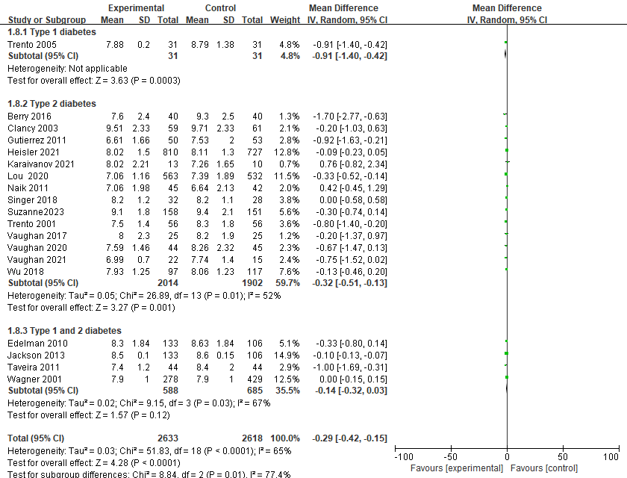
a: Forest plot for changes in HbA1c: after excluding partial bias studies
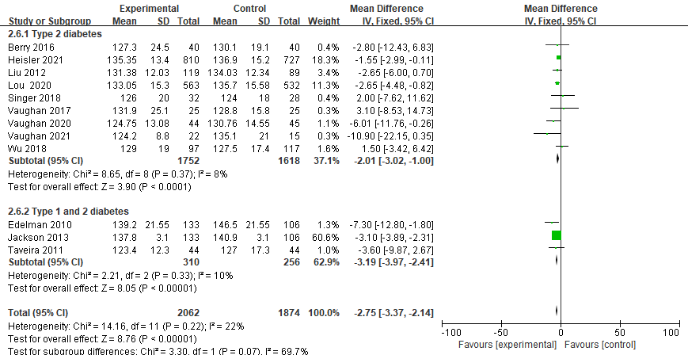
b: Forest plot of SBP changes: after excluding partial bias studies
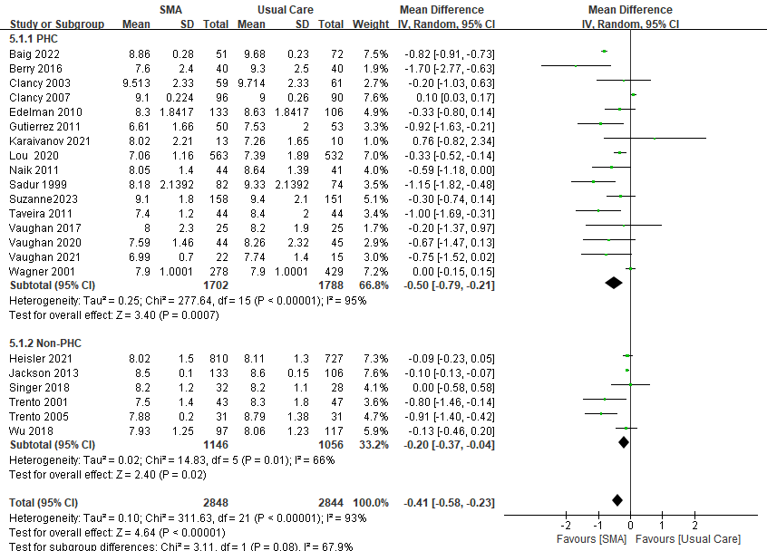
c: Forest plot for changes in HbA1c with PHC setting
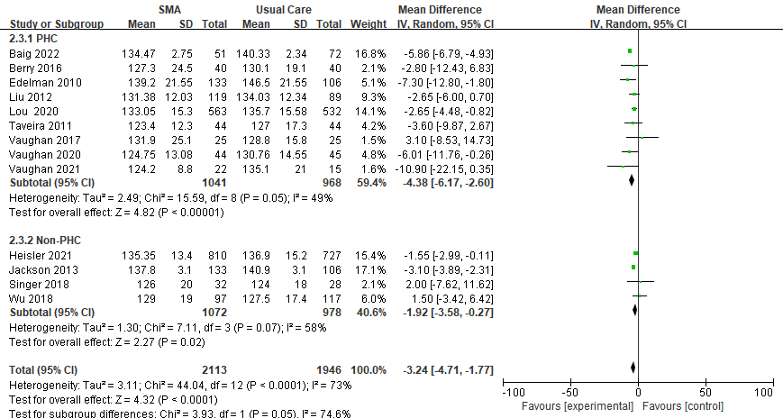
d: Forest plot for changes in SBP with PHC setting
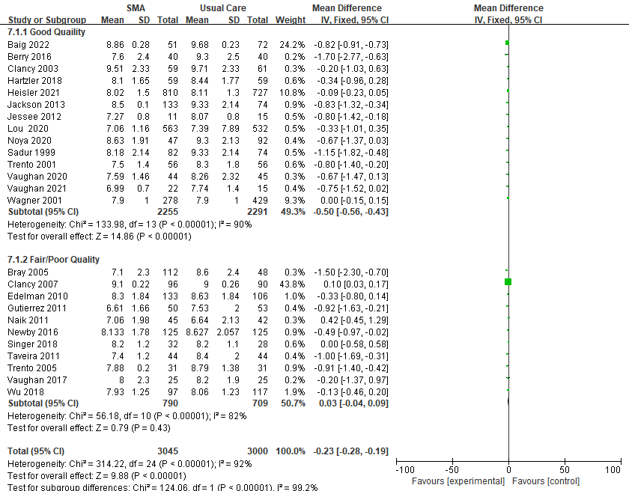
e: Forest plot of HbA1c changes according to study quality scores.

Note: CI: confidence interval; SD: standard deviation

Appendix 5. Summary of Effects of Diabetes SMA on Clinical and Economic Outcomes
Study | Costs measured | Method of cost assignment | Cost difference (SMA vs usual care)
Wagner,  2001 | Total healthcare costs. | GHC administrative data systems | SMA: 2,122.0  SMA vs usual care: 2,208.0  P=0.79
Clancy,  2003 | Facility utilization (i.e., Emergency and outpatient visits and inpatient stays) | Not specified | +$1396 (p=0.0003)
Trento,  2005 | Labor costs of personnel involved in both SMA and control | Average salaries of personnel in Italian NHS | +$207 (no statistical testing reported)
Clancy,  2007 | Facility utilization charges (i.e., charges for the group sessions, emergency and outpatient visits, and inpatient stays) | Billing database of the healthcare system | -$3065 (p<0.05)
Edelman,  2010 | Estimated the cost of a group medical clinic (GMC) | Totaling the labor costs associated with the group sessions, those associated with follow-up calls to patients, and nurse training costs | The annual cost of GMC was $460 per patient.
Jackson,  2013 | Outpatient Expenditures  , Total Expenditures | Not specified | -$1963(p=0.19)  -$7506(p=0.003)
Wu,  2018 | Total VHA Expenditure, VHA Outpatient Expenditure, VHA Inpatient Expenditure, VHA Pharmacy/Medication Expenditure, VHA fee-basis (outsource referral/transfer) costs | A variety of VHA sources that included pharmacy/medication costs, the Fee basis files, outpatient costs, and the hospitalization-related costs from the VHA in patient files | -$1532(p=0.05)  +$124(p=0.19)  +$447(p=0.03)  -$198(p=0.41)  -2005(p=0.08)
Vaughan,  2020 | medications cost | Not specified | The emphasis on low-cost hypoglycemic agents was critical.

Appendix 6. Summarize the results of hospital and emergency room visits
Study | Had an emergency room visit during the intervention |  | P-value | Had a hospitalization during the intervention |  | P-value | Had a primary care visit during the intervention |  | P-value
Study | SMA intervention | Usual Care | P-value | SMA intervention | Usual Care | P-value | SMA intervention | Usual Care | P-value
Wagner ^{A}, 2001 RCT | 0.1 | 0.2 | 0.04 | 16.9 | 21.0 | 0.10 | 6.4 | 5.5 | 0.05
Jackson ^{B}, 2013 RCT | / | / | / | 0.11 | 0.07 | 0.28 | / | / | /
Singer ^{C}, 2018 RCT | 9 | 9 | 0.51 | 11 | 11 | 0.32 | 9 | 10 | 0.22
Baig ^{D}, 2022 RCT | 11 | 10 | 0.10 | 7 | 10 | 0.21 | 47 | 65 | 0.72
Edelman ^{E}, 2010 RCT | 0.9 | 1.3 | ＜0.001 | 32 | 23 | 0.8 | 5.3 | 6.2 | 0.010
Sadur ^{F}, 2011 RCT | Visits to the Urgent Care Clinic and the Emergency Department did not differ significantly before or after the intervention. |  |  |  |  |  |  |  | 0.06
Note: A: Average number of times during the trial (mean/year);
B: Probability of hospitalization during the trial;
C: Comparison between individual and group care in patients with type 1 diabetes;
D: Number of people making healthcare utilization during the trial
E: Relative reduction in the number of comparisons between the two groups during the trial
F: The study was only summarized, and no statistical reporting was done

