Supplements

Supplement 1:
Overview of the „arriba Diabetes” software

Originally the software is German. For publication we have translated the software into English.
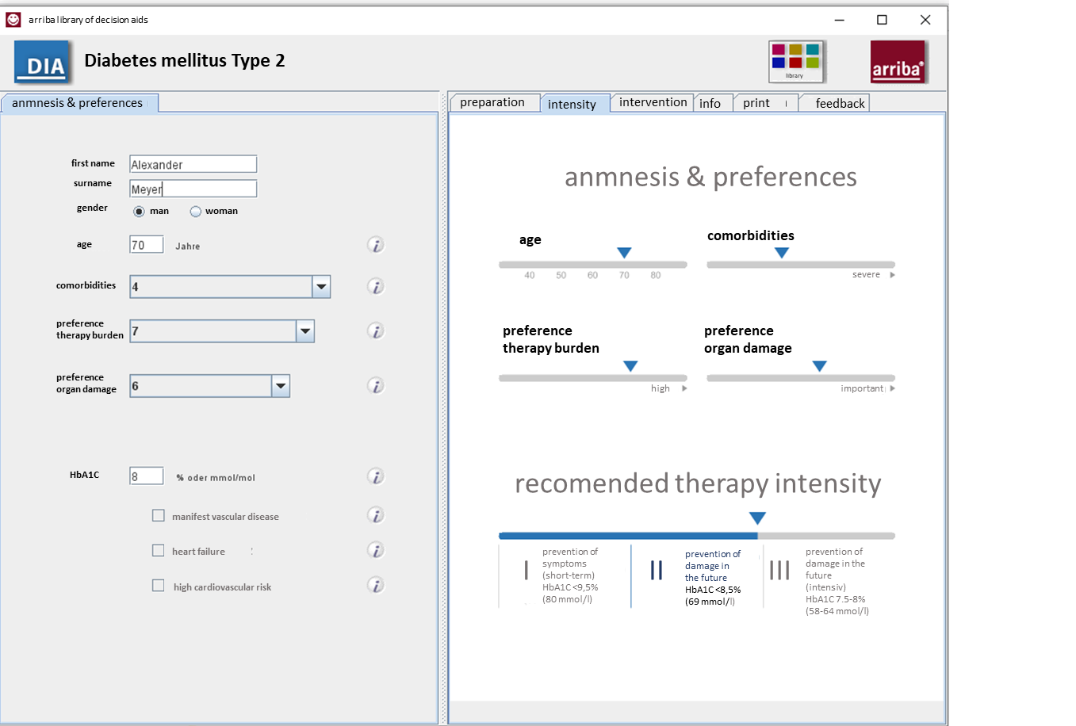

Supplement 2
Case report form

1 | Patient demographic and medical data:  Gender:  - male  - female  - diverse  How long is the diabetes diagnosis known?  - < 5 years  - 5-10 years  - > 10 years  Currently prescribed diabetes medication (multiple entries possible):  - Biguanides, (e.g. metformin)  - Sulphonylureas, (e.g. glibenclamide, glimepiride, gliclacid)  - Gliptins, (e.g. e.g. sitagliptin, saxagliptin, vildagliptin)  - GLP-1 analogues (e.g. exenatide, liraglutide, albiglutide, dulaglutide)  - Gliflozines as SGLT2 inhibitors (e.g. dapagliflozin, empagliflozin, canagliflozin)  - Insulin  - Other: _________________________________________
2 | Do you think the recommended therapy intensity is appropriate for your patient?  - yes  - no  If no:  Please mark the therapy intensity you feel is appropriate on the bar:  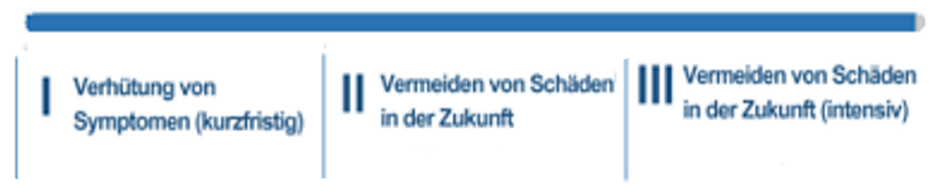  = I Prevention of symptoms II Avoiding complications in III Avoiding complications in  (short-term) the future the future (intensive)
3 | Do you consider the therapy suggestions (‘interventions’) to be appropriate?  - yes  - no  If no: Please indicate alternative (preferable) suggestions:  ______________________________________________________

4 | Do you have the impression that your patient has understood the decision about the intensity of treatment?  no yes  Do you have the impression that your patient was able to contribute to the decision on treatment intensity?  no yes
  1 | - | 2 | - | 3 | - | 4
  1 | - | 2 | - | 3 | - | 4
5 | Will you use the arriba module when it is available?  - yes  - no  If no: What are your concerns?  ______________________________________________________
6 | Any other comments?  For example on the layout, i-buttons and info texts, or on the brochure?  ______________________________________________________

