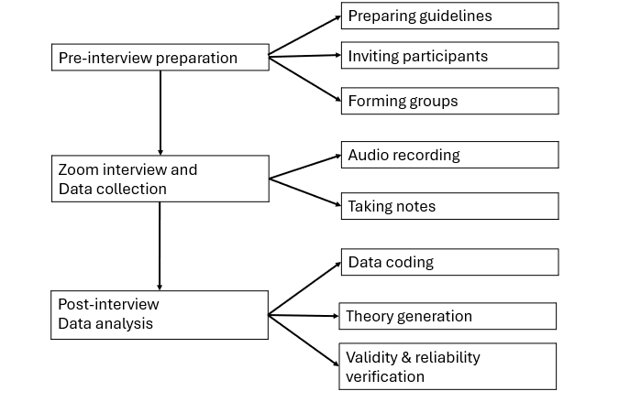
Figure 1 Flow-chart of focus group interview

