Calculating mean age and SD from 2 groups:
When there are more than two groups to combine, the simplest strategy is to apply the above formula sequentially (i.e. combine Group 1 and Group 2 to create Group ‘1+2’, then combine Group ‘1+2’ and Group 3 to create Group ‘1+2+3’, and so on).
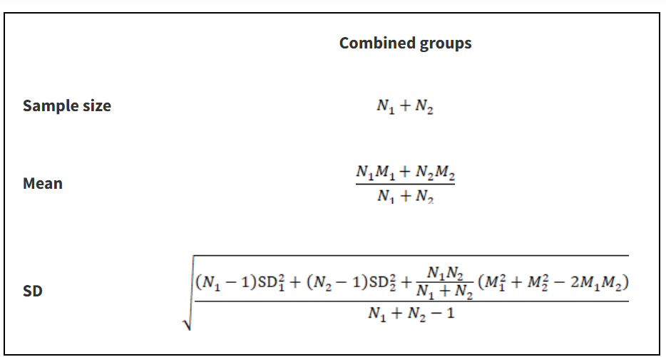
Table 6.5.a Formulae for combining summary statistics across two groups: Group 1 (with sample size = N₁, mean = M₁ and SD = SD₁) and Group 2 (with sample size = N₂, mean = M₂ and SD = SD₂)

Calculating SD from IQR:

