Supplementary Material

Attitudes and confidence toward deprescribing: a survey among Italian general practitioners

Andrea Rossi^{1,2}, Stefano Scotti^{1,2}, Lara Perrella^{3,4}, Federica Galimberti², Elena Olmastroni^{1,2}, Enrica Menditto^{3,4}, Valentina Orlando^{3,4}, Ilaria Ardoino⁵, Carlotta Franchi⁵, Manuela Casula^{1,2}

1 Epidemiology and Preventive Pharmacology Service (SEFAP), Department of Pharmacological and Biomolecular Sciences, University of Milan, Milan, Italy
2 IRCCS MultiMedica, Sesto San Giovanni (Milan), Italy.
3 CIRFF, Center of Pharmacoeconomics and Drug Utilization Research, University of Naples Federico II, Naples, Italy.
4 Department of Pharmacy, University of Naples Federico II, Naples, Italy.
5 Laboratory of Pharmacoepidemiology and Human Nutrition, Department of Health Policy, Istituto di Ricerche Farmacologiche Mario Negri IRCCS, Milan, Italy.

Corresponding Author: Lara Perrella, CIRFF, Center of Pharmacoeconomics and Drug Utilization Research, Department of Pharmacy, University of Naples Federico II, Naples, Italy. E-mail: lara-perrella@unina.it

SURVEY about DEPRESCRIBING

DEMOGRAPHIC DATA
GENDER
- M
- F
- X, O, different, non-binary gender indication, or no indication

YEARS OF WORK EXPERIENCE
- <5 years
- 5-15 years
- 15-25 years
- >25 years

GEOGRAPHICAL LOCATION
- Northern Italy
- Central Italy
- Southern Italy and Islands

SPECIALIZATION (if applicable)
Free text

DEPRESCRIBING – General Considerations

1. Based on your experience, which definition of deprescribing do you most agree with?
- A review process consisting of dose reduction or discontinuation of therapy when the risk/benefit profile is no longer acceptable for the patient
- A process of discontinuing inappropriate therapy, supervised by a healthcare professional, with the aim of managing polypharmacy, improving outcomes, and reducing costs for the NHS
- A process aimed at safely discontinuing unnecessary or potentially harmful medications
- A review process of therapy in cases of ineffective treatment, adverse drug reactions, or when treatment goals have changed
- Other (specify)

2. How relevant do you think deprescribing is in General Medicine? (1 = irrelevant; 5 = very relevant)
1 | 2 | 3 | 4 | 5

(If response is ‘2-5’ to question 2)
2a In your opinion, what are the most important reasons for a doctor to implement deprescribing? (Multiple answers allowed)
- Reduce the total number of medications taken by the patient
- Reduce costs for the NHS
- Prevent potential adverse drug reactions
- Align with updated therapeutic guidelines
- Reassess the risk/benefit ratio of therapy considering patient age and comorbidities
- Improve patient adherence
- Comply with regional/national deprescribing policies

3. Which of the following factors should encourage deprescribing? (Multiple answers allowed)
- Comorbid conditions or polypharmacy in the patient
- Side effects caused by chronic drug use
- Pathophysiological changes that could interfere with drug metabolism
- Advanced patient age
- Patient's socioeconomic condition
- Patient's desire to discontinue therapy
- Previous successful discontinuation of drug therapy

4. Do you agree that General Practitioners (GPs) should be responsible for deprescribing?
- Yes, it should be exclusively GPs’ responsibility
- Yes, but more time and resources are needed
- Yes, while evaluating whether to act personally or refer the patient to a specialist
- No, GPs could support specially trained physicians formally designated for this activity
- No, it should be exclusively managed by trained physicians designated for deprescribing

5. Which of the following tools could facilitate deprescribing? (Multiple answers allowed)
- Specific training on deprescribing
- Development/revision of accessible deprescribing guidelines
- Availability of criteria to identify potentially inappropriate medications
- Use of Decision Support Software (e.g., Micromedex, MSD Manual, Farmadati, INTERcheck, Codifa, etc.)
- Consultation service provided by trained professionals (e.g., a clinical pharmacologist)

DEPRESCRIBING – Your Experience

6. How often do you implement deprescribing? (1 = never; 5 = very often)
1 | 2 | 3 | 4 | 5

(If response is ‘1’ to question 6)
6a How applicable do you think deprescribing would be in your routine practice, considering time constraints and patient volume? (1 = not at all; 5 = very much)
1 | 2 | 3 | 4 | 5

6b What are the reasons you do not implement deprescribing? (Multiple answers allowed)
- Lack of time to review the patient's full clinical profile
- The therapy was not prescribed by myself
- Concern about adverse events and/or symptom recurrence
- Fear of resistance from the patient/family/caregiver
- Lack of useful guidelines for deprescribing
- Lack of literature on risk/benefit after deprescribing
- Insufficient experience in deprescribing
- Uncertainty about being sufficiently updated on the topic
- Other (specify)

(If response is ‘2-5’ to question 6)
6a In which age group do you most frequently implement deprescribing?
- Adults (≤64 years)
- Elderly (65-79 years)
- Very elderly (≥80 years)

6b Which approach do you use to implement deprescribing? (Multiple answers allowed)
- Explicit criteria (such as Beers, START/STOPP, etc.)
- Personal experience and knowledge
- Clinical evaluation of the individual patient
- Specific guidelines or algorithms
- Other (specify)

6c How do you collect patient feedback after deprescribing?
- I schedule a follow-up visit or phone consultation within a set time
- I wait for the next visit or opportunity to interact with the patient
- I wait for the patient to provide feedback
- I do not collect feedback

6d What obstacles or difficulties do you find in deprescribing? (Multiple answers allowed)
- Lack of time to review the patient’s overall clinical status
- Need to intervene on therapies prescribed by other physicians
- Concern about adverse events or symptom recurrence
- Resistance from the patient/family/caregiver
- Lack of useful guidelines for deprescribing
- Lack of literature on risk/benefit after deprescribing
- Limited experience in deprescribing
- Difficulty staying sufficiently updated on deprescribing
- Other (specify)

6e How often do you deprescribe the following medications? (1 = never; 5 = often):
Benzodiazepines
1 | 2 | 3 | 4 | 5

Antidepressants
1 | 2 | 3 | 4 | 5

Antihypertensives
1 | 2 | 3 | 4 | 5

Statins
1 | 2 | 3 | 4 | 5

Bisphosphonates
1 | 2 | 3 | 4 | 5

Proton Pump Inhibitors (PPIs)
1 | 2 | 3 | 4 | 5

DEPRESCRIBING – PROTON PUMP INHIBITORS
(If response is ‘2-5’ to question 6e on PPIs)

7. In which age group do you most frequently deprescribe PPIs?
- Adults (≤64 years)
- Elderly (65-79 years)
- Very elderly (≥80 years)

8. What were the most common indications/symptoms/conditions in your PPI-treated patients who underwent deprescribing? (Multiple answers allowed)
- Mild to moderate esophagitis
- Gastroesophageal reflux disease (GERD)
- Peptic ulcer disease
- Treatment of H. pylori infection
- Barrett’s esophagus
- Chronic NSAID therapy with high bleeding risk
- Severe esophagitis
- Documented history of bleeding ulcer
- Other (specify)

9. What were the main reasons for deprescribing a PPI? (Multiple answers allowed)
- The patient did not meet the indications for PPI therapy
- The condition could be managed through lifestyle modifications
- Risk of interaction with other medications
- The therapy was initially appropriate but is no longer needed
- The patient experienced adverse drug reactions (ADRs)
- The risk of ADRs was excessive
- Inadequate therapeutic response

10. How do you implement PPI deprescribing? (Multiple answers allowed)
- Immediate discontinuation
- Dose reduction followed by discontinuation
- Dose reduction
- On-demand use

11. What level of acceptance have you observed in patients for PPI deprescribing? (1 = not accepted; 5 = well accepted)
1 | 2 | 3 | 4 | 5

12. How often have you observed recurrence of the following symptoms after PPI deprescribing? (1 = never; 5 = always)
Heartburn
1 | 2 | 3 | 4 | 5

Dyspepsia
1 | 2 | 3 | 4 | 5

Regurgitation
1 | 2 | 3 | 4 | 5

Epigastric pain
1 | 2 | 3 | 4 | 5

Loss of appetite
1 | 2 | 3 | 4 | 5

Weight loss
1 | 2 | 3 | 4 | 5

Supplementary Figure 1 Responses to the question “Why a doctor should implement deprescribing” (respondents could provide more than one answer) – Stratification by years of professional experience

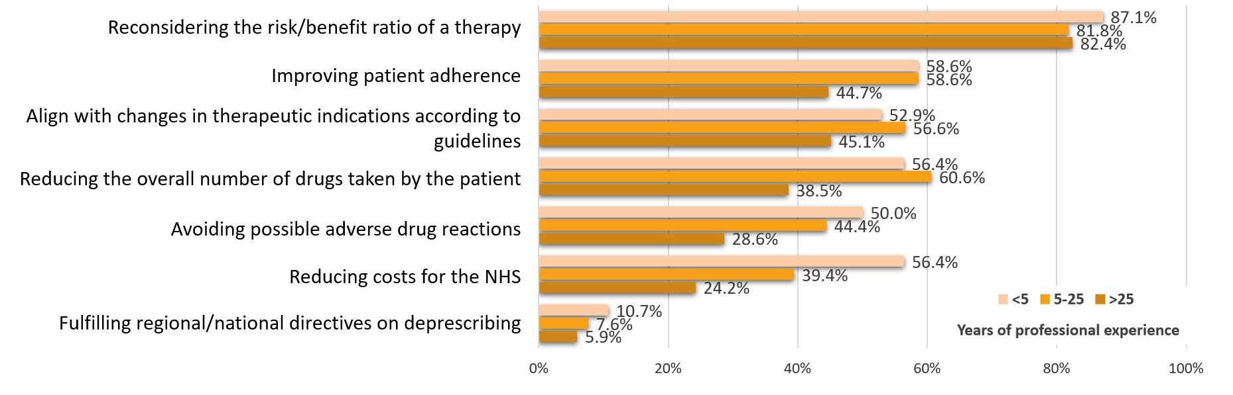

Supplementary Figure 2 Responses to the question “Do you agree with the statement that deprescribing should be in charge to the general practitioner?” (respondents could provide only one answer) – Stratification by years of professional experience
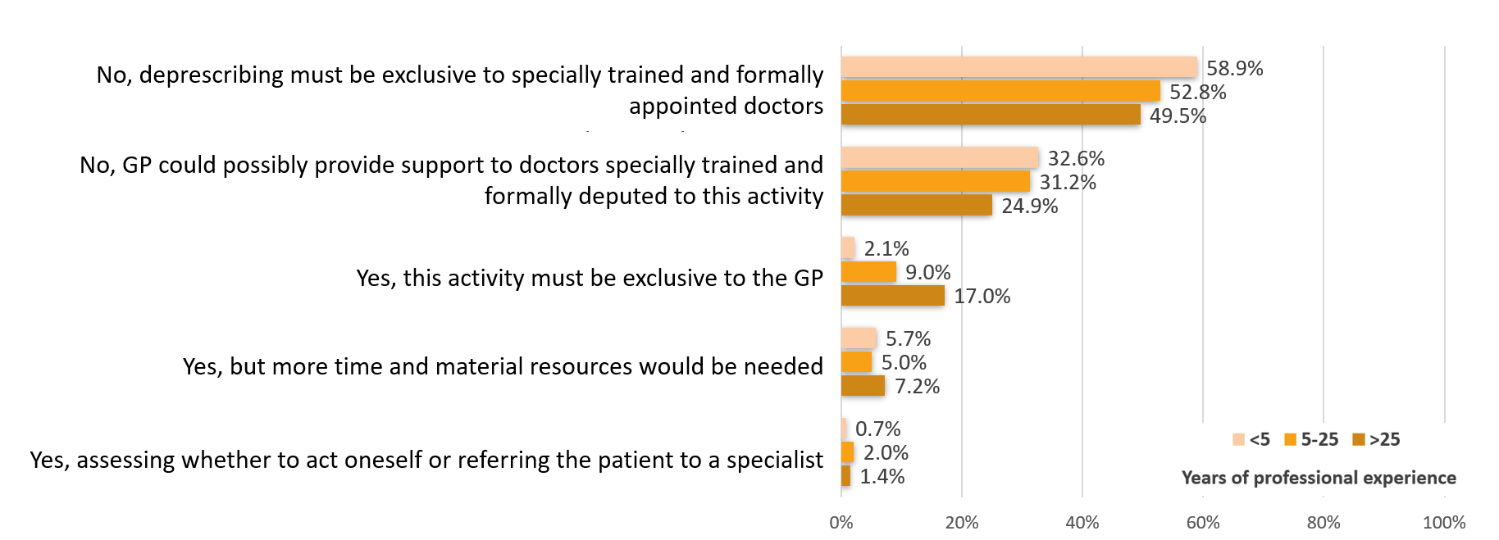

Supplementary Figure 3 Responses to the question “What do you perceive as the main obstacles or challenges in the deprescribing process?” (respondents could provide more than one answer) – Stratification by years of professional experience
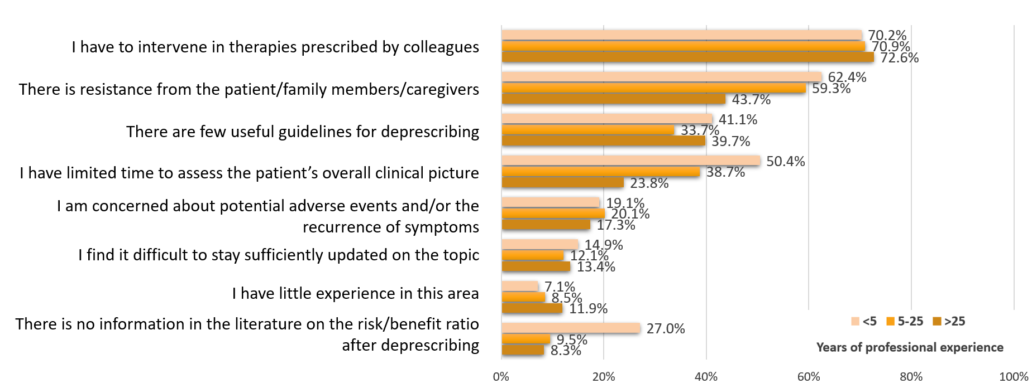

Supplementary Figure 4 Responses to the question “Which of the following instruments could most facilitate deprescribing?” (respondents could provide more than one answer) – Stratification by years of professional experience
