Additional file 1. Consolidated criteria for reporting qualitative studies (COREQ): 32-item checklist
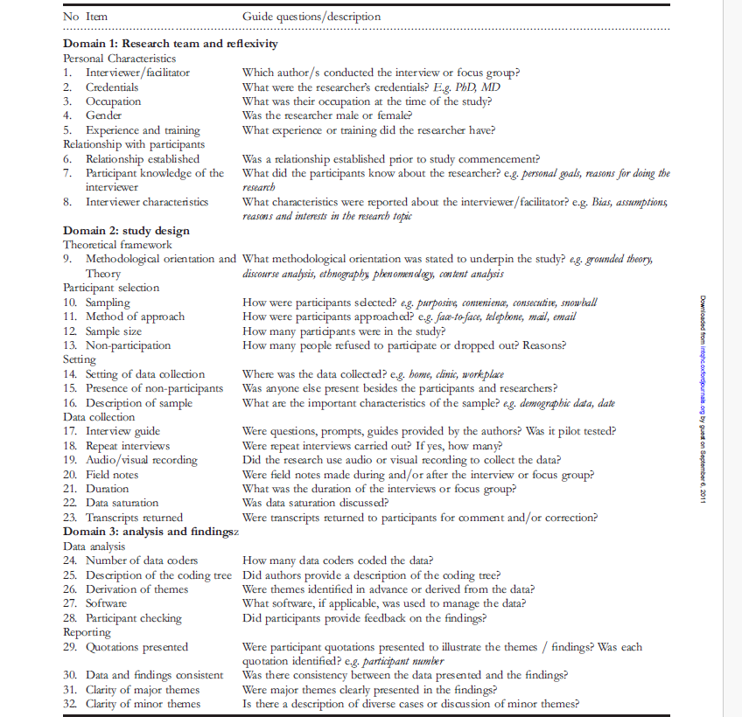

Developed from: Tong A, Sainsbury P, Craig J. Consolidated criteria for reporting qualitative research (COREQ): a 32-item checklist for interviews and focus groups. International Journal for Quality in Health Care. 2007. Volume 19, Number 6: pp. 349 – 357

