Appendix C - Proportion of studies and their result, after excluding studies with biases on outcome

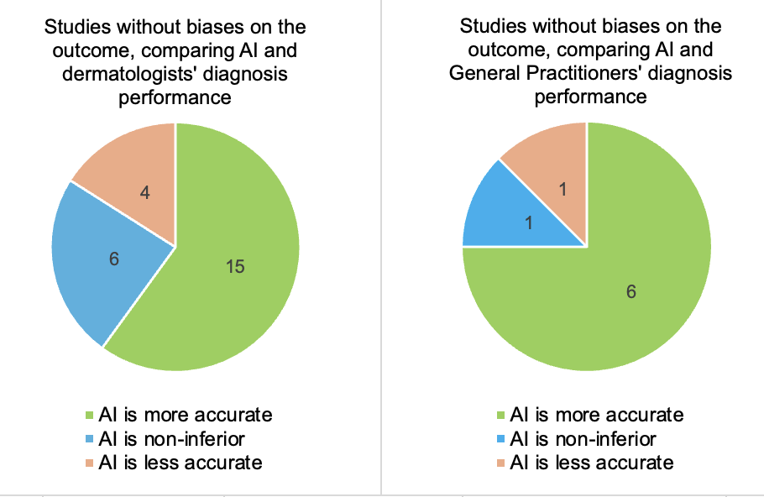

Appendix D: Studies results of AI’s diagnostic accuracy compared to physicians, depending on the presence of conflict of interest or not

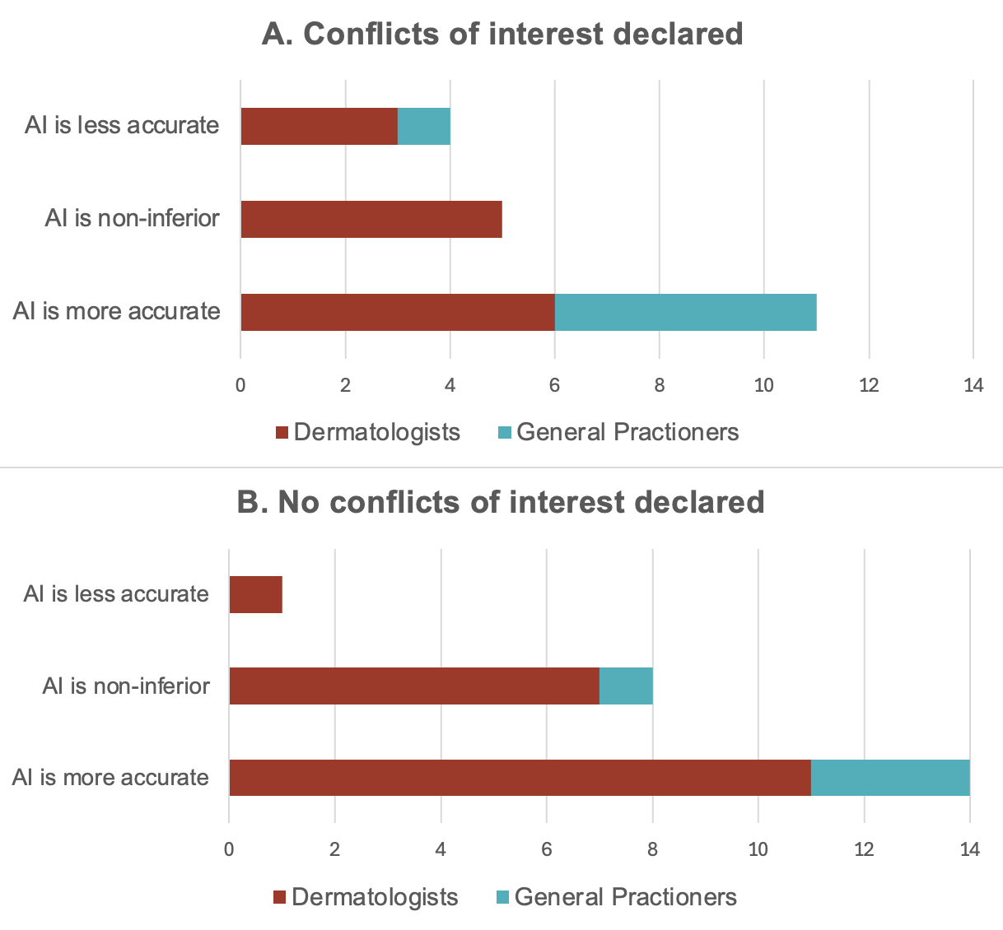

Appendix E : qualitative risk of bias assessment
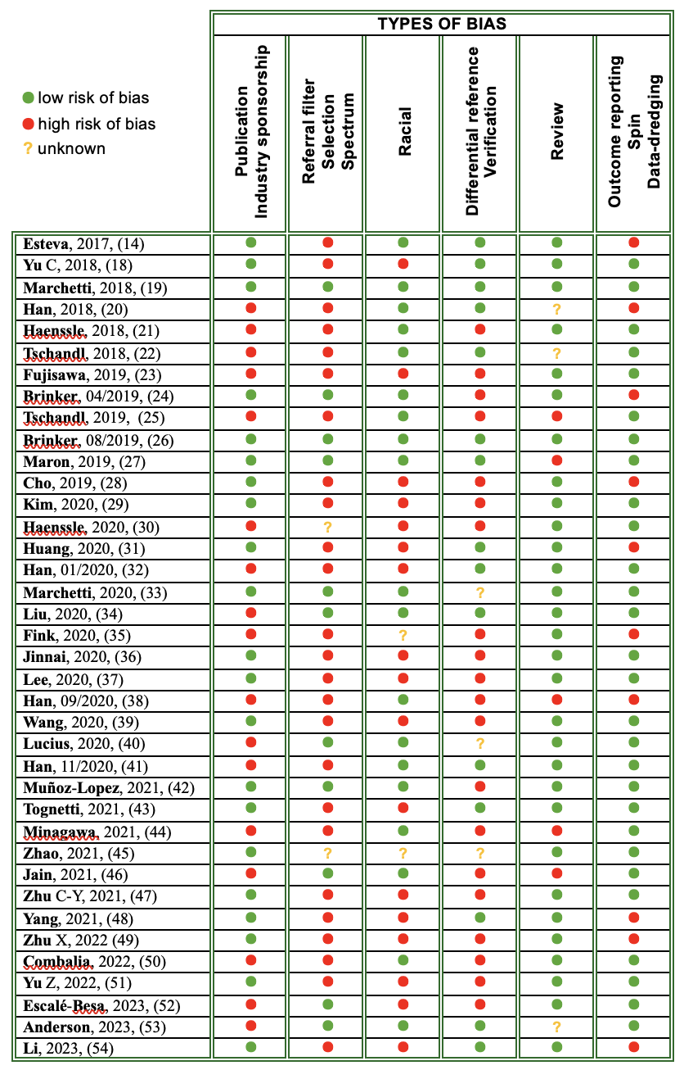
Appendix E : Bias definitions on Catalogofbias.org

Data-dredging bias: A distortion that arises from presenting the results of unplanned statistical tests as if they were a fully prespecified course of analyses.

Differential reference bias: When not all participants receive the same reference test in a diagnostic accuracy study. A type of verification bias

Hot stuff bias: When a topic is fashionable (‘hot’) investigators may be less critical in their approach to their research, and investigators and editors may not be able to resist the temptation to publish the results.

Industry sponsorship bias = Funding bias: A tendency for the methods and results of a study to support the interests of the funding organisation.

Outcome reporting bias: The selective reporting of pre-specified outcomes in published clinical trials.

Publication bias: When the likelihood of a study being published is affected by the findings of the study.

Racial bias: A distortion arising from systemic, institutional, interpersonal or individual forms of explicit (conscious) or implicit (unconscious) prejudice against individuals or groups based on social constructs of race or ethnicity that influences the planning, methods, results, interpretation, dissemination and application of health research.

Referral filter bias: Referral of any group of unwell people from primary to secondary to tertiary care, causing an increase in the concentration of rare cases, more complex cases or people with worse outcomes.

Review bias: Occurs in diagnostic test accuracy studies when the person interpreting the results of the index test has knowledge of the results of the reference standard (diagnostic review bias), or, the person interpreting the results of the reference standard has knowledge of the results of the index test (index review bias). Clinical review bias occurs when relevant clinical and patient information is available to the person interpreting the test or reference result. These are all forms of observer bias.

Selection bias: occurs when individuals or groups in a study differ systematically from the population of interest leading to a systematic error in an association or outcome.

Spectrum bias: Occurs when a diagnostic test is studied in a different range of individuals to the intended population for the test.

Spin bias: The intentional or unintentional distorted interpretation of research results, unjustifiably suggesting favourable or unfavourable findings that can result in misleading conclusions

Verification bias: when only a proportion of the study group receives confirmation of the diagnosis by the reference standard, or if some patients receive a different reference standard at the time of diagnosis.

