Appendix 1. Interview Guide
- Interview guide for healthcare policymakers/ healthcare professionals
Introduction
Hi, I am [your name] from [your institution]. We are currently conducting this research to improve the cardiovascular health among children and adolescents. Before we begin, I would like to let you know that I am interested in your personal views and opinions. There is no right or wrong answer. You may refuse to answer some of the questions if you do not feel comfortable with your views will be kept confidential. I would like to audio-record this interview for data analysis purpose.

Explain what CVH assessment is
Before we start, I would like to briefly explain to you what is cardiovascular health assessment that we will be discussing today. According to the American Heart Association recommendation, there are 8 components of cardiovascular health: blood pressure, blood sugar, blood lipid, body mass index (BMI), diet, physical activity, nicotine exposure and duration of sleep.

Here is a visual aid that summarizes these 8 components. Behavioral metrics—such as dietary habits, physical activity, sleep, and smoking—are expected to be assessed through a 20-minute questionnaire. Biological metrics—such as BMI, blood pressure, glucose, and cholesterol—would be obtained through clinical measurements and blood samples.

The objective of this interview is to explore your current practice and views about conducting CVH assessment among children and adolescents in primary care settings.

Do you have any questions before we start?

No | Constructs | General Questions | Probe
1. | Current practice | What is the current practice of CVH assessment programme in your centre? | How about in children and adolescents?  If yes, can you tell me about the programme?  If no, is there any plan to do so?
2. | Views | What is your view about CVH assessment in children and adolescents?
3. | Barriers and facilitators | If we were to implement a comprehensive CVH assessment (as in AHA recommendation) in children and adolescents,  - What are the opportunities?  - What are the potential barriers?
 | TICD Domain | Specific Questions
 | Guideline factors | Are you aware of any recommendation for CVH assessment in children and adolescents? | - If yes, what do you think about the recommendations/guideline?  (is the guideline appropriate /clear/ accessible/culturally appropriate?)  - Do you think it is important/not important? /will lead to desirable/ undesirable outcome?
 | Individual health professional factors | What do you think about conducting CVH assessment in children and adolescents? | - How about healthcare professionals' skills, knowledge, attitude/agreement towards recommendation, motivation  - amount of change/ effort required
 | Patient factors | What are the important patient factors to implementing CVH assessment? | - Patient needs, knowledge, preference, motivation, behavior  - How receptive do you believe parents/adolescents would be towards CVH assessment? (cooperation, understanding)  - Potential misconception or concerns parents/adolescents might have?
 | Professional interactions | How does the current work process influence the implementation of CVH assessment? | Which setting would you think is more appropriate for this type of comprehensive CVH assessment?
 | Incentives and resources | - What are the important resources necessary to conduct CVH assessment? Are they available in your clinic?  - Are incentives important? What type of incentives will encourage the implementation of CVH assessment? | - Financial, human resources, facilities, equipment, and supplies, information system  - training, continuing education system  - Checklists, decision aids
 | Capacity of organizational change | What organizational changes are required to implement CVH assessment? Who are the influential people? | - Do you feel this recommendation will be given the necessary priority? Ways to elevate priority/mandate the guideline?  - How healthcare leaders support and drive integration of CVH assessment into current practice?
 | Social, political, and legal factors | Any social, political, or legal factors that can influence the implementation of CVH assessment? | Healthcare budget  Regulations  Payer/funder policies
 |  | General Questions
4. | Closing | Do you think it is feasible to implement CVH assessment in children and adolescents in primary health care settings? | Practicality, compatibility with current practice

- Interview guide for parents of children aged <12
Introduction
Hi, I am [your name] from [your institution]. We are currently conducting this research to improve the cardiovascular health among children and adolescents. Before we begin, I would like to let you know that I am interested in your personal views and opinions. There is no right or wrong answer. You may refuse to answer some of the questions if you do not feel comfortable with your views will be kept confidential. I would like to audio-record this interview for data analysis purpose.

Explain what CVH assessment is
Before we start, I would like to briefly explain to you what is cardiovascular health assessment that we will be discussing today. According to the American Heart Association recommendation, there are 8 components of cardiovascular health: blood pressure, blood sugar, blood lipid, body mass index (BMI), diet, physical activity, nicotine exposure/smoking and duration of sleep.

Here is a visual aid that summarizes these 8 components. Information like your child’s diet, physical activity, sleep, and exposure to smoking would be collected through a questionnaire that takes about 20 minutes. Other information—such as height and weight, blood pressure, blood sugar, and cholesterol—would likely be collected through measurements and a blood test.

The objective of this interview is to explore your views about assessing your child’s CVH.

Do you have any questions before we start?

No | Constructs | General Questions | Probe
1. | Experience | - Can you tell us a bit about your experiences with visits to the doctor and health check-ups for your child?  - How often do you bring your child to the clinic and what is the reason for visit/ what is usually discussed during those visits?  - Have your child ever had health check-ups specifically related to the CVH in any setting? | If yes: When, Where, What CVH metrics were assessed, how has it been done?  If no: Do you wish to have a CVH assessment for your child?
2. | Views | What is your view about assessing your child’s CVH? | - What are your thoughts about CVH?  - How important do you think it is to know about your child’s CVH from an early age?  - What benefits do you think your child could gain from CVH assessment?  - What steps/process do you think might be involved while assessing your child’s CVH? Would you be okay with it?  - How do you see your role as a parent in helping your child maintain a healthy CVH?  - How do you feel about including CVH assessment as part of your child’s routine care?
3. | Barriers | What do you think are the challenges in assessing your child’s CVH? | - Any potential obstacles/worries you have about getting your child’s CVH assessed?
4. | Facilitators | What do you think are effective ways to encourage your child to participate in CVH assessment? | - Any suggestions on how to make the whole experience of CVH assessment feasible for parents and children?
 | TICD Domain | Specific Questions
 | Patient factors | What would motivate you to have a CVH assessment done for your child?  - What are your expectations?  - What kind of information or treatment advice would you like to receive from a CVH assessment for your child? | - How do you think your child would react to CVH assessment at the clinic? (cooperation, understanding)  - How feasible in terms of time and logistics for you/your child to have CVH assessment done?  - When and where the CVH assessment should be done?  - Is there a specific time during the day or week you prefer?  - What other factors might encourage or discourage you from having CVH discussion with the doctor or for bringing your child for CVH assessment?
 | Incentives and resources | - Where do you think is the best place to have your child’s CVH assessed?  - Are incentives important for you? What type of incentives will encourage you? | Clinic, school, or community centre  - What kind of support or resources would help?
 | Social, political, and legal factors | Do you have any policy or regulation concern regarding CVH assessment | Insurance coverage
 |  | General Questions
4. | Closing | Do you think it is feasible to implement CVH assessment in children and adolescents in primary health care settings? | Are there any concerns/questions that you want me to address? Do you have anything else to add?

- Interview guide for adolescents
Introduction
Hi, I am [your name] from [your institution]. We are currently conducting this research to improve heart health among children and adolescents. We’re interested in learning more about how you feel about getting your heart health checked. There is no right or wrong answer. You may refuse to answer some of the questions if you do not feel comfortable with your views will be kept confidential. I would like to audio-record this interview for data analysis purpose.

Explain what CVH assessment is
Before we start, I would like to briefly explain to you what is heart health assessment that we will be discussing today. There are 8 components of heart health: blood pressure, blood sugar, blood lipid, body mass index (BMI), diet, exercise, smoke exposure/smoking and duration of sleep.

This picture shows the 8 components of heart health. We would ask you some questions about your diet, exercise, sleep, and whether you smoke or are around people who smoke. This would take about 20 minutes. Other things—like your height and weight, blood pressure, blood sugar, and blood lipid—would probably be checked through measurements and a blood test.

The objective of this interview is to explore your views about assessing your heart health.

Do you have any questions before we start?

No | Constructs | General Questions | Probe
1. | Experience | - Can you tell us a bit about your experience with visiting the clinic and health check-ups in general?  - How often do you visit the clinic and what was done during the visits?  - Do you have any experience of checking your heart health (blood pressure, blood sugar, blood lipid, BMI, diet, physical activity, nicotine exposure, sleep) in any setting? | If yes: When, Where, What CVH metrics were assessed, how has it been done?  If no: Do you wish to have a CVH assessment for yourself?
2. | Views | What is your view about assessing your heart health? | - How important do you think it is to have your heart health checked by a doctor?  - What do you already know about heart health and what is good for your heart?  - Does your school or friends talk about it?  - What do you think might be involved to assess your heart health? Would you be okay with it?
3. | Barriers | What do you think are the challenges in assessing your heart health? | - Is there anything you are curious or worried about when it comes to heart assessments?
4. | Facilitators | What do you think are effective ways to encourage you to participate in heart assessment? | - How should doctors make heart assessments more appealing or understandable?  - Any suggestions on how to make the whole experience better?  - What could encourage you to take an interest in your heart health?
 | TICD Domain | Specific Questions
 | Patient factors | - What would motivate you to have a heart assessment done for yourself?  - What kind of information or advice would you like to receive?  - Do you think advice on how to improve your heart health through things like eating better or being more active will be helpful? | - How do you feel when discussing about personal things like your lifestyle and habits, body, and any health concerns you might have? (e.g., eating habits, physical activity, sleep patterns, smoke exposure)  - Are there any ways doctors can make sure you feel comfortable during these discussions?  - We understand you might be busy from schoolwork and activities; how would you feel about the extra time needed for heart assessment and talking about heart health?  - Is there a specific time during the day or week you prefer?
 | Incentives and resources | - Where do you think is the best place to have your heart assessed? | Clinic, school, or community centre
 |  | General Questions
4. | Closing | Do you think it is practical to implement heart assessment in children and adolescents in primary health care settings? | Are there any concerns/questions that you want me to address? Do you have anything else to add?

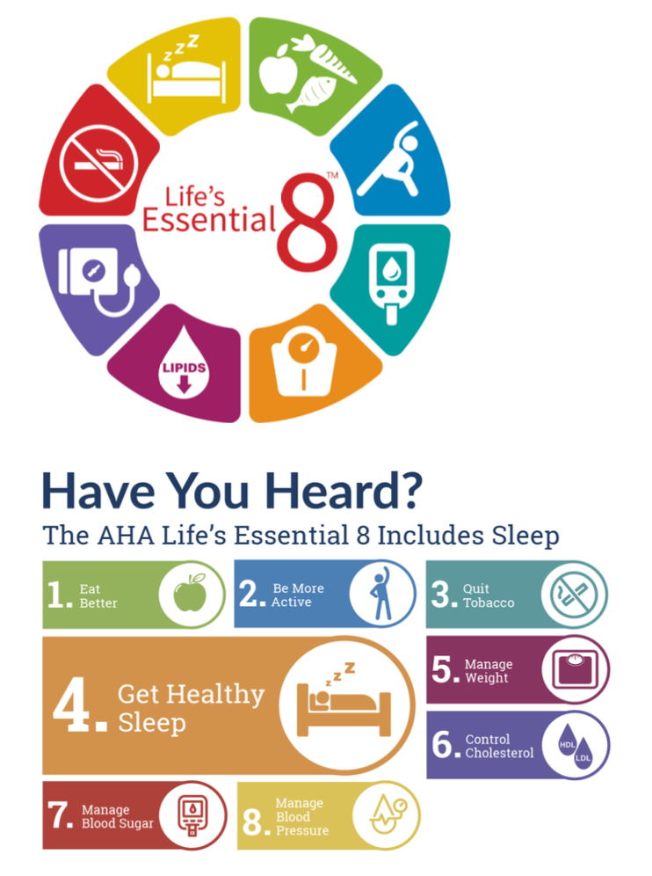
Appendix 2. Life’s Essential 8 Metrics for CVH Assessment

