Supplemental Figure

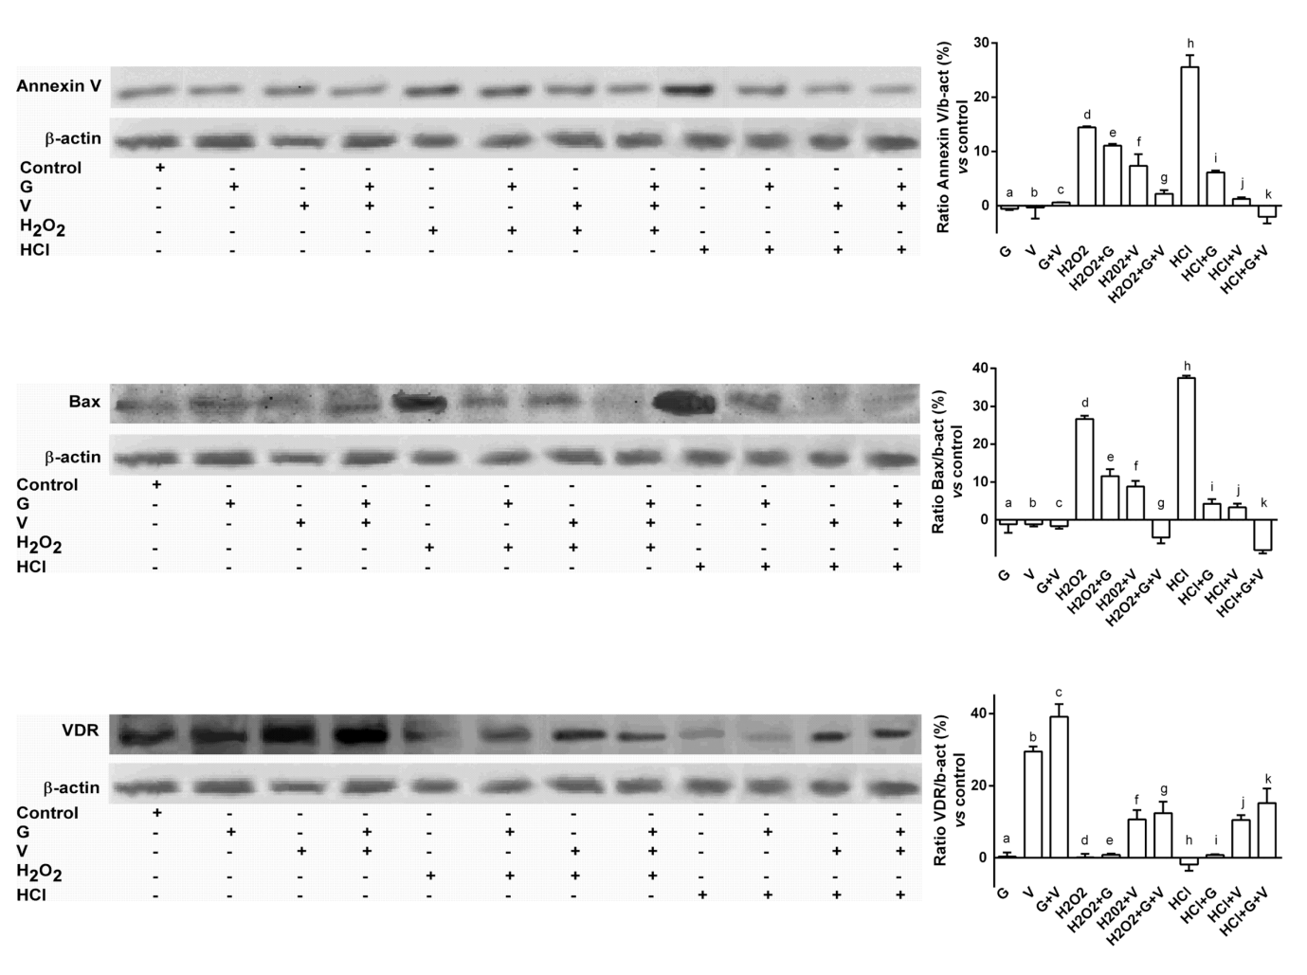

S1 Western Blot and densitometric analysis in GTL-16 cells.
Western blot of protein extracts are analyzed by immunoblotting with specific antibodies against the indicated proteins with the relative densitometric analysis. The abbreviations are the same reported in the main manuscript. The images reported are an example of 5 biological replicates and the data are expressed as means ±(SD) (%). Annexin V p<0.05: d, e, f, h, i vs control (line 0%); e, f, g vs d; g vs k; i, j, k vs h. Bax p<0.05: d, e, f, g, h, i, j, k vs control (line 0%); i, j, k vs h; e, f, g vs d; g vs k. VDR p<0.05: b, c, f, g, j, k vs control (line 0%); f, g vs d; j, k vs h.

