Additional file 1

Table S1 16S Primer sequences used in this study
Primer Name | Sequence (5'-3')
V3 Forward Primer | TCGTCGGCAGCGTCAGATGTG-TATAAGAGACAGCCTACGGG-NGGCWGCAG
V4 Reverse Primer | GTCTCGTGGGCTCGGAGATGTG-TATAAGAGACAGGACTACHVGGG-TATCTAATCC
 | TAAGGCGAAAGGCTAT
  N701(FP) | S520(RP)
 | TAAGGCGAGAGCCTTA
  N701(FP) | S521(RP)
 | TAAGGCGATTATGCGA
  N701(FP) | S522(RP)
 | CGTACTAGTCGACTAG
  N702(FP) | S513(RP)
 | CGTACTAGTTCTAGCT
  N702(FP) | S515(RP)
 | GCTACTAGAAGGCTAT
  N702(FP) | S520(RP)
 | CGTACTAGGAGCCTTA
  N702(FP) | S521(RP)
 | CGTACTAGTTATGCGA
  N702(FP) | S522(RP)
 | CGTACTAGCCTAGAGT
  N702(FP) | S516(RP)
 | CGTACTAGGCGTAAGA
  N702(FP) | S517(RP)
 | CGTACTAGCTATTAAG
  N702(FP) | S518(RP)
 | AGGCAGAACTATTAAG
  N703(FP) | S518(RP)
 | GCTCATGAAAGGAGTA
  N714(FP) | S507(RP)
 | CGTACTAGAAGGAGTA
  N702(FP) | S507(RP)
 | CGTACTAGCTAAGCCT
  N702(FP) | S508(RP)
 | CGTACTAGCGTCTAAT
  N702(FP) | S510(RP)
 | GGACTCCTTATCCTCT
  N705(FP) | S503(RP)
 | GGACTCCTGTAAGGAG
  N705(FP) | S505(RP)
 | GGACTCCTACTGCATA
  N705(FP) | S506(RP)
 | GGACTCCTAAGGAGTA
  N705(FP) | S507(RP)
 | GGACTCCTCTAAGCCT
  N705(FP) | S508(RP)
 | GGACTCCTCGTCTAAT
  N705(FP) | S510(RP)

Table S2 Bile acids identified by UPLC-MS analysis
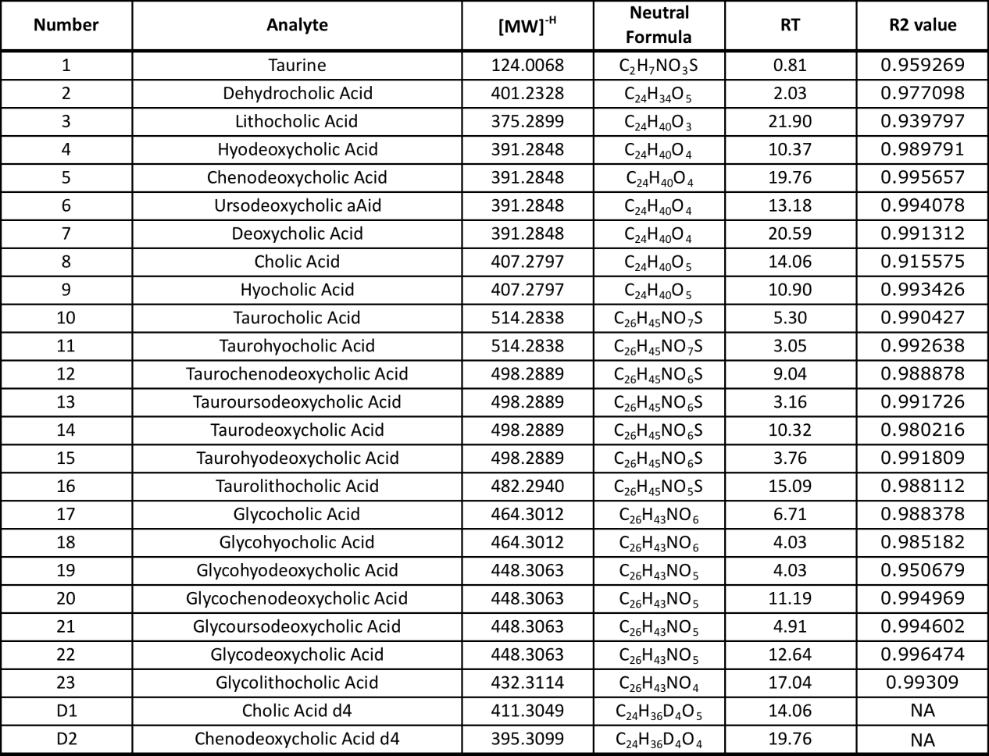

Table S3 Bile acid profile of fresh donor samples vs frozen donor.
Bile Acid | FTD 007 | OPEN BIOME (FTD 010) | FTD 006
Taurine | 150.07 | 29.21 | 152.40
LCA | 7126.13 | 1230.45 | 5268.66
DCA | 2773.91 | 232.36 | 3550.45
UDCA | 340.74 | 35.63 | 1282.73
CA | 36.98 | 9.97 | 42.96
CDCA | 82.58 | 8.32 | 143.21
HDCA | 5.91 | 3.55 | 9.47
HCA | 5.89 | 1.82 | 4.82
GCDCA | 14.78 | 2.11 | 15.49
GCA | 13.07 | 1.63 | 8.22
GHCA | 11.44 | 1.51 | 8.67
GHDCA | 2.73 | 0.66 | 4.64
GUDCA | 0.38 | 0.41 | 2.23
GDCA | 11.29 | 1.34 | 6.98
GLCA | 9.76 | 0.42 | 9.84
TCDCA | 9.48 | 0.62 | 7.03
TUDCA | 8.84 | 0.19 | 0.44
TDCA | 2.80 | 0.79 | 6.49
THDCA | 0.74 | 0.15 | 3.16
TCA | 8.08 | 0.36 | 4.45
TLCA | 1.55 | 2.25 | 8.18
THCA | 0.46 | 0.21 | 3.54

Table S4 Fatty acids identified by UPLC-MS analysis
Analyte | [MW]^{-H} | Neutral Formula | RT | R value
Pyruvic acid | 87.0082 | C₃H₄O₃ | 0.81 | 0.8712
Lactic acid | 89.0239 | C₃H₆O₃ | 0.8 | 0.827
Heptanoic acid | 129.0916 | C₇H₁₄O₂ | 2.95 | 0.9018
Octanoic acid | 143.1072 | C₈H₁₆O₂ | 4.93 | 0.93
Myristic acid | 227.2011 | C₁₄H₂₈O₂ | 22.15 | 0.8059
Palmitoleic acid | 253.2168 | C₁₆H₃₀O₂ | 22.25 | 0.9577
Palmitic acid | 255.2324 | C₁₆H₃₂O₂ | 22.55 | 0.9815
Linolenic acid | 277.2168 | C₁₈H₃₀O₂ | 22.15 | 0.9115
Linoleic acid | 279.2324 | C₁₈H₃₂O₂ | 22.34 | 0.8765
Oleic acid | 281.2481 | C₁₈H₃₄O₂ | 22.59 | 0.9123
cis-5,8,11,14,17-Eicosapentaenoic acid | 301.2168 | C₂₀H₃₀O₂ | 22.11 | 0.9484
Arachidonic acid | 303.2324 | C₂₀H₃₂O₂ | 22.3 | 0.9669
Cis-11-Eicosenoic acid | 309.2794 | C₂₀H₃₈O₂ | 22.97 | 0.8664
Cis-4,7,10,13,16,19-Docosahexaenoic acid | 327.2324 | C₂₂H₃₂O₂ | 22.25 | 0.8965

Table S5 R Libraries and the Versions

Version and system information
## R version 3.3.2 (2016-10-31)
## Platform: x86_64-w64-mingw32/x64 (64-bit)
## Running under: Windows 7 x64 (build 7601) Service Pack 1
##
## locale:
## [1] LC_COLLATE=English_Ireland.1252 LC_CTYPE=English_Ireland.1252
## [3] LC_MONETARY=English_Ireland.1252 LC_NUMERIC=C
## [5] LC_TIME=English_Ireland.1252
##
## attached base packages:
## [1] stats graphics grDevices utils datasets methods base
##
## loaded via a namespace (and not attached):
## [1] SummarizedExperiment_1.2.3 genefilter_1.54.2
## [3] locfit_1.5-9.1 splines_3.3.2
## [5] lattice_0.20-34 colorspace_1.3-2
## [7] htmltools_0.3.6 stats4_3.3.2
## [9] yaml_2.1.14 base64enc_0.1-3
## [11] survival_2.39-5 XML_3.98-1.6
## [13] foreign_0.8-68 DBI_0.6-1
## [15] BiocParallel_1.6.6 BiocGenerics_0.18.0
## [17] RColorBrewer_1.1-2 plyr_1.8.4
## [19] stringr_1.2.0 zlibbioc_1.18.0
## [21] munsell_0.4.3 gtable_0.2.0
## [23] DESeq2_1.12.4 htmlwidgets_0.8
## [25] evaluate_0.10 memoise_1.1.0
## [27] latticeExtra_0.6-28 Biobase_2.32.0
## [29] knitr_1.15.1 geneplotter_1.50.0
## [31] IRanges_2.6.1 GenomeInfoDb_1.8.7
## [33] parallel_3.3.2 AnnotationDbi_1.34.4
## [35] htmlTable_1.9 Rcpp_0.12.10
## [37] acepack_1.4.1 xtable_1.8-2
## [39] scales_0.4.1 backports_1.0.5
## [41] checkmate_1.8.2 S4Vectors_0.10.3
## [43] Hmisc_4.0-3 annotate_1.50.1
## [45] XVector_0.12.1 gridExtra_2.2.1
## [47] ggplot2_2.2.1 digest_0.6.12
## [49] stringi_1.1.5 GenomicRanges_1.24.3
## [51] grid_3.3.2 rprojroot_1.2
## [53] tools_3.3.2 bitops_1.0-6
## [55] magrittr_1.5 lazyeval_0.2.0
## [57] RCurl_1.95-4.8 tibble_1.3.0
## [59] RSQLite_1.1-2 Formula_1.2-1
## [61] cluster_2.0.6 Matrix_1.2-8
## [63] data.table_1.10.4 rmarkdown_1.5
## [65] rpart_4.1-11 nnet_7.3-12
## sysname release
## "Windows" "7 x64"
## version nodename
## "build 7601, Service Pack 1" "POTOOLE-PC"
## machine login
## "x86-64" "Burk"
## user effective_user
## "Burk" "Burk"

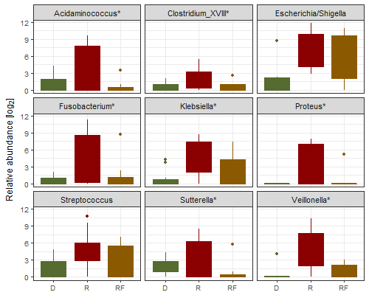
Figure S1: The relative abundance of many bacterial genera is restored to donor levels after FMT. Shown are boxplots for genera with statistically significantly higher abundance (P < .001, Wald-test) in patients with CDI (recipients) compared to donors. Most of these genera were not differentially abundant after the FMT procedure (follow-up) compared to donors, indicated by asterix. D: Donor, R: Recipient, RF: Recipient post-FMT.

A
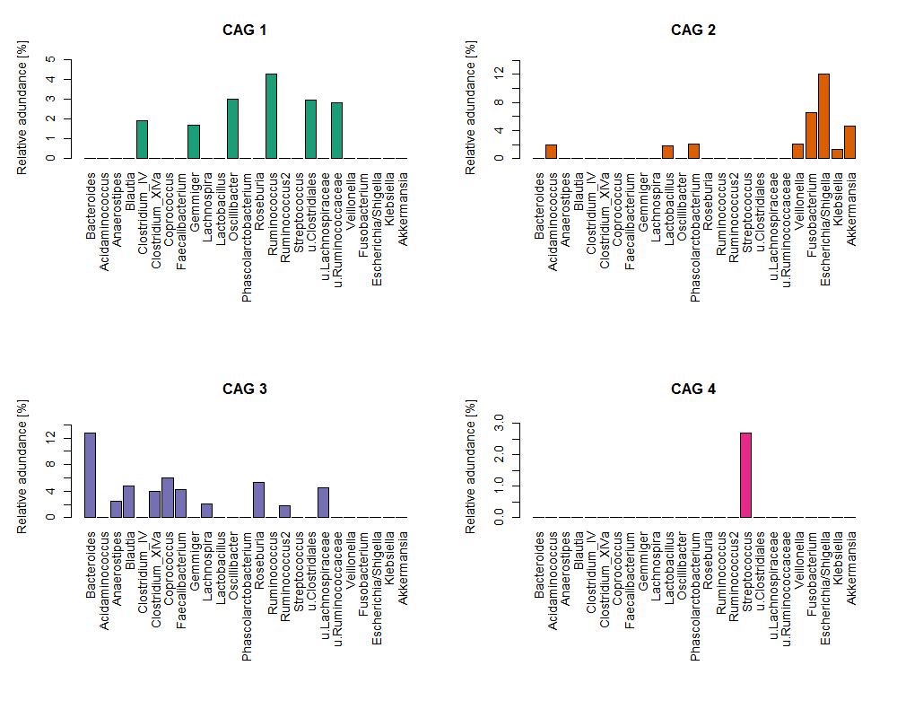
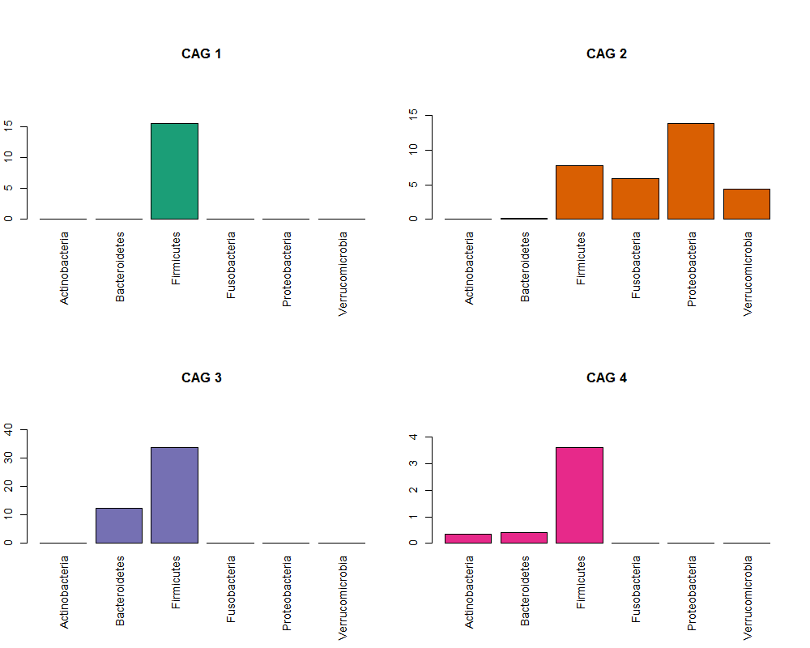
B

Figure S2: Composition of the 4 Co-abundance groups in Figure 2. A: Classification at genus level. B: Classification at phylum level.

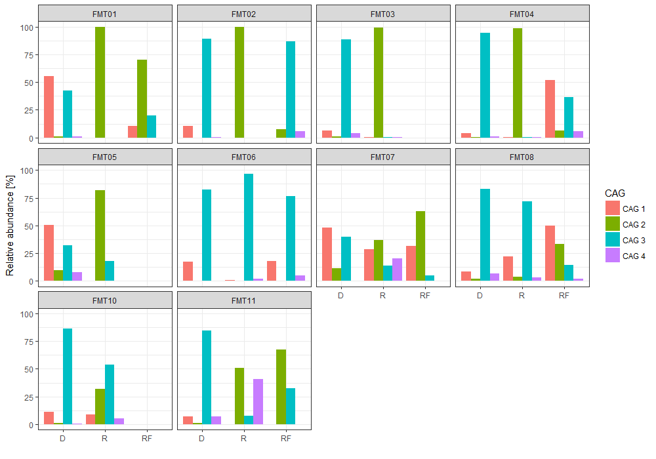
Figure S3: The relative abundance of Co-abundance Groups across all samples. Colour coding of CAGs (Figure 2) according to legend to the right. D = donor, R = recipient, RF = follow-up.

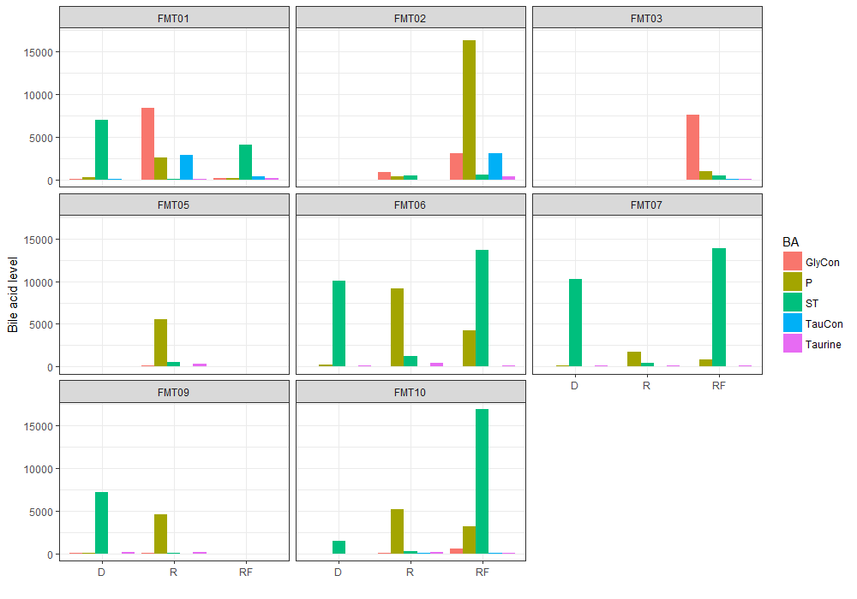

Figure S4: Faecal bile acid levels in all the samples. The levels obtained for single bile acids (see Supplementary Table 2) were combined to glyco-conjugated bile acids (GlyCon), primary bile acids (P), secondary and tertiary bile acids (ST), tauro conjugated bile acids (TauCon) and taurine bile acids. Colour coding is according to the legend at the right. D = donor, R = recipient, RF = follow-up.

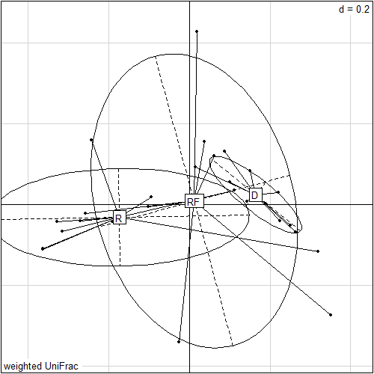

Figure S5: PCoA of the microbiota based on the weighted UniFrac distance. Similar to unweighted UniFrac, recipient samples were significantly different from donor samples (P < .01, F-statistic = 7.71, R vs D) but assumed a more donor-like microbiota composition after FMT (P > .1, F-statistic 2.1, RF vs D). R = recipient, D = donor, RF = follow-up.

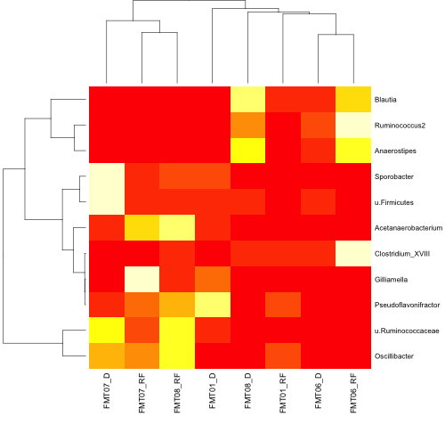
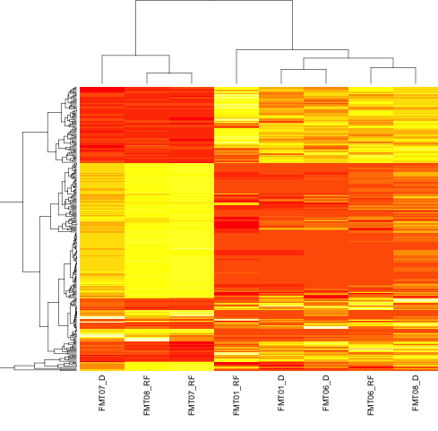

Figure S6: Heatmap based on metagenomic shotgun sequencing. Stratification is based on the functional and phylogenetic profiles of faecal bacterial communities which is similar. Left: Column dendrogram based on Spearman distance and Ward-linkage clustering. Right: Heatmap based on 16S-amplicon sequencing. Column dendrogram based on Unweighted UniFrac distance and Ward-linkage clustering. Shown are the bacterial genera with significant differences between the two sample groups defined by the two main branches of the dendrogram

