Supplementary Table 1. Delayed adverse events (from 1 hour after infusion to 28 days follow-up).

Adverse event | IBD (n, %) | Non-IBD (n, %)
Headache† | 0 (0) | 3 (15)
Arthralgia / myalgia† | 6 (25) | 5 (25)
Fatigue† | 3 (13) | 3 (15)
Nausea / vomiting | 1 (4) | 3 (15)
Abdominal pain | 2 (8) | 2 (10)
Diarrhoea | 1 (4) | 1 (5)
PR bleeding | 0 (0) | 1 (5)
Dyspnoea† | 0 (0) | 1 (5)
Dizziness† | 0 (0) | 1 (5)
Palpitations | 0 (0) | 1 (5)
Rash | 1 (4) | 0 (0)

† symptoms considered as possibly or likely due to ferric carboxymaltose

Supplementary Figure 1. Correlation between minimum serum phosphate during follow-up and multiple markers in patients with IBD
A  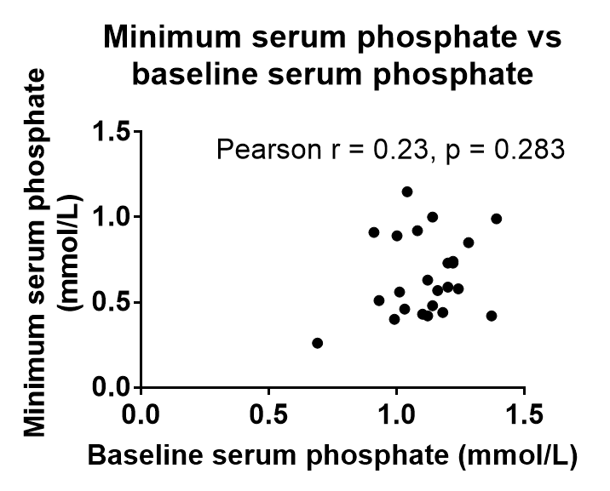 | B  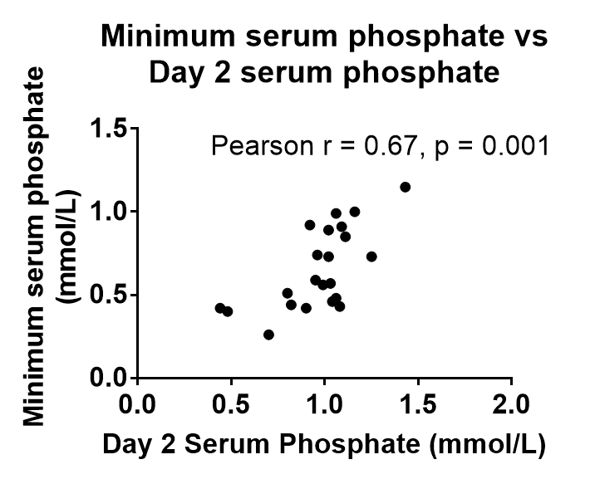
C  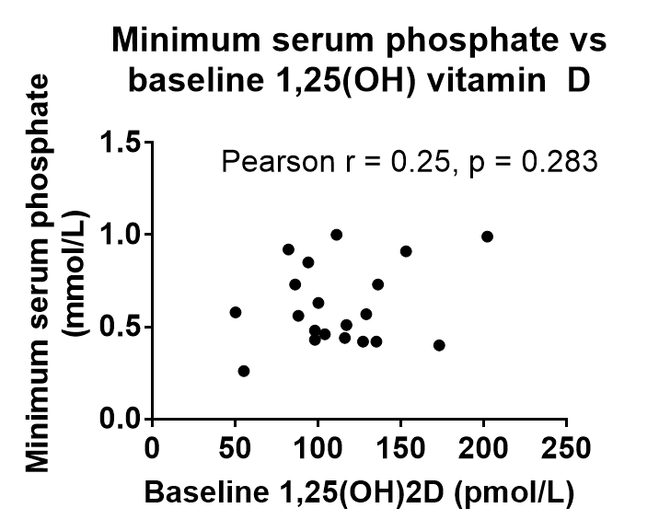 | D  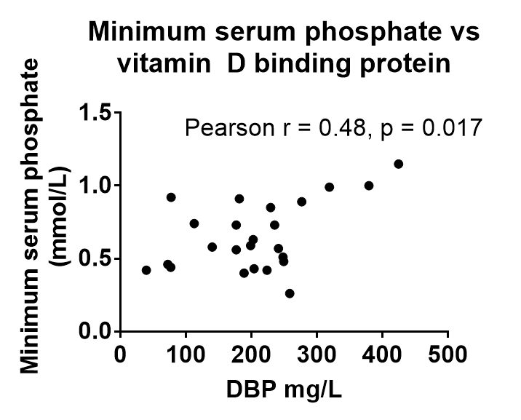
E  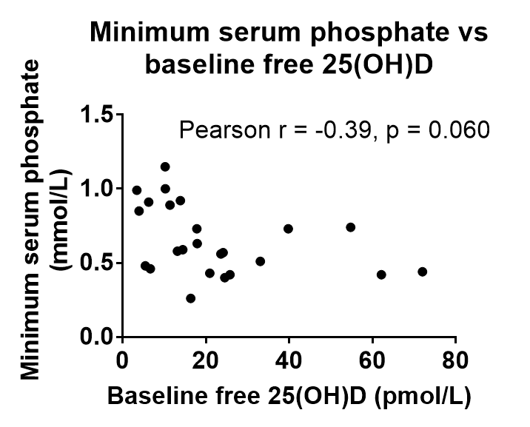 | F  