Supporting Information:
Plasma cell free DNA methylation markers for Hepatocellular Carcinoma surveillance in patients with cirrhosis.
Patients – Training Set (3 from BioSophia, 38 from Halle)

Patients – Testing Set – Inclusion Criteria
Both Groups:
- Men or women age 18 years or older;
- Able to read, understand and sign informed consent to participate in study;
- Willing and able to provide written informed consent;
- Willing and able to meet all study requirements and undergo venipuncture to provide blood samples;
- Child class A or B.

Group 1:
Diagnosis of cirrhosis and no HCC confirmed by an abdominal contrast-enhanced MRI or CT imaging performed ≤ 90 days prior to the date of consent or an abdominal contrast-enhanced MRI performed ≤ 45 days after Visit 1. Patients with no lesions or lesions with an LI-RADS score of LR-1 or LR-2.

Group 2:
Diagnosis of HCC confirmed by an abdominal contrast-enhanced MRI or CT imaging performed ≤ 90 days prior to the date of consent or an abdominal contrast-enhanced MRI performed ≤ 45 days after Visit 1 with LI-RADS score of LR-5 and/or biopsy with histopathology.

Exclusion Criteria
Both Groups:
- Child class of C;
- Subject has undergone a colonoscopy, endoscopy or other invasive diagnostic procedure (other than venipuncture) during the 10 days prior to providing a blood sample for this study;
- Pregnancy;
- Breastfeeding;
- Currently undergoing dialysis;
- Currently receiving investigational treatments of any type;
- History of receiving any drug therapy, surgery or liver transplant for the treatment of HCC;
- Diagnosis of any non-HCC cancer (other than non-melanoma skin cancer) within past 5 years and/or currently undergoing treatment for any cancer;
- Any clinical condition, diagnosis, or social circumstance that, in the opinion of the Investigator, would be mean participation in the study would be contraindicated.
Group 1:
- Diagnosis of HCC or imaging data indicative of anything other than no lesion or lesions with an LR-1 or LR-2 classification.
Group 2:
- Imaging classification of LR-1, LR-2, LR-3 or LR-4.

FIGURES
Supplement Figure 1: Patient distribution of Class/Stage, Sex and Child class by different source of cirrhosis.

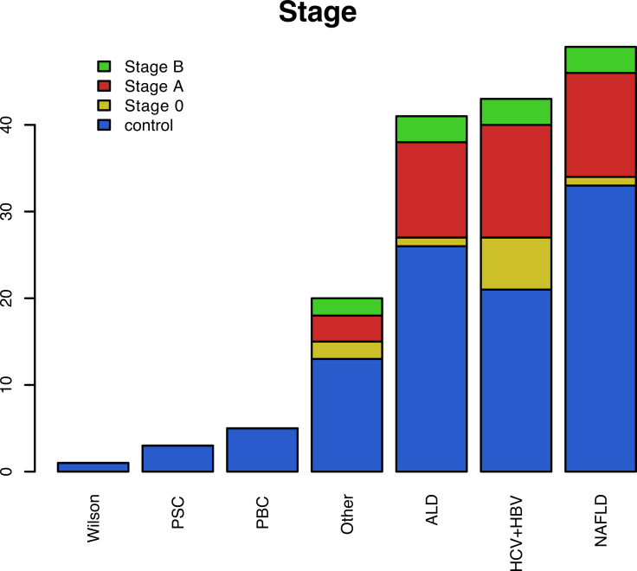
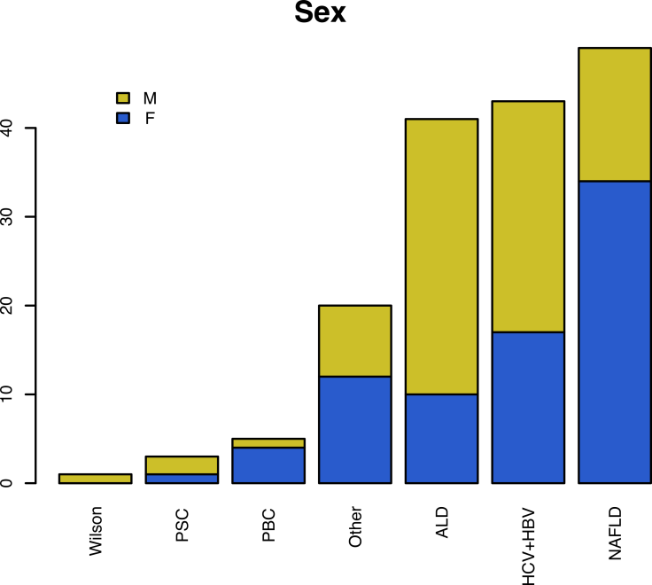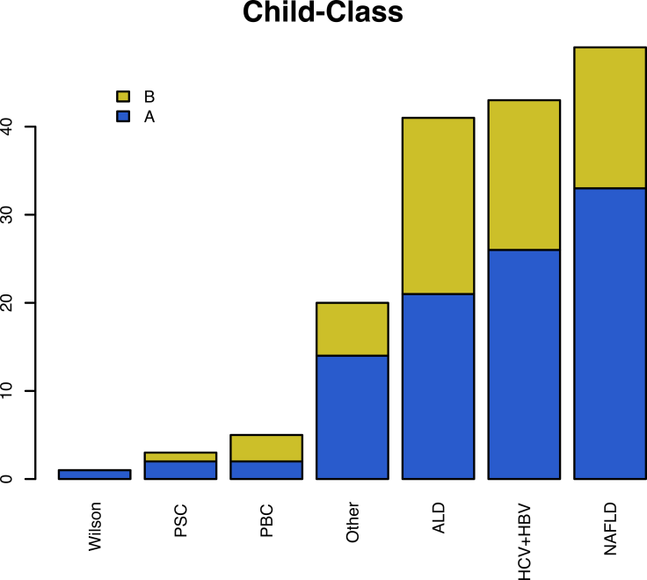

Supplement Table 1. Detailed performance of the NGS panel in comparison with AFP by Stage, Cirrhosis Etiology and Child-Pugh Score.

