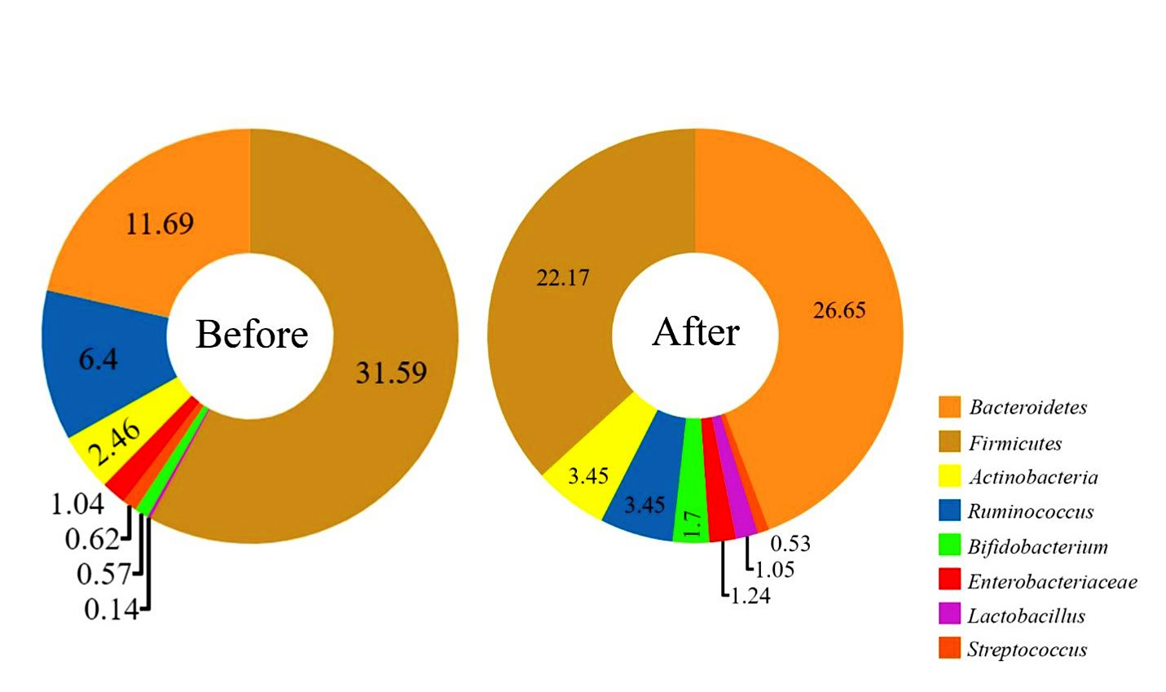
Figure S1. Pie charts representing the mean percentage of the bacterial taxa that constitute the fecal microbiota in IBS patients before and after LF-GFD.

