S1. Docking analysis between NS5A 1a and Daclatasvir

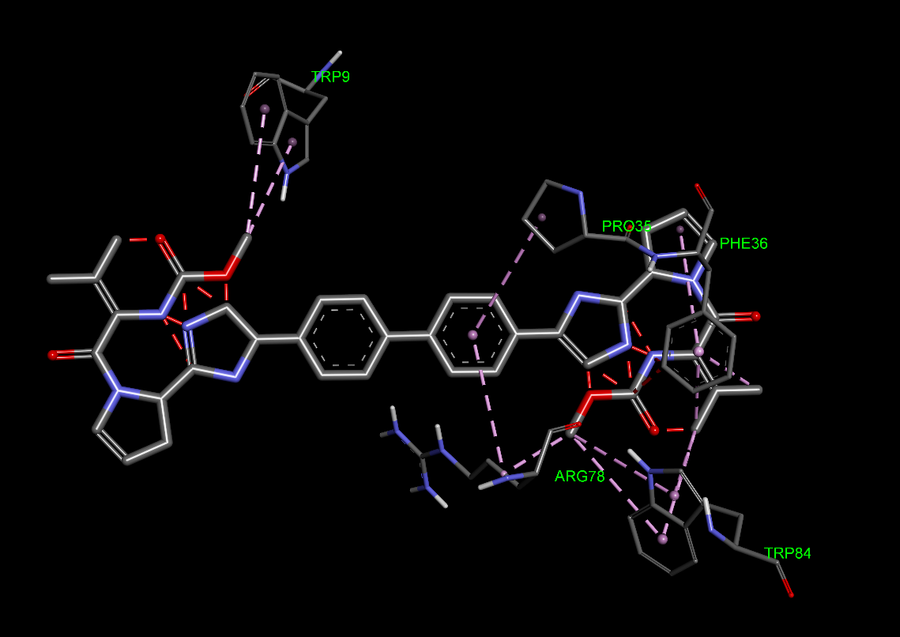

S2. Docking analysis between NS5A 1a and Elbasvir
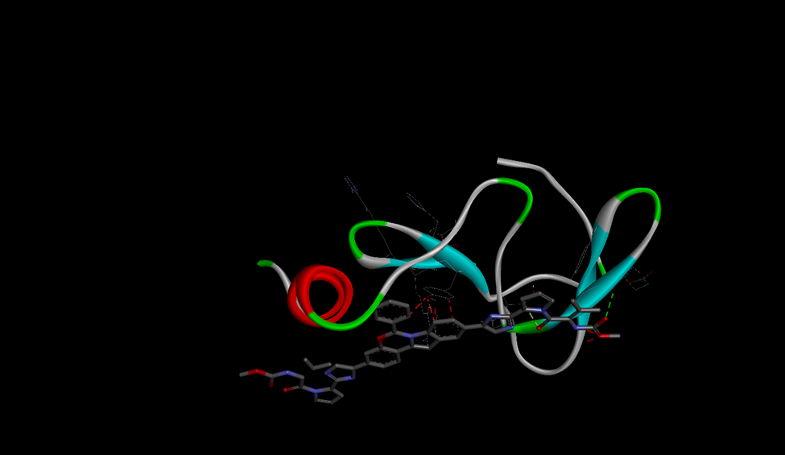

S3. Docking analysis between NS5A 1a and Ledipasvir
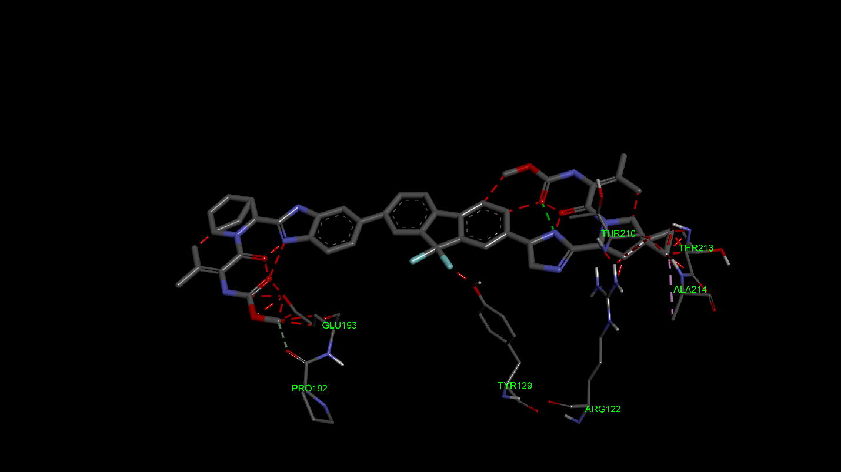

S4. Docking analysis between NS5A 1a and Ombitasvir
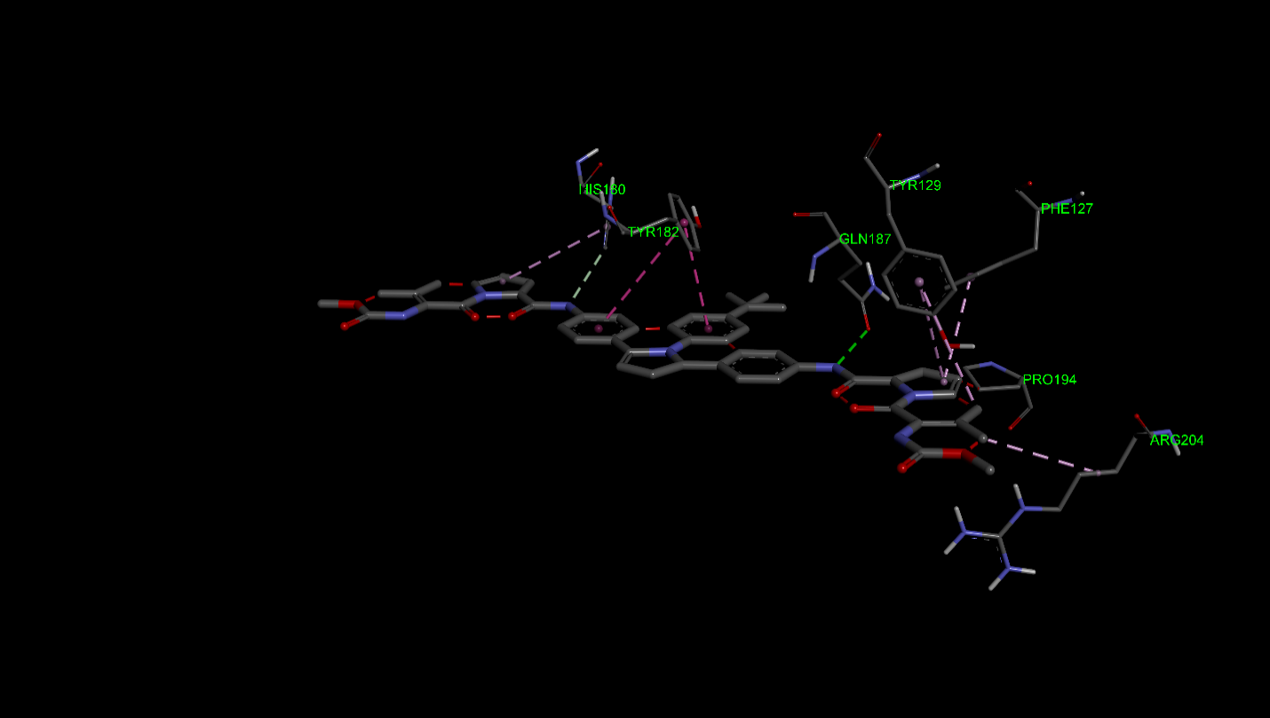

S5. Docking analysis between NS5A 3a and Daclatasvir
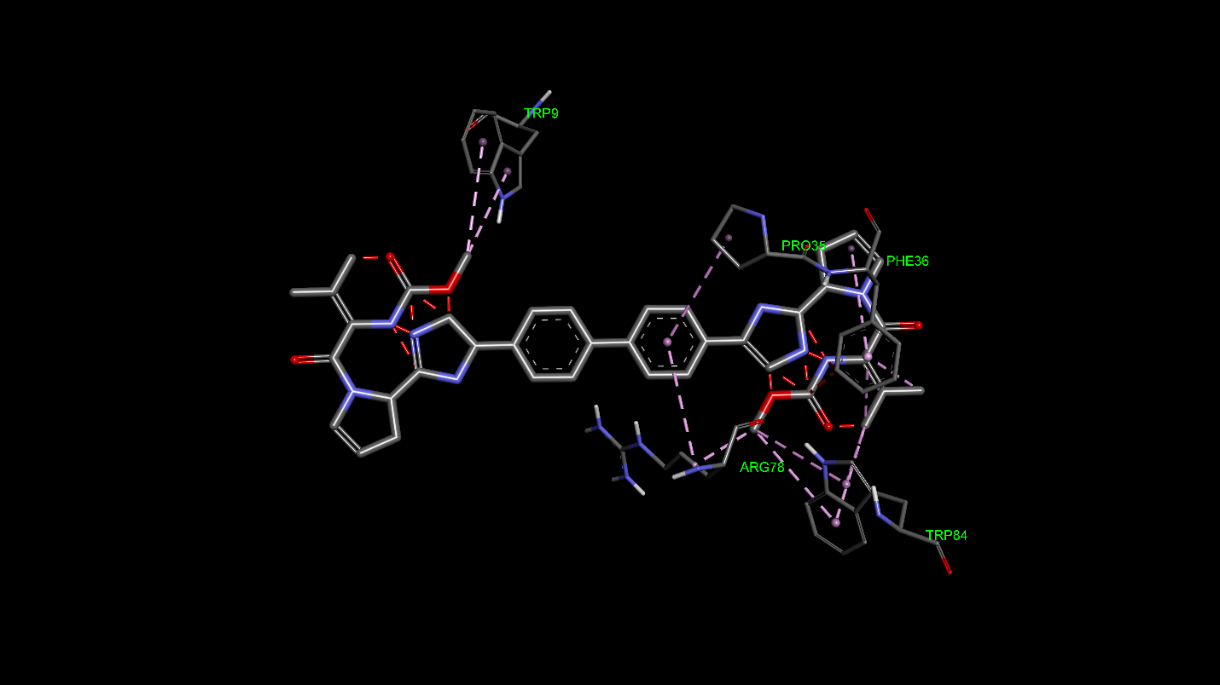

S6. Docking analysis between NS5A 3a and Elbasvir
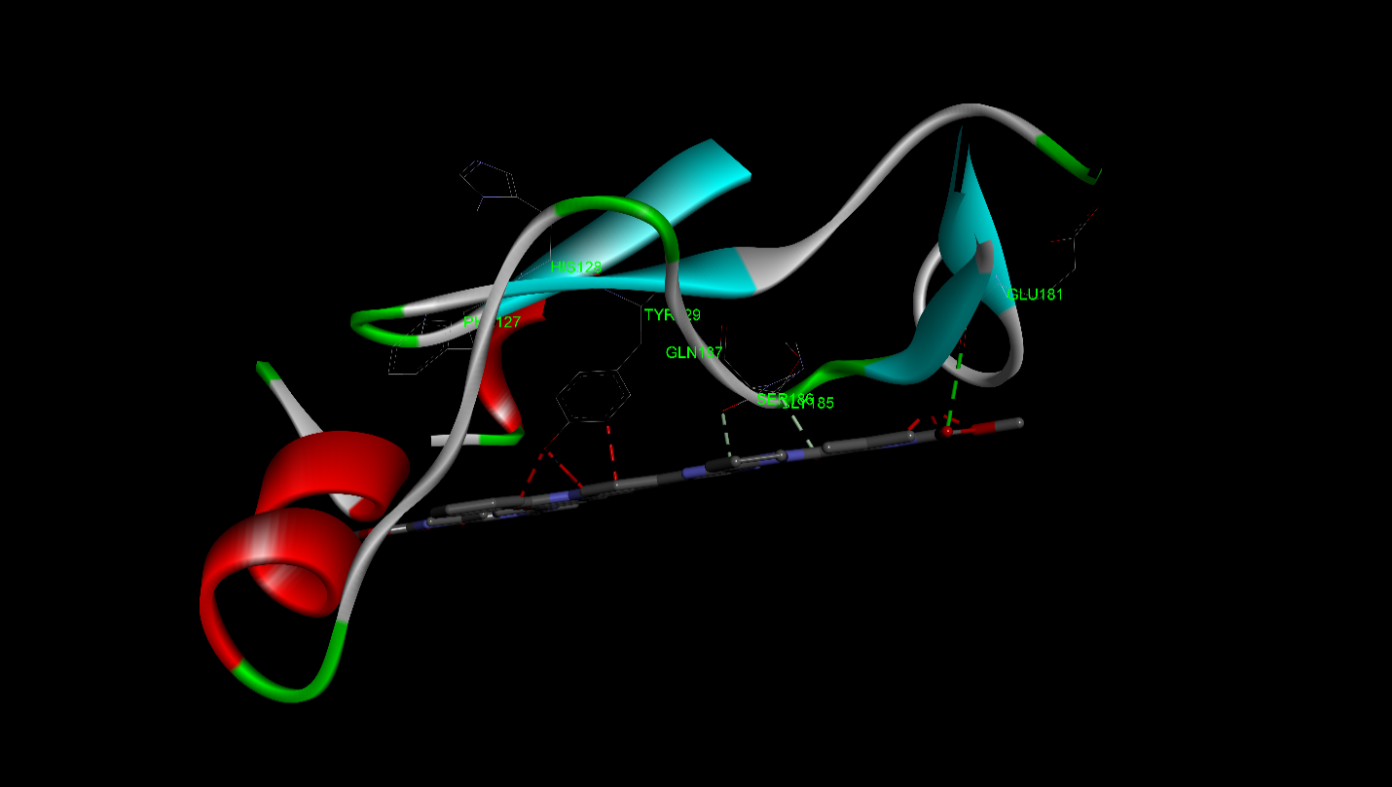

S7. Docking analysis between NS5A 3a and Ledipasvir
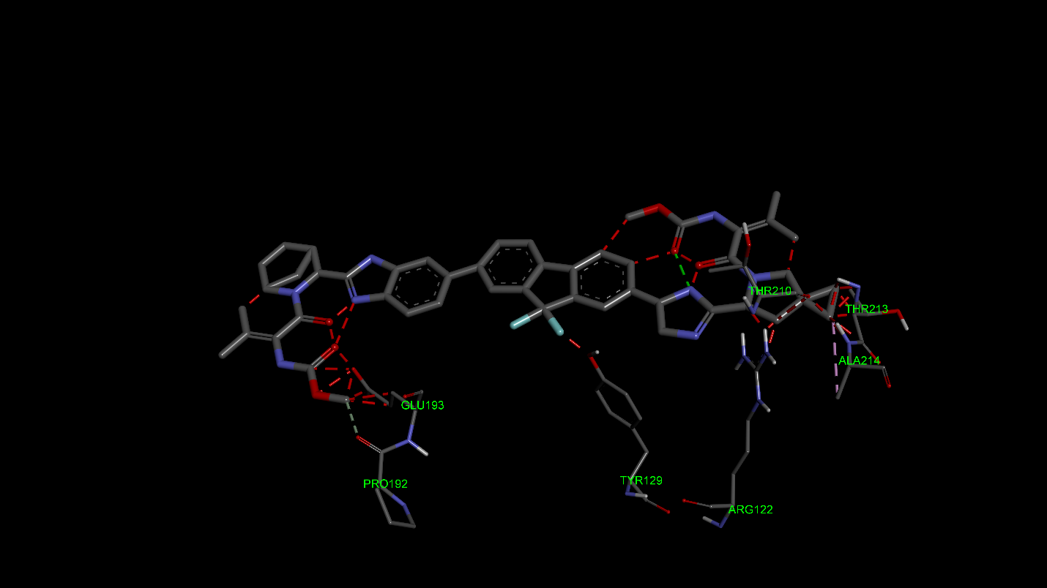

S8. Docking analysis between NS5A 3a and Ombitasvir
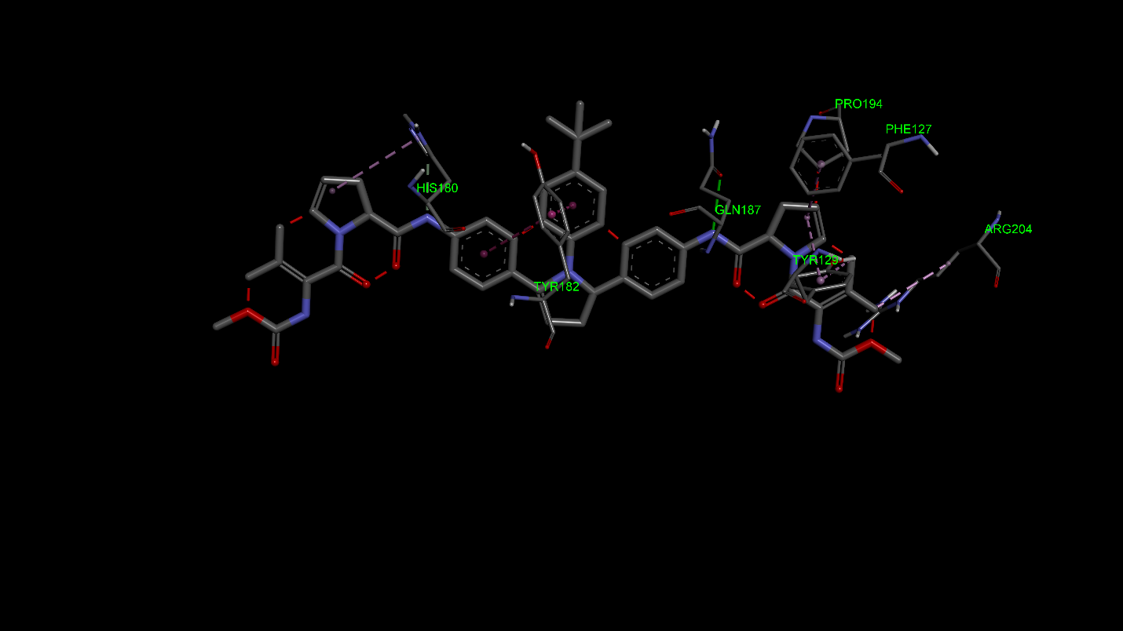

S9. Docking analysis between NS5B 1a and Dasabuvir
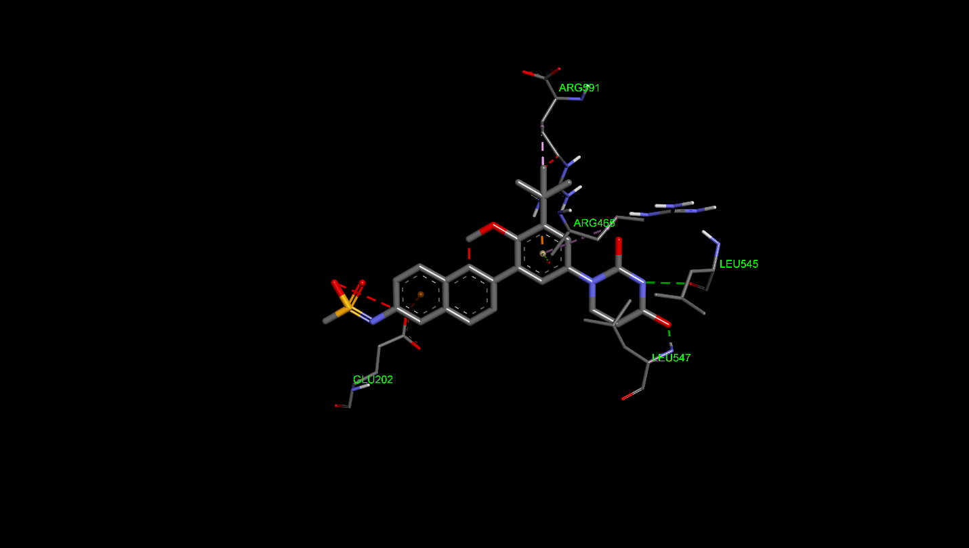

S10. Docking analysis between NS5B 1a and Sofosbuvir
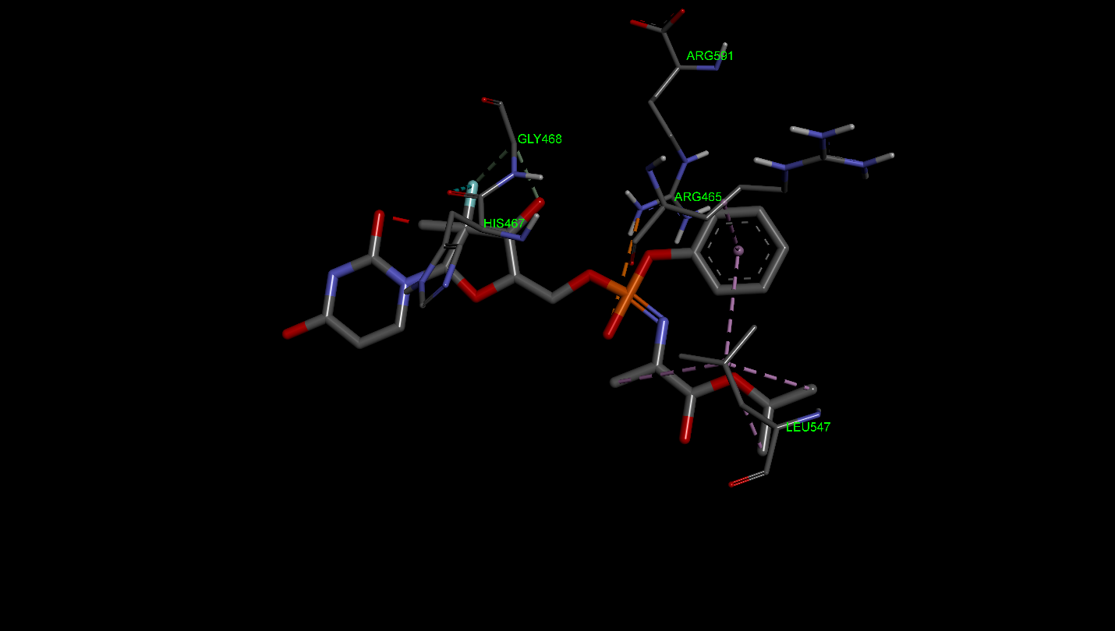

S11. Docking analysis between NS5B 3a and Dasabuvir
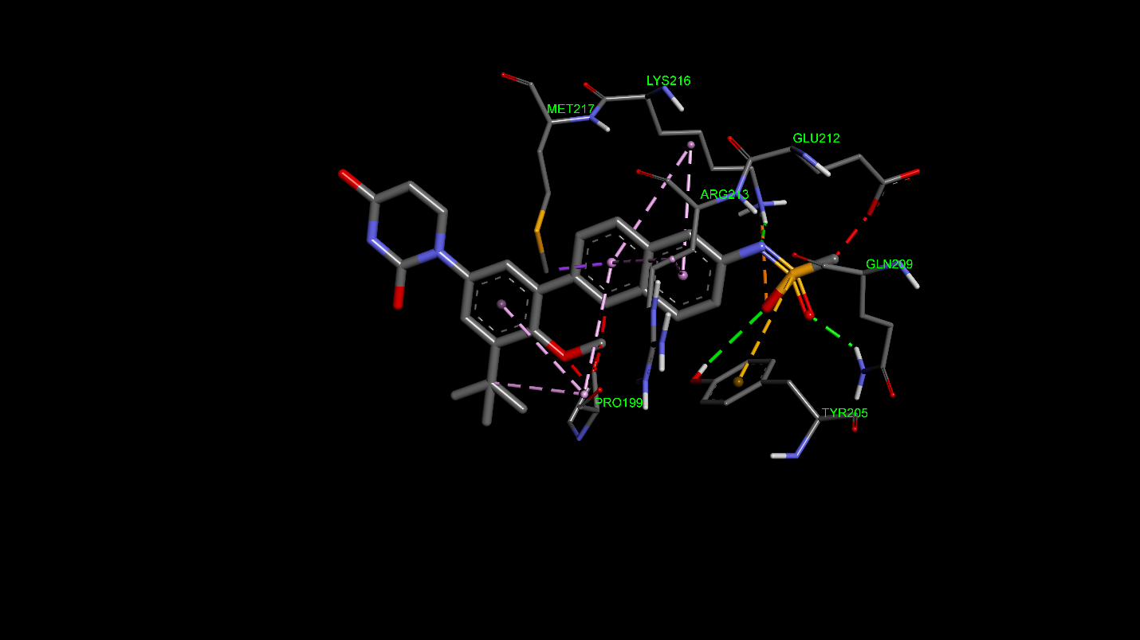

S12. Docking analysis between NS5B 3a and Sofosbuvir
