Supplementary material

Kaplan-Meier survival curves showing HCC-free survival stratificed by presence or absence of potential clinical and biochemical risk factors. Significant covariates, according to log-rank testing, were alcohol use above 14 units / week, platelet count below lower limit of normal and AFP above upper limit of normal (Table 3).

a) BMI

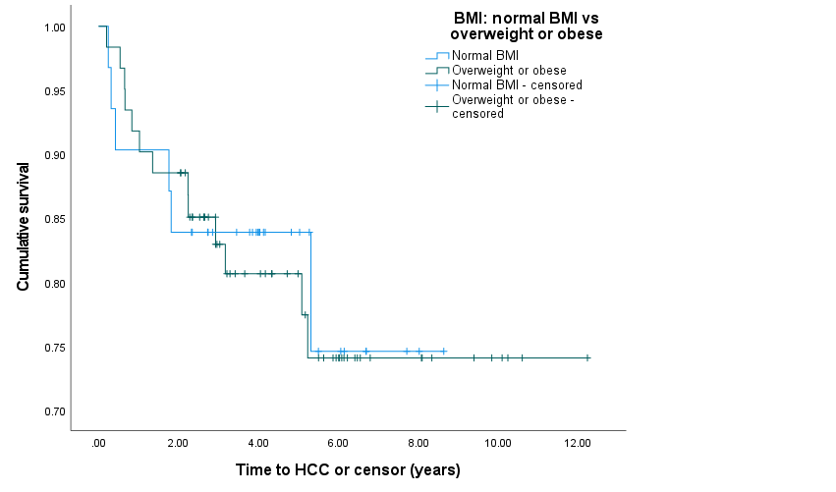
b) Smoking status: non-smoker vs smoker or ex-smoker

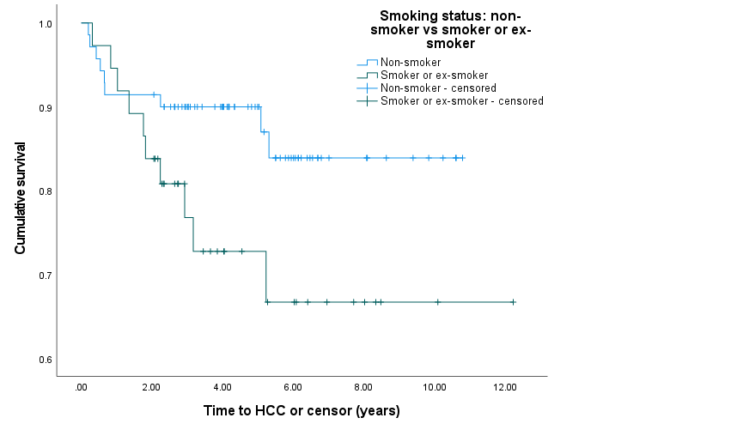
c) Smoking status: non-smoker or ex-smoker vs smoker

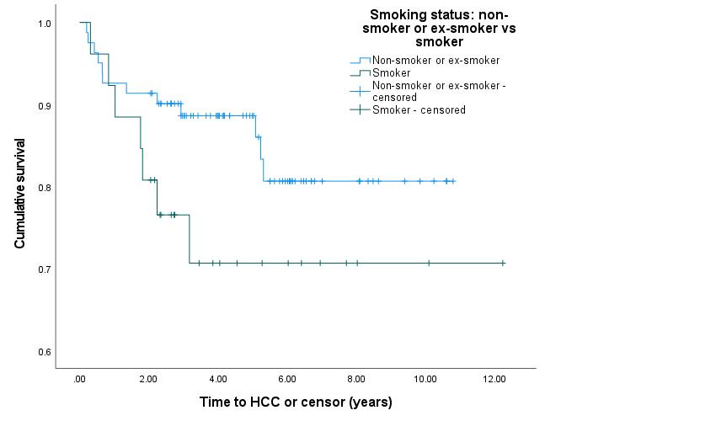
d) Alcohol use

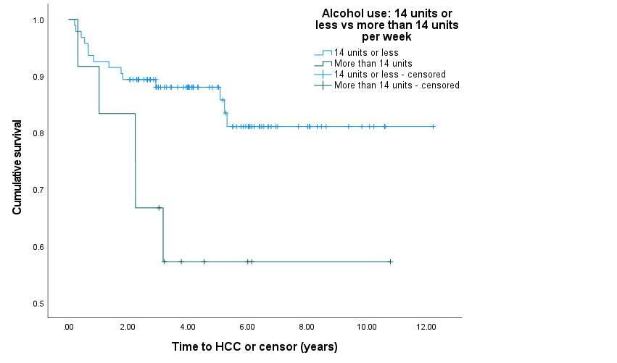

e) Platelet count
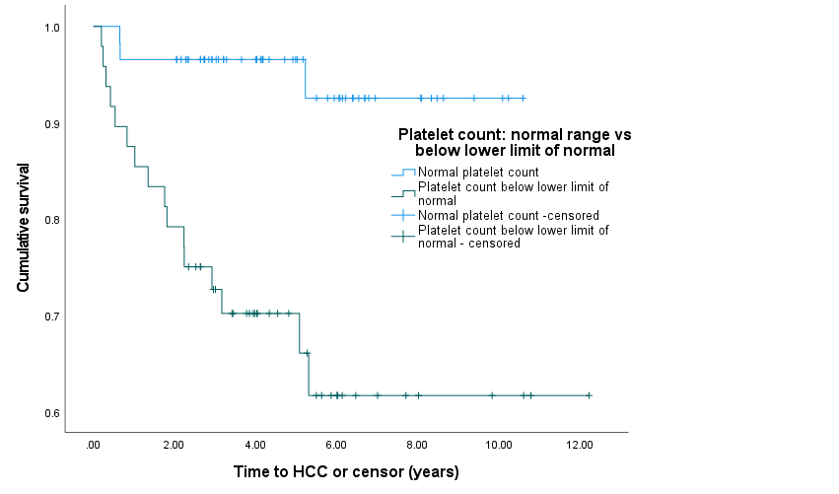

f) ALT
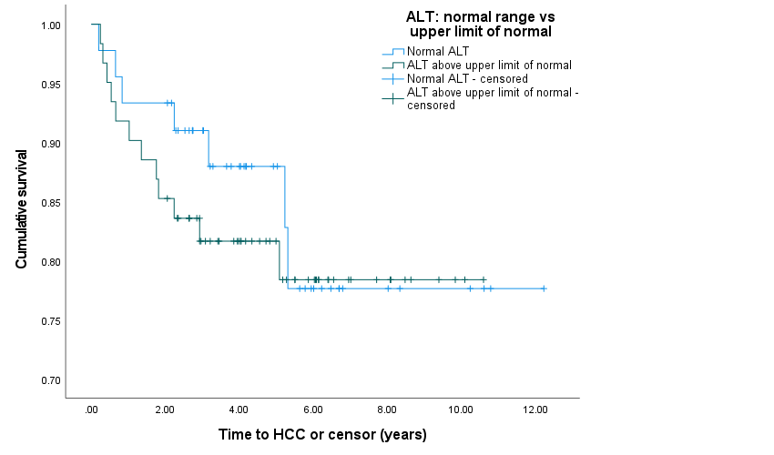

g) AST
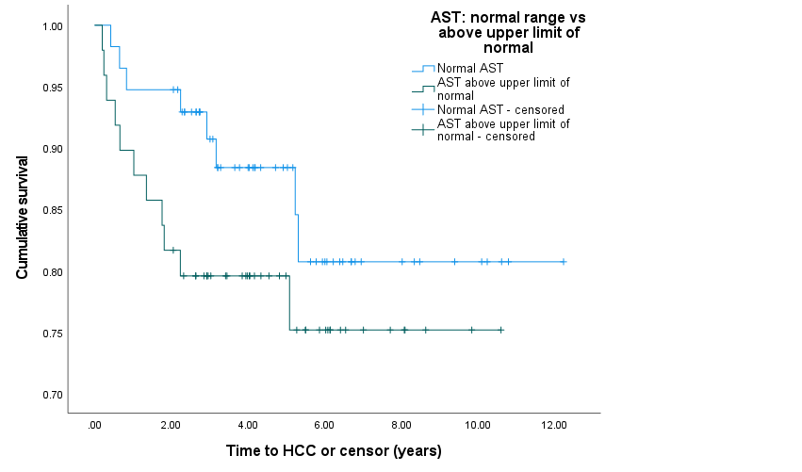

h) ALP
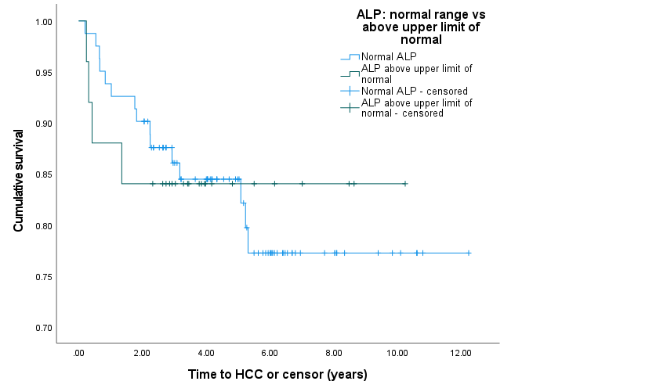

i) Albumin
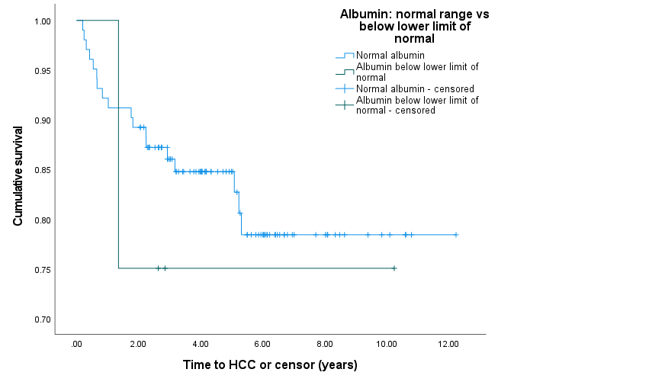

j) AFP

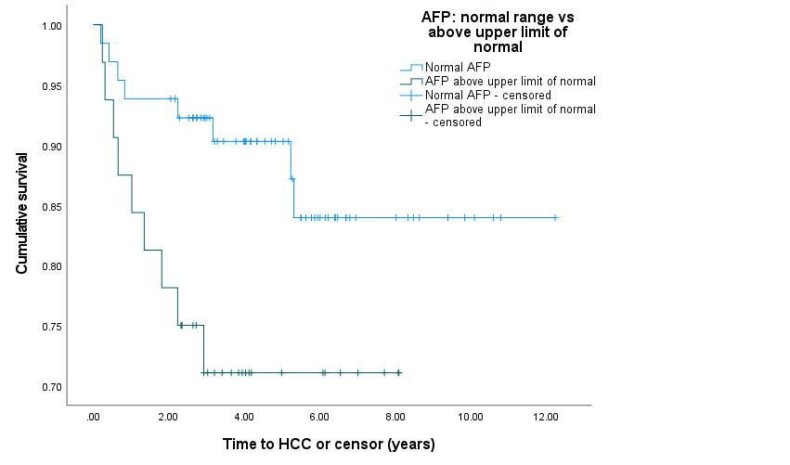

k) Index lesion less than 1 cm vs 1 cm or more
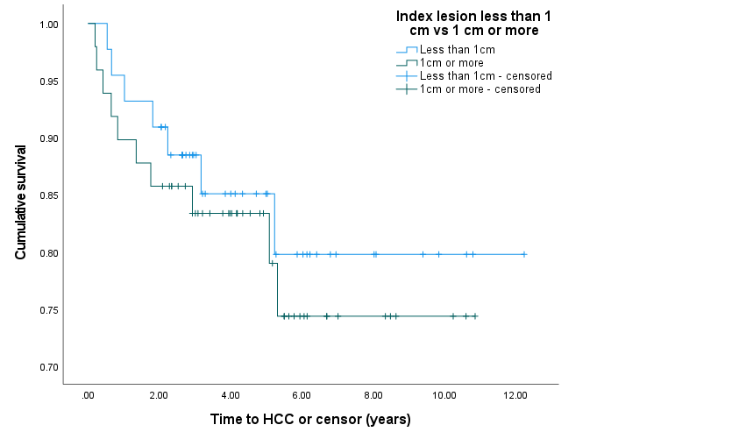

l) Index lesion less than 2 cm vs 2 cm or more

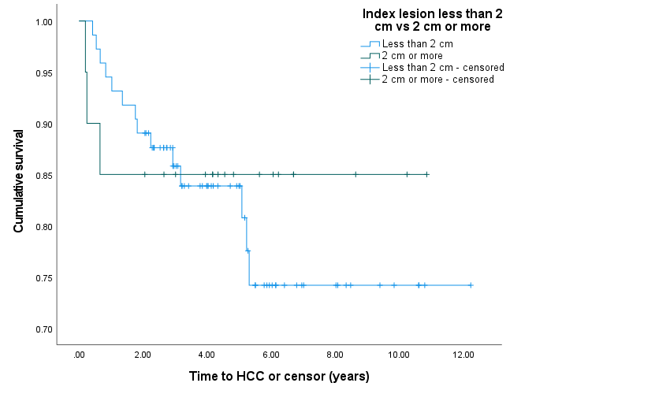

HCC, hepatocellular carcinoma; BMI, body mass index; ALT, alanine aminotransferase; AST, aspartate aminotransferase; ALP, alkaline phosphatase; AFP, alphafetoprotein

