Appendix

This appendix has been provided by the authors to give readers additional information about their work.

Supplement to: Chiang TH, Chen YN, Chen YR, et al. Brand interchangeability of pepsinogen tests in the real-world setting after eradication of Helicobacter pylori: A community-based study

Item | Description
Supplementary Table 1 | The comparison of baseline data between endoscopic receivers and refusers.
Supplementary Figure 1 | Multivariate logistic regression model between the two test brands regarding the PPV for atrophic gastritis.
Supplementary Figure 2 | Multivariate logistic regression model between the two test brands regarding the PPV for intestinal metaplasia.
Supplementary Figure 3 | Multivariate logistic regression model between the two test brands regarding the detection rate for atrophic gastritis.
Supplementary Figure 4 | Multivariate logistic regression model between the two test brands regarding the detection rate for intestinal metaplasia.

Supplementary Table 1. The comparison of baseline data between endoscopic receivers and refusers
Participants with positive test results | Endoscopic receivers  (n=105) | Endoscopic refusers  (n=179) | P value*
Mean age, years (SD; range) | 57.5 (11.9; 30-88) | 58.5 (14.2; 30-96) | 0.59
Male sex, no. (%) | 58 (55.2) | 88 (49.2) | 0.33
Body mass index, kg/m² (SD; range) | 25.6 (4.0; 19.3-52.1) | 24.8 (3.9; 15.8-37.2) | 0.08
Social habits, no. (%)
Current smoker | 20 (19.0) | 24 (13.4) | 0.21
Regular alcohol drinking | 4 (3.8) | 9 (5.0) | 0.64
Betel nut chewing | 4 (3.8) | 9 (5.0) | 0.64
Medical history, no. (%)
Hypertension | 39 (37.1) | 71 (40.0) | 0.63
Diabetes mellitus | 8 (7.6) | 15 (8.4) | 0.27
Hyperlipidemia | 14 (13.3) | 15 (8.4) | <0.001*
Cardiovascular disease | 8 (7.6) | 8 (4.5) | 0.007*
Stroke | 1 (1.0) | 0 (0) | 0.18
Chronic hepatitis B | 17 (16.2) | 23 (12.8) | 0.90
Chronic hepatitis C | 1 (1.0) | 2 (1.1) | 0.94
Chronic kidney disease | 1 (1.0) | 1 (0.6) | 0.71
Abbreviation: SD=standard deviation
*P <0.05 in the comparison between the endoscopic receivers and refusers.

Supplementary Figure 1. Multivariate logistic regression model between the two test brands regarding the PPV for atrophic gastritis. Test 1=GastroPanel (Biohit HealthCare, Helsinki, Finland) and Test 2=LZ-Test (Eiken Chemical Co., Ltd, Tokyo, Japan).
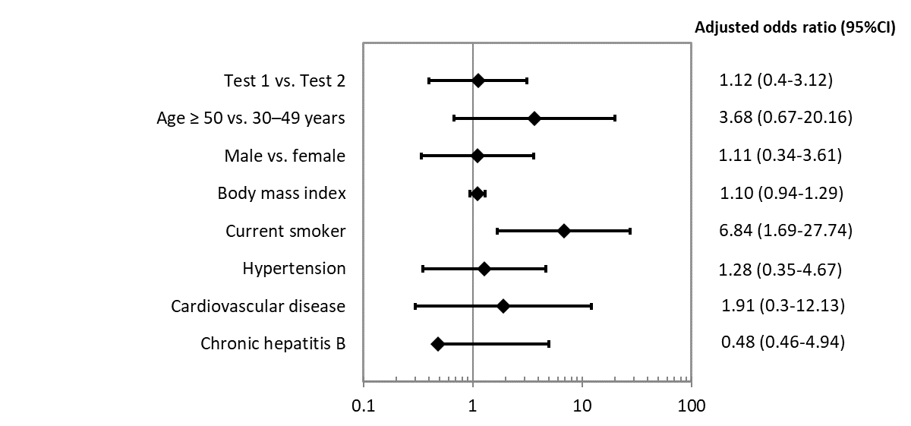

Supplementary Figure 2. Multivariate logistic regression model between the two test brands regarding the PPV for intestinal metaplasia. Test 1=GastroPanel (Biohit HealthCare, Helsinki, Finland) and Test 2=LZ-Test (Eiken Chemical Co., Ltd, Tokyo, Japan).

Supplementary Figure 3. Multivariate logistic regression model between the two test brands regarding the detection rate for atrophic gastritis. Test 1=GastroPanel (Biohit HealthCare, Helsinki, Finland) and Test 2=LZ-Test (Eiken Chemical Co., Ltd, Tokyo, Japan).

Supplementary Figure 4. Multivariate logistic regression model between the two test brands regarding the detection rate for intestinal metaplasia. Test 1=GastroPanel (Biohit HealthCare, Helsinki, Finland) and Test 2=LZ-Test (Eiken Chemical Co., Ltd, Tokyo, Japan).

