Supporting information

The molecular characteristics of gastric cancer patients living in Qinghai-Tibetan Plateau
LingYuan^{1,2}, Shilong Chen^{3,4}, Yongcui Wang^{3,4*}, Yingcai Ma^{2*}
¹ Department of Medicine, Soochow University, Suzhou, Jiangsu, 2115006, China
² Department of Gastroenterology, Qinghai Provincial People’s Hospital, Xining, Qinghai, 810007, China
³ Institute of Sanjiangyuan National Park, Chinese Academy of Sciences, Xining, 810008, China
⁴ Qinghai Provincial Key Laboratory of Crop Molecular Breeding, Northwest Institute of Plateau Biology, Chinese Academy of Sciences, Xining, 810008, China

* To whom correspondence should be addressed.
Email: mayingcai0271@sina.com; ycwang@nwipb.cas.cn
# These authors contributed equally to this work as first authors.

Legend
Table S1.
The details of fusion genes obtained by FusionMap.

Figure S1. The distribution of genome coverage at gene level in gastric adenocarcinoma patients collected from Qinghai Provincial People’s Hospital. A, B, the distribution of genome coverage at gene level in tumor bio-samples, C,D, the distribution of genome coverage at gene level in normal bio-samples.

Figure S2
The comparison of mutation rates in terms of somatic variation obtained via different references.

Table S1
No. of patients with fusion gene reports | Fusion gene (exon number) | position | FrameShiftClass
9 | IPO4 (28)->DNHD1 (21) | chr14:24650800chr11: 6567900 | InFrame
6 | HOXD11 (1)AGAP3 (11) | chr2:176972342chr7: 150783926 | InFrame
5 | HLA-A (8)HLA-J (7) | chr6:29913277chr6: 29977361 | InFrame
2 | KRTAP10-7 (2)->KRTAP10-6 (1) | chr21:46020997chr21: 46011685 | InFrame

Figure S1.
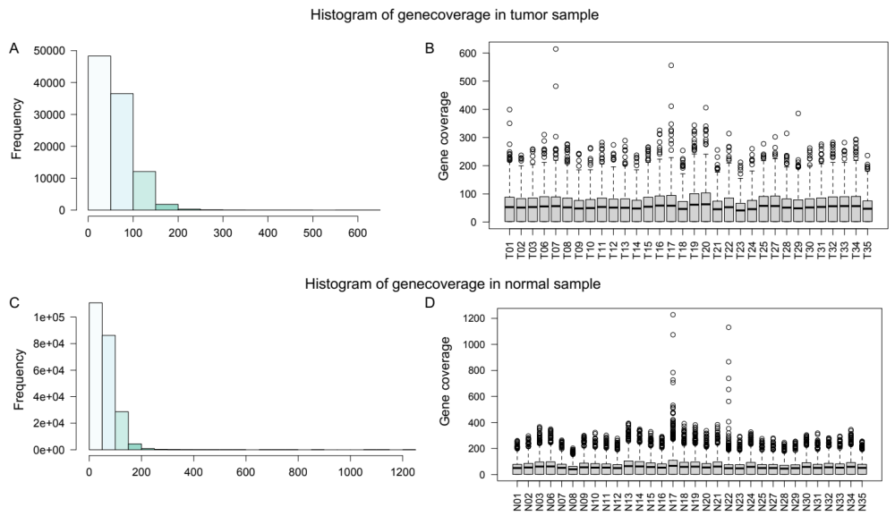
Figure S2
