Supplementary Table 1. Detailed information of the questionnaire.
Questions and Answers | Number  (n=1,021) | Percentage  (%)
1.What is your gender？
Male | 588 | 57.6
Female | 433 | 42.4
2.What is your age?
20-31 | 23 | 2.3
31-40 | 198 | 19.4
41-50 | 411 | 40.3
>50 | 389 | 38.1
3.Where do you work?
East China | 321 | 31.4
Central China | 351 | 34.4
West China | 255 | 25.0
Northeast China | 94 | 9.2
4. How long have you been working?
1-5 years | 35 | 3.4
6-15 years | 179 | 17.5
16-25 years | 322 | 31.5
>25 years | 485 | 47.5
5.What is your professional rank?
Resident | 27 | 2.6
Attending physician | 136 | 13.3
Deputy chief physician | 356 | 34.9
Chief physician | 502 | 49.2
6. Which department are you in?
Hepatology Department | 367 | 36.0
Infection Department | 397 | 38.9
Gastroenterology Department | 178 | 17.4
Oncology Department | 14 | 1.4
Interventional Radiotherapy Department | 2 | 0.2
Others | 37 | 3.6
7.What is the level of your hospital?
Secondary and lower hospital | 265 | 26.0
Tertiary hospital | 185 | 18.1
Tertiary first-class hospital | 571 | 55.9
8. What is the type of your hospital?
Specialist hospital | 229 | 22.4
General hospital | 792 | 77.6
9. Do you think it is necessary to prescribe serum markers such as alpha-fetoprotein and abdominal imaging examinations for patients with liver disease during regular outpatient follow-ups?
Yes | 1017 | 99.6
No | 4 | 0.4
10. Is your hospital able to conduct further tests to determine the nature of the liver masses?
Yes | 981 | 96.1
No | 40 | 3.9
11. What is your recommended hospital when the diagnosis is vague?
Local hospitals | 153 | 15.0
Provincial capital hospitals | 462 | 45.3
National top hospitals | 406 | 39.8
12. Is the method of diagnosis enough?
Yes | 513 | 50.2
No | 508 | 49.8
13. What is the percentage of first diagnosis?
0-20% | 540 | 52.9
20-40% | 291 | 28.5
40-60% | 112 | 11.0
>60% | 78 | 7.6
14. What is the percentage of advanced stage cancer in your practice？
0-20% | 95 | 9.3
20-40% | 205 | 20.1
40-60% | 386 | 37.8
>60% | 335 | 32.8
15. Is the pathological diagnosis important?
Yes | 519 | 50.8
No | 502 | 49.2
16. If patients with hepatitis B-related liver cancer are positive for the virus, do they need immediate antiviral treatment?
Yes | 1004 | 98.3
No | 17 | 1.7
17. If patients with hepatitis C-related liver cancer are positive for the virus, do they need immediate antiviral treatment?
Yes | 982 | 96.2
No | 39 | 3.8
18. Will you actively help a patient with NASH through lifestyle changes, exercise, weight loss and other measures to reduce the possibility of subsequent liver cirrhosis and liver cancer?
Yes | 1010 | 98.9
No | 11 | 1.1
19. Who will make the final decisions on the treatment?
Doctors | 141 | 13.8
Patients | 242 | 23.7
Patients’ family | 638 | 62.5
20. Do you support the disclosure of the patients’ true conditions?
Yes | 632 | 61.9
No | 389 | 38.1
21. What’s your preferred treatment regimen?
Targeted therapy | 114 | 11.2
Immunotherapy | 12 | 1.2
Target therapy & Immunotherapy | 871 | 85.3
Chemotherapy | 24 | 2.4
22. What’s your preferred targeted drug?
Sorafenib | 572 | 56.0
Lenvatinib | 344 | 33.7
Rigorfenib | 26 | 2.6
Apatinib | 70 | 6.9
Cabotinib | 9 | 0.9
23. How do you deal with adverse effects of targeted therapy?
Keeping the dosage and frequency | 356 | 34.9
Reducing the dosage | 533 | 52.2
Interrupted medication on weekends | 48 | 4.7
Take medicine every other day | 84 | 8.2
24. What’s your preferred immunotherapy drug?
PD-1 | 773 | 75.7
PD-L1 | 210 | 20.6
CTLA-4 | 38 | 3.72
25. What’s your major drug source?
Imported | 338 | 33.1
Domestic | 154 | 15.1
Available | 529 | 51.8
26. What’s your major considerations for prescribing?
Insurance | 303 | 29.7
Effectiveness | 494 | 48.4
Cost | 57 | 5.6
Availability | 167 | 16.4
27. Do you advocate traditional Chinese medicine?
Yes | 634 | 62.1
No | 387 | 37.9
28. Are drugs sufficient?
Yes | 250 | 24.5
No | 771 | 75.5
29. Is the price of medication acceptable?
Yes | 287 | 28.1
No | 734 | 71.9
30. Is the treatment satisfactory?
Yes | 239 | 23.4
No | 782 | 76.6
31. Which of the following treatment models for liver cancer do you expect?
Complete cure | 570 | 55.8
Long-term treatment | 913 | 89.4
Minimize the suffering of patients and improved the quality of lives | 908 | 88.9
Not to implement painful and risky treatment | 119 | 11.7
32. What do patients with liver cancer need as far as you are concerned?
Psychological counseling | 953 | 93.3
Improvement in the quality of life | 958 | 93.8
Relief of economic burden | 952 | 93.2
Promoted early diagnosis rate | 971 | 95.1
More new medications available | 916 | 89.7
33. How would you like to get access to the updated knowledge on the progress of liver cancer diagnosis and treatment?
Participating in academic conferences | 1000 | 97.9
Accessing journal literature | 922 | 90.3
Attending video lectures on professional websites | 968 | 94.8
Learning the official policy | 548 | 53.7

Supplementary Table 2. Correlations between doctors’ satisfaction with other variables.
Variables | Satisfied | Dissatisfied | P | OR (95% CI) | P
Economic regions |  |  | 0.015 * |  | 0.016*
East China | 59 (24.7%) | 262 (33.5%) |  | Reference
Central China | 82 (34.3%) | 269 (34.4%) |  | 1.354 (0.930-1.970) | 0.114
West China | 67 (28.0%) | 188 (24.0%) |  | 1.583 (1.064-2.354) | 0.023
Northeast China | 31 (13.0%) | 63 (8.1%) |  | 2.185 (1.306-3.655) | 0.003
Professional ranks |  |  | 0.696 |  | 0.696
Chief physician | 112（46.9%） | 390（49.9%） |  | Reference
Deputy chief physician | 86（36.0%） | 270（34.5%） |  | 1.109 (0.805-1.529) | 0.527
Attending physician and resident | 41（17.2%） | 122（15.6%） |  | 1.170 (0.775-1.766) | 0.454
Level of hospital |  |  | 0.240 |  | 0.241
Tertiary first-class hospital | 127（53.1%） | 444（56.8%） |  | Reference
Tertiary hospital | 40（16.7%） | 145（18.5%） |  | 0.964 (0.645-1.441) | 0.860
Secondary and lower hospital | 72（30.1%） | 193（24.7%） |  | 1.304 (0.933-1.823) | 0.120
Are drugs sufficient? |  |  | <0.001*
Yes | 111（46.4%） | 139（17.8%） |  | Reference
No | 128（53.6%） | 643（82.2%） |  | 0.249 (0.182-0.341) | <0.001*
What’s your major drug source? |  |  | 0.055 |  | 0.056
Imported | 85（35.6%） | 253（32.4%） |  | Reference
Domestic | 109（45.6%） | 420（53.7%） |  | 0.772 (0.559-1.068) | 0.118
Available | 45（18.8%） | 109（13.9%） |  | 1.229 (0.803-1.880) | 0.342
What is the percentage of advanced stage in your practice? |  |  | <0.001* |  | <0.001*
<40% | 104（43.5%） | 196（25.1%） |  | Reference
40-60% | 86（36.0%） | 300（38.4%） |  | 0.540 (0.385-0.757) | <0.001
>60% | 49（20.5%） | 286（36.6%） |  | 0.323 (0.220-0.475) | <0.001
What is the percentage of first diagnosis? |  |  | 0.306 |  | 0.307
<20% | 136（56.9%） | 404（51.7%） |  | Reference
20-40% | 65（27.2%） | 226（28.9%） |  | 0.854 (0.610-1.197) | 0.361
>40% | 38（15.9%） | 152（19.4%） |  | 0743 (0.495-1.114) | 0.150
Is the method of diagnosis enough? |  |  | <0.001*
Yes | 146（61.1%） | 367（46.9%） |  | Reference
No | 93（38.9%） | 415（53.1%） |  | 0.563 (0.419-0.757) | <0.001*
Do you advocate traditional Chinese medicine? |  |  | 0.484
Yes | 153（64.0%） | 481（61.5%） |  | Reference
No | 86（36.0%） | 301（38.5%） |  | 0.898 (0.665-1.214) | 0.484
What’s your preferred immunotherapy drug? |  |  | 0.144 |  | 0.147
PD-1 | 192（80.3%） | 581（74.3%） |  | Reference
PD-L1 | 41（17.2%） | 169（21.6%） |  | 0.734 (0.503-1.072) | 0.109
CTLA-4 | 6（2.5%） | 32（4.1%） |  | 0.567 (0.234-1.378) | 0.211
What is your preferred targeted drug? |  |  | 0.065
First-line drugs | 222（92.9%） | 694（88.7%） |  | Reference
Second-line drugs | 17（7.1%） | 88（11.3%） |  | 0.604 (0.352-1.037) | 0.068
How do you deal with adverse effects of targeted therapy? |  |  | 0.003* |  | 0.004*
Keeping the dosage and frequency | 105（43.9%） | 251（32.1%） |  | Reference
Reducing the dosage | 108（45.2%） | 425（54.3%） |  | 0.607 (0.445-0.829) | 0.003
Intermittent medication | 26（10.9%） | 106（13.6%） |  | 0.586 (0.361-0.953) | 0.031
What are your major considerations for prescribing? |  |  | 0.226 |  | 0.228
Cost or insurance | 84（35.1%） | 276（35.3%） |  | Reference
Effectiveness | 124（51.9%） | 370（47.3%） |  | 1.101 (0.801-1.513) | 0.552
Availability | 31（13.0%） | 136（17.4%） |  | 0.749 (0.473-1.187) | 0.218
What’s your preferred treatment regimen? |  |  | 0.603 |  | 0.641
Targeted therapy | 25（10.5%） | 89（11.4%） |  | Reference
Immunotherapy | 1（0.4%） | 11（1.4%） |  | 0.324 (0.040-2.629) | 0.291
Target therapy & Immunotherapy | 208（87.0%） | 663（84.8%） |  | 1.117 (0.698-1.787) | 0.645
Chemotherapy | 5（2.1%） | 19（2.4%） |  | 0.937 (0.318-2.760) | 0.906
Do you support the disclosure of the patients’ true conditions? |  |  | 0.032*
No | 77（32.2%） | 312（39.9%） |  | Reference
Yes | 162（67.8%） | 470（60.1%） |  | 1.397 (1.028-1.898) | 0.033*
Who will make the final decisions on treatment? |  |  | 0.796 |  | 0.797
Doctors | 36（15.1%） | 105（13.4%） |  | Reference
Patients | 57（23.8%） | 185（23.7%） |  | 0.899 (0.555-1.454) | 0.663
Patients’ family | 146（61.1%） | 492（62.9%） |  | 0.866 (0.568-1.319) | 0.502
Is the pathological diagnosis important? |  |  | 0.160
Yes | 131（54.8%） | 388（49.6%） |  | Reference
No | 108（45.2%） | 394（50.4%） |  | 0.812 (0.607-1.086) | 0.160
What is your recommended hospital when the diagnosis is vague? |  |  | 0.135 |  | 0.136
Local hospitals | 35（14.6%） | 118（15.1%） |  | Reference
Provincial capital hospitals | 121（50.6%） | 341（43.6%） |  | 1.196 (0.778-1.840) | 0.414
National top hospitals | 83（34.7%） | 323（41.3%） |  | 0.866 (0.554-1.356) | 0.530
Notes: P values in the fourth column belong to χ2 analysis; P values in the sixth column belong to univariate logistic analysis. * indicates statistical significance (P<0.05).
Supplementary Figure
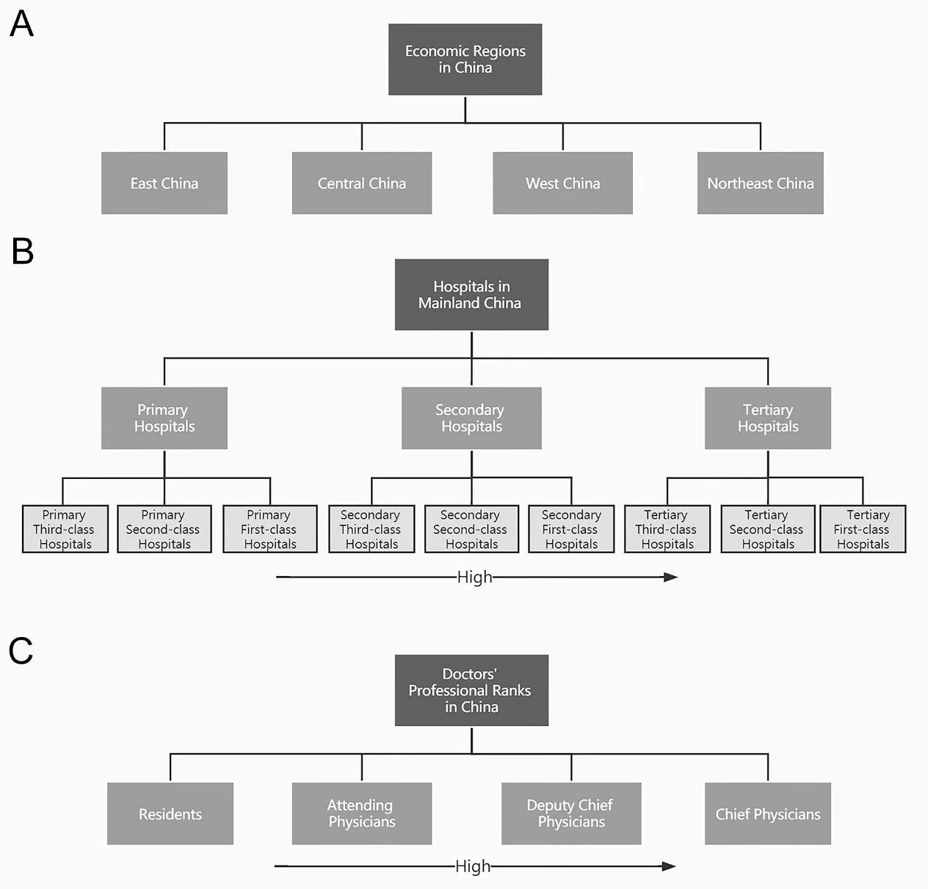
Supplementary Figure 1. Illustration of the economic regions (A), hospital levels (B), and doctors' professional ranks (C) in mainland China. The arrows indicated higher hospital level in panel B and higher professional rank in panel C.

