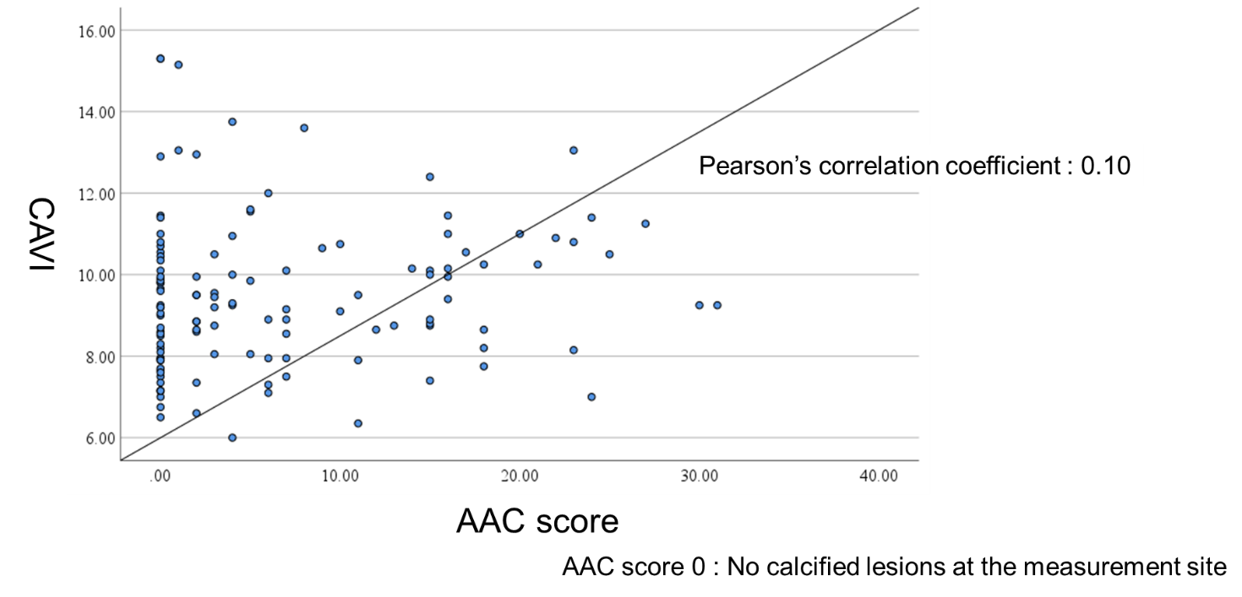
Additional File 1 Scatter plots of CAVI and AAC score.

