Additional file 2. DOC. Reasons for choice of tofacitinib in patients with moderate-to-severe UC by length of time on tofacitinib

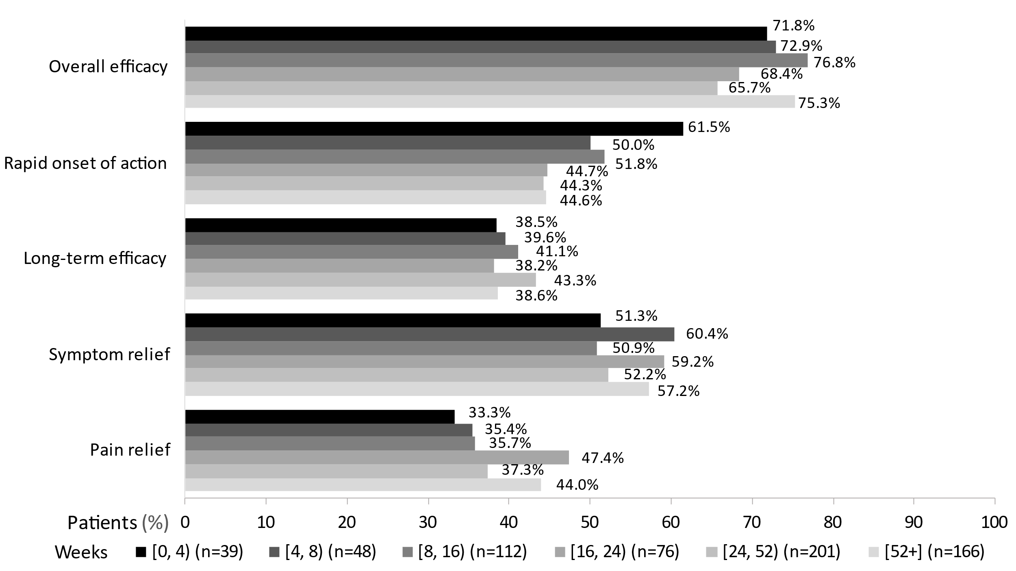
UC, ulcerative colitis.

