Additional file 3. DOC. Changes in steroid dose/frequency during the course of the treatment regimen in patients with moderate-to-severe UC on tofacitinib.

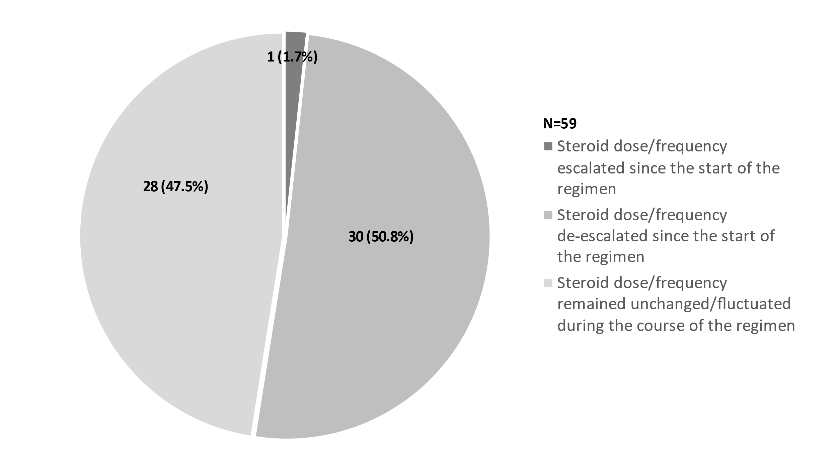
UC, ulcerative colitis.

