Additional file 4. DOC. Change in severity of symptoms, pain and fatigue among patients with moderate-to-severe UC from tofacitinib initiation. a Overall symptom severity; b Overall pain severity; c Overall fatigue/tiredness severity

a.
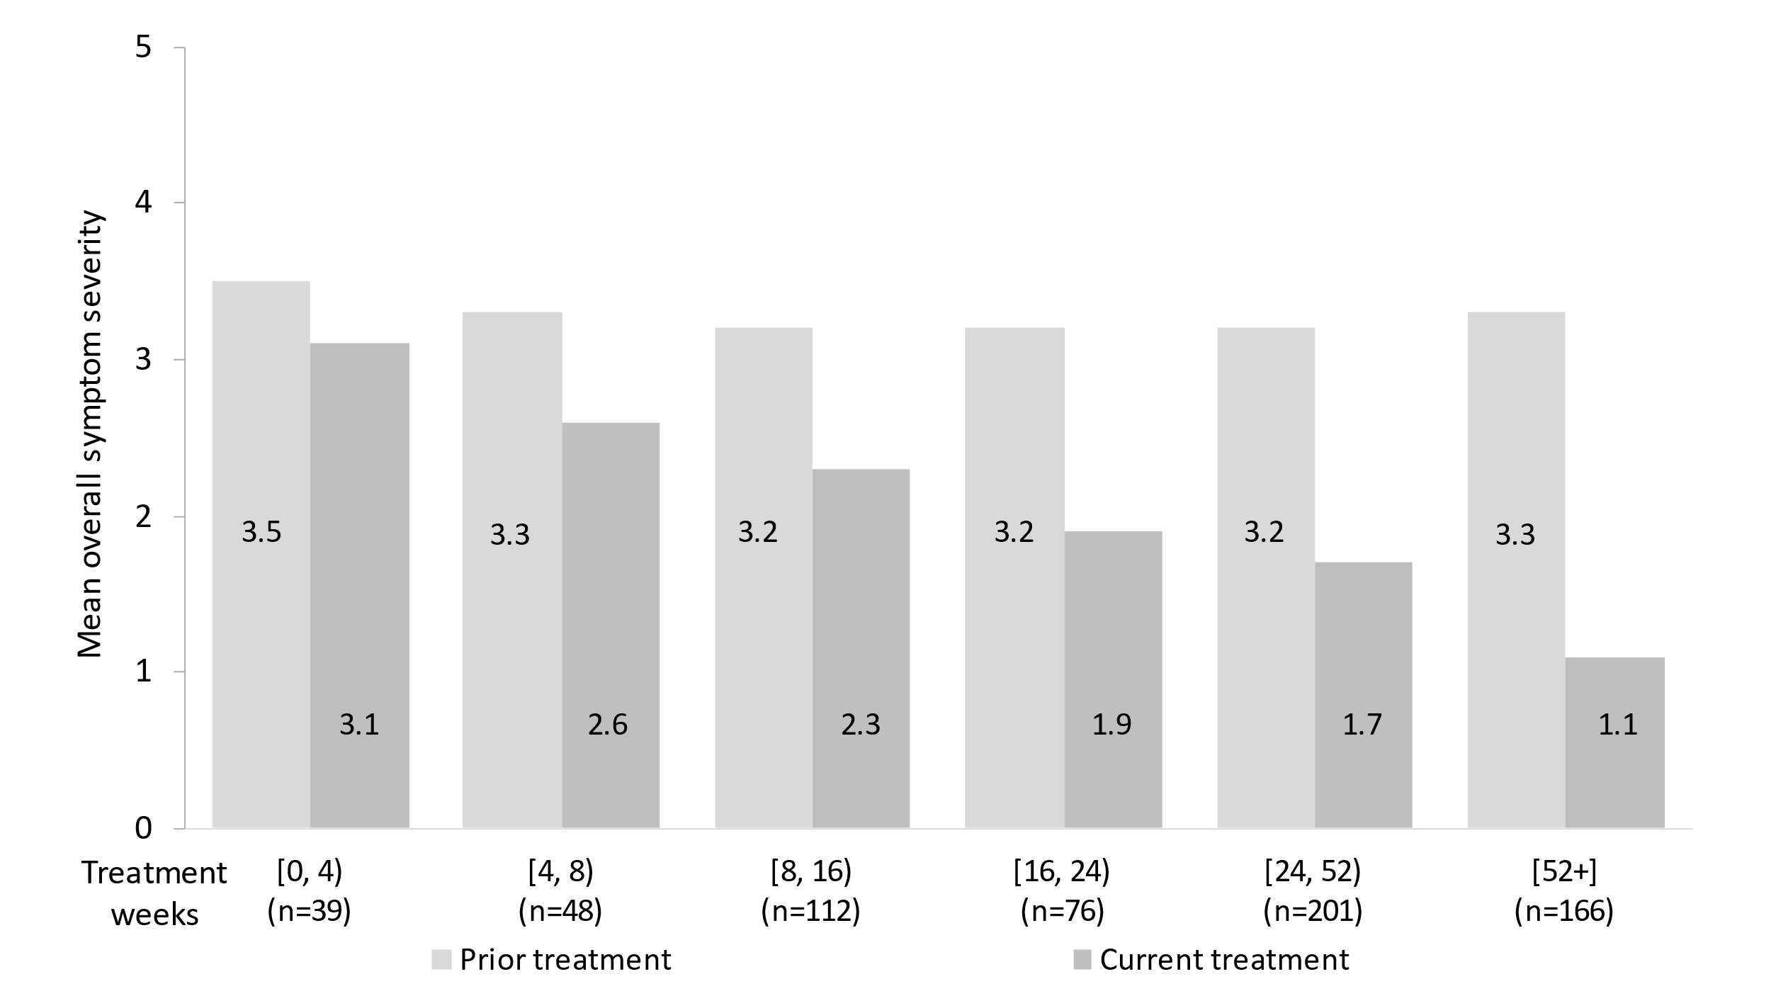
.
b. 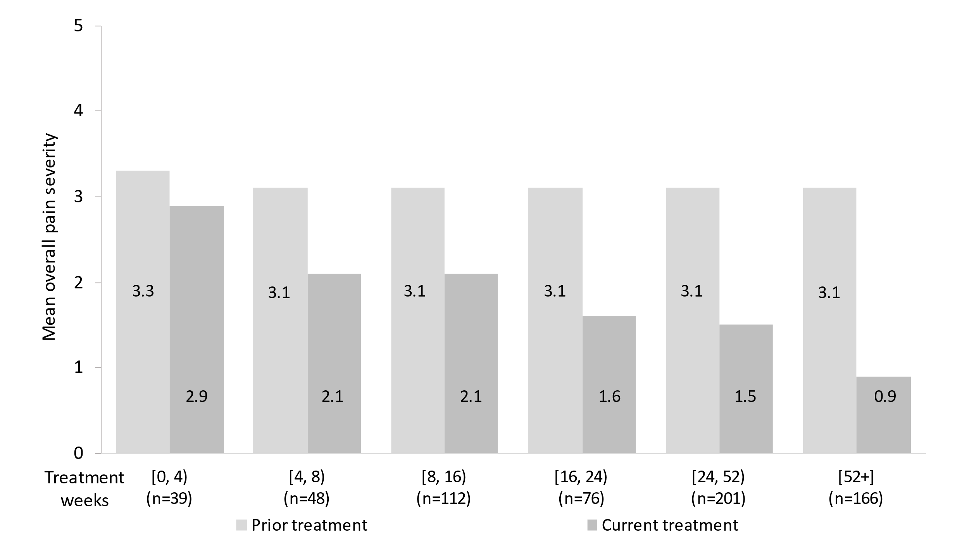

.
c.
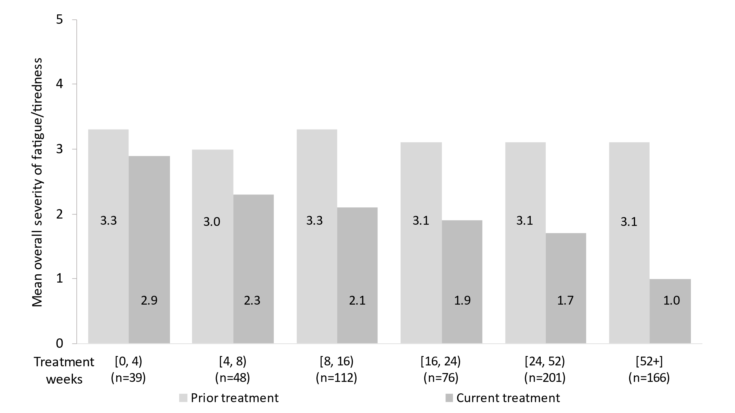
Physician-reported patient data. One observation per patient; the groups are mutually exclusive.
Patients’ clinical severity was rated at the start of tofacitinib treatment (i.e., status when on prior treatment) and currently (at data collection) on a scale ranging from 0 (none) to 5 (extremely severe).
UC, ulcerative colitis.

