Additional file 5. DOC. Patient-reported outcomes in patients with moderate-to-severe UC. a EQ-5D-5L Index total score (US tariff); b SIBDQ total score; c WPAI component scores

a.
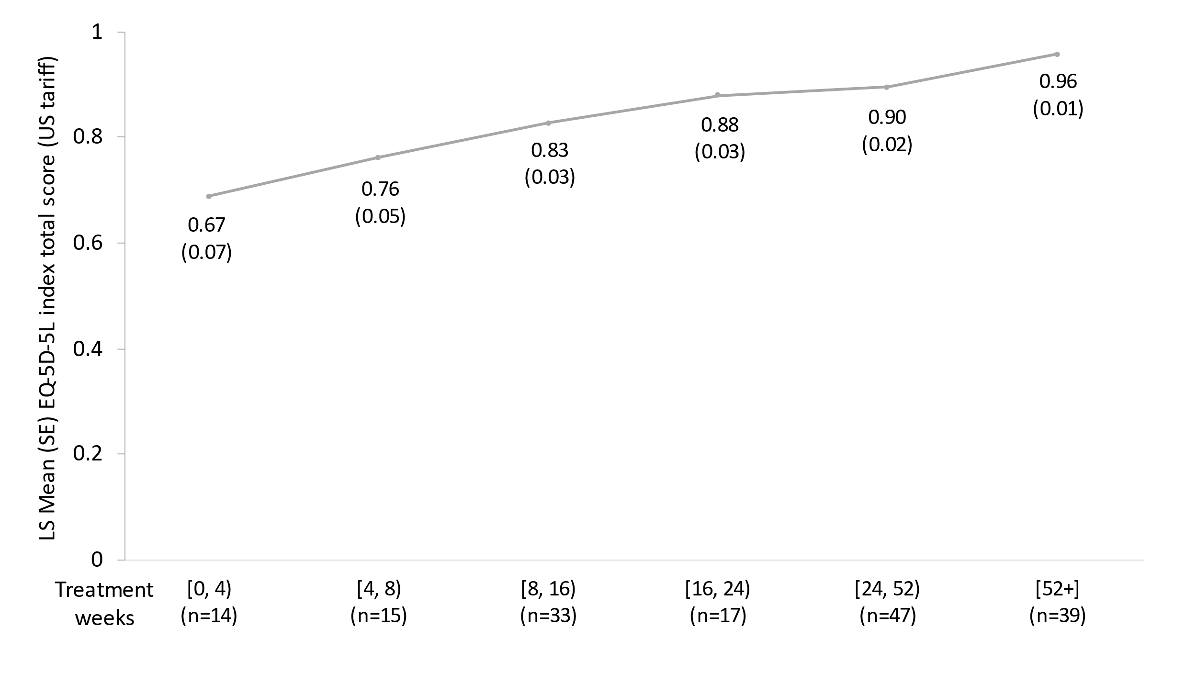
.
b.
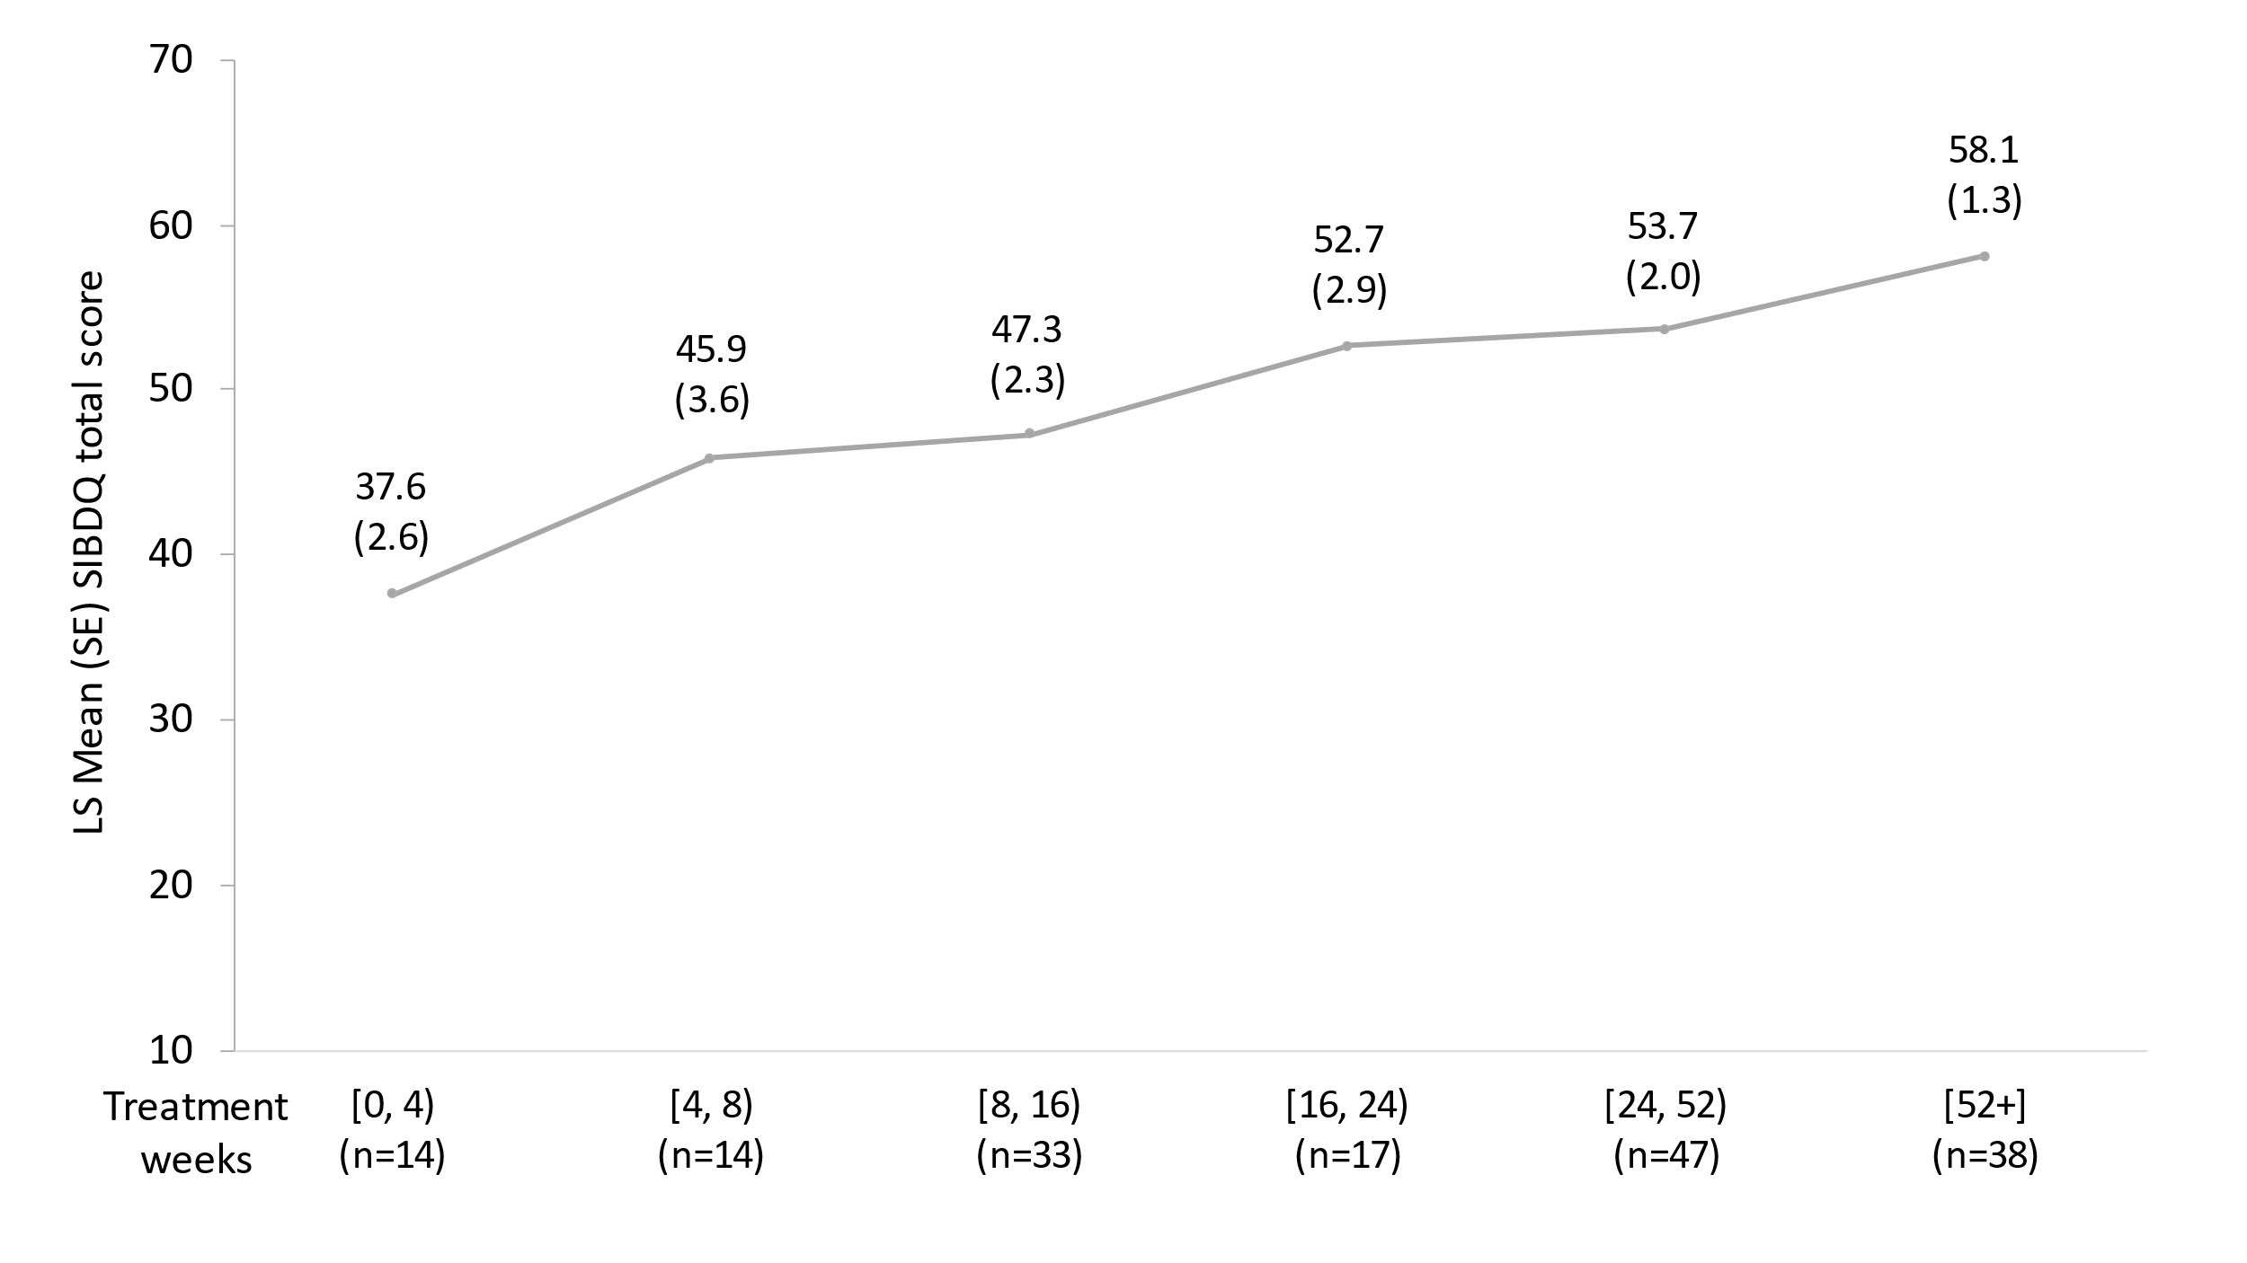
.
c.
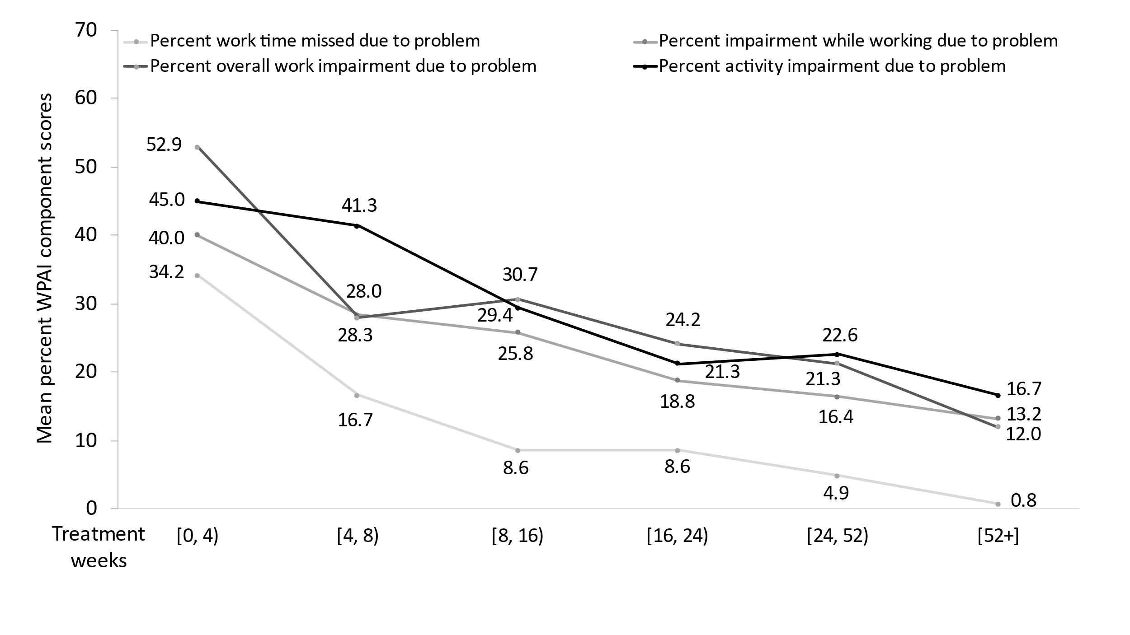

Base sizes for the four WPAI components varied. One observation per patient.
Linear regression with categorised time and additional covariates included.
The EQ-5D index total score ranges from <0.00 to 1.00, where higher scores indicate better HRQL; a 0.074-point change in the EQ-5D scale is considered a MCID.
The SIBDQ total score ranges from 10 indicating worst health to 70 indicating best health; a 9-point change in the SIBDQ is considered the MCID.
The WPAI component ranges from 0%, no impairment to 100%, total loss of work productivity or activity; a change of 6.5%, 6.1%, 7.3%, and 8.5% are considered to be MCIDs for absenteeism, presenteeism, overall work impairment, and total activity impairment, respectively.
EQ-5D-5L, EuroQol- 5 Dimension-5 Level; MCID, minimal clinically important difference; SE, standard error; SIBDQ, short version of the Inflammatory Bowel Disease Questionnaire; WPAI, Work Productivity and Activity Impairment.
UC, ulcerative colitis.

