Supplementary Materials
Figure S1. Receiver-operating characteristic curve based on the serum sCD163 levels in patients with NAFLD
(a) fibrosis stage 3-4, (b) fibrosis stage 4, (c) Grade 2–3, (d) NAS ≧5

Figure S2. Comparison of sCD163 with other fibrosis markers (type 4 collagen 7S, hyaluronic acid, TIMP-1, P-Ⅲ-P, WFA+M2BP)
Figure S3. Changes in liver histology were examined in patients who underwent repeated biopsies (n=287) (5.7±3.1 years)

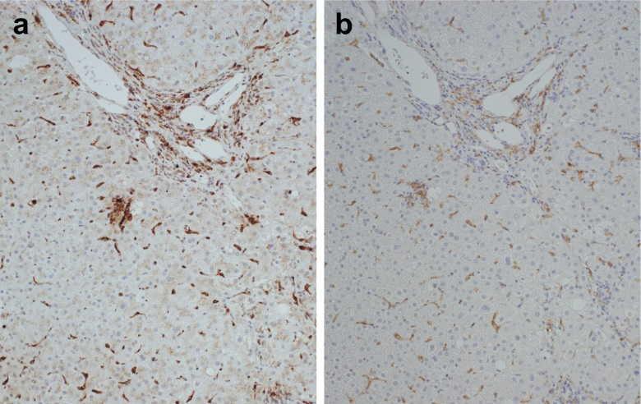
Figure S4. Representative case of immunohistochemical staining, (a) CD68, (b) sCD163

Table S1. Receiver-operating characteristic curve based on the serum sCD163, type4collagen7S, hyaluronic acid, P-III-P, WFA+M2BP levels in fibrosis stage 3 or higher patients with NAFLD
 | AUC | 95%CI | cut off | sensitivity | specificity | PPV | NPV
s CD163 | 0.726 | 0.6447-0.7758 | 730 | 67 | 40 | 59.2 | 79
Type4collagen7S | 0.7783 | 0.7155-0.8340 | 4.3 | 68.8 | 76.5 | 61.1 | 82
Hyaronic acid | 0.7438 | 0.6763-0.8028 | 40 | 70.3 | 69.2 | 57.1 | 80
P-Ⅲ-P | 0.6189 | 0.5485-0.6915 | 0.73 | 44.3 | 79.6 | 53.8 | 72.7
WFA+M2BP | 0.7075 | 0.6354-0.7798 | 1.09 | 65.6 | 72.6 | 56.7 | 79.3
TIMP-1 | 0.6755 | 0.5864-0.7631 | 172.5 | 71.1 | 60.5 | 41.6 | 84.1
P-III-P, procollagen-III-peptide; TIMP-1, Tissue inhibitor of metalloproteinases-1; WFA⁺M2BP, Wisteria floribunda agglutinin Mac-2 binding protein; sCD163, soluble CD163.

