Supplementary Figures
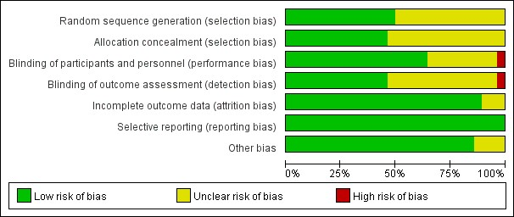
Supplementary Figure 1 Risk of bias graph
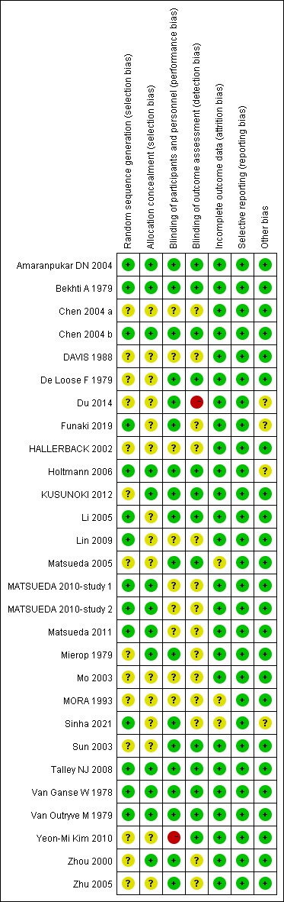
Supplementary Figure 2 Risk of bias summary
Supplementary Figure 3 Network plot of relevant studies on total efficacy rate
Notes: Nodes represent the prokinetic drugs and lines represent the direct comparisons. The size of each node indicates the overall number of participants receiving each prokinetic drug, and the line thickness between the nodes indicates the number of studies comparing two drugs.
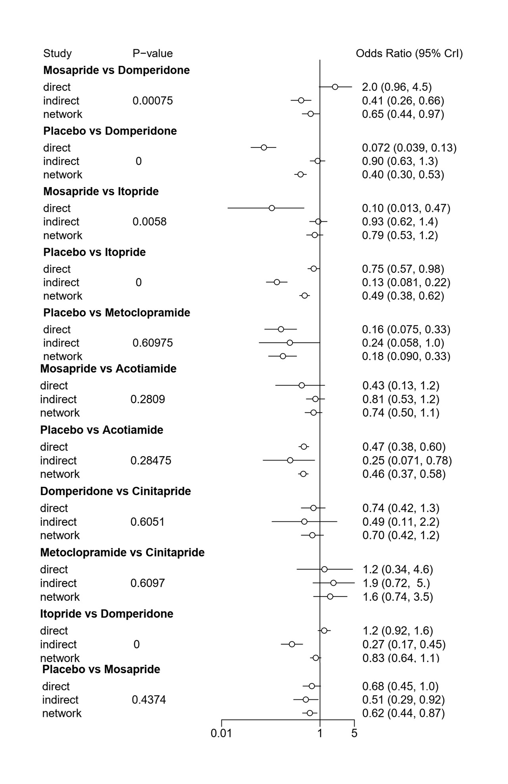
Supplementary Figure 4 Nodesplit forest plot of total efficacy rate
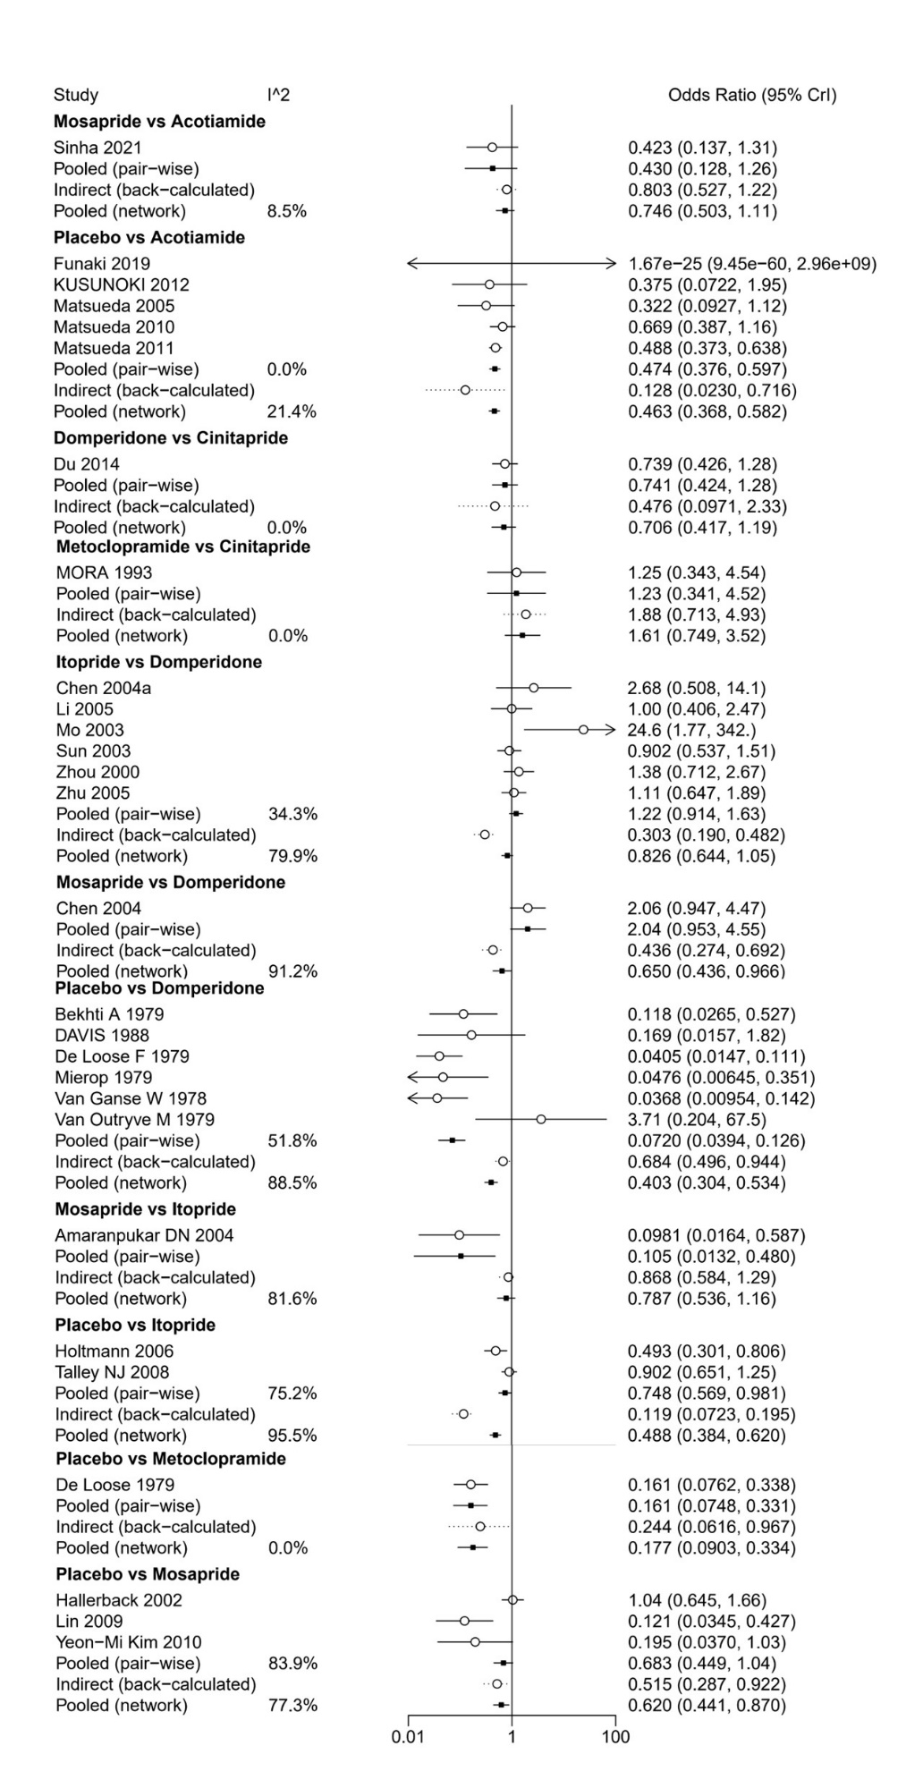
Supplementary Figure 5 Pairwise meta-analysis forest plot of total therapeutic efficacy rate
Supplementary Figure 6 Network plot of total adverse events rate from relevant studies
Notes: Nodes represent prokinetic drugs, and lines represent the direct comparisons. The size of each node indicates the overall number of participants receiving each prokinetic drug, and line thickness between the nodes indicates the number of studies comparing two drugs
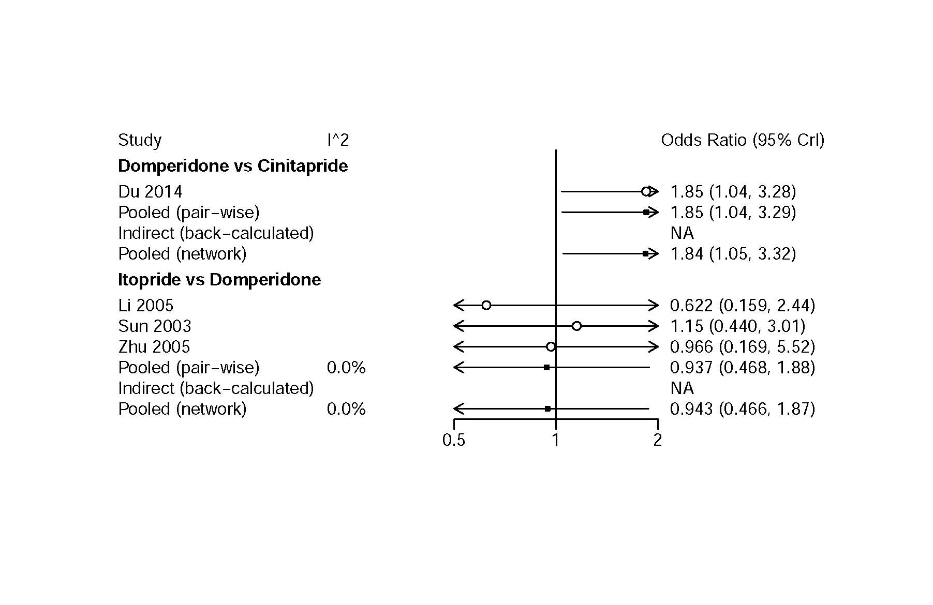
Supplementary Figure 7 Pairwise meta-analysis forest plot of total adverse events rate.
Note: As there is only one study comparing mosapride with acotiamide and placebo reporting total adverse events respectively, meta-analysis between mosapride-acotiamide-placebo was not performed.
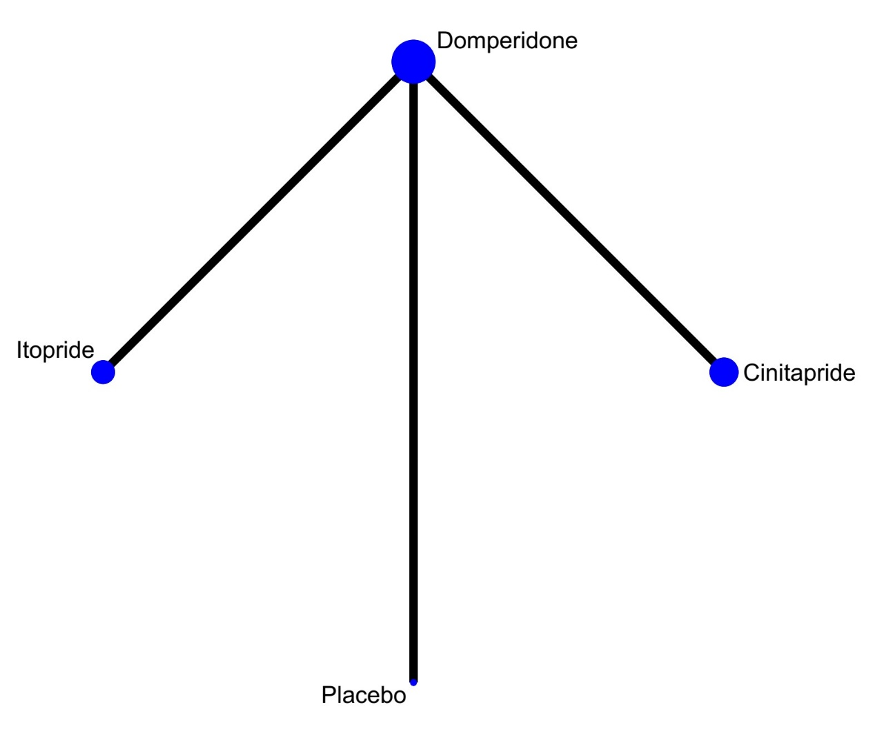
Supplementary Figure 8 Network plot of relevant studies on drug-related adverse events rate

